CLOUD COMPUTING LAB | CSE12045

EXPERIMENT 5
Implementation of Various Scheduling Mechanisms Using an Open-Source Cloud Simulator

1 Update Ubuntu

sudo apt update
Why: Refreshes Ubuntu’s package index so the system can identify available package versions.
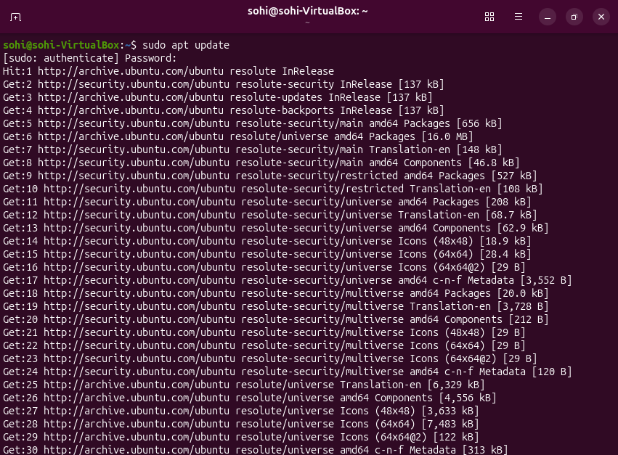
sudo apt upgrade -y
Why: Installs available updates for already-installed software. The -y flag automatically confirms the operation.
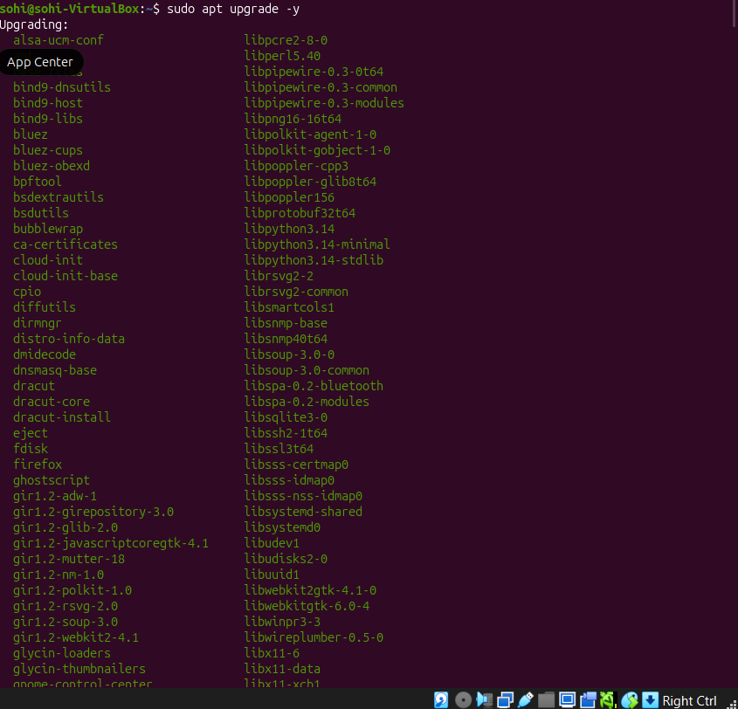

2 Install Java, Maven and Git sudo apt install openjdk-17-jdk maven git -y
Why: Installs the Java compiler/runtime, Maven build tool and Git version-control utility.
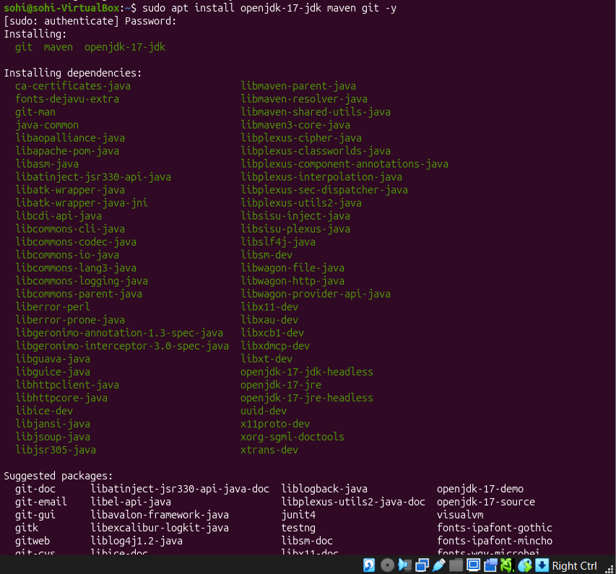
java -version
Why: Checks the installed Java runtime version.
javac -version
Why: Checks that the Java compiler is available.

mvn -version
Why: Confirms Maven installation and displays the Java version Maven uses.
git --version
Why: Confirms Git installation.
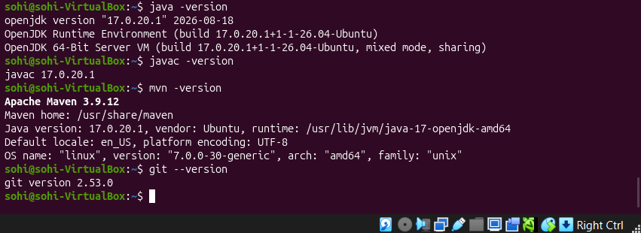
Expected check: Java and javac should report version 17.x. Maven should display a version and show that it is using Java 17. Resolve any Java-version mismatch before proceeding.

3. Create the CloudSim Plus Maven project
3.1 Create folders
mkdir -p ~/CloudSchedulingLab/src/main/java/lab
Why: Creates the project directory and standard Maven Java source directory. -p creates missing parent directories too.
cd ~/CloudSchedulingLab
Why: Changes the terminal’s current directory to the project root.
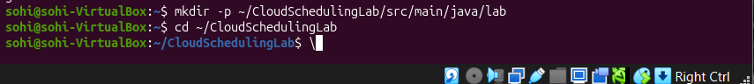

3.2 Create pom.xml nano pom.xml
Why: Opens the nano text editor to create the Maven configuration file.
Enter the following content exactly:
<project xmlns="http://maven.apache.org/POM/4.0.0"
xmlns:xsi="http://www.w3.org/2001/XMLSchema-instance" xsi:schemaLocation="http://maven.apache.org/POM/4.0.0
https://maven.apache.org/xsd/maven-4.0.0.xsd">
<modelVersion>4.0.0</modelVersion>
<groupId>lab</groupId>
<artifactId>cloud-scheduling-lab</artifactId>
<version>1.0-SNAPSHOT</version>
<properties>
<maven.compiler.release>17</maven.compiler.release>
<project.build.sourceEncoding>UTF-8</project.build.sourceEncoding>
</properties>
<dependencies>
<dependency>
<groupId>org.cloudsimplus</groupId>
<artifactId>cloudsimplus</artifactId>
<version>8.5.5</version>
</dependency>
</dependencies>
</project>
Save in nano: Ctrl+O, press Enter, then Ctrl+X.
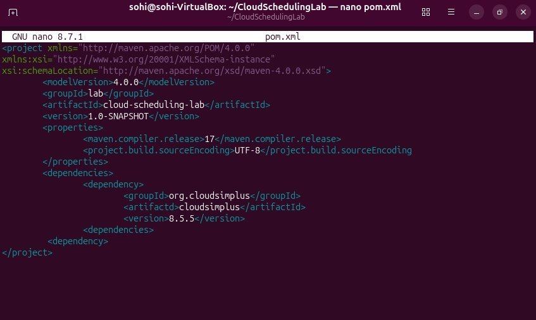
Why this file is required: It defines the Maven project, sets Java 17 as the target and declares CloudSim Plus as a dependency. Maven downloads the required library files automatically.

3.3 Resolve dependencies

mvn dependency:resolve
Why: Downloads the declared CloudSim Plus library and supporting dependencies into Maven’s local repository.
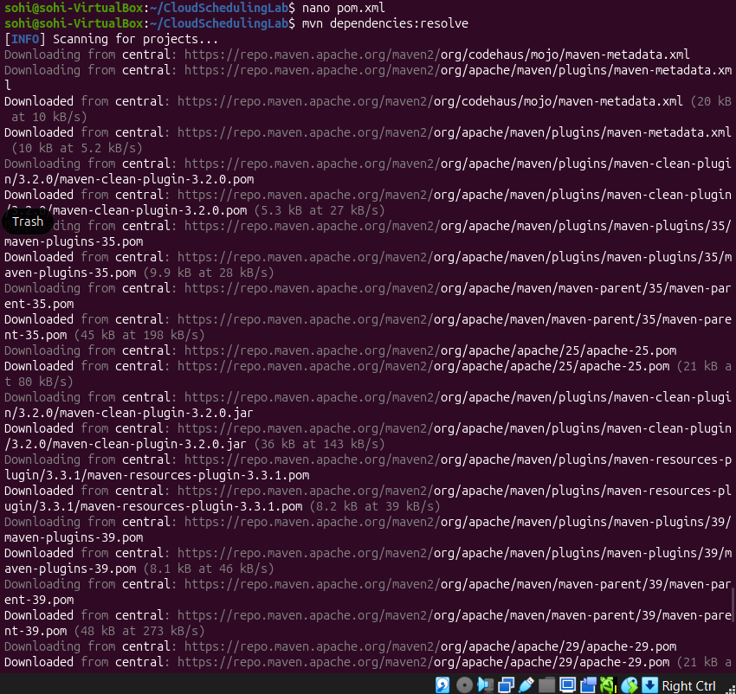
mvn clean
Why: Removes old build output (the target directory), ensuring the next build starts cleanly.

4. Implement the experiment

nano src/main/java/lab/SchedulingExperiment.java
Why: Creates the Java source file containing the simulation setup, scheduler configurations and output code.
Copy the complete Java program below. Preserve the package declaration and all class/method names.
package lab;

import java.util.ArrayList; import java.util.List;

import org.cloudbus.cloudsim.core.CloudSim; import org.cloudbus.cloudsim.datacenters.Datacenter; import org.cloudbus.cloudsim.datacenters.DatacenterSimple; import org.cloudbus.cloudsim.brokers.DatacenterBroker; import org.cloudbus.cloudsim.brokers.DatacenterBrokerSimple; import org.cloudbus.cloudsim.cloudlets.Cloudlet; import org.cloudbus.cloudsim.cloudlets.CloudletSimple; import org.cloudbus.cloudsim.hosts.Host; import org.cloudbus.cloudsim.hosts.HostSimple; import org.cloudbus.cloudsim.resources.Pe; import org.cloudbus.cloudsim.resources.PeSimple;
import org.cloudbus.cloudsim.schedulers.cloudlet.CloudletScheduler; import org.cloudbus.cloudsim.schedulers.cloudlet.CloudletSchedulerSpaceShared; import org.cloudbus.cloudsim.schedulers.cloudlet.CloudletSchedulerTimeShared; import org.cloudbus.cloudsim.schedulers.vm.VmScheduler; import org.cloudbus.cloudsim.schedulers.vm.VmSchedulerSpaceShared; import org.cloudbus.cloudsim.schedulers.vm.VmSchedulerTimeShared; import org.cloudbus.cloudsim.utilizationmodels.UtilizationModel; import org.cloudbus.cloudsim.utilizationmodels.UtilizationModelFull;
import org.cloudbus.cloudsim.vms.Vm; import org.cloudbus.cloudsim.vms.VmSimple; import org.cloudbus.cloudsim.provisioners.ResourceProvisionerSimple; import org.cloudbus.cloudsim.allocationpolicies.VmAllocationPolicySimple;

public class SchedulingExperiment { private static final int HOST_PES = 4; private static final int VM_COUNT = 2; private static final int CLOUDLET_COUNT = 4; private static final long MIPS = 1000; private static final long CLOUDLET_LENGTH = 20000;

public static void main(String[] args) { runScenario("A: VM SpaceShared + Cloudlet SpaceShared", new VmSchedulerSpaceShared(), new CloudletSchedulerSpaceShared()); runScenario("B: VM SpaceShared + Cloudlet TimeShared", new VmSchedulerSpaceShared(), new CloudletSchedulerTimeShared()); runScenario("C: VM TimeShared + Cloudlet SpaceShared", new VmSchedulerTimeShared(), new CloudletSchedulerSpaceShared()); runScenario("D: VM TimeShared + Cloudlet TimeShared", new VmSchedulerTimeShared(), new CloudletSchedulerTimeShared());
}

private static void runScenario(String title,
VmScheduler vmScheduler,
CloudletScheduler cloudletScheduler) {
System.out.println("\n==================================================");
System.out.println(title);
System.out.println("==================================================");

CloudSim simulation = new CloudSim(); createDatacenter(simulation, vmScheduler);
DatacenterBroker broker = new DatacenterBrokerSimple(simulation);

List<Vm> vmList = createVms(cloudletScheduler);
List<Cloudlet> cloudletList = createCloudlets();

broker.submitVmList(vmList); broker.submitCloudletList(cloudletList); simulation.start();

List<Cloudlet> finished = broker.getCloudletFinishedList();
System.out.printf("%-10s %-10s %-12s %-12s %-12s%n", "Cloudlet", "VM", "Status", "Start", "Finish"); for (Cloudlet cloudlet : finished) {
System.out.printf("%-10d %-10d %-12s %-12.2f %-12.2f%n", cloudlet.getId(), cloudlet.getVm().getId(), cloudlet.getStatus(), cloudlet.getExecStartTime(), cloudlet.getFinishTime());
}
System.out.println("Completed Cloudlets: " + finished.size()
+ " / " + CLOUDLET_COUNT);
}

private static Datacenter createDatacenter(CloudSim simulation,
VmScheduler vmScheduler) { List<Pe> peList = new ArrayList<>(); for (int i = 0; i < HOST_PES; i++) { peList.add(new PeSimple(MIPS));
}
Host host = new HostSimple(8192, 100000, 1000000, peList); host.setRamProvisioner(new ResourceProvisionerSimple()); host.setBwProvisioner(new ResourceProvisionerSimple()); host.setVmScheduler(vmScheduler);

List<Host> hostList = new ArrayList<>(); hostList.add(host); return new DatacenterSimple(simulation, hostList, new VmAllocationPolicySimple());
}

private static List<Vm> createVms(CloudletScheduler scheduler) { List<Vm> vmList = new ArrayList<>(); for (int i = 0; i < VM_COUNT; i++) { Vm vm = new VmSimple(i, MIPS, 2); vm.setRam(2048).setBw(10000).setSize(10000); vm.setCloudletScheduler(scheduler); vmList.add(vm);
}
return vmList;
}

private static List<Cloudlet> createCloudlets() {
List<Cloudlet> cloudletList = new ArrayList<>();
UtilizationModel utilization = new UtilizationModelFull(); for (int i = 0; i < CLOUDLET_COUNT; i++) { Cloudlet cloudlet = new CloudletSimple( CLOUDLET_LENGTH, 1, utilization); cloudlet.setSizes(300); cloudletList.add(cloudlet);
} return cloudletList;
}
}
Save: Ctrl+O → Enter → Ctrl+X.
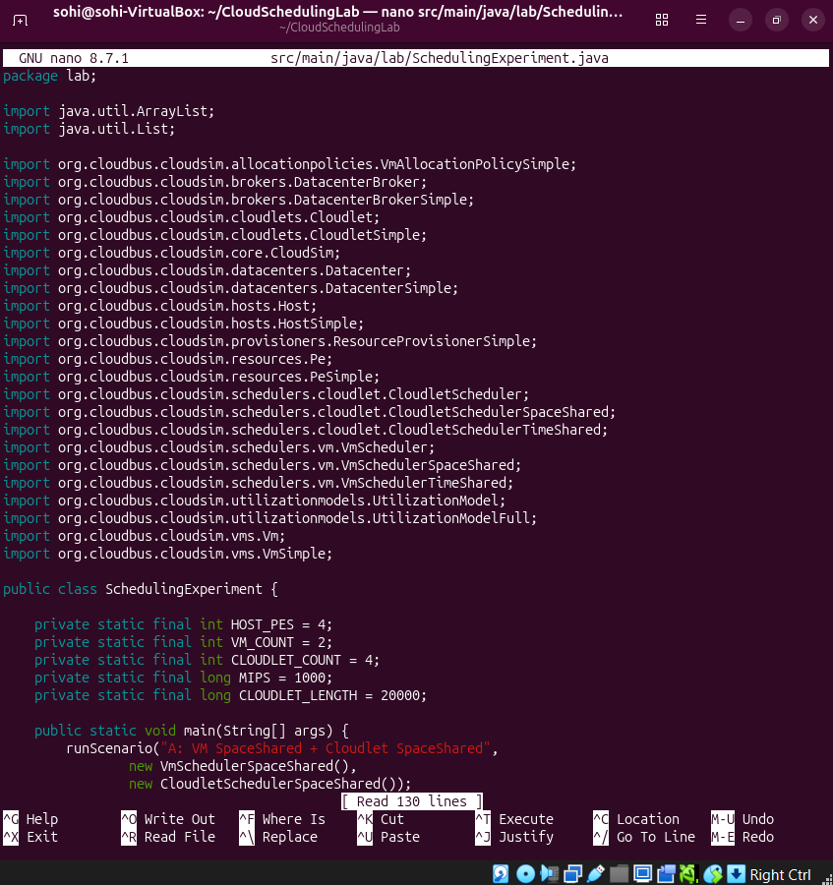

5. Compile and execute
5.1 Compile mvn clean compile
Why: Compiles the Java source code and reports syntax or API errors before running the simulation.

5.2 Run mvn exec:java -Dexec.mainClass="lab.SchedulingExperiment" -Dexec.classpathScope=compile
Why: Executes the main() method with Maven and the project dependency classpath.
If the exec plugin prefix is not resolved, run the fully qualified plugin command:

mvn org.codehaus.mojo:exec-maven-plugin:3.5.0:java -Dexec.mainClass="lab.SchedulingExperiment" -Dexec.classpathScope=compile
Why: Invokes a specific Maven Exec plugin version directly.

