Hi Team,
If anyone receives cases related to the update to DesktopVirtualization API v. 2024-04-03, please ask the customer which API version they are currently using.
To find the API version, you can follow these steps: log in to the Azure portal, navigate to Hostpool, then go to Overview and click on the JSON view. There, you will be able to check the API version you are currently using.
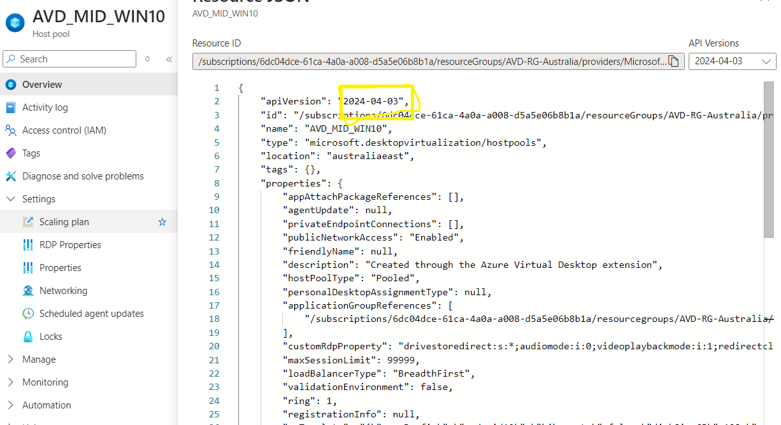
Additionally, we can review the available API versions for Desktop Virtualization under the Subscription.
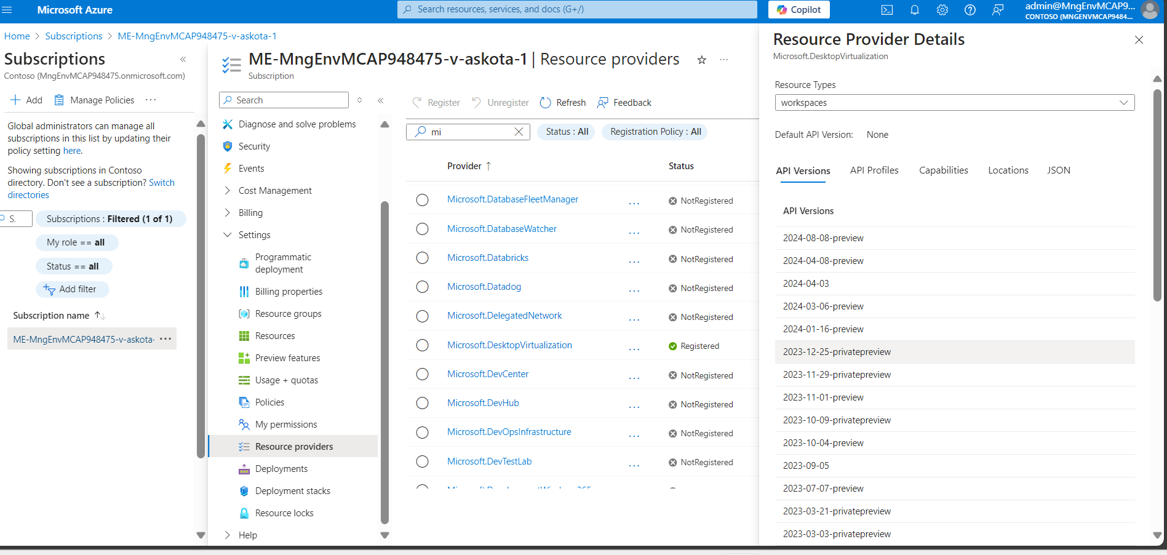
Additionally, please confirm with the customer how they are creating host pools, whether from the Azure portal or any third-party tools such as Terraform or VBScript. If they are creating host pools from the Azure portal, inform them that they do not need to worry about the email; it is an automatic message from Microsoft, and no action is required on their part as it will be automatically updated. If the customer created host pools using any third-party tool, we need to route the case to the API team.

Please refer to the email below for your reference.
Hello CX name,
I hope you're well! As you confirmed, you're using API version 2024-04-03, which is the latest. Can you confirm if you're creating the host pool using the Azure portal or a third-party tool like VBScript or Terraform?
If using the Azure portal, you can ignore Microsoft’s email; it's an automatic notification, and updates will happen automatically. If using a third-party tool, please let me know.
Thanks and looking forward to your response.

