Microsft.powershell.DSC extension failure

- Connect to the VM via Bastion or RDP.
- To join the machine to a domain, follow these steps:
- Open `Firewall.cpl` and turn off the firewalls.
- Open `ncpa.cpl`, select IPV4 properties, and add the Domain IP address as DNS.
- Open `sysdm.cpl`, change to the domain, and enter your domain name. Provide domain admin credentials when prompted. Restart the machine after it successfully joins the domain.

- If we got any error like Powershell.DSC
- 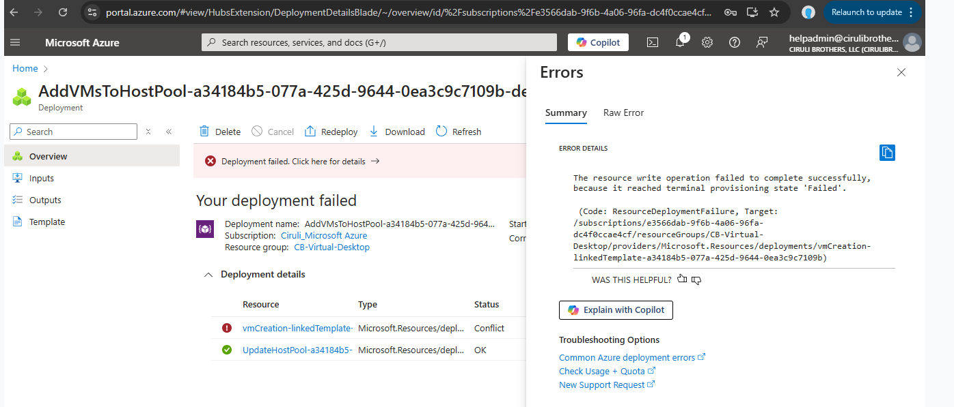

Click the vmCreation-linkedTemplate it will open like below

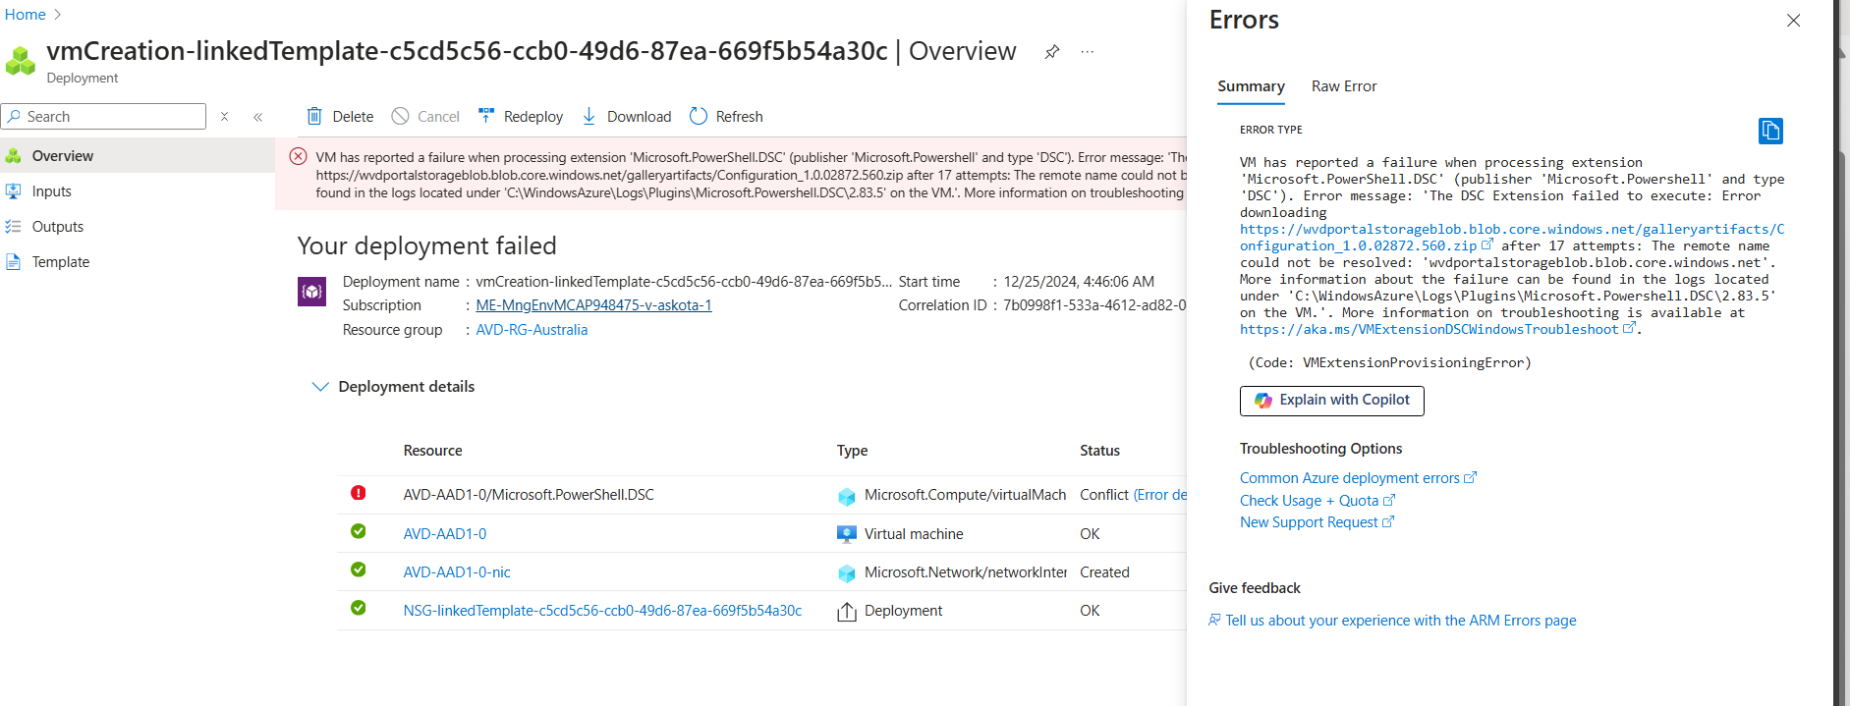

https://wvdportalstorageblob.blob.core.windows.net/galleryartifacts/Configuration_1.0.02872.560.zip
Paste the link on your VM connected through Bastion.
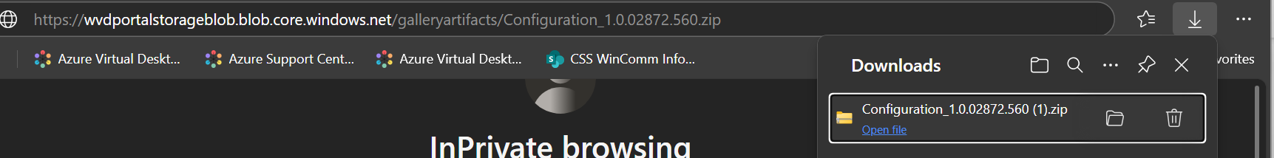

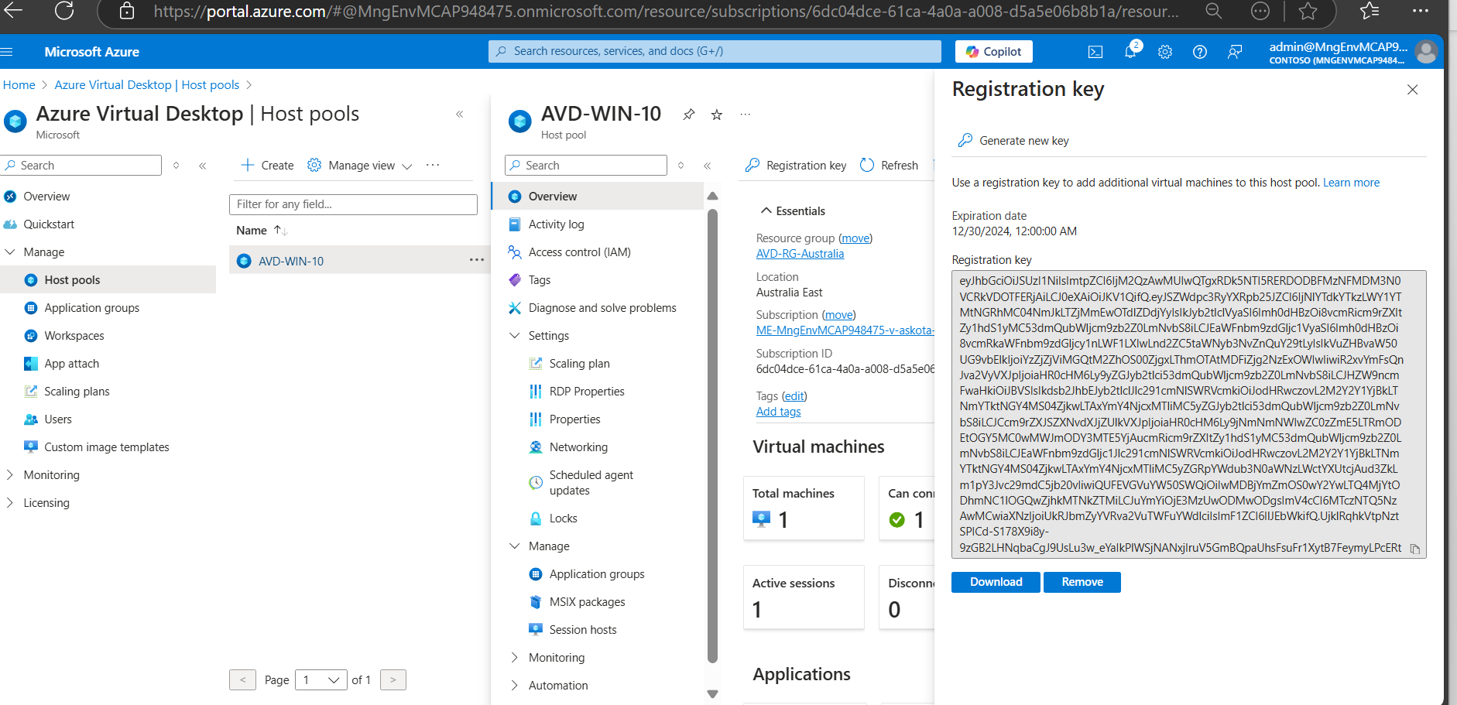

Below script we have to run on powershell
Copy the Registration key on your Host pool and paste it heare
$new Key = 'Registration key'

Set-ItemProperty -Path "HKLM:\SOFTWARE\Microsoft\RDInfraAgent" -Name "RegistrationToken" -Value $newKey -Force
Set-ItemProperty -Path "HKLM:\SOFTWARE\Microsoft\RDInfraAgent" -Name "IsRegistered" -Value 1 -Force
Get-ItemProperty -Path "HKLM:\SOFTWARE\Microsoft\RDInfraAgent" -Name IsRegistered | FL IsRegistered
Get-ItemProperty -Path "HKLM:\SOFTWARE\Microsoft\RDInfraAgent" -Name RegistrationToken | FL RegistrationToken
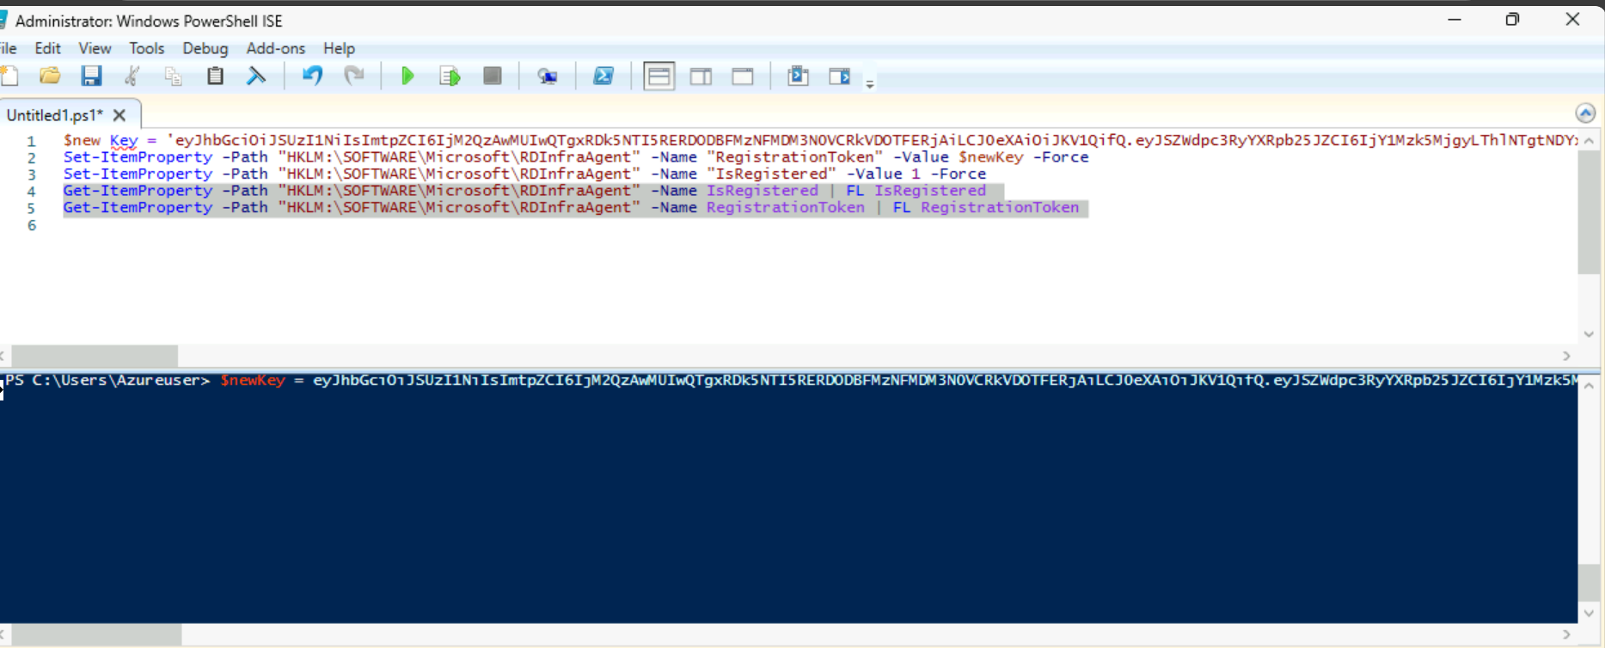
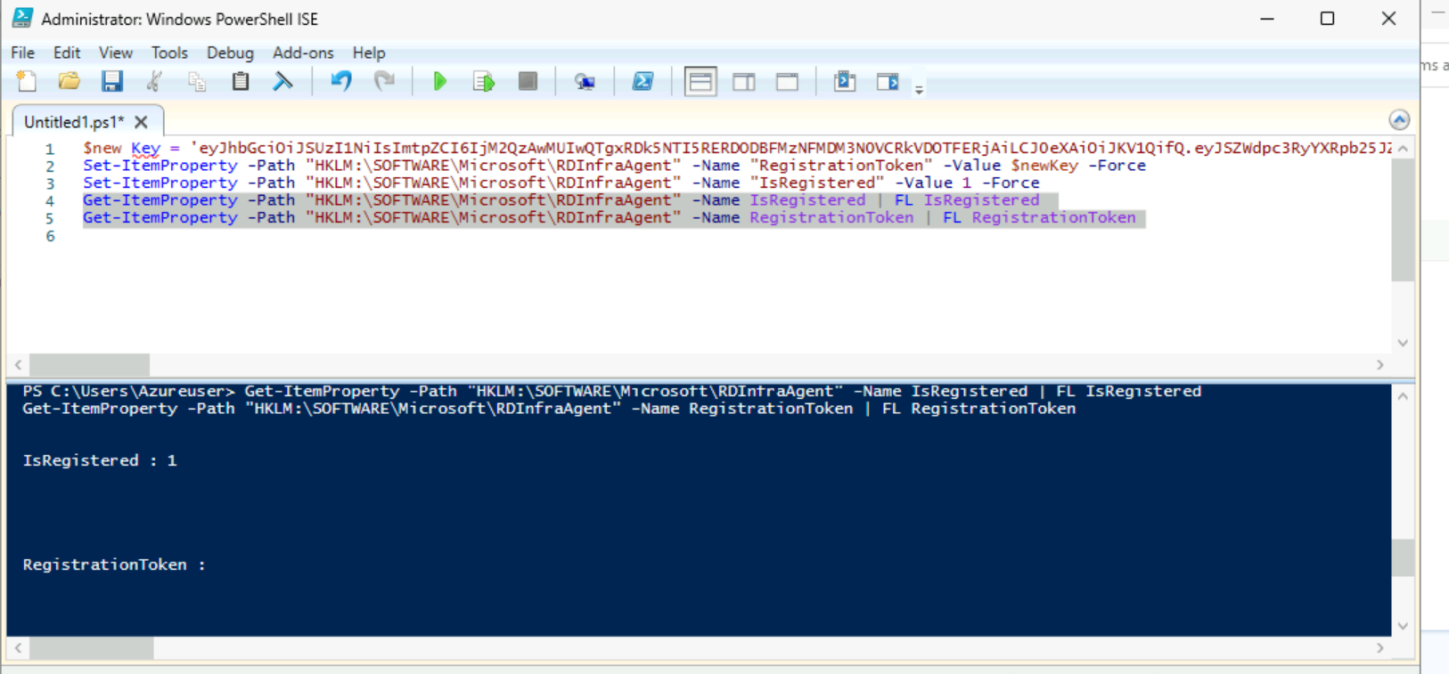
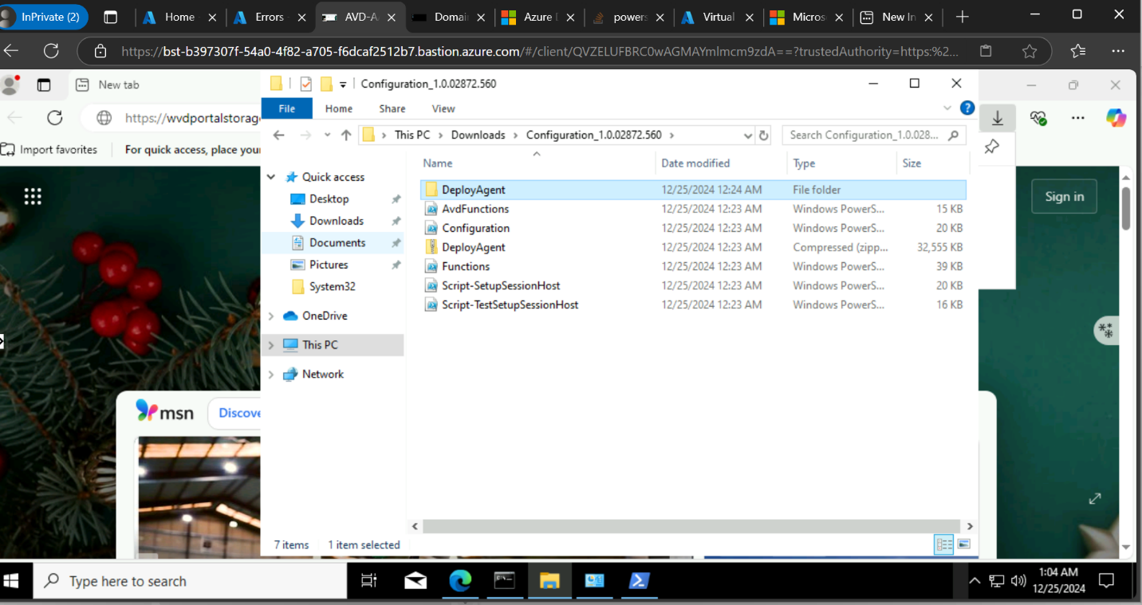

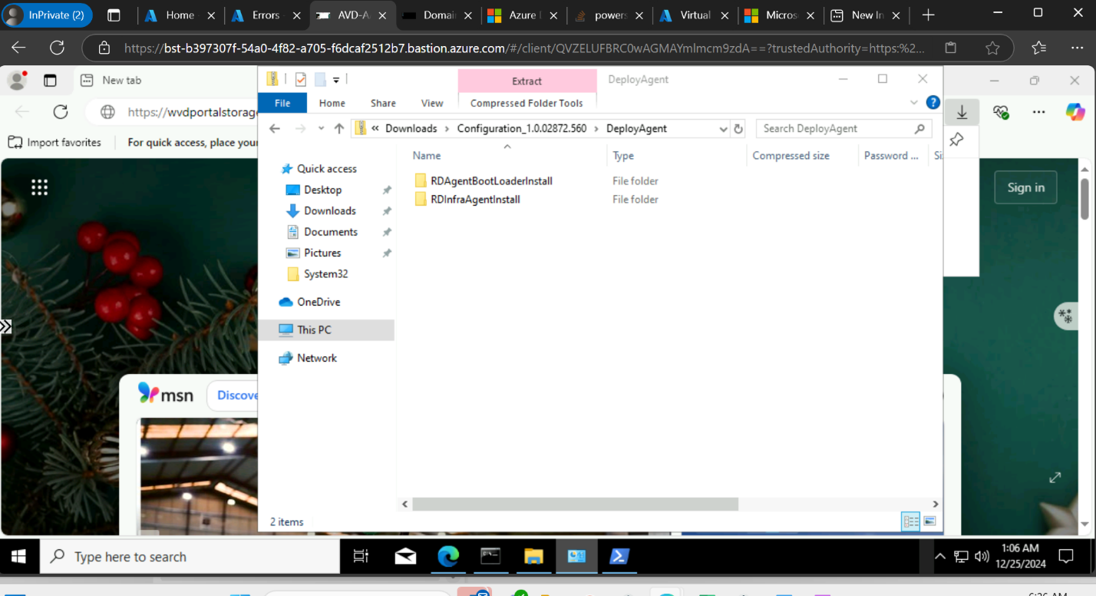

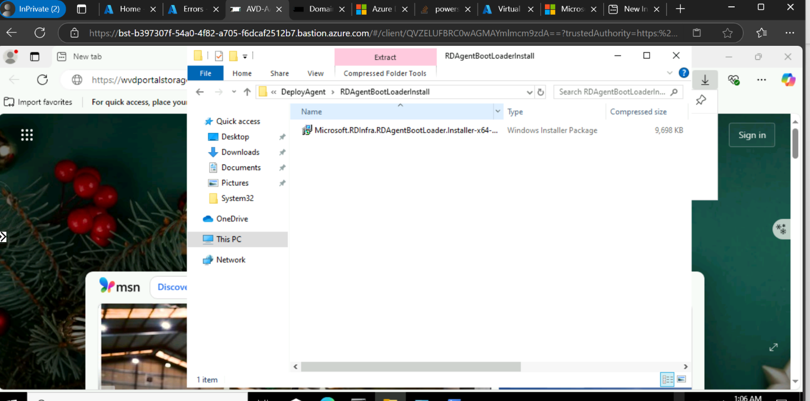
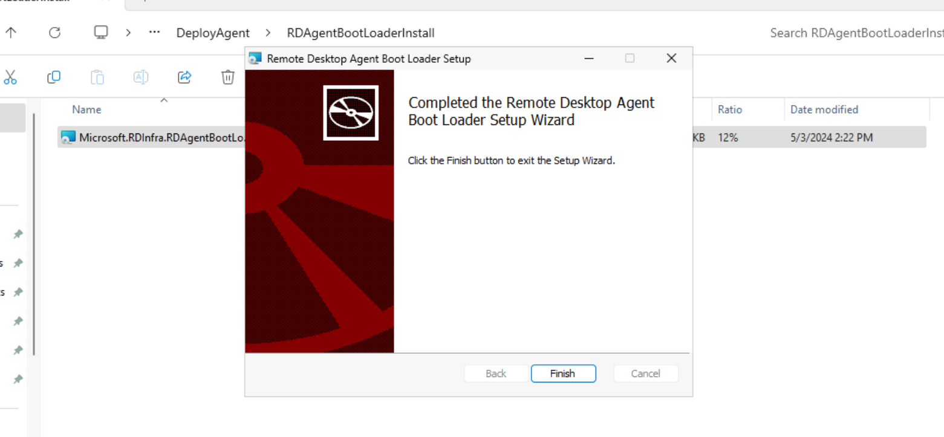

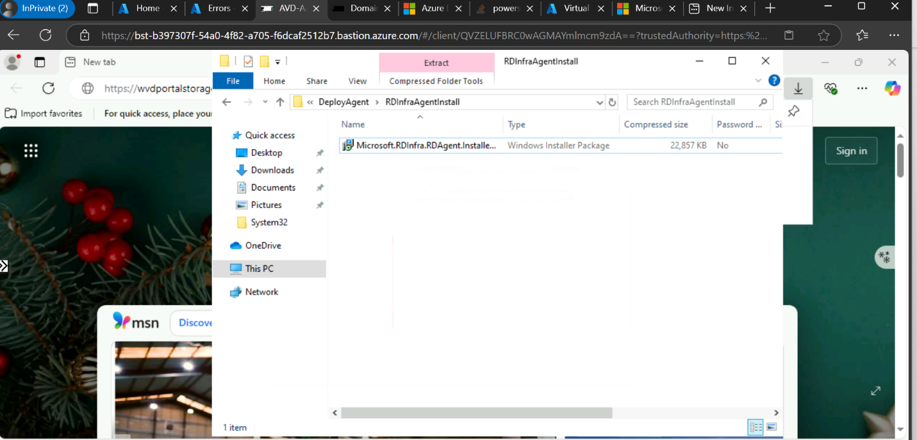
It will ask token, there we have to put registration token what we have copied from your hostpool



After installing we have to check all the agents are installed or not.

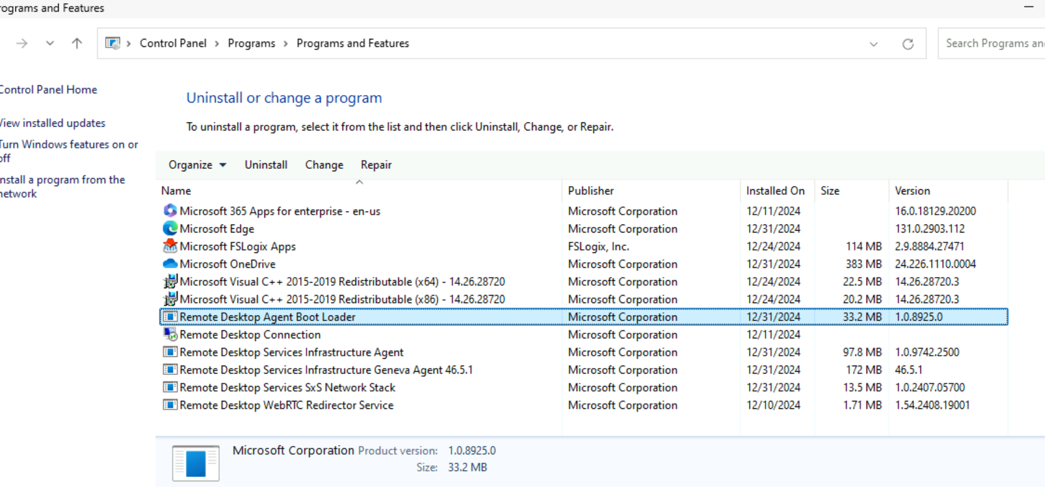
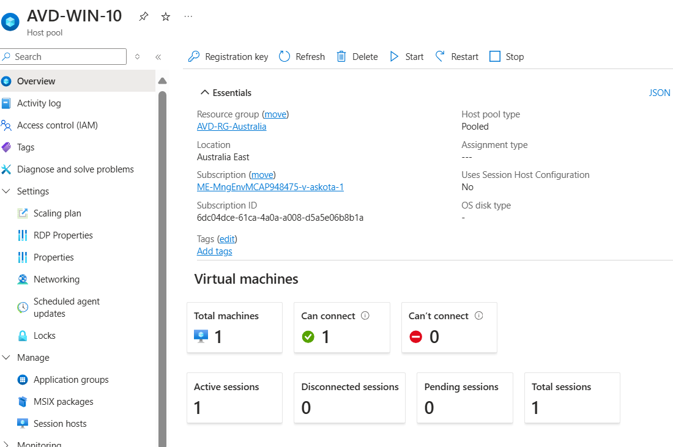



$new Key = 'Registration key'

Set-ItemProperty -Path "HKLM:\SOFTWARE\Microsoft\RDInfraAgent" -Name "RegistrationToken" -Value $newKey -Force
Set-ItemProperty -Path "HKLM:\SOFTWARE\Microsoft\RDInfraAgent" -Name "IsRegistered" -Value 1 -Force
Get-ItemProperty -Path "HKLM:\SOFTWARE\Microsoft\RDInfraAgent" -Name IsRegistered | FL IsRegistered
Get-ItemProperty -Path "HKLM:\SOFTWARE\Microsoft\RDInfraAgent" -Name RegistrationToken | FL RegistrationToken

Get-ItemProperty -Path "HKLM:\SOFTWARE\Microsoft\RDInfraAgent" -Name IsRegistered | FL IsRegistered

Set-ItemProperty -Path "HKLM:\SOFTWARE\Microsoft\RDInfraAgent" -Name "IsRegistered" -Value 1 -Force

nslookup wvdportalstorageblob.blob.core.windows.net-->CMD



The case was assigned to me at the age of 29.

