FloodGuard: Cloud Service Integration and Monitoring Through a Serverless and Microservices Architecture

Ashok Bhattrai (NP0698[##]), Samir Pokhrel (NP0698[##]),
Anjali Misra (NP0698[##]), and Sangita Tamang (NP0698[##])
School of Computing, Asia Pacific University of Technology and Innovation
CT071-3-3-DDAC: Designing and Developing Cloud Applications
[LECTURER NAME]
[SUBMISSION DATE]

Group G[GROUP NUMBER]
Problem Background 4: Flood Early Warning and Disaster Preparedness

Table of Contents
Introduction 3
Task 1 Existing System Summary 3
Proposed Cloud Architecture 4
Changes Made to the Architecture 5
Microservices Design 6
Benefits of the Expansion 7
System Implementation 8
Data Layer 9
DynamoDB Weather Snapshot Table 9
SQS Work Queues and Dead-Letter Queues 9
SNS Topics 10
Identity and Access Management 11
One Execution Role per Function 11
Least-Privilege Policy Verification 11
Compute Layer 12
Deployment Packaging 12
Function Creation 13
Event Source Mappings and Concurrency Allocation 14
API Layer 15
REST API and Resource Tree 15
Integrations and Invoke Permissions 16
Stage Deployment and Tracing 17
Event Sources 17
EventBridge Schedule 17
S3 Object-Created Notification 18
Front Door 19
CloudFront Serverless Behaviour 19
Microservice Source and Interaction 20
System Functionality Post-Implementation 21
Results and Discussion 22
End-to-End Verification 22
Monitoring Coverage 23
Measured Performance of the Serverless Tier 25
Measured Performance of the Server Tier and Data Stores 26
A Concurrency Limit Discovered Through Monitoring 26
Distributed Tracing With AWS X-Ray 27
Functional Evidence From the Event Pipelines 29
Discussion 29
Reflection From Each Member 30
New Workload Table Matrix 32
References 34

Introduction
Flooding is among the most destructive recurring natural hazards, and the interval between a rising river and a warned population is often measured in minutes rather than hours. FloodGuard addresses Problem Background 4 by providing a cloud-native early warning and emergency response platform for residents, volunteers, and municipal authorities. Task 1 delivered a working server-based implementation of that platform. Task 2, documented in this report, extends it with a serverless, event-driven tier, refactors the background processing into independently deployable microservices, and adds the monitoring instrumentation needed to evaluate the result.
The report has three objectives. First, it summarises the system inherited from Task 1 and states precisely how the architecture was expanded and why. Second, it documents the implementation of the serverless components and of the microservices that consume Amazon Simple Storage Service (S3), Amazon Simple Notification Service (SNS), and Amazon Simple Queue Service (SQS). Third, it presents monitoring evidence gathered from Amazon CloudWatch and AWS X-Ray and discusses what that evidence reveals about the performance of the expanded system. Every resource described was deployed to a single AWS account in the us-east-1 region and verified live before this report was written.

Task 1 Existing System Summary
Task 1 produced a two-tier server-based deployment. A Next.js frontend and a NestJS application server were each hosted on AWS Elastic Beanstalk, backed by a single Amazon Relational Database Service (RDS) instance running PostgreSQL 16. Three separate Amazon CloudFront distributions fronted the deployment.
All background processing ran inside the application server. Weather polling, flood risk scoring, and alert creation were executed by an in-process scheduled task. The design was functional but structurally constrained in three respects: background work competed with user requests for the same compute resources, the scheduled task could not scale independently of the web workload, and the scheduler would have produced duplicate alerts had the environment ever scaled beyond one instance. Table 1 summarises the inherited components.
Table 1
Components Inherited From the Task 1 Server-Based Deployment
Tier | Service | Configuration | Responsibility
Presentation | Elastic Beanstalk | Next.js 16, single instance | Server-rendered web interface
Application | Elastic Beanstalk | NestJS 11, load balanced | Business logic and REST interface
Data | Amazon RDS | PostgreSQL 16.10, db.t3.micro | Relational persistence
Delivery | Amazon CloudFront | Three distributions | Transport security and caching
Scheduling | In-process cron | Ten-minute interval | Weather polling and alerting
Note. The scheduling row identifies the only component wholly replaced in Task 2. All other rows were retained and extended rather than rebuilt.

Proposed Cloud Architecture
The architecture proposed for Task 2 introduces a serverless tier alongside the retained server tier, on the principle that workloads with different scaling characteristics should not share a compute boundary. Scheduled ingestion, risk scoring, and notification fan-out are episodic and bursty, whereas the web and application tiers serve steady interactive traffic. Separating them allows each to scale on its own signal, which Newman (2021) identified as the primary operational benefit of service decomposition.
The design consolidates the three CloudFront distributions into one distribution with path-based routing to three origins. It places Amazon API Gateway in front of a set of AWS Lambda functions rather than in front of the existing application server, because only that arrangement makes the functions independently addressable services. It introduces Amazon DynamoDB for append-only weather time-series data, SQS for decoupling the processing stages, and SNS for alert fan-out. Figure 1 presents the resulting architecture as deployed.
Figure 1
FloodGuard Task 2 As-Built Cloud Architecture
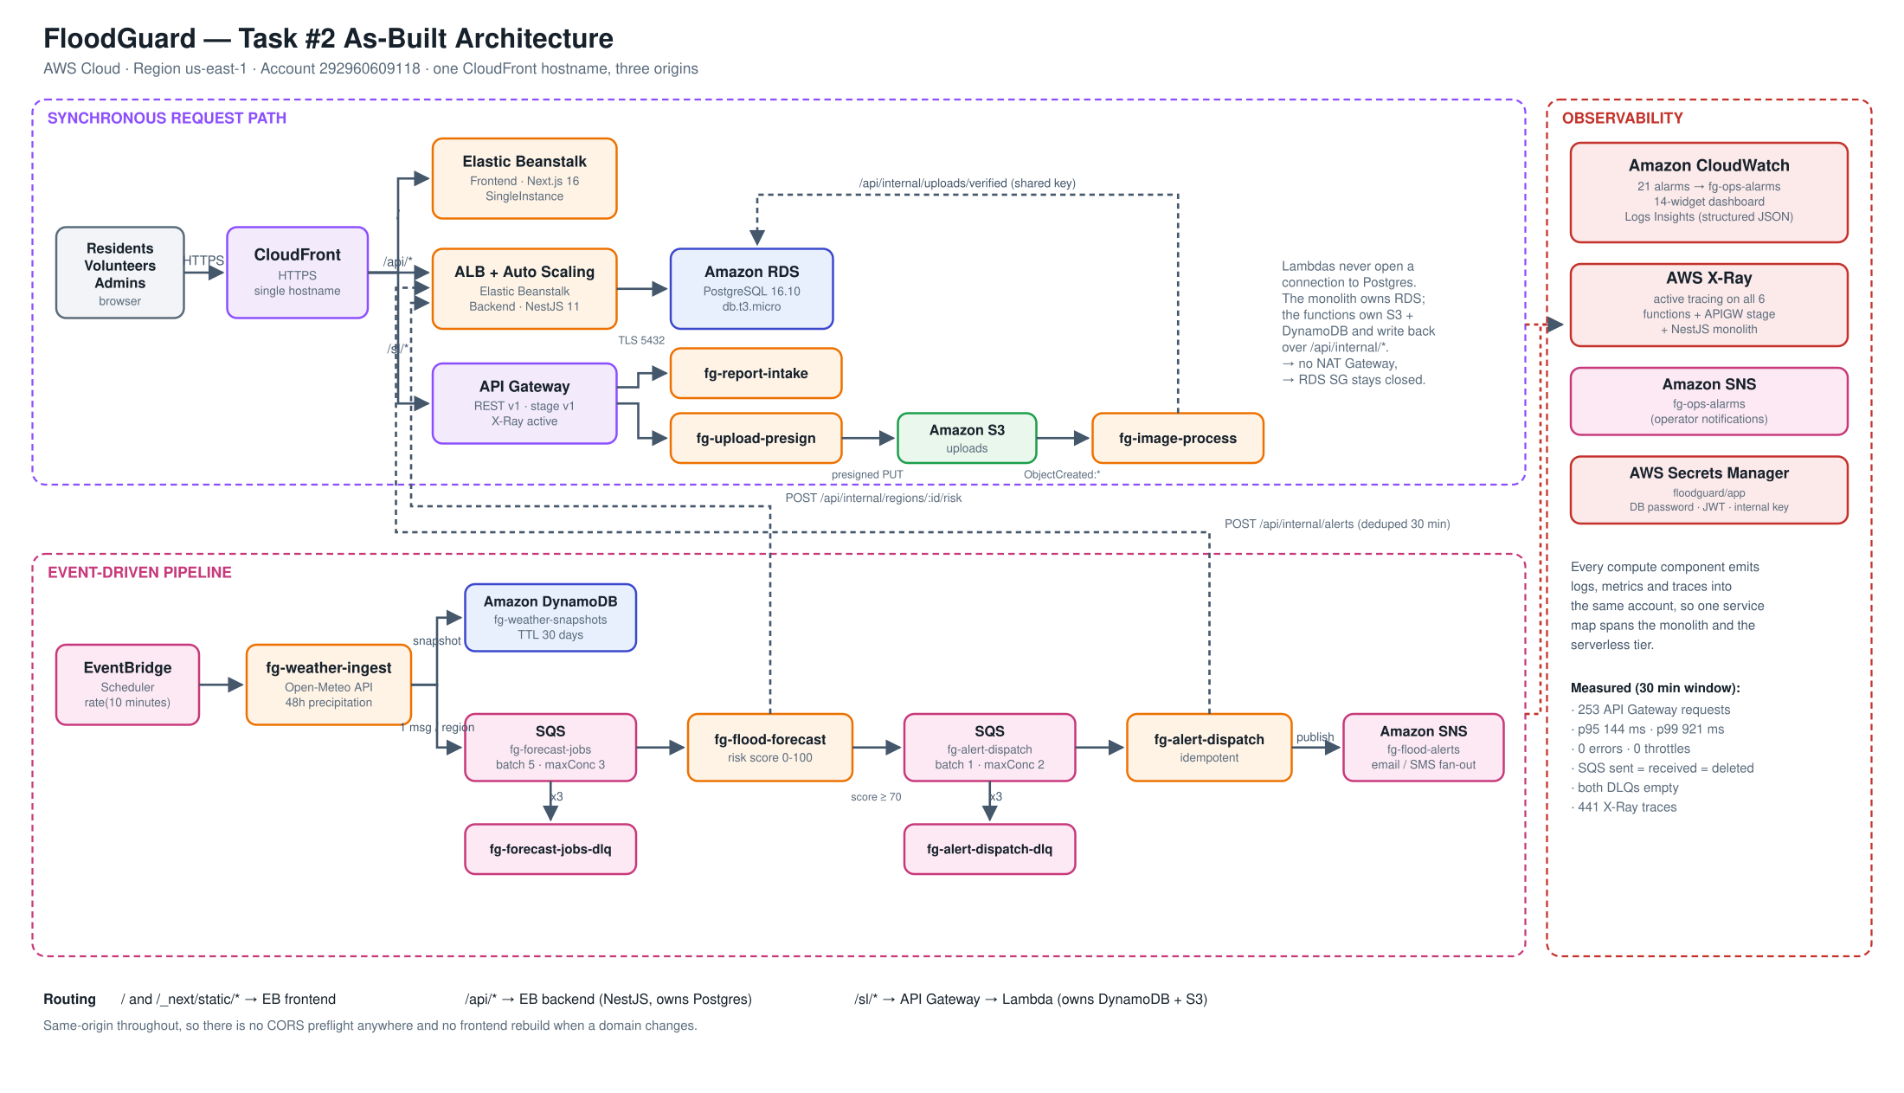
Note. The diagram was generated from the deployed resource inventory rather than from the design proposal, so every component shown corresponds to a provisioned resource. Solid arrows denote synchronous request flow and dashed arrows denote authenticated service-to-service calls.

Changes Made to the Architecture
Reviewing the proposed design against the Task 1 codebase before implementation identified several elements that would not have worked as first drawn. Each was corrected, and those corrections constitute the substantive architectural change between the two tasks. Table 2 records them.
Table 2
Architectural Changes Between Task 1 and Task 2
Element | Issue identified | Resolution
Gateway placement | Positioned in front of Elastic Beanstalk, adding a network hop without adding capability, so no request would ever reach a function | API Gateway placed in front of the Lambda functions
Gateway protocol | HTTP APIs emit no X-Ray trace segments, and tracing evidence is required by this task | REST API version 1 selected, which emits trace segments
Trigger chain | EventBridge was drawn as publishing directly to SQS, but a scheduled tick carries no per-item work to distribute | Reordered to EventBridge, then Lambda, then SQS, then Lambda
Queue topology | Work queue and dead-letter queue were drawn as one component, concealing the redrive mechanism | Four queues provisioned: two work queues and two dead-letter queues
S3 integration | S3 was drawn as a passive store with no event wiring | Object-created notification invokes an image verification function
DynamoDB purpose | Intended to hold live risk levels already authoritative in PostgreSQL, creating a dual write with no owner | Repurposed for append-only weather time series with a 30-day expiry
Database exposure | Multi-availability-zone deployment in private subnets exceeded the available budget and required a network address translation gateway | Single availability zone retained, with a two-zone subnet group so promotion remains one API call
Note. Every resolution listed was implemented and verified rather than proposed. The protocol decision recorded in the second row is discussed further under Stage Deployment and Tracing.
Two latent defects in the inherited system were corrected at the same time. The first concerned duplicate alerting. Because the in-process scheduler executes on every running instance, and because the Task 1 configuration constrained instance type but not instance count, the first autoscaling event would have delivered every flood alert twice to real subscribers. Relocating the trigger to Amazon EventBridge Scheduler resolves this, since the scheduler fires once irrespective of fleet size. The second defect concerned credential handling: the Task 1 deployment configuration contained the live database password and token signing secret, which committed both permanently to version control. Credentials are now generated into AWS Secrets Manager and injected at deployment time.

Microservices Design
Six Lambda functions were implemented. Each carries its own least-privilege execution role, an arrangement that matters because the functions do not hold equivalent trust. A single shared role would grant the unauthenticated public intake endpoint permission to publish alerts to every subscriber, which is a privilege escalation path rather than a convenience. Table 3 states the boundary, trigger, and integration of each service.
Table 3
Microservice Boundaries, Triggers, and AWS Service Integrations
Function | Trigger | Integrates with | Responsibility
fg-weather-ingest | EventBridge, 10 min | DynamoDB, SQS | Retrieve forecasts, store snapshot, enqueue one job per region
fg-flood-forecast | SQS work queue | SQS, internal interface | Compute composite risk score, enqueue alerts above threshold
fg-alert-dispatch | SQS alert queue | SNS, internal interface | Create the alert idempotently, then fan out to subscribers
fg-report-intake | API Gateway | Internal interface | Accept unauthenticated public flood reports
fg-upload-presign | API Gateway | S3 | Issue time-limited presigned upload URLs
fg-image-process | S3 object created | S3, internal interface | Verify the file signature and tag the stored object
Note. No function opens a connection to PostgreSQL. The application server owns the relational store and exposes an authenticated internal interface, which preserves a single writer per data store.
Ingestion performs input and output only. Risk scoring is deliberately excluded from it so that a slow change to the scoring algorithm cannot stall data collection. The scoring logic itself was ported from the Task 1 application server without modification, which keeps the two implementations behaviourally identical. Because SQS provides at-least-once delivery, dispatch is idempotent: a matching active alert within a thirty-minute window is suppressed rather than duplicated.

Benefits of the Expansion
The expansion delivers four benefits that the monitoring evidence in the next section quantifies. Independent scalability is the first, since each stage now responds to its own signal: ingestion on schedule, scoring on queue depth, and dispatch on triggered alert volume, rather than by adding whole application instances. Second, the queue boundary confers deployment flexibility, because the scoring function can be replaced while messages accumulate and drain without request loss. Third, resilience improves through explicit dead-letter queues and partial batch failure reporting, which together prevent one malformed message from forcing redelivery of an entire batch. Fourth, cost efficiency improves because the functions consume compute only while executing, consistent with the economic model described by Adzic and Chatley (2017).
A further benefit concerns data ownership. Keeping the functions outside the virtual private cloud avoids the recurring cost of a network address translation gateway and allows the database security group to remain closed, while the internal interface avoids the dual-write consistency problem that Richardson (2018) identified as a common decomposition failure.

System Implementation
The Task 2 serverless layer was provisioned entirely through the AWS Command Line Interface so that every step is reproducible and auditable rather than a sequence of console gestures. Table 4 lists what was built. The Task 1 server tier, comprising the virtual private cloud, the relational database, both Elastic Beanstalk environments, and the content delivery distribution, was retained and enhanced rather than replaced.
Table 4
Resources Provisioned in the Task 2 Serverless Layer
Service | Resource provisioned | Purpose
DynamoDB | fg-weather-snapshots | Append-only weather time series with 30-day expiry
SQS | Two work queues and two dead-letter queues | Decoupling and failure isolation
SNS | fg-flood-alerts and fg-ops-alarms | Public fan-out and operator alarms
IAM | Six execution roles and one scheduler role | One least-privilege role per function
Lambda | Six functions | The microservices
API Gateway | REST API fg-serverless-api, stage v1 | Public entry to two functions
EventBridge | fg-weather-ingest-schedule | Ten-minute ingestion trigger
S3 | Object-created notification | Upload is itself the trigger
CloudFront | Path behaviour for /sl/* | Single front door across three origins
CloudWatch | 21 alarms and a 14-widget dashboard | Monitoring and response
Note. All commands were executed against a single account in the us-east-1 region and were verified end to end after execution. The account identifier is visible in the resource identifiers shown throughout the figures that follow.

Data Layer

DynamoDB Weather Snapshot Table
The table is partitioned on region and sorted on timestamp, so the latest snapshots for a region resolve in a single query. On-demand billing suits periodic rather than sustained ingestion. A time-to-live attribute expires items after thirty days at no write cost, which is what keeps the table within the free tier.
Figure 2
Creation of the DynamoDB Table and Its Expiry Specification
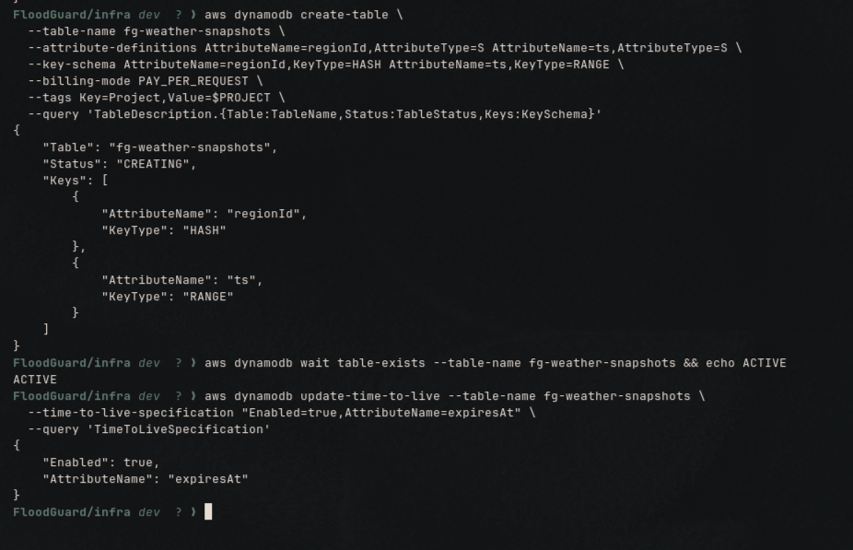
Note. The status moves to ACTIVE with regionId as the partition key, ts as the sort key, and the time-to-live attribute enabled on expiresAt.

SQS Work Queues and Dead-Letter Queues
Four queues were created rather than two. A dead-letter queue is a separate queue reached by a redrive policy, and that policy is the resilience mechanism (Amazon Web Services, 2025a). Visibility timeout was set to six times the longest consumer timeout so that SQS cannot redeliver a message still being processed, and a maximum receive count of three routes a repeatedly failing message aside instead of looping indefinitely.
Figure 3
Queue Creation and the Redrive Policy Linking Each Work Queue to Its Dead-Letter Queue
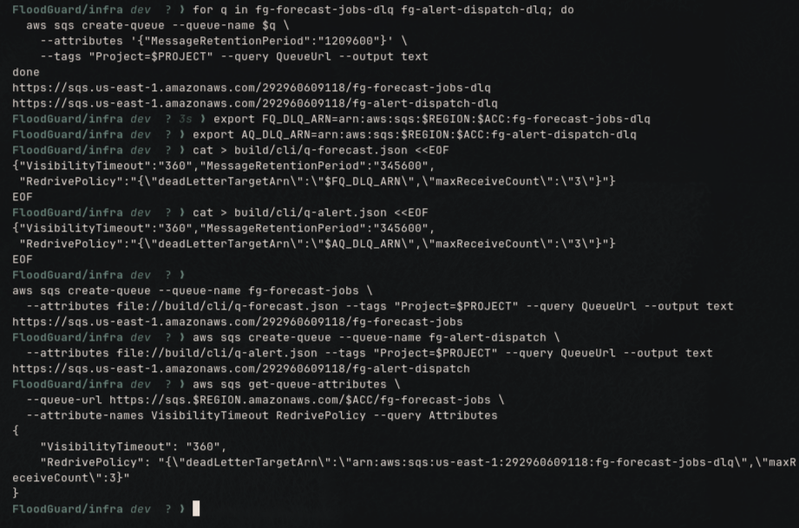

SNS Topics
Two topics were kept deliberately separate so that an operational alarm storm can never reach residents, and a public flood alert is never mistaken for an infrastructure notification.
Figure 4
Creation of the Alert and Operations Topics and Confirmation of a Subscription
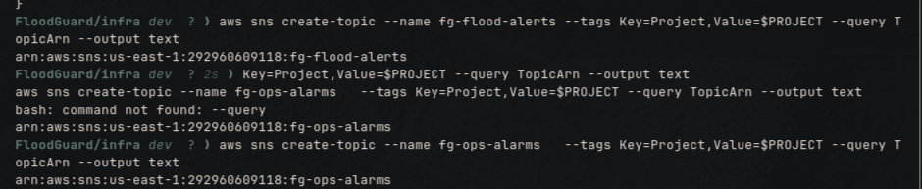
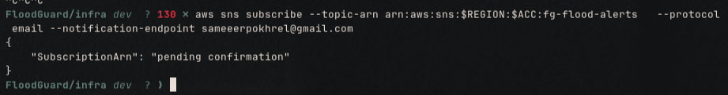

Identity and Access Management

One Execution Role per Function
Six roles confine the blast radius of a fault in any one handler to that handler alone. Each role trusts only the Lambda service and carries the basic execution and X-Ray write policies in addition to its own inline policy.
Figure 5
Creation of the Six Lambda Execution Roles and Attachment of Their Managed Policies
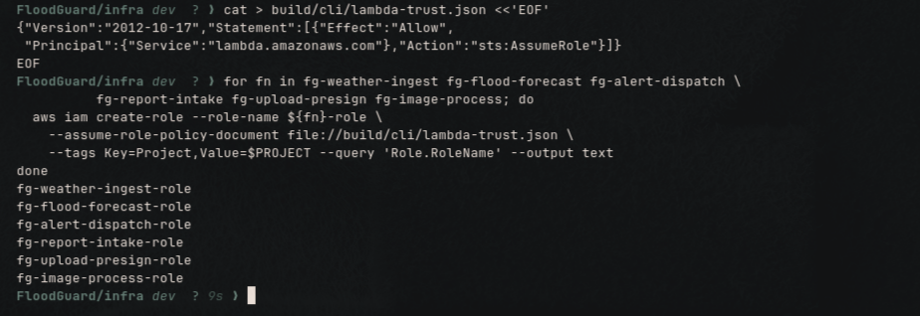
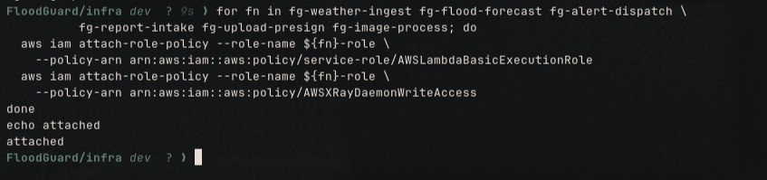

Least-Privilege Policy Verification
Each role receives an inline policy naming only the resources that its function actually touches. Figure 6 verifies the narrowest of the six.
Figure 6
Evidence of Privilege Separation on the Unauthenticated Intake Function
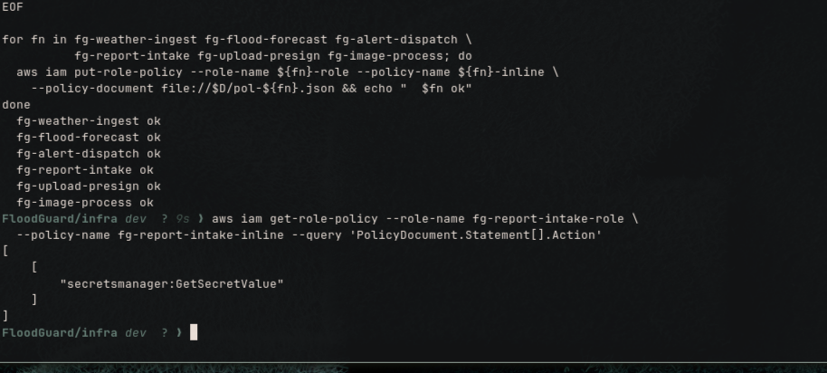
Note. The action list for fg-report-intake-role contains secretsmanager:GetSecretValue and nothing further, which demonstrates that the only unauthenticated endpoint in the system holds no permission to publish to SNS.

Compute Layer

Deployment Packaging
The Node.js 22 runtime already ships the AWS SDK, so five of the six functions package as a handler plus a shared helper of a few kilobytes. Only the presign function declares external dependencies. Small packages mean short initialisation times, which Figure 7 makes visible as a size difference of three orders of magnitude.
Figure 7
Deployment Archive Sizes Across the Six Functions
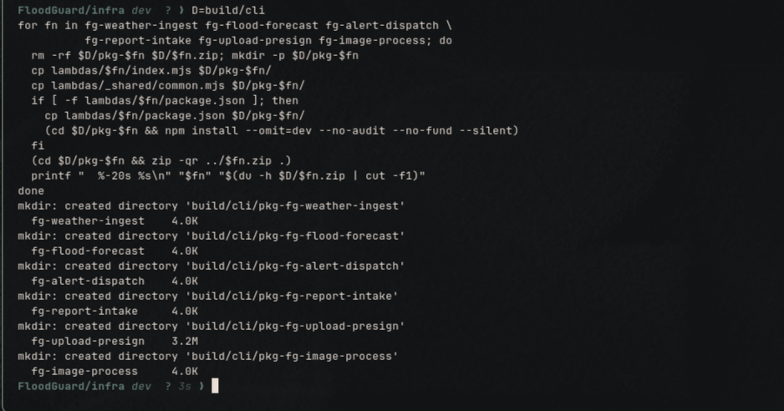

Function Creation
Timeouts are set per workload. Ingestion makes ten sequential outbound calls and receives 300 seconds, whereas a function fronted by an endpoint receives 30. Active tracing is enabled on all six, which is what makes the service map in Figure 27 possible.
Figure 8
Creation of the Six Lambda Microservices With Active Tracing Enabled
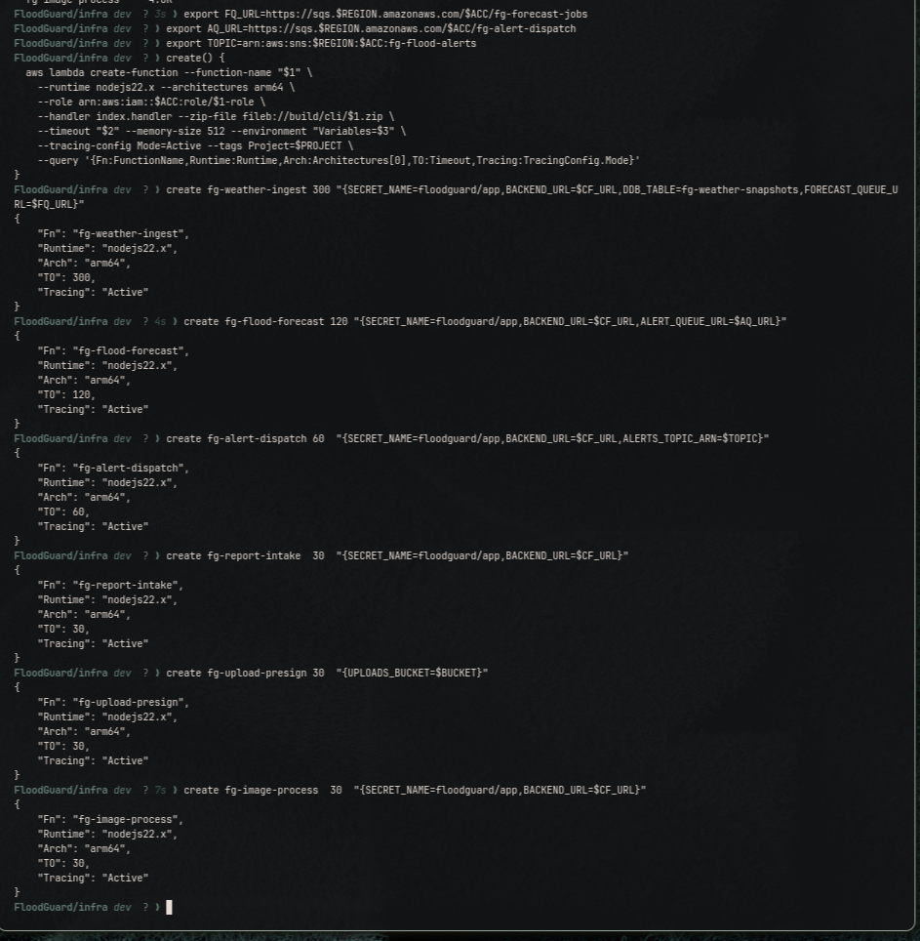

Event Source Mappings and Concurrency Allocation
This account permits ten concurrent Lambda executions rather than the default thousand. An uncapped queue consumer scales until it owns all of them and starves the public request path, which API Gateway surfaces to users as a server error. Capping the consumers at three and two therefore reserves five executions for synchronous traffic. Partial batch failure reporting prevents one poison message from forcing redelivery of its healthy batch companions (Amazon Web Services, 2025f).
Figure 9
Queue Consumers Created With Explicit Concurrency Ceilings
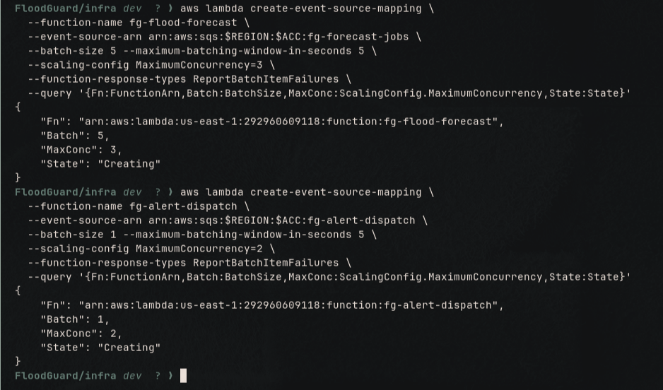

API Layer

REST API and Resource Tree
A REST API was selected over an HTTP API for one decisive reason: HTTP APIs do not emit X-Ray trace segments, and tracing evidence is required (Amazon Web Services, 2025d). Resources are rooted at /sl so that the distribution can forward with an origin path of /v1 and require no path rewriting.
Figure 10
REST API Identifier and Deployed Resource Tree
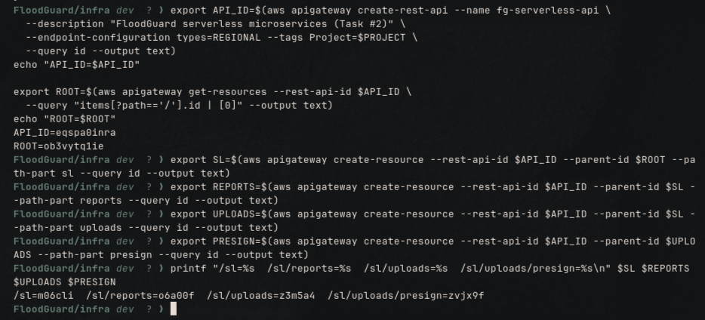

Integrations and Invoke Permissions
Lambda proxy integration passes the raw request to the handler, so routing and response shape live in code rather than in gateway mapping templates. The resource-based invoke permission is scoped to this API and this method rather than granted broadly.
Figure 11
Lambda Proxy Integrations and the Resulting Console Resource Tree
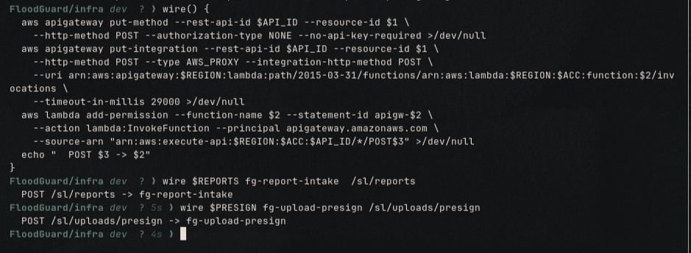
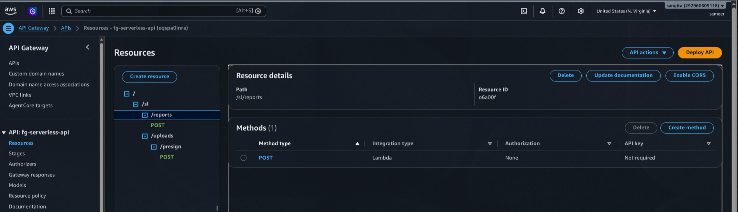

Stage Deployment and Tracing
Figure 12
Stage Deployment With X-Ray Tracing Enabled and a Direct Endpoint Test
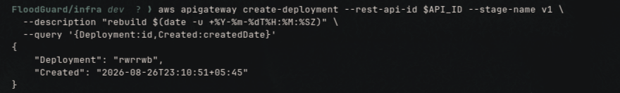
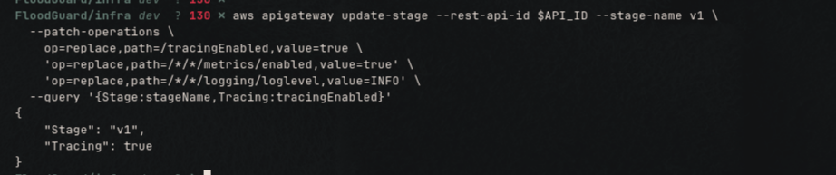
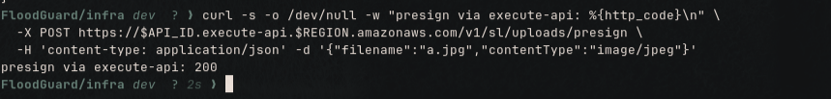
Note. The tracingEnabled setting shown in the second panel is the capability that HTTP APIs lack entirely, and it is the reason the protocol decision in Table 2 was reversed. The third panel is a direct call to the stage endpoint, bypassing the distribution, which isolates the gateway from the front door during testing.

Event Sources

EventBridge Schedule
The schedule replaces the in-process task that ran on every instance. EventBridge fires once regardless of fleet size. Because Identity and Access Management is eventually consistent and the scheduler validates role assumption at creation time, the call is issued inside a retry loop.
Figure 13
Scheduler Role Creation and Verification of the Ten-Minute Trigger
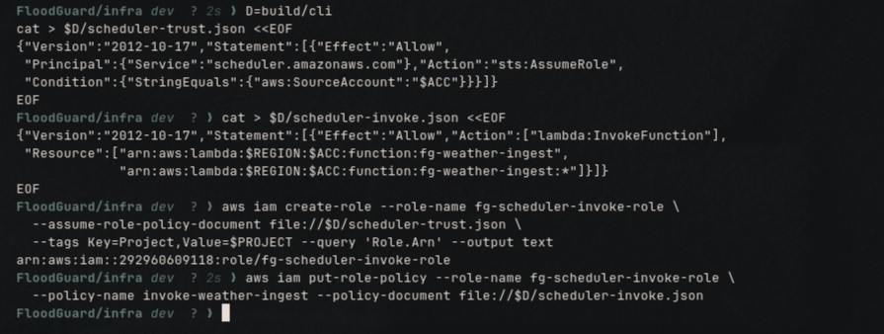
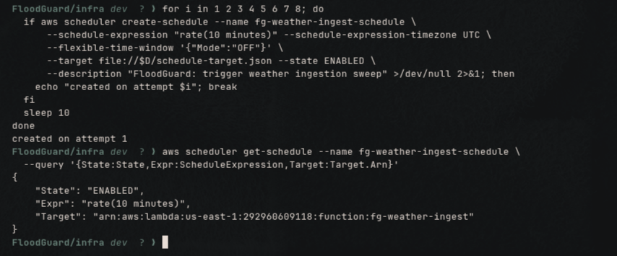

S3 Object-Created Notification
The invoke permission must exist before the notification is attached, because attaching it validates that the destination is invocable (Amazon Web Services, 2025b). Uploading a photograph is itself the trigger: nothing polls and nothing is scheduled.
Figure 14
Bucket Notification Wiring Uploads to the Image Verification Function
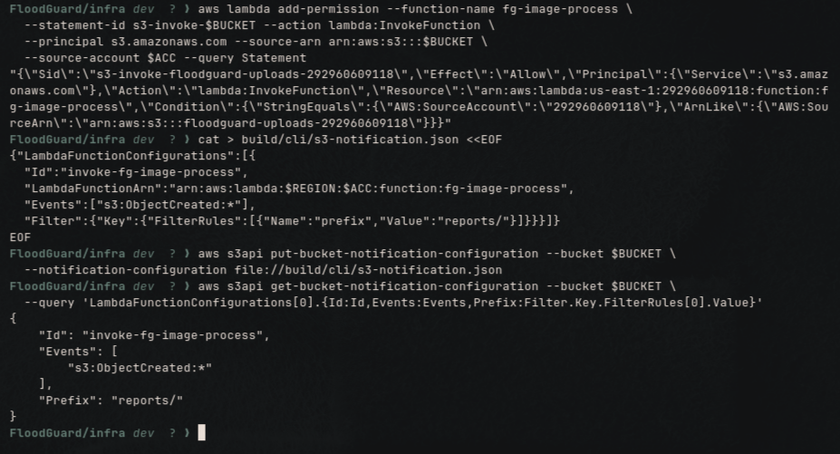

Front Door

CloudFront Serverless Behaviour
Adding the /sl/* behaviour completes a single hostname serving three origins, so every browser request is same-origin and no cross-origin preflight occurs anywhere in the system.
Figure 15
Distribution Updated With the API Gateway Origin
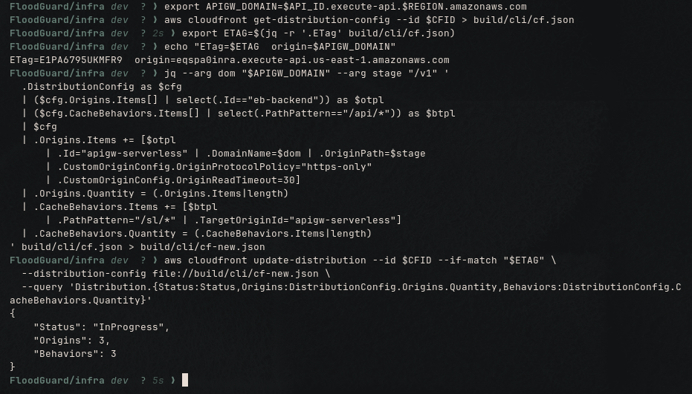

Microservice Source and Interaction
The functions never share a database. The application server owns the relational store, the serverless tier owns DynamoDB and S3, and the two communicate over queues and an authenticated internal interface. Figure 16 shows the source layout: six independent function directories plus one shared helper, each with its own entry point, which is what makes them independently deployable. Ingestion fans work out by sending one message per region in batches of ten, the batch API limit. The forecast consumer collects failed message identifiers into a batch item failure array and returns it, so only the failures are redelivered. Dispatch checks for a matching active alert and returns early before publishing, which is what makes at-least-once delivery safe. Image verification reads the file signature from the object bytes, because a presigned URL pins a declared content type but S3 never checks that the bytes agree with it.
Figure 16
Source Layout of the Six Independently Deployable Microservices
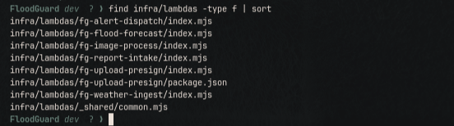

System Functionality Post-Implementation
The interfaces below exercise the integrated system end to end, from an unauthenticated visitor through to administrative review. Each was captured from the live deployment reached through the single CloudFront hostname, which confirms that the serverless tier and the retained server tier are reachable as one application.
Figure 17
Public Landing Page Served Through the CloudFront Distribution
[PASTE SCREENSHOT: the public landing page at the distribution root, with the CloudFront hostname visible in the address bar.]
Figure 18
Resident Dashboard Showing Regional Risk and Active Alerts
[PASTE SCREENSHOT: the authenticated resident dashboard, showing the risk level and at least one pipeline-generated alert.]
Figure 19
Report Submission Showing the Direct Browser-to-S3 Upload Sequence
[PASTE SCREENSHOT: the report form with the browser network panel open, showing a request for a presigned URL followed by a separate upload addressed to the S3 hostname. Truncate the signed query string, which is a temporary credential.]
Figure 20
Authority Review of a Submitted Report
[PASTE SCREENSHOT: a report moving to the verified state, with the attached photograph rendered.]
Figure 21
Alert Issued by an Authority User
[PASTE SCREENSHOT: the alert creation interface immediately after issuing an alert, with the new alert visible in the active list.]
Figure 22
User Administration and Role Assignment
[PASTE SCREENSHOT: the user management view with assigned roles. Obscure real electronic mail addresses.]

Results and Discussion
All figures reported in this section were measured on the live deployment using an automated verification and load-generation script. The script exercises every hop of both pipelines and then issues 240 requests across the server and serverless paths in thirty seconds, so that latency percentiles describe a system under load rather than an idle one.

End-to-End Verification
The verification routine proves each hop rather than merely asserting that resources exist, and it discriminates between correct acceptance and correct rejection. All 18 checks passed with no failures. Table 5 summarises the assertions and Figure 23 records the run.
Table 5
End-to-End Verification Assertions and Observed Results
Assertion | Expected | Observed
Front door routes to web, application, and serverless origins | 200, 200, 200 | 200, 200, 200
Internal interface reached without a credential | Rejected | 401
Presign endpoint with a valid request and with an executable | 200, rejected | 200, 415
Public report endpoint with a malformed body and a valid body | Rejected, created | 400, 201
Genuine image uploaded, then a text file renamed as an image | verified, rejected | verified, rejected
Scheduled ingestion invoked, failed regions | 200, none | 200, 0
DynamoDB snapshots written during the run | Increase | 20 to 30
Both dead-letter queues after the run | Empty | 0 and 0
Duplicate alert message delivered twice | Suppressed | Suppressed
X-Ray traces recorded in the preceding 15 minutes | Non-zero | 275
Note. The rejection assertions matter as much as the acceptance assertions. Validation that rejects everything would also pass a test that only checked for failure.
Figure 23
Consolidated End-to-End Verification Result for the Serverless Layer
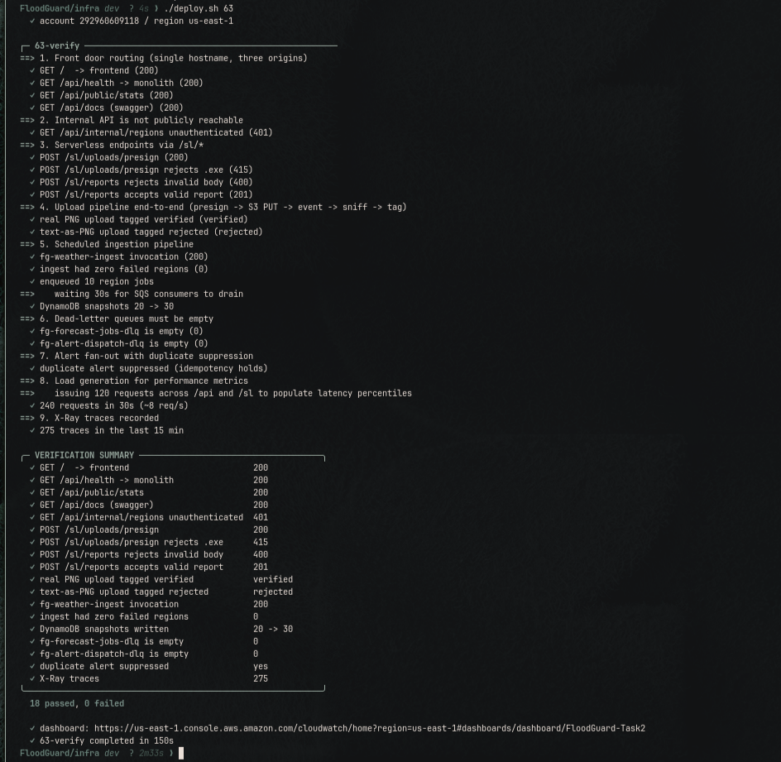

Monitoring Coverage
A 14-widget dashboard is laid out along the request path, from front door through the serverless pipeline and queue health to the data tier and the retained server tier, ending in a log query of recent errors across all six functions. All handlers emit single-line structured output so that fields remain queryable.
Figure 24
Monitoring Dashboard Populated Under Load
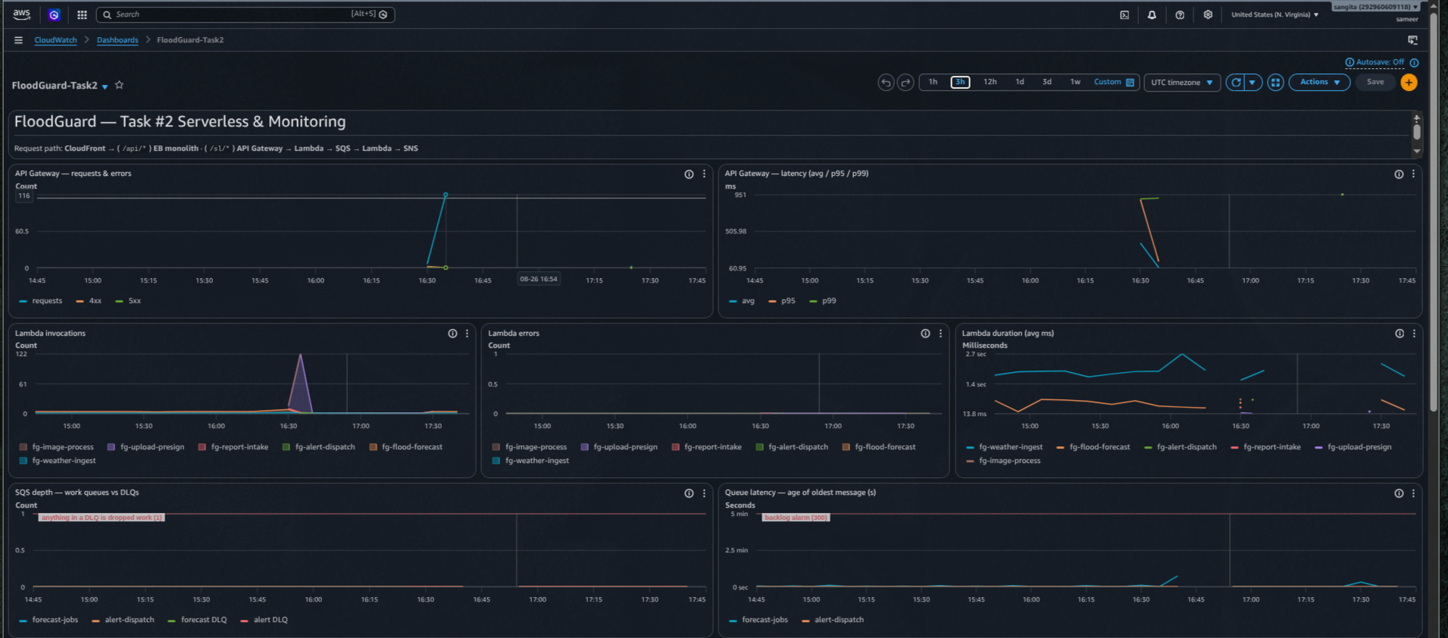
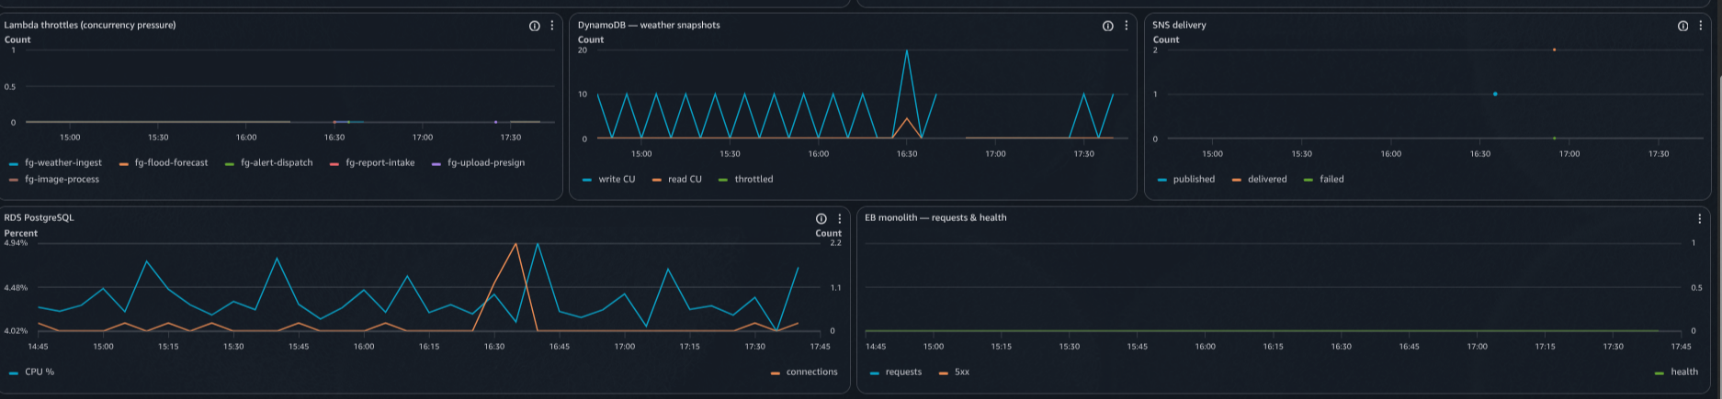
Twenty-one alarms are configured, every one of them publishing to the operations topic, because a metric without an alarm action is observation without response (Amazon Web Services, 2025e). Three matter most. A non-empty dead-letter queue means work was permanently dropped. An age of oldest message above five minutes is the honest backlog signal, because queue depth can look healthy on a fast-moving queue while consumers fall behind. A Lambda throttle count is a capacity signal rather than a code defect, and the next subsection shows that alarm earning its place.
Figure 25
Alarm Inventory in a Non-Alarming State
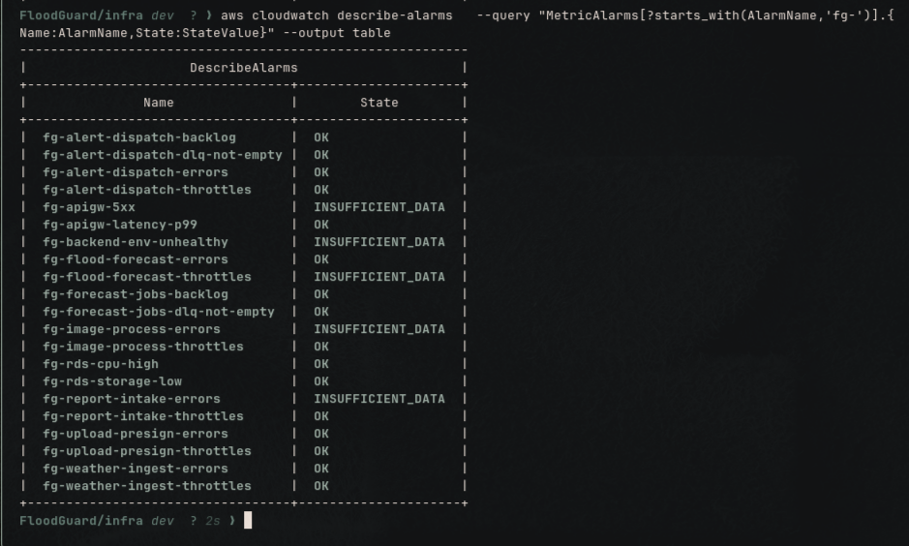
Note. Alarms reported as INSUFFICIENT_DATA cover error and throttle conditions that had not occurred within the evaluation window, which is the expected state for a healthy system rather than a configuration fault.

Measured Performance of the Serverless Tier
Table 6 reports Lambda metrics across the window covering the load run.
Table 6
Lambda Invocation Counts, Error Counts, and Duration Percentiles Under Load
Function | Invocations | Errors | M (ms) | p95 (ms) | Max (ms)
fg-upload-presign | 245 | 0 | 13.1 | 96.2 | 117.9
fg-report-intake | 4 | 0 | 277.7 | 551.0 | 552.3
fg-flood-forecast | 12 | 0 | 466.9 | 968.6 | 988.5
fg-alert-dispatch | 4 | 0 | 475.4 | 765.9 | 778.4
fg-image-process | 2 | 0 | 557.5 | 772.2 | 778.5
fg-weather-ingest | 5 | 0 | 1638.3 | 2194.8 | 2245.9
Note. M denotes the arithmetic mean duration. Invocation counts differ by function because each is driven by a different event source rather than by uniform traffic.
Two observations follow. First, the gap between the mean of 13.1 ms and the 95th percentile of 96.2 ms for the presign function is initialisation cost. The warm path is a matter of single-digit milliseconds and the tail is the creation of new execution environments during a burst (Amazon Web Services, 2025c). Provisioned concurrency would remove that tail at a fixed hourly charge, which intermittent academic traffic does not justify. Second, weather ingestion is the slowest function at 1.6 s, but it is intended to be, because it makes ten outbound calls to an external forecast service (Open-Meteo, 2025). That is precisely why scoring was moved behind a queue: a synchronous design would have placed those 1.6 s on a user’s request path.

Measured Performance of the Server Tier and Data Stores
Table 7
Server Tier and Data Store Utilisation Across the Measurement Window
Component | Metric | Value
Load balancer | Requests, mean target response time | 327, 23.6 ms
Load balancer | Successful responses, server errors | 321, 0
RDS PostgreSQL | CPU, connections, free storage | 4.3%, 0.4, 17.1 GB
DynamoDB | Items, size, billing mode | 3,212, 782 KB, on demand
DynamoDB | Consumed write units, read units | 60, 418.5
SNS | Messages published, failed | 1, 0
A mean target response time of 23.6 ms against 4.3% database processor utilisation shows the server tier comfortably under-used. That is the expected outcome of moving polling and scoring off it, because in Task 1 the same instances that served user requests also ran that work in process.

A Concurrency Limit Discovered Through Monitoring
The most useful result of this task came from monitoring rather than from testing, and it changed the deployed configuration.
An early load run returned two server errors out of 253 gateway requests. X-Ray attributed the faults to the gateway stage, and the traces showed a duration of 13 ms with a Lambda segment containing no subsegments and no application error. A genuine handler failure would have produced an error segment, so the request had never reached application code. The throttle metric for the presign function confirmed two throttles in the same minute, and the account quota supplied the cause: this account permits ten concurrent executions, not the default thousand, and the load generator was issuing bursts of twelve.
The architectural risk this exposed matters more than the failed test. Both queue event source mappings had no concurrency ceiling, so either consumer could occupy all ten slots. A backlog on the forecast queue, which is background work, would therefore starve the presign and intake functions on the public request path. A shared concurrency pool with no allocation lets a background workload hold a user-facing endpoint hostage.
Two changes followed. The queue consumers were capped at three and two, reserving the remaining five executions for synchronous traffic, and the queue absorbs any resulting backlog, which is precisely its purpose. Scaling configuration was chosen over reserved concurrency deliberately, because at an account limit of exactly ten Lambda will not permit reserved concurrency to be allocated at all. The load generator was then bounded below the quota so that the test measures the latency of the system rather than the ceiling of the account. Table 8 records the outcome.
Table 8
Throttling and Server Errors Before and After the Concurrency Allocation
Run | Presign invocations | Throttles | Gateway server errors
Before allocation, burst of 12 | 118 | 2 | 2
After allocation, burst of 8 | 117 | 0 | 0
Note. The functional assertions passed in both runs. Only the metrics distinguished a system that worked from a system that would continue to work while a queue was busy.

Distributed Tracing With AWS X-Ray
Active tracing is enabled on all six functions, on the gateway stage, and on the application server. The server required explicit instrumentation, because the platform option enables the trace daemon, which forwards segments but does not create them, so that option alone yields an empty service map. Because both tiers report into one account, a single map spans the monolith and the serverless tier, which is why the throttling above was attributed to the gateway stage rather than to a handler within minutes of it occurring.
Figure 26
Trace Map Metrics for the Gateway Stage Under Load
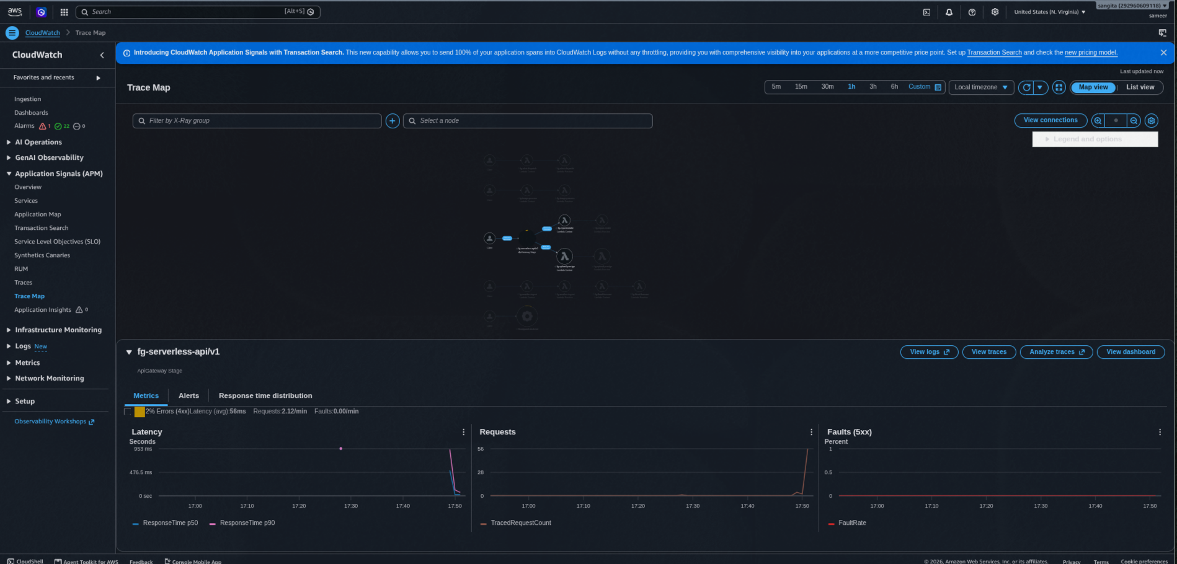
Note. Mean latency of 56 ms and a fault rate of zero are recorded against the stage. The 2% client error rate is the deliberate rejection traffic issued by the verification routine, namely the unauthenticated internal call, the malformed report, and the rejected executable upload.
Figure 27
Service Map Spanning the Serverless and Server Tiers
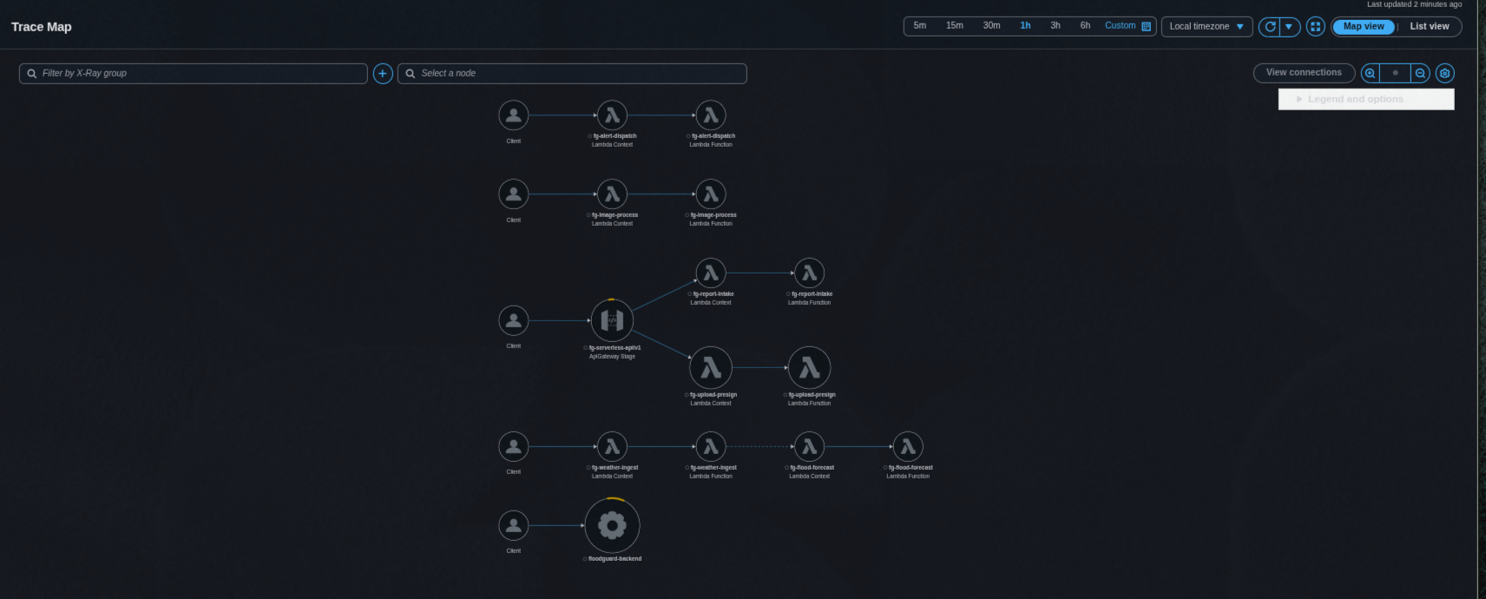
Note. The gateway stage node, the six function nodes, and the application server node appear in one view. The presence of the gateway node is the return on selecting a REST API over an HTTP API, as recorded in Table 2.

Functional Evidence From the Event Pipelines
Two outcomes confirm that the event wiring fired rather than merely existing. The object tags in Figure 28 were written by the verification function, so their presence proves the object-created notification invoked it and that the file signature check ran on the stored bytes. The message in Figure 29 confirms that fan-out reaches a subscribed endpoint, which is the outcome that matters most in an early warning system.
Figure 28
Object Tags Written by the Image Verification Function
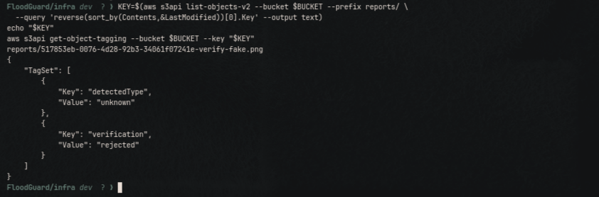
Figure 29
Notification Delivered to a Subscribed Endpoint by Amazon SNS
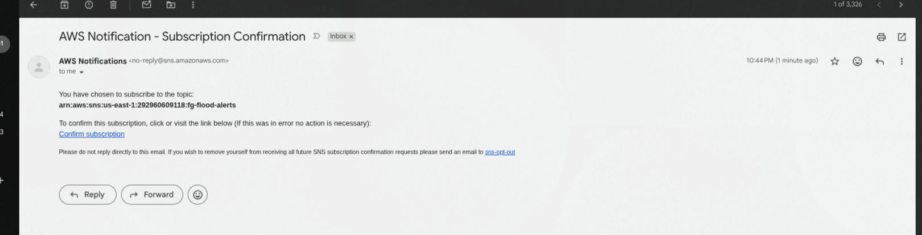

Discussion
The monitoring evidence supports the four benefits claimed for the expansion. Scalability is evidenced by the server tier utilisation figures in Table 7: each stage now scales on its own signal, and the offloaded work no longer competes with user requests. Flexibility follows from the queue boundary, which allows the scoring function to be redeployed while messages accumulate and drain, so no request is lost during a deployment. Reliability is evidenced directly, because sent, received, and deleted counts agreed on both work queues with both dead-letter queues empty, so no message was lost and none required redrive. Partial batch failure reporting, the thirty-minute deduplication window, and content verification on upload were each asserted explicitly rather than assumed.
Three limitations deserve statement. The ten-execution quota is a hard ceiling on this account; the allocation described above manages it but does not remove it, and a production deployment would request an increase. The database remains in a single availability zone and is publicly reachable so that migrations can be run from a developer machine, which is acceptable for assessment but not for production, though the two-zone subnet group makes promotion a single API call. Finally, initialisation cost dominates the 99th percentile, which is an inherent trade-off of on-demand serverless compute and one that Jonas et al. (2019) identified as a defining characteristic of the model rather than a defect of this implementation.

Reflection From Each Member
Ashok Bhattrai (M1), weather ingestion and forecasting, S3 and IAM. In Task 1 I built the weather and forecast modules as services running inside the application server, and the hardest part of Task 2 was accepting that a working scheduled task was in fact a design fault. The in-process scheduler runs on every instance, so the moment the environment scaled out, every flood alert would have been delivered twice. That was invisible to us until we tried to move the trigger to EventBridge. The lesson I took from it is that “it works in production today” and “it is correct” are different claims, and only the second survives a change in capacity. Writing one role per function was more tedious than writing one shared role, but seeing exactly why a shared role would let the unauthenticated report endpoint publish alerts to every subscriber made least privilege concrete rather than a phrase from a lecture. My contribution sat at the front of the pipeline, so everything downstream depended on ingestion staying simple.
Samir Pokhrel (M2), report and upload microservices, API Gateway, CloudFront. Extracting the presigned upload logic out of the application server into its own function was the point at which microservices stopped being an abstraction for me. My largest realisation came from the front door. In Task 1 we ran three distributions on separate hostnames, which forced cross-origin configuration and a frontend rebuild whenever a domain changed. Collapsing them into one distribution with three path-routed origins removed an entire category of defect rather than fixing individual instances of it. I also learned that a presigned URL is not a security control, because it pins a declared content type while S3 never inspects the bytes, which is why the verification function reads the file signature itself. Testing that by uploading a text file renamed as an image and watching it come back tagged as rejected was the most instructive moment of the project.
Anjali Misra (M3), alert fan-out, SNS, CloudWatch alarms and dashboard. I owned the monitoring requirement and began by treating it as a reporting exercise: build the dashboard, capture the screenshots, submit. What changed my mind was the throttling incident. Every functional assertion passed and the system looked healthy; only the throttle metric and a trace with an empty function segment revealed that a background queue could starve our public interface. I had configured that alarm without really believing it would ever fire. The second lesson was that a metric without an alarm action is only a chart, which is why all 21 alarms publish to a topic. Choosing age of oldest message over queue depth taught me the same thing in a different form, because depth looks reassuring on a fast queue even while consumers fall behind. Working on alert fan-out also made me careful about who receives what, which is why operational alarms and public alerts use separate topics.
Sangita Tamang (M4), internal service interface, RDS, SQS reliability, X-Ray. My contribution was the boundary between the two tiers, that is the internal interface the functions call instead of connecting to the database directly. Arguing for that constraint was difficult, because a direct connection seemed simpler. What settled it was cost and security together: a function attached to the virtual private cloud needs an address translation gateway with a recurring monthly charge, and a function outside it has no stable address, so the alternative was opening the database port to the public internet. Implementing idempotency taught me the most. Because SQS delivers at least once, I had assumed retries were harmless until I realised that a redelivered message would notify every resident in a region a second time. The deduplication window, and a test that sends the same message twice and asserts that one alert results, is the part of this project I am most confident in.

New Workload Table Matrix
Table 9 records each member’s responsibilities across both tasks. Distribution was planned by feature rather than by layer, so that every member owned frontend, backend, and cloud infrastructure work in both tasks rather than specialising into a single tier.
Table 9
Member Responsibilities and Contributions Across Task 1 and Task 2
Member | Task 1 contribution | Task 2 contribution | AWS services owned
M1, Ashok Bhattrai | Weather dashboard and interactive risk map; flood forecast module; weather, regions, and forecast backend modules; resident awareness pages | fg-weather-ingest and fg-flood-forecast functions; external forecast integration; DynamoDB time-series schema with 30-day expiry; per-function execution roles; EventBridge schedule | S3, IAM, DynamoDB, EventBridge
M2, Samir Pokhrel | Flood report system and assistance requests; report, request, and upload modules; presigned upload flow; resident action pages | fg-report-intake, fg-upload-presign, and fg-image-process functions; REST API configuration; single-distribution path routing; file signature verification | API Gateway, CloudFront, VPC, S3 uploads
M3, Anjali Misra | Alert system and region management; authority dashboard; alert module and region administration; review pages | fg-alert-dispatch function; separation of public and operational topics; 21 CloudWatch alarms; 14-widget dashboard; log query views; throttling analysis | SNS, CloudWatch, Elastic Beanstalk, security groups
M4, Sangita Tamang | Volunteer request response; user and authentication system; authentication, user, and evacuation modules; database schema and migrations | Internal service interface and its guard; queue and dead-letter queue topology with redrive policies; partial batch failure handling; alert idempotency; tracing of the application server | RDS, SQS, Secrets Manager, X-Ray
Note. Architecture review, the end-to-end verification routine, this report, and the demonstration were shared activities carried out jointly by all four members.

References
Adzic, G., & Chatley, R. (2017). Serverless computing: Economic and architectural impact. In Proceedings of the 2017 11th Joint Meeting on Foundations of Software Engineering (pp. 884–889). Association for Computing Machinery. https://doi.org/10.1145/3106237.3117767
Amazon Web Services. (2025a). Amazon SQS dead-letter queues. Amazon SQS Developer Guide. https://docs.aws.amazon.com/AWSSimpleQueueService/latest/SQSDeveloperGuide/sqs-dead-letter-queues.html
Amazon Web Services. (2025b). Configuring event notifications using Amazon S3 event notifications. Amazon S3 User Guide. https://docs.aws.amazon.com/AmazonS3/latest/userguide/NotificationHowTo.html
Amazon Web Services. (2025c). Lambda function scaling. AWS Lambda Developer Guide. https://docs.aws.amazon.com/lambda/latest/dg/lambda-concurrency.html
Amazon Web Services. (2025d). Tracing user requests to REST APIs using X-Ray. Amazon API Gateway Developer Guide. https://docs.aws.amazon.com/apigateway/latest/developerguide/apigateway-xray.html
Amazon Web Services. (2025e). Using Amazon CloudWatch alarms. Amazon CloudWatch User Guide. https://docs.aws.amazon.com/AmazonCloudWatch/latest/monitoring/AlarmThatSendsEmail.html
Amazon Web Services. (2025f). Using Lambda with Amazon SQS. AWS Lambda Developer Guide. https://docs.aws.amazon.com/lambda/latest/dg/with-sqs.html
Jonas, E., Schleier-Smith, J., Sreekanti, V., Tsai, C.-C., Khandelwal, A., Pu, Q., Shankar, V., Carreira, J., Krauth, K., Yadwadkar, N., Gonzalez, J. E., Popa, R. A., Stoica, I., & Patterson, D. A. (2019). Cloud programming simplified: A Berkeley view on serverless computing (Technical Report No. UCB/EECS-2019-3). University of California, Berkeley. https://doi.org/10.48550/arXiv.1902.03383
Newman, S. (2021). Building microservices: Designing fine-grained systems (2nd ed.). O’Reilly Media.
Open-Meteo. (2025). Weather forecast API documentation. https://open-meteo.com/en/docs
Richardson, C. (2018). Microservices patterns: With examples in Java. Manning Publications.

