System Implementation
The Task 2 serverless layer was provisioned entirely through the AWS Command Line Interface so that each step is reproducible and auditable. Table 1 lists what was built. The Task 1 server tier, that is the virtual private cloud, the relational database, both Elastic Beanstalk environments and the content delivery distribution, was retained unchanged and enhanced rather than replaced.

Table 1
Resources Provisioned in the Task 2 Serverless Layer
Service | Resource | Purpose
DynamoDB | fg-weather-snapshots | Append-only weather time series, 30-day expiry
SQS | 2 work queues, 2 dead-letter queues | Decoupling and failure isolation
SNS | fg-flood-alerts, fg-ops-alarms | Public fan-out and operator alarms
IAM | 6 execution roles, 1 scheduler role | One least-privilege role per function
Lambda | 6 functions | The microservices
API Gateway | REST API fg-serverless-api, stage v1 | Public entry to two functions
EventBridge | fg-weather-ingest-schedule | Ten-minute ingestion trigger
S3 | Object-created notification | Upload is the trigger
CloudFront | /sl/* behaviour | Single front door
CloudWatch | 21 alarms, 14-widget dashboard | Monitoring and response
Note. All commands were executed against account 292960609118 in region us-east-1 and verified end to end. The full command sequence is given in the accompanying rebuild guide.
Figure 1
Target Account Confirmation Before Provisioning

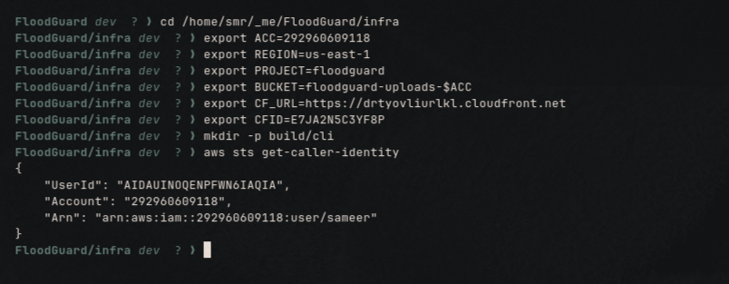

Data Layer

DynamoDB Weather Snapshot Table
Partitioned on region and sorted on timestamp, so the latest snapshots for a region resolve in one query. On-demand billing suits periodic rather than sustained ingestion. A time-to-live attribute expires items after thirty days at no write cost, which is what keeps the table inside the free tier.
Figure 2
Creation of the DynamoDB Table and Its Expiry Specification
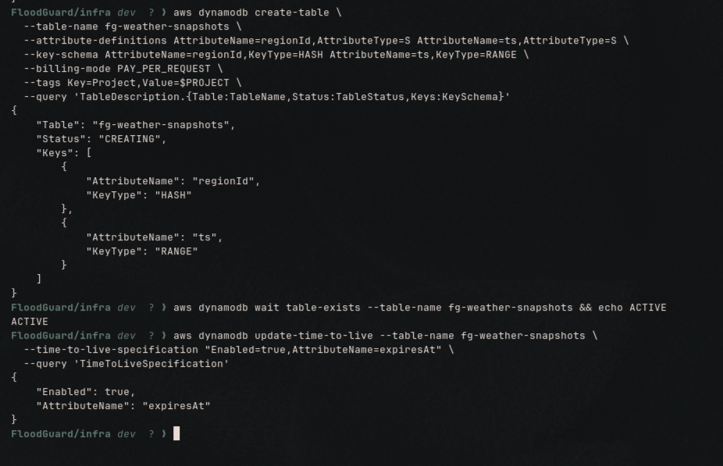

SQS Work Queues and Dead-Letter Queues
Four queues rather than two. A dead-letter queue is a separate queue reached by a redrive policy, and that policy is the resilience mechanism. Visibility timeout is six times the longest consumer timeout so SQS cannot redeliver a message that is still being processed, and maxReceiveCount of three routes a repeatedly failing message aside instead of looping forever.
Figure 3
Queue Creation and the Redrive Policy Linking Each Work Queue to Its Dead-Letter Queue

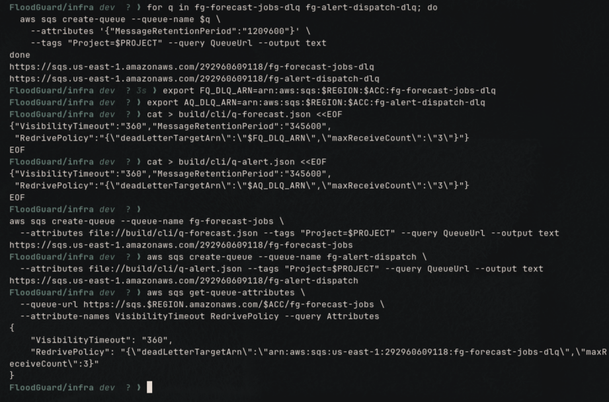

SNS Topics
Two topics kept deliberately separate, so an operational alarm storm can never reach residents and a public flood alert is never mistaken for an infrastructure notification.
Figure 4
Creation of the Public Alert and Operations Alarm Topics
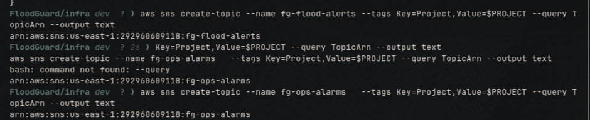

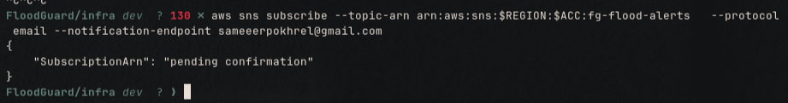
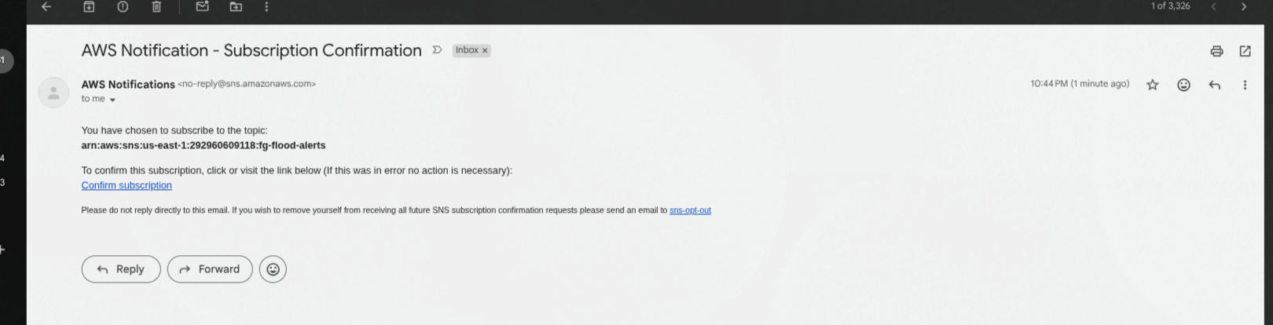

Identity and Access

One Execution Role per Function
A single shared role would give fg-report-intake, the only unauthenticated endpoint in the system, permission to publish flood alerts to every subscriber. Six roles confine the blast radius of a bug in any one handler to that handler.
Figure 5
Creation of the Six Lambda Execution Roles
SCREENSHOT: the six role names returned by the iam create-role loop.

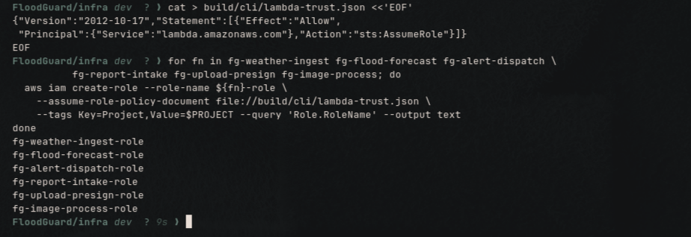
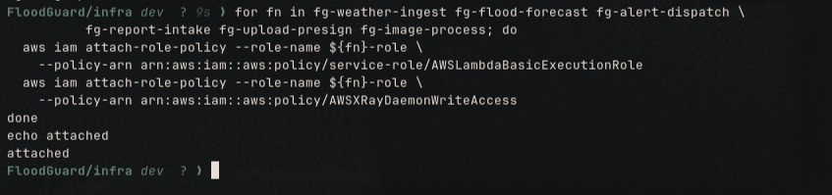
CloudWatch Logs and X-Ray write access, attached to all six roles.

Least-Privilege Policy Verification
Each role receives an inline policy naming only the resources that function actually touches.
Figure 6
Evidence of Privilege Separation on the Unauthenticated Intake Function
SCREENSHOT: iam get-role-policy for fg-report-intake-role. The action list must contain secretsmanager:GetSecretValue and nothing else, demonstrating the public endpoint holds no sns:Publish.

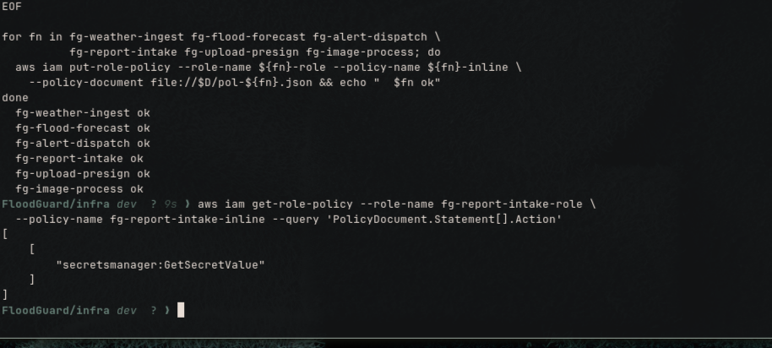

Compute Layer

Deployment Packaging
The Node.js 22 runtime already ships the AWS SDK, so five of the six functions are a handler plus a shared helper of a few kilobytes. Only the presign function declares dependencies. Small packages mean short cold starts.
Figure 7
Deployment Archive Sizes Across the Six Functions
SCREENSHOT: the packaging loop output. Five archives at 4 KB and the presign archive at 3.2 MB, showing the dependency cost.

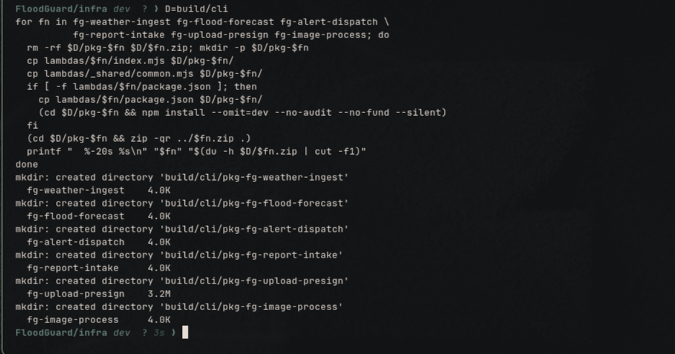

Function Creation
Timeouts are set per workload. Ingestion makes ten sequential outbound calls and receives 300 seconds; an endpoint-fronted function receives 30. Active tracing is enabled on all six, which is what makes the later service map possible.
Figure 8
Creation of the Six Lambda Microservices With Active Tracing
SCREENSHOT: the six JSON responses, each showing nodejs22.x, arm64, its timeout, and Tracing: Active.
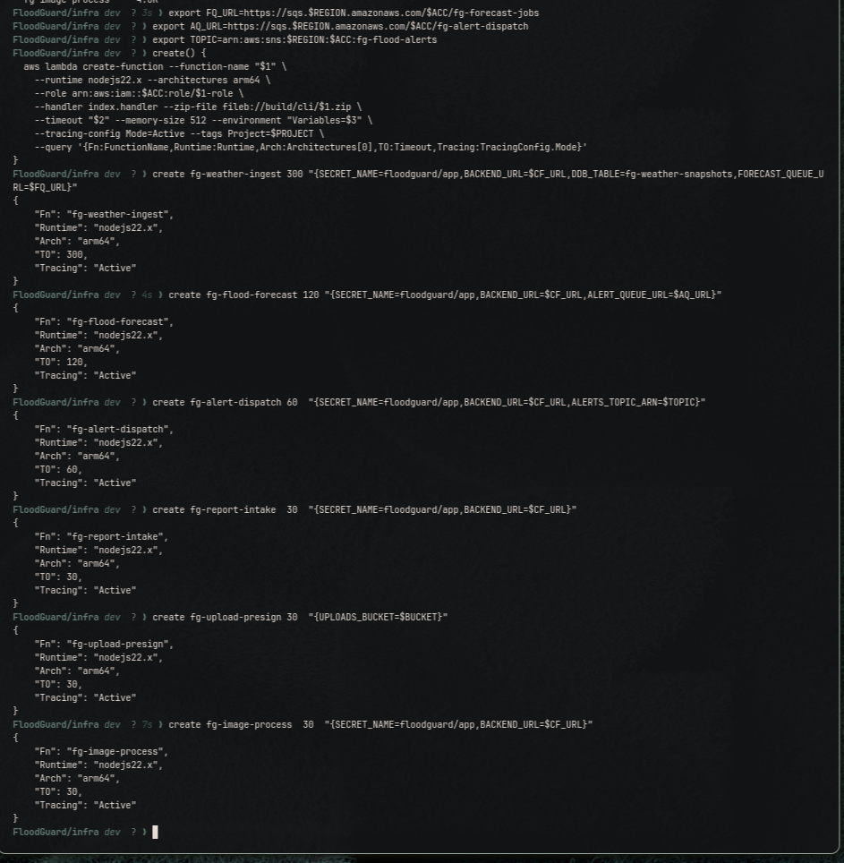

Event Source Mappings and Concurrency Allocation
This account permits ten concurrent Lambda executions, not the default thousand. An uncapped queue consumer scales until it owns all of them and starves the public request path, which API Gateway surfaces to users as a server error. Capping the consumers at three and two reserves five executions for synchronous traffic. Partial batch failure reporting prevents one poison message forcing redelivery of its healthy batch-mates.
Figure 9
Queue Consumers Created With Explicit Concurrency Ceilings
SCREENSHOT: both create-event-source-mapping responses, showing batch sizes 5 and 1 against maximum concurrency 3 and 2.
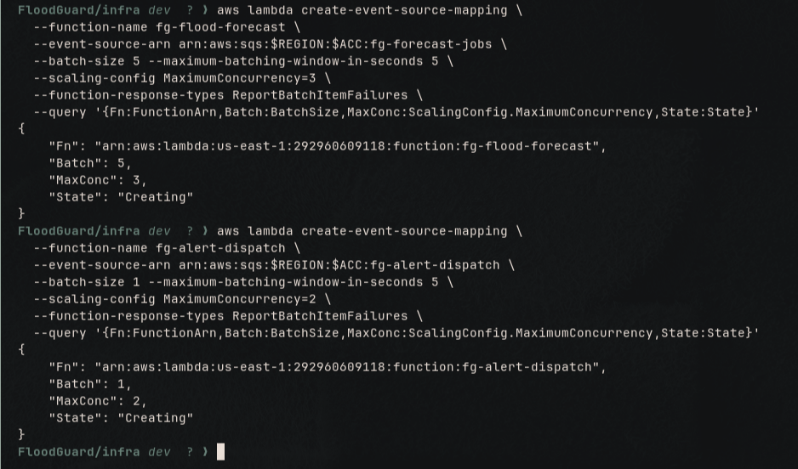

API Layer

REST API and Resource Tree
REST v1 was selected over HTTP API v2 for one decisive reason: HTTP APIs do not emit X-Ray trace segments, and tracing evidence is required. Resources are rooted at /sl so the distribution can forward with an origin path of /v1 and require no path rewriting.
Figure 10
REST API Identifier and Resource Tree
SCREENSHOT: the generated API identifier and the four resource identifiers. Note the identifier is generated fresh on every rebuild.
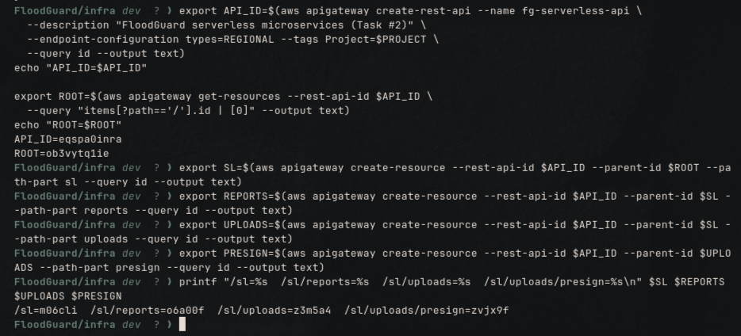

Integrations and Invoke Permissions
Lambda proxy integration passes the raw request to the handler, so routing and response shape live in code rather than in gateway mapping templates. The resource-based invoke permission is scoped to this API and this method.
Figure 11
Lambda Proxy Integrations and Scoped Invoke Permissions
SCREENSHOT: the two wiring confirmations, plus the console view at API Gateway, fg-serverless-api, Resources, with the POST method selected and the proxy target visible.

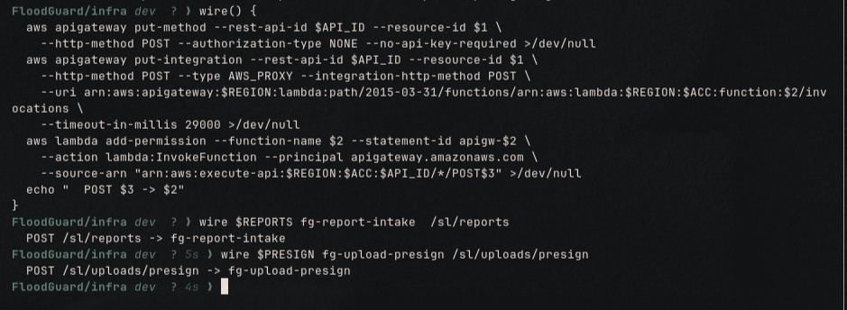
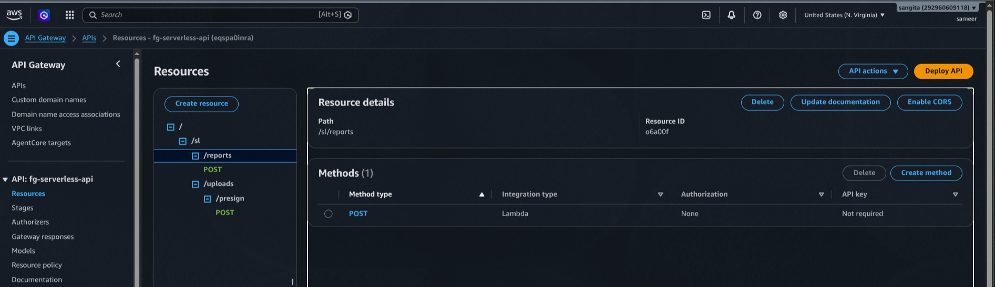

Stage Deployment and Tracing
Figure 12
Stage Deployment With X-Ray Tracing Enabled and a Direct Endpoint Test
SCREENSHOT: the deployment identifier, Tracing: true, and the HTTP 200 from the direct execute-api smoke test. tracingEnabled is the setting HTTP APIs lack entirely.

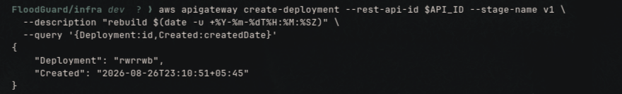

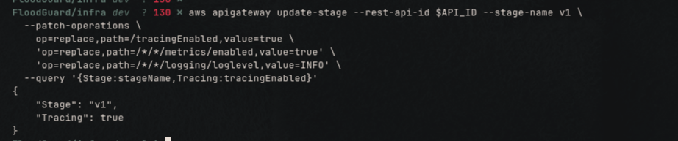
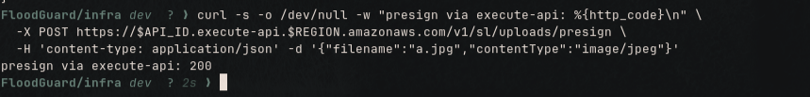

Event Sources

EventBridge Schedule
This replaces an in-process scheduled task that ran on every instance and would have delivered every flood alert twice after the first autoscaling event. EventBridge fires once regardless of fleet size. Identity and Access Management is eventually consistent and the scheduler validates role assumption up front, so creation is retried; on the verified build it succeeded on the second attempt.
Figure 13
Scheduled Trigger Created and Verified
SCREENSHOT: the attempt counter and the verification showing ENABLED, rate(10 minutes), and the ingest function as target.
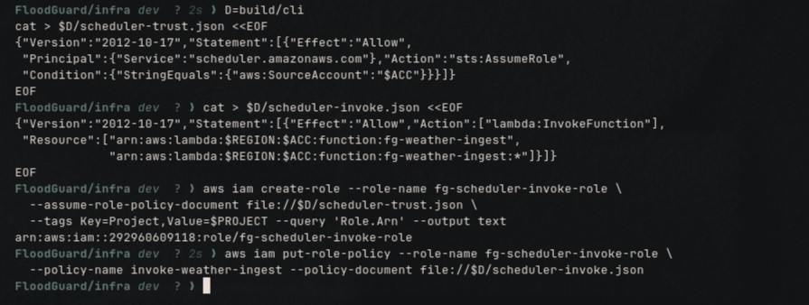
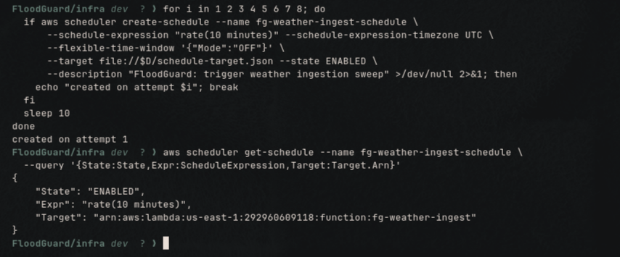

S3 Object-Created Notification
The invoke permission must exist before the notification, because attaching it validates that the destination is invocable. Uploading a photograph is itself the trigger; nothing polls and nothing is scheduled.
Figure 14
Bucket Notification Wiring Uploads to the Verification Function
SCREENSHOT: the notification verification showing s3:ObjectCreated:* filtered to the reports/ prefix.

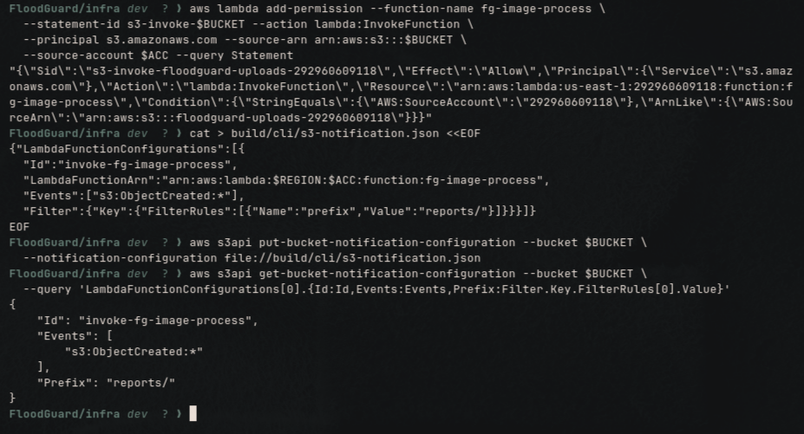

Front Door

CloudFront Serverless Behaviour
Adding the /sl/* behaviour completes a single hostname with three origins, so every browser request is same-origin and no preflight occurs anywhere in the system.
Figure 15
Distribution Updated With the API Gateway Origin
SCREENSHOT: the update response showing InProgress, three origins and three cache behaviours. Propagation takes five to ten minutes.
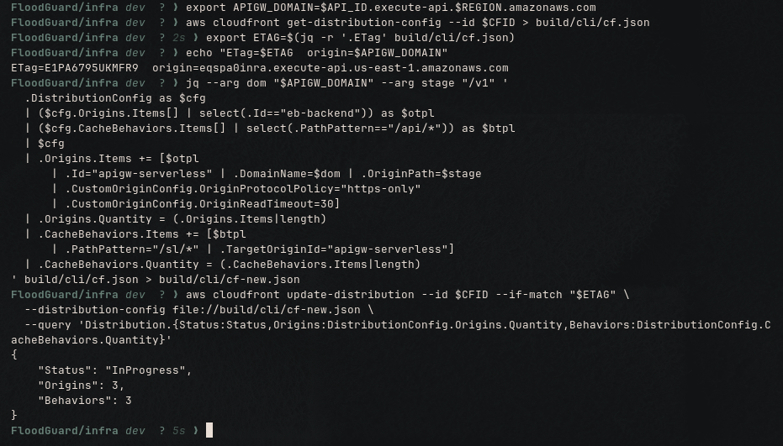

Monitoring

Alarms
Twenty-one alarms, every one publishing to the operations topic. Metrics without alarm actions is observation without response. The dead-letter queue alarms matter most: a message there means work was permanently dropped.
Figure 16
Alarm Inventory in a Non-Alarming State
SCREENSHOT: the table of 21 alarms, all reporting OK.

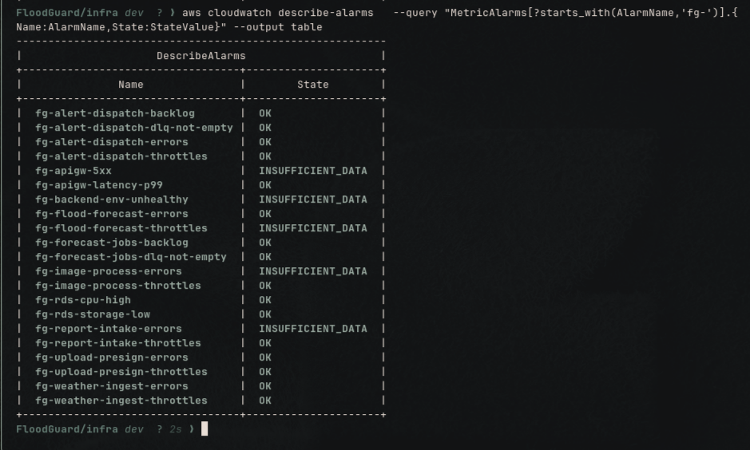

Dashboard
Fourteen widgets laid out along the request path, ending in a log query of recent pipeline errors across all six functions.
Figure 17
Monitoring Dashboard Populated Under Load
SCREENSHOT: the FloodGuard-Task2 dashboard, time range one hour, captured after the verification run so widgets contain data. Take the upper and lower halves separately so axis labels stay readable.
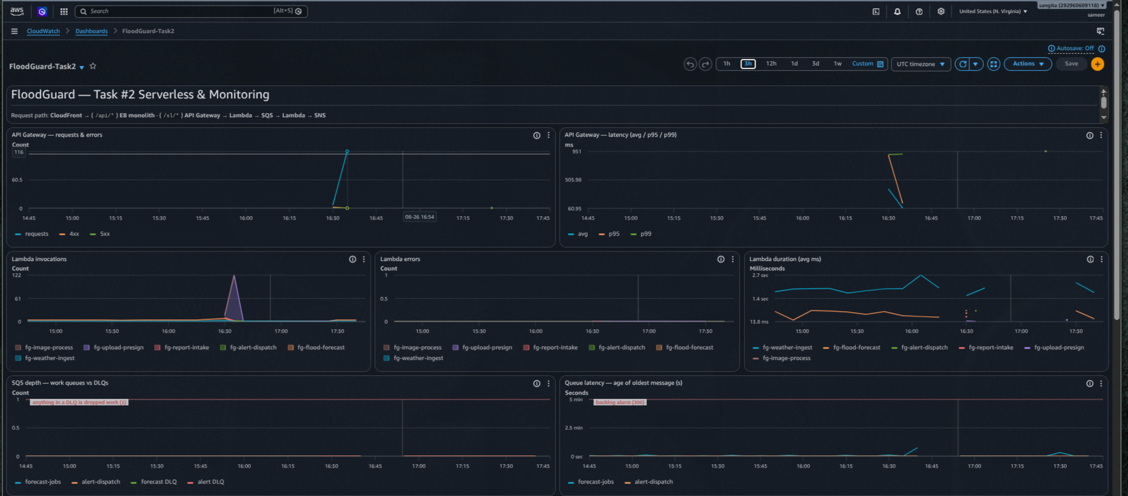
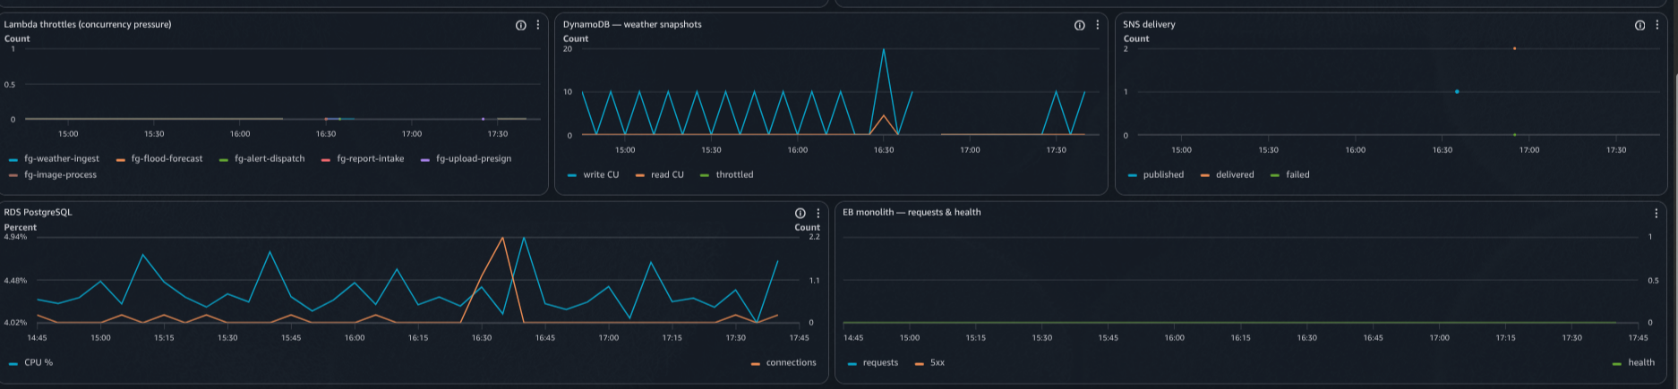

Verification
An automated check exercises every hop of both pipelines and issues 240 requests so latency percentiles are meaningful rather than idle.
Figure 18
End-to-End Verification of the Rebuilt Serverless Layer
SCREENSHOT: the verification summary. The verified rebuild returned 18 passed, 0 failed, covering routing, the 401 on the internal interface, input rejection at 400 and 415, upload verification, scheduled ingestion, empty dead-letter queues, duplicate suppression and recorded traces.

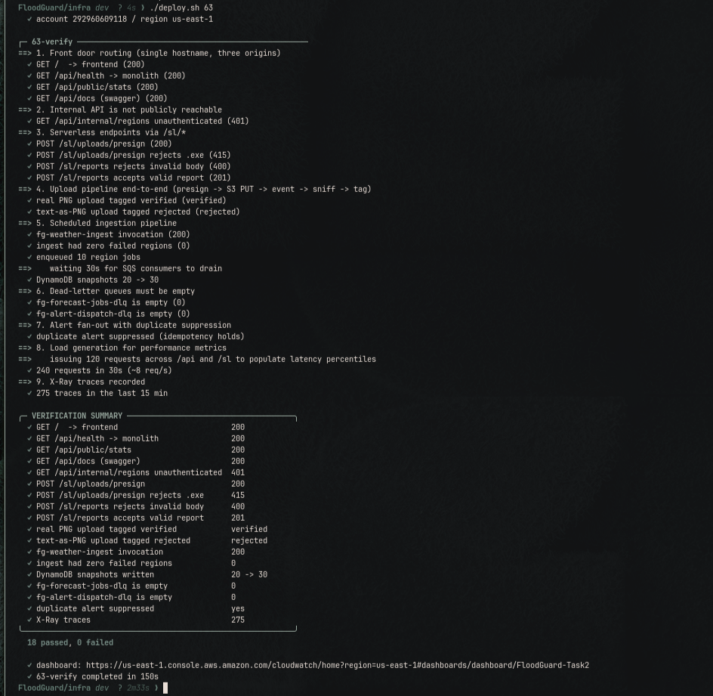
Figure 19
X-Ray Service Map Spanning Both Tiers
SCREENSHOT: the service map at a one-hour range, showing the API Gateway stage node, the Lambda nodes and the application server node connected. The presence of the gateway node is the payoff for choosing REST over HTTP API.

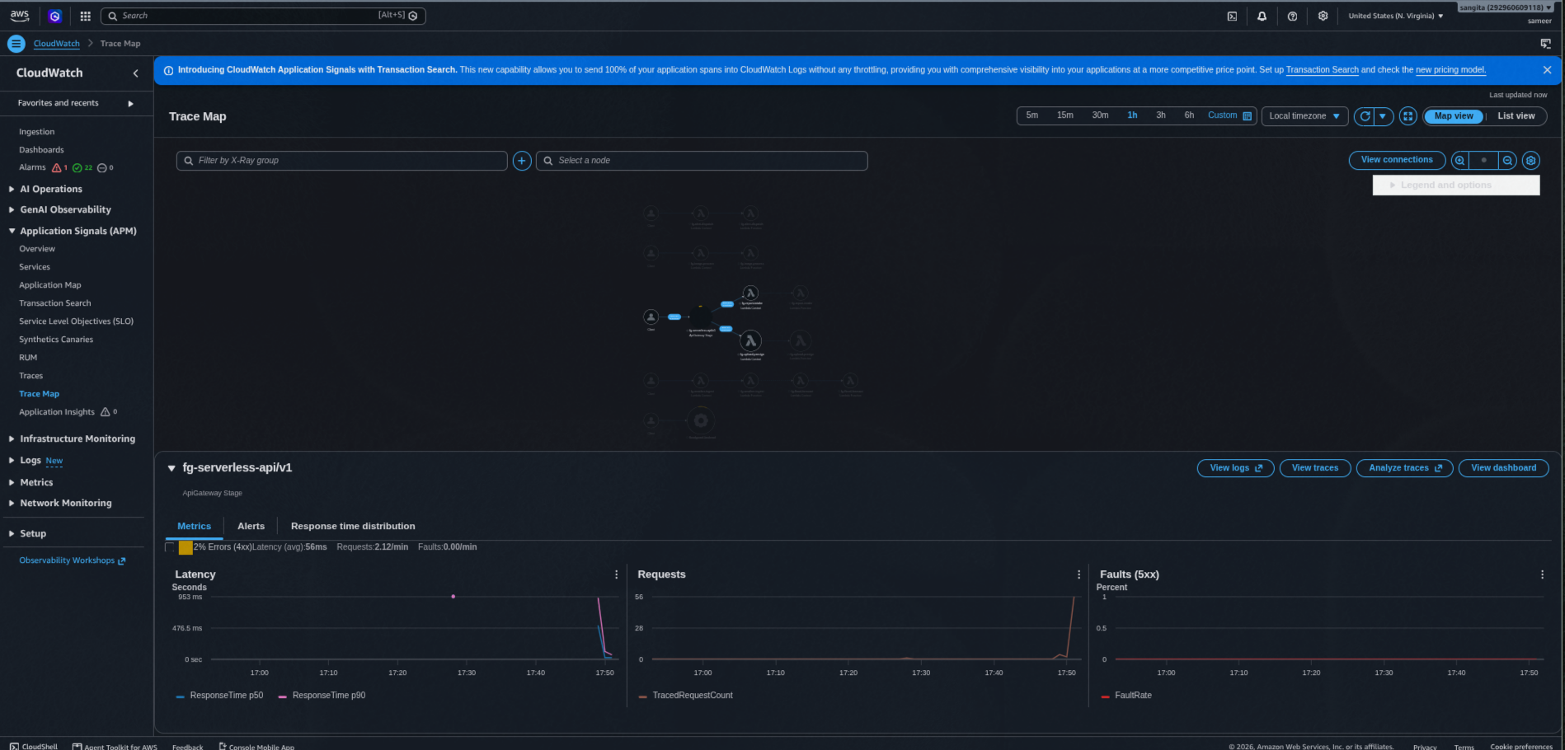
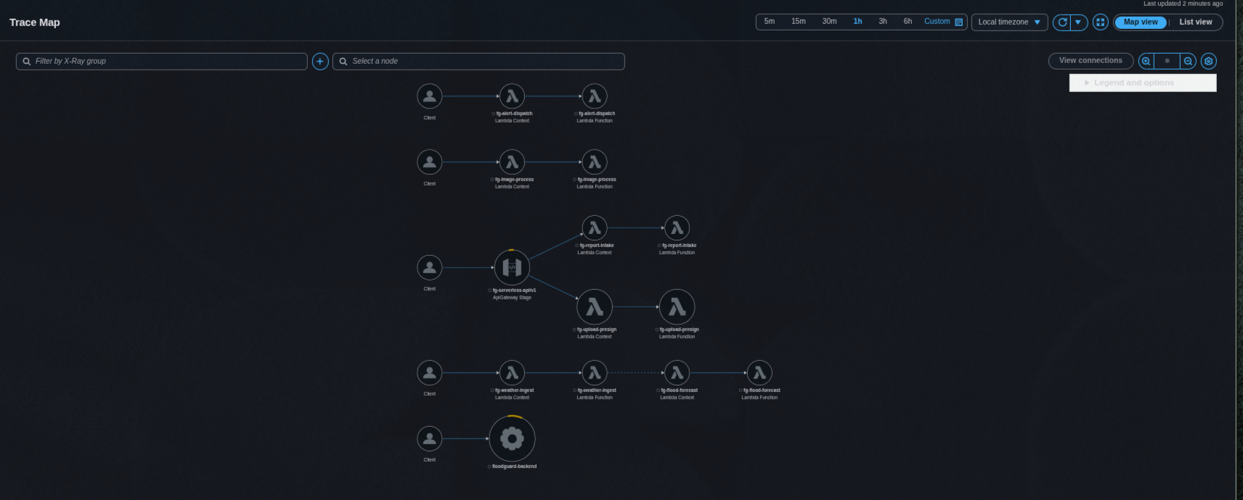

Figure 20
Object Tags Written by the Image Verification Function

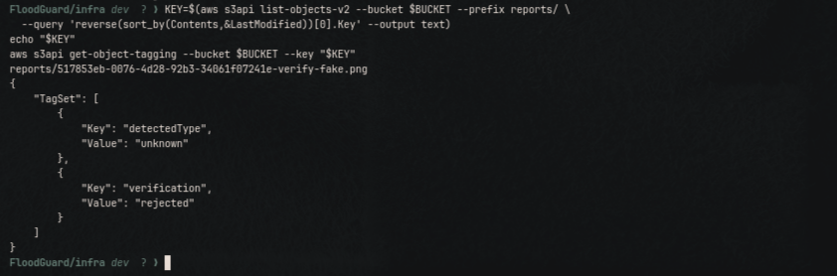
SCREENSHOT: get-object-tagging on the most recent upload, showing verification set to verified and the detected media type. Proof the object notification fired and the file signature check ran.

Code screenshots

