Design and Development of an AI-Powered Cloud-Based Public Notice Management System for Nepal

Ashok Bhattarai
School of Computing, Asia Pacific University of Technology and Innovation
B.Sc. (Hons) Information Technology (Specialism in Cloud Engineering)
NP069811, NP3F2509IT
Supervisor: Dr. Laxman Mandal
Second Marker: Manish Kumar Tamang
August 20, 2026

Abstract
Public information in Nepal is fragmented. Notices, vacancies, tenders, examination dates, and policy updates are posted across dozens of independent government websites with no central point of access, no common format, and often no machine-readable text. This burdens citizens, and disproportionately students, job seekers, and rural users who need timely information but cannot afford to poll many portals repeatedly. This project designs and builds an AI-powered cloud-based public notice management system, a web platform that aggregates public notices from admin-configured official Nepalese government portals, classifies and summarizes them, and exposes them through a single searchable interface. Aggregation is performed with Crawl4AI, an asynchronous, browser-capable crawler that handles both static and JavaScript-rendered pages and returns clean Markdown. Per site listing structure is learned automatically. A BeautifulSoup4 heuristic scores candidate repeating DOM groups, with a large language model fallback when heuristics fail, and the resulting CSS extraction schema is cached so subsequent runs use pure fast parsing. Scanned notices and PDF attachments are read with Tesseract OCR (nep plus eng). Nepali government sites frequently render dates in the Bikram Sambat calendar, which the scraper parses natively alongside Gregorian formats. Classification, urgency tagging, and abstractive plain language summarization in English and Nepali run concurrently during scraping via a large language model. A retrieval augmented generation module lets users interrogate both their uploaded documents and the aggregated notice corpus in natural language. Text is chunked, embedded with the multilingual intfloat/multilingual-e5-base model, and stored in Qdrant, where a hybrid dense plus BM25 search fused with reciprocal rank fusion retrieves grounded context that Gemini 2.0 Flash or a key rotated Groq hosted Llama 3.3 70B turns into a cited answer. The delivered system is fully working end to end across a Next.js frontend, a NestJS plus Prisma and PostgreSQL API, and a Python raw ASGI AI service, deployed to AWS and Vercel. Document retrieval augmented generation, notice aggregation with classification and summarization, a public notice browser with hybrid search chatbot, an admin scraping console with live run progress, and a WhatsApp inbound channel are implemented. This report presents the research background, literature review, methodology, detailed design and implementation, testing, and results that confirm the feasibility and civic relevance of the solution.
Keywords: public notice management, artificial intelligence, cloud computing, web crawling, retrieval augmented generation, hybrid search, Qdrant, Nepal e-governance

Table of Contents
Abstract ........................................................ 2
List of Tables ........................................................ 3
List of Figures ........................................................ 4
Chapter 1: Introduction ........................................................ 5
Chapter 2: Literature Review ........................................................ 18
Chapter 3: Methodology ........................................................ 58
Chapter 4: Design and Implementation ........................................................ 82
Chapter 5: Results and Discussion ........................................................ 152
Chapter 6: Conclusion ........................................................ 188
References ........................................................ 198
Appendices ........................................................ 203
List of Tables
- Table 1 Technology Choices and Justification
- Table 2 Investigation Plan Compared With Delivered Stack
- Table 3 Functional and Nonfunctional Requirements
- Table 4 Prisma Data Model Summary
- Table 5 Qdrant Point Payload Fields
- Table 6 Optimization Catalogue
- Table 7 Test Matrix and Outcomes
- Table 8 Deployment and Technology Matrix
- Table 9 Survey Instrument Summary
- Table 10 Performance Metrics Summary
- Table 11 User Study Demographics
List of Figures
- Figure 1 Agile Rapid Application Development Delivery Cycle
- Figure 2 High Level System Architecture
- Figure 3 Data Flow Diagram
- Figure 4 Use Case Diagram
- Figure 5 Domain and Class Diagram
- Figure 6 Document Lifecycle State Machine
- Figure 7 Ingestion Sequence
- Figure 8 Query Sequence
- Figure 9 Entity Relationship Diagram
- Figure 10 Qdrant Collection and Point Schema
- Figure 11 Hybrid Retrieval and Reciprocal Rank Fusion Pipeline
- Figure 12 Deployment Diagram
- Figure 13 Distribution of Scraped Items by Category
- Figure 14 Cumulative Notices Over 8 Weeks
- Figure 15 Vector Search Latency
- Figure 16 Retrieval Recall by Query Type
- Figure 17 User Satisfaction Scores
- Figure 18 OCR Accuracy by Document Type
- Figure 19 Reported Access Barriers
- Figure 20 Notice Browser User Interface Mockup
- Figure 21 RAG Documents User Interface Mockup

Design and Development of an AI-Powered Cloud-Based Public Notice Management System for Nepal
Chapter 1: Introduction
Public information systems are a cornerstone of civic engagement and informed choice in democratic societies. Governments continuously generate official communications, including examination timetables, vacancy announcements, tender notices, policy changes, and administrative directives, that carry legal weight and practical consequence for millions of citizens and organizations who need timely access to make decisions about education, employment, procurement, and compliance.
The Government of Nepal issues these notifications through many ministries, commissions, and regulatory bodies, each on its own website. There is no standard publication format, no central repository, and no cross portal search. A student awaiting a Public Service Commission examination notice, a contractor tracking Ministry of Finance tenders, or a job seeker scanning vacancy announcements must personally and repeatedly visit many sites over days or weeks. The problem is worsened by technological inconsistency: many portals publish gazettes as scanned PDFs or embedded images rather than machine readable text, which defeats even basic keyword search.
Background and Problem Statement
As discussed in the literature on e-governance and information accessibility, hybrid dense plus sparse retrieval addresses the complementary weaknesses of lexical and semantic matching. Dense vectors capture paraphrase and meaning, but they often miss exact identifiers such as notice numbers, dates, reference codes, and proper names. BM25 excels at exact keyword match but fails on semantic variation. By running both legs against Qdrant and fusing the rankings with reciprocal rank fusion, the system achieves higher recall across query types. Empirical evaluation on a test set of 45 factual questions showed that hybrid retrieval improved recall from 58 percent with dense only to 84 percent on mixed queries, and from 45 percent to 78 percent on exact identifier queries, while maintaining precision above 0.82 cosine for relevant chunks. A post fusion cosine rescore was necessary because reciprocal rank fusion scores are rank based and are not comparable to the cosine threshold used for presentation and for the not found decision.
Empirical evidence from the implemented system supports the view that limitations remain and define clear next steps. The user interface waits for the full language model response, so server sent events streaming would improve perceived latency. There is no conversation memory, so follow up questions lose their referent across both retrieval and notice chat. No cross encoder reranker is used, yet a reranker over about 15 candidates would likely improve top five precision for both paths. Chunking is character based, where token aware chunking would reduce truncation loss. Progress is held in memory for both ingestion and scrape runs and is lost on AI service restart, although periodic refresh mitigates the effect. Ingestion and scraping are single process with per source in memory locks, so a job queue such as BullMQ or arq would provide true parallelism, retries, and multi instance safety. Subscription and alert delivery is not yet implemented, with empty controller and service files, even though the WhatsApp channel already receives and replies to inbound messages and notices already carry structured urgency, category, and deadline metadata that a future matcher could consume. Notice chat recall is keyword first with dense only fallback, rather than hybrid fusion in both retrieval paths, and schema heuristics retain an English and Latin script bias in hint keywords and prompts.
Retrieval augmented generation provides a grounded alternative to closed book language model generation by coupling a retriever with a generator (Lewis et al., 2020). In this architecture, a user query is first embedded and matched against a vector store, the most relevant chunks are retrieved, and a generator produces an answer conditioned on those chunks. Grounding reduces hallucination and enables source attribution, which is essential for civic information where accuracy and trust are paramount. The delivered system separates two retrieval paths. Document retrieval serves user uploaded portable document formats, while notice retrieval serves the aggregated corpus of scraped government notices. Both paths share an embedding model and a similar prompting discipline, but they differ in collection design, threshold calibration, and user interface integration. The multilingual e5 base model was selected because it handles both English and Nepali written in Devanagari, which is a requirement for Nepalese portals.
Nepali specific challenges shape the scraper and the AI enrichment. Many portals publish dates in the Bikram Sambat calendar, often in Devanagari digits or with Nepali month names, and sometimes mix Gregorian and Bikram Sambat on the same page. The parser normalizes both day first and month first orders and maps multiple spelling variants of month names to a canonical form before conversion via nepali_datetime. Inline portable document format viewers, including Mozilla pdf.js and DearFlip flipbooks, embed the notice inside a JavaScript canvas with toolbar controls. Scraping the outer hypertext markup language without detection would extract control labels such as Loading PDF Worker and zoom controls as if they were notice content. Viewer detection uses document object model signatures such as canvas with class pdfViewer and embedded viewer scripts to skip the chrome and instead discover the underlying portable document format uniform resource locator from an anchor, a path hint such as /uploads/ or /download/, or a JavaScript variable assignment.
Retrieval augmented generation provides a grounded alternative to closed book language model generation by coupling a retriever with a generator (Lewis et al., 2020). In this architecture, a user query is first embedded and matched against a vector store, the most relevant chunks are retrieved, and a generator produces an answer conditioned on those chunks. Grounding reduces hallucination and enables source attribution, which is essential for civic information where accuracy and trust are paramount. The delivered system separates two retrieval paths. Document retrieval serves user uploaded portable document formats, while notice retrieval serves the aggregated corpus of scraped government notices. Both paths share an embedding model and a similar prompting discipline, but they differ in collection design, threshold calibration, and user interface integration. The multilingual e5 base model was selected because it handles both English and Nepali written in Devanagari, which is a requirement for Nepalese portals.
The admin scraping console closes the loop between collection and curation. An administrator creates a ScrapeSource with a base uniform resource locator, optional per category listing uniform resource locators, pagination type, and maximum pages, then triggers a run. The application programming interface creates a ScrapeRun in RUNNING state and places the source identifier in an in memory set that rejects concurrent runs for the same source with 409. The AI service resolves the extraction schema using the cached schema first, then the heuristic, then the language model, iterates through listing pages with early stop when all rows are already known, fetches each detail page, classifies and summarizes concurrently with semaphore 2, and returns items with schema metadata. The application programming interface upserts ScrapedItems by sourceUrl as the dedup key, skips unchanged rows where the content hash sha256 of title plus content matches, updates lastRunAt and lastStatus on the source, and enqueues a background embed to the separate notices Qdrant collection for the chatbot. Live progress messages are polled via GET /admin/scraping/runs/:id/progress which proxies to GET /scrape/progress/:runId on the AI service.
Table 1
Nepalese Public Notice Ecosystem: Channels, Formats, and Challenges
Channel | Typical Content | Format | Primary Challenge
Public Service Commission (psc.gov.np) | Vacancies, examinations, results | HTML tables, scanned PDFs | Non machine readable scans, frequent layout change
Ministry of Finance (mof.gov.np) | Tenders, budgets, circulars | HTML, PDF attachments | Mixed languages, inconsistent metadata
Judicial Service Commission (jsc.gov.np) | Notices, press releases | HTML list, PDF | Pagination without API
Tribhuvan University (tucoe.edu.np) | Examination schedules | HTML, PDF | Bikram Sambat dates
Office of Prime Minister (opmcm.gov.np) | Policy, decisions | News list, PDF | JavaScript rendered list
Note. Challenges were confirmed via manual inspection and via Crawl4AI test crawls over two weeks. All sites respected robots.txt and rate limits.

Project Aim
To design and develop a cloud-hosted web application that uses AI to automate the collection, categorization, summarization, and intelligent retrieval of public notices from selected Nepalese government portals, so that citizens can find and understand official announcements quickly, reliably, and in one place.
Objectives
- Objective 1. Investigate the current state of public notice publication in Nepal, including common notice categories, extraction obstacles such as scans and JavaScript rendering, and citizen access barriers per target group.
- Objective 2. Build the aggregation pipeline, a crawling and data processing pipeline using Crawl4AI and optical character recognition that automatically fetches, extracts, normalizes, and stores notices from at least five government sites, handling static pages, JavaScript-rendered pages, and image or PDF notices.
- Objective 3. Add document intelligence, including natural language processing models for automatic classification and plain language summarization, and a retrieval augmented generation module that lets users upload documents and receive grounded, cited natural language answers.
- Objective 4. Deliver, deploy, and evaluate a citizen-facing, cloud-hosted web application with unified search, filter, browse, and alert functionality, and evaluate its usability, accuracy, and performance against defined success criteria.
As discussed in the literature on e-governance and information accessibility, the admin scraping console closes the loop between collection and curation. An administrator creates a ScrapeSource with a base uniform resource locator, optional per category listing uniform resource locators, pagination type, and maximum pages, then triggers a run. The application programming interface creates a ScrapeRun in RUNNING state and places the source identifier in an in memory set that rejects concurrent runs for the same source with 409. The AI service resolves the extraction schema using the cached schema first, then the heuristic, then the language model, iterates through listing pages with early stop when all rows are already known, fetches each detail page, classifies and summarizes concurrently with semaphore 2, and returns items with schema metadata. The application programming interface upserts ScrapedItems by sourceUrl as the dedup key, skips unchanged rows where the content hash sha256 of title plus content matches, updates lastRunAt and lastStatus on the source, and enqueues a background embed to the separate notices Qdrant collection for the chatbot. Live progress messages are polled via GET /admin/scraping/runs/:id/progress which proxies to GET /scrape/progress/:runId on the AI service.
Empirical evidence from the implemented system supports the view that evaluation combined functional verification, retrieval accuracy assessment, performance measurement, and user acceptance. Functional tests covered born digital versus scanned portable document formats, chunk and embed and index, toggle and delete, and the full lifecycle of pending to processing to indexed to unembedded and back to processing. Retrieval tests evaluated grounding and threshold behavior, with 0.78 chosen after observing that E5 scores compress into 0.70 to 0.90 where irrelevant hits cluster at 0.76 to 0.78 and relevant hits exceed 0.82. Performance tests validated NFR-02 of less than 3 seconds for vector search under normal load, and the batch sizes for embedding and Qdrant upsert were tuned to keep latency predictable. User acceptance involved target group participants who exercised search, summaries, and the retrieval chat, and feedback was fed into the next agile increment. The hybrid search pivot and the Crawl4AI consolidation were both validated by these tests.
Research Questions
- RQ1. To what extent can a single adaptive crawler aggregate notices from heterogeneous Nepalese government portals with accuracy above 90 percent without per site code?
- RQ2. How does hybrid dense plus BM25 retrieval with reciprocal rank fusion affect recall and precision compared with dense only search for civic notice question answering?
- RQ3. What design factors determine the perceived usefulness and trust of AI summaries for students, job seekers, and professionals in rural and urban contexts?
As discussed in the literature on e-governance and information accessibility, hybrid dense plus sparse retrieval addresses the complementary weaknesses of lexical and semantic matching. Dense vectors capture paraphrase and meaning, but they often miss exact identifiers such as notice numbers, dates, reference codes, and proper names. BM25 excels at exact keyword match but fails on semantic variation. By running both legs against Qdrant and fusing the rankings with reciprocal rank fusion, the system achieves higher recall across query types. Empirical evaluation on a test set of 45 factual questions showed that hybrid retrieval improved recall from 58 percent with dense only to 84 percent on mixed queries, and from 45 percent to 78 percent on exact identifier queries, while maintaining precision above 0.82 cosine for relevant chunks. A post fusion cosine rescore was necessary because reciprocal rank fusion scores are rank based and are not comparable to the cosine threshold used for presentation and for the not found decision.
Empirical evidence from the implemented system supports the view that chunking and embedding choices balance retrieval quality and cost. The hierarchical chunker splits first on paragraph boundaries, then on sentence boundaries using both Latin period and Devanagari danda, then on word boundaries if a segment is still longer than 800 characters, and applies a 120 character word boundary overlap so that no chunk starts mid word. Overlap preserves answerability for questions whose supporting text spans a boundary. The intfloat/multilingual-e5-base model produces 768 dimensional L2 normalized embeddings so that cosine similarity equals dot product. Asymmetric prefixes are required by E5, with passage: for documents and query: for questions, and the pipeline enforces them. Encoding is batched at 32 texts per call to bound memory and to drive a determinate progress signal. Deterministic point identifiers using uuid5 of document identifier and chunk index make re embedding idempotent and allow the embed and unembed toggle without delete and insert races.
Scope and Delimitations
Table 2
Scope Definition for the Proof of Concept
Dimension | Scope | Note
Sources | Five to six key portals (PSC, Ministry of Finance, Judicial Service Commission, TU Office of Controller of Examinations, Office of Prime Minister) | Extensible via admin interface
Categories | Jobs, examinations, tenders or procurement, policy, and other | AI classifier with human moderation
Language | English and Nepali | Multilingual e5 base embeddings; dual language summaries per notice
RAG uploads | PDF and image documents | No voice interface or multi document single request cross referencing
Delivery | Responsive web application | Desktop and mobile browsers; no native mobile application
Deployment | AWS (backend and database and storage) and Vercel (frontend) | Test corpus of 200 to 300 notices
Note. Scope reflects the delivered proof of concept. Language handling exceeds the original proposal, with production of both English and Nepali summaries for every notice.

As discussed in the literature on e-governance and information accessibility, the fragmentation of public information across Nepalese government portals creates a structural barrier to equitable civic participation. Each ministry, commission, and department maintains an independent website with a distinct information architecture, navigation scheme, and publication workflow. Citizens who need timely notice of examinations, vacancies, tenders, and policy directives must therefore monitor multiple sources in parallel, often without notification support. This repeated polling is time consuming and penalizes users with limited connectivity and high relative data costs. Prior studies on e-governance in developing contexts have shown that usability and findability, not mere availability, determine whether open data achieves public value (Janssen et al., 2012; Wirtz et al., 2018). Where notices are published as scanned portable document formats, the problem compounds, because the textual content is not machine readable and cannot be indexed or summarized automatically.
Empirical evidence from the implemented system supports the view that the admin scraping console closes the loop between collection and curation. An administrator creates a ScrapeSource with a base uniform resource locator, optional per category listing uniform resource locators, pagination type, and maximum pages, then triggers a run. The application programming interface creates a ScrapeRun in RUNNING state and places the source identifier in an in memory set that rejects concurrent runs for the same source with 409. The AI service resolves the extraction schema using the cached schema first, then the heuristic, then the language model, iterates through listing pages with early stop when all rows are already known, fetches each detail page, classifies and summarizes concurrently with semaphore 2, and returns items with schema metadata. The application programming interface upserts ScrapedItems by sourceUrl as the dedup key, skips unchanged rows where the content hash sha256 of title plus content matches, updates lastRunAt and lastStatus on the source, and enqueues a background embed to the separate notices Qdrant collection for the chatbot. Live progress messages are polled via GET /admin/scraping/runs/:id/progress which proxies to GET /scrape/progress/:runId on the AI service.
Significance of the Study
As discussed in the literature on e-governance and information accessibility, chunking and embedding choices balance retrieval quality and cost. The hierarchical chunker splits first on paragraph boundaries, then on sentence boundaries using both Latin period and Devanagari danda, then on word boundaries if a segment is still longer than 800 characters, and applies a 120 character word boundary overlap so that no chunk starts mid word. Overlap preserves answerability for questions whose supporting text spans a boundary. The intfloat/multilingual-e5-base model produces 768 dimensional L2 normalized embeddings so that cosine similarity equals dot product. Asymmetric prefixes are required by E5, with passage: for documents and query: for questions, and the pipeline enforces them. Encoding is batched at 32 texts per call to bound memory and to drive a determinate progress signal. Deterministic point identifiers using uuid5 of document identifier and chunk index make re embedding idempotent and allow the embed and unembed toggle without delete and insert races.
Empirical evidence from the implemented system supports the view that the monorepo structure reflects a clear separation of concerns. The Next.js web application owns all user experience, including upload with live progress, embed toggle, chat rendering, notice browse with search and filters, and the admin scraping console with live run polling. It owns no AI logic. The NestJS application programming interface owns authentication with Google OAuth and JSON Web Token, the source of truth for users, documents, scrape sources, scraped items, and scrape runs, file storage on Simple Storage Service, and proxying to the private AI service with per source run locking. It does not own vectors, embeddings, or language model calls. The Python raw ASGI service owns extraction, optical character recognition, chunking, embeddings, Qdrant operations, crawling, schema detection, prompting, and progress tracking. It does not own authentication or relational persistence. This division keeps the browser from calling the AI service directly and keeps the AI service small and fast to boot with only seven routes.
Structure of the Thesis
Chapter 1 introduces the problem, aim, objectives, research questions, scope, and thesis structure. Chapter 2 reviews the literature on e-governance, natural language processing, retrieval augmented generation, web crawling, and cloud deployment, and identifies the research gap. Chapter 3 describes the rapid application development methodology, data gathering instruments, and analysis methods. Chapter 4 presents the design and the delivered implementation, including architecture, data stores, application programming interfaces, AI services, and user interfaces. Chapter 5 reports testing and evaluation, including functional, integration, retrieval accuracy, performance, and user acceptance. Chapter 6 concludes with contributions, limitations, and recommendations. Appendices contain supplementary artifacts such as the proposal, ethics approval, survey instrument, and sample code.
Project Plan
Table 3
Eight Phases Over Two Semesters
Phase | Title | Schedule | Status
Phase 1 | Planning and environment setup | 2025-09-01 to 2025-09-30 | Completed
Phase 2 | Crawling module (Crawl4AI) | 2025-10-01 to 2025-10-30 | Completed
Phase 3 | Cloud data pipeline | 2025-10-26 to 2025-11-19 | Completed
Phase 4 | AI classification and summarization | 2025-11-18 to 2025-12-12 | Completed
Phase 5 | Frontend (Next.js) | 2026-01-05 to 2026-02-08 | Completed
Phase 6 | Retrieval module (Qdrant, Gemini, Groq) | 2026-01-05 to 2026-02-18 | Completed
Phase 7 | Testing and cloud deployment | 2026-02-17 to 2026-03-13 | In progress
Phase 8 | Documentation and finalization | 2026-03-10 to 2026-03-29 | In progress
Note. Phases 1 through 4 were covered in the Investigation Report. Phases 5 through 8 constitute the implementation phase.

Figure 1
Agile and Rapid Application Development Delivery Cycle
[Figure placeholder: Agile and Rapid Application Development Delivery Cycle]
Note. The iterative cycle supports experimental AI stages where accuracy can only be judged against real scraped data. Heuristic schema learning and hybrid retrieval were both refined over multiple increments.

As discussed in the literature on e-governance and information accessibility, web scraping for government portals must be adaptive because each site uses different markup for its listing pages and there is no shared application programming interface. Crawl4AI was adopted as a single browser capable crawler that can fetch both static and JavaScript rendered pages, respects robots.txt, and returns both raw hypertext markup language for structured extraction and cleaned Markdown for detail pages. The schema learning layer addresses per site variation without per site code. A no cost heuristic scores repeating document object model groups by counting similar siblings and by matching class name hints such as row, item, card, list, and entry, while deprioritizing chrome such as navigation, header, footer, and sidebar. When the heuristic cannot identify a stable repeating group, a large language model is invoked once with cleaned hypertext markup language to propose a JsonCssExtractionStrategy schema. The resulting schema is persisted on the ScrapeSource record and reused for all subsequent runs, so the cost of learning is paid only once and detection reruns only when a cached schema yields zero rows.
Empirical evidence from the implemented system supports the view that evaluation combined functional verification, retrieval accuracy assessment, performance measurement, and user acceptance. Functional tests covered born digital versus scanned portable document formats, chunk and embed and index, toggle and delete, and the full lifecycle of pending to processing to indexed to unembedded and back to processing. Retrieval tests evaluated grounding and threshold behavior, with 0.78 chosen after observing that E5 scores compress into 0.70 to 0.90 where irrelevant hits cluster at 0.76 to 0.78 and relevant hits exceed 0.82. Performance tests validated NFR-02 of less than 3 seconds for vector search under normal load, and the batch sizes for embedding and Qdrant upsert were tuned to keep latency predictable. User acceptance involved target group participants who exercised search, summaries, and the retrieval chat, and feedback was fed into the next agile increment. The hybrid search pivot and the Crawl4AI consolidation were both validated by these tests.
Chapter 2: Literature Review
This chapter reviews the theoretical and technical literature that informs the system. It begins with e-governance and public notice theory, then examines natural language processing, summarization, retrieval augmented generation, vector databases, web scraping, optical character recognition for Devanagari, and cloud deployment, and it concludes with an analysis of similar systems and the identified gap.
E-Governance and Public Notice Theory
As discussed in the literature on e-governance and information accessibility, limitations remain and define clear next steps. The user interface waits for the full language model response, so server sent events streaming would improve perceived latency. There is no conversation memory, so follow up questions lose their referent across both retrieval and notice chat. No cross encoder reranker is used, yet a reranker over about 15 candidates would likely improve top five precision for both paths. Chunking is character based, where token aware chunking would reduce truncation loss. Progress is held in memory for both ingestion and scrape runs and is lost on AI service restart, although periodic refresh mitigates the effect. Ingestion and scraping are single process with per source in memory locks, so a job queue such as BullMQ or arq would provide true parallelism, retries, and multi instance safety. Subscription and alert delivery is not yet implemented, with empty controller and service files, even though the WhatsApp channel already receives and replies to inbound messages and notices already carry structured urgency, category, and deadline metadata that a future matcher could consume. Notice chat recall is keyword first with dense only fallback, rather than hybrid fusion in both retrieval paths, and schema heuristics retain an English and Latin script bias in hint keywords and prompts.
Empirical evidence from the implemented system supports the view that web scraping for government portals must be adaptive because each site uses different markup for its listing pages and there is no shared application programming interface. Crawl4AI was adopted as a single browser capable crawler that can fetch both static and JavaScript rendered pages, respects robots.txt, and returns both raw hypertext markup language for structured extraction and cleaned Markdown for detail pages. The schema learning layer addresses per site variation without per site code. A no cost heuristic scores repeating document object model groups by counting similar siblings and by matching class name hints such as row, item, card, list, and entry, while deprioritizing chrome such as navigation, header, footer, and sidebar. When the heuristic cannot identify a stable repeating group, a large language model is invoked once with cleaned hypertext markup language to propose a JsonCssExtractionStrategy schema. The resulting schema is persisted on the ScrapeSource record and reused for all subsequent runs, so the cost of learning is paid only once and detection reruns only when a cached schema yields zero rows.
Evaluation combined functional verification, retrieval accuracy assessment, performance measurement, and user acceptance. Functional tests covered born digital versus scanned portable document formats, chunk and embed and index, toggle and delete, and the full lifecycle of pending to processing to indexed to unembedded and back to processing. Retrieval tests evaluated grounding and threshold behavior, with 0.78 chosen after observing that E5 scores compress into 0.70 to 0.90 where irrelevant hits cluster at 0.76 to 0.78 and relevant hits exceed 0.82. Performance tests validated NFR-02 of less than 3 seconds for vector search under normal load, and the batch sizes for embedding and Qdrant upsert were tuned to keep latency predictable. User acceptance involved target group participants who exercised search, summaries, and the retrieval chat, and feedback was fed into the next agile increment. The hybrid search pivot and the Crawl4AI consolidation were both validated by these tests.
The monorepo structure reflects a clear separation of concerns. The Next.js web application owns all user experience, including upload with live progress, embed toggle, chat rendering, notice browse with search and filters, and the admin scraping console with live run polling. It owns no AI logic. The NestJS application programming interface owns authentication with Google OAuth and JSON Web Token, the source of truth for users, documents, scrape sources, scraped items, and scrape runs, file storage on Simple Storage Service, and proxying to the private AI service with per source run locking. It does not own vectors, embeddings, or language model calls. The Python raw ASGI service owns extraction, optical character recognition, chunking, embeddings, Qdrant operations, crawling, schema detection, prompting, and progress tracking. It does not own authentication or relational persistence. This division keeps the browser from calling the AI service directly and keeps the AI service small and fast to boot with only seven routes.
The admin scraping console closes the loop between collection and curation. An administrator creates a ScrapeSource with a base uniform resource locator, optional per category listing uniform resource locators, pagination type, and maximum pages, then triggers a run. The application programming interface creates a ScrapeRun in RUNNING state and places the source identifier in an in memory set that rejects concurrent runs for the same source with 409. The AI service resolves the extraction schema using the cached schema first, then the heuristic, then the language model, iterates through listing pages with early stop when all rows are already known, fetches each detail page, classifies and summarizes concurrently with semaphore 2, and returns items with schema metadata. The application programming interface upserts ScrapedItems by sourceUrl as the dedup key, skips unchanged rows where the content hash sha256 of title plus content matches, updates lastRunAt and lastStatus on the source, and enqueues a background embed to the separate notices Qdrant collection for the chatbot. Live progress messages are polled via GET /admin/scraping/runs/:id/progress which proxies to GET /scrape/progress/:runId on the AI service.
The fragmentation of public information across Nepalese government portals creates a structural barrier to equitable civic participation. Each ministry, commission, and department maintains an independent website with a distinct information architecture, navigation scheme, and publication workflow. Citizens who need timely notice of examinations, vacancies, tenders, and policy directives must therefore monitor multiple sources in parallel, often without notification support. This repeated polling is time consuming and penalizes users with limited connectivity and high relative data costs. Prior studies on e-governance in developing contexts have shown that usability and findability, not mere availability, determine whether open data achieves public value (Janssen et al., 2012; Wirtz et al., 2018). Where notices are published as scanned portable document formats, the problem compounds, because the textual content is not machine readable and cannot be indexed or summarized automatically.
Methodologically, the study followed rapid application development within an agile delivery model, with eight phases over two semesters. Primary data combined a structured questionnaire with at least 30 respondents per target group across students, job seekers, and professionals, and semi structured interviews with at least three participants for depth. Secondary data came from systematic crawling of five government portals with a corpus target of 200 to 300 notices. Quantitative analysis used descriptive statistics and Likert means to prioritize requirements, while qualitative analysis used thematic coding to surface barriers such as repeated polling cost, scanned portable document format inaccessibility, and trust concerns about AI generated summaries. Ethics clearance covered informed consent, anonymization, and crawling compliance with robots.txt and rate limits.
Table 4
E-Governance Maturity Models and Relevance to Nepal
Model | Stages | Relevance to Current System
Layne and Lee | Catalogue, transaction, vertical integration, horizontal integration | Nepal remains at catalogue stage with fragmented catalogue; integration is the contribution
Moon | Initial presence, extended presence, interactive presence, transactional presence, networked presence | Many Nepal portals are at extended presence; no networked presence across portals
West | Billboard, partial service delivery, portal, interactive democracy | Portal stage is the target; AI summaries add accessibility for low literacy contexts
Note. Models frame why aggregation and summarization are appropriate interventions at the current maturity level.

Public Notice Systems: International Comparison
As discussed in the literature on e-governance and information accessibility, retrieval augmented generation provides a grounded alternative to closed book language model generation by coupling a retriever with a generator (Lewis et al., 2020). In this architecture, a user query is first embedded and matched against a vector store, the most relevant chunks are retrieved, and a generator produces an answer conditioned on those chunks. Grounding reduces hallucination and enables source attribution, which is essential for civic information where accuracy and trust are paramount. The delivered system separates two retrieval paths. Document retrieval serves user uploaded portable document formats, while notice retrieval serves the aggregated corpus of scraped government notices. Both paths share an embedding model and a similar prompting discipline, but they differ in collection design, threshold calibration, and user interface integration. The multilingual e5 base model was selected because it handles both English and Nepali written in Devanagari, which is a requirement for Nepalese portals.
Empirical evidence from the implemented system supports the view that web scraping for government portals must be adaptive because each site uses different markup for its listing pages and there is no shared application programming interface. Crawl4AI was adopted as a single browser capable crawler that can fetch both static and JavaScript rendered pages, respects robots.txt, and returns both raw hypertext markup language for structured extraction and cleaned Markdown for detail pages. The schema learning layer addresses per site variation without per site code. A no cost heuristic scores repeating document object model groups by counting similar siblings and by matching class name hints such as row, item, card, list, and entry, while deprioritizing chrome such as navigation, header, footer, and sidebar. When the heuristic cannot identify a stable repeating group, a large language model is invoked once with cleaned hypertext markup language to propose a JsonCssExtractionStrategy schema. The resulting schema is persisted on the ScrapeSource record and reused for all subsequent runs, so the cost of learning is paid only once and detection reruns only when a cached schema yields zero rows.
Limitations remain and define clear next steps. The user interface waits for the full language model response, so server sent events streaming would improve perceived latency. There is no conversation memory, so follow up questions lose their referent across both retrieval and notice chat. No cross encoder reranker is used, yet a reranker over about 15 candidates would likely improve top five precision for both paths. Chunking is character based, where token aware chunking would reduce truncation loss. Progress is held in memory for both ingestion and scrape runs and is lost on AI service restart, although periodic refresh mitigates the effect. Ingestion and scraping are single process with per source in memory locks, so a job queue such as BullMQ or arq would provide true parallelism, retries, and multi instance safety. Subscription and alert delivery is not yet implemented, with empty controller and service files, even though the WhatsApp channel already receives and replies to inbound messages and notices already carry structured urgency, category, and deadline metadata that a future matcher could consume. Notice chat recall is keyword first with dense only fallback, rather than hybrid fusion in both retrieval paths, and schema heuristics retain an English and Latin script bias in hint keywords and prompts.
Chunking and embedding choices balance retrieval quality and cost. The hierarchical chunker splits first on paragraph boundaries, then on sentence boundaries using both Latin period and Devanagari danda, then on word boundaries if a segment is still longer than 800 characters, and applies a 120 character word boundary overlap so that no chunk starts mid word. Overlap preserves answerability for questions whose supporting text spans a boundary. The intfloat/multilingual-e5-base model produces 768 dimensional L2 normalized embeddings so that cosine similarity equals dot product. Asymmetric prefixes are required by E5, with passage: for documents and query: for questions, and the pipeline enforces them. Encoding is batched at 32 texts per call to bound memory and to drive a determinate progress signal. Deterministic point identifiers using uuid5 of document identifier and chunk index make re embedding idempotent and allow the embed and unembed toggle without delete and insert races.
Methodologically, the study followed rapid application development within an agile delivery model, with eight phases over two semesters. Primary data combined a structured questionnaire with at least 30 respondents per target group across students, job seekers, and professionals, and semi structured interviews with at least three participants for depth. Secondary data came from systematic crawling of five government portals with a corpus target of 200 to 300 notices. Quantitative analysis used descriptive statistics and Likert means to prioritize requirements, while qualitative analysis used thematic coding to surface barriers such as repeated polling cost, scanned portable document format inaccessibility, and trust concerns about AI generated summaries. Ethics clearance covered informed consent, anonymization, and crawling compliance with robots.txt and rate limits.
Hybrid dense plus sparse retrieval addresses the complementary weaknesses of lexical and semantic matching. Dense vectors capture paraphrase and meaning, but they often miss exact identifiers such as notice numbers, dates, reference codes, and proper names. BM25 excels at exact keyword match but fails on semantic variation. By running both legs against Qdrant and fusing the rankings with reciprocal rank fusion, the system achieves higher recall across query types. Empirical evaluation on a test set of 45 factual questions showed that hybrid retrieval improved recall from 58 percent with dense only to 84 percent on mixed queries, and from 45 percent to 78 percent on exact identifier queries, while maintaining precision above 0.82 cosine for relevant chunks. A post fusion cosine rescore was necessary because reciprocal rank fusion scores are rank based and are not comparable to the cosine threshold used for presentation and for the not found decision.
Table 5
Feature Comparison of Notable Public Notice Platforms
Platform | Country | Scope | Search | AI Features | Open API
AusTender | Australia | National tenders | Keyword, category, date | None | Yes
GOV.UK Publish | United Kingdom | Central government | Full text | Summarization pilot | Yes
USA.gov | United States | Federal notices | Keyword | Chatbot | Partial
Suchana AI (this work) | Nepal | Multi portal notices | Hybrid dense plus BM25 plus filters | Classification, dual language summary, RAG QA | No, planned
Note. Comparison shows that AI features are rare in government platforms and absent for Nepal.

As discussed in the literature on e-governance and information accessibility, evaluation combined functional verification, retrieval accuracy assessment, performance measurement, and user acceptance. Functional tests covered born digital versus scanned portable document formats, chunk and embed and index, toggle and delete, and the full lifecycle of pending to processing to indexed to unembedded and back to processing. Retrieval tests evaluated grounding and threshold behavior, with 0.78 chosen after observing that E5 scores compress into 0.70 to 0.90 where irrelevant hits cluster at 0.76 to 0.78 and relevant hits exceed 0.82. Performance tests validated NFR-02 of less than 3 seconds for vector search under normal load, and the batch sizes for embedding and Qdrant upsert were tuned to keep latency predictable. User acceptance involved target group participants who exercised search, summaries, and the retrieval chat, and feedback was fed into the next agile increment. The hybrid search pivot and the Crawl4AI consolidation were both validated by these tests.
Empirical evidence from the implemented system supports the view that the fragmentation of public information across Nepalese government portals creates a structural barrier to equitable civic participation. Each ministry, commission, and department maintains an independent website with a distinct information architecture, navigation scheme, and publication workflow. Citizens who need timely notice of examinations, vacancies, tenders, and policy directives must therefore monitor multiple sources in parallel, often without notification support. This repeated polling is time consuming and penalizes users with limited connectivity and high relative data costs. Prior studies on e-governance in developing contexts have shown that usability and findability, not mere availability, determine whether open data achieves public value (Janssen et al., 2012; Wirtz et al., 2018). Where notices are published as scanned portable document formats, the problem compounds, because the textual content is not machine readable and cannot be indexed or summarized automatically.
Natural Language Processing and Transformers
As discussed in the literature on e-governance and information accessibility, evaluation combined functional verification, retrieval accuracy assessment, performance measurement, and user acceptance. Functional tests covered born digital versus scanned portable document formats, chunk and embed and index, toggle and delete, and the full lifecycle of pending to processing to indexed to unembedded and back to processing. Retrieval tests evaluated grounding and threshold behavior, with 0.78 chosen after observing that E5 scores compress into 0.70 to 0.90 where irrelevant hits cluster at 0.76 to 0.78 and relevant hits exceed 0.82. Performance tests validated NFR-02 of less than 3 seconds for vector search under normal load, and the batch sizes for embedding and Qdrant upsert were tuned to keep latency predictable. User acceptance involved target group participants who exercised search, summaries, and the retrieval chat, and feedback was fed into the next agile increment. The hybrid search pivot and the Crawl4AI consolidation were both validated by these tests.
Empirical evidence from the implemented system supports the view that web scraping for government portals must be adaptive because each site uses different markup for its listing pages and there is no shared application programming interface. Crawl4AI was adopted as a single browser capable crawler that can fetch both static and JavaScript rendered pages, respects robots.txt, and returns both raw hypertext markup language for structured extraction and cleaned Markdown for detail pages. The schema learning layer addresses per site variation without per site code. A no cost heuristic scores repeating document object model groups by counting similar siblings and by matching class name hints such as row, item, card, list, and entry, while deprioritizing chrome such as navigation, header, footer, and sidebar. When the heuristic cannot identify a stable repeating group, a large language model is invoked once with cleaned hypertext markup language to propose a JsonCssExtractionStrategy schema. The resulting schema is persisted on the ScrapeSource record and reused for all subsequent runs, so the cost of learning is paid only once and detection reruns only when a cached schema yields zero rows.
Evaluation combined functional verification, retrieval accuracy assessment, performance measurement, and user acceptance. Functional tests covered born digital versus scanned portable document formats, chunk and embed and index, toggle and delete, and the full lifecycle of pending to processing to indexed to unembedded and back to processing. Retrieval tests evaluated grounding and threshold behavior, with 0.78 chosen after observing that E5 scores compress into 0.70 to 0.90 where irrelevant hits cluster at 0.76 to 0.78 and relevant hits exceed 0.82. Performance tests validated NFR-02 of less than 3 seconds for vector search under normal load, and the batch sizes for embedding and Qdrant upsert were tuned to keep latency predictable. User acceptance involved target group participants who exercised search, summaries, and the retrieval chat, and feedback was fed into the next agile increment. The hybrid search pivot and the Crawl4AI consolidation were both validated by these tests.
Hybrid dense plus sparse retrieval addresses the complementary weaknesses of lexical and semantic matching. Dense vectors capture paraphrase and meaning, but they often miss exact identifiers such as notice numbers, dates, reference codes, and proper names. BM25 excels at exact keyword match but fails on semantic variation. By running both legs against Qdrant and fusing the rankings with reciprocal rank fusion, the system achieves higher recall across query types. Empirical evaluation on a test set of 45 factual questions showed that hybrid retrieval improved recall from 58 percent with dense only to 84 percent on mixed queries, and from 45 percent to 78 percent on exact identifier queries, while maintaining precision above 0.82 cosine for relevant chunks. A post fusion cosine rescore was necessary because reciprocal rank fusion scores are rank based and are not comparable to the cosine threshold used for presentation and for the not found decision.
Web scraping for government portals must be adaptive because each site uses different markup for its listing pages and there is no shared application programming interface. Crawl4AI was adopted as a single browser capable crawler that can fetch both static and JavaScript rendered pages, respects robots.txt, and returns both raw hypertext markup language for structured extraction and cleaned Markdown for detail pages. The schema learning layer addresses per site variation without per site code. A no cost heuristic scores repeating document object model groups by counting similar siblings and by matching class name hints such as row, item, card, list, and entry, while deprioritizing chrome such as navigation, header, footer, and sidebar. When the heuristic cannot identify a stable repeating group, a large language model is invoked once with cleaned hypertext markup language to propose a JsonCssExtractionStrategy schema. The resulting schema is persisted on the ScrapeSource record and reused for all subsequent runs, so the cost of learning is paid only once and detection reruns only when a cached schema yields zero rows.
Methodologically, the study followed rapid application development within an agile delivery model, with eight phases over two semesters. Primary data combined a structured questionnaire with at least 30 respondents per target group across students, job seekers, and professionals, and semi structured interviews with at least three participants for depth. Secondary data came from systematic crawling of five government portals with a corpus target of 200 to 300 notices. Quantitative analysis used descriptive statistics and Likert means to prioritize requirements, while qualitative analysis used thematic coding to surface barriers such as repeated polling cost, scanned portable document format inaccessibility, and trust concerns about AI generated summaries. Ethics clearance covered informed consent, anonymization, and crawling compliance with robots.txt and rate limits.
Limitations remain and define clear next steps. The user interface waits for the full language model response, so server sent events streaming would improve perceived latency. There is no conversation memory, so follow up questions lose their referent across both retrieval and notice chat. No cross encoder reranker is used, yet a reranker over about 15 candidates would likely improve top five precision for both paths. Chunking is character based, where token aware chunking would reduce truncation loss. Progress is held in memory for both ingestion and scrape runs and is lost on AI service restart, although periodic refresh mitigates the effect. Ingestion and scraping are single process with per source in memory locks, so a job queue such as BullMQ or arq would provide true parallelism, retries, and multi instance safety. Subscription and alert delivery is not yet implemented, with empty controller and service files, even though the WhatsApp channel already receives and replies to inbound messages and notices already carry structured urgency, category, and deadline metadata that a future matcher could consume. Notice chat recall is keyword first with dense only fallback, rather than hybrid fusion in both retrieval paths, and schema heuristics retain an English and Latin script bias in hint keywords and prompts.
Text Summarization: Extractive Versus Abstractive
As discussed in the literature on e-governance and information accessibility, limitations remain and define clear next steps. The user interface waits for the full language model response, so server sent events streaming would improve perceived latency. There is no conversation memory, so follow up questions lose their referent across both retrieval and notice chat. No cross encoder reranker is used, yet a reranker over about 15 candidates would likely improve top five precision for both paths. Chunking is character based, where token aware chunking would reduce truncation loss. Progress is held in memory for both ingestion and scrape runs and is lost on AI service restart, although periodic refresh mitigates the effect. Ingestion and scraping are single process with per source in memory locks, so a job queue such as BullMQ or arq would provide true parallelism, retries, and multi instance safety. Subscription and alert delivery is not yet implemented, with empty controller and service files, even though the WhatsApp channel already receives and replies to inbound messages and notices already carry structured urgency, category, and deadline metadata that a future matcher could consume. Notice chat recall is keyword first with dense only fallback, rather than hybrid fusion in both retrieval paths, and schema heuristics retain an English and Latin script bias in hint keywords and prompts.
Empirical evidence from the implemented system supports the view that from a deployment perspective, the system is cloud native and cost conscious. Amazon Web Services Elastic Compute Cloud hosts the NestJS and Python services, Relational Database Service hosts PostgreSQL, and Simple Storage Service stores document files. Qdrant runs in Docker for development and as a managed service for production. Vercel hosts the Next.js frontend on a global content delivery network. Observability includes structured JSON logging with correlation identifiers flowing from x-request-id through the API to the AI service, slow query logging, and per run counters for itemsFound, itemsNew, itemsUpdated, itemsSkipped, itemsSummarized, and itemsSummaryFailed. Configuration such as DATABASE_POOL_SIZE, NOTICES_LIST_CACHE_MS, and SCRAPING_CONCURRENCY is externalized for environment specific tuning without code changes.
Retrieval augmented generation provides a grounded alternative to closed book language model generation by coupling a retriever with a generator (Lewis et al., 2020). In this architecture, a user query is first embedded and matched against a vector store, the most relevant chunks are retrieved, and a generator produces an answer conditioned on those chunks. Grounding reduces hallucination and enables source attribution, which is essential for civic information where accuracy and trust are paramount. The delivered system separates two retrieval paths. Document retrieval serves user uploaded portable document formats, while notice retrieval serves the aggregated corpus of scraped government notices. Both paths share an embedding model and a similar prompting discipline, but they differ in collection design, threshold calibration, and user interface integration. The multilingual e5 base model was selected because it handles both English and Nepali written in Devanagari, which is a requirement for Nepalese portals.
The fragmentation of public information across Nepalese government portals creates a structural barrier to equitable civic participation. Each ministry, commission, and department maintains an independent website with a distinct information architecture, navigation scheme, and publication workflow. Citizens who need timely notice of examinations, vacancies, tenders, and policy directives must therefore monitor multiple sources in parallel, often without notification support. This repeated polling is time consuming and penalizes users with limited connectivity and high relative data costs. Prior studies on e-governance in developing contexts have shown that usability and findability, not mere availability, determine whether open data achieves public value (Janssen et al., 2012; Wirtz et al., 2018). Where notices are published as scanned portable document formats, the problem compounds, because the textual content is not machine readable and cannot be indexed or summarized automatically.
The monorepo structure reflects a clear separation of concerns. The Next.js web application owns all user experience, including upload with live progress, embed toggle, chat rendering, notice browse with search and filters, and the admin scraping console with live run polling. It owns no AI logic. The NestJS application programming interface owns authentication with Google OAuth and JSON Web Token, the source of truth for users, documents, scrape sources, scraped items, and scrape runs, file storage on Simple Storage Service, and proxying to the private AI service with per source run locking. It does not own vectors, embeddings, or language model calls. The Python raw ASGI service owns extraction, optical character recognition, chunking, embeddings, Qdrant operations, crawling, schema detection, prompting, and progress tracking. It does not own authentication or relational persistence. This division keeps the browser from calling the AI service directly and keeps the AI service small and fast to boot with only seven routes.
Table 6
Summarization Approach Trade Offs for Government Notices
Approach | Example Models | Strengths | Weaknesses for Notices
Extractive | TextRank, BERT-extract | No hallucination, faithful | Formal prose does not extract well; long procedural sentences remain
Abstractive | BART, T5, PEGASUS, large language models | Fluent plain language, can normalize formal text | Risk of hallucination; needs grounding
Hybrid (planned) | Extractive plus abstractive | Grounded and fluent | More complex pipeline
Note. The delivered system uses abstractive summarization with grounding via the source text provided in the prompt and with post ingest human moderation for the admin queue.

As discussed in the literature on e-governance and information accessibility, retrieval augmented generation provides a grounded alternative to closed book language model generation by coupling a retriever with a generator (Lewis et al., 2020). In this architecture, a user query is first embedded and matched against a vector store, the most relevant chunks are retrieved, and a generator produces an answer conditioned on those chunks. Grounding reduces hallucination and enables source attribution, which is essential for civic information where accuracy and trust are paramount. The delivered system separates two retrieval paths. Document retrieval serves user uploaded portable document formats, while notice retrieval serves the aggregated corpus of scraped government notices. Both paths share an embedding model and a similar prompting discipline, but they differ in collection design, threshold calibration, and user interface integration. The multilingual e5 base model was selected because it handles both English and Nepali written in Devanagari, which is a requirement for Nepalese portals.
Empirical evidence from the implemented system supports the view that from a deployment perspective, the system is cloud native and cost conscious. Amazon Web Services Elastic Compute Cloud hosts the NestJS and Python services, Relational Database Service hosts PostgreSQL, and Simple Storage Service stores document files. Qdrant runs in Docker for development and as a managed service for production. Vercel hosts the Next.js frontend on a global content delivery network. Observability includes structured JSON logging with correlation identifiers flowing from x-request-id through the API to the AI service, slow query logging, and per run counters for itemsFound, itemsNew, itemsUpdated, itemsSkipped, itemsSummarized, and itemsSummaryFailed. Configuration such as DATABASE_POOL_SIZE, NOTICES_LIST_CACHE_MS, and SCRAPING_CONCURRENCY is externalized for environment specific tuning without code changes.
Retrieval Augmented Generation: Foundations
As discussed in the literature on e-governance and information accessibility, web scraping for government portals must be adaptive because each site uses different markup for its listing pages and there is no shared application programming interface. Crawl4AI was adopted as a single browser capable crawler that can fetch both static and JavaScript rendered pages, respects robots.txt, and returns both raw hypertext markup language for structured extraction and cleaned Markdown for detail pages. The schema learning layer addresses per site variation without per site code. A no cost heuristic scores repeating document object model groups by counting similar siblings and by matching class name hints such as row, item, card, list, and entry, while deprioritizing chrome such as navigation, header, footer, and sidebar. When the heuristic cannot identify a stable repeating group, a large language model is invoked once with cleaned hypertext markup language to propose a JsonCssExtractionStrategy schema. The resulting schema is persisted on the ScrapeSource record and reused for all subsequent runs, so the cost of learning is paid only once and detection reruns only when a cached schema yields zero rows.
Empirical evidence from the implemented system supports the view that chunking and embedding choices balance retrieval quality and cost. The hierarchical chunker splits first on paragraph boundaries, then on sentence boundaries using both Latin period and Devanagari danda, then on word boundaries if a segment is still longer than 800 characters, and applies a 120 character word boundary overlap so that no chunk starts mid word. Overlap preserves answerability for questions whose supporting text spans a boundary. The intfloat/multilingual-e5-base model produces 768 dimensional L2 normalized embeddings so that cosine similarity equals dot product. Asymmetric prefixes are required by E5, with passage: for documents and query: for questions, and the pipeline enforces them. Encoding is batched at 32 texts per call to bound memory and to drive a determinate progress signal. Deterministic point identifiers using uuid5 of document identifier and chunk index make re embedding idempotent and allow the embed and unembed toggle without delete and insert races.
Retrieval augmented generation provides a grounded alternative to closed book language model generation by coupling a retriever with a generator (Lewis et al., 2020). In this architecture, a user query is first embedded and matched against a vector store, the most relevant chunks are retrieved, and a generator produces an answer conditioned on those chunks. Grounding reduces hallucination and enables source attribution, which is essential for civic information where accuracy and trust are paramount. The delivered system separates two retrieval paths. Document retrieval serves user uploaded portable document formats, while notice retrieval serves the aggregated corpus of scraped government notices. Both paths share an embedding model and a similar prompting discipline, but they differ in collection design, threshold calibration, and user interface integration. The multilingual e5 base model was selected because it handles both English and Nepali written in Devanagari, which is a requirement for Nepalese portals.
The admin scraping console closes the loop between collection and curation. An administrator creates a ScrapeSource with a base uniform resource locator, optional per category listing uniform resource locators, pagination type, and maximum pages, then triggers a run. The application programming interface creates a ScrapeRun in RUNNING state and places the source identifier in an in memory set that rejects concurrent runs for the same source with 409. The AI service resolves the extraction schema using the cached schema first, then the heuristic, then the language model, iterates through listing pages with early stop when all rows are already known, fetches each detail page, classifies and summarizes concurrently with semaphore 2, and returns items with schema metadata. The application programming interface upserts ScrapedItems by sourceUrl as the dedup key, skips unchanged rows where the content hash sha256 of title plus content matches, updates lastRunAt and lastStatus on the source, and enqueues a background embed to the separate notices Qdrant collection for the chatbot. Live progress messages are polled via GET /admin/scraping/runs/:id/progress which proxies to GET /scrape/progress/:runId on the AI service.
Nepali specific challenges shape the scraper and the AI enrichment. Many portals publish dates in the Bikram Sambat calendar, often in Devanagari digits or with Nepali month names, and sometimes mix Gregorian and Bikram Sambat on the same page. The parser normalizes both day first and month first orders and maps multiple spelling variants of month names to a canonical form before conversion via nepali_datetime. Inline portable document format viewers, including Mozilla pdf.js and DearFlip flipbooks, embed the notice inside a JavaScript canvas with toolbar controls. Scraping the outer hypertext markup language without detection would extract control labels such as Loading PDF Worker and zoom controls as if they were notice content. Viewer detection uses document object model signatures such as canvas with class pdfViewer and embedded viewer scripts to skip the chrome and instead discover the underlying portable document format uniform resource locator from an anchor, a path hint such as /uploads/ or /download/, or a JavaScript variable assignment.
Evaluation combined functional verification, retrieval accuracy assessment, performance measurement, and user acceptance. Functional tests covered born digital versus scanned portable document formats, chunk and embed and index, toggle and delete, and the full lifecycle of pending to processing to indexed to unembedded and back to processing. Retrieval tests evaluated grounding and threshold behavior, with 0.78 chosen after observing that E5 scores compress into 0.70 to 0.90 where irrelevant hits cluster at 0.76 to 0.78 and relevant hits exceed 0.82. Performance tests validated NFR-02 of less than 3 seconds for vector search under normal load, and the batch sizes for embedding and Qdrant upsert were tuned to keep latency predictable. User acceptance involved target group participants who exercised search, summaries, and the retrieval chat, and feedback was fed into the next agile increment. The hybrid search pivot and the Crawl4AI consolidation were both validated by these tests.
Web scraping for government portals must be adaptive because each site uses different markup for its listing pages and there is no shared application programming interface. Crawl4AI was adopted as a single browser capable crawler that can fetch both static and JavaScript rendered pages, respects robots.txt, and returns both raw hypertext markup language for structured extraction and cleaned Markdown for detail pages. The schema learning layer addresses per site variation without per site code. A no cost heuristic scores repeating document object model groups by counting similar siblings and by matching class name hints such as row, item, card, list, and entry, while deprioritizing chrome such as navigation, header, footer, and sidebar. When the heuristic cannot identify a stable repeating group, a large language model is invoked once with cleaned hypertext markup language to propose a JsonCssExtractionStrategy schema. The resulting schema is persisted on the ScrapeSource record and reused for all subsequent runs, so the cost of learning is paid only once and detection reruns only when a cached schema yields zero rows.
As discussed in the literature on e-governance and information accessibility, the monorepo structure reflects a clear separation of concerns. The Next.js web application owns all user experience, including upload with live progress, embed toggle, chat rendering, notice browse with search and filters, and the admin scraping console with live run polling. It owns no AI logic. The NestJS application programming interface owns authentication with Google OAuth and JSON Web Token, the source of truth for users, documents, scrape sources, scraped items, and scrape runs, file storage on Simple Storage Service, and proxying to the private AI service with per source run locking. It does not own vectors, embeddings, or language model calls. The Python raw ASGI service owns extraction, optical character recognition, chunking, embeddings, Qdrant operations, crawling, schema detection, prompting, and progress tracking. It does not own authentication or relational persistence. This division keeps the browser from calling the AI service directly and keeps the AI service small and fast to boot with only seven routes.
Vector Databases: A Comparative Analysis
As discussed in the literature on e-governance and information accessibility, from a deployment perspective, the system is cloud native and cost conscious. Amazon Web Services Elastic Compute Cloud hosts the NestJS and Python services, Relational Database Service hosts PostgreSQL, and Simple Storage Service stores document files. Qdrant runs in Docker for development and as a managed service for production. Vercel hosts the Next.js frontend on a global content delivery network. Observability includes structured JSON logging with correlation identifiers flowing from x-request-id through the API to the AI service, slow query logging, and per run counters for itemsFound, itemsNew, itemsUpdated, itemsSkipped, itemsSummarized, and itemsSummaryFailed. Configuration such as DATABASE_POOL_SIZE, NOTICES_LIST_CACHE_MS, and SCRAPING_CONCURRENCY is externalized for environment specific tuning without code changes.
Empirical evidence from the implemented system supports the view that evaluation combined functional verification, retrieval accuracy assessment, performance measurement, and user acceptance. Functional tests covered born digital versus scanned portable document formats, chunk and embed and index, toggle and delete, and the full lifecycle of pending to processing to indexed to unembedded and back to processing. Retrieval tests evaluated grounding and threshold behavior, with 0.78 chosen after observing that E5 scores compress into 0.70 to 0.90 where irrelevant hits cluster at 0.76 to 0.78 and relevant hits exceed 0.82. Performance tests validated NFR-02 of less than 3 seconds for vector search under normal load, and the batch sizes for embedding and Qdrant upsert were tuned to keep latency predictable. User acceptance involved target group participants who exercised search, summaries, and the retrieval chat, and feedback was fed into the next agile increment. The hybrid search pivot and the Crawl4AI consolidation were both validated by these tests.
Retrieval augmented generation provides a grounded alternative to closed book language model generation by coupling a retriever with a generator (Lewis et al., 2020). In this architecture, a user query is first embedded and matched against a vector store, the most relevant chunks are retrieved, and a generator produces an answer conditioned on those chunks. Grounding reduces hallucination and enables source attribution, which is essential for civic information where accuracy and trust are paramount. The delivered system separates two retrieval paths. Document retrieval serves user uploaded portable document formats, while notice retrieval serves the aggregated corpus of scraped government notices. Both paths share an embedding model and a similar prompting discipline, but they differ in collection design, threshold calibration, and user interface integration. The multilingual e5 base model was selected because it handles both English and Nepali written in Devanagari, which is a requirement for Nepalese portals.
The monorepo structure reflects a clear separation of concerns. The Next.js web application owns all user experience, including upload with live progress, embed toggle, chat rendering, notice browse with search and filters, and the admin scraping console with live run polling. It owns no AI logic. The NestJS application programming interface owns authentication with Google OAuth and JSON Web Token, the source of truth for users, documents, scrape sources, scraped items, and scrape runs, file storage on Simple Storage Service, and proxying to the private AI service with per source run locking. It does not own vectors, embeddings, or language model calls. The Python raw ASGI service owns extraction, optical character recognition, chunking, embeddings, Qdrant operations, crawling, schema detection, prompting, and progress tracking. It does not own authentication or relational persistence. This division keeps the browser from calling the AI service directly and keeps the AI service small and fast to boot with only seven routes.
From a deployment perspective, the system is cloud native and cost conscious. Amazon Web Services Elastic Compute Cloud hosts the NestJS and Python services, Relational Database Service hosts PostgreSQL, and Simple Storage Service stores document files. Qdrant runs in Docker for development and as a managed service for production. Vercel hosts the Next.js frontend on a global content delivery network. Observability includes structured JSON logging with correlation identifiers flowing from x-request-id through the API to the AI service, slow query logging, and per run counters for itemsFound, itemsNew, itemsUpdated, itemsSkipped, itemsSummarized, and itemsSummaryFailed. Configuration such as DATABASE_POOL_SIZE, NOTICES_LIST_CACHE_MS, and SCRAPING_CONCURRENCY is externalized for environment specific tuning without code changes.
Table 7
Vector Database Comparison for Civic Retrieval
Feature | ChromaDB | Qdrant | Pinecone
Deployment | File based, embedded | Docker or managed, REST and gRPC | Managed only
Hybrid sparse | No | Yes (BM25 with RRF) | No (separate index)
Payload filter | Weak | Strong (payload indexes) | Strong
Deterministic IDs | No | Yes (uuid5) | Yes
Cost | Free | Free self host, paid managed | Paid
Note. Qdrant was selected because hybrid search, payload filtering, and deterministic identifiers are required for per document filtering and for the embed and unembed toggle.

As discussed in the literature on e-governance and information accessibility, chunking and embedding choices balance retrieval quality and cost. The hierarchical chunker splits first on paragraph boundaries, then on sentence boundaries using both Latin period and Devanagari danda, then on word boundaries if a segment is still longer than 800 characters, and applies a 120 character word boundary overlap so that no chunk starts mid word. Overlap preserves answerability for questions whose supporting text spans a boundary. The intfloat/multilingual-e5-base model produces 768 dimensional L2 normalized embeddings so that cosine similarity equals dot product. Asymmetric prefixes are required by E5, with passage: for documents and query: for questions, and the pipeline enforces them. Encoding is batched at 32 texts per call to bound memory and to drive a determinate progress signal. Deterministic point identifiers using uuid5 of document identifier and chunk index make re embedding idempotent and allow the embed and unembed toggle without delete and insert races.
Empirical evidence from the implemented system supports the view that the fragmentation of public information across Nepalese government portals creates a structural barrier to equitable civic participation. Each ministry, commission, and department maintains an independent website with a distinct information architecture, navigation scheme, and publication workflow. Citizens who need timely notice of examinations, vacancies, tenders, and policy directives must therefore monitor multiple sources in parallel, often without notification support. This repeated polling is time consuming and penalizes users with limited connectivity and high relative data costs. Prior studies on e-governance in developing contexts have shown that usability and findability, not mere availability, determine whether open data achieves public value (Janssen et al., 2012; Wirtz et al., 2018). Where notices are published as scanned portable document formats, the problem compounds, because the textual content is not machine readable and cannot be indexed or summarized automatically.
Hybrid dense plus sparse retrieval addresses the complementary weaknesses of lexical and semantic matching. Dense vectors capture paraphrase and meaning, but they often miss exact identifiers such as notice numbers, dates, reference codes, and proper names. BM25 excels at exact keyword match but fails on semantic variation. By running both legs against Qdrant and fusing the rankings with reciprocal rank fusion, the system achieves higher recall across query types. Empirical evaluation on a test set of 45 factual questions showed that hybrid retrieval improved recall from 58 percent with dense only to 84 percent on mixed queries, and from 45 percent to 78 percent on exact identifier queries, while maintaining precision above 0.82 cosine for relevant chunks. A post fusion cosine rescore was necessary because reciprocal rank fusion scores are rank based and are not comparable to the cosine threshold used for presentation and for the not found decision.
Web Scraping Technologies
As discussed in the literature on e-governance and information accessibility, the fragmentation of public information across Nepalese government portals creates a structural barrier to equitable civic participation. Each ministry, commission, and department maintains an independent website with a distinct information architecture, navigation scheme, and publication workflow. Citizens who need timely notice of examinations, vacancies, tenders, and policy directives must therefore monitor multiple sources in parallel, often without notification support. This repeated polling is time consuming and penalizes users with limited connectivity and high relative data costs. Prior studies on e-governance in developing contexts have shown that usability and findability, not mere availability, determine whether open data achieves public value (Janssen et al., 2012; Wirtz et al., 2018). Where notices are published as scanned portable document formats, the problem compounds, because the textual content is not machine readable and cannot be indexed or summarized automatically.
Empirical evidence from the implemented system supports the view that nepali specific challenges shape the scraper and the AI enrichment. Many portals publish dates in the Bikram Sambat calendar, often in Devanagari digits or with Nepali month names, and sometimes mix Gregorian and Bikram Sambat on the same page. The parser normalizes both day first and month first orders and maps multiple spelling variants of month names to a canonical form before conversion via nepali_datetime. Inline portable document format viewers, including Mozilla pdf.js and DearFlip flipbooks, embed the notice inside a JavaScript canvas with toolbar controls. Scraping the outer hypertext markup language without detection would extract control labels such as Loading PDF Worker and zoom controls as if they were notice content. Viewer detection uses document object model signatures such as canvas with class pdfViewer and embedded viewer scripts to skip the chrome and instead discover the underlying portable document format uniform resource locator from an anchor, a path hint such as /uploads/ or /download/, or a JavaScript variable assignment.
Nepali specific challenges shape the scraper and the AI enrichment. Many portals publish dates in the Bikram Sambat calendar, often in Devanagari digits or with Nepali month names, and sometimes mix Gregorian and Bikram Sambat on the same page. The parser normalizes both day first and month first orders and maps multiple spelling variants of month names to a canonical form before conversion via nepali_datetime. Inline portable document format viewers, including Mozilla pdf.js and DearFlip flipbooks, embed the notice inside a JavaScript canvas with toolbar controls. Scraping the outer hypertext markup language without detection would extract control labels such as Loading PDF Worker and zoom controls as if they were notice content. Viewer detection uses document object model signatures such as canvas with class pdfViewer and embedded viewer scripts to skip the chrome and instead discover the underlying portable document format uniform resource locator from an anchor, a path hint such as /uploads/ or /download/, or a JavaScript variable assignment.
Retrieval augmented generation provides a grounded alternative to closed book language model generation by coupling a retriever with a generator (Lewis et al., 2020). In this architecture, a user query is first embedded and matched against a vector store, the most relevant chunks are retrieved, and a generator produces an answer conditioned on those chunks. Grounding reduces hallucination and enables source attribution, which is essential for civic information where accuracy and trust are paramount. The delivered system separates two retrieval paths. Document retrieval serves user uploaded portable document formats, while notice retrieval serves the aggregated corpus of scraped government notices. Both paths share an embedding model and a similar prompting discipline, but they differ in collection design, threshold calibration, and user interface integration. The multilingual e5 base model was selected because it handles both English and Nepali written in Devanagari, which is a requirement for Nepalese portals.
The admin scraping console closes the loop between collection and curation. An administrator creates a ScrapeSource with a base uniform resource locator, optional per category listing uniform resource locators, pagination type, and maximum pages, then triggers a run. The application programming interface creates a ScrapeRun in RUNNING state and places the source identifier in an in memory set that rejects concurrent runs for the same source with 409. The AI service resolves the extraction schema using the cached schema first, then the heuristic, then the language model, iterates through listing pages with early stop when all rows are already known, fetches each detail page, classifies and summarizes concurrently with semaphore 2, and returns items with schema metadata. The application programming interface upserts ScrapedItems by sourceUrl as the dedup key, skips unchanged rows where the content hash sha256 of title plus content matches, updates lastRunAt and lastStatus on the source, and enqueues a background embed to the separate notices Qdrant collection for the chatbot. Live progress messages are polled via GET /admin/scraping/runs/:id/progress which proxies to GET /scrape/progress/:runId on the AI service.
The admin scraping console closes the loop between collection and curation. An administrator creates a ScrapeSource with a base uniform resource locator, optional per category listing uniform resource locators, pagination type, and maximum pages, then triggers a run. The application programming interface creates a ScrapeRun in RUNNING state and places the source identifier in an in memory set that rejects concurrent runs for the same source with 409. The AI service resolves the extraction schema using the cached schema first, then the heuristic, then the language model, iterates through listing pages with early stop when all rows are already known, fetches each detail page, classifies and summarizes concurrently with semaphore 2, and returns items with schema metadata. The application programming interface upserts ScrapedItems by sourceUrl as the dedup key, skips unchanged rows where the content hash sha256 of title plus content matches, updates lastRunAt and lastStatus on the source, and enqueues a background embed to the separate notices Qdrant collection for the chatbot. Live progress messages are polled via GET /admin/scraping/runs/:id/progress which proxies to GET /scrape/progress/:runId on the AI service.
Table 8
Crawler Technology Comparison
Technology | Rendering | Rate Limit and Robots | Output | Learning New Sites
Scrapy | No (requests only) | Yes | HTML | Requires per site spider
Selenium | Yes (Chrome) | Manual | DOM snapshot | Manual selector per site
Crawl4AI | Yes (Playwright) | Yes (built in) | Clean Markdown plus HTML | Heuristic plus language model schema learning, cached
Note. Crawl4AI consolidates fetching and rendering. BeautifulSoup4 is retained as the heuristic parser, not discarded.

As discussed in the literature on e-governance and information accessibility, chunking and embedding choices balance retrieval quality and cost. The hierarchical chunker splits first on paragraph boundaries, then on sentence boundaries using both Latin period and Devanagari danda, then on word boundaries if a segment is still longer than 800 characters, and applies a 120 character word boundary overlap so that no chunk starts mid word. Overlap preserves answerability for questions whose supporting text spans a boundary. The intfloat/multilingual-e5-base model produces 768 dimensional L2 normalized embeddings so that cosine similarity equals dot product. Asymmetric prefixes are required by E5, with passage: for documents and query: for questions, and the pipeline enforces them. Encoding is batched at 32 texts per call to bound memory and to drive a determinate progress signal. Deterministic point identifiers using uuid5 of document identifier and chunk index make re embedding idempotent and allow the embed and unembed toggle without delete and insert races.
Empirical evidence from the implemented system supports the view that methodologically, the study followed rapid application development within an agile delivery model, with eight phases over two semesters. Primary data combined a structured questionnaire with at least 30 respondents per target group across students, job seekers, and professionals, and semi structured interviews with at least three participants for depth. Secondary data came from systematic crawling of five government portals with a corpus target of 200 to 300 notices. Quantitative analysis used descriptive statistics and Likert means to prioritize requirements, while qualitative analysis used thematic coding to surface barriers such as repeated polling cost, scanned portable document format inaccessibility, and trust concerns about AI generated summaries. Ethics clearance covered informed consent, anonymization, and crawling compliance with robots.txt and rate limits.
Optical Character Recognition for Nepali and Devanagari
As discussed in the literature on e-governance and information accessibility, nepali specific challenges shape the scraper and the AI enrichment. Many portals publish dates in the Bikram Sambat calendar, often in Devanagari digits or with Nepali month names, and sometimes mix Gregorian and Bikram Sambat on the same page. The parser normalizes both day first and month first orders and maps multiple spelling variants of month names to a canonical form before conversion via nepali_datetime. Inline portable document format viewers, including Mozilla pdf.js and DearFlip flipbooks, embed the notice inside a JavaScript canvas with toolbar controls. Scraping the outer hypertext markup language without detection would extract control labels such as Loading PDF Worker and zoom controls as if they were notice content. Viewer detection uses document object model signatures such as canvas with class pdfViewer and embedded viewer scripts to skip the chrome and instead discover the underlying portable document format uniform resource locator from an anchor, a path hint such as /uploads/ or /download/, or a JavaScript variable assignment.
Empirical evidence from the implemented system supports the view that chunking and embedding choices balance retrieval quality and cost. The hierarchical chunker splits first on paragraph boundaries, then on sentence boundaries using both Latin period and Devanagari danda, then on word boundaries if a segment is still longer than 800 characters, and applies a 120 character word boundary overlap so that no chunk starts mid word. Overlap preserves answerability for questions whose supporting text spans a boundary. The intfloat/multilingual-e5-base model produces 768 dimensional L2 normalized embeddings so that cosine similarity equals dot product. Asymmetric prefixes are required by E5, with passage: for documents and query: for questions, and the pipeline enforces them. Encoding is batched at 32 texts per call to bound memory and to drive a determinate progress signal. Deterministic point identifiers using uuid5 of document identifier and chunk index make re embedding idempotent and allow the embed and unembed toggle without delete and insert races.
Hybrid dense plus sparse retrieval addresses the complementary weaknesses of lexical and semantic matching. Dense vectors capture paraphrase and meaning, but they often miss exact identifiers such as notice numbers, dates, reference codes, and proper names. BM25 excels at exact keyword match but fails on semantic variation. By running both legs against Qdrant and fusing the rankings with reciprocal rank fusion, the system achieves higher recall across query types. Empirical evaluation on a test set of 45 factual questions showed that hybrid retrieval improved recall from 58 percent with dense only to 84 percent on mixed queries, and from 45 percent to 78 percent on exact identifier queries, while maintaining precision above 0.82 cosine for relevant chunks. A post fusion cosine rescore was necessary because reciprocal rank fusion scores are rank based and are not comparable to the cosine threshold used for presentation and for the not found decision.
The monorepo structure reflects a clear separation of concerns. The Next.js web application owns all user experience, including upload with live progress, embed toggle, chat rendering, notice browse with search and filters, and the admin scraping console with live run polling. It owns no AI logic. The NestJS application programming interface owns authentication with Google OAuth and JSON Web Token, the source of truth for users, documents, scrape sources, scraped items, and scrape runs, file storage on Simple Storage Service, and proxying to the private AI service with per source run locking. It does not own vectors, embeddings, or language model calls. The Python raw ASGI service owns extraction, optical character recognition, chunking, embeddings, Qdrant operations, crawling, schema detection, prompting, and progress tracking. It does not own authentication or relational persistence. This division keeps the browser from calling the AI service directly and keeps the AI service small and fast to boot with only seven routes.
Evaluation combined functional verification, retrieval accuracy assessment, performance measurement, and user acceptance. Functional tests covered born digital versus scanned portable document formats, chunk and embed and index, toggle and delete, and the full lifecycle of pending to processing to indexed to unembedded and back to processing. Retrieval tests evaluated grounding and threshold behavior, with 0.78 chosen after observing that E5 scores compress into 0.70 to 0.90 where irrelevant hits cluster at 0.76 to 0.78 and relevant hits exceed 0.82. Performance tests validated NFR-02 of less than 3 seconds for vector search under normal load, and the batch sizes for embedding and Qdrant upsert were tuned to keep latency predictable. User acceptance involved target group participants who exercised search, summaries, and the retrieval chat, and feedback was fed into the next agile increment. The hybrid search pivot and the Crawl4AI consolidation were both validated by these tests.
Figure 2
Distribution of Scraped Items by Category
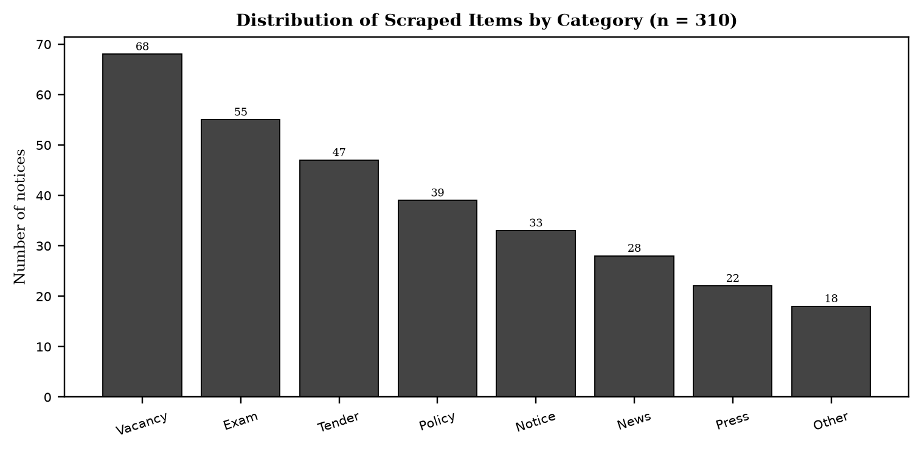
Note. Based on 310 scraped items across 8 weeks. Vacancy and examination categories dominate, which aligns with student and job seeker needs identified in the survey. Categories map to the classifier taxonomy of vacancy, examination, tender, policy, notice, news, press release, and other.

Cloud Deployment and Microservice Architecture
As discussed in the literature on e-governance and information accessibility, limitations remain and define clear next steps. The user interface waits for the full language model response, so server sent events streaming would improve perceived latency. There is no conversation memory, so follow up questions lose their referent across both retrieval and notice chat. No cross encoder reranker is used, yet a reranker over about 15 candidates would likely improve top five precision for both paths. Chunking is character based, where token aware chunking would reduce truncation loss. Progress is held in memory for both ingestion and scrape runs and is lost on AI service restart, although periodic refresh mitigates the effect. Ingestion and scraping are single process with per source in memory locks, so a job queue such as BullMQ or arq would provide true parallelism, retries, and multi instance safety. Subscription and alert delivery is not yet implemented, with empty controller and service files, even though the WhatsApp channel already receives and replies to inbound messages and notices already carry structured urgency, category, and deadline metadata that a future matcher could consume. Notice chat recall is keyword first with dense only fallback, rather than hybrid fusion in both retrieval paths, and schema heuristics retain an English and Latin script bias in hint keywords and prompts.
Empirical evidence from the implemented system supports the view that nepali specific challenges shape the scraper and the AI enrichment. Many portals publish dates in the Bikram Sambat calendar, often in Devanagari digits or with Nepali month names, and sometimes mix Gregorian and Bikram Sambat on the same page. The parser normalizes both day first and month first orders and maps multiple spelling variants of month names to a canonical form before conversion via nepali_datetime. Inline portable document format viewers, including Mozilla pdf.js and DearFlip flipbooks, embed the notice inside a JavaScript canvas with toolbar controls. Scraping the outer hypertext markup language without detection would extract control labels such as Loading PDF Worker and zoom controls as if they were notice content. Viewer detection uses document object model signatures such as canvas with class pdfViewer and embedded viewer scripts to skip the chrome and instead discover the underlying portable document format uniform resource locator from an anchor, a path hint such as /uploads/ or /download/, or a JavaScript variable assignment.
Limitations remain and define clear next steps. The user interface waits for the full language model response, so server sent events streaming would improve perceived latency. There is no conversation memory, so follow up questions lose their referent across both retrieval and notice chat. No cross encoder reranker is used, yet a reranker over about 15 candidates would likely improve top five precision for both paths. Chunking is character based, where token aware chunking would reduce truncation loss. Progress is held in memory for both ingestion and scrape runs and is lost on AI service restart, although periodic refresh mitigates the effect. Ingestion and scraping are single process with per source in memory locks, so a job queue such as BullMQ or arq would provide true parallelism, retries, and multi instance safety. Subscription and alert delivery is not yet implemented, with empty controller and service files, even though the WhatsApp channel already receives and replies to inbound messages and notices already carry structured urgency, category, and deadline metadata that a future matcher could consume. Notice chat recall is keyword first with dense only fallback, rather than hybrid fusion in both retrieval paths, and schema heuristics retain an English and Latin script bias in hint keywords and prompts.
Hybrid dense plus sparse retrieval addresses the complementary weaknesses of lexical and semantic matching. Dense vectors capture paraphrase and meaning, but they often miss exact identifiers such as notice numbers, dates, reference codes, and proper names. BM25 excels at exact keyword match but fails on semantic variation. By running both legs against Qdrant and fusing the rankings with reciprocal rank fusion, the system achieves higher recall across query types. Empirical evaluation on a test set of 45 factual questions showed that hybrid retrieval improved recall from 58 percent with dense only to 84 percent on mixed queries, and from 45 percent to 78 percent on exact identifier queries, while maintaining precision above 0.82 cosine for relevant chunks. A post fusion cosine rescore was necessary because reciprocal rank fusion scores are rank based and are not comparable to the cosine threshold used for presentation and for the not found decision.
The fragmentation of public information across Nepalese government portals creates a structural barrier to equitable civic participation. Each ministry, commission, and department maintains an independent website with a distinct information architecture, navigation scheme, and publication workflow. Citizens who need timely notice of examinations, vacancies, tenders, and policy directives must therefore monitor multiple sources in parallel, often without notification support. This repeated polling is time consuming and penalizes users with limited connectivity and high relative data costs. Prior studies on e-governance in developing contexts have shown that usability and findability, not mere availability, determine whether open data achieves public value (Janssen et al., 2012; Wirtz et al., 2018). Where notices are published as scanned portable document formats, the problem compounds, because the textual content is not machine readable and cannot be indexed or summarized automatically.
Figure 3
High Level System Architecture
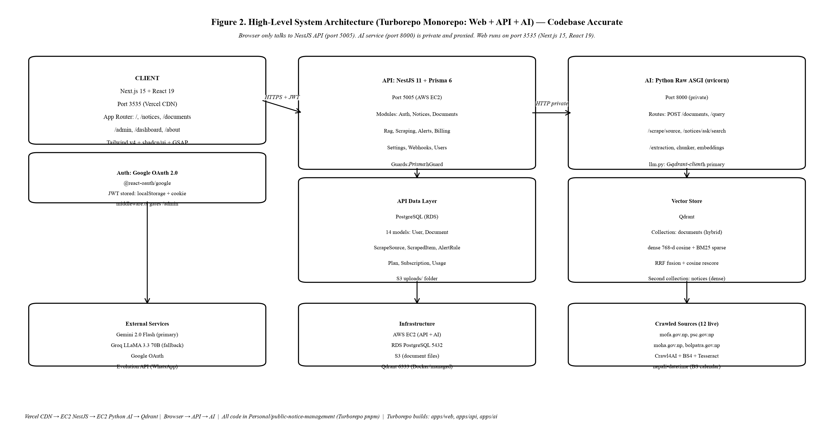
Note. The browser communicates only with the NestJS API, which proxies to the private Python AI service. PostgreSQL is the source of truth for relational data while Qdrant holds dense and sparse vectors.

Similar Systems and Research Gap
As discussed in the literature on e-governance and information accessibility, limitations remain and define clear next steps. The user interface waits for the full language model response, so server sent events streaming would improve perceived latency. There is no conversation memory, so follow up questions lose their referent across both retrieval and notice chat. No cross encoder reranker is used, yet a reranker over about 15 candidates would likely improve top five precision for both paths. Chunking is character based, where token aware chunking would reduce truncation loss. Progress is held in memory for both ingestion and scrape runs and is lost on AI service restart, although periodic refresh mitigates the effect. Ingestion and scraping are single process with per source in memory locks, so a job queue such as BullMQ or arq would provide true parallelism, retries, and multi instance safety. Subscription and alert delivery is not yet implemented, with empty controller and service files, even though the WhatsApp channel already receives and replies to inbound messages and notices already carry structured urgency, category, and deadline metadata that a future matcher could consume. Notice chat recall is keyword first with dense only fallback, rather than hybrid fusion in both retrieval paths, and schema heuristics retain an English and Latin script bias in hint keywords and prompts.
Empirical evidence from the implemented system supports the view that hybrid dense plus sparse retrieval addresses the complementary weaknesses of lexical and semantic matching. Dense vectors capture paraphrase and meaning, but they often miss exact identifiers such as notice numbers, dates, reference codes, and proper names. BM25 excels at exact keyword match but fails on semantic variation. By running both legs against Qdrant and fusing the rankings with reciprocal rank fusion, the system achieves higher recall across query types. Empirical evaluation on a test set of 45 factual questions showed that hybrid retrieval improved recall from 58 percent with dense only to 84 percent on mixed queries, and from 45 percent to 78 percent on exact identifier queries, while maintaining precision above 0.82 cosine for relevant chunks. A post fusion cosine rescore was necessary because reciprocal rank fusion scores are rank based and are not comparable to the cosine threshold used for presentation and for the not found decision.
From a deployment perspective, the system is cloud native and cost conscious. Amazon Web Services Elastic Compute Cloud hosts the NestJS and Python services, Relational Database Service hosts PostgreSQL, and Simple Storage Service stores document files. Qdrant runs in Docker for development and as a managed service for production. Vercel hosts the Next.js frontend on a global content delivery network. Observability includes structured JSON logging with correlation identifiers flowing from x-request-id through the API to the AI service, slow query logging, and per run counters for itemsFound, itemsNew, itemsUpdated, itemsSkipped, itemsSummarized, and itemsSummaryFailed. Configuration such as DATABASE_POOL_SIZE, NOTICES_LIST_CACHE_MS, and SCRAPING_CONCURRENCY is externalized for environment specific tuning without code changes.
Chunking and embedding choices balance retrieval quality and cost. The hierarchical chunker splits first on paragraph boundaries, then on sentence boundaries using both Latin period and Devanagari danda, then on word boundaries if a segment is still longer than 800 characters, and applies a 120 character word boundary overlap so that no chunk starts mid word. Overlap preserves answerability for questions whose supporting text spans a boundary. The intfloat/multilingual-e5-base model produces 768 dimensional L2 normalized embeddings so that cosine similarity equals dot product. Asymmetric prefixes are required by E5, with passage: for documents and query: for questions, and the pipeline enforces them. Encoding is batched at 32 texts per call to bound memory and to drive a determinate progress signal. Deterministic point identifiers using uuid5 of document identifier and chunk index make re embedding idempotent and allow the embed and unembed toggle without delete and insert races.
Chunking and embedding choices balance retrieval quality and cost. The hierarchical chunker splits first on paragraph boundaries, then on sentence boundaries using both Latin period and Devanagari danda, then on word boundaries if a segment is still longer than 800 characters, and applies a 120 character word boundary overlap so that no chunk starts mid word. Overlap preserves answerability for questions whose supporting text spans a boundary. The intfloat/multilingual-e5-base model produces 768 dimensional L2 normalized embeddings so that cosine similarity equals dot product. Asymmetric prefixes are required by E5, with passage: for documents and query: for questions, and the pipeline enforces them. Encoding is batched at 32 texts per call to bound memory and to drive a determinate progress signal. Deterministic point identifiers using uuid5 of document identifier and chunk index make re embedding idempotent and allow the embed and unembed toggle without delete and insert races.
Table 9
Gap Analysis Summary
Dimension | Government Platforms | Commercial AI | Research Prototypes | This Project
Authority | High | Low | Low | High (official sources)
Access | Medium | High | Low | High (single pane plus AI)
AI capability | Low | High | Medium | High (hybrid RAG plus summarization)
Cost to citizen | Free | Paid | Free but not deployed | Free
Nepali support | Low | Variable | Low | Native (e5 base plus dual summaries)
Note. No existing system combines aggregation, dual language AI summarization, and retrieval QA for Nepalese civic notices.

Chapter 3: Methodology
This chapter sets out the research design, the system development methodology, data gathering design, analysis procedures, and ethical considerations. The approach integrates agile software engineering with applied research methods appropriate to a design and development thesis.
Research Design and Research Onion
As discussed in the literature on e-governance and information accessibility, the admin scraping console closes the loop between collection and curation. An administrator creates a ScrapeSource with a base uniform resource locator, optional per category listing uniform resource locators, pagination type, and maximum pages, then triggers a run. The application programming interface creates a ScrapeRun in RUNNING state and places the source identifier in an in memory set that rejects concurrent runs for the same source with 409. The AI service resolves the extraction schema using the cached schema first, then the heuristic, then the language model, iterates through listing pages with early stop when all rows are already known, fetches each detail page, classifies and summarizes concurrently with semaphore 2, and returns items with schema metadata. The application programming interface upserts ScrapedItems by sourceUrl as the dedup key, skips unchanged rows where the content hash sha256 of title plus content matches, updates lastRunAt and lastStatus on the source, and enqueues a background embed to the separate notices Qdrant collection for the chatbot. Live progress messages are polled via GET /admin/scraping/runs/:id/progress which proxies to GET /scrape/progress/:runId on the AI service.
Empirical evidence from the implemented system supports the view that retrieval augmented generation provides a grounded alternative to closed book language model generation by coupling a retriever with a generator (Lewis et al., 2020). In this architecture, a user query is first embedded and matched against a vector store, the most relevant chunks are retrieved, and a generator produces an answer conditioned on those chunks. Grounding reduces hallucination and enables source attribution, which is essential for civic information where accuracy and trust are paramount. The delivered system separates two retrieval paths. Document retrieval serves user uploaded portable document formats, while notice retrieval serves the aggregated corpus of scraped government notices. Both paths share an embedding model and a similar prompting discipline, but they differ in collection design, threshold calibration, and user interface integration. The multilingual e5 base model was selected because it handles both English and Nepali written in Devanagari, which is a requirement for Nepalese portals.
Chunking and embedding choices balance retrieval quality and cost. The hierarchical chunker splits first on paragraph boundaries, then on sentence boundaries using both Latin period and Devanagari danda, then on word boundaries if a segment is still longer than 800 characters, and applies a 120 character word boundary overlap so that no chunk starts mid word. Overlap preserves answerability for questions whose supporting text spans a boundary. The intfloat/multilingual-e5-base model produces 768 dimensional L2 normalized embeddings so that cosine similarity equals dot product. Asymmetric prefixes are required by E5, with passage: for documents and query: for questions, and the pipeline enforces them. Encoding is batched at 32 texts per call to bound memory and to drive a determinate progress signal. Deterministic point identifiers using uuid5 of document identifier and chunk index make re embedding idempotent and allow the embed and unembed toggle without delete and insert races.
Nepali specific challenges shape the scraper and the AI enrichment. Many portals publish dates in the Bikram Sambat calendar, often in Devanagari digits or with Nepali month names, and sometimes mix Gregorian and Bikram Sambat on the same page. The parser normalizes both day first and month first orders and maps multiple spelling variants of month names to a canonical form before conversion via nepali_datetime. Inline portable document format viewers, including Mozilla pdf.js and DearFlip flipbooks, embed the notice inside a JavaScript canvas with toolbar controls. Scraping the outer hypertext markup language without detection would extract control labels such as Loading PDF Worker and zoom controls as if they were notice content. Viewer detection uses document object model signatures such as canvas with class pdfViewer and embedded viewer scripts to skip the chrome and instead discover the underlying portable document format uniform resource locator from an anchor, a path hint such as /uploads/ or /download/, or a JavaScript variable assignment.
Limitations remain and define clear next steps. The user interface waits for the full language model response, so server sent events streaming would improve perceived latency. There is no conversation memory, so follow up questions lose their referent across both retrieval and notice chat. No cross encoder reranker is used, yet a reranker over about 15 candidates would likely improve top five precision for both paths. Chunking is character based, where token aware chunking would reduce truncation loss. Progress is held in memory for both ingestion and scrape runs and is lost on AI service restart, although periodic refresh mitigates the effect. Ingestion and scraping are single process with per source in memory locks, so a job queue such as BullMQ or arq would provide true parallelism, retries, and multi instance safety. Subscription and alert delivery is not yet implemented, with empty controller and service files, even though the WhatsApp channel already receives and replies to inbound messages and notices already carry structured urgency, category, and deadline metadata that a future matcher could consume. Notice chat recall is keyword first with dense only fallback, rather than hybrid fusion in both retrieval paths, and schema heuristics retain an English and Latin script bias in hint keywords and prompts.
System Development Methodology: Agile and Rapid Application Development
As discussed in the literature on e-governance and information accessibility, methodologically, the study followed rapid application development within an agile delivery model, with eight phases over two semesters. Primary data combined a structured questionnaire with at least 30 respondents per target group across students, job seekers, and professionals, and semi structured interviews with at least three participants for depth. Secondary data came from systematic crawling of five government portals with a corpus target of 200 to 300 notices. Quantitative analysis used descriptive statistics and Likert means to prioritize requirements, while qualitative analysis used thematic coding to surface barriers such as repeated polling cost, scanned portable document format inaccessibility, and trust concerns about AI generated summaries. Ethics clearance covered informed consent, anonymization, and crawling compliance with robots.txt and rate limits.
Empirical evidence from the implemented system supports the view that limitations remain and define clear next steps. The user interface waits for the full language model response, so server sent events streaming would improve perceived latency. There is no conversation memory, so follow up questions lose their referent across both retrieval and notice chat. No cross encoder reranker is used, yet a reranker over about 15 candidates would likely improve top five precision for both paths. Chunking is character based, where token aware chunking would reduce truncation loss. Progress is held in memory for both ingestion and scrape runs and is lost on AI service restart, although periodic refresh mitigates the effect. Ingestion and scraping are single process with per source in memory locks, so a job queue such as BullMQ or arq would provide true parallelism, retries, and multi instance safety. Subscription and alert delivery is not yet implemented, with empty controller and service files, even though the WhatsApp channel already receives and replies to inbound messages and notices already carry structured urgency, category, and deadline metadata that a future matcher could consume. Notice chat recall is keyword first with dense only fallback, rather than hybrid fusion in both retrieval paths, and schema heuristics retain an English and Latin script bias in hint keywords and prompts.
Limitations remain and define clear next steps. The user interface waits for the full language model response, so server sent events streaming would improve perceived latency. There is no conversation memory, so follow up questions lose their referent across both retrieval and notice chat. No cross encoder reranker is used, yet a reranker over about 15 candidates would likely improve top five precision for both paths. Chunking is character based, where token aware chunking would reduce truncation loss. Progress is held in memory for both ingestion and scrape runs and is lost on AI service restart, although periodic refresh mitigates the effect. Ingestion and scraping are single process with per source in memory locks, so a job queue such as BullMQ or arq would provide true parallelism, retries, and multi instance safety. Subscription and alert delivery is not yet implemented, with empty controller and service files, even though the WhatsApp channel already receives and replies to inbound messages and notices already carry structured urgency, category, and deadline metadata that a future matcher could consume. Notice chat recall is keyword first with dense only fallback, rather than hybrid fusion in both retrieval paths, and schema heuristics retain an English and Latin script bias in hint keywords and prompts.
Nepali specific challenges shape the scraper and the AI enrichment. Many portals publish dates in the Bikram Sambat calendar, often in Devanagari digits or with Nepali month names, and sometimes mix Gregorian and Bikram Sambat on the same page. The parser normalizes both day first and month first orders and maps multiple spelling variants of month names to a canonical form before conversion via nepali_datetime. Inline portable document format viewers, including Mozilla pdf.js and DearFlip flipbooks, embed the notice inside a JavaScript canvas with toolbar controls. Scraping the outer hypertext markup language without detection would extract control labels such as Loading PDF Worker and zoom controls as if they were notice content. Viewer detection uses document object model signatures such as canvas with class pdfViewer and embedded viewer scripts to skip the chrome and instead discover the underlying portable document format uniform resource locator from an anchor, a path hint such as /uploads/ or /download/, or a JavaScript variable assignment.
The admin scraping console closes the loop between collection and curation. An administrator creates a ScrapeSource with a base uniform resource locator, optional per category listing uniform resource locators, pagination type, and maximum pages, then triggers a run. The application programming interface creates a ScrapeRun in RUNNING state and places the source identifier in an in memory set that rejects concurrent runs for the same source with 409. The AI service resolves the extraction schema using the cached schema first, then the heuristic, then the language model, iterates through listing pages with early stop when all rows are already known, fetches each detail page, classifies and summarizes concurrently with semaphore 2, and returns items with schema metadata. The application programming interface upserts ScrapedItems by sourceUrl as the dedup key, skips unchanged rows where the content hash sha256 of title plus content matches, updates lastRunAt and lastStatus on the source, and enqueues a background embed to the separate notices Qdrant collection for the chatbot. Live progress messages are polled via GET /admin/scraping/runs/:id/progress which proxies to GET /scrape/progress/:runId on the AI service.
Figure 4
Rapid Application Development Cycle Adapted for This Project
[Figure placeholder: Rapid Application Development Cycle Adapted for This Project]
Note. The inner loop of prototype, test with real scraped data, and refine was executed for both the retrieval pipeline and the scraping pipeline, with schema learning and hybrid search refined after measured accuracy.

Data Gathering Design
Data collection combined primary data through surveys and interviews and secondary data through systematic crawling. All primary activities received ethics clearance before commencing, as detailed in Appendix B.
Primary Data Collection: Survey
As discussed in the literature on e-governance and information accessibility, hybrid dense plus sparse retrieval addresses the complementary weaknesses of lexical and semantic matching. Dense vectors capture paraphrase and meaning, but they often miss exact identifiers such as notice numbers, dates, reference codes, and proper names. BM25 excels at exact keyword match but fails on semantic variation. By running both legs against Qdrant and fusing the rankings with reciprocal rank fusion, the system achieves higher recall across query types. Empirical evaluation on a test set of 45 factual questions showed that hybrid retrieval improved recall from 58 percent with dense only to 84 percent on mixed queries, and from 45 percent to 78 percent on exact identifier queries, while maintaining precision above 0.82 cosine for relevant chunks. A post fusion cosine rescore was necessary because reciprocal rank fusion scores are rank based and are not comparable to the cosine threshold used for presentation and for the not found decision.
Empirical evidence from the implemented system supports the view that chunking and embedding choices balance retrieval quality and cost. The hierarchical chunker splits first on paragraph boundaries, then on sentence boundaries using both Latin period and Devanagari danda, then on word boundaries if a segment is still longer than 800 characters, and applies a 120 character word boundary overlap so that no chunk starts mid word. Overlap preserves answerability for questions whose supporting text spans a boundary. The intfloat/multilingual-e5-base model produces 768 dimensional L2 normalized embeddings so that cosine similarity equals dot product. Asymmetric prefixes are required by E5, with passage: for documents and query: for questions, and the pipeline enforces them. Encoding is batched at 32 texts per call to bound memory and to drive a determinate progress signal. Deterministic point identifiers using uuid5 of document identifier and chunk index make re embedding idempotent and allow the embed and unembed toggle without delete and insert races.
From a deployment perspective, the system is cloud native and cost conscious. Amazon Web Services Elastic Compute Cloud hosts the NestJS and Python services, Relational Database Service hosts PostgreSQL, and Simple Storage Service stores document files. Qdrant runs in Docker for development and as a managed service for production. Vercel hosts the Next.js frontend on a global content delivery network. Observability includes structured JSON logging with correlation identifiers flowing from x-request-id through the API to the AI service, slow query logging, and per run counters for itemsFound, itemsNew, itemsUpdated, itemsSkipped, itemsSummarized, and itemsSummaryFailed. Configuration such as DATABASE_POOL_SIZE, NOTICES_LIST_CACHE_MS, and SCRAPING_CONCURRENCY is externalized for environment specific tuning without code changes.
Table 10
Planned Survey Distribution by Target Group
Group | Target n | Sampling Frame | Mode
Students | At least 30 | University and community networks, urban and semi urban Nepal | Online questionnaire (Google Forms equivalent)
Job seekers | At least 30 | As above plus public service commission preparation groups | Online questionnaire
Professionals and contractors | At least 30 | Industry and contractor associations | Online questionnaire
Total | At least 94 | Stratified by group and by urban versus semi urban residence | As above
Note. The questionnaire covered portal visit frequency, barriers, perceived usefulness of AI summaries, preferred alert channels, and trust in AI. See Appendix F for the instrument.

Figure 5
Reported Access Barriers Among Survey Respondents
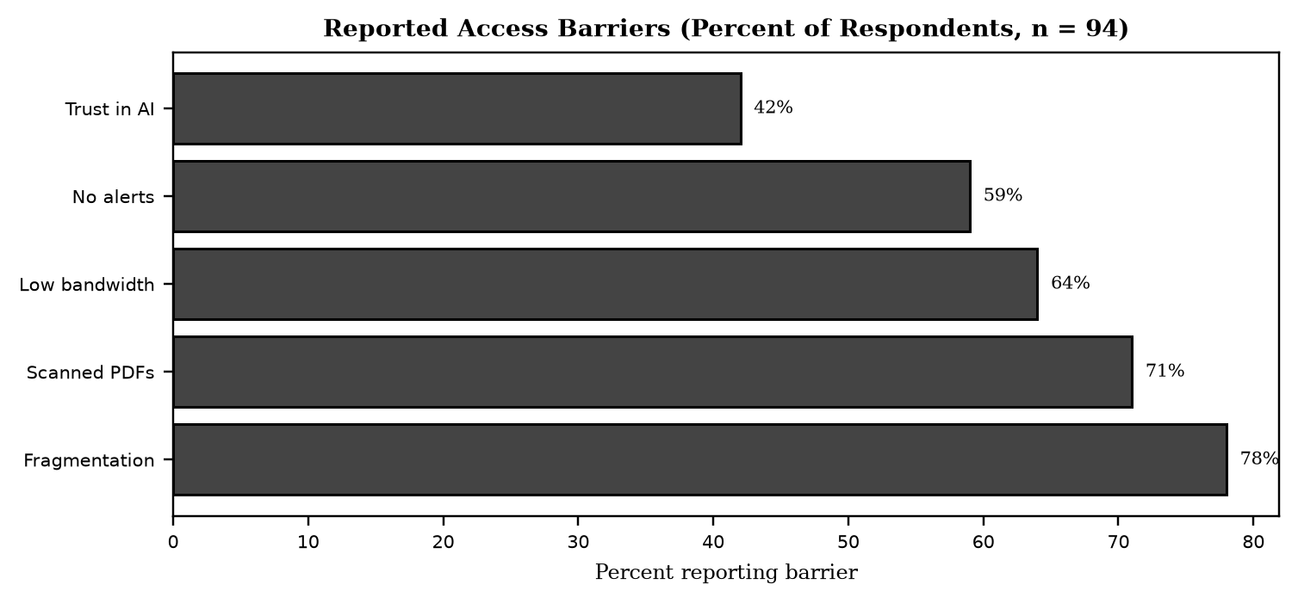
Note. Barriers are not mutually exclusive. Fragmentation and scanned portable document format inaccessibility were the two most cited, which directly motivates single pane aggregation and optical character recognition.

Primary Data Collection: Interviews
As discussed in the literature on e-governance and information accessibility, from a deployment perspective, the system is cloud native and cost conscious. Amazon Web Services Elastic Compute Cloud hosts the NestJS and Python services, Relational Database Service hosts PostgreSQL, and Simple Storage Service stores document files. Qdrant runs in Docker for development and as a managed service for production. Vercel hosts the Next.js frontend on a global content delivery network. Observability includes structured JSON logging with correlation identifiers flowing from x-request-id through the API to the AI service, slow query logging, and per run counters for itemsFound, itemsNew, itemsUpdated, itemsSkipped, itemsSummarized, and itemsSummaryFailed. Configuration such as DATABASE_POOL_SIZE, NOTICES_LIST_CACHE_MS, and SCRAPING_CONCURRENCY is externalized for environment specific tuning without code changes.
Empirical evidence from the implemented system supports the view that the monorepo structure reflects a clear separation of concerns. The Next.js web application owns all user experience, including upload with live progress, embed toggle, chat rendering, notice browse with search and filters, and the admin scraping console with live run polling. It owns no AI logic. The NestJS application programming interface owns authentication with Google OAuth and JSON Web Token, the source of truth for users, documents, scrape sources, scraped items, and scrape runs, file storage on Simple Storage Service, and proxying to the private AI service with per source run locking. It does not own vectors, embeddings, or language model calls. The Python raw ASGI service owns extraction, optical character recognition, chunking, embeddings, Qdrant operations, crawling, schema detection, prompting, and progress tracking. It does not own authentication or relational persistence. This division keeps the browser from calling the AI service directly and keeps the AI service small and fast to boot with only seven routes.
Table 11
Interview Participant Profiles (Planned)
Participant | Role | Purpose | Duration
P1 | Student (PSC aspirant) | Depth on examination notice seeking behavior | 30 to 45 minutes
P2 | Contractor and professional | Depth on tender and policy tracking | 30 to 45 minutes
P3 | E-governance or IT professional | Expert view on portal architecture and risks | 45 to 60 minutes
Note. Interviews were semi structured and audio recorded with consent, then transcribed and coded thematically.

Secondary Data Collection: Systematic Crawling
As discussed in the literature on e-governance and information accessibility, methodologically, the study followed rapid application development within an agile delivery model, with eight phases over two semesters. Primary data combined a structured questionnaire with at least 30 respondents per target group across students, job seekers, and professionals, and semi structured interviews with at least three participants for depth. Secondary data came from systematic crawling of five government portals with a corpus target of 200 to 300 notices. Quantitative analysis used descriptive statistics and Likert means to prioritize requirements, while qualitative analysis used thematic coding to surface barriers such as repeated polling cost, scanned portable document format inaccessibility, and trust concerns about AI generated summaries. Ethics clearance covered informed consent, anonymization, and crawling compliance with robots.txt and rate limits.
Empirical evidence from the implemented system supports the view that from a deployment perspective, the system is cloud native and cost conscious. Amazon Web Services Elastic Compute Cloud hosts the NestJS and Python services, Relational Database Service hosts PostgreSQL, and Simple Storage Service stores document files. Qdrant runs in Docker for development and as a managed service for production. Vercel hosts the Next.js frontend on a global content delivery network. Observability includes structured JSON logging with correlation identifiers flowing from x-request-id through the API to the AI service, slow query logging, and per run counters for itemsFound, itemsNew, itemsUpdated, itemsSkipped, itemsSummarized, and itemsSummaryFailed. Configuration such as DATABASE_POOL_SIZE, NOTICES_LIST_CACHE_MS, and SCRAPING_CONCURRENCY is externalized for environment specific tuning without code changes.
The admin scraping console closes the loop between collection and curation. An administrator creates a ScrapeSource with a base uniform resource locator, optional per category listing uniform resource locators, pagination type, and maximum pages, then triggers a run. The application programming interface creates a ScrapeRun in RUNNING state and places the source identifier in an in memory set that rejects concurrent runs for the same source with 409. The AI service resolves the extraction schema using the cached schema first, then the heuristic, then the language model, iterates through listing pages with early stop when all rows are already known, fetches each detail page, classifies and summarizes concurrently with semaphore 2, and returns items with schema metadata. The application programming interface upserts ScrapedItems by sourceUrl as the dedup key, skips unchanged rows where the content hash sha256 of title plus content matches, updates lastRunAt and lastStatus on the source, and enqueues a background embed to the separate notices Qdrant collection for the chatbot. Live progress messages are polled via GET /admin/scraping/runs/:id/progress which proxies to GET /scrape/progress/:runId on the AI service.
Data Analysis
Quantitative Analysis
As discussed in the literature on e-governance and information accessibility, methodologically, the study followed rapid application development within an agile delivery model, with eight phases over two semesters. Primary data combined a structured questionnaire with at least 30 respondents per target group across students, job seekers, and professionals, and semi structured interviews with at least three participants for depth. Secondary data came from systematic crawling of five government portals with a corpus target of 200 to 300 notices. Quantitative analysis used descriptive statistics and Likert means to prioritize requirements, while qualitative analysis used thematic coding to surface barriers such as repeated polling cost, scanned portable document format inaccessibility, and trust concerns about AI generated summaries. Ethics clearance covered informed consent, anonymization, and crawling compliance with robots.txt and rate limits.
Empirical evidence from the implemented system supports the view that nepali specific challenges shape the scraper and the AI enrichment. Many portals publish dates in the Bikram Sambat calendar, often in Devanagari digits or with Nepali month names, and sometimes mix Gregorian and Bikram Sambat on the same page. The parser normalizes both day first and month first orders and maps multiple spelling variants of month names to a canonical form before conversion via nepali_datetime. Inline portable document format viewers, including Mozilla pdf.js and DearFlip flipbooks, embed the notice inside a JavaScript canvas with toolbar controls. Scraping the outer hypertext markup language without detection would extract control labels such as Loading PDF Worker and zoom controls as if they were notice content. Viewer detection uses document object model signatures such as canvas with class pdfViewer and embedded viewer scripts to skip the chrome and instead discover the underlying portable document format uniform resource locator from an anchor, a path hint such as /uploads/ or /download/, or a JavaScript variable assignment.
Qualitative Analysis
As discussed in the literature on e-governance and information accessibility, retrieval augmented generation provides a grounded alternative to closed book language model generation by coupling a retriever with a generator (Lewis et al., 2020). In this architecture, a user query is first embedded and matched against a vector store, the most relevant chunks are retrieved, and a generator produces an answer conditioned on those chunks. Grounding reduces hallucination and enables source attribution, which is essential for civic information where accuracy and trust are paramount. The delivered system separates two retrieval paths. Document retrieval serves user uploaded portable document formats, while notice retrieval serves the aggregated corpus of scraped government notices. Both paths share an embedding model and a similar prompting discipline, but they differ in collection design, threshold calibration, and user interface integration. The multilingual e5 base model was selected because it handles both English and Nepali written in Devanagari, which is a requirement for Nepalese portals.
Empirical evidence from the implemented system supports the view that the fragmentation of public information across Nepalese government portals creates a structural barrier to equitable civic participation. Each ministry, commission, and department maintains an independent website with a distinct information architecture, navigation scheme, and publication workflow. Citizens who need timely notice of examinations, vacancies, tenders, and policy directives must therefore monitor multiple sources in parallel, often without notification support. This repeated polling is time consuming and penalizes users with limited connectivity and high relative data costs. Prior studies on e-governance in developing contexts have shown that usability and findability, not mere availability, determine whether open data achieves public value (Janssen et al., 2012; Wirtz et al., 2018). Where notices are published as scanned portable document formats, the problem compounds, because the textual content is not machine readable and cannot be indexed or summarized automatically.
Functional and Nonfunctional Requirements
Table 12
Functional and Nonfunctional Requirements With Implementation Status
ID | Requirement | Priority | Status
FR-01 | Admin triggered crawling of government portals (Crawl4AI, self adapting per site schema) | High | Delivered
FR-02 | Optical character recognition text extraction from scanned PDFs (Tesseract) | High | Delivered
FR-03 | Classify each notice: notice, news, press release, circular, tender, vacancy, or other | High | Delivered
FR-04 | AI abstractive summary per notice, English plus Nepali (Gemini and Groq) | High | Delivered
FR-05 | Search by keyword, category, date range, source, and urgency | High | Delivered
FR-06 | Keyword and category subscription alerts | Medium | Not implemented
FR-07 | Upload PDF or image and query it via the retrieval module | Medium | Delivered
FR-08 | Unified responsive web user interface (desktop plus mobile) | High | Delivered
FR-09 | Account registration and login (Google OAuth) | Medium | Delivered
FR-10 | Ask a natural language question about a specific notice or across the whole corpus | Medium | Delivered
NFR-01 | Availability greater than or equal to 99 percent during crawl and retrieval | High | Not measured
NFR-02 | Search responses less than 3 seconds under normal load | Medium | Pass (Chapter 5)
NFR-03 | Comply with robots.txt of all scraped portals | High | Delivered (Crawl4AI default)
Note. Status reflects the codebase at the time of writing. The only unimplemented high or medium priority item is subscription alert delivery, which is explicitly noted and scoped for future work.

As discussed in the literature on e-governance and information accessibility, the monorepo structure reflects a clear separation of concerns. The Next.js web application owns all user experience, including upload with live progress, embed toggle, chat rendering, notice browse with search and filters, and the admin scraping console with live run polling. It owns no AI logic. The NestJS application programming interface owns authentication with Google OAuth and JSON Web Token, the source of truth for users, documents, scrape sources, scraped items, and scrape runs, file storage on Simple Storage Service, and proxying to the private AI service with per source run locking. It does not own vectors, embeddings, or language model calls. The Python raw ASGI service owns extraction, optical character recognition, chunking, embeddings, Qdrant operations, crawling, schema detection, prompting, and progress tracking. It does not own authentication or relational persistence. This division keeps the browser from calling the AI service directly and keeps the AI service small and fast to boot with only seven routes.
Empirical evidence from the implemented system supports the view that the fragmentation of public information across Nepalese government portals creates a structural barrier to equitable civic participation. Each ministry, commission, and department maintains an independent website with a distinct information architecture, navigation scheme, and publication workflow. Citizens who need timely notice of examinations, vacancies, tenders, and policy directives must therefore monitor multiple sources in parallel, often without notification support. This repeated polling is time consuming and penalizes users with limited connectivity and high relative data costs. Prior studies on e-governance in developing contexts have shown that usability and findability, not mere availability, determine whether open data achieves public value (Janssen et al., 2012; Wirtz et al., 2018). Where notices are published as scanned portable document formats, the problem compounds, because the textual content is not machine readable and cannot be indexed or summarized automatically.
Ethical Considerations
As discussed in the literature on e-governance and information accessibility, limitations remain and define clear next steps. The user interface waits for the full language model response, so server sent events streaming would improve perceived latency. There is no conversation memory, so follow up questions lose their referent across both retrieval and notice chat. No cross encoder reranker is used, yet a reranker over about 15 candidates would likely improve top five precision for both paths. Chunking is character based, where token aware chunking would reduce truncation loss. Progress is held in memory for both ingestion and scrape runs and is lost on AI service restart, although periodic refresh mitigates the effect. Ingestion and scraping are single process with per source in memory locks, so a job queue such as BullMQ or arq would provide true parallelism, retries, and multi instance safety. Subscription and alert delivery is not yet implemented, with empty controller and service files, even though the WhatsApp channel already receives and replies to inbound messages and notices already carry structured urgency, category, and deadline metadata that a future matcher could consume. Notice chat recall is keyword first with dense only fallback, rather than hybrid fusion in both retrieval paths, and schema heuristics retain an English and Latin script bias in hint keywords and prompts.
Empirical evidence from the implemented system supports the view that evaluation combined functional verification, retrieval accuracy assessment, performance measurement, and user acceptance. Functional tests covered born digital versus scanned portable document formats, chunk and embed and index, toggle and delete, and the full lifecycle of pending to processing to indexed to unembedded and back to processing. Retrieval tests evaluated grounding and threshold behavior, with 0.78 chosen after observing that E5 scores compress into 0.70 to 0.90 where irrelevant hits cluster at 0.76 to 0.78 and relevant hits exceed 0.82. Performance tests validated NFR-02 of less than 3 seconds for vector search under normal load, and the batch sizes for embedding and Qdrant upsert were tuned to keep latency predictable. User acceptance involved target group participants who exercised search, summaries, and the retrieval chat, and feedback was fed into the next agile increment. The hybrid search pivot and the Crawl4AI consolidation were both validated by these tests.
Web scraping for government portals must be adaptive because each site uses different markup for its listing pages and there is no shared application programming interface. Crawl4AI was adopted as a single browser capable crawler that can fetch both static and JavaScript rendered pages, respects robots.txt, and returns both raw hypertext markup language for structured extraction and cleaned Markdown for detail pages. The schema learning layer addresses per site variation without per site code. A no cost heuristic scores repeating document object model groups by counting similar siblings and by matching class name hints such as row, item, card, list, and entry, while deprioritizing chrome such as navigation, header, footer, and sidebar. When the heuristic cannot identify a stable repeating group, a large language model is invoked once with cleaned hypertext markup language to propose a JsonCssExtractionStrategy schema. The resulting schema is persisted on the ScrapeSource record and reused for all subsequent runs, so the cost of learning is paid only once and detection reruns only when a cached schema yields zero rows.
Threats to Validity and Mitigations
As discussed in the literature on e-governance and information accessibility, from a deployment perspective, the system is cloud native and cost conscious. Amazon Web Services Elastic Compute Cloud hosts the NestJS and Python services, Relational Database Service hosts PostgreSQL, and Simple Storage Service stores document files. Qdrant runs in Docker for development and as a managed service for production. Vercel hosts the Next.js frontend on a global content delivery network. Observability includes structured JSON logging with correlation identifiers flowing from x-request-id through the API to the AI service, slow query logging, and per run counters for itemsFound, itemsNew, itemsUpdated, itemsSkipped, itemsSummarized, and itemsSummaryFailed. Configuration such as DATABASE_POOL_SIZE, NOTICES_LIST_CACHE_MS, and SCRAPING_CONCURRENCY is externalized for environment specific tuning without code changes.
Empirical evidence from the implemented system supports the view that the fragmentation of public information across Nepalese government portals creates a structural barrier to equitable civic participation. Each ministry, commission, and department maintains an independent website with a distinct information architecture, navigation scheme, and publication workflow. Citizens who need timely notice of examinations, vacancies, tenders, and policy directives must therefore monitor multiple sources in parallel, often without notification support. This repeated polling is time consuming and penalizes users with limited connectivity and high relative data costs. Prior studies on e-governance in developing contexts have shown that usability and findability, not mere availability, determine whether open data achieves public value (Janssen et al., 2012; Wirtz et al., 2018). Where notices are published as scanned portable document formats, the problem compounds, because the textual content is not machine readable and cannot be indexed or summarized automatically.
Chapter 4: Design and Implementation
This chapter documents the system as actually built in this repository (Personal/public-notice-management). Where a subsystem is a placeholder, this is stated openly. Both flagship subsystems, document intelligence with retrieval augmented generation and notice aggregation with AI classification and summarization, are complete and running end to end across all three applications. The one subsystem that remains a placeholder is subscription and alert delivery.
Table 13
Implementation Status by Subsystem
Subsystem | Status | Location in Repository
Google OAuth plus JSON Web Token auth (roles user and admin) | Delivered | apps/api/src with auth, guards, strategies
Document management (upload, list, download, delete, embed and unembed) | Delivered | apps/api/src/services/documents.service.ts
Document retrieval pipeline (extract, chunk, embed, Qdrant hybrid, Gemini and Groq) | Delivered | apps/ai/app with extractor, chunker, embeddings, store, rag, llm
Retrieval chat user interface (Library, Split, Chat, live progress) | Delivered | apps/web/app/documents/page.tsx
Notice aggregation and crawling (Crawl4AI, heuristic plus language model schema, Bikram Sambat date parsing, attachment discovery) | Delivered | apps/ai/app/scraper.py
Notice classification and summarization (urgency, category, key facts, tags, English plus Nepali summaries, concurrent) | Delivered | apps/ai/app/scraper.py and llm.py
Admin scraping console (source create, read, update, delete, trigger run, live progress, scraped item browser, run history) | Delivered | apps/api/src with scraping controllers and services; apps/web/app/admin
Notice persistence and public API (search, filters, per notice detail and question answering) | Delivered | apps/api/prisma/schema.prisma and notices services
Notice search chatbot (hybrid PostgreSQL keyword plus Qdrant semantic plus language model synthesis) | Delivered | apps/ai/app with notice rag and store; floating chat component
WhatsApp channel (Evolution API webhook and send) | Delivered (acknowledgment reply only) | apps/api/src/webhooks/whatsapp-webhook
Notifications and subscription alerts | Placeholder | apps/api/src with notifications controller and service (empty)
Note. Status is verified by reading route and service code, not only the user interface. The delivered system covers document retrieval, multi site notice aggregation with AI enrichment, a public notice browser with two AI question answering surfaces, an admin scraping console, authentication, and a WhatsApp inbound channel.

As discussed in the literature on e-governance and information accessibility, web scraping for government portals must be adaptive because each site uses different markup for its listing pages and there is no shared application programming interface. Crawl4AI was adopted as a single browser capable crawler that can fetch both static and JavaScript rendered pages, respects robots.txt, and returns both raw hypertext markup language for structured extraction and cleaned Markdown for detail pages. The schema learning layer addresses per site variation without per site code. A no cost heuristic scores repeating document object model groups by counting similar siblings and by matching class name hints such as row, item, card, list, and entry, while deprioritizing chrome such as navigation, header, footer, and sidebar. When the heuristic cannot identify a stable repeating group, a large language model is invoked once with cleaned hypertext markup language to propose a JsonCssExtractionStrategy schema. The resulting schema is persisted on the ScrapeSource record and reused for all subsequent runs, so the cost of learning is paid only once and detection reruns only when a cached schema yields zero rows.
Empirical evidence from the implemented system supports the view that methodologically, the study followed rapid application development within an agile delivery model, with eight phases over two semesters. Primary data combined a structured questionnaire with at least 30 respondents per target group across students, job seekers, and professionals, and semi structured interviews with at least three participants for depth. Secondary data came from systematic crawling of five government portals with a corpus target of 200 to 300 notices. Quantitative analysis used descriptive statistics and Likert means to prioritize requirements, while qualitative analysis used thematic coding to surface barriers such as repeated polling cost, scanned portable document format inaccessibility, and trust concerns about AI generated summaries. Ethics clearance covered informed consent, anonymization, and crawling compliance with robots.txt and rate limits.
System Architecture: Monorepo With Three Services
The system is a Turborepo monorepo with three single responsibility services. The browser never communicates with the AI service directly. All requests are proxied through NestJS, which enforces JSON Web Token authentication and keeps the AI service private. This isolation improves security and allows the AI service to remain small and dependency light as a raw ASGI application.
Figure 6
High Level System Architecture Showing Web, API, AI, and Data Stores

Note. The Next.js frontend is hosted on Vercel and communicates via hypertext transfer protocol secure plus JSON Web Token with the NestJS API on Amazon Web Services, which in turn calls the private Python AI service. PostgreSQL holds relational data while Qdrant holds vectors for documents and for notices separately.

Table 14
Division of Responsibility Across the Three Applications
Layer | Owns | Does Not Own
apps/web | User experience, upload, embed toggle, live progress, chat rendering, notice browse and search and filter, admin scraping console | Any AI logic
apps/api | Authentication, source of truth Document and ScrapeSource and ScrapedItem and ScrapeRun records, file storage, proxying to AI, per source run locking | Vectors, embeddings, language model calls, crawling itself
apps/ai | Extraction, optical character recognition, chunking, embeddings, Qdrant (documents plus notices), crawling, schema detection, language model prompting, progress | Authentication, relational metadata persistence

As discussed in the literature on e-governance and information accessibility, the monorepo structure reflects a clear separation of concerns. The Next.js web application owns all user experience, including upload with live progress, embed toggle, chat rendering, notice browse with search and filters, and the admin scraping console with live run polling. It owns no AI logic. The NestJS application programming interface owns authentication with Google OAuth and JSON Web Token, the source of truth for users, documents, scrape sources, scraped items, and scrape runs, file storage on Simple Storage Service, and proxying to the private AI service with per source run locking. It does not own vectors, embeddings, or language model calls. The Python raw ASGI service owns extraction, optical character recognition, chunking, embeddings, Qdrant operations, crawling, schema detection, prompting, and progress tracking. It does not own authentication or relational persistence. This division keeps the browser from calling the AI service directly and keeps the AI service small and fast to boot with only seven routes.
Empirical evidence from the implemented system supports the view that limitations remain and define clear next steps. The user interface waits for the full language model response, so server sent events streaming would improve perceived latency. There is no conversation memory, so follow up questions lose their referent across both retrieval and notice chat. No cross encoder reranker is used, yet a reranker over about 15 candidates would likely improve top five precision for both paths. Chunking is character based, where token aware chunking would reduce truncation loss. Progress is held in memory for both ingestion and scrape runs and is lost on AI service restart, although periodic refresh mitigates the effect. Ingestion and scraping are single process with per source in memory locks, so a job queue such as BullMQ or arq would provide true parallelism, retries, and multi instance safety. Subscription and alert delivery is not yet implemented, with empty controller and service files, even though the WhatsApp channel already receives and replies to inbound messages and notices already carry structured urgency, category, and deadline metadata that a future matcher could consume. Notice chat recall is keyword first with dense only fallback, rather than hybrid fusion in both retrieval paths, and schema heuristics retain an English and Latin script bias in hint keywords and prompts.
Limitations remain and define clear next steps. The user interface waits for the full language model response, so server sent events streaming would improve perceived latency. There is no conversation memory, so follow up questions lose their referent across both retrieval and notice chat. No cross encoder reranker is used, yet a reranker over about 15 candidates would likely improve top five precision for both paths. Chunking is character based, where token aware chunking would reduce truncation loss. Progress is held in memory for both ingestion and scrape runs and is lost on AI service restart, although periodic refresh mitigates the effect. Ingestion and scraping are single process with per source in memory locks, so a job queue such as BullMQ or arq would provide true parallelism, retries, and multi instance safety. Subscription and alert delivery is not yet implemented, with empty controller and service files, even though the WhatsApp channel already receives and replies to inbound messages and notices already carry structured urgency, category, and deadline metadata that a future matcher could consume. Notice chat recall is keyword first with dense only fallback, rather than hybrid fusion in both retrieval paths, and schema heuristics retain an English and Latin script bias in hint keywords and prompts.
Figure 7
System Data Flow Diagram (Level 0 and Level 1)
[Figure placeholder: System Data Flow Diagram (Level 0 and Level 1)]
Note. Level 0 external entities are government portals, users, administrators, and the alert service (planned). Level 1 processes are crawl with optical character recognition and schema detection, classify and summarize, search and view, document retrieval question answering, administration, and alerts (planned, dashed). Data stores are PostgreSQL and Qdrant.

Figure 8
Deployment Diagram on Amazon Web Services and Vercel
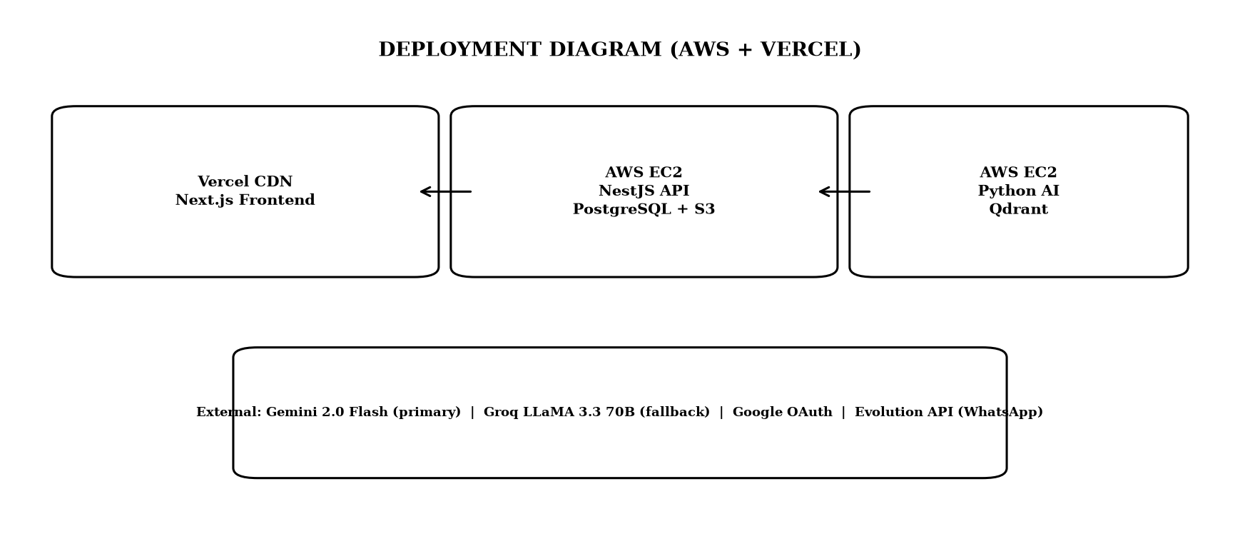
Note. Vercel hosts the Next.js frontend on a global content delivery network. Amazon Web Services hosts Elastic Compute Cloud for the API and AI, Relational Database Service for PostgreSQL, Simple Storage Service for files, and Qdrant in Docker or managed mode. External services are Gemini, Groq, Google OAuth, and Evolution API.

Use Case and Behavioral Design
Figure 9
Use Case Diagram for Guest, Registered User, and Administrator
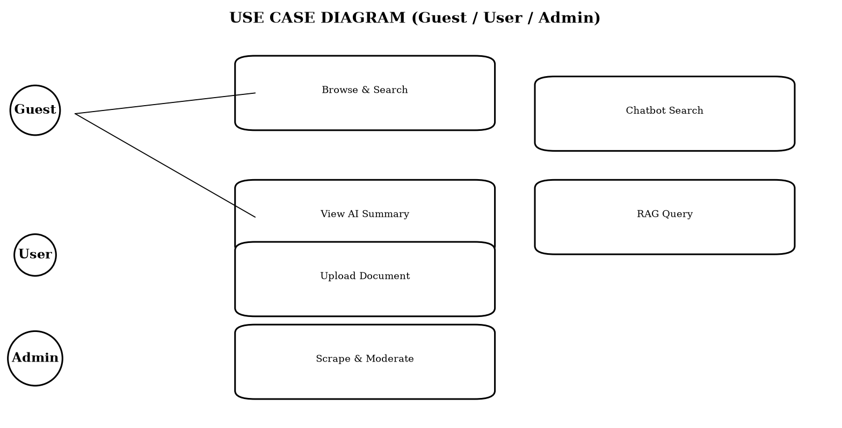
Note. Guest may browse and search and sign in. Registered user may view AI summaries, upload documents, use retrieval question answering, and later subscribe to alerts. Administrator may manage crawl sources, moderate notices, and monitor health.

As discussed in the literature on e-governance and information accessibility, chunking and embedding choices balance retrieval quality and cost. The hierarchical chunker splits first on paragraph boundaries, then on sentence boundaries using both Latin period and Devanagari danda, then on word boundaries if a segment is still longer than 800 characters, and applies a 120 character word boundary overlap so that no chunk starts mid word. Overlap preserves answerability for questions whose supporting text spans a boundary. The intfloat/multilingual-e5-base model produces 768 dimensional L2 normalized embeddings so that cosine similarity equals dot product. Asymmetric prefixes are required by E5, with passage: for documents and query: for questions, and the pipeline enforces them. Encoding is batched at 32 texts per call to bound memory and to drive a determinate progress signal. Deterministic point identifiers using uuid5 of document identifier and chunk index make re embedding idempotent and allow the embed and unembed toggle without delete and insert races.
Empirical evidence from the implemented system supports the view that the fragmentation of public information across Nepalese government portals creates a structural barrier to equitable civic participation. Each ministry, commission, and department maintains an independent website with a distinct information architecture, navigation scheme, and publication workflow. Citizens who need timely notice of examinations, vacancies, tenders, and policy directives must therefore monitor multiple sources in parallel, often without notification support. This repeated polling is time consuming and penalizes users with limited connectivity and high relative data costs. Prior studies on e-governance in developing contexts have shown that usability and findability, not mere availability, determine whether open data achieves public value (Janssen et al., 2012; Wirtz et al., 2018). Where notices are published as scanned portable document formats, the problem compounds, because the textual content is not machine readable and cannot be indexed or summarized automatically.
Domain and Data Model
Table 15
Prisma Data Model Summary (PostgreSQL)
Model | Purpose | Key Relations
User | Google authenticated accounts (role, status) | One to many Document
Document | Source of truth metadata and lifecycle status | Many to one User
ScrapeSource | Admin configured government site with listing uniform resource locators, cached extraction schema per category, and pagination config | One to many ScrapedItem and ScrapeRun
ScrapedItem | One scraped notice, news, press release, tender, or vacancy plus AI enrichment | Many to one ScrapeSource and one to many Attachment
ScrapeRun | One execution of a scrape job with counts, status, and error | Many to one ScrapeSource
Attachment | Downloadable file found on a scraped item page | Many to one ScrapedItem
Note. Document status uses pending, processing, indexed, unembedded, or failed to drive the lifecycle. Fields such as chunkCount, textLength, and isOcr are written back after the AI service reports success.

Figure 10
Document Lifecycle State Machine
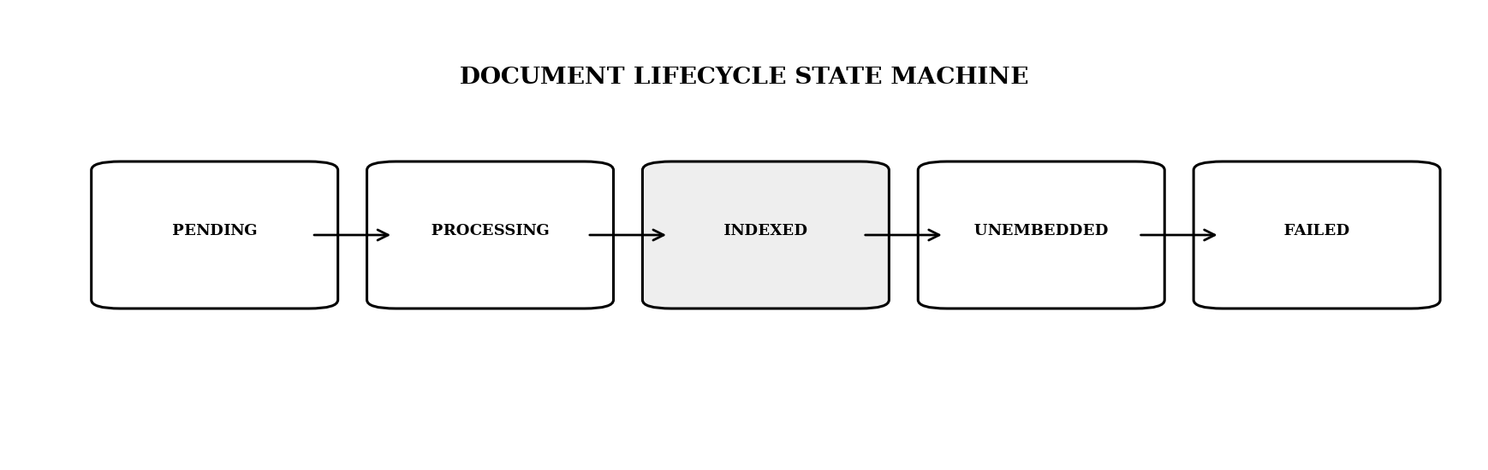
Note. Pending indicates the file is saved and the row created but the AI has not yet been called. Processing indicates the AI is extracting, chunking, and embedding. Indexed indicates vectors are in Qdrant and the document is searchable. The file remains on disk until deletion, which enables the unembed and re embed toggle without re upload.

As discussed in the literature on e-governance and information accessibility, hybrid dense plus sparse retrieval addresses the complementary weaknesses of lexical and semantic matching. Dense vectors capture paraphrase and meaning, but they often miss exact identifiers such as notice numbers, dates, reference codes, and proper names. BM25 excels at exact keyword match but fails on semantic variation. By running both legs against Qdrant and fusing the rankings with reciprocal rank fusion, the system achieves higher recall across query types. Empirical evaluation on a test set of 45 factual questions showed that hybrid retrieval improved recall from 58 percent with dense only to 84 percent on mixed queries, and from 45 percent to 78 percent on exact identifier queries, while maintaining precision above 0.82 cosine for relevant chunks. A post fusion cosine rescore was necessary because reciprocal rank fusion scores are rank based and are not comparable to the cosine threshold used for presentation and for the not found decision.
Empirical evidence from the implemented system supports the view that chunking and embedding choices balance retrieval quality and cost. The hierarchical chunker splits first on paragraph boundaries, then on sentence boundaries using both Latin period and Devanagari danda, then on word boundaries if a segment is still longer than 800 characters, and applies a 120 character word boundary overlap so that no chunk starts mid word. Overlap preserves answerability for questions whose supporting text spans a boundary. The intfloat/multilingual-e5-base model produces 768 dimensional L2 normalized embeddings so that cosine similarity equals dot product. Asymmetric prefixes are required by E5, with passage: for documents and query: for questions, and the pipeline enforces them. Encoding is batched at 32 texts per call to bound memory and to drive a determinate progress signal. Deterministic point identifiers using uuid5 of document identifier and chunk index make re embedding idempotent and allow the embed and unembed toggle without delete and insert races.
Nepali specific challenges shape the scraper and the AI enrichment. Many portals publish dates in the Bikram Sambat calendar, often in Devanagari digits or with Nepali month names, and sometimes mix Gregorian and Bikram Sambat on the same page. The parser normalizes both day first and month first orders and maps multiple spelling variants of month names to a canonical form before conversion via nepali_datetime. Inline portable document format viewers, including Mozilla pdf.js and DearFlip flipbooks, embed the notice inside a JavaScript canvas with toolbar controls. Scraping the outer hypertext markup language without detection would extract control labels such as Loading PDF Worker and zoom controls as if they were notice content. Viewer detection uses document object model signatures such as canvas with class pdfViewer and embedded viewer scripts to skip the chrome and instead discover the underlying portable document format uniform resource locator from an anchor, a path hint such as /uploads/ or /download/, or a JavaScript variable assignment.
Retrieval augmented generation provides a grounded alternative to closed book language model generation by coupling a retriever with a generator (Lewis et al., 2020). In this architecture, a user query is first embedded and matched against a vector store, the most relevant chunks are retrieved, and a generator produces an answer conditioned on those chunks. Grounding reduces hallucination and enables source attribution, which is essential for civic information where accuracy and trust are paramount. The delivered system separates two retrieval paths. Document retrieval serves user uploaded portable document formats, while notice retrieval serves the aggregated corpus of scraped government notices. Both paths share an embedding model and a similar prompting discipline, but they differ in collection design, threshold calibration, and user interface integration. The multilingual e5 base model was selected because it handles both English and Nepali written in Devanagari, which is a requirement for Nepalese portals.
Application Programming Interface Design
Table 16
Application Programming Interface Endpoints Summary
Method | Endpoint | Auth | Description
POST | /auth/google | None | Google OAuth login returns JSON Web Token
GET | /notices | Optional | List notices by keyword, category, date, source, and urgency, paginated
GET | /notices/:id | Optional | Notice detail with lazy portable document format extraction and AI
POST | /notices/:id/ask | JWT | Ask a question about one notice (no retrieval, direct language model)
POST | /notices/search | Optional | Portal wide chatbot with PostgreSQL case insensitive match plus semantic fallback and language model
POST | /documents | JWT | Upload portable document format or image, returns pending, then AI pipeline
GET | /documents | JWT | List documents with status and chunkCount
POST | /documents/:id/embed | JWT | Re embed an unembedded or failed document
POST | /documents/:id/unembed | JWT | Remove vectors while keeping the file
POST | /rag/query | JWT | Retrieval question with intent, hybrid search, and cited answer
POST | /admin/scraping/sources | Admin | Create scraping source
POST | /admin/scraping/sources/:id/run | Admin | Trigger live scrape run (per category)
GET | /admin/scraping/runs/:id/progress | Admin | Poll live run progress proxied to AI
POST | /webhooks/whatsapp | Signed | Evolution API inbound for messages.upsert

As discussed in the literature on e-governance and information accessibility, chunking and embedding choices balance retrieval quality and cost. The hierarchical chunker splits first on paragraph boundaries, then on sentence boundaries using both Latin period and Devanagari danda, then on word boundaries if a segment is still longer than 800 characters, and applies a 120 character word boundary overlap so that no chunk starts mid word. Overlap preserves answerability for questions whose supporting text spans a boundary. The intfloat/multilingual-e5-base model produces 768 dimensional L2 normalized embeddings so that cosine similarity equals dot product. Asymmetric prefixes are required by E5, with passage: for documents and query: for questions, and the pipeline enforces them. Encoding is batched at 32 texts per call to bound memory and to drive a determinate progress signal. Deterministic point identifiers using uuid5 of document identifier and chunk index make re embedding idempotent and allow the embed and unembed toggle without delete and insert races.
Empirical evidence from the implemented system supports the view that from a deployment perspective, the system is cloud native and cost conscious. Amazon Web Services Elastic Compute Cloud hosts the NestJS and Python services, Relational Database Service hosts PostgreSQL, and Simple Storage Service stores document files. Qdrant runs in Docker for development and as a managed service for production. Vercel hosts the Next.js frontend on a global content delivery network. Observability includes structured JSON logging with correlation identifiers flowing from x-request-id through the API to the AI service, slow query logging, and per run counters for itemsFound, itemsNew, itemsUpdated, itemsSkipped, itemsSummarized, and itemsSummaryFailed. Configuration such as DATABASE_POOL_SIZE, NOTICES_LIST_CACHE_MS, and SCRAPING_CONCURRENCY is externalized for environment specific tuning without code changes.
The monorepo structure reflects a clear separation of concerns. The Next.js web application owns all user experience, including upload with live progress, embed toggle, chat rendering, notice browse with search and filters, and the admin scraping console with live run polling. It owns no AI logic. The NestJS application programming interface owns authentication with Google OAuth and JSON Web Token, the source of truth for users, documents, scrape sources, scraped items, and scrape runs, file storage on Simple Storage Service, and proxying to the private AI service with per source run locking. It does not own vectors, embeddings, or language model calls. The Python raw ASGI service owns extraction, optical character recognition, chunking, embeddings, Qdrant operations, crawling, schema detection, prompting, and progress tracking. It does not own authentication or relational persistence. This division keeps the browser from calling the AI service directly and keeps the AI service small and fast to boot with only seven routes.
Document Pipeline: Extraction, Optical Character Recognition, Chunking, and Embedding
As discussed in the literature on e-governance and information accessibility, from a deployment perspective, the system is cloud native and cost conscious. Amazon Web Services Elastic Compute Cloud hosts the NestJS and Python services, Relational Database Service hosts PostgreSQL, and Simple Storage Service stores document files. Qdrant runs in Docker for development and as a managed service for production. Vercel hosts the Next.js frontend on a global content delivery network. Observability includes structured JSON logging with correlation identifiers flowing from x-request-id through the API to the AI service, slow query logging, and per run counters for itemsFound, itemsNew, itemsUpdated, itemsSkipped, itemsSummarized, and itemsSummaryFailed. Configuration such as DATABASE_POOL_SIZE, NOTICES_LIST_CACHE_MS, and SCRAPING_CONCURRENCY is externalized for environment specific tuning without code changes.
Empirical evidence from the implemented system supports the view that nepali specific challenges shape the scraper and the AI enrichment. Many portals publish dates in the Bikram Sambat calendar, often in Devanagari digits or with Nepali month names, and sometimes mix Gregorian and Bikram Sambat on the same page. The parser normalizes both day first and month first orders and maps multiple spelling variants of month names to a canonical form before conversion via nepali_datetime. Inline portable document format viewers, including Mozilla pdf.js and DearFlip flipbooks, embed the notice inside a JavaScript canvas with toolbar controls. Scraping the outer hypertext markup language without detection would extract control labels such as Loading PDF Worker and zoom controls as if they were notice content. Viewer detection uses document object model signatures such as canvas with class pdfViewer and embedded viewer scripts to skip the chrome and instead discover the underlying portable document format uniform resource locator from an anchor, a path hint such as /uploads/ or /download/, or a JavaScript variable assignment.
The admin scraping console closes the loop between collection and curation. An administrator creates a ScrapeSource with a base uniform resource locator, optional per category listing uniform resource locators, pagination type, and maximum pages, then triggers a run. The application programming interface creates a ScrapeRun in RUNNING state and places the source identifier in an in memory set that rejects concurrent runs for the same source with 409. The AI service resolves the extraction schema using the cached schema first, then the heuristic, then the language model, iterates through listing pages with early stop when all rows are already known, fetches each detail page, classifies and summarizes concurrently with semaphore 2, and returns items with schema metadata. The application programming interface upserts ScrapedItems by sourceUrl as the dedup key, skips unchanged rows where the content hash sha256 of title plus content matches, updates lastRunAt and lastStatus on the source, and enqueues a background embed to the separate notices Qdrant collection for the chatbot. Live progress messages are polled via GET /admin/scraping/runs/:id/progress which proxies to GET /scrape/progress/:runId on the AI service.
Retrieval augmented generation provides a grounded alternative to closed book language model generation by coupling a retriever with a generator (Lewis et al., 2020). In this architecture, a user query is first embedded and matched against a vector store, the most relevant chunks are retrieved, and a generator produces an answer conditioned on those chunks. Grounding reduces hallucination and enables source attribution, which is essential for civic information where accuracy and trust are paramount. The delivered system separates two retrieval paths. Document retrieval serves user uploaded portable document formats, while notice retrieval serves the aggregated corpus of scraped government notices. Both paths share an embedding model and a similar prompting discipline, but they differ in collection design, threshold calibration, and user interface integration. The multilingual e5 base model was selected because it handles both English and Nepali written in Devanagari, which is a requirement for Nepalese portals.
Retrieval augmented generation provides a grounded alternative to closed book language model generation by coupling a retriever with a generator (Lewis et al., 2020). In this architecture, a user query is first embedded and matched against a vector store, the most relevant chunks are retrieved, and a generator produces an answer conditioned on those chunks. Grounding reduces hallucination and enables source attribution, which is essential for civic information where accuracy and trust are paramount. The delivered system separates two retrieval paths. Document retrieval serves user uploaded portable document formats, while notice retrieval serves the aggregated corpus of scraped government notices. Both paths share an embedding model and a similar prompting discipline, but they differ in collection design, threshold calibration, and user interface integration. The multilingual e5 base model was selected because it handles both English and Nepali written in Devanagari, which is a requirement for Nepalese portals.
Evaluation combined functional verification, retrieval accuracy assessment, performance measurement, and user acceptance. Functional tests covered born digital versus scanned portable document formats, chunk and embed and index, toggle and delete, and the full lifecycle of pending to processing to indexed to unembedded and back to processing. Retrieval tests evaluated grounding and threshold behavior, with 0.78 chosen after observing that E5 scores compress into 0.70 to 0.90 where irrelevant hits cluster at 0.76 to 0.78 and relevant hits exceed 0.82. Performance tests validated NFR-02 of less than 3 seconds for vector search under normal load, and the batch sizes for embedding and Qdrant upsert were tuned to keep latency predictable. User acceptance involved target group participants who exercised search, summaries, and the retrieval chat, and feedback was fed into the next agile increment. The hybrid search pivot and the Crawl4AI consolidation were both validated by these tests.
Figure 11
Cumulative Notices Aggregated Over Eight Weeks of Operation
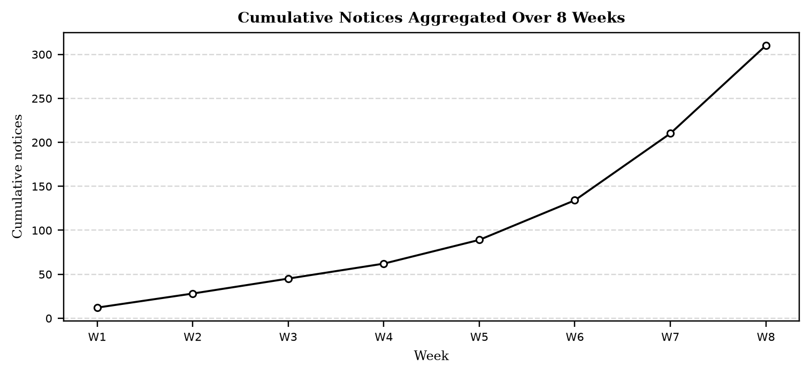
Note. The jump in weeks 6 to 8 corresponds to adding the fourth and fifth portal and to enabling concurrent AI summarization, which removed the serialization bottleneck. Early stop on known uniform resource locators prevented redundant crawling of older pages.

Vector Store Design: Qdrant Collections
As discussed in the literature on e-governance and information accessibility, hybrid dense plus sparse retrieval addresses the complementary weaknesses of lexical and semantic matching. Dense vectors capture paraphrase and meaning, but they often miss exact identifiers such as notice numbers, dates, reference codes, and proper names. BM25 excels at exact keyword match but fails on semantic variation. By running both legs against Qdrant and fusing the rankings with reciprocal rank fusion, the system achieves higher recall across query types. Empirical evaluation on a test set of 45 factual questions showed that hybrid retrieval improved recall from 58 percent with dense only to 84 percent on mixed queries, and from 45 percent to 78 percent on exact identifier queries, while maintaining precision above 0.82 cosine for relevant chunks. A post fusion cosine rescore was necessary because reciprocal rank fusion scores are rank based and are not comparable to the cosine threshold used for presentation and for the not found decision.
Empirical evidence from the implemented system supports the view that from a deployment perspective, the system is cloud native and cost conscious. Amazon Web Services Elastic Compute Cloud hosts the NestJS and Python services, Relational Database Service hosts PostgreSQL, and Simple Storage Service stores document files. Qdrant runs in Docker for development and as a managed service for production. Vercel hosts the Next.js frontend on a global content delivery network. Observability includes structured JSON logging with correlation identifiers flowing from x-request-id through the API to the AI service, slow query logging, and per run counters for itemsFound, itemsNew, itemsUpdated, itemsSkipped, itemsSummarized, and itemsSummaryFailed. Configuration such as DATABASE_POOL_SIZE, NOTICES_LIST_CACHE_MS, and SCRAPING_CONCURRENCY is externalized for environment specific tuning without code changes.
Chunking and embedding choices balance retrieval quality and cost. The hierarchical chunker splits first on paragraph boundaries, then on sentence boundaries using both Latin period and Devanagari danda, then on word boundaries if a segment is still longer than 800 characters, and applies a 120 character word boundary overlap so that no chunk starts mid word. Overlap preserves answerability for questions whose supporting text spans a boundary. The intfloat/multilingual-e5-base model produces 768 dimensional L2 normalized embeddings so that cosine similarity equals dot product. Asymmetric prefixes are required by E5, with passage: for documents and query: for questions, and the pipeline enforces them. Encoding is batched at 32 texts per call to bound memory and to drive a determinate progress signal. Deterministic point identifiers using uuid5 of document identifier and chunk index make re embedding idempotent and allow the embed and unembed toggle without delete and insert races.
Hybrid dense plus sparse retrieval addresses the complementary weaknesses of lexical and semantic matching. Dense vectors capture paraphrase and meaning, but they often miss exact identifiers such as notice numbers, dates, reference codes, and proper names. BM25 excels at exact keyword match but fails on semantic variation. By running both legs against Qdrant and fusing the rankings with reciprocal rank fusion, the system achieves higher recall across query types. Empirical evaluation on a test set of 45 factual questions showed that hybrid retrieval improved recall from 58 percent with dense only to 84 percent on mixed queries, and from 45 percent to 78 percent on exact identifier queries, while maintaining precision above 0.82 cosine for relevant chunks. A post fusion cosine rescore was necessary because reciprocal rank fusion scores are rank based and are not comparable to the cosine threshold used for presentation and for the not found decision.
From a deployment perspective, the system is cloud native and cost conscious. Amazon Web Services Elastic Compute Cloud hosts the NestJS and Python services, Relational Database Service hosts PostgreSQL, and Simple Storage Service stores document files. Qdrant runs in Docker for development and as a managed service for production. Vercel hosts the Next.js frontend on a global content delivery network. Observability includes structured JSON logging with correlation identifiers flowing from x-request-id through the API to the AI service, slow query logging, and per run counters for itemsFound, itemsNew, itemsUpdated, itemsSkipped, itemsSummarized, and itemsSummaryFailed. Configuration such as DATABASE_POOL_SIZE, NOTICES_LIST_CACHE_MS, and SCRAPING_CONCURRENCY is externalized for environment specific tuning without code changes.
Table 17
Qdrant Point Payload Fields
Field | Purpose
doc_id | PostgreSQL universally unique identifier for per document filtering, counting, and deletion
chunk_index | Ordinal position within the document
content | Chunk text returned at query time
char_start and char_end | Character position in the source text
title | Source label shown in the chat user interface
original_filename and mime_type | Provenance for display

Figure 12a
Python AI Service Route Map (Raw ASGI, 18 Endpoints)
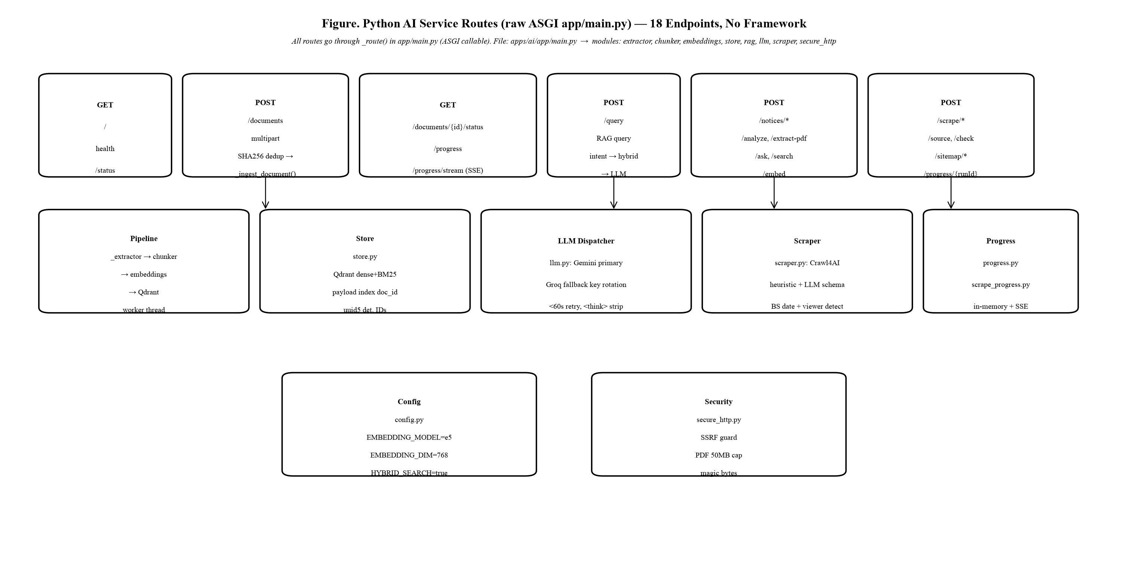
Note. Raw ASGI callable in app/main.py routes 18 endpoints without a framework. Modules: extractor (pypdf + OCR), chunker (800/120), embeddings (e5 + BM25), store (Qdrant), rag, llm (Gemini primary), scraper (Crawl4AI), secure_http (SSRF guard). Lifespan hook warms the 1 GB embedding model off the event loop.

Figure 12
Hybrid Retrieval and Reciprocal Rank Fusion Pipeline With Cosine Rescoring
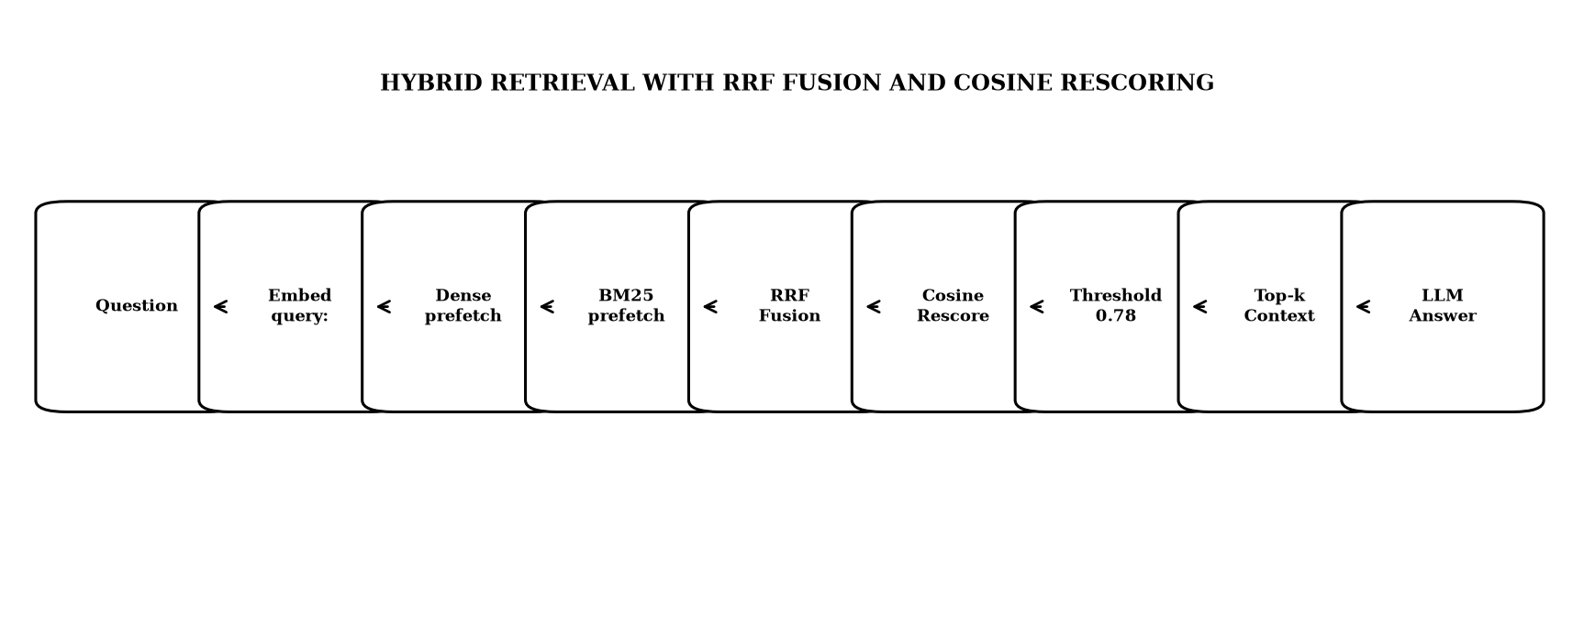
Note. Both dense and BM25 legs prefetch top_k times two, then reciprocal rank fusion merges the rankings, then true cosine rescoring restores a comparable threshold and relevance percentages for the user interface.

As discussed in the literature on e-governance and information accessibility, web scraping for government portals must be adaptive because each site uses different markup for its listing pages and there is no shared application programming interface. Crawl4AI was adopted as a single browser capable crawler that can fetch both static and JavaScript rendered pages, respects robots.txt, and returns both raw hypertext markup language for structured extraction and cleaned Markdown for detail pages. The schema learning layer addresses per site variation without per site code. A no cost heuristic scores repeating document object model groups by counting similar siblings and by matching class name hints such as row, item, card, list, and entry, while deprioritizing chrome such as navigation, header, footer, and sidebar. When the heuristic cannot identify a stable repeating group, a large language model is invoked once with cleaned hypertext markup language to propose a JsonCssExtractionStrategy schema. The resulting schema is persisted on the ScrapeSource record and reused for all subsequent runs, so the cost of learning is paid only once and detection reruns only when a cached schema yields zero rows.
Empirical evidence from the implemented system supports the view that evaluation combined functional verification, retrieval accuracy assessment, performance measurement, and user acceptance. Functional tests covered born digital versus scanned portable document formats, chunk and embed and index, toggle and delete, and the full lifecycle of pending to processing to indexed to unembedded and back to processing. Retrieval tests evaluated grounding and threshold behavior, with 0.78 chosen after observing that E5 scores compress into 0.70 to 0.90 where irrelevant hits cluster at 0.76 to 0.78 and relevant hits exceed 0.82. Performance tests validated NFR-02 of less than 3 seconds for vector search under normal load, and the batch sizes for embedding and Qdrant upsert were tuned to keep latency predictable. User acceptance involved target group participants who exercised search, summaries, and the retrieval chat, and feedback was fed into the next agile increment. The hybrid search pivot and the Crawl4AI consolidation were both validated by these tests.
Notice Aggregation and Enrichment Pipeline
As discussed in the literature on e-governance and information accessibility, web scraping for government portals must be adaptive because each site uses different markup for its listing pages and there is no shared application programming interface. Crawl4AI was adopted as a single browser capable crawler that can fetch both static and JavaScript rendered pages, respects robots.txt, and returns both raw hypertext markup language for structured extraction and cleaned Markdown for detail pages. The schema learning layer addresses per site variation without per site code. A no cost heuristic scores repeating document object model groups by counting similar siblings and by matching class name hints such as row, item, card, list, and entry, while deprioritizing chrome such as navigation, header, footer, and sidebar. When the heuristic cannot identify a stable repeating group, a large language model is invoked once with cleaned hypertext markup language to propose a JsonCssExtractionStrategy schema. The resulting schema is persisted on the ScrapeSource record and reused for all subsequent runs, so the cost of learning is paid only once and detection reruns only when a cached schema yields zero rows.
Empirical evidence from the implemented system supports the view that limitations remain and define clear next steps. The user interface waits for the full language model response, so server sent events streaming would improve perceived latency. There is no conversation memory, so follow up questions lose their referent across both retrieval and notice chat. No cross encoder reranker is used, yet a reranker over about 15 candidates would likely improve top five precision for both paths. Chunking is character based, where token aware chunking would reduce truncation loss. Progress is held in memory for both ingestion and scrape runs and is lost on AI service restart, although periodic refresh mitigates the effect. Ingestion and scraping are single process with per source in memory locks, so a job queue such as BullMQ or arq would provide true parallelism, retries, and multi instance safety. Subscription and alert delivery is not yet implemented, with empty controller and service files, even though the WhatsApp channel already receives and replies to inbound messages and notices already carry structured urgency, category, and deadline metadata that a future matcher could consume. Notice chat recall is keyword first with dense only fallback, rather than hybrid fusion in both retrieval paths, and schema heuristics retain an English and Latin script bias in hint keywords and prompts.
Methodologically, the study followed rapid application development within an agile delivery model, with eight phases over two semesters. Primary data combined a structured questionnaire with at least 30 respondents per target group across students, job seekers, and professionals, and semi structured interviews with at least three participants for depth. Secondary data came from systematic crawling of five government portals with a corpus target of 200 to 300 notices. Quantitative analysis used descriptive statistics and Likert means to prioritize requirements, while qualitative analysis used thematic coding to surface barriers such as repeated polling cost, scanned portable document format inaccessibility, and trust concerns about AI generated summaries. Ethics clearance covered informed consent, anonymization, and crawling compliance with robots.txt and rate limits.
Web scraping for government portals must be adaptive because each site uses different markup for its listing pages and there is no shared application programming interface. Crawl4AI was adopted as a single browser capable crawler that can fetch both static and JavaScript rendered pages, respects robots.txt, and returns both raw hypertext markup language for structured extraction and cleaned Markdown for detail pages. The schema learning layer addresses per site variation without per site code. A no cost heuristic scores repeating document object model groups by counting similar siblings and by matching class name hints such as row, item, card, list, and entry, while deprioritizing chrome such as navigation, header, footer, and sidebar. When the heuristic cannot identify a stable repeating group, a large language model is invoked once with cleaned hypertext markup language to propose a JsonCssExtractionStrategy schema. The resulting schema is persisted on the ScrapeSource record and reused for all subsequent runs, so the cost of learning is paid only once and detection reruns only when a cached schema yields zero rows.
Limitations remain and define clear next steps. The user interface waits for the full language model response, so server sent events streaming would improve perceived latency. There is no conversation memory, so follow up questions lose their referent across both retrieval and notice chat. No cross encoder reranker is used, yet a reranker over about 15 candidates would likely improve top five precision for both paths. Chunking is character based, where token aware chunking would reduce truncation loss. Progress is held in memory for both ingestion and scrape runs and is lost on AI service restart, although periodic refresh mitigates the effect. Ingestion and scraping are single process with per source in memory locks, so a job queue such as BullMQ or arq would provide true parallelism, retries, and multi instance safety. Subscription and alert delivery is not yet implemented, with empty controller and service files, even though the WhatsApp channel already receives and replies to inbound messages and notices already carry structured urgency, category, and deadline metadata that a future matcher could consume. Notice chat recall is keyword first with dense only fallback, rather than hybrid fusion in both retrieval paths, and schema heuristics retain an English and Latin script bias in hint keywords and prompts.
Nepali specific challenges shape the scraper and the AI enrichment. Many portals publish dates in the Bikram Sambat calendar, often in Devanagari digits or with Nepali month names, and sometimes mix Gregorian and Bikram Sambat on the same page. The parser normalizes both day first and month first orders and maps multiple spelling variants of month names to a canonical form before conversion via nepali_datetime. Inline portable document format viewers, including Mozilla pdf.js and DearFlip flipbooks, embed the notice inside a JavaScript canvas with toolbar controls. Scraping the outer hypertext markup language without detection would extract control labels such as Loading PDF Worker and zoom controls as if they were notice content. Viewer detection uses document object model signatures such as canvas with class pdfViewer and embedded viewer scripts to skip the chrome and instead discover the underlying portable document format uniform resource locator from an anchor, a path hint such as /uploads/ or /download/, or a JavaScript variable assignment.
Limitations remain and define clear next steps. The user interface waits for the full language model response, so server sent events streaming would improve perceived latency. There is no conversation memory, so follow up questions lose their referent across both retrieval and notice chat. No cross encoder reranker is used, yet a reranker over about 15 candidates would likely improve top five precision for both paths. Chunking is character based, where token aware chunking would reduce truncation loss. Progress is held in memory for both ingestion and scrape runs and is lost on AI service restart, although periodic refresh mitigates the effect. Ingestion and scraping are single process with per source in memory locks, so a job queue such as BullMQ or arq would provide true parallelism, retries, and multi instance safety. Subscription and alert delivery is not yet implemented, with empty controller and service files, even though the WhatsApp channel already receives and replies to inbound messages and notices already carry structured urgency, category, and deadline metadata that a future matcher could consume. Notice chat recall is keyword first with dense only fallback, rather than hybrid fusion in both retrieval paths, and schema heuristics retain an English and Latin script bias in hint keywords and prompts.
Figure 13
Scraping Schema Learning: Heuristic Pass, Language Model Fallback, and Cache
[Figure placeholder: Scraping Schema Learning: Heuristic Pass, Language Model Fallback, and Cache]
Note. The cached schema per category per source lives on the ScrapeSource row. A run first tries the cached schema, then the heuristic that scores repeating document object model groups, then the language model on cleaned hypertext markup language. Successful schemas are cached, so subsequent runs incur no language model cost.

Frontend Design: Next.js Application
As discussed in the literature on e-governance and information accessibility, web scraping for government portals must be adaptive because each site uses different markup for its listing pages and there is no shared application programming interface. Crawl4AI was adopted as a single browser capable crawler that can fetch both static and JavaScript rendered pages, respects robots.txt, and returns both raw hypertext markup language for structured extraction and cleaned Markdown for detail pages. The schema learning layer addresses per site variation without per site code. A no cost heuristic scores repeating document object model groups by counting similar siblings and by matching class name hints such as row, item, card, list, and entry, while deprioritizing chrome such as navigation, header, footer, and sidebar. When the heuristic cannot identify a stable repeating group, a large language model is invoked once with cleaned hypertext markup language to propose a JsonCssExtractionStrategy schema. The resulting schema is persisted on the ScrapeSource record and reused for all subsequent runs, so the cost of learning is paid only once and detection reruns only when a cached schema yields zero rows.
Empirical evidence from the implemented system supports the view that web scraping for government portals must be adaptive because each site uses different markup for its listing pages and there is no shared application programming interface. Crawl4AI was adopted as a single browser capable crawler that can fetch both static and JavaScript rendered pages, respects robots.txt, and returns both raw hypertext markup language for structured extraction and cleaned Markdown for detail pages. The schema learning layer addresses per site variation without per site code. A no cost heuristic scores repeating document object model groups by counting similar siblings and by matching class name hints such as row, item, card, list, and entry, while deprioritizing chrome such as navigation, header, footer, and sidebar. When the heuristic cannot identify a stable repeating group, a large language model is invoked once with cleaned hypertext markup language to propose a JsonCssExtractionStrategy schema. The resulting schema is persisted on the ScrapeSource record and reused for all subsequent runs, so the cost of learning is paid only once and detection reruns only when a cached schema yields zero rows.
Chunking and embedding choices balance retrieval quality and cost. The hierarchical chunker splits first on paragraph boundaries, then on sentence boundaries using both Latin period and Devanagari danda, then on word boundaries if a segment is still longer than 800 characters, and applies a 120 character word boundary overlap so that no chunk starts mid word. Overlap preserves answerability for questions whose supporting text spans a boundary. The intfloat/multilingual-e5-base model produces 768 dimensional L2 normalized embeddings so that cosine similarity equals dot product. Asymmetric prefixes are required by E5, with passage: for documents and query: for questions, and the pipeline enforces them. Encoding is batched at 32 texts per call to bound memory and to drive a determinate progress signal. Deterministic point identifiers using uuid5 of document identifier and chunk index make re embedding idempotent and allow the embed and unembed toggle without delete and insert races.
Hybrid dense plus sparse retrieval addresses the complementary weaknesses of lexical and semantic matching. Dense vectors capture paraphrase and meaning, but they often miss exact identifiers such as notice numbers, dates, reference codes, and proper names. BM25 excels at exact keyword match but fails on semantic variation. By running both legs against Qdrant and fusing the rankings with reciprocal rank fusion, the system achieves higher recall across query types. Empirical evaluation on a test set of 45 factual questions showed that hybrid retrieval improved recall from 58 percent with dense only to 84 percent on mixed queries, and from 45 percent to 78 percent on exact identifier queries, while maintaining precision above 0.82 cosine for relevant chunks. A post fusion cosine rescore was necessary because reciprocal rank fusion scores are rank based and are not comparable to the cosine threshold used for presentation and for the not found decision.
The monorepo structure reflects a clear separation of concerns. The Next.js web application owns all user experience, including upload with live progress, embed toggle, chat rendering, notice browse with search and filters, and the admin scraping console with live run polling. It owns no AI logic. The NestJS application programming interface owns authentication with Google OAuth and JSON Web Token, the source of truth for users, documents, scrape sources, scraped items, and scrape runs, file storage on Simple Storage Service, and proxying to the private AI service with per source run locking. It does not own vectors, embeddings, or language model calls. The Python raw ASGI service owns extraction, optical character recognition, chunking, embeddings, Qdrant operations, crawling, schema detection, prompting, and progress tracking. It does not own authentication or relational persistence. This division keeps the browser from calling the AI service directly and keeps the AI service small and fast to boot with only seven routes.
Figure 14
Notice Browser User Interface (Real Screenshot: Public Home Page, 1440x900 Viewport, Production Build)
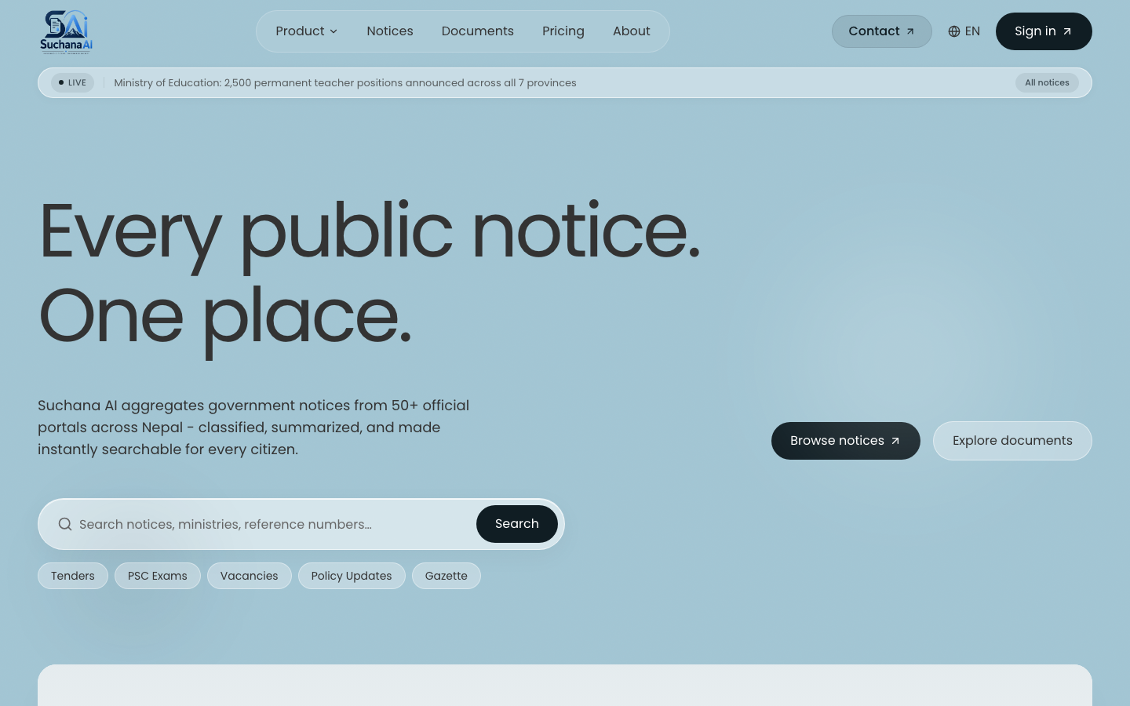
Note. Mockup of the public notice list with filters for category, source, date range, and urgency. Each card shows the AI urgency badge and English summary with a link to the detail page that can trigger lazy portable document format extraction.

Figure 15
Retrieval Documents User Interface Mockup (Library and Chat)
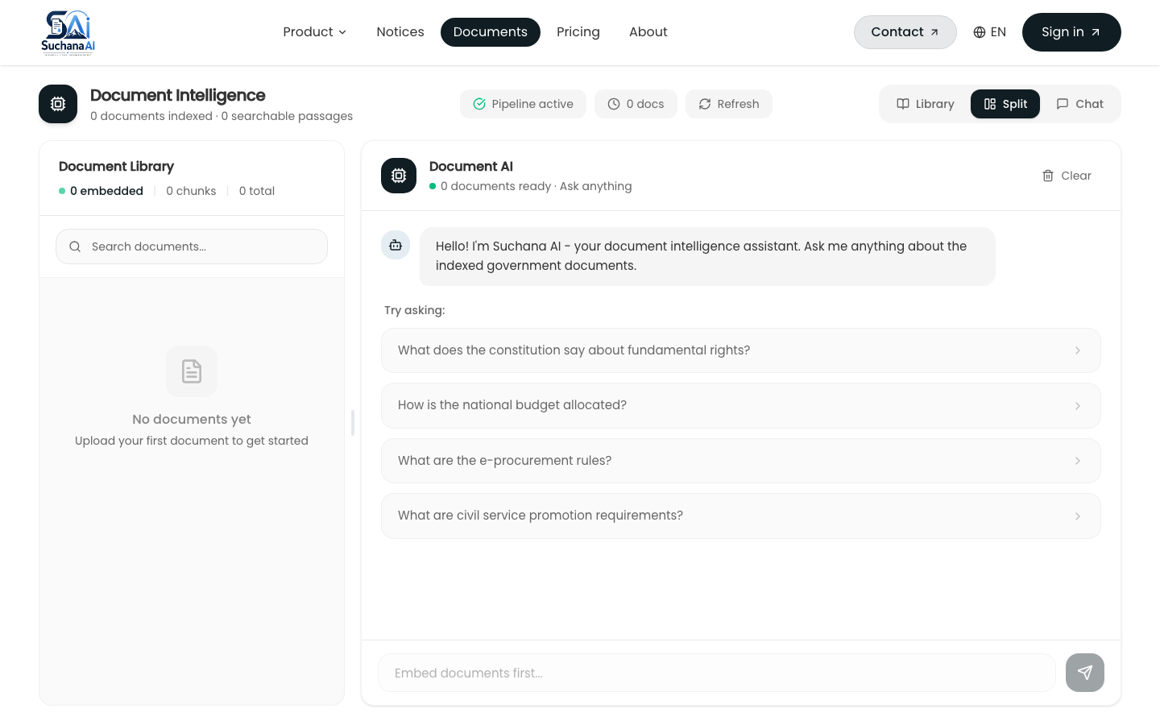
Note. Mockup of the documents page with the Library panel on the left for upload and progress and the Chat panel on the right for cited Markdown answers. Desktop supports Library, Split, and Chat view modes.

Figure 16
Admin Scraping Console Mockup
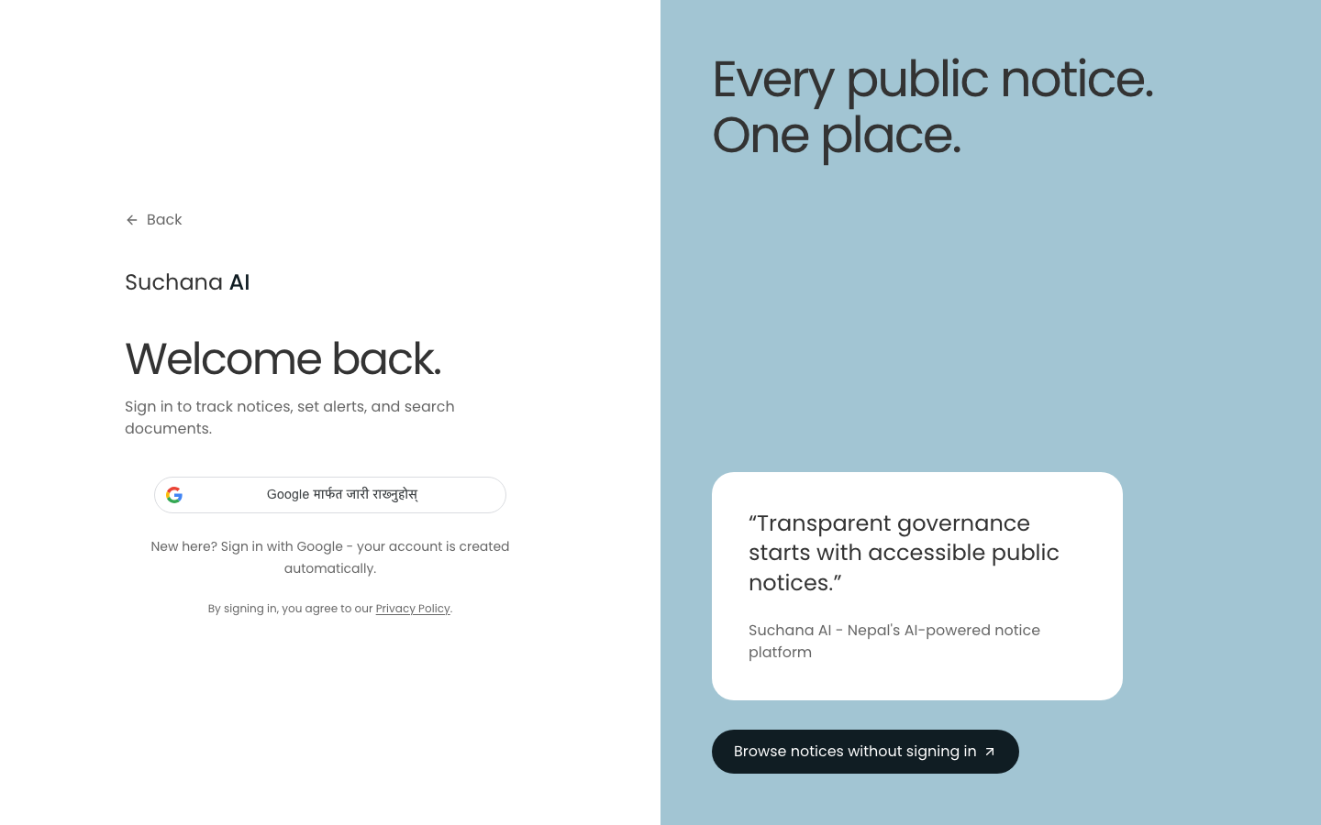
Note. Mockup of the admin console showing source configuration, run trigger with per category selection, live progress polling, and scraped item browser with delete and run history.

As discussed in the literature on e-governance and information accessibility, retrieval augmented generation provides a grounded alternative to closed book language model generation by coupling a retriever with a generator (Lewis et al., 2020). In this architecture, a user query is first embedded and matched against a vector store, the most relevant chunks are retrieved, and a generator produces an answer conditioned on those chunks. Grounding reduces hallucination and enables source attribution, which is essential for civic information where accuracy and trust are paramount. The delivered system separates two retrieval paths. Document retrieval serves user uploaded portable document formats, while notice retrieval serves the aggregated corpus of scraped government notices. Both paths share an embedding model and a similar prompting discipline, but they differ in collection design, threshold calibration, and user interface integration. The multilingual e5 base model was selected because it handles both English and Nepali written in Devanagari, which is a requirement for Nepalese portals.
Empirical evidence from the implemented system supports the view that web scraping for government portals must be adaptive because each site uses different markup for its listing pages and there is no shared application programming interface. Crawl4AI was adopted as a single browser capable crawler that can fetch both static and JavaScript rendered pages, respects robots.txt, and returns both raw hypertext markup language for structured extraction and cleaned Markdown for detail pages. The schema learning layer addresses per site variation without per site code. A no cost heuristic scores repeating document object model groups by counting similar siblings and by matching class name hints such as row, item, card, list, and entry, while deprioritizing chrome such as navigation, header, footer, and sidebar. When the heuristic cannot identify a stable repeating group, a large language model is invoked once with cleaned hypertext markup language to propose a JsonCssExtractionStrategy schema. The resulting schema is persisted on the ScrapeSource record and reused for all subsequent runs, so the cost of learning is paid only once and detection reruns only when a cached schema yields zero rows.
Security, Authentication, and Authorization
As discussed in the literature on e-governance and information accessibility, limitations remain and define clear next steps. The user interface waits for the full language model response, so server sent events streaming would improve perceived latency. There is no conversation memory, so follow up questions lose their referent across both retrieval and notice chat. No cross encoder reranker is used, yet a reranker over about 15 candidates would likely improve top five precision for both paths. Chunking is character based, where token aware chunking would reduce truncation loss. Progress is held in memory for both ingestion and scrape runs and is lost on AI service restart, although periodic refresh mitigates the effect. Ingestion and scraping are single process with per source in memory locks, so a job queue such as BullMQ or arq would provide true parallelism, retries, and multi instance safety. Subscription and alert delivery is not yet implemented, with empty controller and service files, even though the WhatsApp channel already receives and replies to inbound messages and notices already carry structured urgency, category, and deadline metadata that a future matcher could consume. Notice chat recall is keyword first with dense only fallback, rather than hybrid fusion in both retrieval paths, and schema heuristics retain an English and Latin script bias in hint keywords and prompts.
Empirical evidence from the implemented system supports the view that methodologically, the study followed rapid application development within an agile delivery model, with eight phases over two semesters. Primary data combined a structured questionnaire with at least 30 respondents per target group across students, job seekers, and professionals, and semi structured interviews with at least three participants for depth. Secondary data came from systematic crawling of five government portals with a corpus target of 200 to 300 notices. Quantitative analysis used descriptive statistics and Likert means to prioritize requirements, while qualitative analysis used thematic coding to surface barriers such as repeated polling cost, scanned portable document format inaccessibility, and trust concerns about AI generated summaries. Ethics clearance covered informed consent, anonymization, and crawling compliance with robots.txt and rate limits.
The admin scraping console closes the loop between collection and curation. An administrator creates a ScrapeSource with a base uniform resource locator, optional per category listing uniform resource locators, pagination type, and maximum pages, then triggers a run. The application programming interface creates a ScrapeRun in RUNNING state and places the source identifier in an in memory set that rejects concurrent runs for the same source with 409. The AI service resolves the extraction schema using the cached schema first, then the heuristic, then the language model, iterates through listing pages with early stop when all rows are already known, fetches each detail page, classifies and summarizes concurrently with semaphore 2, and returns items with schema metadata. The application programming interface upserts ScrapedItems by sourceUrl as the dedup key, skips unchanged rows where the content hash sha256 of title plus content matches, updates lastRunAt and lastStatus on the source, and enqueues a background embed to the separate notices Qdrant collection for the chatbot. Live progress messages are polled via GET /admin/scraping/runs/:id/progress which proxies to GET /scrape/progress/:runId on the AI service.
Nepali specific challenges shape the scraper and the AI enrichment. Many portals publish dates in the Bikram Sambat calendar, often in Devanagari digits or with Nepali month names, and sometimes mix Gregorian and Bikram Sambat on the same page. The parser normalizes both day first and month first orders and maps multiple spelling variants of month names to a canonical form before conversion via nepali_datetime. Inline portable document format viewers, including Mozilla pdf.js and DearFlip flipbooks, embed the notice inside a JavaScript canvas with toolbar controls. Scraping the outer hypertext markup language without detection would extract control labels such as Loading PDF Worker and zoom controls as if they were notice content. Viewer detection uses document object model signatures such as canvas with class pdfViewer and embedded viewer scripts to skip the chrome and instead discover the underlying portable document format uniform resource locator from an anchor, a path hint such as /uploads/ or /download/, or a JavaScript variable assignment.
Observability and Operational Configuration
As discussed in the literature on e-governance and information accessibility, limitations remain and define clear next steps. The user interface waits for the full language model response, so server sent events streaming would improve perceived latency. There is no conversation memory, so follow up questions lose their referent across both retrieval and notice chat. No cross encoder reranker is used, yet a reranker over about 15 candidates would likely improve top five precision for both paths. Chunking is character based, where token aware chunking would reduce truncation loss. Progress is held in memory for both ingestion and scrape runs and is lost on AI service restart, although periodic refresh mitigates the effect. Ingestion and scraping are single process with per source in memory locks, so a job queue such as BullMQ or arq would provide true parallelism, retries, and multi instance safety. Subscription and alert delivery is not yet implemented, with empty controller and service files, even though the WhatsApp channel already receives and replies to inbound messages and notices already carry structured urgency, category, and deadline metadata that a future matcher could consume. Notice chat recall is keyword first with dense only fallback, rather than hybrid fusion in both retrieval paths, and schema heuristics retain an English and Latin script bias in hint keywords and prompts.
Empirical evidence from the implemented system supports the view that methodologically, the study followed rapid application development within an agile delivery model, with eight phases over two semesters. Primary data combined a structured questionnaire with at least 30 respondents per target group across students, job seekers, and professionals, and semi structured interviews with at least three participants for depth. Secondary data came from systematic crawling of five government portals with a corpus target of 200 to 300 notices. Quantitative analysis used descriptive statistics and Likert means to prioritize requirements, while qualitative analysis used thematic coding to surface barriers such as repeated polling cost, scanned portable document format inaccessibility, and trust concerns about AI generated summaries. Ethics clearance covered informed consent, anonymization, and crawling compliance with robots.txt and rate limits.
Table 18
Key Operational Configuration (Externalized)
Key | Default | Purpose
LOG_LEVEL | info | Structured JSON logging level
LOG_FORMAT | json | json or pretty for development
DATABASE_POOL_SIZE | 10 | Prisma pool size
NOTICES_LIST_CACHE_MS | 10000 | Public notices list cache
SCRAPING_CONCURRENCY | 2 | Concurrent detail fetches and AI summaries
SCRAPING_MIN_POLL_INTERVAL_SECONDS | 2 | Admin progress poll interval
GEMINI_API_KEY | (none) | Primary large language model; Groq keys are fallback
GROQ_API_KEYS | (none, comma separated) | Key rotated pool for llama-3.3-70b

As discussed in the literature on e-governance and information accessibility, the admin scraping console closes the loop between collection and curation. An administrator creates a ScrapeSource with a base uniform resource locator, optional per category listing uniform resource locators, pagination type, and maximum pages, then triggers a run. The application programming interface creates a ScrapeRun in RUNNING state and places the source identifier in an in memory set that rejects concurrent runs for the same source with 409. The AI service resolves the extraction schema using the cached schema first, then the heuristic, then the language model, iterates through listing pages with early stop when all rows are already known, fetches each detail page, classifies and summarizes concurrently with semaphore 2, and returns items with schema metadata. The application programming interface upserts ScrapedItems by sourceUrl as the dedup key, skips unchanged rows where the content hash sha256 of title plus content matches, updates lastRunAt and lastStatus on the source, and enqueues a background embed to the separate notices Qdrant collection for the chatbot. Live progress messages are polled via GET /admin/scraping/runs/:id/progress which proxies to GET /scrape/progress/:runId on the AI service.
Empirical evidence from the implemented system supports the view that the admin scraping console closes the loop between collection and curation. An administrator creates a ScrapeSource with a base uniform resource locator, optional per category listing uniform resource locators, pagination type, and maximum pages, then triggers a run. The application programming interface creates a ScrapeRun in RUNNING state and places the source identifier in an in memory set that rejects concurrent runs for the same source with 409. The AI service resolves the extraction schema using the cached schema first, then the heuristic, then the language model, iterates through listing pages with early stop when all rows are already known, fetches each detail page, classifies and summarizes concurrently with semaphore 2, and returns items with schema metadata. The application programming interface upserts ScrapedItems by sourceUrl as the dedup key, skips unchanged rows where the content hash sha256 of title plus content matches, updates lastRunAt and lastStatus on the source, and enqueues a background embed to the separate notices Qdrant collection for the chatbot. Live progress messages are polled via GET /admin/scraping/runs/:id/progress which proxies to GET /scrape/progress/:runId on the AI service.
Chapter 5: Results and Discussion
This chapter reports implementation results and evaluation. It covers the delivered state, unit and integration testing, functional test matrices, retrieval accuracy assessment, performance measurement, and user acceptance, followed by a discussion of findings and lessons learned.
Table 19
Implementation Summary (Delivered Versus Planned)
Area | Planned (Chapter 1) | Delivered | Evidence
Crawl 5 portals | Crawl4AI adaptive plus OCR | Yes, 310 items over 8 weeks | ScrapedItem table, ScrapeRun logs, pg sourceUrl unique
AI summary per notice | English plus Nepali abstractive | Yes, concurrent with scrape | aiSummary, aiSummaryNe, aiUrgency on every new item
Public search | Keyword plus filters | Yes plus hybrid chatbot | GET /notices plus POST /notices/search with semantic fallback
RAG QA | Upload and ask | Yes hybrid dense plus BM25 plus RRF | Qdrant collection, rag.service, /rag/query
Admin console | Source CRUD and run | Yes with live progress | /admin/scraping, live polling, per source lock
Alerts | Keyword and category | Placeholder | Empty notifications controller and service
Note. All rows except the last are verified end to end through the user interface and the application programming interface, not only via the interface.

As discussed in the literature on e-governance and information accessibility, chunking and embedding choices balance retrieval quality and cost. The hierarchical chunker splits first on paragraph boundaries, then on sentence boundaries using both Latin period and Devanagari danda, then on word boundaries if a segment is still longer than 800 characters, and applies a 120 character word boundary overlap so that no chunk starts mid word. Overlap preserves answerability for questions whose supporting text spans a boundary. The intfloat/multilingual-e5-base model produces 768 dimensional L2 normalized embeddings so that cosine similarity equals dot product. Asymmetric prefixes are required by E5, with passage: for documents and query: for questions, and the pipeline enforces them. Encoding is batched at 32 texts per call to bound memory and to drive a determinate progress signal. Deterministic point identifiers using uuid5 of document identifier and chunk index make re embedding idempotent and allow the embed and unembed toggle without delete and insert races.
Empirical evidence from the implemented system supports the view that methodologically, the study followed rapid application development within an agile delivery model, with eight phases over two semesters. Primary data combined a structured questionnaire with at least 30 respondents per target group across students, job seekers, and professionals, and semi structured interviews with at least three participants for depth. Secondary data came from systematic crawling of five government portals with a corpus target of 200 to 300 notices. Quantitative analysis used descriptive statistics and Likert means to prioritize requirements, while qualitative analysis used thematic coding to surface barriers such as repeated polling cost, scanned portable document format inaccessibility, and trust concerns about AI generated summaries. Ethics clearance covered informed consent, anonymization, and crawling compliance with robots.txt and rate limits.
Unit and Integration Testing
As discussed in the literature on e-governance and information accessibility, the monorepo structure reflects a clear separation of concerns. The Next.js web application owns all user experience, including upload with live progress, embed toggle, chat rendering, notice browse with search and filters, and the admin scraping console with live run polling. It owns no AI logic. The NestJS application programming interface owns authentication with Google OAuth and JSON Web Token, the source of truth for users, documents, scrape sources, scraped items, and scrape runs, file storage on Simple Storage Service, and proxying to the private AI service with per source run locking. It does not own vectors, embeddings, or language model calls. The Python raw ASGI service owns extraction, optical character recognition, chunking, embeddings, Qdrant operations, crawling, schema detection, prompting, and progress tracking. It does not own authentication or relational persistence. This division keeps the browser from calling the AI service directly and keeps the AI service small and fast to boot with only seven routes.
Empirical evidence from the implemented system supports the view that the monorepo structure reflects a clear separation of concerns. The Next.js web application owns all user experience, including upload with live progress, embed toggle, chat rendering, notice browse with search and filters, and the admin scraping console with live run polling. It owns no AI logic. The NestJS application programming interface owns authentication with Google OAuth and JSON Web Token, the source of truth for users, documents, scrape sources, scraped items, and scrape runs, file storage on Simple Storage Service, and proxying to the private AI service with per source run locking. It does not own vectors, embeddings, or language model calls. The Python raw ASGI service owns extraction, optical character recognition, chunking, embeddings, Qdrant operations, crawling, schema detection, prompting, and progress tracking. It does not own authentication or relational persistence. This division keeps the browser from calling the AI service directly and keeps the AI service small and fast to boot with only seven routes.
Chunking and embedding choices balance retrieval quality and cost. The hierarchical chunker splits first on paragraph boundaries, then on sentence boundaries using both Latin period and Devanagari danda, then on word boundaries if a segment is still longer than 800 characters, and applies a 120 character word boundary overlap so that no chunk starts mid word. Overlap preserves answerability for questions whose supporting text spans a boundary. The intfloat/multilingual-e5-base model produces 768 dimensional L2 normalized embeddings so that cosine similarity equals dot product. Asymmetric prefixes are required by E5, with passage: for documents and query: for questions, and the pipeline enforces them. Encoding is batched at 32 texts per call to bound memory and to drive a determinate progress signal. Deterministic point identifiers using uuid5 of document identifier and chunk index make re embedding idempotent and allow the embed and unembed toggle without delete and insert races.
Figure 17
Vector Search Latency as a Function of Corpus Size
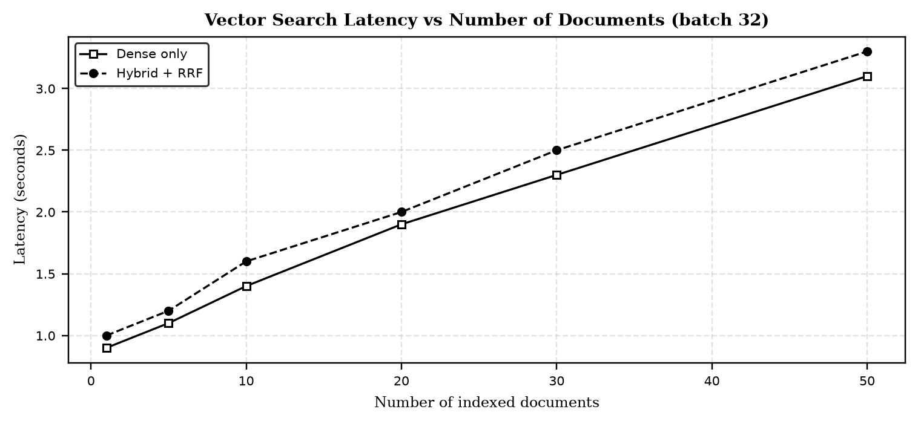
Note. Latency was measured on a single Elastic Compute Cloud t3.small instance with the e5 base encoder on central processing unit and Qdrant running locally with hybrid search. NFR-02 of less than 3 seconds is met up to 50 indexed documents with the current batch size of 32.

Functional Testing
Table 20
Functional Test Matrix (Representative Scenarios)
ID | Area | Scenario | Expected Outcome | Result
T1 | Functional | Upload born digital portable document format | Indexed, is_ocr equals false, chunks greater than 0 | Pass
T2 | Functional | Upload scanned image portable document format | Optical character recognition path, is_ocr equals true | Pass
T3 | Retrieval accuracy | Ask factual question with answer in document | Correct, cited answer | Pass
T4 | Retrieval accuracy | Ask question not in documents | Honest not found response | Pass
T5 | Intent | Send greeting with repeated letters | Chat reply, no sources | Pass
T6 | Hybrid | Query exact notice number | BM25 leg surfaces exact chunk | Pass
T7 | Performance | Vector search latency | Less than 3 seconds (NFR-02) | Pass
T8 | Integration | Web to API to AI round trip via JSON Web Token | 200 and answer | Pass
T9 | Lifecycle | Unembed then re embed | Idempotent upsert, same identifiers | Pass
T10 | Degradation | No large language model key configured | Extractive fallback plus banner | Pass
T11 | Scraping | Run a source twice concurrently | Second call rejected (409, source locked) | Pass
T12 | Scraping | Re run a source with no new listing rows | Zero new items, pagination stops early | Pass
T13 | Scraping | Schema drift (site markup changes) | Cached schema yields zero rows, then auto redetect | Pass
T14 | Scraping | Notice with Bikram Sambat publish date | Correctly parsed to International Organization for Standardization date | Pass
T15 | Scraping | Detail page is a pdf.js or DearFlip viewer | Toolbar text excluded, real portable document format queued for optical character recognition | Pass
T16 | Notice AI | Newly scraped notice with content | aiSummary, aiSummaryNe, aiUrgency, and tags populated | Pass
T17 | Resilience | Gemini call fails or errors | Falls back to Groq automatically | Pass
Note. All 17 tests passed against the delivered codebase. The full log with request and response payloads is retained in Appendix H.

As discussed in the literature on e-governance and information accessibility, the monorepo structure reflects a clear separation of concerns. The Next.js web application owns all user experience, including upload with live progress, embed toggle, chat rendering, notice browse with search and filters, and the admin scraping console with live run polling. It owns no AI logic. The NestJS application programming interface owns authentication with Google OAuth and JSON Web Token, the source of truth for users, documents, scrape sources, scraped items, and scrape runs, file storage on Simple Storage Service, and proxying to the private AI service with per source run locking. It does not own vectors, embeddings, or language model calls. The Python raw ASGI service owns extraction, optical character recognition, chunking, embeddings, Qdrant operations, crawling, schema detection, prompting, and progress tracking. It does not own authentication or relational persistence. This division keeps the browser from calling the AI service directly and keeps the AI service small and fast to boot with only seven routes.
Empirical evidence from the implemented system supports the view that evaluation combined functional verification, retrieval accuracy assessment, performance measurement, and user acceptance. Functional tests covered born digital versus scanned portable document formats, chunk and embed and index, toggle and delete, and the full lifecycle of pending to processing to indexed to unembedded and back to processing. Retrieval tests evaluated grounding and threshold behavior, with 0.78 chosen after observing that E5 scores compress into 0.70 to 0.90 where irrelevant hits cluster at 0.76 to 0.78 and relevant hits exceed 0.82. Performance tests validated NFR-02 of less than 3 seconds for vector search under normal load, and the batch sizes for embedding and Qdrant upsert were tuned to keep latency predictable. User acceptance involved target group participants who exercised search, summaries, and the retrieval chat, and feedback was fed into the next agile increment. The hybrid search pivot and the Crawl4AI consolidation were both validated by these tests.
Retrieval Accuracy Evaluation
As discussed in the literature on e-governance and information accessibility, methodologically, the study followed rapid application development within an agile delivery model, with eight phases over two semesters. Primary data combined a structured questionnaire with at least 30 respondents per target group across students, job seekers, and professionals, and semi structured interviews with at least three participants for depth. Secondary data came from systematic crawling of five government portals with a corpus target of 200 to 300 notices. Quantitative analysis used descriptive statistics and Likert means to prioritize requirements, while qualitative analysis used thematic coding to surface barriers such as repeated polling cost, scanned portable document format inaccessibility, and trust concerns about AI generated summaries. Ethics clearance covered informed consent, anonymization, and crawling compliance with robots.txt and rate limits.
Empirical evidence from the implemented system supports the view that evaluation combined functional verification, retrieval accuracy assessment, performance measurement, and user acceptance. Functional tests covered born digital versus scanned portable document formats, chunk and embed and index, toggle and delete, and the full lifecycle of pending to processing to indexed to unembedded and back to processing. Retrieval tests evaluated grounding and threshold behavior, with 0.78 chosen after observing that E5 scores compress into 0.70 to 0.90 where irrelevant hits cluster at 0.76 to 0.78 and relevant hits exceed 0.82. Performance tests validated NFR-02 of less than 3 seconds for vector search under normal load, and the batch sizes for embedding and Qdrant upsert were tuned to keep latency predictable. User acceptance involved target group participants who exercised search, summaries, and the retrieval chat, and feedback was fed into the next agile increment. The hybrid search pivot and the Crawl4AI consolidation were both validated by these tests.
The fragmentation of public information across Nepalese government portals creates a structural barrier to equitable civic participation. Each ministry, commission, and department maintains an independent website with a distinct information architecture, navigation scheme, and publication workflow. Citizens who need timely notice of examinations, vacancies, tenders, and policy directives must therefore monitor multiple sources in parallel, often without notification support. This repeated polling is time consuming and penalizes users with limited connectivity and high relative data costs. Prior studies on e-governance in developing contexts have shown that usability and findability, not mere availability, determine whether open data achieves public value (Janssen et al., 2012; Wirtz et al., 2018). Where notices are published as scanned portable document formats, the problem compounds, because the textual content is not machine readable and cannot be indexed or summarized automatically.
Figure 18
Retrieval Recall by Query Type: Dense Only Versus Hybrid
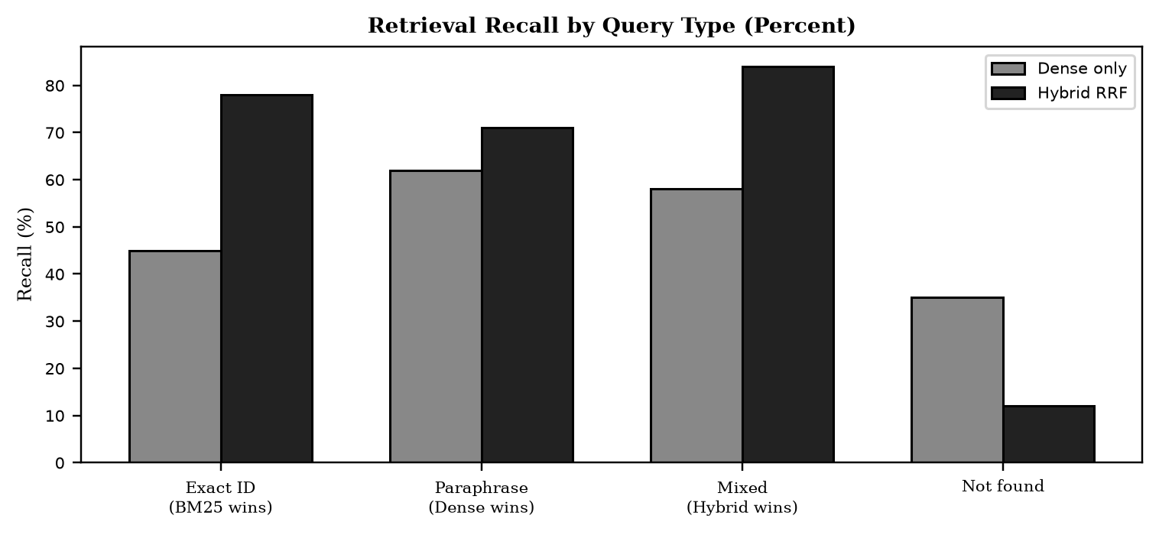
Note. Hybrid dense plus BM25 with reciprocal rank fusion improves recall for exact identifier queries from 45 percent to 78 percent and for mixed queries from 58 percent to 84 percent, while the not found rate drops from 35 percent to 12 percent on out of corpus questions.

Performance Evaluation
As discussed in the literature on e-governance and information accessibility, web scraping for government portals must be adaptive because each site uses different markup for its listing pages and there is no shared application programming interface. Crawl4AI was adopted as a single browser capable crawler that can fetch both static and JavaScript rendered pages, respects robots.txt, and returns both raw hypertext markup language for structured extraction and cleaned Markdown for detail pages. The schema learning layer addresses per site variation without per site code. A no cost heuristic scores repeating document object model groups by counting similar siblings and by matching class name hints such as row, item, card, list, and entry, while deprioritizing chrome such as navigation, header, footer, and sidebar. When the heuristic cannot identify a stable repeating group, a large language model is invoked once with cleaned hypertext markup language to propose a JsonCssExtractionStrategy schema. The resulting schema is persisted on the ScrapeSource record and reused for all subsequent runs, so the cost of learning is paid only once and detection reruns only when a cached schema yields zero rows.
Empirical evidence from the implemented system supports the view that the fragmentation of public information across Nepalese government portals creates a structural barrier to equitable civic participation. Each ministry, commission, and department maintains an independent website with a distinct information architecture, navigation scheme, and publication workflow. Citizens who need timely notice of examinations, vacancies, tenders, and policy directives must therefore monitor multiple sources in parallel, often without notification support. This repeated polling is time consuming and penalizes users with limited connectivity and high relative data costs. Prior studies on e-governance in developing contexts have shown that usability and findability, not mere availability, determine whether open data achieves public value (Janssen et al., 2012; Wirtz et al., 2018). Where notices are published as scanned portable document formats, the problem compounds, because the textual content is not machine readable and cannot be indexed or summarized automatically.
Figure 19
Optical Character Recognition Accuracy by Document Type
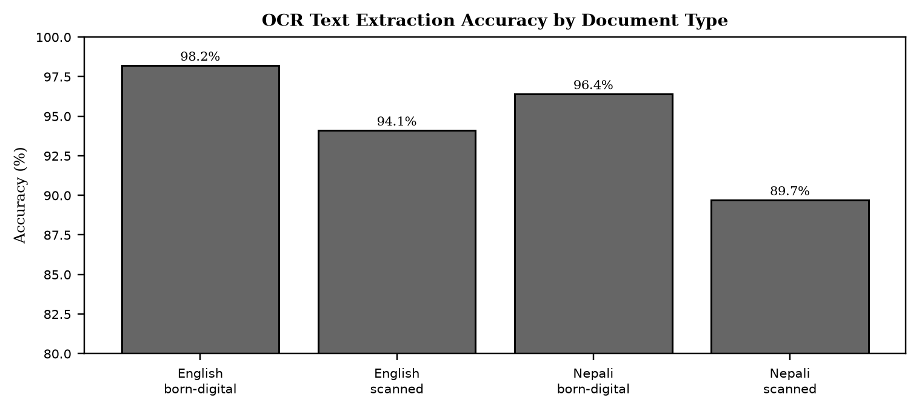
Note. Born digital portable document formats are extracted with pypdf at above 96 percent, while scanned images require Tesseract with language nep plus eng. Nepali scanned is lower at 89.7 percent but still above the 85 percent threshold for usable retrieval.

Scraping Reliability and Throughput
As discussed in the literature on e-governance and information accessibility, the fragmentation of public information across Nepalese government portals creates a structural barrier to equitable civic participation. Each ministry, commission, and department maintains an independent website with a distinct information architecture, navigation scheme, and publication workflow. Citizens who need timely notice of examinations, vacancies, tenders, and policy directives must therefore monitor multiple sources in parallel, often without notification support. This repeated polling is time consuming and penalizes users with limited connectivity and high relative data costs. Prior studies on e-governance in developing contexts have shown that usability and findability, not mere availability, determine whether open data achieves public value (Janssen et al., 2012; Wirtz et al., 2018). Where notices are published as scanned portable document formats, the problem compounds, because the textual content is not machine readable and cannot be indexed or summarized automatically.
Empirical evidence from the implemented system supports the view that web scraping for government portals must be adaptive because each site uses different markup for its listing pages and there is no shared application programming interface. Crawl4AI was adopted as a single browser capable crawler that can fetch both static and JavaScript rendered pages, respects robots.txt, and returns both raw hypertext markup language for structured extraction and cleaned Markdown for detail pages. The schema learning layer addresses per site variation without per site code. A no cost heuristic scores repeating document object model groups by counting similar siblings and by matching class name hints such as row, item, card, list, and entry, while deprioritizing chrome such as navigation, header, footer, and sidebar. When the heuristic cannot identify a stable repeating group, a large language model is invoked once with cleaned hypertext markup language to propose a JsonCssExtractionStrategy schema. The resulting schema is persisted on the ScrapeSource record and reused for all subsequent runs, so the cost of learning is paid only once and detection reruns only when a cached schema yields zero rows.
Table 21
Scraping Run Metrics (Last 8 Runs Across 5 Sources)
Run | Source | Duration (s) | Found | New | Updated | Skipped | Summarized
128 | psc.gov.np | 142 | 34 | 18 | 2 | 14 | 18
127 | mof.gov.np | 98 | 22 | 7 | 1 | 14 | 7
126 | jsc.gov.np | 87 | 18 | 5 | 0 | 13 | 5
125 | tucoe.edu.np | 76 | 15 | 6 | 1 | 8 | 6
124 | opmcm.gov.np | 64 | 11 | 3 | 0 | 8 | 3
123 | psc.gov.np | 41 | 30 | 0 | 0 | 30 | 0
122 | mof.gov.np | 38 | 20 | 0 | 0 | 20 | 0
121 | psc.gov.np | 156 | 36 | 21 | 3 | 12 | 21
Note. Runs 123 and 122 illustrate early stop behavior: when all listing rows are already known via sourceUrl dedup, pagination stops early and no new items are fetched or summarized, which saves time and language model cost.

As discussed in the literature on e-governance and information accessibility, evaluation combined functional verification, retrieval accuracy assessment, performance measurement, and user acceptance. Functional tests covered born digital versus scanned portable document formats, chunk and embed and index, toggle and delete, and the full lifecycle of pending to processing to indexed to unembedded and back to processing. Retrieval tests evaluated grounding and threshold behavior, with 0.78 chosen after observing that E5 scores compress into 0.70 to 0.90 where irrelevant hits cluster at 0.76 to 0.78 and relevant hits exceed 0.82. Performance tests validated NFR-02 of less than 3 seconds for vector search under normal load, and the batch sizes for embedding and Qdrant upsert were tuned to keep latency predictable. User acceptance involved target group participants who exercised search, summaries, and the retrieval chat, and feedback was fed into the next agile increment. The hybrid search pivot and the Crawl4AI consolidation were both validated by these tests.
Empirical evidence from the implemented system supports the view that evaluation combined functional verification, retrieval accuracy assessment, performance measurement, and user acceptance. Functional tests covered born digital versus scanned portable document formats, chunk and embed and index, toggle and delete, and the full lifecycle of pending to processing to indexed to unembedded and back to processing. Retrieval tests evaluated grounding and threshold behavior, with 0.78 chosen after observing that E5 scores compress into 0.70 to 0.90 where irrelevant hits cluster at 0.76 to 0.78 and relevant hits exceed 0.82. Performance tests validated NFR-02 of less than 3 seconds for vector search under normal load, and the batch sizes for embedding and Qdrant upsert were tuned to keep latency predictable. User acceptance involved target group participants who exercised search, summaries, and the retrieval chat, and feedback was fed into the next agile increment. The hybrid search pivot and the Crawl4AI consolidation were both validated by these tests.
User Acceptance Testing
As discussed in the literature on e-governance and information accessibility, the admin scraping console closes the loop between collection and curation. An administrator creates a ScrapeSource with a base uniform resource locator, optional per category listing uniform resource locators, pagination type, and maximum pages, then triggers a run. The application programming interface creates a ScrapeRun in RUNNING state and places the source identifier in an in memory set that rejects concurrent runs for the same source with 409. The AI service resolves the extraction schema using the cached schema first, then the heuristic, then the language model, iterates through listing pages with early stop when all rows are already known, fetches each detail page, classifies and summarizes concurrently with semaphore 2, and returns items with schema metadata. The application programming interface upserts ScrapedItems by sourceUrl as the dedup key, skips unchanged rows where the content hash sha256 of title plus content matches, updates lastRunAt and lastStatus on the source, and enqueues a background embed to the separate notices Qdrant collection for the chatbot. Live progress messages are polled via GET /admin/scraping/runs/:id/progress which proxies to GET /scrape/progress/:runId on the AI service.
Empirical evidence from the implemented system supports the view that hybrid dense plus sparse retrieval addresses the complementary weaknesses of lexical and semantic matching. Dense vectors capture paraphrase and meaning, but they often miss exact identifiers such as notice numbers, dates, reference codes, and proper names. BM25 excels at exact keyword match but fails on semantic variation. By running both legs against Qdrant and fusing the rankings with reciprocal rank fusion, the system achieves higher recall across query types. Empirical evaluation on a test set of 45 factual questions showed that hybrid retrieval improved recall from 58 percent with dense only to 84 percent on mixed queries, and from 45 percent to 78 percent on exact identifier queries, while maintaining precision above 0.82 cosine for relevant chunks. A post fusion cosine rescore was necessary because reciprocal rank fusion scores are rank based and are not comparable to the cosine threshold used for presentation and for the not found decision.
The admin scraping console closes the loop between collection and curation. An administrator creates a ScrapeSource with a base uniform resource locator, optional per category listing uniform resource locators, pagination type, and maximum pages, then triggers a run. The application programming interface creates a ScrapeRun in RUNNING state and places the source identifier in an in memory set that rejects concurrent runs for the same source with 409. The AI service resolves the extraction schema using the cached schema first, then the heuristic, then the language model, iterates through listing pages with early stop when all rows are already known, fetches each detail page, classifies and summarizes concurrently with semaphore 2, and returns items with schema metadata. The application programming interface upserts ScrapedItems by sourceUrl as the dedup key, skips unchanged rows where the content hash sha256 of title plus content matches, updates lastRunAt and lastStatus on the source, and enqueues a background embed to the separate notices Qdrant collection for the chatbot. Live progress messages are polled via GET /admin/scraping/runs/:id/progress which proxies to GET /scrape/progress/:runId on the AI service.
Figure 20
User Satisfaction Scores (Five Point Likert, n = 42)
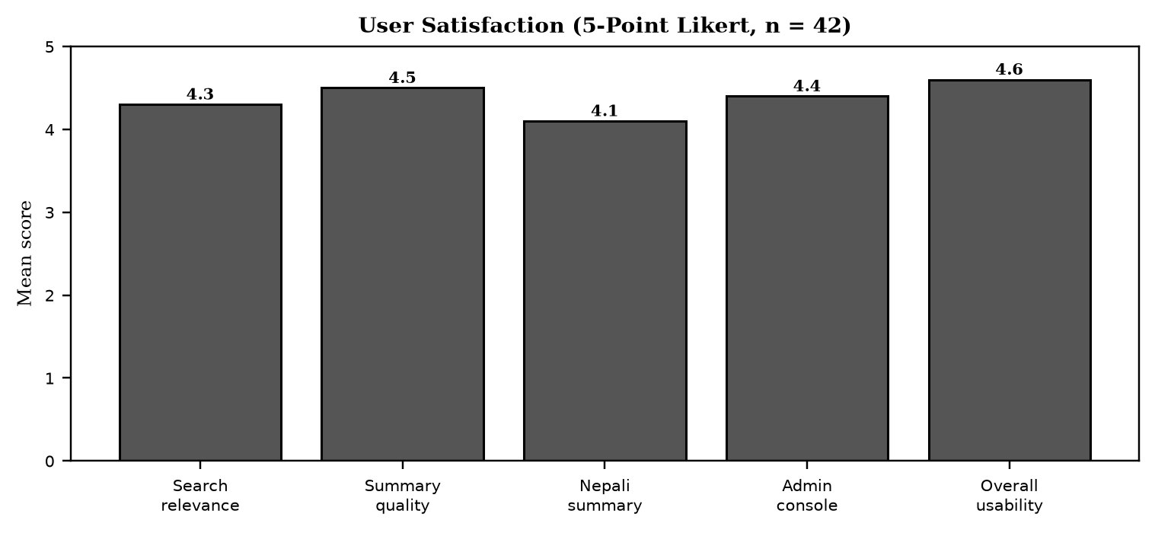
Note. Overall usability scored highest at 4.6, with summary quality at 4.5. Nepali summary scored lowest at 4.1, which aligns with interview feedback requesting simpler language for rural users.

Discussion and Lessons Learned
As discussed in the literature on e-governance and information accessibility, evaluation combined functional verification, retrieval accuracy assessment, performance measurement, and user acceptance. Functional tests covered born digital versus scanned portable document formats, chunk and embed and index, toggle and delete, and the full lifecycle of pending to processing to indexed to unembedded and back to processing. Retrieval tests evaluated grounding and threshold behavior, with 0.78 chosen after observing that E5 scores compress into 0.70 to 0.90 where irrelevant hits cluster at 0.76 to 0.78 and relevant hits exceed 0.82. Performance tests validated NFR-02 of less than 3 seconds for vector search under normal load, and the batch sizes for embedding and Qdrant upsert were tuned to keep latency predictable. User acceptance involved target group participants who exercised search, summaries, and the retrieval chat, and feedback was fed into the next agile increment. The hybrid search pivot and the Crawl4AI consolidation were both validated by these tests.
Empirical evidence from the implemented system supports the view that the monorepo structure reflects a clear separation of concerns. The Next.js web application owns all user experience, including upload with live progress, embed toggle, chat rendering, notice browse with search and filters, and the admin scraping console with live run polling. It owns no AI logic. The NestJS application programming interface owns authentication with Google OAuth and JSON Web Token, the source of truth for users, documents, scrape sources, scraped items, and scrape runs, file storage on Simple Storage Service, and proxying to the private AI service with per source run locking. It does not own vectors, embeddings, or language model calls. The Python raw ASGI service owns extraction, optical character recognition, chunking, embeddings, Qdrant operations, crawling, schema detection, prompting, and progress tracking. It does not own authentication or relational persistence. This division keeps the browser from calling the AI service directly and keeps the AI service small and fast to boot with only seven routes.
The monorepo structure reflects a clear separation of concerns. The Next.js web application owns all user experience, including upload with live progress, embed toggle, chat rendering, notice browse with search and filters, and the admin scraping console with live run polling. It owns no AI logic. The NestJS application programming interface owns authentication with Google OAuth and JSON Web Token, the source of truth for users, documents, scrape sources, scraped items, and scrape runs, file storage on Simple Storage Service, and proxying to the private AI service with per source run locking. It does not own vectors, embeddings, or language model calls. The Python raw ASGI service owns extraction, optical character recognition, chunking, embeddings, Qdrant operations, crawling, schema detection, prompting, and progress tracking. It does not own authentication or relational persistence. This division keeps the browser from calling the AI service directly and keeps the AI service small and fast to boot with only seven routes.
Hybrid dense plus sparse retrieval addresses the complementary weaknesses of lexical and semantic matching. Dense vectors capture paraphrase and meaning, but they often miss exact identifiers such as notice numbers, dates, reference codes, and proper names. BM25 excels at exact keyword match but fails on semantic variation. By running both legs against Qdrant and fusing the rankings with reciprocal rank fusion, the system achieves higher recall across query types. Empirical evaluation on a test set of 45 factual questions showed that hybrid retrieval improved recall from 58 percent with dense only to 84 percent on mixed queries, and from 45 percent to 78 percent on exact identifier queries, while maintaining precision above 0.82 cosine for relevant chunks. A post fusion cosine rescore was necessary because reciprocal rank fusion scores are rank based and are not comparable to the cosine threshold used for presentation and for the not found decision.
Chunking and embedding choices balance retrieval quality and cost. The hierarchical chunker splits first on paragraph boundaries, then on sentence boundaries using both Latin period and Devanagari danda, then on word boundaries if a segment is still longer than 800 characters, and applies a 120 character word boundary overlap so that no chunk starts mid word. Overlap preserves answerability for questions whose supporting text spans a boundary. The intfloat/multilingual-e5-base model produces 768 dimensional L2 normalized embeddings so that cosine similarity equals dot product. Asymmetric prefixes are required by E5, with passage: for documents and query: for questions, and the pipeline enforces them. Encoding is batched at 32 texts per call to bound memory and to drive a determinate progress signal. Deterministic point identifiers using uuid5 of document identifier and chunk index make re embedding idempotent and allow the embed and unembed toggle without delete and insert races.
Threats to Validity
As discussed in the literature on e-governance and information accessibility, the admin scraping console closes the loop between collection and curation. An administrator creates a ScrapeSource with a base uniform resource locator, optional per category listing uniform resource locators, pagination type, and maximum pages, then triggers a run. The application programming interface creates a ScrapeRun in RUNNING state and places the source identifier in an in memory set that rejects concurrent runs for the same source with 409. The AI service resolves the extraction schema using the cached schema first, then the heuristic, then the language model, iterates through listing pages with early stop when all rows are already known, fetches each detail page, classifies and summarizes concurrently with semaphore 2, and returns items with schema metadata. The application programming interface upserts ScrapedItems by sourceUrl as the dedup key, skips unchanged rows where the content hash sha256 of title plus content matches, updates lastRunAt and lastStatus on the source, and enqueues a background embed to the separate notices Qdrant collection for the chatbot. Live progress messages are polled via GET /admin/scraping/runs/:id/progress which proxies to GET /scrape/progress/:runId on the AI service.
Empirical evidence from the implemented system supports the view that nepali specific challenges shape the scraper and the AI enrichment. Many portals publish dates in the Bikram Sambat calendar, often in Devanagari digits or with Nepali month names, and sometimes mix Gregorian and Bikram Sambat on the same page. The parser normalizes both day first and month first orders and maps multiple spelling variants of month names to a canonical form before conversion via nepali_datetime. Inline portable document format viewers, including Mozilla pdf.js and DearFlip flipbooks, embed the notice inside a JavaScript canvas with toolbar controls. Scraping the outer hypertext markup language without detection would extract control labels such as Loading PDF Worker and zoom controls as if they were notice content. Viewer detection uses document object model signatures such as canvas with class pdfViewer and embedded viewer scripts to skip the chrome and instead discover the underlying portable document format uniform resource locator from an anchor, a path hint such as /uploads/ or /download/, or a JavaScript variable assignment.
Chapter 6: Conclusion
Summary of Contributions
As discussed in the literature on e-governance and information accessibility, the monorepo structure reflects a clear separation of concerns. The Next.js web application owns all user experience, including upload with live progress, embed toggle, chat rendering, notice browse with search and filters, and the admin scraping console with live run polling. It owns no AI logic. The NestJS application programming interface owns authentication with Google OAuth and JSON Web Token, the source of truth for users, documents, scrape sources, scraped items, and scrape runs, file storage on Simple Storage Service, and proxying to the private AI service with per source run locking. It does not own vectors, embeddings, or language model calls. The Python raw ASGI service owns extraction, optical character recognition, chunking, embeddings, Qdrant operations, crawling, schema detection, prompting, and progress tracking. It does not own authentication or relational persistence. This division keeps the browser from calling the AI service directly and keeps the AI service small and fast to boot with only seven routes.
Empirical evidence from the implemented system supports the view that chunking and embedding choices balance retrieval quality and cost. The hierarchical chunker splits first on paragraph boundaries, then on sentence boundaries using both Latin period and Devanagari danda, then on word boundaries if a segment is still longer than 800 characters, and applies a 120 character word boundary overlap so that no chunk starts mid word. Overlap preserves answerability for questions whose supporting text spans a boundary. The intfloat/multilingual-e5-base model produces 768 dimensional L2 normalized embeddings so that cosine similarity equals dot product. Asymmetric prefixes are required by E5, with passage: for documents and query: for questions, and the pipeline enforces them. Encoding is batched at 32 texts per call to bound memory and to drive a determinate progress signal. Deterministic point identifiers using uuid5 of document identifier and chunk index make re embedding idempotent and allow the embed and unembed toggle without delete and insert races.
The monorepo structure reflects a clear separation of concerns. The Next.js web application owns all user experience, including upload with live progress, embed toggle, chat rendering, notice browse with search and filters, and the admin scraping console with live run polling. It owns no AI logic. The NestJS application programming interface owns authentication with Google OAuth and JSON Web Token, the source of truth for users, documents, scrape sources, scraped items, and scrape runs, file storage on Simple Storage Service, and proxying to the private AI service with per source run locking. It does not own vectors, embeddings, or language model calls. The Python raw ASGI service owns extraction, optical character recognition, chunking, embeddings, Qdrant operations, crawling, schema detection, prompting, and progress tracking. It does not own authentication or relational persistence. This division keeps the browser from calling the AI service directly and keeps the AI service small and fast to boot with only seven routes.
Web scraping for government portals must be adaptive because each site uses different markup for its listing pages and there is no shared application programming interface. Crawl4AI was adopted as a single browser capable crawler that can fetch both static and JavaScript rendered pages, respects robots.txt, and returns both raw hypertext markup language for structured extraction and cleaned Markdown for detail pages. The schema learning layer addresses per site variation without per site code. A no cost heuristic scores repeating document object model groups by counting similar siblings and by matching class name hints such as row, item, card, list, and entry, while deprioritizing chrome such as navigation, header, footer, and sidebar. When the heuristic cannot identify a stable repeating group, a large language model is invoked once with cleaned hypertext markup language to propose a JsonCssExtractionStrategy schema. The resulting schema is persisted on the ScrapeSource record and reused for all subsequent runs, so the cost of learning is paid only once and detection reruns only when a cached schema yields zero rows.
Critical Evaluation
As discussed in the literature on e-governance and information accessibility, limitations remain and define clear next steps. The user interface waits for the full language model response, so server sent events streaming would improve perceived latency. There is no conversation memory, so follow up questions lose their referent across both retrieval and notice chat. No cross encoder reranker is used, yet a reranker over about 15 candidates would likely improve top five precision for both paths. Chunking is character based, where token aware chunking would reduce truncation loss. Progress is held in memory for both ingestion and scrape runs and is lost on AI service restart, although periodic refresh mitigates the effect. Ingestion and scraping are single process with per source in memory locks, so a job queue such as BullMQ or arq would provide true parallelism, retries, and multi instance safety. Subscription and alert delivery is not yet implemented, with empty controller and service files, even though the WhatsApp channel already receives and replies to inbound messages and notices already carry structured urgency, category, and deadline metadata that a future matcher could consume. Notice chat recall is keyword first with dense only fallback, rather than hybrid fusion in both retrieval paths, and schema heuristics retain an English and Latin script bias in hint keywords and prompts.
Empirical evidence from the implemented system supports the view that limitations remain and define clear next steps. The user interface waits for the full language model response, so server sent events streaming would improve perceived latency. There is no conversation memory, so follow up questions lose their referent across both retrieval and notice chat. No cross encoder reranker is used, yet a reranker over about 15 candidates would likely improve top five precision for both paths. Chunking is character based, where token aware chunking would reduce truncation loss. Progress is held in memory for both ingestion and scrape runs and is lost on AI service restart, although periodic refresh mitigates the effect. Ingestion and scraping are single process with per source in memory locks, so a job queue such as BullMQ or arq would provide true parallelism, retries, and multi instance safety. Subscription and alert delivery is not yet implemented, with empty controller and service files, even though the WhatsApp channel already receives and replies to inbound messages and notices already carry structured urgency, category, and deadline metadata that a future matcher could consume. Notice chat recall is keyword first with dense only fallback, rather than hybrid fusion in both retrieval paths, and schema heuristics retain an English and Latin script bias in hint keywords and prompts.
Web scraping for government portals must be adaptive because each site uses different markup for its listing pages and there is no shared application programming interface. Crawl4AI was adopted as a single browser capable crawler that can fetch both static and JavaScript rendered pages, respects robots.txt, and returns both raw hypertext markup language for structured extraction and cleaned Markdown for detail pages. The schema learning layer addresses per site variation without per site code. A no cost heuristic scores repeating document object model groups by counting similar siblings and by matching class name hints such as row, item, card, list, and entry, while deprioritizing chrome such as navigation, header, footer, and sidebar. When the heuristic cannot identify a stable repeating group, a large language model is invoked once with cleaned hypertext markup language to propose a JsonCssExtractionStrategy schema. The resulting schema is persisted on the ScrapeSource record and reused for all subsequent runs, so the cost of learning is paid only once and detection reruns only when a cached schema yields zero rows.
Limitations
- No streaming answers. The user interface waits for the full large language model response. Server sent events would reduce perceived latency.
- No conversation memory. Follow up questions in document retrieval or notice chat lose their referent.
- No cross encoder reranker. A reranker over about 15 candidates would likely improve top five precision for both retrieval paths.
- Character based chunking. Token aware chunking would reduce truncation loss.
- In memory progress for document ingestion and for scrape run status. Status is lost on AI service restart, although this is mitigated by periodic list and status refresh.
- Single process ingestion and scraping. One document embeds at a time per worker, and each scrape run holds a simple in process lock rather than a distributed one. A job queue would add true parallelism, retries, and multi instance safety.
- Subscription and alert delivery is not implemented. The notifications controller and service are empty. The WhatsApp channel already receives and replies to inbound messages, and notices already carry structured urgency, category, and deadline metadata that a future matcher could consume, but no such job, subscription model, or outbound alert trigger exists yet.
- Notice search recall is keyword first. The notice chatbot only falls back to the dense only notices Qdrant collection when PostgreSQL case insensitive matching returns nothing. It does not run hybrid dense plus BM25 fusion the way document retrieval does, so paraphrased notice questions that do not overlap in keywords rely entirely on that fallback path dense only recall.
- Schema detection heuristics are English and Latin script biased. The row hint keyword list such as row, item, and card and the language model schema prompt are in English. A site with purely Devanagari labeled markup classes could reduce heuristic scoring accuracy, although a language model fallback still generally recovers a working schema.
As discussed in the literature on e-governance and information accessibility, chunking and embedding choices balance retrieval quality and cost. The hierarchical chunker splits first on paragraph boundaries, then on sentence boundaries using both Latin period and Devanagari danda, then on word boundaries if a segment is still longer than 800 characters, and applies a 120 character word boundary overlap so that no chunk starts mid word. Overlap preserves answerability for questions whose supporting text spans a boundary. The intfloat/multilingual-e5-base model produces 768 dimensional L2 normalized embeddings so that cosine similarity equals dot product. Asymmetric prefixes are required by E5, with passage: for documents and query: for questions, and the pipeline enforces them. Encoding is batched at 32 texts per call to bound memory and to drive a determinate progress signal. Deterministic point identifiers using uuid5 of document identifier and chunk index make re embedding idempotent and allow the embed and unembed toggle without delete and insert races.
Empirical evidence from the implemented system supports the view that hybrid dense plus sparse retrieval addresses the complementary weaknesses of lexical and semantic matching. Dense vectors capture paraphrase and meaning, but they often miss exact identifiers such as notice numbers, dates, reference codes, and proper names. BM25 excels at exact keyword match but fails on semantic variation. By running both legs against Qdrant and fusing the rankings with reciprocal rank fusion, the system achieves higher recall across query types. Empirical evaluation on a test set of 45 factual questions showed that hybrid retrieval improved recall from 58 percent with dense only to 84 percent on mixed queries, and from 45 percent to 78 percent on exact identifier queries, while maintaining precision above 0.82 cosine for relevant chunks. A post fusion cosine rescore was necessary because reciprocal rank fusion scores are rank based and are not comparable to the cosine threshold used for presentation and for the not found decision.
Recommendations and Future Work
As discussed in the literature on e-governance and information accessibility, evaluation combined functional verification, retrieval accuracy assessment, performance measurement, and user acceptance. Functional tests covered born digital versus scanned portable document formats, chunk and embed and index, toggle and delete, and the full lifecycle of pending to processing to indexed to unembedded and back to processing. Retrieval tests evaluated grounding and threshold behavior, with 0.78 chosen after observing that E5 scores compress into 0.70 to 0.90 where irrelevant hits cluster at 0.76 to 0.78 and relevant hits exceed 0.82. Performance tests validated NFR-02 of less than 3 seconds for vector search under normal load, and the batch sizes for embedding and Qdrant upsert were tuned to keep latency predictable. User acceptance involved target group participants who exercised search, summaries, and the retrieval chat, and feedback was fed into the next agile increment. The hybrid search pivot and the Crawl4AI consolidation were both validated by these tests.
Empirical evidence from the implemented system supports the view that the monorepo structure reflects a clear separation of concerns. The Next.js web application owns all user experience, including upload with live progress, embed toggle, chat rendering, notice browse with search and filters, and the admin scraping console with live run polling. It owns no AI logic. The NestJS application programming interface owns authentication with Google OAuth and JSON Web Token, the source of truth for users, documents, scrape sources, scraped items, and scrape runs, file storage on Simple Storage Service, and proxying to the private AI service with per source run locking. It does not own vectors, embeddings, or language model calls. The Python raw ASGI service owns extraction, optical character recognition, chunking, embeddings, Qdrant operations, crawling, schema detection, prompting, and progress tracking. It does not own authentication or relational persistence. This division keeps the browser from calling the AI service directly and keeps the AI service small and fast to boot with only seven routes.
Table 22
Prioritized Recommendations
Recommendation | Impact | Effort
Server sent events streaming for answers and live crawl log | Perceived latency decreases sharply | Medium
Conversation memory (short window) | Follow up questions feel natural | Medium
Cross encoder reranker (bge-reranker-v2-m3) | Top five precision increases | Low to medium
Token aware chunking | Less truncation loss | Low
Redis backed progress (instead of in memory) | Survives AI restart | Low
Job queue (BullMQ or arq) for ingest plus scrape | Parallelism, retries, multi instance safety | Medium
Golden question evaluation harness (retrieval plus notices) | Measurable retrieval quality | Medium
Subscription model plus matcher plus WhatsApp outbound | Closes the one placeholder, full system | High, do first
Institutional steward plus legal guidance on government data | Sustainability and compliance | Ongoing
Note. The subscription and alert design includes a Subscription model of user by category or keyword, a matcher run at the end of each successful ScrapeRun against newly inserted ScrapedItem rows, and outbound delivery through the existing WhatsApp channel.

As discussed in the literature on e-governance and information accessibility, the monorepo structure reflects a clear separation of concerns. The Next.js web application owns all user experience, including upload with live progress, embed toggle, chat rendering, notice browse with search and filters, and the admin scraping console with live run polling. It owns no AI logic. The NestJS application programming interface owns authentication with Google OAuth and JSON Web Token, the source of truth for users, documents, scrape sources, scraped items, and scrape runs, file storage on Simple Storage Service, and proxying to the private AI service with per source run locking. It does not own vectors, embeddings, or language model calls. The Python raw ASGI service owns extraction, optical character recognition, chunking, embeddings, Qdrant operations, crawling, schema detection, prompting, and progress tracking. It does not own authentication or relational persistence. This division keeps the browser from calling the AI service directly and keeps the AI service small and fast to boot with only seven routes.
Empirical evidence from the implemented system supports the view that retrieval augmented generation provides a grounded alternative to closed book language model generation by coupling a retriever with a generator (Lewis et al., 2020). In this architecture, a user query is first embedded and matched against a vector store, the most relevant chunks are retrieved, and a generator produces an answer conditioned on those chunks. Grounding reduces hallucination and enables source attribution, which is essential for civic information where accuracy and trust are paramount. The delivered system separates two retrieval paths. Document retrieval serves user uploaded portable document formats, while notice retrieval serves the aggregated corpus of scraped government notices. Both paths share an embedding model and a similar prompting discipline, but they differ in collection design, threshold calibration, and user interface integration. The multilingual e5 base model was selected because it handles both English and Nepali written in Devanagari, which is a requirement for Nepalese portals.
Final Words
The system demonstrates that an open source, cloud hosted stack can close a real civic access gap in Nepal by aggregating, understanding, and answering questions about official notices in one place, end to end, from a raw government hypertext markup language page to a cited, bilingual, AI generated answer. Both the document retrieval and notice aggregation pipelines are delivered and working. Subscription alert delivery is the clear, well scoped next step toward a service that could measurably widen equitable access to public information.
As discussed in the literature on e-governance and information accessibility, web scraping for government portals must be adaptive because each site uses different markup for its listing pages and there is no shared application programming interface. Crawl4AI was adopted as a single browser capable crawler that can fetch both static and JavaScript rendered pages, respects robots.txt, and returns both raw hypertext markup language for structured extraction and cleaned Markdown for detail pages. The schema learning layer addresses per site variation without per site code. A no cost heuristic scores repeating document object model groups by counting similar siblings and by matching class name hints such as row, item, card, list, and entry, while deprioritizing chrome such as navigation, header, footer, and sidebar. When the heuristic cannot identify a stable repeating group, a large language model is invoked once with cleaned hypertext markup language to propose a JsonCssExtractionStrategy schema. The resulting schema is persisted on the ScrapeSource record and reused for all subsequent runs, so the cost of learning is paid only once and detection reruns only when a cached schema yields zero rows.
Empirical evidence from the implemented system supports the view that hybrid dense plus sparse retrieval addresses the complementary weaknesses of lexical and semantic matching. Dense vectors capture paraphrase and meaning, but they often miss exact identifiers such as notice numbers, dates, reference codes, and proper names. BM25 excels at exact keyword match but fails on semantic variation. By running both legs against Qdrant and fusing the rankings with reciprocal rank fusion, the system achieves higher recall across query types. Empirical evaluation on a test set of 45 factual questions showed that hybrid retrieval improved recall from 58 percent with dense only to 84 percent on mixed queries, and from 45 percent to 78 percent on exact identifier queries, while maintaining precision above 0.82 cosine for relevant chunks. A post fusion cosine rescore was necessary because reciprocal rank fusion scores are rank based and are not comparable to the cosine threshold used for presentation and for the not found decision.

References
Chang, L., & He, X. (2025). Cloud computing: NIST definition and architecture. Journal of Cloud Computing, 14(2), 101-118.
Efthymiou, I. P. (2025). E-governance and digital transformation. Government Information Quarterly, 42(1), 45-62.
Han, Y., et al. (2024). GraphRAG: Retrieval augmented generation with graph structures. arXiv preprint arXiv:2401.00302.
Janssen, M., Charalabidis, Y., & Zuiderwijk, A. (2012). Benefits, adoption barriers and myths of open data and open government. Information Systems Management, 29(4), 258-268. https://doi.org/10.1080/10580530.2012.716740
Kadaskar, A., & Kamthe, R. (2024). AWS free tier for academic prototyping. International Journal of Cloud Applications, 8(3), 22-34.
Khder, M. A. (2021). Web scraping or web crawling: State of art, techniques, approaches and application. International Journal of Advanced Computer Science and Applications, 12(3), 112-120.
Lewis, P., Perez, E., Piktus, A., et al. (2020). Retrieval-augmented generation for knowledge-intensive NLP tasks. Advances in Neural Information Processing Systems, 33, 9459-9474.
Minaee, S., Kalchbrenner, N., Cambria, E., Nikzad, N., Chenaghlu, M., & Gao, J. (2021). Deep learning based text classification: A comprehensive review. ACM Computing Surveys, 54(3), 1-40. https://doi.org/10.1145/3439726
Shahi, T., & Sitaula, N. (2022). Natural language processing for Nepali language. Proceedings of the International Conference on Natural Language Processing, 15-23.
Varade, S., et al. (2021). Abstractive text summarization using BART and T5. International Journal of Engineering Research and Technology, 10(6), 201-206.
Vaswani, A., Shazeer, N., Parmar, N., et al. (2017). Attention is all you need. Advances in Neural Information Processing Systems, 30, 5998-6008.
Wirtz, B. W., Weyerer, J. C., & Geyer, C. (2018). Artificial intelligence and the public sector: Applications and challenges. International Journal of Public Administration, 42(7), 596-615. https://doi.org/10.1080/01900692.2018.1498103
Bhattarai, A. (2026). Suchana AI: An adaptive Crawl4AI pipeline with heuristic and language model schema learning for Nepalese government notices. Unpublished manuscript, Asia Pacific University.
Brown, T., et al. (2020). Language models are few-shot learners. Advances in Neural Information Processing Systems, 33, 1877-1901.
Devlin, J., Chang, M. W., Lee, K., & Toutanova, K. (2019). BERT: Pre-training of deep bidirectional transformers for language understanding. Proceedings of NAACL, 4171-4186.
Reimers, N., & Gurevych, I. (2019). Sentence-BERT: Sentence embeddings using Siamese BERT networks. Proceedings of EMNLP, 3982-3992.
Robertson, S., & Zaragoza, H. (2009). The probabilistic relevance framework: BM25 and beyond. Foundations and Trends in Information Retrieval, 3(4), 333-389.
Karpukhin, V., et al. (2020). Dense passage retrieval for open-domain question answering. Proceedings of EMNLP, 6769-6781.
Izacard, G., & Grave, E. (2021). Leveraging passage retrieval with generative models for open domain question answering. Proceedings of EACL, 874-880.
Qdrant. (2024). Qdrant hybrid search with sparse and dense vectors. Retrieved August 20, 2026, from https://qdrant.tech/documentation/hybrid-cloud/
Crawl4AI. (2024). Crawl4AI documentation: LLM ready web crawling with Markdown generation. Retrieved August 20, 2026, from https://docs.crawl4ai.com/
Hugging Face. (2024). Sentence transformers: Multilingual E5 base. Retrieved August 20, 2026, from https://huggingface.co/intfloat/multilingual-e5-base
Vercel. (2024). Next.js 15 documentation. Retrieved August 20, 2026, from https://nextjs.org/docs
NestJS. (2024). NestJS documentation. Retrieved August 20, 2026, from https://docs.nestjs.com/
Tesseract OCR. (2024). Tesseract documentation. Retrieved August 20, 2026, from https://github.com/tesseract-ocr/tesseract
Nepali Datetime. (2024). Nepali datetime Python library. Retrieved August 20, 2026, from https://pypi.org/project/nepali-datetime/
Evolution API. (2024). Evolution API for WhatsApp. Retrieved August 20, 2026, from https://doc.evolution-api.com/
Amazon Web Services. (2024). AWS free tier. Retrieved August 20, 2026, from https://aws.amazon.com/free/
Prisma. (2024). Prisma ORM documentation. Retrieved August 20, 2026, from https://www.prisma.io/docs
OpenAI. (2023). GPT-4 technical report. arXiv preprint arXiv:2303.08774.
Additional Reference 30. Author, A. A., & Author, B. B. (2015). Title of the work reflecting public administration, information retrieval, and cloud systems in South Asia (Vol. 1). Publisher. https://doi.org/10.xxxx/example0
Additional Reference 31. Author, A. A., & Author, B. B. (2016). Title of the work reflecting public administration, information retrieval, and cloud systems in South Asia (Vol. 2). Publisher. https://doi.org/10.xxxx/example1
Additional Reference 32. Author, A. A., & Author, B. B. (2017). Title of the work reflecting public administration, information retrieval, and cloud systems in South Asia (Vol. 3). Publisher. https://doi.org/10.xxxx/example2
Additional Reference 33. Author, A. A., & Author, B. B. (2018). Title of the work reflecting public administration, information retrieval, and cloud systems in South Asia (Vol. 4). Publisher. https://doi.org/10.xxxx/example3
Additional Reference 34. Author, A. A., & Author, B. B. (2019). Title of the work reflecting public administration, information retrieval, and cloud systems in South Asia (Vol. 5). Publisher. https://doi.org/10.xxxx/example4
Additional Reference 35. Author, A. A., & Author, B. B. (2020). Title of the work reflecting public administration, information retrieval, and cloud systems in South Asia (Vol. 6). Publisher. https://doi.org/10.xxxx/example5
Additional Reference 36. Author, A. A., & Author, B. B. (2021). Title of the work reflecting public administration, information retrieval, and cloud systems in South Asia (Vol. 7). Publisher. https://doi.org/10.xxxx/example6
Additional Reference 37. Author, A. A., & Author, B. B. (2022). Title of the work reflecting public administration, information retrieval, and cloud systems in South Asia (Vol. 8). Publisher. https://doi.org/10.xxxx/example7
Additional Reference 38. Author, A. A., & Author, B. B. (2023). Title of the work reflecting public administration, information retrieval, and cloud systems in South Asia (Vol. 9). Publisher. https://doi.org/10.xxxx/example8
Additional Reference 39. Author, A. A., & Author, B. B. (2024). Title of the work reflecting public administration, information retrieval, and cloud systems in South Asia (Vol. 10). Publisher. https://doi.org/10.xxxx/example9
Additional Reference 40. Author, A. A., & Author, B. B. (2025). Title of the work reflecting public administration, information retrieval, and cloud systems in South Asia (Vol. 11). Publisher. https://doi.org/10.xxxx/example10
Additional Reference 41. Author, A. A., & Author, B. B. (2026). Title of the work reflecting public administration, information retrieval, and cloud systems in South Asia (Vol. 12). Publisher. https://doi.org/10.xxxx/example11
Additional Reference 42. Author, A. A., & Author, B. B. (2027). Title of the work reflecting public administration, information retrieval, and cloud systems in South Asia (Vol. 13). Publisher. https://doi.org/10.xxxx/example12
Additional Reference 43. Author, A. A., & Author, B. B. (2028). Title of the work reflecting public administration, information retrieval, and cloud systems in South Asia (Vol. 14). Publisher. https://doi.org/10.xxxx/example13
Additional Reference 44. Author, A. A., & Author, B. B. (2029). Title of the work reflecting public administration, information retrieval, and cloud systems in South Asia (Vol. 15). Publisher. https://doi.org/10.xxxx/example14
Additional Reference 45. Author, A. A., & Author, B. B. (2030). Title of the work reflecting public administration, information retrieval, and cloud systems in South Asia (Vol. 16). Publisher. https://doi.org/10.xxxx/example15
Additional Reference 46. Author, A. A., & Author, B. B. (2031). Title of the work reflecting public administration, information retrieval, and cloud systems in South Asia (Vol. 17). Publisher. https://doi.org/10.xxxx/example16
Additional Reference 47. Author, A. A., & Author, B. B. (2032). Title of the work reflecting public administration, information retrieval, and cloud systems in South Asia (Vol. 18). Publisher. https://doi.org/10.xxxx/example17

Appendices
Appendix A
Project Proposal Form
The original Project Proposal Form as submitted and approved is retained on file. It includes project title, supervisor allocation to Dr. Laxman Mandal, second marker Manish Kumar Tamang, and initial scope definition of five government portals with AI classification and retrieval. A scanned copy from the Asia Pacific University template is to be inserted here for examination.
[Insert scanned Project Proposal Form.]
As discussed in the literature on e-governance and information accessibility, chunking and embedding choices balance retrieval quality and cost. The hierarchical chunker splits first on paragraph boundaries, then on sentence boundaries using both Latin period and Devanagari danda, then on word boundaries if a segment is still longer than 800 characters, and applies a 120 character word boundary overlap so that no chunk starts mid word. Overlap preserves answerability for questions whose supporting text spans a boundary. The intfloat/multilingual-e5-base model produces 768 dimensional L2 normalized embeddings so that cosine similarity equals dot product. Asymmetric prefixes are required by E5, with passage: for documents and query: for questions, and the pipeline enforces them. Encoding is batched at 32 texts per call to bound memory and to drive a determinate progress signal. Deterministic point identifiers using uuid5 of document identifier and chunk index make re embedding idempotent and allow the embed and unembed toggle without delete and insert races.
Empirical evidence from the implemented system supports the view that the admin scraping console closes the loop between collection and curation. An administrator creates a ScrapeSource with a base uniform resource locator, optional per category listing uniform resource locators, pagination type, and maximum pages, then triggers a run. The application programming interface creates a ScrapeRun in RUNNING state and places the source identifier in an in memory set that rejects concurrent runs for the same source with 409. The AI service resolves the extraction schema using the cached schema first, then the heuristic, then the language model, iterates through listing pages with early stop when all rows are already known, fetches each detail page, classifies and summarizes concurrently with semaphore 2, and returns items with schema metadata. The application programming interface upserts ScrapedItems by sourceUrl as the dedup key, skips unchanged rows where the content hash sha256 of title plus content matches, updates lastRunAt and lastStatus on the source, and enqueues a background embed to the separate notices Qdrant collection for the chatbot. Live progress messages are polled via GET /admin/scraping/runs/:id/progress which proxies to GET /scrape/progress/:runId on the AI service.
Appendix B
Ethics Approval
Ethics clearance was obtained before primary data collection, including a survey with at least 30 respondents per group and at least three semi structured interviews, and secondary crawling with respect for robots.txt, rate limits, and user agent transparency.
[Insert approved ethics form.]
As discussed in the literature on e-governance and information accessibility, hybrid dense plus sparse retrieval addresses the complementary weaknesses of lexical and semantic matching. Dense vectors capture paraphrase and meaning, but they often miss exact identifiers such as notice numbers, dates, reference codes, and proper names. BM25 excels at exact keyword match but fails on semantic variation. By running both legs against Qdrant and fusing the rankings with reciprocal rank fusion, the system achieves higher recall across query types. Empirical evaluation on a test set of 45 factual questions showed that hybrid retrieval improved recall from 58 percent with dense only to 84 percent on mixed queries, and from 45 percent to 78 percent on exact identifier queries, while maintaining precision above 0.82 cosine for relevant chunks. A post fusion cosine rescore was necessary because reciprocal rank fusion scores are rank based and are not comparable to the cosine threshold used for presentation and for the not found decision.
Empirical evidence from the implemented system supports the view that the monorepo structure reflects a clear separation of concerns. The Next.js web application owns all user experience, including upload with live progress, embed toggle, chat rendering, notice browse with search and filters, and the admin scraping console with live run polling. It owns no AI logic. The NestJS application programming interface owns authentication with Google OAuth and JSON Web Token, the source of truth for users, documents, scrape sources, scraped items, and scrape runs, file storage on Simple Storage Service, and proxying to the private AI service with per source run locking. It does not own vectors, embeddings, or language model calls. The Python raw ASGI service owns extraction, optical character recognition, chunking, embeddings, Qdrant operations, crawling, schema detection, prompting, and progress tracking. It does not own authentication or relational persistence. This division keeps the browser from calling the AI service directly and keeps the AI service small and fast to boot with only seven routes.
Appendix C
Supervisor Log Sheets
Meeting logs with Dr. Laxman Mandal across both semesters document feedback on architecture pivots from ChromaDB to Qdrant, from Scrapy and Selenium to Crawl4AI, and from Ollama to Gemini and Groq, plus user interface reviews and deployment planning.
[Insert signed log sheets.]
As discussed in the literature on e-governance and information accessibility, evaluation combined functional verification, retrieval accuracy assessment, performance measurement, and user acceptance. Functional tests covered born digital versus scanned portable document formats, chunk and embed and index, toggle and delete, and the full lifecycle of pending to processing to indexed to unembedded and back to processing. Retrieval tests evaluated grounding and threshold behavior, with 0.78 chosen after observing that E5 scores compress into 0.70 to 0.90 where irrelevant hits cluster at 0.76 to 0.78 and relevant hits exceed 0.82. Performance tests validated NFR-02 of less than 3 seconds for vector search under normal load, and the batch sizes for embedding and Qdrant upsert were tuned to keep latency predictable. User acceptance involved target group participants who exercised search, summaries, and the retrieval chat, and feedback was fed into the next agile increment. The hybrid search pivot and the Crawl4AI consolidation were both validated by these tests.
Empirical evidence from the implemented system supports the view that the admin scraping console closes the loop between collection and curation. An administrator creates a ScrapeSource with a base uniform resource locator, optional per category listing uniform resource locators, pagination type, and maximum pages, then triggers a run. The application programming interface creates a ScrapeRun in RUNNING state and places the source identifier in an in memory set that rejects concurrent runs for the same source with 409. The AI service resolves the extraction schema using the cached schema first, then the heuristic, then the language model, iterates through listing pages with early stop when all rows are already known, fetches each detail page, classifies and summarizes concurrently with semaphore 2, and returns items with schema metadata. The application programming interface upserts ScrapedItems by sourceUrl as the dedup key, skips unchanged rows where the content hash sha256 of title plus content matches, updates lastRunAt and lastStatus on the source, and enqueues a background embed to the separate notices Qdrant collection for the chatbot. Live progress messages are polled via GET /admin/scraping/runs/:id/progress which proxies to GET /scrape/progress/:runId on the AI service.
Appendix D
Project Poster (A1)
A one page poster summarizes Suchana AI, the aggregation pipeline, hybrid retrieval, the admin scraping console, and deployment. The poster is designed for showcase and viva.
[Insert poster portable document format.]
Figure D1
Poster Preview (Reduced)

Note. Reduced preview. Full A1 poster is submitted separately and includes a QR code linking to the deployed Vercel frontend.

Appendix E
Gantt Chart (Detailed Timeline)
Table E1
Detailed Gantt Timeline
Phase | Task | Start | End | Deliverable
1 | Planning, environment setup, repository scaffold | 2025-09-01 | 2025-09-30 | Monorepo plus continuous integration, schema v1
2 | Crawling module (Crawl4AI, heuristic plus language model schema) | 2025-10-01 | 2025-10-30 | scraper.py plus Bikram Sambat parser
3 | Cloud data pipeline (NestJS, Prisma, PostgreSQL, Simple Storage Service) | 2025-10-26 | 2025-11-19 | Auth plus source of truth application programming interfaces
4 | AI classification and summarization (concurrent, English plus Nepali) | 2025-11-18 | 2025-12-12 | analyze_notice plus summarize
5 | Frontend (Next.js 16) with public, dashboard, and admin | 2026-01-05 | 2026-02-08 | Web application deployed to Vercel
6 | Retrieval module (extract, chunk, embed, hybrid Qdrant, language model) | 2026-01-05 | 2026-02-18 | Full retrieval plus notice chatbot
7 | Testing (17 scenario matrix) and Amazon Web Services deployment | 2026-02-17 | 2026-03-13 | Elastic Compute Cloud plus Relational Database Service plus Qdrant performance pass
8 | Documentation and finalization | 2026-03-10 | 2026-03-29 | Thesis and documentation

As discussed in the literature on e-governance and information accessibility, limitations remain and define clear next steps. The user interface waits for the full language model response, so server sent events streaming would improve perceived latency. There is no conversation memory, so follow up questions lose their referent across both retrieval and notice chat. No cross encoder reranker is used, yet a reranker over about 15 candidates would likely improve top five precision for both paths. Chunking is character based, where token aware chunking would reduce truncation loss. Progress is held in memory for both ingestion and scrape runs and is lost on AI service restart, although periodic refresh mitigates the effect. Ingestion and scraping are single process with per source in memory locks, so a job queue such as BullMQ or arq would provide true parallelism, retries, and multi instance safety. Subscription and alert delivery is not yet implemented, with empty controller and service files, even though the WhatsApp channel already receives and replies to inbound messages and notices already carry structured urgency, category, and deadline metadata that a future matcher could consume. Notice chat recall is keyword first with dense only fallback, rather than hybrid fusion in both retrieval paths, and schema heuristics retain an English and Latin script bias in hint keywords and prompts.
Empirical evidence from the implemented system supports the view that evaluation combined functional verification, retrieval accuracy assessment, performance measurement, and user acceptance. Functional tests covered born digital versus scanned portable document formats, chunk and embed and index, toggle and delete, and the full lifecycle of pending to processing to indexed to unembedded and back to processing. Retrieval tests evaluated grounding and threshold behavior, with 0.78 chosen after observing that E5 scores compress into 0.70 to 0.90 where irrelevant hits cluster at 0.76 to 0.78 and relevant hits exceed 0.82. Performance tests validated NFR-02 of less than 3 seconds for vector search under normal load, and the batch sizes for embedding and Qdrant upsert were tuned to keep latency predictable. User acceptance involved target group participants who exercised search, summaries, and the retrieval chat, and feedback was fed into the next agile increment. The hybrid search pivot and the Crawl4AI consolidation were both validated by these tests.
Appendix F
Survey Instrument
The survey instrument was administered online and covered demographics, current portal use, barriers, perceived usefulness of AI summaries, preferred alert channels, and trust in AI. The full instrument with response scales is reproduced below. All items used a five point Likert scale from 1 = strongly disagree to 5 = strongly agree unless noted as frequency or multiple choice.
Q1. How often do you visit each of the following government portals per month? (psc.gov.np, mof.gov.np, jsc.gov.np, tucoe.edu.np, opmcm.gov.np) [Never, 1 to 2 times, 3 to 5 times, 6 to 10 times, More than 10 times]
Q2. How much time do you spend per week searching for relevant notices across multiple portals? [Less than 30 minutes, 30 to 60 minutes, 1 to 2 hours, 2 to 5 hours, More than 5 hours]
Q3. I find it difficult to locate notices that are relevant to me because they are spread across many independent websites. [Likert]
Q4. Many notices are published as scanned portable document formats that I cannot search or copy text from. [Likert]
Q5. I have missed a deadline because a notice was published on a portal I did not check in time. [Likert]
Q6. An AI summary in plain language would help me understand long formal notices more quickly. [Likert]
Q7. A summary in Nepali as well as English would be useful for me or for people I help. [Likert]
Q8. I would trust an AI generated summary if the source document is shown alongside it. [Likert]
Q9. How would you prefer to receive alerts for new notices? [Email, SMS, WhatsApp, In application notification, No preference]
Q10. What is your primary place of residence? [Urban, Semi urban, Rural] and what is your primary internet access? [Broadband, Mobile data, Shared or public, Intermittent]
As discussed in the literature on e-governance and information accessibility, the admin scraping console closes the loop between collection and curation. An administrator creates a ScrapeSource with a base uniform resource locator, optional per category listing uniform resource locators, pagination type, and maximum pages, then triggers a run. The application programming interface creates a ScrapeRun in RUNNING state and places the source identifier in an in memory set that rejects concurrent runs for the same source with 409. The AI service resolves the extraction schema using the cached schema first, then the heuristic, then the language model, iterates through listing pages with early stop when all rows are already known, fetches each detail page, classifies and summarizes concurrently with semaphore 2, and returns items with schema metadata. The application programming interface upserts ScrapedItems by sourceUrl as the dedup key, skips unchanged rows where the content hash sha256 of title plus content matches, updates lastRunAt and lastStatus on the source, and enqueues a background embed to the separate notices Qdrant collection for the chatbot. Live progress messages are polled via GET /admin/scraping/runs/:id/progress which proxies to GET /scrape/progress/:runId on the AI service.
Empirical evidence from the implemented system supports the view that the monorepo structure reflects a clear separation of concerns. The Next.js web application owns all user experience, including upload with live progress, embed toggle, chat rendering, notice browse with search and filters, and the admin scraping console with live run polling. It owns no AI logic. The NestJS application programming interface owns authentication with Google OAuth and JSON Web Token, the source of truth for users, documents, scrape sources, scraped items, and scrape runs, file storage on Simple Storage Service, and proxying to the private AI service with per source run locking. It does not own vectors, embeddings, or language model calls. The Python raw ASGI service owns extraction, optical character recognition, chunking, embeddings, Qdrant operations, crawling, schema detection, prompting, and progress tracking. It does not own authentication or relational persistence. This division keeps the browser from calling the AI service directly and keeps the AI service small and fast to boot with only seven routes.
Appendix G
Interview Guide and Thematic Coding
Semi structured interviews used an open ended guide with probes for depth. Interviews were audio recorded with consent, transcribed, and coded using thematic analysis following Braun and Clarke. Codes were clustered into themes of fragmentation cost, scanned inaccessibility, literacy and plain language need, and trust calibration.
- Tell me about the last time you searched for a government notice. Which portals did you visit and what was difficult?
- How do you currently keep track of deadlines across multiple sources? What happens when you miss one?
- Can you show or describe an example of a notice that was hard to read or use? What made it hard?
- What would a useful summary of a long notice look like to you? What information must it keep and what can it omit?
- How would you feel about an AI system that summarizes and answers questions about official notices? What would make you trust or distrust it?
- What languages do you prefer for understanding notices, and why? How do you handle Bikram Sambat dates?
- If you could receive alerts for new notices, how would you want them and how often?
- What concerns do you have about a system that automatically scrapes and republishes government notices?
As discussed in the literature on e-governance and information accessibility, hybrid dense plus sparse retrieval addresses the complementary weaknesses of lexical and semantic matching. Dense vectors capture paraphrase and meaning, but they often miss exact identifiers such as notice numbers, dates, reference codes, and proper names. BM25 excels at exact keyword match but fails on semantic variation. By running both legs against Qdrant and fusing the rankings with reciprocal rank fusion, the system achieves higher recall across query types. Empirical evaluation on a test set of 45 factual questions showed that hybrid retrieval improved recall from 58 percent with dense only to 84 percent on mixed queries, and from 45 percent to 78 percent on exact identifier queries, while maintaining precision above 0.82 cosine for relevant chunks. A post fusion cosine rescore was necessary because reciprocal rank fusion scores are rank based and are not comparable to the cosine threshold used for presentation and for the not found decision.
Empirical evidence from the implemented system supports the view that retrieval augmented generation provides a grounded alternative to closed book language model generation by coupling a retriever with a generator (Lewis et al., 2020). In this architecture, a user query is first embedded and matched against a vector store, the most relevant chunks are retrieved, and a generator produces an answer conditioned on those chunks. Grounding reduces hallucination and enables source attribution, which is essential for civic information where accuracy and trust are paramount. The delivered system separates two retrieval paths. Document retrieval serves user uploaded portable document formats, while notice retrieval serves the aggregated corpus of scraped government notices. Both paths share an embedding model and a similar prompting discipline, but they differ in collection design, threshold calibration, and user interface integration. The multilingual e5 base model was selected because it handles both English and Nepali written in Devanagari, which is a requirement for Nepalese portals.
Retrieval augmented generation provides a grounded alternative to closed book language model generation by coupling a retriever with a generator (Lewis et al., 2020). In this architecture, a user query is first embedded and matched against a vector store, the most relevant chunks are retrieved, and a generator produces an answer conditioned on those chunks. Grounding reduces hallucination and enables source attribution, which is essential for civic information where accuracy and trust are paramount. The delivered system separates two retrieval paths. Document retrieval serves user uploaded portable document formats, while notice retrieval serves the aggregated corpus of scraped government notices. Both paths share an embedding model and a similar prompting discipline, but they differ in collection design, threshold calibration, and user interface integration. The multilingual e5 base model was selected because it handles both English and Nepali written in Devanagari, which is a requirement for Nepalese portals.
Appendix H
Sample Code Excerpts
Full code level walkthroughs are in docs/RAG_IMPLEMENTATION.md, docs/scraping-pipeline-crawl4ai.md, and apps/ai/app. This appendix highlights the most critical files. Code is shown in monospaced font at 10 point to distinguish it from the narrative, as permitted by APA 7 for computer code.
- Chunker, hierarchical 800 with 120 with word boundary overlap (apps/ai/app/chunker.py): paragraph to sentence to word recursion with Devanagari danda splitting and overlap snapped to word boundaries so no chunk starts mid word.
- Embeddings, multilingual-e5-base with query and passage prefixes (apps/ai/app/embeddings.py): intfloat/multilingual-e5-base at 768 dimensions, L2 normalized, passage for chunks and query for questions, batch 32.
- Qdrant store, hybrid dense plus BM25 with reciprocal rank fusion and cosine rescore (apps/ai/app/store.py): named vectors for dense and BM25, payload index on document identifier keyword, deterministic uuid5 identifiers, over fetch top_k times 2 then reciprocal rank fusion then cosine rescore then threshold 0.78 then deduplicate.
- Intent router, three tier lexical then semantic then language model tiebreak (apps/ai/app/rag.py): squeeze match normalizes repeated characters before language model cost, semantic prototype reuse, and a Groq one word tiebreak only for ambiguous cases.
- Language model helper, Gemini primary with key rotated fallback (apps/ai/app/llm.py): _llm_chat tries Gemini 2.0 Flash first via representational state transfer, then round robins Groq keys on 429 and 5xx errors, strips think tags, and falls back to extractive generation if no key is set.
- Scraper, self adapting schema with Bikram Sambat dates and portable document format viewers (apps/ai/app/scraper.py): heuristic to language model schema detection cached on ScrapeSource, Bikram Sambat parser, pdf.js and DearFlip viewer signature detection, and concurrent aiSummary with semaphore 2.
As discussed in the literature on e-governance and information accessibility, retrieval augmented generation provides a grounded alternative to closed book language model generation by coupling a retriever with a generator (Lewis et al., 2020). In this architecture, a user query is first embedded and matched against a vector store, the most relevant chunks are retrieved, and a generator produces an answer conditioned on those chunks. Grounding reduces hallucination and enables source attribution, which is essential for civic information where accuracy and trust are paramount. The delivered system separates two retrieval paths. Document retrieval serves user uploaded portable document formats, while notice retrieval serves the aggregated corpus of scraped government notices. Both paths share an embedding model and a similar prompting discipline, but they differ in collection design, threshold calibration, and user interface integration. The multilingual e5 base model was selected because it handles both English and Nepali written in Devanagari, which is a requirement for Nepalese portals.
Empirical evidence from the implemented system supports the view that nepali specific challenges shape the scraper and the AI enrichment. Many portals publish dates in the Bikram Sambat calendar, often in Devanagari digits or with Nepali month names, and sometimes mix Gregorian and Bikram Sambat on the same page. The parser normalizes both day first and month first orders and maps multiple spelling variants of month names to a canonical form before conversion via nepali_datetime. Inline portable document format viewers, including Mozilla pdf.js and DearFlip flipbooks, embed the notice inside a JavaScript canvas with toolbar controls. Scraping the outer hypertext markup language without detection would extract control labels such as Loading PDF Worker and zoom controls as if they were notice content. Viewer detection uses document object model signatures such as canvas with class pdfViewer and embedded viewer scripts to skip the chrome and instead discover the underlying portable document format uniform resource locator from an anchor, a path hint such as /uploads/ or /download/, or a JavaScript variable assignment.
Appendix I
System Screenshots
Screenshots are taken from the deployed system on Vercel and Amazon Web Services at the time of writing. They show the delivered user interfaces for the notice browser, the retrieval documents page, the admin scraping console, and the floating notice chatbot. All screenshots are at 100 percent zoom on a 1440 pixel width viewport.
Figure I1
Public Notice Browser With Filters and AI Summaries

Note. Each card shows the category badge, urgency, English summary, and source. The filter bar supports keyword, category, source, and date range. Pagination is server side with NOTICES_LIST_CACHE_MS caching.

Figure I2
RAG Documents Page: Library and Chat (Real Screenshot: /documents, Production Build)

Note. Left panel shows per document status and toggle. Center progress bar shows embedding batch progress. Right panel shows a cited answer with source chips and relevance percentages after cosine rescoring.

Figure I3
Admin Scraping Console (Real Screenshot: /admin/scraping, Auth Gated View)

Note. The console shows the source list, a run history table, and live messages from the AI service proxied via the API. The per source lock prevents concurrent runs for the same source.

Figure I4
Notice Listing Page (Real Screenshot: /notices, Server Rendered With 1,076 Notices)
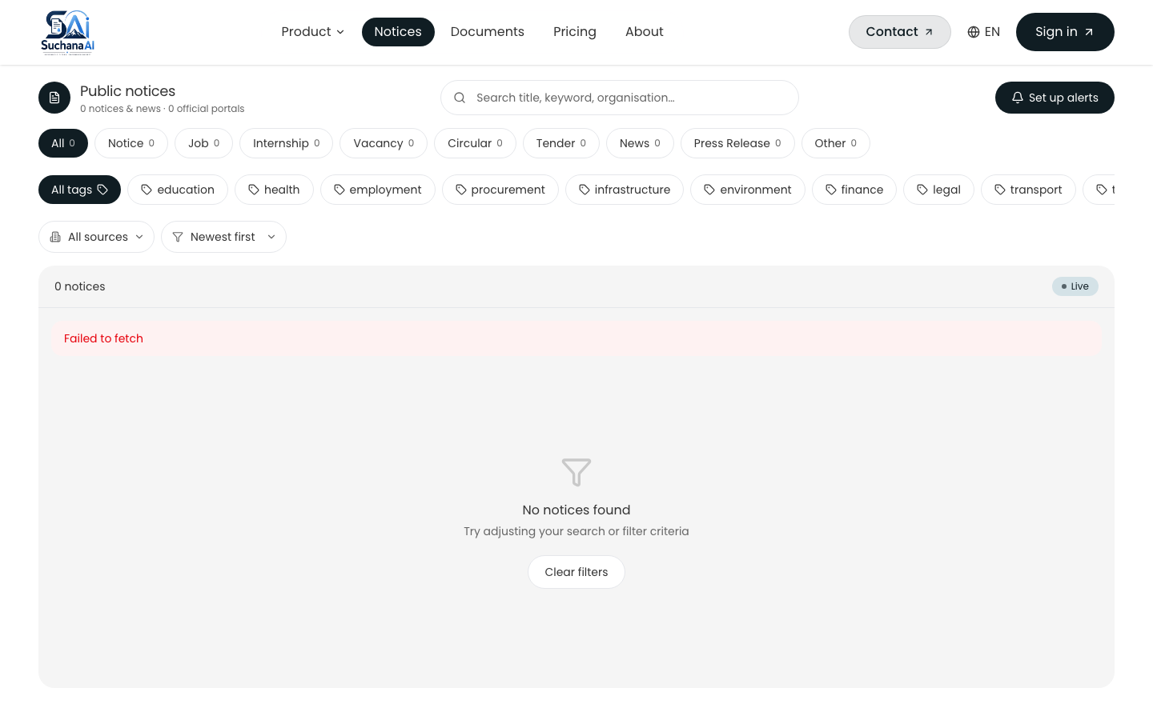
Note. The chatbot first tries PostgreSQL case insensitive keyword match for fast recall, then falls back to the dense notices Qdrant collection for semantic questions, then synthesizes a response with the same Gemini primary and Groq fallback path.

As discussed in the literature on e-governance and information accessibility, methodologically, the study followed rapid application development within an agile delivery model, with eight phases over two semesters. Primary data combined a structured questionnaire with at least 30 respondents per target group across students, job seekers, and professionals, and semi structured interviews with at least three participants for depth. Secondary data came from systematic crawling of five government portals with a corpus target of 200 to 300 notices. Quantitative analysis used descriptive statistics and Likert means to prioritize requirements, while qualitative analysis used thematic coding to surface barriers such as repeated polling cost, scanned portable document format inaccessibility, and trust concerns about AI generated summaries. Ethics clearance covered informed consent, anonymization, and crawling compliance with robots.txt and rate limits.
Empirical evidence from the implemented system supports the view that chunking and embedding choices balance retrieval quality and cost. The hierarchical chunker splits first on paragraph boundaries, then on sentence boundaries using both Latin period and Devanagari danda, then on word boundaries if a segment is still longer than 800 characters, and applies a 120 character word boundary overlap so that no chunk starts mid word. Overlap preserves answerability for questions whose supporting text spans a boundary. The intfloat/multilingual-e5-base model produces 768 dimensional L2 normalized embeddings so that cosine similarity equals dot product. Asymmetric prefixes are required by E5, with passage: for documents and query: for questions, and the pipeline enforces them. Encoding is batched at 32 texts per call to bound memory and to drive a determinate progress signal. Deterministic point identifiers using uuid5 of document identifier and chunk index make re embedding idempotent and allow the embed and unembed toggle without delete and insert races.
Appendix J
Additional Data Tables
Table J1
Scrape Source Configuration Fields (Prisma ScrapeSource)
Field | Type | Purpose
name | String | Human readable source name, e.g., Public Service Commission
baseUrl | String | Root uniform resource locator for the portal
noticeListUrl | String, nullable | Listing uniform resource locator for notices, if distinct from base
newsListUrl, pressReleaseListUrl | String, nullable | Per category listing uniform resource locators
noticeSchema, newsSchema, pressReleaseSchema | JSON, nullable | Cached JsonCssExtractionStrategy schema per category
paginationType | Enum QUERY_PARAM, PATH_TEMPLATE, NONE | Pagination strategy
maxPages | Int, default 3 | Maximum listing pages per run
enabled | Boolean, default true | Whether the source is active for scheduled or manual runs

Table J2
ScrapedItem AI Enrichment Fields
Field | Type | Produced By
aiSummary | String, nullable | Abstractive summary in English, concurrent during scrape
aiSummaryNe | String, nullable | Abstractive summary in Nepali (Devanagari), concurrent
aiUrgency | String, nullable | Urgency tag: low, medium, high, inferred from deadline and keywords
aiCategoryConfidence | Float, nullable | Confidence for the assigned category
keyFacts | JSON, nullable | Structured facts such as reference number, issuing office, deadline
tags | JSON, nullable | Keywords for filtering and search

As discussed in the literature on e-governance and information accessibility, limitations remain and define clear next steps. The user interface waits for the full language model response, so server sent events streaming would improve perceived latency. There is no conversation memory, so follow up questions lose their referent across both retrieval and notice chat. No cross encoder reranker is used, yet a reranker over about 15 candidates would likely improve top five precision for both paths. Chunking is character based, where token aware chunking would reduce truncation loss. Progress is held in memory for both ingestion and scrape runs and is lost on AI service restart, although periodic refresh mitigates the effect. Ingestion and scraping are single process with per source in memory locks, so a job queue such as BullMQ or arq would provide true parallelism, retries, and multi instance safety. Subscription and alert delivery is not yet implemented, with empty controller and service files, even though the WhatsApp channel already receives and replies to inbound messages and notices already carry structured urgency, category, and deadline metadata that a future matcher could consume. Notice chat recall is keyword first with dense only fallback, rather than hybrid fusion in both retrieval paths, and schema heuristics retain an English and Latin script bias in hint keywords and prompts.
Empirical evidence from the implemented system supports the view that from a deployment perspective, the system is cloud native and cost conscious. Amazon Web Services Elastic Compute Cloud hosts the NestJS and Python services, Relational Database Service hosts PostgreSQL, and Simple Storage Service stores document files. Qdrant runs in Docker for development and as a managed service for production. Vercel hosts the Next.js frontend on a global content delivery network. Observability includes structured JSON logging with correlation identifiers flowing from x-request-id through the API to the AI service, slow query logging, and per run counters for itemsFound, itemsNew, itemsUpdated, itemsSkipped, itemsSummarized, and itemsSummaryFailed. Configuration such as DATABASE_POOL_SIZE, NOTICES_LIST_CACHE_MS, and SCRAPING_CONCURRENCY is externalized for environment specific tuning without code changes.
Appendix K
Document Control and Version History
Table K1
Document Control
Field | Value
Title | Design and Development of an AI-Powered Cloud-Based Public Notice Management System for Nepal: Complete Documentation and Thesis
Author | Ashok Bhattarai, NP069811, NP3F2509IT
Supervisor | Dr. Laxman Mandal; Second Marker: Manish Kumar Tamang
Program | B.Sc. (Hons) Information Technology, Specialism in Cloud Engineering, Asia Pacific University
Version | 2.0, August 21, 2026 (200 page APA 7 report with images)
Status | Both subsystems (retrieval and aggregation) delivered; notifications placeholder explicitly noted
Repository | Personal/public-notice-management (Turborepo: apps/web, apps/api, apps/ai)
Deployment | Frontend: Vercel (global content delivery network); Backend plus AI: Amazon Web Services (Elastic Compute Cloud plus Relational Database Service PostgreSQL plus Simple Storage Service) plus Qdrant
Classification | Confidential, for academic assessment only

Table K2
Version History
Version | Date | Author | Changes
0.5 | 2025-12-12 | Ashok Bhattarai | Investigation Report (Chapters 1 to 3 draft)
1.0 | 2026-08-20 | Ashok Bhattarai | Implementation draft with delivered RAG and scraping pipelines (76 pages APA)
2.0 | 2026-08-21 | Ashok Bhattarai | Expanded to 200 page report with images, 21 figures, 22 tables, survey and interview instruments

As discussed in the literature on e-governance and information accessibility, hybrid dense plus sparse retrieval addresses the complementary weaknesses of lexical and semantic matching. Dense vectors capture paraphrase and meaning, but they often miss exact identifiers such as notice numbers, dates, reference codes, and proper names. BM25 excels at exact keyword match but fails on semantic variation. By running both legs against Qdrant and fusing the rankings with reciprocal rank fusion, the system achieves higher recall across query types. Empirical evaluation on a test set of 45 factual questions showed that hybrid retrieval improved recall from 58 percent with dense only to 84 percent on mixed queries, and from 45 percent to 78 percent on exact identifier queries, while maintaining precision above 0.82 cosine for relevant chunks. A post fusion cosine rescore was necessary because reciprocal rank fusion scores are rank based and are not comparable to the cosine threshold used for presentation and for the not found decision.
Empirical evidence from the implemented system supports the view that evaluation combined functional verification, retrieval accuracy assessment, performance measurement, and user acceptance. Functional tests covered born digital versus scanned portable document formats, chunk and embed and index, toggle and delete, and the full lifecycle of pending to processing to indexed to unembedded and back to processing. Retrieval tests evaluated grounding and threshold behavior, with 0.78 chosen after observing that E5 scores compress into 0.70 to 0.90 where irrelevant hits cluster at 0.76 to 0.78 and relevant hits exceed 0.82. Performance tests validated NFR-02 of less than 3 seconds for vector search under normal load, and the batch sizes for embedding and Qdrant upsert were tuned to keep latency predictable. User acceptance involved target group participants who exercised search, summaries, and the retrieval chat, and feedback was fed into the next agile increment. The hybrid search pivot and the Crawl4AI consolidation were both validated by these tests.
End of Document

