Table of Contents

INTRODUCTION 2

PROBLEM STATEMENT 2

OBJECTIVE 2

SCOPE AND LIMITATION 3

SCOPE 3

LIMITATIONS 3

PROJECT PLANNING 4

EXPECTED OUTCOME 5

# INTRODUCTION

**National Children Database is a web application that provides a platform for government and private sectors that are working for child welfare. This platform provides a managed way of keeping track of every stage of children growth and efficient way of accessing those information.**

# PROBLEM STATEMENT

Nepal is a developing country and we are well known about its development in various sector.The government still has the traditional way of storing the information manually. There are no standard mechanisms and foundations to collect and interlink those information and providing easy access to the records.

The collection and maintaing process of information in most of the organization is done using paper and are not digitized. And there is no common platform for the all the organizations for maintaing the information which can not be interlink between the different organizations for the same children’s information.

# OBJECTIVE

The main objective of the National Children Database is to make a centralize application which will be governed by the government to provide the common platform to maintain the information about the childrens for the organizations all over the country. The objectives to support the main objective can be listed as:

* Providing a common platform to store the information about the childrens.
* Providing platform to interlink the same children’s information independent of the organizations.
* Providing diffrent control and access to the system according to the nature of the organization keeping the records of the childrens.
* Providing the easy access mechanism to the infromation according to the degree of access to the system.

# SCOPE AND LIMITATION

Every project has its area of scope and limitaion.

## SCOPE

The proposed project ‘National Children Database’ has wide range of scope and it has high posibility of growth also. This proposed application can be implemented in many organizations around the country under the government control. This application can be very helpful for the organizaitons which are working on the childrens growth and development for making effective planning by understanig the current actual conditions of the childrens in the country and specifially in some particular part of the counrty.

This application can be extended in the future to keep the information about the all the persons in the country instead of only children. Due to time limitaion we are targating to develop the application to maintaing the information of childrens from their birth to the premature stage. So it has high posibility of growth.

## LIMITATIONS

Besides the scope and advantages of the purposed project , there may be some limitations also. The limitations of the application can be listed as:

* There may be problem to manage different interface for different the organisations and provide seperate permissions to them.
* There may be problem to implement the application in all the organizations all around the country.

# PROJECT PLANNING

We are plannig to complete this project within 119(including one day as a non working day for each week) days from February 23 2015 to June 21 2015. We divided project into different tasks and stage and scheduled as follows:

|  |  |  |  |
| --- | --- | --- | --- |
| Task Name | Duration | Start | Finish |
| Requirement Analysis and Feasibility Analysis | 10 days | Mon 2/23/15 | Thu 3/5/15 |
| Framework Understanding and Selection | 20 days | Fri 3/6/15 | Sun 3/29/15 |
| **System Design** | **32 days** | **Mon 3/30/15** | **Tue 5/5/15** |
| Architectural Design | 7 days | Mon 3/30/15 | Mon 4/6/15 |
| Database Design | 7 days | Tue 4/7/15 | Tue 4/14/15 |
| Interface Design | 12 days | Wed 4/15/15 | Tue 4/28/15 |
| Procedure/Algorithm Design | 6 days | Wed 4/29/15 | Tue 5/5/15 |
| Coding | 25 days | Wed 5/6/15 | Wed 6/3/15 |
| Testing and Debugging | 15 days | Thu 6/4/15 | Sun 6/21/15 |

Table 1 Project Planning Task Sheet

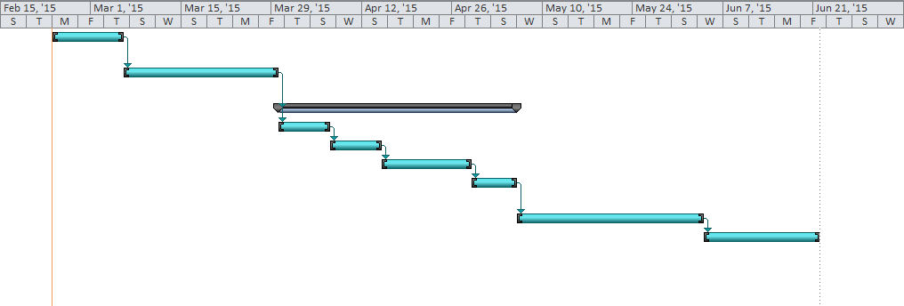

Figure 1 Project Planning Gantt chart

# EXPECTED OUTCOME

After the completion of this project following outcomes are expected :

* A centralized web application to manage the infromation about the childrens of our country.
* Seperate permissions and access mechanism in the system.
* Seperate interface of the application according to the purpose and type of the organization.
* Application control by central authority of government.
* Easy information analysis and searching mechanism in the application.

## 