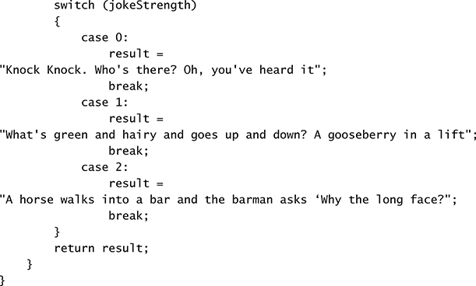

[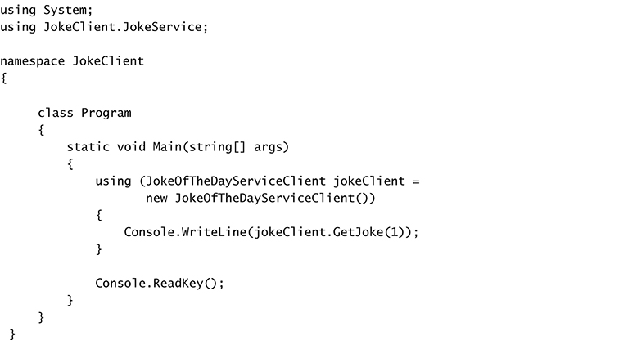](https://learning.oreilly.com/library/view/Exam+Ref+70-483+Programming+in+C,+Second+Edition/9780134891804/chapter4.xhtml#a04lis_28)

[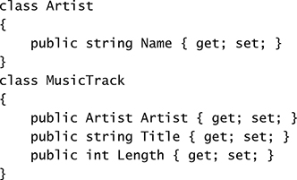](https://learning.oreilly.com/library/view/Exam+Ref+70-483+Programming+in+C,+Second+Edition/9780134891804/chapter4.xhtml#ap0351_01)

[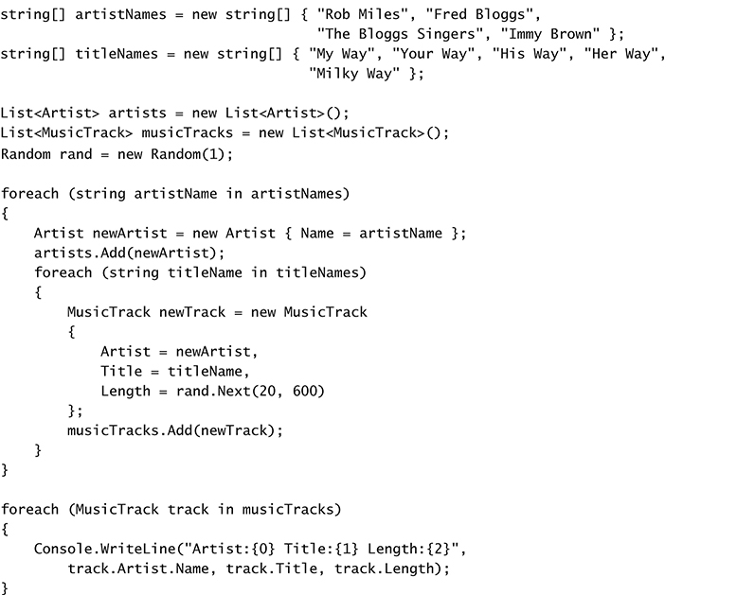](https://learning.oreilly.com/library/view/Exam+Ref+70-483+Programming+in+C,+Second+Edition/9780134891804/chapter4.xhtml#a04lis_29)

[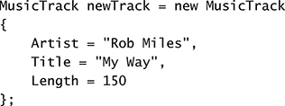](https://learning.oreilly.com/library/view/Exam+Ref+70-483+Programming+in+C,+Second+Edition/9780134891804/chapter4.xhtml#ap0352_01)

[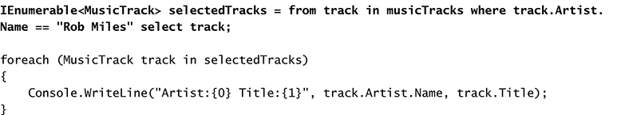](https://learning.oreilly.com/library/view/Exam+Ref+70-483+Programming+in+C,+Second+Edition/9780134891804/chapter4.xhtml#a04lis_30)

[Image](https://learning.oreilly.com/library/view/Exam+Ref+70-483+Programming+in+C,+Second+Edition/9780134891804/chapter4.xhtml#a04lis_31)

[Image](https://learning.oreilly.com/library/view/Exam+Ref+70-483+Programming+in+C,+Second+Edition/9780134891804/chapter4.xhtml#ap0353_01)

[Image](https://learning.oreilly.com/library/view/Exam+Ref+70-483+Programming+in+C,+Second+Edition/9780134891804/chapter4.xhtml#a04lis_32)

[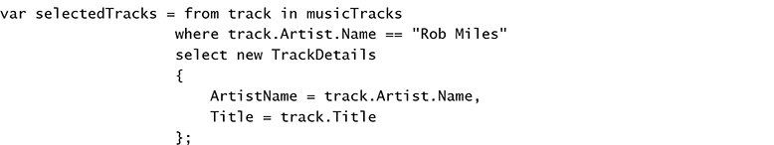](https://learning.oreilly.com/library/view/Exam+Ref+70-483+Programming+in+C,+Second+Edition/9780134891804/chapter4.xhtml#a04lis_33)

[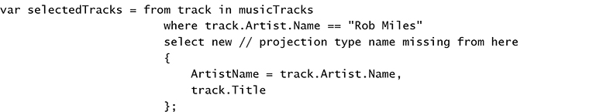](https://learning.oreilly.com/library/view/Exam+Ref+70-483+Programming+in+C,+Second+Edition/9780134891804/chapter4.xhtml#a04lis_34)

[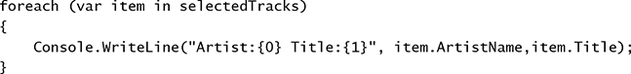](https://learning.oreilly.com/library/view/Exam+Ref+70-483+Programming+in+C,+Second+Edition/9780134891804/chapter4.xhtml#ap0355_01)

[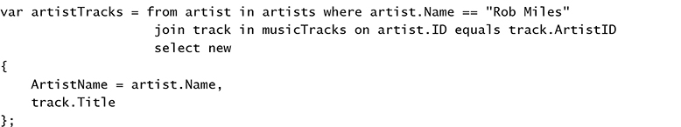](https://learning.oreilly.com/library/view/Exam+Ref+70-483+Programming+in+C,+Second+Edition/9780134891804/chapter4.xhtml#a04lis_35)

[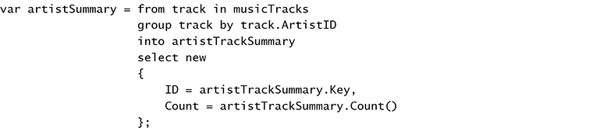](https://learning.oreilly.com/library/view/Exam+Ref+70-483+Programming+in+C,+Second+Edition/9780134891804/chapter4.xhtml#a04lis_36)

[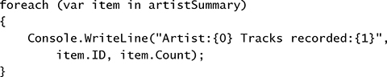](https://learning.oreilly.com/library/view/Exam+Ref+70-483+Programming+in+C,+Second+Edition/9780134891804/chapter4.xhtml#ap0357_01)

[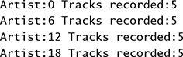](https://learning.oreilly.com/library/view/Exam+Ref+70-483+Programming+in+C,+Second+Edition/9780134891804/chapter4.xhtml#ap0357_02)

[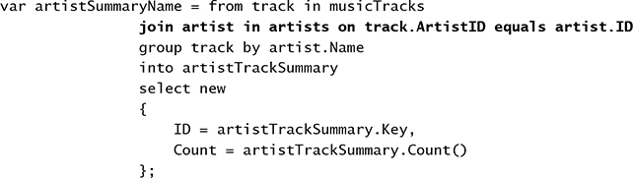](https://learning.oreilly.com/library/view/Exam+Ref+70-483+Programming+in+C,+Second+Edition/9780134891804/chapter4.xhtml#ap0357_03)

[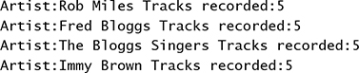](https://learning.oreilly.com/library/view/Exam+Ref+70-483+Programming+in+C,+Second+Edition/9780134891804/chapter4.xhtml#ap0358_01)

[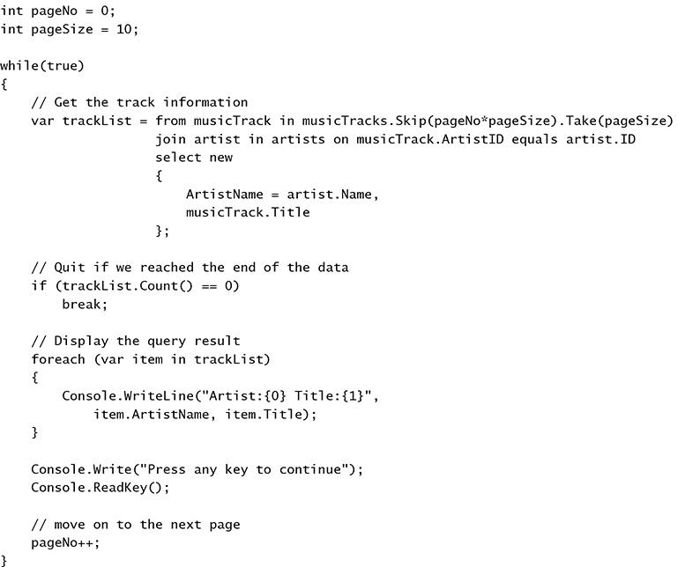](https://learning.oreilly.com/library/view/Exam+Ref+70-483+Programming+in+C,+Second+Edition/9780134891804/chapter4.xhtml#a04lis_37)

[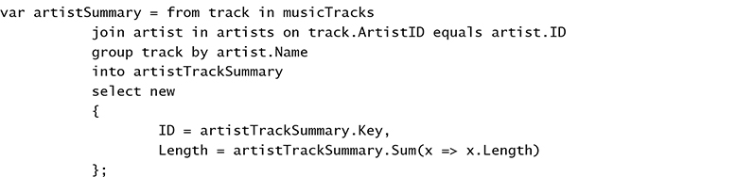](https://learning.oreilly.com/library/view/Exam+Ref+70-483+Programming+in+C,+Second+Edition/9780134891804/chapter4.xhtml#a04lis_38)

[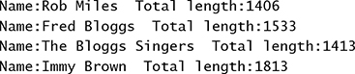](https://learning.oreilly.com/library/view/Exam+Ref+70-483+Programming+in+C,+Second+Edition/9780134891804/chapter4.xhtml#ap0359_01)

[Image](https://learning.oreilly.com/library/view/Exam+Ref+70-483+Programming+in+C,+Second+Edition/9780134891804/chapter4.xhtml#ap0359_02)

[Image](https://learning.oreilly.com/library/view/Exam+Ref+70-483+Programming+in+C,+Second+Edition/9780134891804/chapter4.xhtml#ap0360_01)

[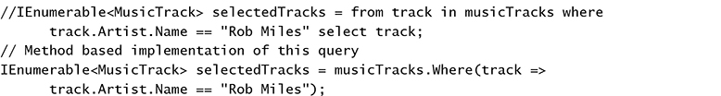](https://learning.oreilly.com/library/view/Exam+Ref+70-483+Programming+in+C,+Second+Edition/9780134891804/chapter4.xhtml#a04lis_39)

[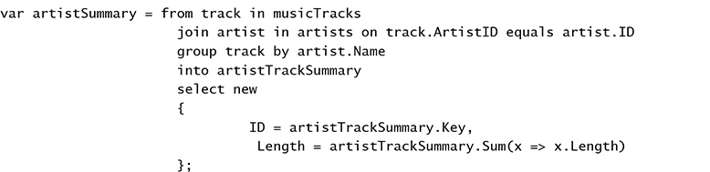](https://learning.oreilly.com/library/view/Exam+Ref+70-483+Programming+in+C,+Second+Edition/9780134891804/chapter4.xhtml#a04lis_40)

[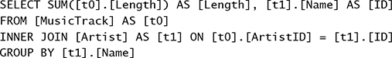](https://learning.oreilly.com/library/view/Exam+Ref+70-483+Programming+in+C,+Second+Edition/9780134891804/chapter4.xhtml#ap0361_01)

[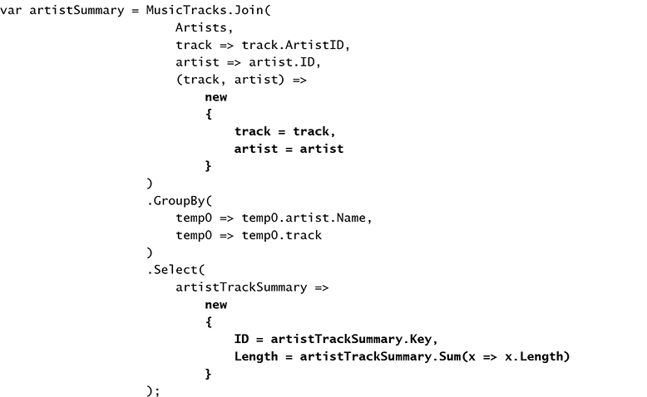](https://learning.oreilly.com/library/view/Exam+Ref+70-483+Programming+in+C,+Second+Edition/9780134891804/chapter4.xhtml#a04lis_41)

[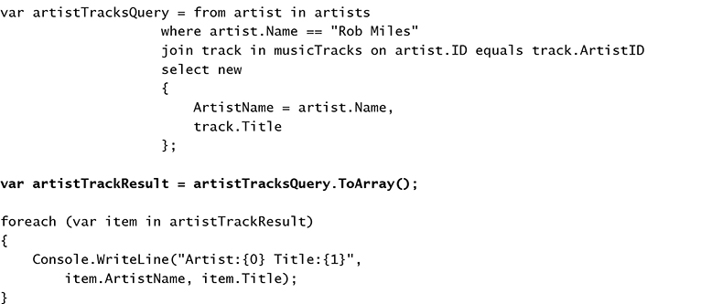](https://learning.oreilly.com/library/view/Exam+Ref+70-483+Programming+in+C,+Second+Edition/9780134891804/chapter4.xhtml#a04lis_42)

[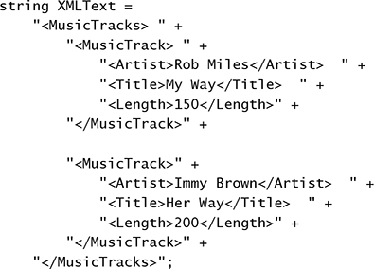](https://learning.oreilly.com/library/view/Exam+Ref+70-483+Programming+in+C,+Second+Edition/9780134891804/chapter4.xhtml#ap0363_01)

[Image](https://learning.oreilly.com/library/view/Exam+Ref+70-483+Programming+in+C,+Second+Edition/9780134891804/chapter4.xhtml#ap0363_02)

[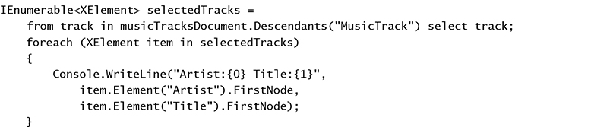](https://learning.oreilly.com/library/view/Exam+Ref+70-483+Programming+in+C,+Second+Edition/9780134891804/chapter4.xhtml#a04lis_43)

[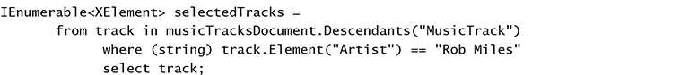](https://learning.oreilly.com/library/view/Exam+Ref+70-483+Programming+in+C,+Second+Edition/9780134891804/chapter4.xhtml#a04lis_44)

[Image](https://learning.oreilly.com/library/view/Exam+Ref+70-483+Programming+in+C,+Second+Edition/9780134891804/chapter4.xhtml#ap0364_01)

[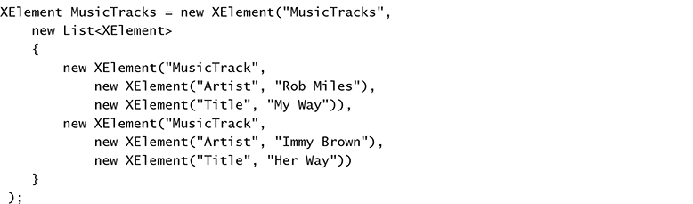](https://learning.oreilly.com/library/view/Exam+Ref+70-483+Programming+in+C,+Second+Edition/9780134891804/chapter4.xhtml#a04lis_45)

[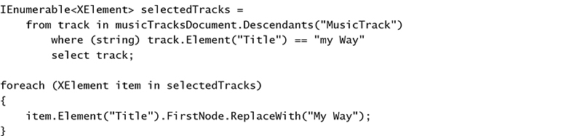](https://learning.oreilly.com/library/view/Exam+Ref+70-483+Programming+in+C,+Second+Edition/9780134891804/chapter4.xhtml#a04lis_46)

[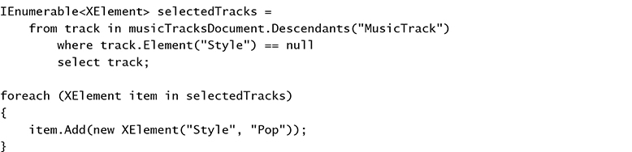](https://learning.oreilly.com/library/view/Exam+Ref+70-483+Programming+in+C,+Second+Edition/9780134891804/chapter4.xhtml#a04lis_47)

[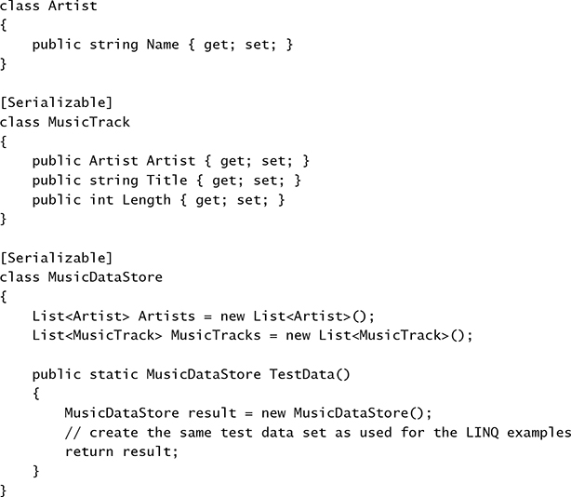](https://learning.oreilly.com/library/view/Exam+Ref+70-483+Programming+in+C,+Second+Edition/9780134891804/chapter4.xhtml#ap0366_01)

[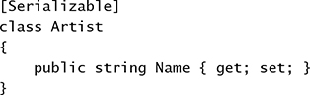](https://learning.oreilly.com/library/view/Exam+Ref+70-483+Programming+in+C,+Second+Edition/9780134891804/chapter4.xhtml#ap0367_01)

[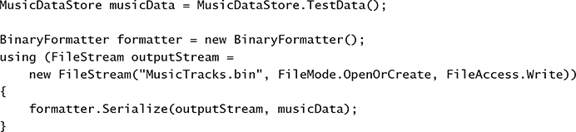](https://learning.oreilly.com/library/view/Exam+Ref+70-483+Programming+in+C,+Second+Edition/9780134891804/chapter4.xhtml#ap0367_02)

[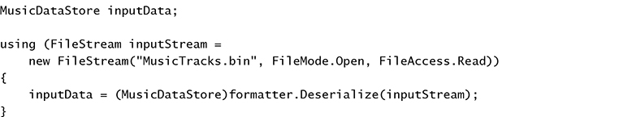](https://learning.oreilly.com/library/view/Exam+Ref+70-483+Programming+in+C,+Second+Edition/9780134891804/chapter4.xhtml#a04lis_48)

[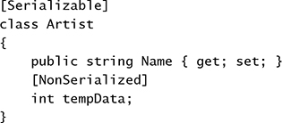](https://learning.oreilly.com/library/view/Exam+Ref+70-483+Programming+in+C,+Second+Edition/9780134891804/chapter4.xhtml#ap0368_01)

[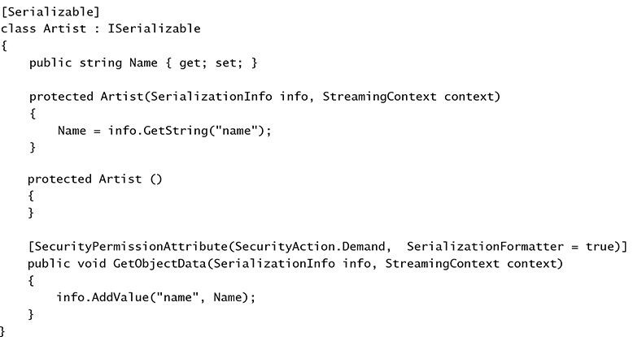](https://learning.oreilly.com/library/view/Exam+Ref+70-483+Programming+in+C,+Second+Edition/9780134891804/chapter4.xhtml#a04lis_49)

[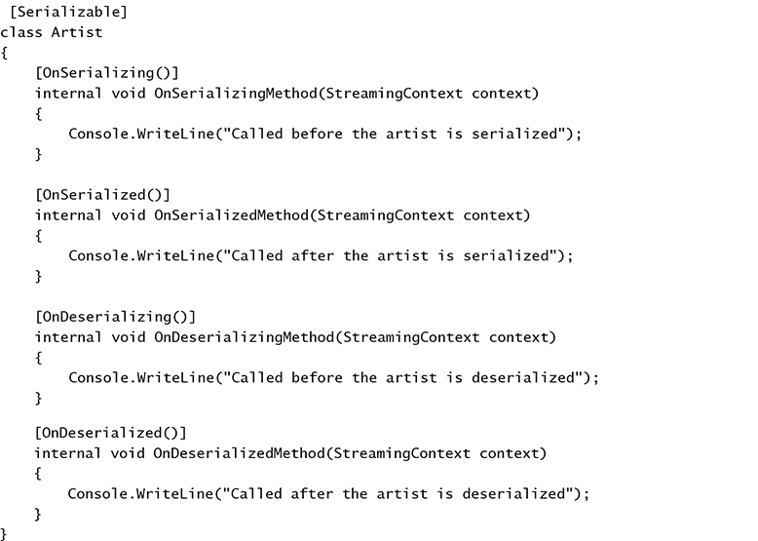](https://learning.oreilly.com/library/view/Exam+Ref+70-483+Programming+in+C,+Second+Edition/9780134891804/chapter4.xhtml#a04lis_50)

[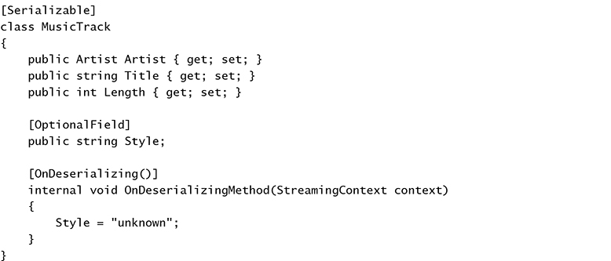](https://learning.oreilly.com/library/view/Exam+Ref+70-483+Programming+in+C,+Second+Edition/9780134891804/chapter4.xhtml#a04lis_51)

[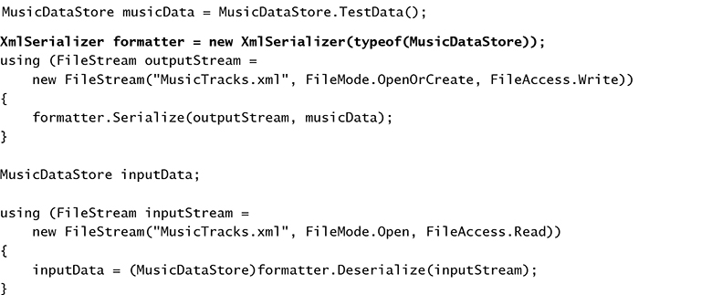](https://learning.oreilly.com/library/view/Exam+Ref+70-483+Programming+in+C,+Second+Edition/9780134891804/chapter4.xhtml#a04lis_52)

[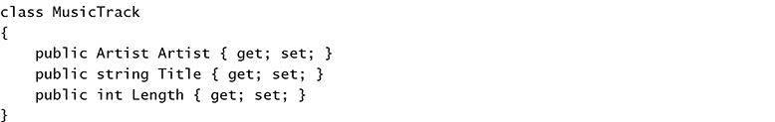](https://learning.oreilly.com/library/view/Exam+Ref+70-483+Programming+in+C,+Second+Edition/9780134891804/chapter4.xhtml#a04lis_53)

[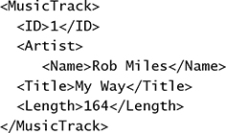](https://learning.oreilly.com/library/view/Exam+Ref+70-483+Programming+in+C,+Second+Edition/9780134891804/chapter4.xhtml#ap0371_01)

[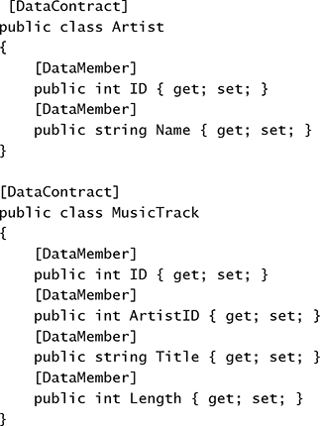](https://learning.oreilly.com/library/view/Exam+Ref+70-483+Programming+in+C,+Second+Edition/9780134891804/chapter4.xhtml#ap0372_01)

[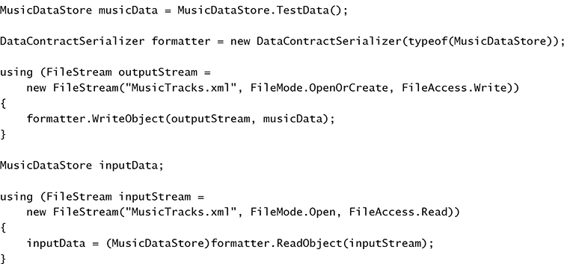](https://learning.oreilly.com/library/view/Exam+Ref+70-483+Programming+in+C,+Second+Edition/9780134891804/chapter4.xhtml#a04lis_54)

[Image](https://learning.oreilly.com/library/view/Exam+Ref+70-483+Programming+in+C,+Second+Edition/9780134891804/chapter4.xhtml#ap0374_01)

[Image](https://learning.oreilly.com/library/view/Exam+Ref+70-483+Programming+in+C,+Second+Edition/9780134891804/chapter4.xhtml#ap0374_02)

[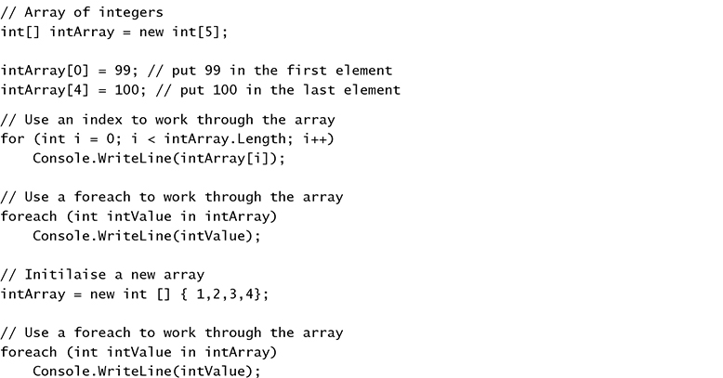](https://learning.oreilly.com/library/view/Exam+Ref+70-483+Programming+in+C,+Second+Edition/9780134891804/chapter4.xhtml#a04lis_55)

[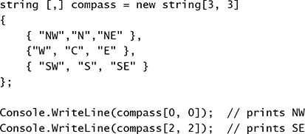](https://learning.oreilly.com/library/view/Exam+Ref+70-483+Programming+in+C,+Second+Edition/9780134891804/chapter4.xhtml#ap0375_01)

[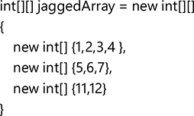](https://learning.oreilly.com/library/view/Exam+Ref+70-483+Programming+in+C,+Second+Edition/9780134891804/chapter4.xhtml#ap0375_02)

[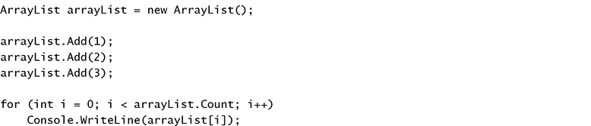](https://learning.oreilly.com/library/view/Exam+Ref+70-483+Programming+in+C,+Second+Edition/9780134891804/chapter4.xhtml#a04lis_56)

[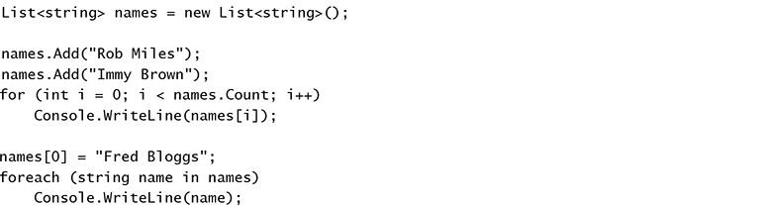](https://learning.oreilly.com/library/view/Exam+Ref+70-483+Programming+in+C,+Second+Edition/9780134891804/chapter4.xhtml#a04lis_57)

[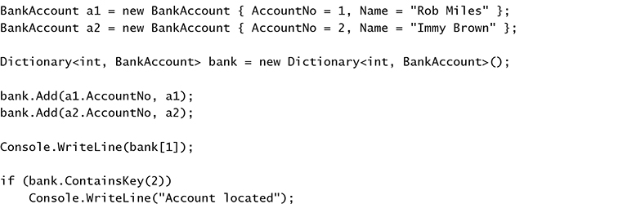](https://learning.oreilly.com/library/view/Exam+Ref+70-483+Programming+in+C,+Second+Edition/9780134891804/chapter4.xhtml#a04lis_58)

[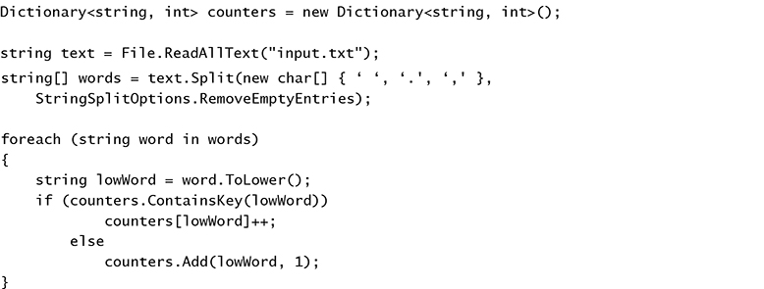](https://learning.oreilly.com/library/view/Exam+Ref+70-483+Programming+in+C,+Second+Edition/9780134891804/chapter4.xhtml#a04lis_59)

[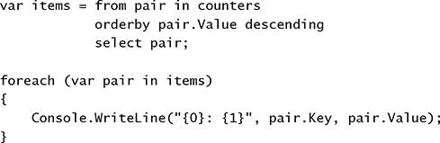](https://learning.oreilly.com/library/view/Exam+Ref+70-483+Programming+in+C,+Second+Edition/9780134891804/chapter4.xhtml#ap0378_01)

[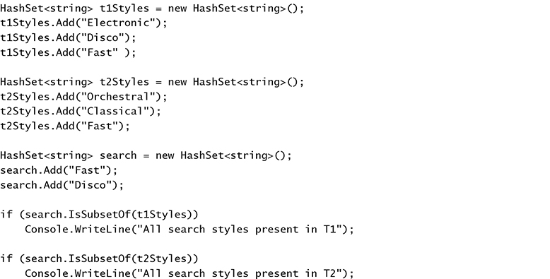](https://learning.oreilly.com/library/view/Exam+Ref+70-483+Programming+in+C,+Second+Edition/9780134891804/chapter4.xhtml#a04lis_60)

[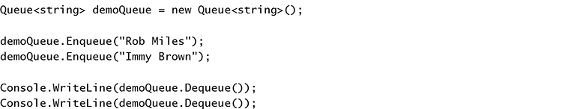](https://learning.oreilly.com/library/view/Exam+Ref+70-483+Programming+in+C,+Second+Edition/9780134891804/chapter4.xhtml#a04lis_61)

[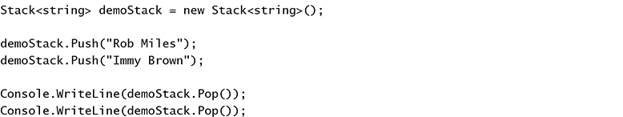](https://learning.oreilly.com/library/view/Exam+Ref+70-483+Programming+in+C,+Second+Edition/9780134891804/chapter4.xhtml#a04lis_62)

[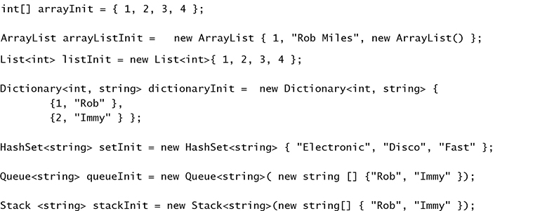](https://learning.oreilly.com/library/view/Exam+Ref+70-483+Programming+in+C,+Second+Edition/9780134891804/chapter4.xhtml#a04lis_63)

[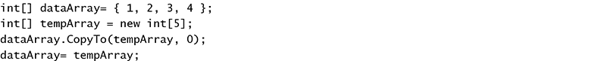](https://learning.oreilly.com/library/view/Exam+Ref+70-483+Programming+in+C,+Second+Edition/9780134891804/chapter4.xhtml#a04lis_64)

[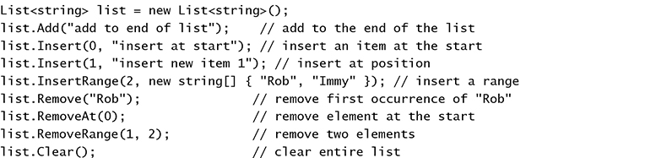](https://learning.oreilly.com/library/view/Exam+Ref+70-483+Programming+in+C,+Second+Edition/9780134891804/chapter4.xhtml#a04lis_65)

[Image](https://learning.oreilly.com/library/view/Exam+Ref+70-483+Programming+in+C,+Second+Edition/9780134891804/chapter4.xhtml#a04lis_66)

[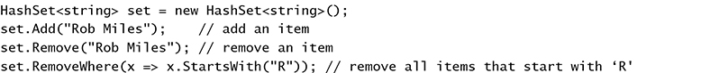](https://learning.oreilly.com/library/view/Exam+Ref+70-483+Programming+in+C,+Second+Edition/9780134891804/chapter4.xhtml#a04lis_67)

[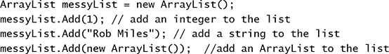](https://learning.oreilly.com/library/view/Exam+Ref+70-483+Programming+in+C,+Second+Edition/9780134891804/chapter4.xhtml#ap0382_02)

[Image](https://learning.oreilly.com/library/view/Exam+Ref+70-483+Programming+in+C,+Second+Edition/9780134891804/chapter4.xhtml#ap0382_03)

[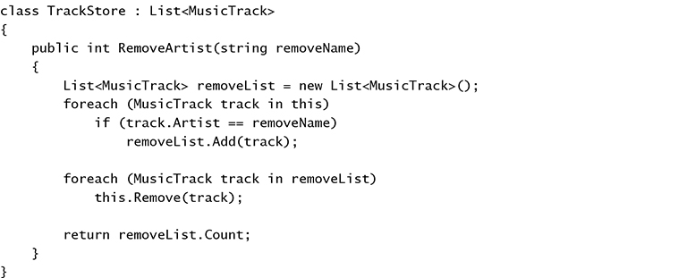](https://learning.oreilly.com/library/view/Exam+Ref+70-483+Programming+in+C,+Second+Edition/9780134891804/chapter4.xhtml#a04lis_68)

[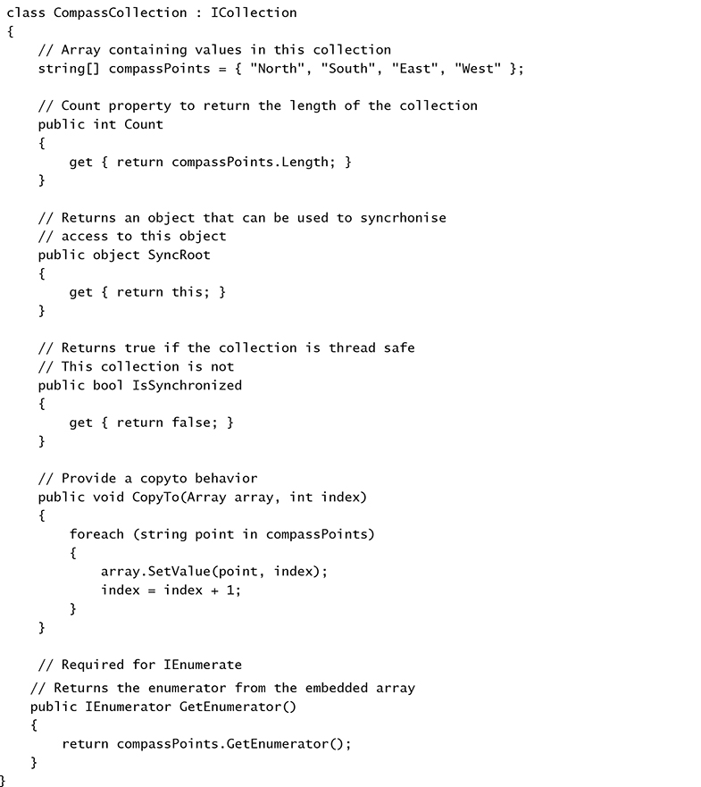](https://learning.oreilly.com/library/view/Exam+Ref+70-483+Programming+in+C,+Second+Edition/9780134891804/chapter4.xhtml#a04lis_69)