Table of Contents

- Abstract

- Introduction

- Synopsis

- Problem Statements
- Synopsis
- Problem Statement
- Objectives
- Overview
- Steganography Techniques
- Steganography vs Cryptography
- Steganography vs Watermarking
- System Analysis and Design
- User Manuals
- Summary

Implementation of LSB Steganography and its Evaluation for Various File Formats
Abstract
Steganography is derived from the Greek word steganos which literally means “Covered” and graphy means “Writing”, i.e. covered writing. Steganography refers to the science of “invisible” communication. For hiding secret information in various file formats, there exists a large variety of steganographic techniques some are more complex than others and all of them have respective strong and weak points. The Least Significant Bit (LSB) embedding technique suggests that data can be hidden in the least significant bits of the cover image and the human eye would be unable to notice the hidden image in the cover file. This technique can be used for hiding images in 24-Bit, 8-Bit, Gray scale
EXISTING SYSTEM
Image compression techniques are extensively used in steganography. Among the two types of image compressions, lossy compression and loss less compression; lossless compression formats offer more promises. Lossy compression compression may not maintain the original image’s integrity. Lossless compression maintains the original image data exactly, hence it is prefered. Example of Lossy compression format is JPEG format files. Examples of Lossless compression formats are GIF[3] and BMP formats.
PROPOSED SYSTEM
The “Data Hiding in Audio Files” mainly developed to embed or extract the messages into audio files. This project basically deals with two important network security concepts namely steganography and encryption. For encryption AES algorithm is used. The plaintext is given as input. The plaintext is encrypted using AES algorithm. The ciphertext is given as output. The output ciphertext is hidden into the audio files using Steganography. For steganography LSB algorithm is used. The audio file is in the wave format is the chosen medium to conceal and transmit the secret information. Since the audio file is in ASCII format, the contents of the text file are also converted to the bit stream. The encrypted file is now embedded behind the audio file by mixing the contents together using LSB algorithm. At the other end, the encrypted file is separated from audio file. The encrypted file is then decrypted and the original text file contents are then viewed.
SYSTEM REQUIREMENTS
Hardware Specification
Processor : Pentium IV
RAM : 256 MB
CPU Clock : 1.6 GHz
Software Specification
Front End : JAVA
Back End : MS-Access
Platform : Windows XP
HIDING METHODS IN IMAGE STEGANOGRAPHY
In Image Steganography, There are a variety of methods using which information can be hidden in images. Least Significant Bit Replacement Technique: In image steganography almost all data hiding techniques try to alter insignificant information in the cover image. Least significant bit (LSB) insertion is a common, simple approach to embedding information in a cover image. For instance, a simple scheme proposed, is to place the embedding data at the least significant bit (LSB) of each pixel in the cover image[7,8,9] . The altered image is called stego-image. Altering LSB doesn’t change the quality of image to human perception but this scheme is sensitive a variety of image processing attacks like compression, cropping etc. We will be emphasizing more on this technique for the various image formats. Moderate Significant Bit Replacement Technique: The moderate significant bits of each pixel in the cover image can be used to embed the secret message. This method improves sensitivity to modification, but it degrades the quality of stego-image. Experiments have shown that the length of hidden messages embedded in the least significant bits of signal samples can be estimated with relatively high precision.
THE LSB TECHNIQUE
The least significant bit i.e. the eighth bit inside an image is changed to a bit of the secret message. When using a 24- bit image, one can store 3 bits in each pixel by changing a bit of each of the red, green and blue colour components, since they are each represented by a byte. An 800×600 pixel image, can thus store a total amount of 1,440,000 bits or 180,000 bytes of embedded data. As an example, suppose that we have three adjacent pixels (9 bytes) with the RGB encoding.
10010101 00001101 11001001
10010110 00001111 11001011
10011111 00010000 11001011
When the number 300, can be which binary representation is 100101100 embedded into the least significant bits of this part of the image. If we overlay these 9 bits over the LSB of the 9 bytes above, we get the following (where bits in bold have been changed)
10010101 00001100 11001000
10010111 00001110 11001011
10011111 00010000 11001010
Here the number 300 was embedded into the grid, only the 5 bits needed to be changed according to the embedded message. On average, only half of the bits in an image will need to be modified to hide a secret message using the maximum cover size. Since there are 256 possible intensities of each primary colour, changing the LSB of a pixel results in small changes in the intensity of the colours. The human eye cannot perceive these changes - thus the message is successfully hidden. With a well-chosen image, one can even hide the message in the LSB without noticing the difference[10].

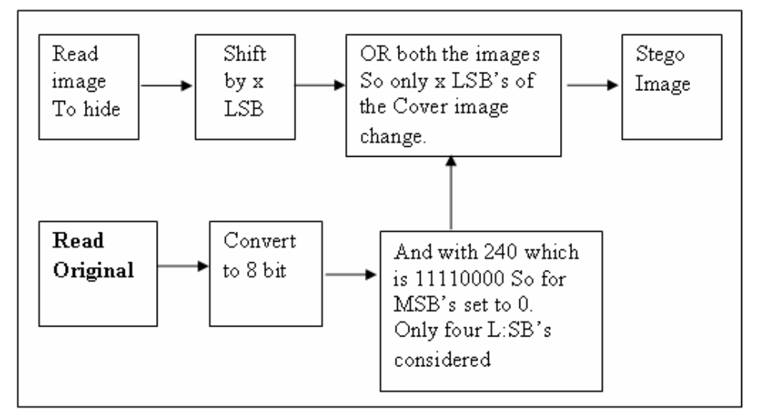

Algorithm for Hiding (Steganography)
- Read the original image and the image which is to be hidden in the original image
- Shift the image to hide in the cover image by X bits.
- And the original image or cover image with 240 which is 11110000 So four MSB’s set to 0. Because of this only four LSB’s considered further.
- The shifted hidden image and the result of step 3 are bitored. This makes changes only in the X LSB bits so that the image is hidden in the original image.
In MATLAB we convert it to unit8 format. This image can be called as the stego image

Algorithm for Steganalysis
1. The stego image is bit shifted by 4 bits since it was shifted by 4 bits to insert it into the original image.
2. The image is the ANDED with 255 i.e., 11111111, which gives the original image. It is ANDED with 255 because initially all the LSB’s were made 0. Now it is recovered back.
3. To get it to Unit8 format we, convert it back to unit8 which is the extracted image.
SYSTEM DESIGN
The system design is the most creative and challenging phase of the system development life cycle. It is an approach for the creation of the proposed system, which still helps the system coding. It provides the understanding and procedural details necessary for implementing the system. A number of subsystems are to be identified which constitutes the whole system. In this phase the data organization is to be discussed, in which the output formats are to be designed. The system design is composed of several steps. Here the emphasis is on translating the performance requirements in to the design specification.

4.1 System Flow Diagram:
4.1.1 Encryption
The process of converting from plaintext to cipher text is known as encryption or enciphering. The plaintext is the original message and the ciphertext is the unintelligible message. The encryption algorithm takes secret key and plaintext, and produces the ciphertext. The encryption algorithm performs various substitutions and transformations on the plaintext.
4.1.2 Decryption
The process of restoring the plaintext from ciphertext is known as decryption or deciphering. The decryption algorithm takes the cipher text and the secret key, and produces the original plaintext.
Message
ENCRYPTION
ALGORITHM
STEGO
SYSTEM
STEGO
SYSTEM
DECRYPTION
ALGORITHM
Secret
key
Secret
key
Audio
File
Audio
File
Message
Cipher
Cipher

Fig: 4.1 System design

4.2 Data Flow Diagram
LEVEL O
Encryption & Audio Steganography
User Data
Steganograped audio file
Steganograped audio file
DeStegnographed / Decryption
User Data

Fig: 4.2 Level 0 DFD
LEVEL 1

User Data
Encryption
Secret Key
Steganography
Secret Key
DeSteganography
Secret Key
DeCryption
Plain text
Secret Key

File

Fig 4.3 Level 1 DFD
The level 0 of DFD specifies the user data that is encrypted and then the cipher text is hiding into the audio file using steganography. The output obtained is steganographed audio file. Using steganographic algorithm the encrypted text is separated from the audio file. Using decryption the cipher text is converted to user data.
The level 1 of DFD specifies the user data which is encrypted using secret key and then the cipher text is hiding into the audio file using steganography with the help of secret key. Thus the audio file with encrypted data is stored in a file. The audio file is steganographed with the help of secret key. Thus the encrypted text is separated from audio file. Using decryption cipher text is converted to plain text using secret key.
UML DIAGRAMS
The Unified Modeling Language allows the software engineer to express an analysis model using the modeling notation that is governed by a set of syntactic semantic and pragmatic rules.

A UML system is represented using five different views that describe the system from distinctly different perspective. Each view is defined by a set of diagram, which is as follows.
  - User Model View
    - This view represents the system from the users perspective.
    - The analysis representation describes a usage scenario from the end-users perspective.

  - Structural model view
    - In this model the data and functionality are arrived from inside the system.
    - This model view models the static structures.

- Behavioral Model View
It represents the dynamic of behavioral as parts of the system, depicting the interactions of collection between various structural elements described in the user model and structural model view.

- Implementation Model View
In this the structural and behavioral as parts of the system are represented as they are to be built.

- Environmental Model View
In this the structural and behavioral aspects of the environment in which the system is to be implemented are represented.

UML is specifically constructed through two different domains they are:
- UML Analysis modeling, this focuses on the user model and structural model views of the system.
- UML design modeling, which focuses on the behavioral modeling, implementation modeling and environmental model views.

Use case Diagrams represent the functionality of the system from a user’s point of view. Use cases are used during requirements elicitation and analysis to represent the functionality of the system. Use cases focus on the behavior of the system from external point of view.
Actors are external entities that interact with the system. Examples of actors include users like administrator, bank customer …etc., or another system like central database.

USE CASE DIAGRAM
Use Case: Use case describes the behavior of a system. It is used to structure things in a model. It contains multiple scenarios, each of which describes a sequence of actions that is clear enough for outsiders to understand.
Actor: An actor represents a coherent set of roles that users of a system play when interacting with the use cases of the system. An actor participates in use cases to accomplish an overall purpose. An actor can represent the role of a human, a device, or any other systems.

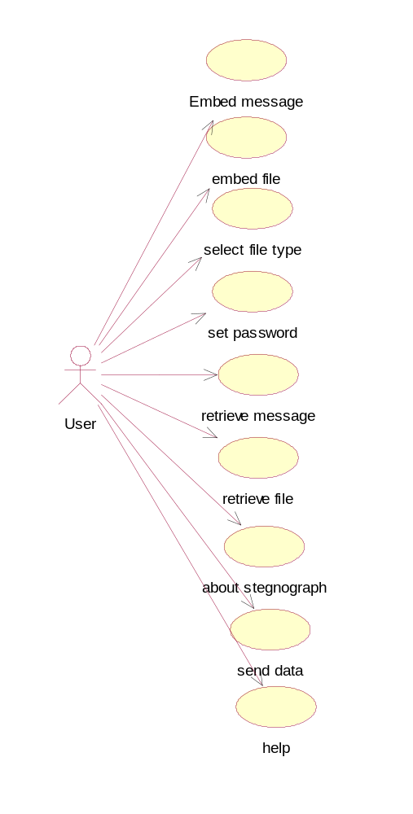

SEQUENCE DIAGRAM:
This diagram is simple and visually logical, so it is easy to see the sequence of the flow of control. It also clearly shows concurrent processes and activations in a design.
Object: Object can be viewed as an entity at a particular point in time with a specific value and as a holder of identity that has different values over time. Associations among objects are not shown. When you place an object tag in the design area, a lifeline is automatically drawn and attached to that object tag.
Actor: An actor represents a coherent set of roles that users of a system play when interacting with the use cases of the system. An actor participates in use cases to accomplish an overall purpose. An actor can represent the role of a human, a device, or any other systems.
Message: A message is a sending of a signal from one sender object to other receiver object(s). It can also be the call of an operation on receiver object by caller object. The arrow can be labeled with the name of the message (operation or signal) and its argument values
Duration Message: A message that indicates an action will cause transition from one state to another state.
Self Message: A message that indicates an action will perform at a particular state and stay there.
Create Message: A message that indicates an action that will perform between two states.

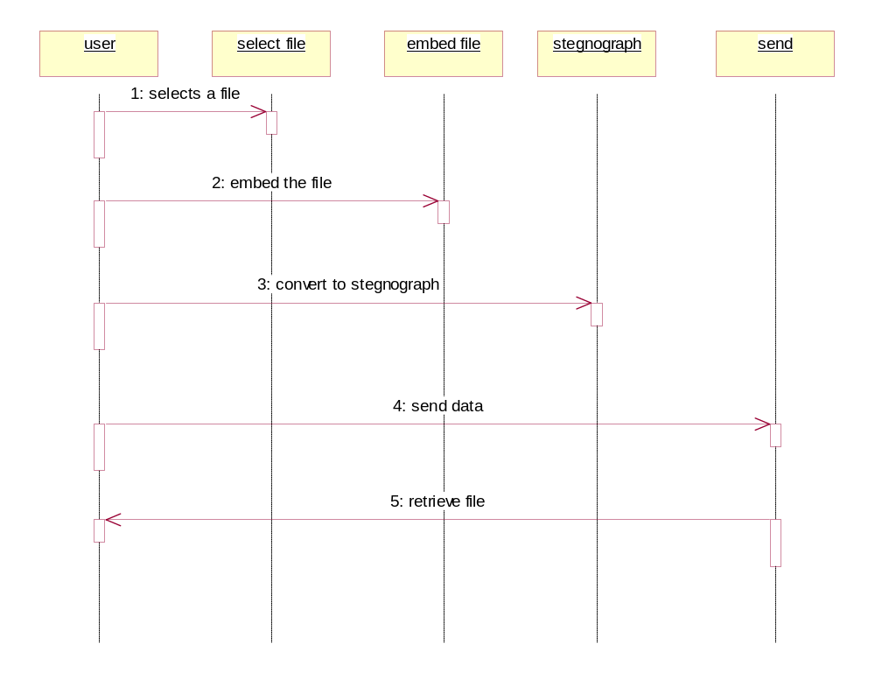

CLASS DIAGRAM:
Class: A Class is a description for a set of objects that shares the same attributes, and has similar operations, relationships, behaviors and semantics.
Generalization: Generalization is a relationship between a general element and a more specific kind of that element. It means that the more specific element can be used whenever the general element appears. This relation is also known as specialization or inheritance link.
Realization: Realization is the relationship between a specialization and its implementation. It is an indication of the inheritance of behavior without the inheritance of structure.
Association: Association is represented by drawing a line between classes. Associations represent structural relationships between classes and can be named to facilitate model understanding. If two classes are associated, you can navigate from an object of one class to an object of the class.
Aggregation: Aggregation is a special kind of association in which one class represents as the larger class that consists of a smaller class. It has the meaning of “has-a” relationship.

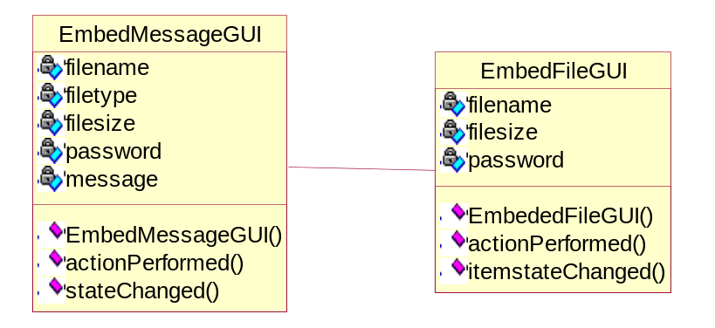

4.3. DATABASE DESIGN
The file design is totally based on the users requirements, which holds the normalized tables done in the system analysis. Every possible measures has taken to avoid duplication of data. After identifying all the requirements the files was created using SQL Server special care was taken.
- To reduce redundancy
- To increase integrity & accuracy and
- For data independence

LOGIN TABLE

Field Name | Data Type
User Name | Text
Password | Text
Table: 4.1

5. SYSTEM IMPLEMENTATION

5.1 Implementation Procedures
Implementation is one of the most important tasks in project implementation is the phase, in which one has to be cautious, because all the efforts undertaken during the project will be fruitful only if the software is properly implemented according to the plans made.
The implementation phase is less creative than system design. It is primarily concerned with user-training, site preparation and file-sites, the tests of the network along with the systems are also included under implementation.
Depending on the nature of the systems extensive user training may be required. Programming is itself a design works. The initial parameters of the management information systems should be modified as a result of programming efforts. Programming provides a real test for the assumption made by the analyst.
System testing checks the readiness and accuracy of the system to access, update and retrieve data from the new files. Once the programs become available the test data are read into the computer and processed. In most conventions parallel run was conducted to establish the efficiency of the system.
Implementation is used here to mean the process of converting a new or revised system in to an operational one. Conversion is one aspect of one implementation.
There are two types of Implementation
- Implementation of a computer system to replace a manual one.
- Implementation of a new computer system to replace an existing one.

AES
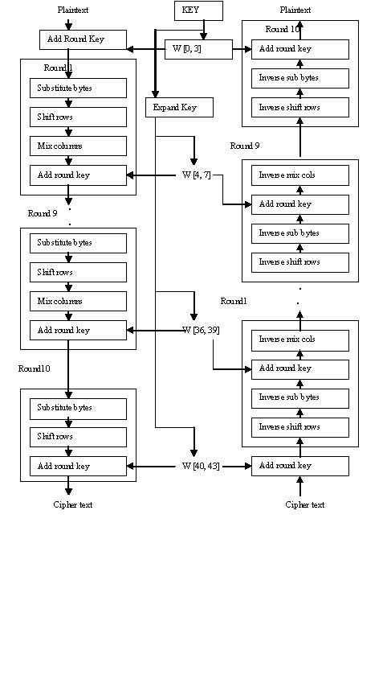 Fig: 5.1 AES Encryption & Decryption

The Advanced Encryption Standard (AES Algorithm) is a computer security standard that became effective on May 26, 2002 by NIST to replace DES. The cryptography scheme is a symmetric block cipher that encrypts and decrypts 128-bit blocks of data. Lengths of 128, 192, and 256 bits are standard key lengths used by AES Algorithm. The algorithm consists of four stages that make up a round which is iterated 10 times for a 128-bit length key, 12 times for a 192-bit key, and 14 times for a 256-bit key. The first stage "SubBytes" transformation is a non-linear byte substitution for each byte of the block. The second stage "Shift Rows" transformation cyclically shifts (permutes) the bytes within the block. The third stage "Mix Columns" transformation groups 4-bytes together forming 4-term polynomials and multiplies the polynomials with a fixed polynomial mod (x^4+1). The fourth stage "AddRoundKey" transformation adds the round key with the block of data. In most ciphers, the iterated transform (or round) usually has a Feistel Structure. Typically in this structure, some of the bits of the intermediate state are transposed unchanged to another position (permutation). AES Algorithm does not have a Feistel structure but is composed of three distinct invertible transforms based on the Wide Trial Strategy design method. The Wide Trial Strategy design method provides resistance against linear and differential cryptanalysis. In the Wide Trail Strategy, every layer has its own function: The linear mixing layer: guarantees high diffusion over multiply rounds.The non-linear layer: parallel application of S-boxes that have the optimum worst-case non-linearity properties.

LSB
Data hiding in the least significant bits (LSBs) of audio samples in the time domain is one of the simplest algorithms with very high data rate of additional information. The LSB watermark encoder usually selects a subset of all available host audio samples chosen by a secret key. The substitution operation on the LSBs is performed on this subset, where the bits to be hidden substitute the original bit values. Extraction process simply retrieves the watermark by reading the value of these bits from the audio stego object. Therefore, the decoder needs all the samples of the stego audio that were used during the embedding process. The random selection of the samples used for embedding introduces low power additive white Gaussian noise (AWGN). It is well known from the psychoacoustics literature [6] that the human auditory system (HAS) is highly sensitive to AWGN. That fact limits the number of LSB that can be imperceptibly modified during watermark embedding. As the number of used LSBs during LSB coding increases or, equivalently, depth of the modified LSB layer becomes larger, perceptual transparency of stego objects is decreased. Therefore, there is a limit for the depth of the used LSB layer in each sample of host audio that can be used for data hiding. Subjective listening test showed that, in average, the maximum LSB depth that can be used for LSB based watermarking without causing noticeable perceptual distortion is the fourth LSB layer when 16 bits per sample audio sequences are used. The tests were performed with a large collection of audio samples and individuals with different background and musical experience. None of the tested audio sequences had perceptual artifacts when the fourth LSB has been used for data hiding, although in certain music styles, the limit is even higher than the fourth LSB layer. Robustness of the watermark, embedded using the LSB coding method, increases with increase of the LSB depth used for data hiding. Therefore, improvement of watermark robustness obtained by increase of depth of the used LSB layer is limited by perceptual transparency bound, which is the fourth LSB layer for the standard LSB coding algorithm.
6. SYSTEM TESTING
Testing is the process of evaluating a system by manual or automatic means to verify that it satisfies the specified requirements or to identify differences between the actual and expected results. During system testing, the system is used experimentally to ensure that the software does not fail. Special test data are input for processing and the results are examined. If the program fails to behave as expected, then the conditions under which such a failure occurs are noted for debugging and correction. Program testing represents the logical elements of the system. The testing ultimately leads to suffice the quality factors such as correctness, reliability, efficiency, usability, maintainability, portability, accuracy, error tolerance and expandability.
6.1 Test strategies:
For testing software, various test strategies can be used such as Unit Testing, Integration Testing, Black-box Testing, White-box Testing, Regression Testing, and Acceptance Testing etc.

6.1.1 Unit Testing:
Unit test focuses verification effort on the smallest unit of software design, the software components or modules. By testing in this method we should be very clear of the bugs occurred. The module interface is tested to ensure that information property flows into and out of the program under test.

6.1.2 Integration Testing:
Integration testing is a systematic technique for constructing the program structure while at the same time conducting tests to uncover errors associated with interfacing. The objective is to take unit tested components and build a program structure that has been dedicated by design.
6.1.3 Black-box Testing:
Black box testing alludes to test that are conducted at the software interface. Although they are designed to uncover errors, black-box tests are used to demonstrate that software functions are operational, that input is properly accepted and the output is correctly produced. A black-box test examines some fundamental aspect of a system with title regard for the internal logical structure of the software.
6.1.4 White-box Testing:
White box testing is predicated on close examination of procedural detail. Logical paths through software are tested by providing test cases that exercise specific set of conditions and loops.
6.1.5 Regression Testing:
Regression testing involves executing old test cases to test that no new errors have been introduced. This testing is performed when some changes are made to an existing system. The modified system needs to be tested to make sure that the new features to be added to work.
6.1.6 Acceptance Testing:
Acceptance testing involves planning and execution of functional tests, performance test to verify that implemented system satisfies its requirements. Acceptance tests are typically performed by the quality assurance and customer organization.
CONCLUSION AND Future Enhancement
In this project it is mainly used for hiding the data in audio files and sends the data in secure manner in audio file. This project implemented our sending the data in secure manner .In this project hiding the data in the audio files. So the hackers can’t access the data. In the receiver side LSB algorithm extract the text from the audio file. Using the AES Algorithm we decrypt the data form the encrypted format.
Future Enhancement:
In future, the data can be hidden using video files. Also enhancement like compression of audio files, more security can be performed.

