Amrit Acharya

05

1). Explain the HILL Climb search as a heuristic search with an example.

* In Hill-Climbing technique, starting at the base of a hill, we walk upwards until we reach the top of the hill. In other words, we start with initial state and we keep improving the solution until its optimal.

It’s a variation of a generate-and-test algorithm which discards all states which do not look promising or seem unlikely to lead us to the goal state. To take such decisions, it uses heuristics (an evaluation function) which indicates how close the current state is to the goal state.

In simple words, Hill-Climbing = generate-and-test + heuristics:

Let’s look at the Simple Hill climbing algorithm:

* Define the current state as an initial state
* Loop until the goal state is achieved or no more operators can be applied on the current state:
  + 1. Apply an operation to current state and get a new state
  + 2. Compare the new state with the goal
  + 3. Quit if the goal state is achieved
  + 4. Evaluate new state with heuristic function and compare it with the current state
  + 5. If the newer state is closer to the goal compared to current state, update the current state

As we can see, it reaches the goal state with iterative improvements. In Hill-Climbing algorithm, finding goal is equivalent to reaching the top of the hill.

Example:

Hill Climbing Algorithm can be categorized as an informed search. So we can implement any node-based search or problems like the n-queens problem using it. To understand the concept easily, we will take up a very simple example.

Let’s look at the image below:

[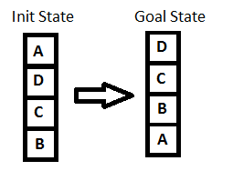](http://www.baeldung.com/wp-content/uploads/2017/06/init_goal.png)

Key point while solving any hill-climbing problem is to choose an appropriate heuristic function.

Let’s define such function h:

h(x) = +1 for all the blocks in the support structure if the block is correctly positioned otherwise -1 for all the blocks in the support structure.

Here, we will call any block correctly positioned if it has the same support structure as the goal state. As per the hill climbing procedure discussed earlier let’s look at all the iterations and their heuristics to reach the target state:

**[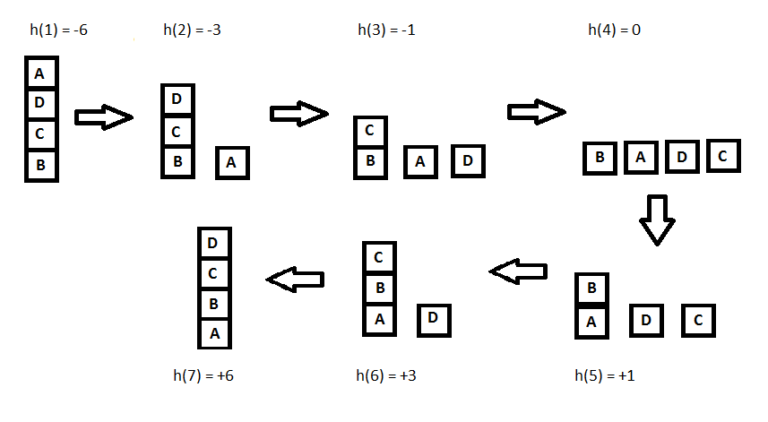](http://www.baeldung.com/wp-content/uploads/2017/06/state_iterations.png)**

2). Explain Human Information Processing with its principle and structure.

* Human information processing theory deals with how people receive, store, integrate, retrieve, and use information.

See also:

* Issues related to (mostly cognitivist) learning theory, e.g. cognitive load, knowledge represent
* Issues related to multimedia design, e.g. research on and multimedia animation which relies a lot on human information processing models.

Today exist various variants of the Atkinson-Schiffrin model, e.g. Mayer's model of multimedia learning which presented below.

An important question raised by many research concerns the power of working memory. It is generally believed that human working memory is very limited, we can only keep in mind a few things at a time. Miller's (1956) famous "The magical number seven plus or minus two" paper layed the groundwork.

Principle:

According to Huitt (2003), there are a few basic principles that most cognitive psychologists agree with:

* The mental system has limited capacities, i.e. bottlenecks in the flow and processing of information, occur at very specific points
* A control mechanism is required to oversee the encoding, transformation, processing, storage, retrieval and utilization of information. This control mechanism requires itself processing power and that varies in function of the difficulty of the task.
* There is a two-way flow of information. Sensory input is combined with information stored in memory in order to construct meaning.
* The human organism has been genetically prepared to process and organize information in specific ways.

Structure

* The selection of pertinent information uses top-down processing. Previous knowledge guides the gathering of information. In the absence of a pertinent mental model to guide visual exploration, other selection processes will be used. Lowe showed that novices learners were mostly relying on perceptive salience to extract information form a meteorological map.
* Knowledge organisation is both based on bottom-up and top-down processing. Perceptive organisation of the elements as well as anterior knowledge are used in order to build a mental model linked with a propositional representation. Of course, these selective and organisational functions stand on working memory.

[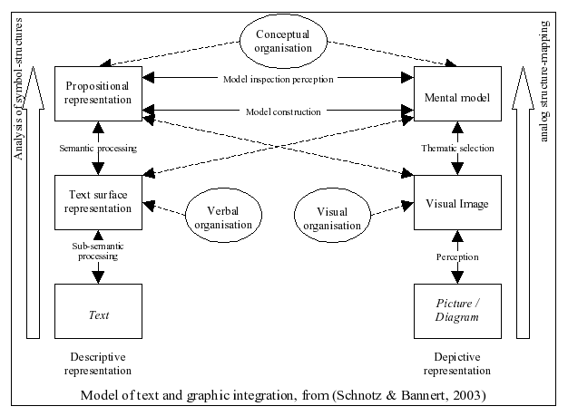](http://edutechwiki.unige.ch/en/File:Schnotz-banner-text-graphics-integration.png)

3).Briefly describe the water leakage problem.

* Globally, water losses from water distribution systems are reaching alarming levels. They are made up of various components including physical losses (leakage), unauthorized consumption and apparent losses . Leakage makes up a large part, sometimes more than 70% of the total water losses .

Leakages are the annual volumes lost through all types of leaks, bursts and overflows up to the point of customer metering . They are caused by lack of active leakage control (ALC), excess pressure, poor operations and maintenance, poor quality of underground assets, vibration and traffic loading and Corrosion .

Bursts and background estimates (BABE) philosophy provides a pragmatic and simple approach to the very complex problem of leakage from water distribution system .

BABE concept recognizes that the annual volume of physical losses consists of numerous leakage events. Each individual loss volume is influenced by flow rate and duration of leak run time before it is repaired .

In BABE analyses, components of leakage can be categorized into three categories .

- Reported breaks and leaks: They typically have high flow rates and short run time before they are reported to the utility either by the general public or the water utility’s own staff. They are visibly evident and disruptive.

- Unreported breaks and leaks: They have moderate flow rates and a long run time.

-Background losses: They are individual events (from joints, fittings, and small cracks) with flow rates too low to be detected by traditional acoustic leak detection techniques. They will continue to flow either detected by chance or until they gradually worsen to a point where they can be detected.

The total leakage from small hidden leaks and undetected breaks is significantly greater than from reported breaks. Main breaks that surfacing and causing supply disruptions are reported quickly and repaired within a short time. Conversely, small hidden leaks and undetected breaks may run for much longer periods until they are detected .

The BABE concepts are most effective when applied in conjunction with the following :

-Fixed area variable area discharges principles.

-The infrastructure leakage index.

-Unavoidable annual real losses principles.

Infrastructure leakage index (ILI) can be defined as the current annual real losses (CARL) divided by the unavoidable annual real losses (UARL) . The volume of unavoidable annual real losses (UARL) represents the lowest technically achievable annual real losses for a well-maintained and well-managed water distribution system .

There are four fundamental leakage management practices that will constrain physical losses including pressure management, speed and quality of repair, active leakage control (ALC), and asset management .

Pressure management is one of the most influential and cost-effective activities of reducing leakage. It can be defined as the practice of managing water distribution system pressures to the optimum levels of service ensuring sufficient and efficient supply to consumers .

The general objectives of pressure management for leakage minimization are three-fold :

-Reduce background leakage which is acoustically undetectable seeps at pipe joints and small cracks. It cannot be economically repaired on an individual basis.

-Reduce the rate of new leaks and breaks which occur on mains and service connections, due to diminished stress on the pipes.

-Reduce the flow rate from any leaks and breaks.

The most common methods of pressure management include establishing zone boundaries, fixed outlet pressure control valves, pump and level control, time modulated control valves and flow modulated control valves. However, one of the most common and effective method is using Pressure Reducing Valves (PRVs).