doing_more_with_ggplot.R

USER

2021-10-22

library(ggplot2)  
library(palmerpenguins)  
  
  
ggplot(data = penguins) +   
 geom_point(mapping = aes(x = flipper_length_mm, y = body_mass_g))

## Warning: Removed 2 rows containing missing values (geom_point).

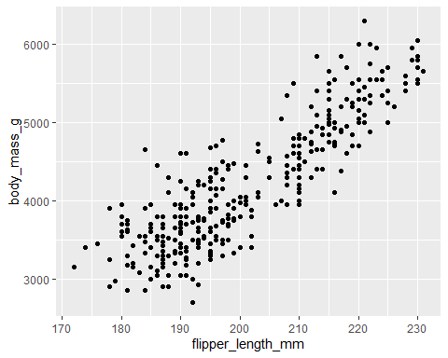

ggplot(data = penguins) +   
 geom_smooth(mapping = aes(x = flipper_length_mm, y = body_mass_g))

## `geom_smooth()` using method = 'loess' and formula 'y ~ x'

## Warning: Removed 2 rows containing non-finite values (stat_smooth).

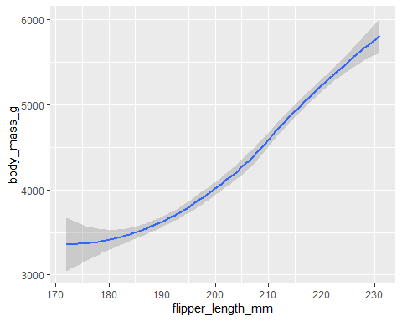

ggplot(data = penguins) +   
 geom_smooth(mapping = aes(x = flipper_length_mm, y = body_mass_g)) +   
 geom_point(mapping = aes(x = flipper_length_mm, y = body_mass_g))

## `geom_smooth()` using method = 'loess' and formula 'y ~ x'

## Warning: Removed 2 rows containing non-finite values (stat_smooth).  
  
## Warning: Removed 2 rows containing missing values (geom_point).

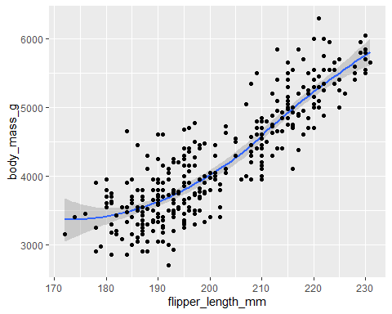

ggplot(data = penguins) +   
 geom_smooth(mapping = aes(x = flipper_length_mm, y = body_mass_g, linetype=species)) +   
 geom_jitter(mapping = aes(x = flipper_length_mm, y = body_mass_g))

## `geom_smooth()` using method = 'loess' and formula 'y ~ x'

## Warning: Removed 2 rows containing non-finite values (stat_smooth).  
  
## Warning: Removed 2 rows containing missing values (geom_point).

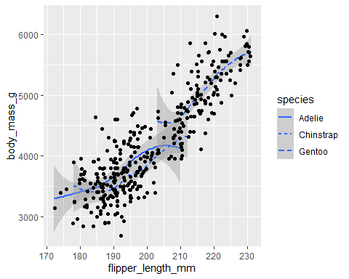

ggplot(data=diamonds) +  
 geom_bar(mapping = aes(x=cut))

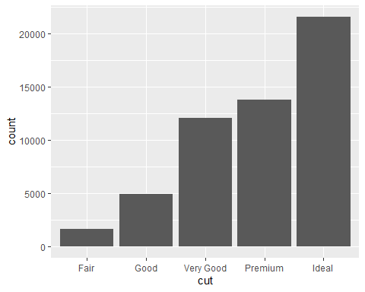

ggplot(data=diamonds) +  
 geom_bar(mapping = aes(x=cut, colour=cut))

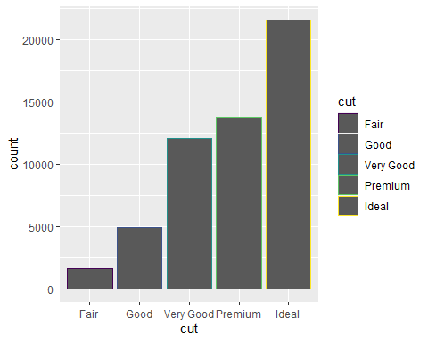

ggplot(data=diamonds) +  
 geom_bar(mapping = aes(x=cut, fill=cut))

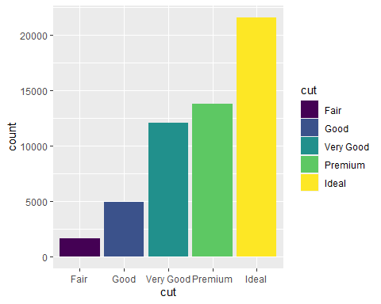

ggplot(data=diamonds) +  
 geom_bar(mapping = aes(x=cut, fill=clarity))

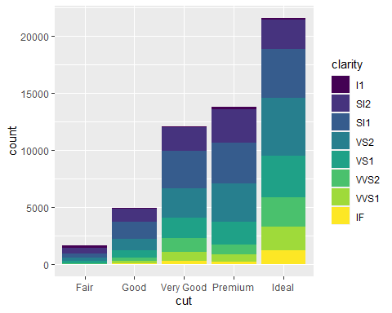

#Aesthetics and facets  
  
ggplot(data = penguins,aes(x = flipper_length_mm, y = body_mass_g)) +   
 geom_point(aes(color = species)) +  
 facet_wrap(~species)

## Warning: Removed 2 rows containing missing values (geom_point).

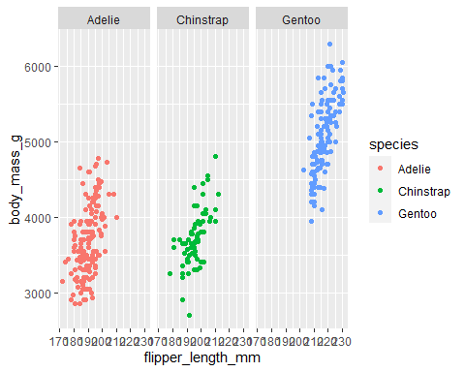

ggplot(data = penguins) +   
 geom_point(aes(x = flipper_length_mm, y = body_mass_g, color = species)) +  
 facet_wrap(~species)

## Warning: Removed 2 rows containing missing values (geom_point).



ggplot(data=diamonds) +  
 geom_bar(mapping = aes(x=color, fill=cut)) +  
 facet_wrap(~cut)

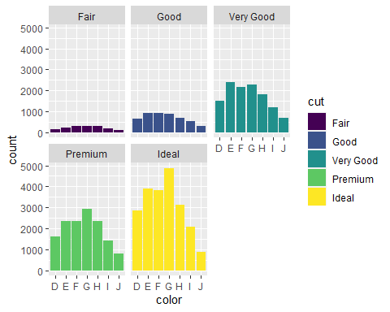

ggplot(data = penguins) +   
 geom_point(mapping = aes(x = flipper_length_mm, y = body_mass_g, color = species)) +  
 facet_grid(sex~species)

## Warning: Removed 2 rows containing missing values (geom_point).

