Output

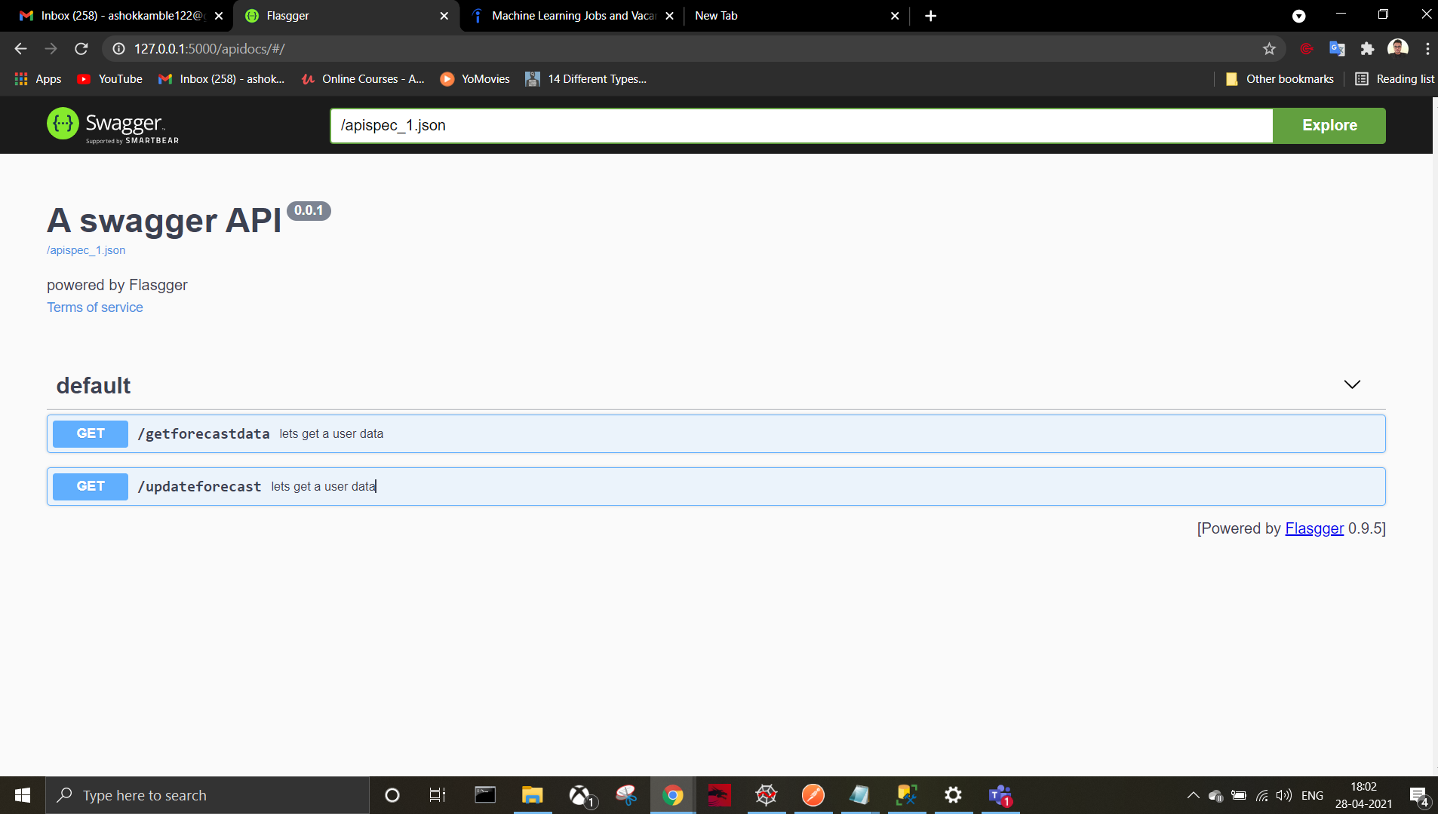

# DB records

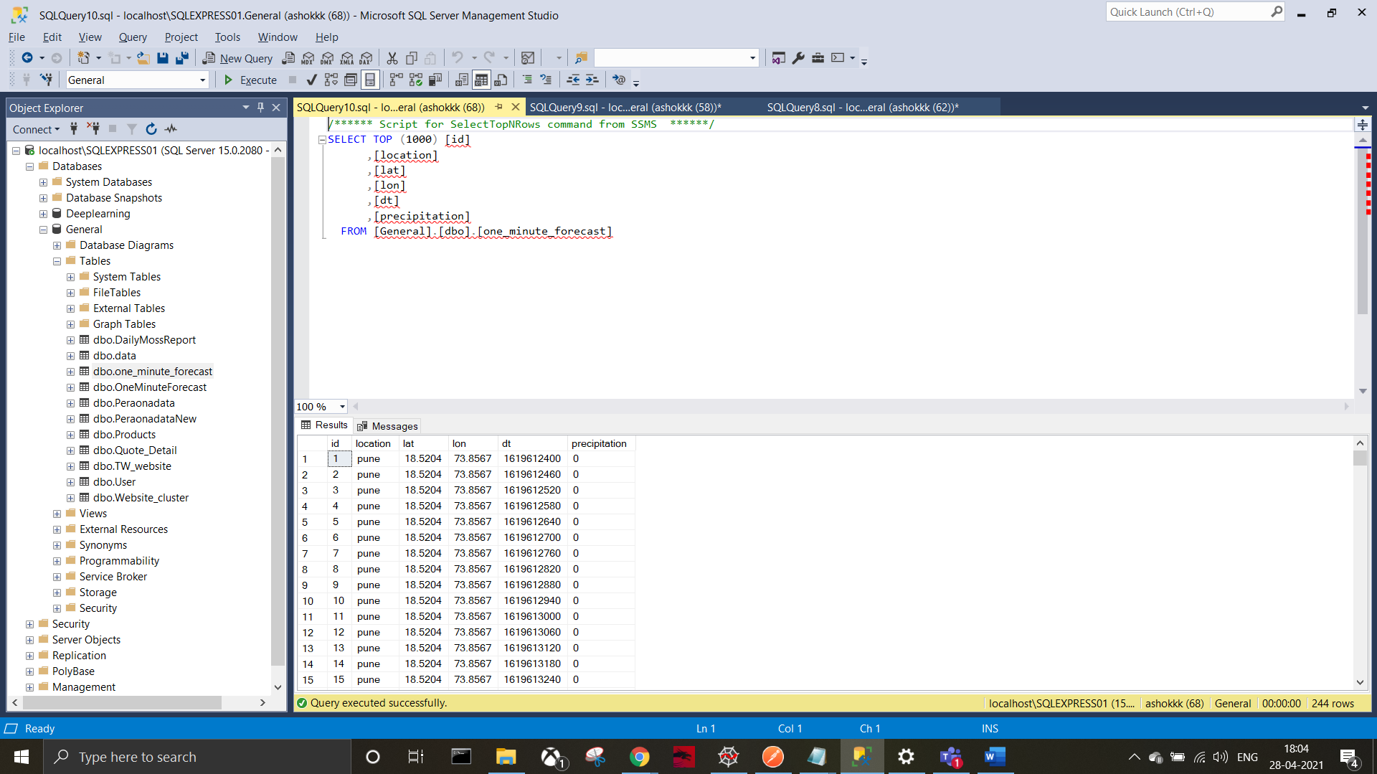

Note/challenges:

1. Start with a blank Python project, initiate with git and virtualenv  
2. List the latitude and longitude of 10 of your favorite places  
3. Write an API endpoint that collects 1 Minute forecast (exclude all  
other types) for each of the 10 cities using this API:  
<https://openweathermap.org/api/one-call-api>  
4. Store the 1 Minute forecast, per lat/long combination in a  
relational database (either SQLite, MySQL or PostgreSQL(have used SSMS))

5. When I call the API endpoint (mentioned in point 3) it should store  
the updated data in the database without duplicates (times are  
available in the API response)  
6. Create another API endpoint that picks 2 of the cities that have  
most similar weather forecast and returns the result as JSON with a  
similarity percentage(created get call only as there requirement was not clear to simmiler forecast calculation params and insufficient time )  
7. The similarity should be calculated as exhaustively as possible  
(like "temp", "feels_like", "pressure", etc.), but should limit to  
only the most recent hour of forecast data stored in the database(whenever you hit the update API it will add the data into db duplicate check is there on LAT,Lan and Time i.e. dt )  
8. The API endpoint (in point 6) should not call the OpenWeather API  
again, instead it should work with only the data in the database(yes, agreed but the data is not sufficient to get only two city an basis of two params only dt and [precipitation] as [precipitation] is always showing 0) we get only two params in minutely data

Note: make sure to mange database connection before run and run db.create_all() to create schema first time

Thanks ,

Ashok

9146759676