**CREATE DABASE AND SHOW DATABASES**

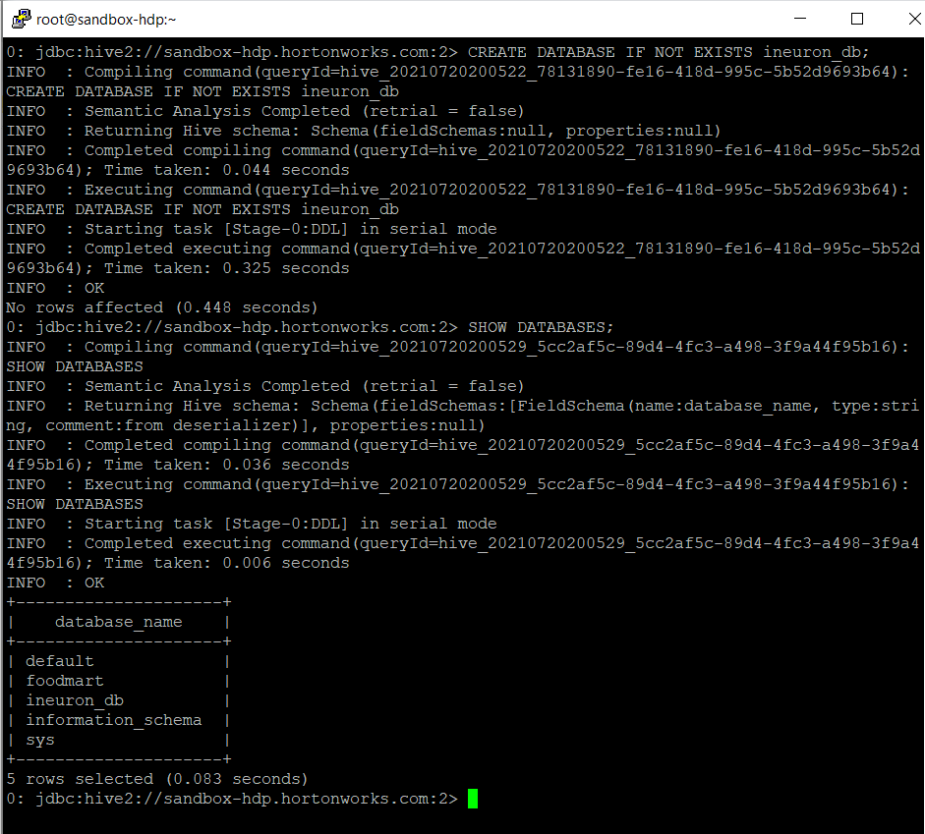

**Show databases**

**DROP DATABASES**

Database at location

DROP DATABASE IF EXISTS ineuron_db CASCADE;

create table emp_details2

DESCRIBE emp_details2;

DESCRIBE FORMATTED emp_details2;

**Renaming a Table: ALTER TABLE emp_details2 RENAME TO emp_details;**

**SHOW TABLES LIKE '*emp*';**

Drop table:

**Rename Column**

**Create a View and Select a View**

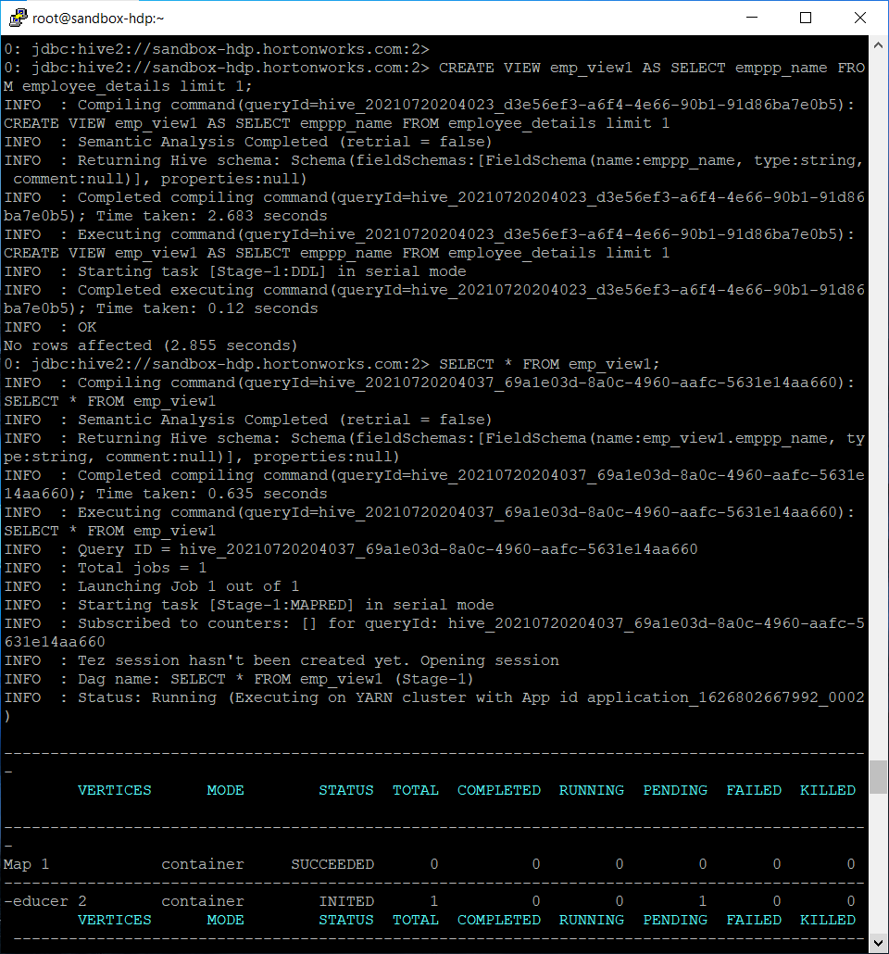

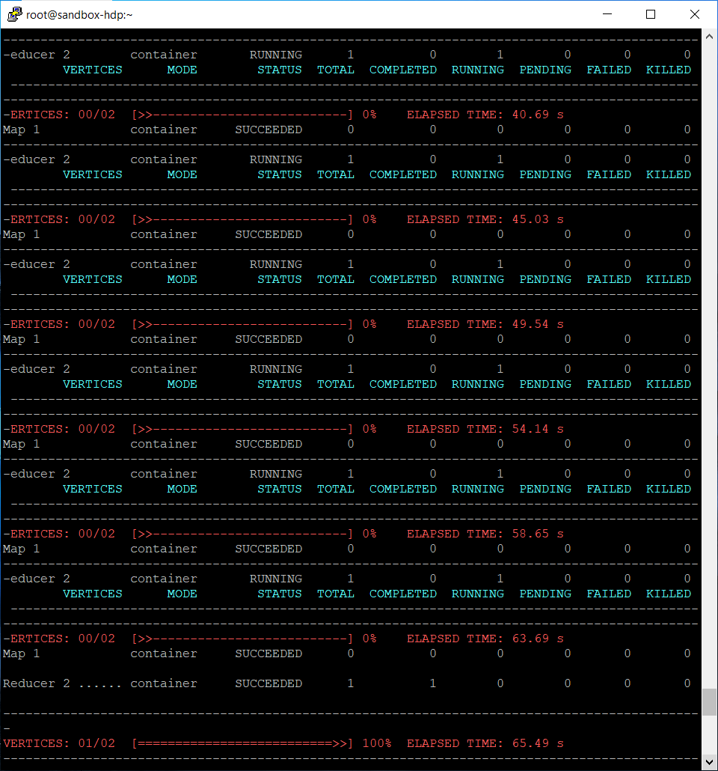

**Loading Text file:**

**Loading data from HDFS:**

**Selecting from table with WHERE condition:**

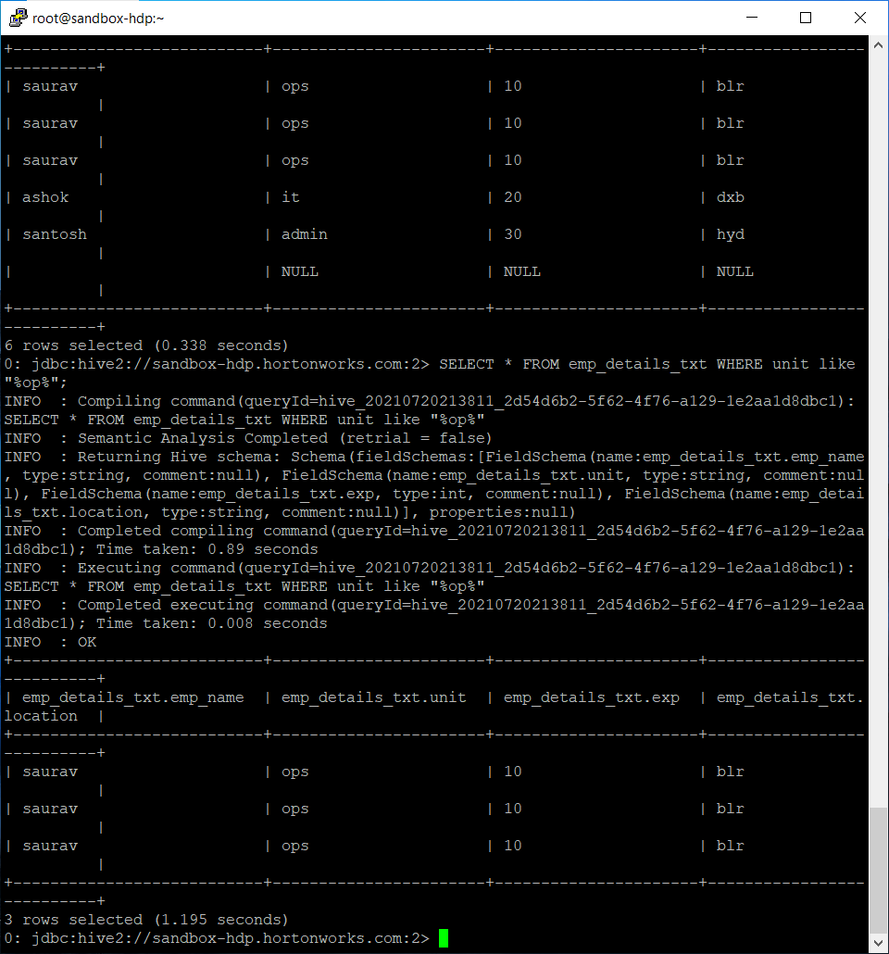

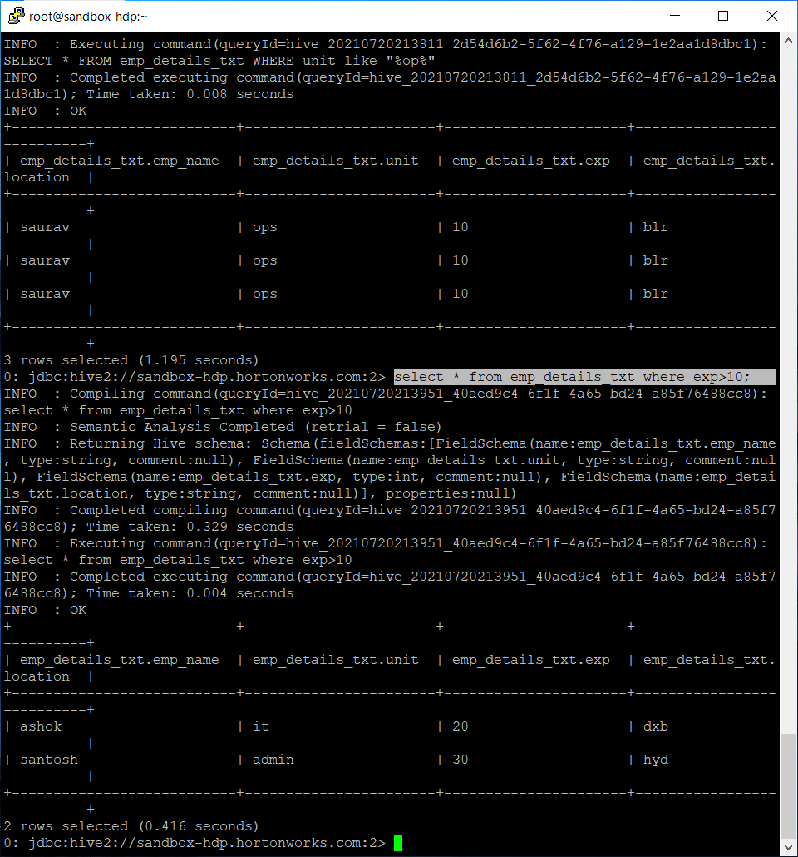

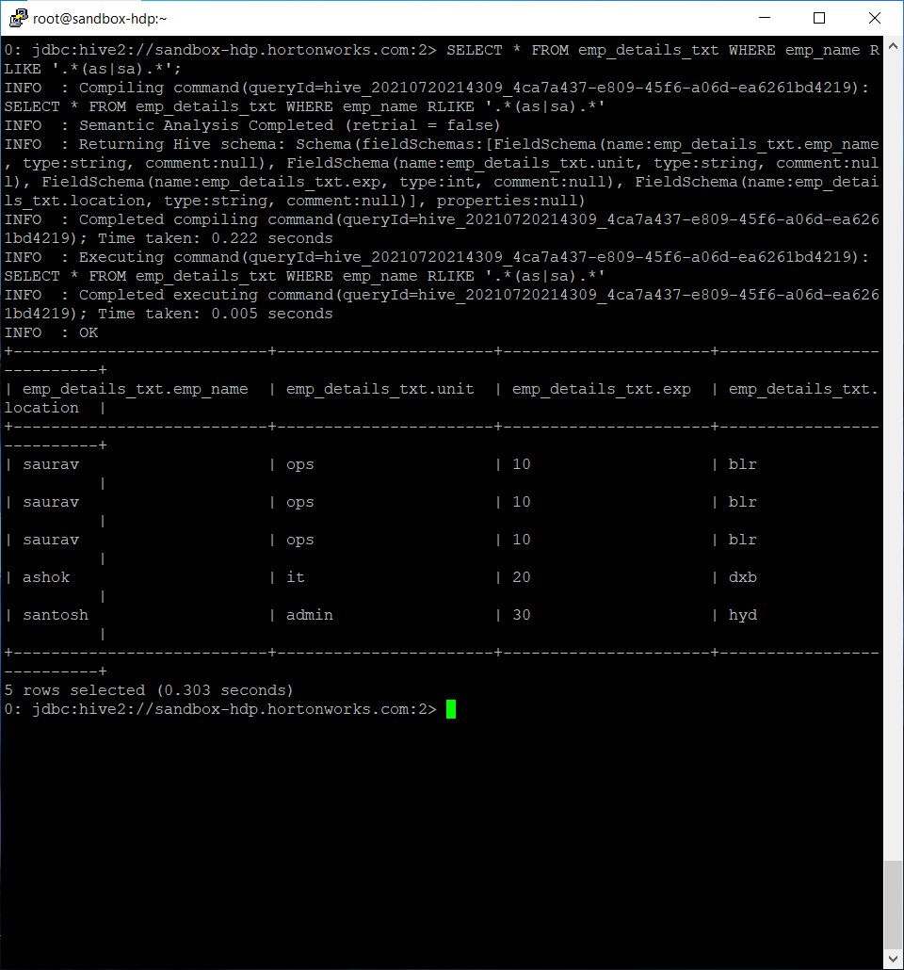

**Grouping on the basis of location:**

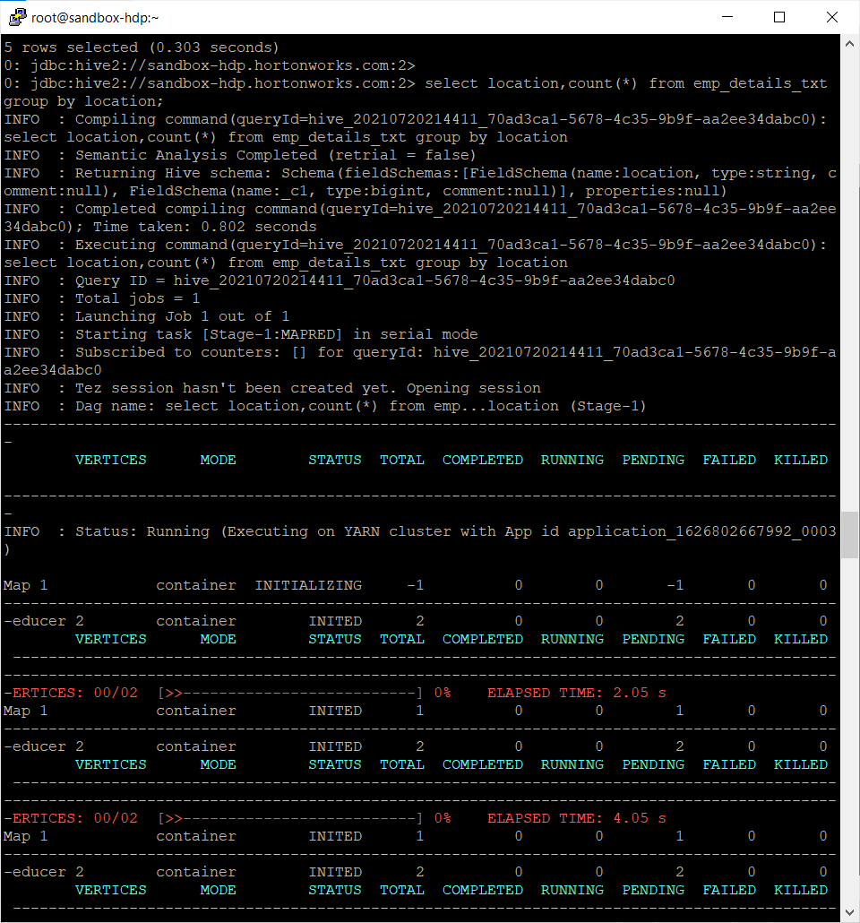

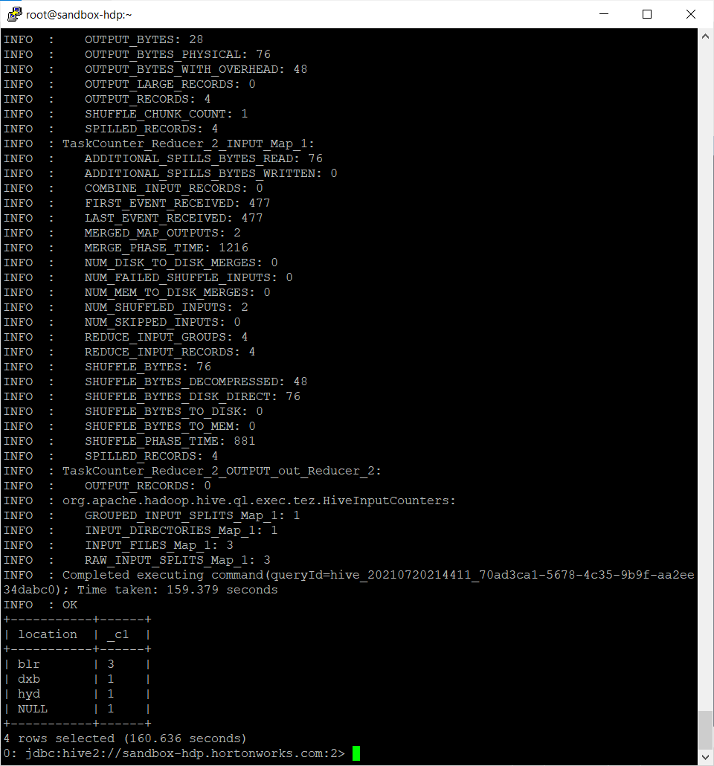

**Getting number of employees present in the locations where average experience of employees is**

**greater than 1.5 years**

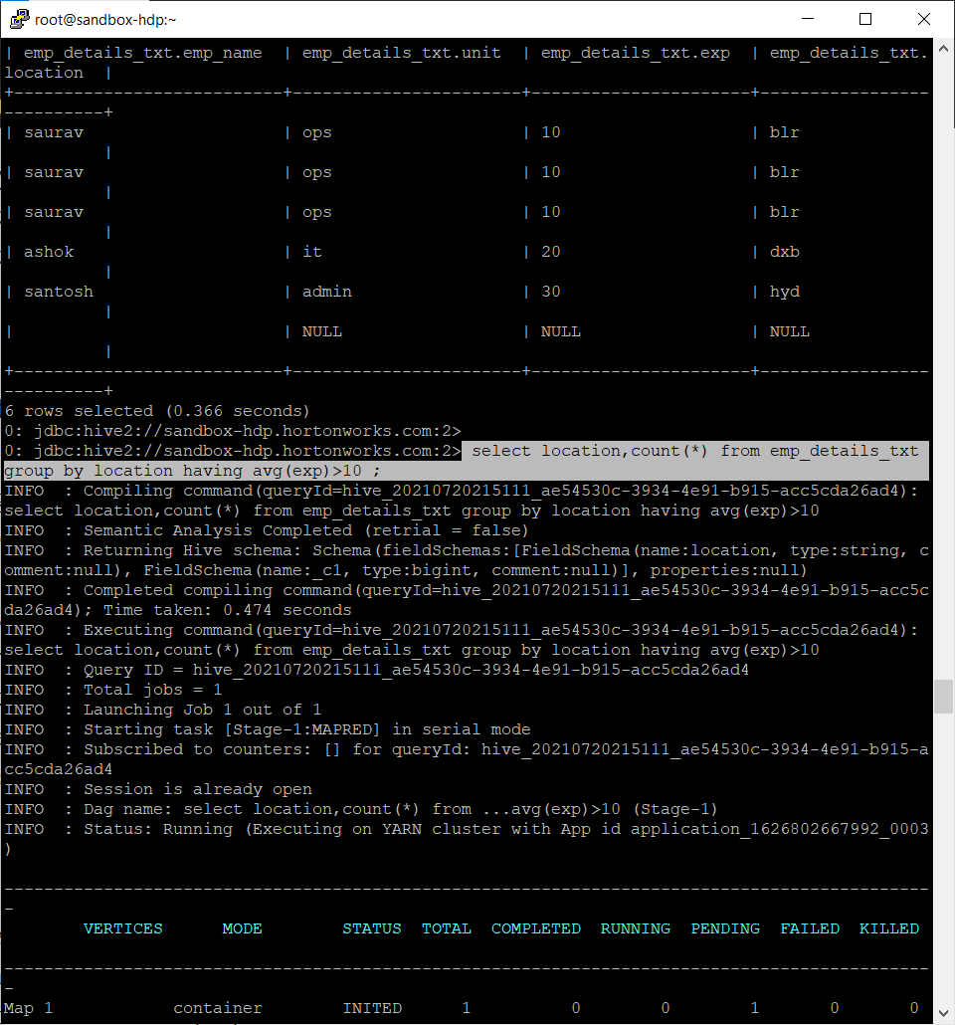

**SELECT * FROM emp_details_txt ORDER BY exp DESC;**

**EXPLAIN command:**

**Creating external tables:**

**Creating complex data type table:**

**Fetching data from complex data type table:**

**Using -e and -f**

**Adding the -S for silent mode:**

