**(1)**

(a) 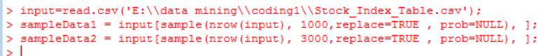

(b)

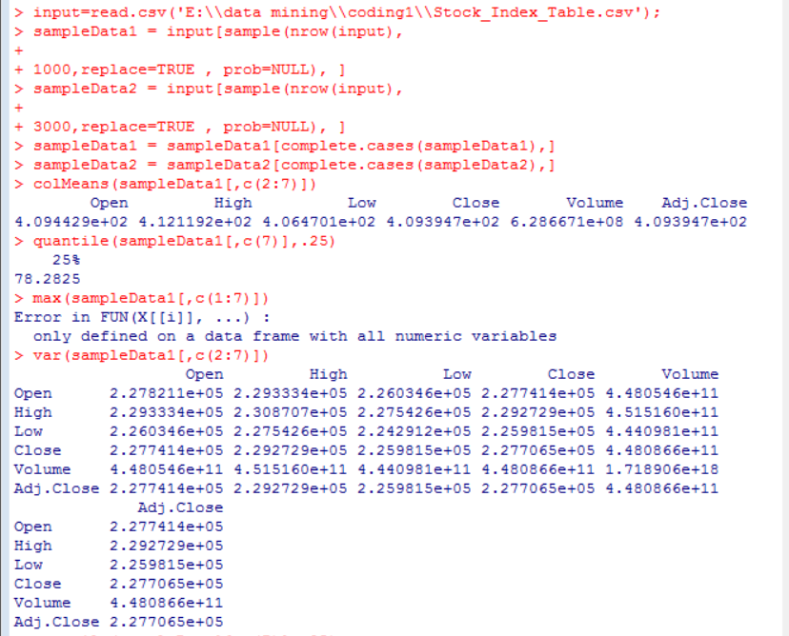1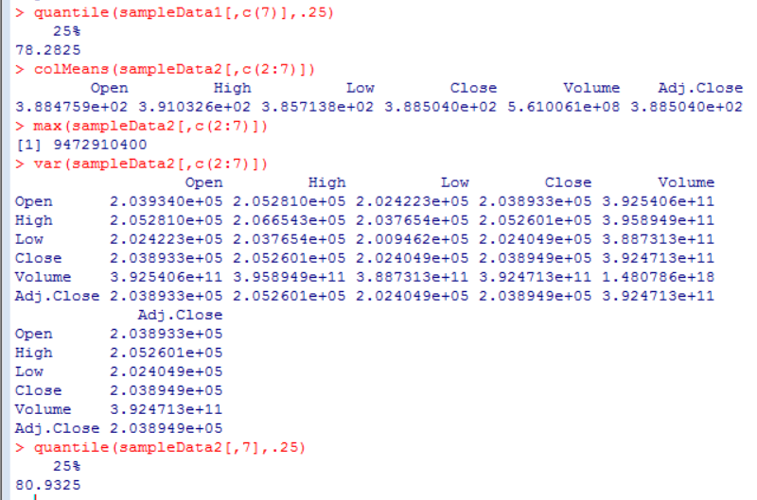

(c)

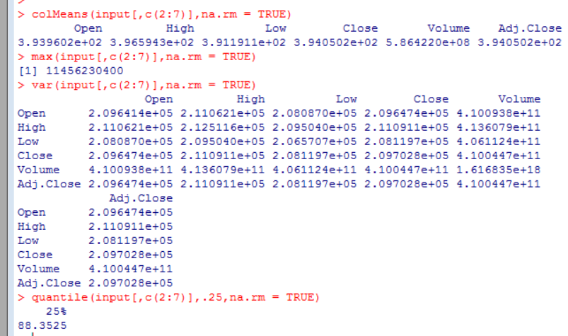

(d)

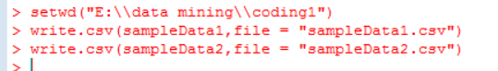

(e)

boxplot(stockData[,2],stockData[,3],stockData[,4],stockData[,5],main="Box Plot")

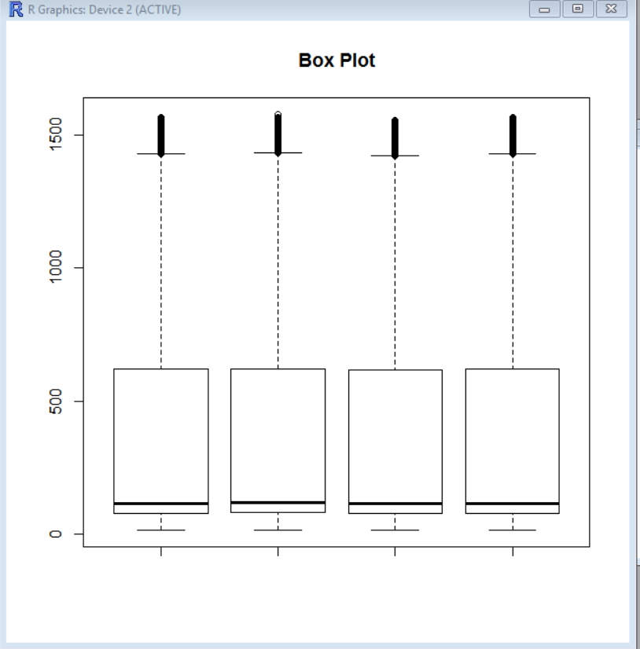

(f)

hist(stockData[,5],breaks<-seq(0,1600,by=2),main="Histogram",xlab="Close")

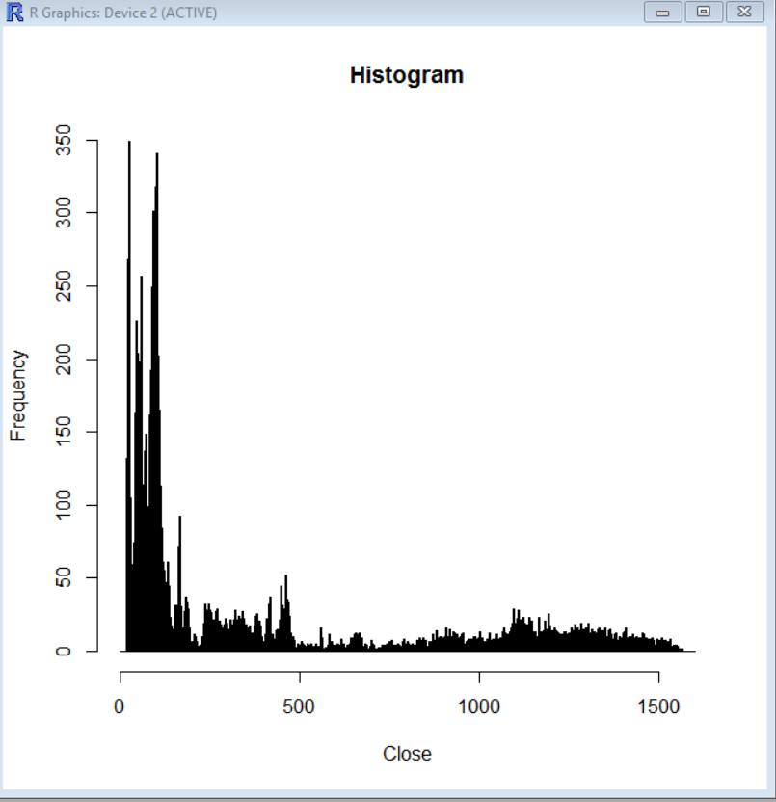

**(3)**

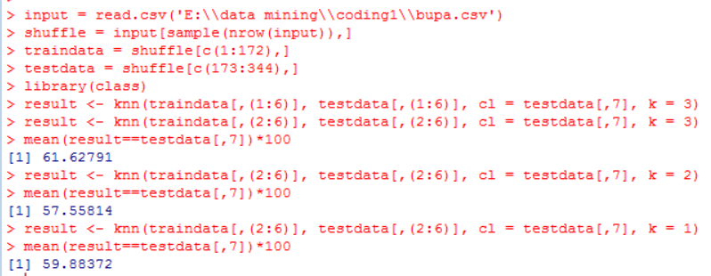

**(4)**

**minimum support of 3**

**Candidate 1 Itemset:**

|  |  |
| --- | --- |
| Itemset | Frequency Count |
| A | 6 |
| B | 6 |
| C | 3 |
| D | 8 |
| E | 6 |
|  |  |
|  |  |

**Candidate 2 Itemset:**

|  |  |
| --- | --- |
| Itemset | Frequency Count |
| AB | 4 |
| AC | 2 |
| AD | 5 |
| AE | 2 |
| BC | 2 |
| BD | 4 |
| BE | 4 |
| CD | 2 |
| CE | 2 |
| DE | 5 |

**Candidate 3 Itemset:**

|  |  |
| --- | --- |
| Itemset | Frequency Count |
| ABD | 3 |
| BDE | 3 |

**Candidate 4 Itemset:**

|  |  |
| --- | --- |
| Itemset | Frequency Count |
| ABDE | 2 |

**Frequent Itemsets:**

|  |  |
| --- | --- |
| Frequent Item sets | Frequency Count |
| A | 6 |
| B | 6 |
| C | 3 |
| D | 8 |
| E | 6 |
| AB | 4 |
| AD | 5 |
| BD | 4 |
| BE | 4 |
| DE | 5 |
| ABD | 3 |
| BDE | 3 |