**Capstone Project: Sport Analysis**

**MESE Breakdown**

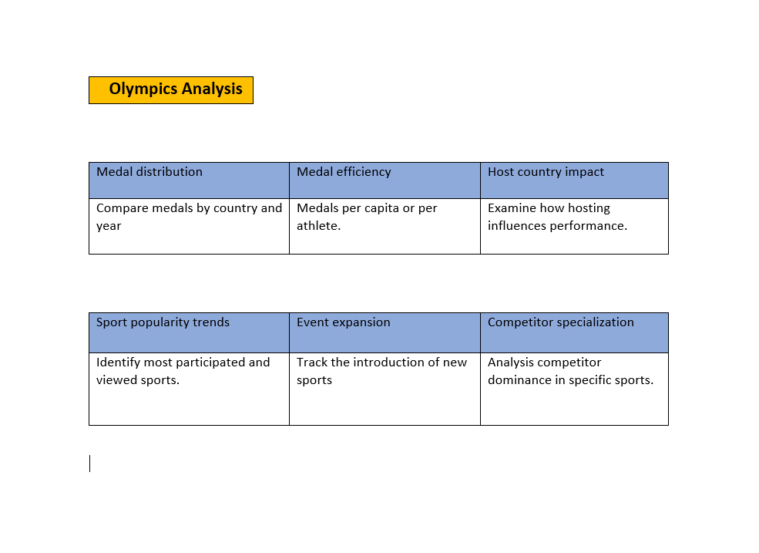

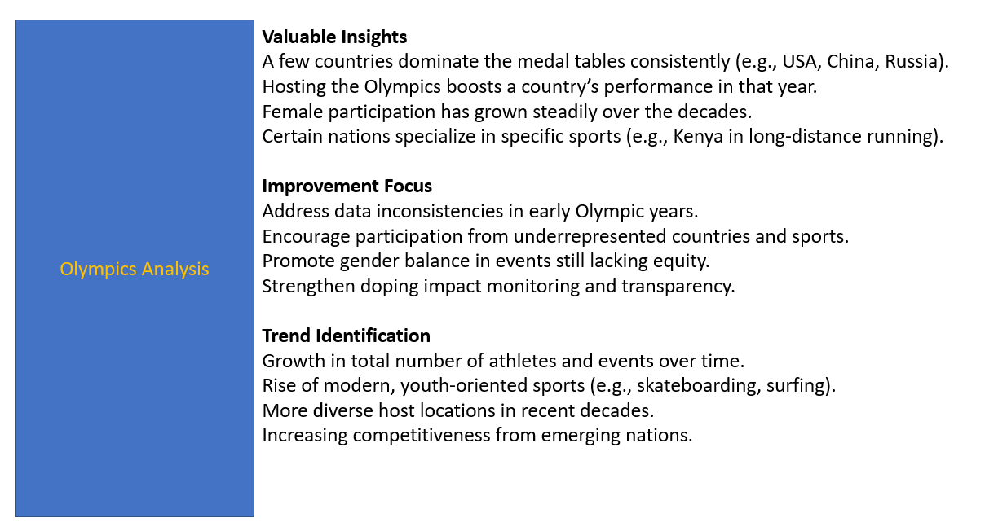

### 🏅 ****Introduction: Olympic Analysis****

The Olympic Games represent the pinnacle of international sports competition, bringing together athletes from around the globe to compete at the highest level. Held every four years, the Summer and Winter Olympics showcase athletic excellence, cultural exchange, and global unity. With a rich history spanning over a century, the Games provide a wealth of data that offers deep insights into global sports trends, participation, and achievements.

This Olympic Analysis project explores and visualizes comprehensive historical data related to the Olympics. It focuses on key dimensions such as:

* **Games distribution across decades and seasons**
* **Cities and regions that hosted the most Olympic Games**
* **Medal counts by country, gender, and sport**
* **Demographics of participants, including age and gender**
* **Geographical distribution of medals and participants**

The goal of this analysis is to uncover patterns, highlight standout nations and athletes, and provide a visual understanding of how the Olympic Games have evolved over time. By leveraging data visualization tools in Power BI, this report aims to present findings in a clear, engaging, and insightful manner for both casual observers and sports enthusiasts.

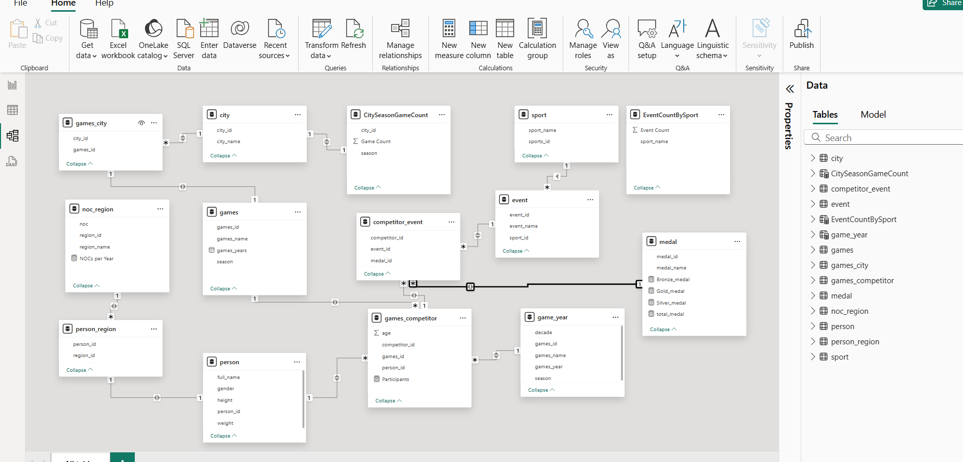

**Power BI Data Model Overview**

This data model appears to relate to Olympic or sports event analytics. It integrates tables related to:

* **Games**
* **Cities and Regions**
* **Participants (Persons and Competitors)**
* **Events and Sports**
* **Medals**
* **Aggregated Metrics**

**🧩 Key Relationships Identified**

1. **Games Table**:
   * Central table with games_id.
   * Linked to games_city, games_competitor, and game_year.
2. **Participant Data**:
   * person → person_region → noc_region
   * games_competitor connects person_id and games_id (many-to-one).
3. **Event Data**:
   * event connected to sport via sport_id.
   * competitor_event links competitor participation in events with medals.
4. **Medals**:
   * medal connected to competitor_event via medal_id.
5. **Aggregated Tables**:
   * CitySeasonGameCount (city-level game count per season)
   * EventCountBySport (event count per sport)
   * Games_year (game_id, decades, games_name , Games_year, season

**📌 Suggestions for Filtering Data**

Here are some ideas on how you could filter this data for deeper insights:

**1. Medal Analysis**

* **Filter by Region or Country**: Use noc_region and medal to summarize medals per region.
* **Filter by Gender or Athlete**: Join with person to analyze medals by gender or athlete attributes (e.g., height/weight).
* **Seasonal Trends**: Add a season filter from games for Summer vs Winter Games.

**2. Participation Insights**

* Filter by:
  + **Sport or Event** (sport_name, event_name)
  + **Game Year** via game_year or games
  + **Age** from games_competitor

**3. City/Host Analysis**

* Filter by city_name or region_name to track:
  + Hosting frequency (CitySeasonGameCount)
  + Game count per city
  + Event and participation intensity

**4. Event Popularity**

* Use EventCountBySport to show sports with the most events over time or by gender.

**✅ Useful Measures to Create**

1. NOCs per Year = DISTINCTCOUNT('noc_region'[noc])
2. Participants = DISTINCTCOUNT( competitor_event[competitor_id] )
3. total_medal = CALCULATE(COUNTROWS(competitor_event), FILTER(medal,medal[medal_name] <> "NA"))
4. Gold_medal = CALCULATE(COUNT(competitor_event[medal_id]),FILTER(medal,medal[medal_name] = "Gold"))
5. Silver_medal = CALCULATE(COUNT(competitor_event[medal_id]),FILTER(medal,medal[medal_name] = "silver"))
6. Bronze_medal = CALCULATE(COUNT(competitor_event[medal_id]),FILTER(medal,medal[medal_name] = "Bronze"))

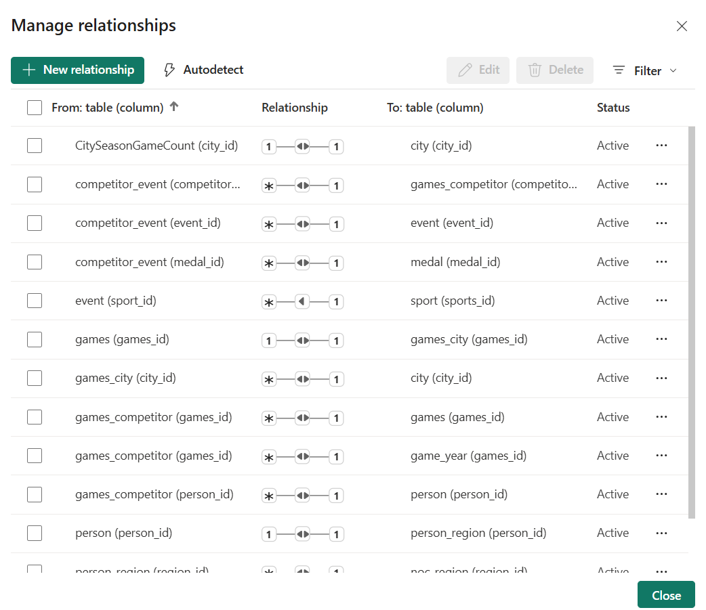

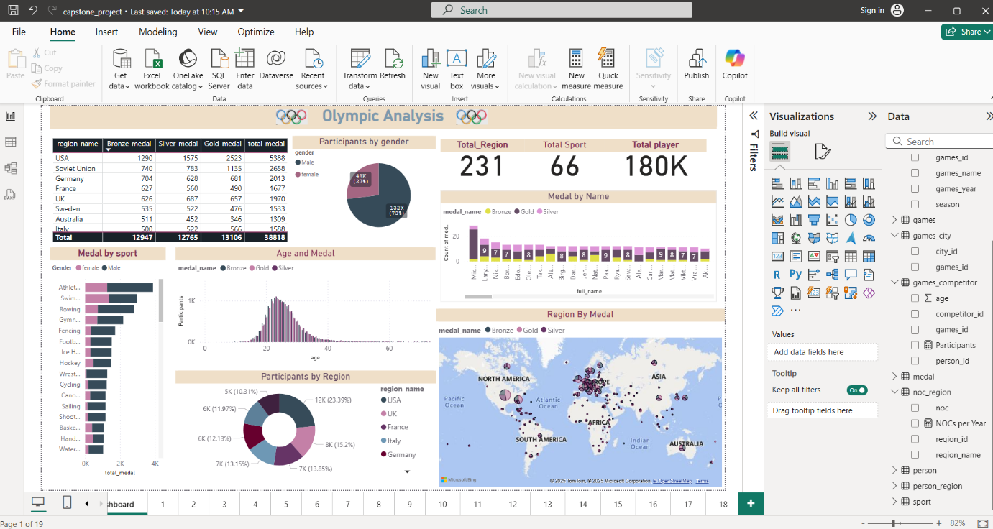

#### 1. ****Top Table: Medal Count by Region****

* Displays **total medals** (Bronze, Silver, Gold) by **region (country)**.
* **USA** leads with **5388 total medals**, followed by:
  + **Soviet Union**: 3261
  + **Germany**: 2013
  + **France**: 1677
  + **UK**: 1970

#### 2. ****KPI Cards (Top Right)****

* **Total Regions:** 231
* **Total Sports:** 66
* **Total Players:** 180K

### 📊 ****Middle Visuals****

#### • ****Participants by Gender (Pie Chart)****

* **Male:** 132K (73%)
* **Female:** 49K (27%)

#### • ****Medal by Name (Bar Chart)****

* Shows the **medal counts for individual athletes**, labeled by name.
* Each bar is segmented by medal type (Gold, Silver, Bronze).

### 📈 ****Bottom Visuals****

#### • ****Medal by Sport (Bar Chart)****

* Top sports for total medals:
  + **Athletics, Swimming, Rowing, Gymnastics, Fencing**
* Bars are broken down by **gender**.

#### • ****Age and Medal (Histogram)****

* Distribution of **participant ages** by **medal type**.
* Peak participation is around age **20–25**.

#### • ****Participants by Region (Donut Chart)****

* Shows top contributing regions:
  + **USA (23.39%)**
  + **UK (15.22%)**
  + **Germany, France, Italy** also prominent

#### • ****Region by Medal (Map Visualization)****

* A global map highlights **regional medal counts**.
* Bubble size and color intensity reflect **total medals and medal type**.
* Concentrated activity in **North America, Europe, parts of Asia and Oceania**.

### ****Visual 1: Bar Chart – Count of Games by Season****

* **X-Axis:** season (Summer, Winter)
* **Y-Axis:** Count of games_id
* **Insight:**
  + **Summer Games:** 29 editions
  + **Winter Games:** 22 editions  
    ✅ Summer Olympics have been held more frequently than Winter Olympics.

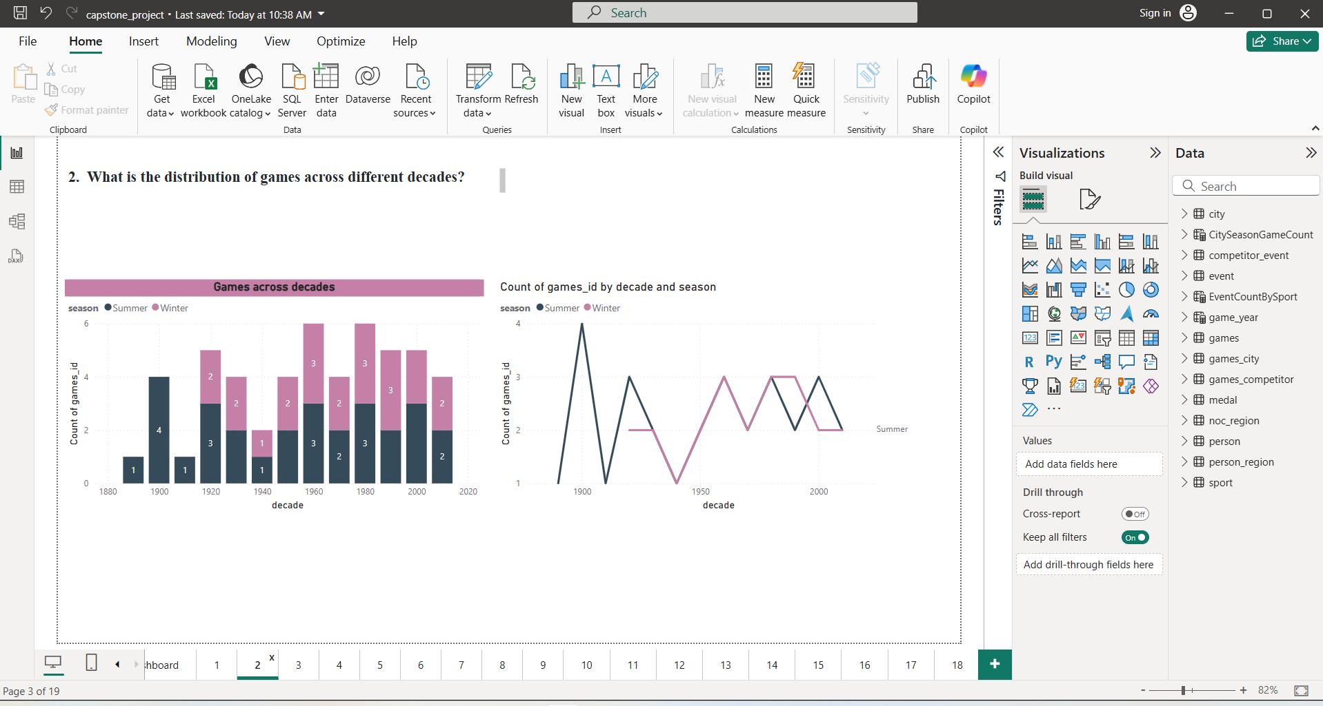

### 🔶 ****Visual 1 (Left): Stacked Bar Chart – Games Across Decades****

* **X-Axis:** decade (from 1890s to 2010s)
* **Y-Axis:** Count of games_id
* **Legend (Color):** season (Summer = dark, Winter = pink)
* **Insight:**
  + Both **Summer and Winter Olympics** are shown stacked to give a total per decade.
  + Notable trends:
    - The **1960s, 1980s, and 1990s** hosted the **most games**, with **up to 6 events** per decade.
    - Fewer games were held in **1940s and 1910s**, likely due to **World Wars**.
    - Summer Games dominated the early 20th century; Winter Games gained momentum later.

### 🔷 ****Visual 2 (Right): Line Chart – Count by Decade and Season****

* **X-Axis:** decade
* **Y-Axis:** Count of games_id
* **Line Colors:**
  + Black: **Summer**
  + Pink: **Winter**
* **Insight:**
  + **Summer Olympics** were consistently held almost every decade except during global conflicts.
  + **Winter Olympics** began later but became consistent post-1930s.
  + Both events show regularity from **1950s onward**.

### 📊 ****Visual: Bar Chart – City-wise Olympic Hosting Frequency****

#### ****Chart Title:**** City have Hosted Olympic

#### ****X-axis:**** city_name – names of host cities

#### ****Y-axis:**** Sum of Game Count – number of times the city hosted

#### ****Legend (Color-Coding):****

* **Dark Blue:** Summer Olympics
* **Light Pink:** Winter Olympics

### ****Chart Type:****

### 

* **Area Chart (Stacked Area Chart)**
* Title: **Top 10 Participants by Year and Sport Name**
* Time Period Covered: **1880 to 2020**
* X-Axis: games_year (shows progression over time)
* Y-Axis: Participants (number of athletes per sport)
* Legend: sport_name (different colors for different sports)

### 🎯 ****Key Insights Represented:****

* **Growth Trend:** There is a noticeable increase in participation across all sports over time, especially post-1960, indicating growing athlete involvement in the Olympics.
* **Top Sports by Participation:** Sports like **Wrestling, Weightlifting, Volleyball, and Water Polo** have consistently high participation.
* **Recent Additions or Growth:** Sports such as **Taekwondo, Table Tennis, and Triathlon** appear later on the timeline, showing they were added more recently and have grown steadily.

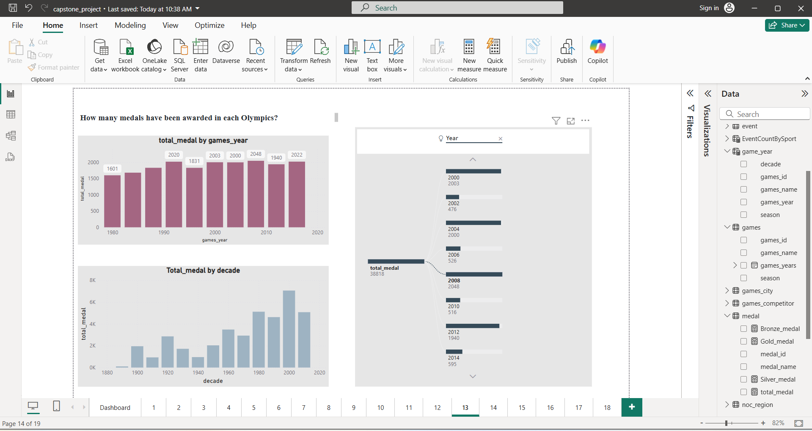

### 📊 Visuals Breakdown:

#### 1. ****Top Left: Column Chart –**** total_medal by games_year

* Displays the total number of medals awarded in each Olympic year from **1980 to 2022**.
* Key values:
  + **1980:** ~1600 medals
  + **2020:** ~2020 medals
  + **Highest:** 2048 medals in **2008**
* Shows a general **increasing trend** in medal distribution over time, reflecting the expansion of Olympic events.

#### 2. ****Bottom Left: Column Chart –**** Total_medal by decade

* Summarizes medal counts across decades from **1880s to 2020s**.
* Clear growth in medals awarded per decade, with a sharp increase starting from the 1980s.
* **2000s decade** records the **highest total medal count (~8000 medals)**, indicating a peak in event and athlete participation.

#### 3. ****Right Side: Decomposition Tree****

* Interactive visual showing breakdown of the total_medal by **Year** and subsequent attributes.
* Helps users **drill down** to explore how medals are distributed over various years (e.g., 2000, 2002, 2004...).
* Total medal count in this view is **38,818**, possibly representing the overall sum for a larger selected range or filter context.

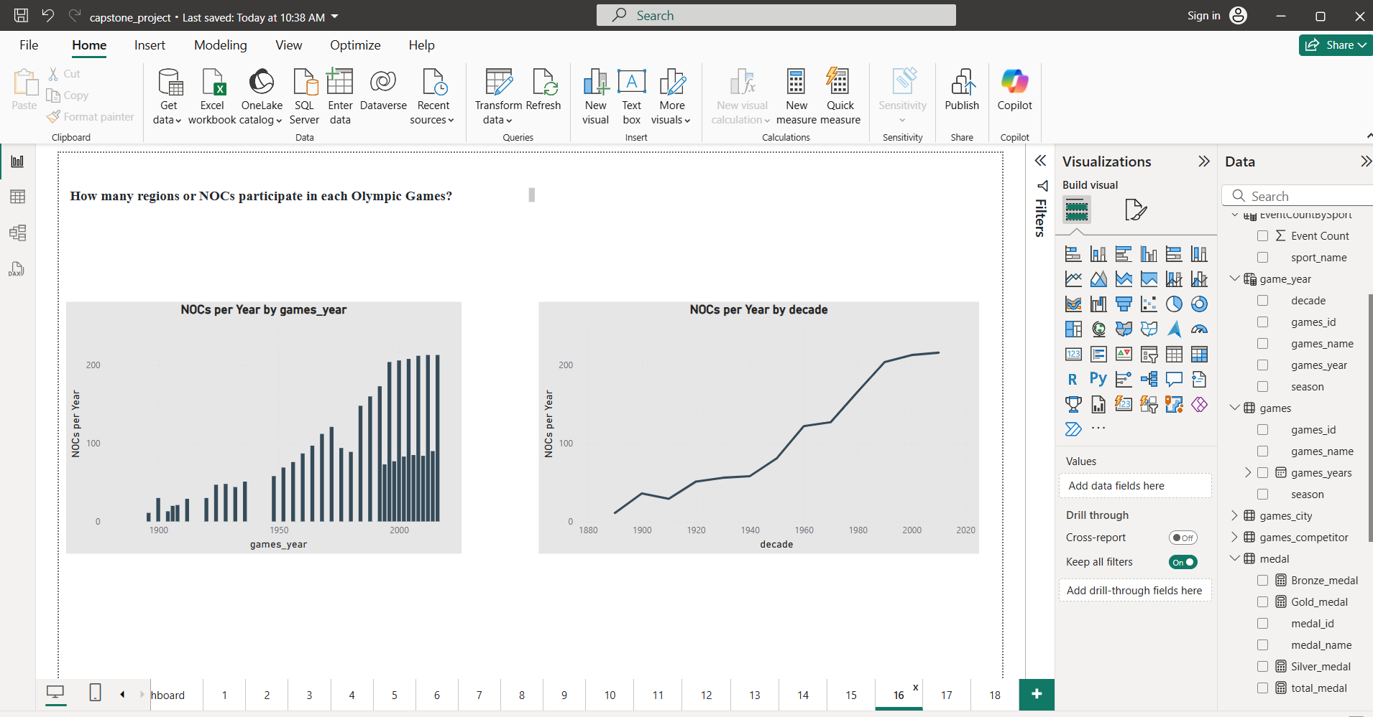

### 📊 ****Visual Overview****

#### 1. ****Left Chart – “NOCs per Year by games_year”****

* **Type:** Vertical bar chart
* **X-axis:** games_year (Olympic year)
* **Y-axis:** Number of NOCs (National Olympic Committees) participating
* **Insights:**
  + Shows a steady **increase in NOC participation** over time.
  + From **fewer than 20** participating countries in the early 1900s to **over 200** in recent Olympics.
  + There is noticeable growth post-1950, aligning with decolonization and increased global representation.

#### 2. ****Right Chart – “NOCs per Year by decade”****

* **Type:** Line chart
* **X-axis:** decade
* **Y-axis:** Average number of NOCs per year within each decade
* **Insights:**
  + Reinforces the upward trend over time.
  + A **major jump after the 1950s**, with another significant increase between **1980 and 2000**.
  + Participation stabilizes around **200+ NOCs** in the 21st century, showing Olympic Games are now a **truly global event**.

### ****Key Takeaways:****

* **Early Olympics** had limited participation, dominated by a small number of countries.
* **Geopolitical changes** (e.g., end of colonialism, formation of new nations) played a major role in increased NOC numbers.
* The **modern Olympics consistently attract over 200 NOCs**, representing a nearly **universal global presence**.