**ZAD Global School Huda Complex**



Winter Vacations Homework

**2018-19**

Name ____________________Class:- 1st Section____________

**“Winter is the time for comfort, for good food and warmth, for the touch of a friendly hand and for a talk beside the fire: it is the time for home.”**

**Dear parents**

**Winter break will commence from 31st December 2018 to 14th January 2019 .**

**The school will reopen on 15th January 2019, Tuesday. School will remain**

**working for all classes till Saturday the 29th of December.**

**Note:There will be P.T.M on 31st of December 2018, Timings 9 A.M to 12 Noon.**

**ZAD GLOBAL FAMILY WISHES YOU**

**Merry Christmas and Happy New Year 2019**

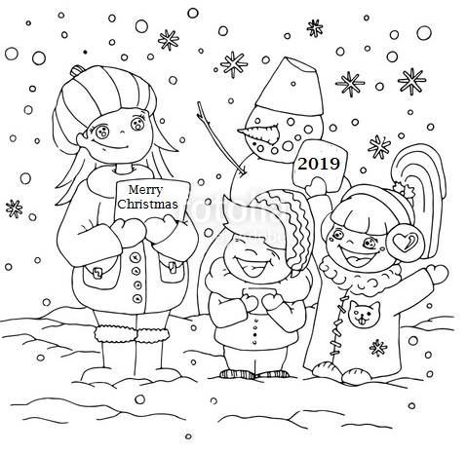**" Prosperity throughout the year, Happiness that multiplies, Health for you and yours, Fun around every corner, Energy to chase your dreams, Peace of mind and Joy to fill your holidays !”**

**English**

* **Learn syllabus of Term-2 done till now.**
* **Paste pictures of a Lion , a Dog and an Elephant in your class work notebook and write six lines on each .**
* **Learn poem “A Little Bird’s Song” and “I use my brain”**
* **Frame 6 sentences using Preposition ‘in , on , under’ and draw or paste their pictures also.**

**Hindi:-**

* कागज के प्रयोग से गुड़िया **o** चूहा बनाए¡ A
* गत्ते की सहायता से स्वरों का प्रयोग कर स्वर माला बनाए¡ A
* हरs कूड़ेदान **o** नीले कूड़ेदान पर एक मॉडल बनाए¡ A
* **f}rh; l=**  परीक्षा के करवाए¡ गए पाठों को याद करें A
* **dfork** Ch-19 and Ch-21 याद करें A

**Maths**

* **Do pages 125,126,130,133,138,148,152,153**
* **Paste five fake currency and write their values.**
* **Practice sums of Carry and Borrow ( 10 each) .**
* **Learn tables 2 to 8.**
* **Make five beautiful clocks with paper plate and show time of breakfast , lunch , dinner , play time and school time.**

**E.V.S**

* **Learn syllabus of Term-2 done till now.**
* **Write the telephone numbers of useful places with pictures in EVS class work notebook.**
* **Make a list of living and non-living things with pictures on A4 size sheet.**
* **Paste pictures of different means of transport in EVS class work notebook.**

**Project Work**

* **Make traffic lights using waste material.**

**OR**

* **Make a scenery showing a valley , also show houses and plants using cardboard / thermocol sheet.**

**G.K :**

* **Make flash cards showing traditional and modern means of transport.**
* **Make a poster of birds / water animal on a chart.**

**Note: Do all the given work in Holidays Home work notebook.**