**ZAD Global School Huda Complex**



Winter Vacations Homework

**2018-19**

Name ____________________Class:- 2nd Section____________

**“Winter is the time for comfort, for good food and warmth, for the touch of a friendly hand and for a talk beside the fire: it is the time for home.”**

**Dear parents**

**Winter break will commence from 31st December 2018 to 14th January 2019 .**

**The school will reopen on 15th January 2019, Tuesday. School will remain**

**working for all classes till Saturday the 29th of December.**

**Note:There will be P.T.M on 31st of December 2018, Timings 9 A.M to 12 Noon.**

**ZAD GLOBAL FAMILY WISHES YOU**

**Merry Christmas and Happy New Year 2019**

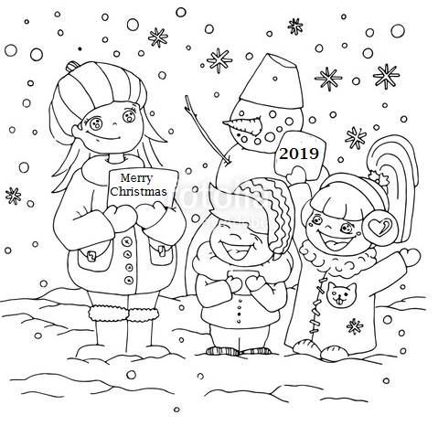**" Prosperity throughout the year, Happiness that multiplies, Health for you and yours, Fun around every corner, Energy to chase your dreams, Peace of mind and Joy to fill your holidays !”**

**English**

* **Paste the pictures showing use of Preposition of ‘Place’ and ‘Time’ and write one sentence about each on A3 size sheet**
* **Revise syllabus of Term-2 done till now.**
* **Learn poem 5 – The Song of the Engine.**
* **Visit a park and describe the park scene using Present continuous tense.**
* **Read five small stories. Write one of the story on A4 sheet and colour naming words with red and adjective with blue and also paste the picture of the story.**

**Hindi:-**

* **Revise Term-II Syllabus done till now.**
* **Learn and Write** गिनती(1 to 50) + पर्यायवाची शब्द (1 to 16)
* यदि आपके पास भी चिड़िया की तरह पंख होते तो आप क्या-क्या करते उसके विषय में एक अनुच्छेद लिखें |
* इंद्रधनुष का चित्र बनाइए और उसमें सही क्रम में रंग भरिए |
* सर्दी , गर्मी और वर्षा ऋतु के चित्र चिपकाकर उनके बारे में दो-दो वाक्य लिखिए |
* पेड़ हमारे लिए उपयोगी क्यों है किन्ही पाँच उपयोगी वृक्ष या पौधों के बारे में दो-दो पंक्तियां लिखिएँ |
* जमीन के नीचे , जमीन के ऊपर और बेल पर उगने वाल**h** सब्जियों के नाम लिखते हुए उनके चित्र बनाओ |

**Maths**

* **Do Practice of Whole Term-II syllabus done till now.**
* **Learn tables 7 to 13, Practice Jumbled tables 2 to 13 (2 times)**
* **Do the given worksheet and paste in maths notebook.**
* **Practice sums of Addition , Subtraction and Division.**
* **Draw beautiful clocks on A4 sheet with different time(Half past, Quarter past and Quarter to ).**

**E.V.S**

* **Learn Ch- 15, 17 , 18**

**Project Work**

* **Paste small cuttings of different types of clothes [cotton , wool , silk , nylon ,polyster etc.] in class work notebook.**
* **Take some cotton and use your finger and palm to make a thin thread. Paste this thread in class work notebook.**
* **Make a small first aid box. OR Make a poster on safety habits.**

**G.K : Do Holiday Homework -2 (Pg-44)**

**I.T : Revise Ch-1 to 7 for Quiz(Internal + Exercise)**

**Note: Do all the given work in Holidays Home work notebook.**

**ZAD GLOBAL SCHOOL(Huda Complex) Worksheet:**



**Name ……………........ Class – 2nd Sec-….…… Topic-Shapes**

**Roll No …………………. Subject :- Maths…… Date-……/……./2019**

**This is a shape of monster. Look carefully and complete the table.**

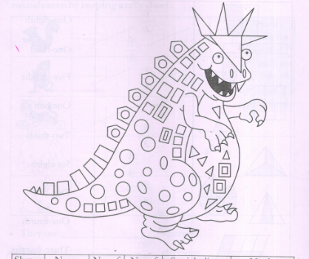

|  |  |  |  |  |  |
| --- | --- | --- | --- | --- | --- |
| **Shapes** | **Name** | **No. of**  **sides** | **No. of vertices** | **Straight lines**  **Or curved lines** | **No. in monster** |
|  |  |  |  |  |  |
|  |  |  |  |  |  |
|  |  |  |  |  |  |
|  |  |  |  |  |  |
|  |  |  |  |  |  |
|  |  |  |  |  |  |

**ZAD GLOBAL SCHOOL(Huda Complex) Worksheet:**



**Name ……………........ Class – 2nd Sec-….…… Topic-Shapes**

**Roll No …………………. Subject :- Maths…… Date-……/……./2019**

**This is a shape of monster. Look carefully and complete the table.**



|  |  |  |  |  |  |
| --- | --- | --- | --- | --- | --- |
| **Shapes** | **Name** | **No. of**  **sides** | **No. of vertices** | **Straight lines**  **Or curved lines** | **No. in monster** |
|  |  |  |  |  |  |
|  |  |  |  |  |  |
|  |  |  |  |  |  |
|  |  |  |  |  |  |
|  |  |  |  |  |  |
|  |  |  |  |  |  |