**ZAD Global School Huda Complex**



Winter Vacations Homework

**2018-19**

Name ____________________Class:- 3rd Section____________

**“Winter is the time for comfort, for good food and warmth, for the touch of a friendly hand and for a talk beside the fire: it is the time for home.”**

**Dear parents**

**Winter break will commence from 31st December 2018 to 14th January 2019 .**

**The school will reopen on 15th January 2019, Tuesday. School will remain**

**working for all classes till Saturday the 29th of December.**

**Note:There will be P.T.M on 31st of December 2018,Timings9:00 A.M to 12:00 Noon.**

**ZAD GLOBAL FAMILY WISHES YOU**

**Merry Christmas and Happy New Year 2019**

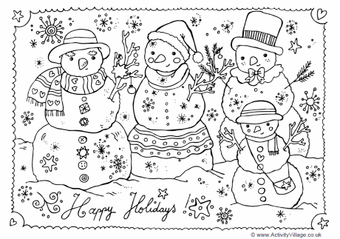**" Prosperity throughout the year, Happiness that multiplies, Health for you and yours, Fun around every corner, Energy to chase your dreams, Peace of mind and Joy to fill your holidays !”**

**English**

* **Revise syllabus of Term-2 done till now.**
* **Write a paragraph on “How you spent your Winter Vacations” using Simple Past Tense.**
* **You are going to attend your cousin’s marriage .Write a leave application to your principal.**
* **Learn poem ‘The House That Jack Built’**
* **Make a word chain of 20 words using the last alphabet of previous word.**

**eg. Abide – enlist – trumpet**

**Hindi :**

* **Learn + Write** मुहावरs **(11 to 15 ) +** पर्यायवाची शब्द**(9 to 16) in class notebook.**
* **Revise syllabus of Term-2 done till now.**
* **Draw the pictures on inventions of “ Thomas Alva Edison “ and write few lines about each.**
* थर्मोकोल शीट का प्रयोग करते हुए वृक्ष बनाएँ और उनके विभिन्न भागों के विषय में लिखें |
* क्या आपकी उम्र के बच्चों को व्हाट्सएप या फेसबुक का प्रयोग करना चाहिए | यदि हाँ तो क्यों यदि नहीं तो क्यों ?
* चिड़िया का घोंसला बनाएँ व कविता लिखें |

**EVS**

* **Revise Ch-16 to 18 with ex.**
* **Paste the pictures of National festivals and religious festivals in EVS notebook.**
* **Write 7 lines on ‘How we can keep ourselves healthy, fit and active’ in Holidays Home Work N.B.**
* **Dip an empty refill into the lemon juice and write a message on paper. Can you read it? No ! Carefully hold the paper near a candle flame. Now observe.**
* **Make a beautiful paper bag and write the slogan SAY NO TO POLYTHENE BAGS on it.**
* **Create an E-mail address for yourself. Ask your friend to send you an E-mail at your E-mail address.**

**Maths**

* **Do Practice of Whole Term-II syllabus done till now.**
* **Learn tables 2 to 15 + Do Practice of Jumbled tables 2 to 15**
* **Make a floor pattern by using any tiles shape (Hint : Pg 67)**
* **Make beautiful clocks showing times of Breakfast / Lunch / Dinner on it.**
* **Do Practice of Addition , Subtraction , Multiplication and Division sums.**

**G.K : Do Holiday Homework -2 (Pg-46)**

**I.T : Revise Ch-1 to 7 (Internal + Book exercise) for I.T Quiz**

**Note: Do all the given work in Holidays Home work notebook.**