**ZAD Global School Huda Complex**



Winter Vacations Homework

**2018-19**

Name ____________________Class:- 4th Section____________

**“Winter is the time for comfort, for good food and warmth, for the touch of a friendly hand and for a talk beside the fire: it is the time for home.”**

**Dear parents**

**Winter break will commence from 31st December 2018 to 14th January 2019 .**

**The school will reopen on 15th January 2019, Tuesday. School will remain**

**working for all classes till Saturday the 29th of December.**

**Note:There will be P.T.M on 31st of December 2018,Timings9:00 A.M to 12:00 Noon.**

**ZAD GLOBAL FAMILY WISHES YOU**

**Merry Christmas and Happy New Year 2019**

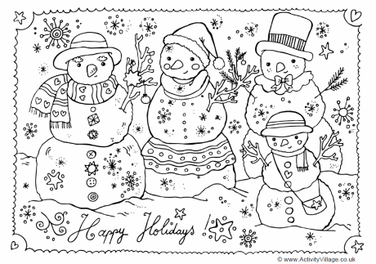**" Prosperity throughout the year, Happiness that multiplies, Health for you and yours, Fun around every corner, Energy to chase your dreams, Peace of mind and Joy to fill your holidays !”**

**English**

* **Revise syllabus of Term-2 done till now.**
* **Learn poem “Laughing Song”**
* **Write a paragraph on “How you celebrate New Year” using Simple Past Tense on A4 size sheet and also paste picture of celebration.**
* **Write a letter to your friend inviting him for New Year Party.**
* **Listen English news daily and mention two main important incidents happened in the country.**

**Hindi :**

* + **Learn + Write**  **पर्यायवाची शब्द(21 to 32 ) +** विलोम शब्द**(19 to 28) in class work notebook.**
* **Revise syllabus of Term-2 done till now.**
* **Make a chart of Indian festivals and write few lines about each.**
  + आप बड़े होकर क्या बनना चाहते हो और क्यों ? अपने शब्दों में लिखिए**(100-150** शब्द)
* “ शरद ऋतु ” पर आधारित एक स्वयंनिर्मित कविता लिखें |
* **विभिन्न वाद्य यंत्रों के चित्र - चिपकाकर उनके विषय में कुछ वाक्य लिखें |**

**Maths:**

* **Revise whole syllabus of Term-II till done in class**
* **Do practice of Addition , Subtraction , Multiplication and Division sums**
* **Learn tables 2 to 20.**
* **Make a clock with the help of waste material.**
* **On a chart paper , make a time line showing the important events in your life. Paste your pictures related to each event on it.**
* **Take a graph paper, Make 5 different pattern of leaves on it, then find the approximate area of each leaf.**

**Science**

* **Revise Ch-8 to Ch-12 with ex.**
* **Visit a zoo. Find out the animals that lay eggs and also the ones that give birth to their young ones. Make a list of all of them in HHW notebook.**
* **Write 7 lines on ‘The importance of Solar Energy.’**
* **Make a chart of different types of energy with pictures.**
* **Take a piece of coloured cloth and dip one end of it in some water in a mug . The water will rise up steadily, wetting it . Find out why the water rises up the cloth.**

**S.St:**

* **Revise Ch-5,8**
* **Make a collage on renewable resources(Roll No. 1-20), Make a collage on non renewable resources (Roll No. 21-38)**

**G.K : Do Holidays Homework-2(Pg 52 and 53)**

**I.T :**  **Draw and color the LOGO Window and its part on half chart paper**

**Note: Do all the given work in Holidays Home work notebook.**