**ZAD Global School Huda Complex**



Winter Vacations Homework

**2018-19**

Name ____________________Class:- 5th Section____________

**“Winter is the time for comfort, for good food and warmth, for the touch of a friendly hand and for a talk beside the fire: it is the time for home.”**

**Dear parents**

**Winter break will commence from 31st December 2018 to 14th January 2019 .**

**The school will reopen on 15th January 2019, Tuesday. School will remain**

**working for all classes till Saturday the 29th of December.**

**Note:There will be P.T.M on 31st of December 2018,Timings9:00 A.M to 12:00 Noon.**

**ZAD GLOBAL FAMILY WISHES YOU**

**Merry Christmas and Happy New Year 2019**

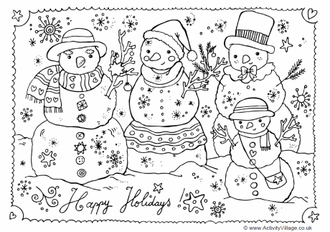**" Prosperity throughout the year, Happiness that multiplies, Health for you and yours, Fun around every corner, Energy to chase your dreams, Peace of mind and Joy to fill your holidays !”**

**English**

* **Revise syllabus of Term-2 done till now.**
* **Write a factual description on your favourite place where you often want to visit.**
* **Visit a temple and describe the temple scene using past Continuous Tense.**
* **Search 2 new words from dictionary daily. Write Their meanings and also make sentences using these words .**

**Hindi :**

* + **Learn + Write**  **पर्यायवाची** शब्द**(21 to 34 ) +** विलोम शब्द**(31-44) in class work notebook.**
* **Revise syllabus of Term-2 done till now.** 
  + **प्रतिदिन डायरी लिखें |**
  + **सर्दियों में खाई जाने वाली किसी वस्तु की बनाने की विधि लिखे |**
  + **पढ़े गए पाठों में से संज्ञा , सर्वनाम** o **विशेषण शब्द छाँटकर लिखें|**
  + **"शिक्षा पाना प्रत्येक बच्चे का अधिकार है" इस विषय पर अनुच्छेद लिखें |**
  + **मेट्रो ट्रेन के बारे में जानकारी एकत्रित करके परियोजना तैयार करें व थर्मोकोल के प्रयोग से मेट्रो ट्रेन बनाएँ |**

**Maths**

* **Do Practice of whole Term-II syllabus done till now.**
* **Draw any 5 different shapes on a square grid/ graph sheet and find area and perimeter.[Hint- Pg: 159,165 ]**
* **Measure the temperature for 1 week in the Morning at 6:00 a.m and at night at 9:00 p.m and make a record on A4 size sheet.**
* **Do Practice of sums of Multiplication , Division , Factors & Multiples.**

**Science:**

* + **Revise whole syllabus of Term-II done in class.**
  + **Make a model of human skeletal system.**
  + **Make a neat and clean chart on Layers of atmosphere or composition of air**
  + **Make it a habit :- If you or your family members want to go some where, walk as much as you can. Use the bicycle or rickshaw instead of using vehicles that run on petrol or diesel. Use public transport instead of using your own vehicle. In this way you can reduce air pollution and be healthy as well.**
  + **Observe the moon for 15 days straight from the day one, when no moon is seen in the sky. Draw the shapes of the moon, as you observe today. Write the day and date below the figure.**

**S.St**

* + **Make a collage on the animals of frigid zone.**
  + **Prepare a documentary on natural disasters.**

**I.T :**

* **Revise ch-1 to 6 and 10 for I.T Quiz(Internal + Book exercise).**
* **Make a collage on Computer’s short cut keys OR Parts of Computer on chart.**

**G.K : Do Holidays Homework-2(Pg 53,54)**

**Note: Do all the given work in Holidays Home work notebook.**