**ZAD Global School Huda Complex**



Winter Vacations Homework

**2018-19**

Name ____________________Class:- L.K.G Section____________

**“Winter is the time for comfort, for good food and warmth, for the touch of a friendly hand and for a talk beside the fire: it is the time for home.”**

**Dear parents**

**Winter break will commence from 31st December 2018 to 14th January 2019 .**

**The school will reopen on 15th January 2019, Tuesday. School will remain**

**working for all classes till Saturday the 29th of December.**

**ZAD GLOBAL FAMILY WISHES YOU**

**Merry Christmas and Happy New Year 2019**

**" Prosperity throughout the year, Happiness that multiplies, Health for you and yours, Fun around every corner, Energy to chase your dreams, Peace of mind and Joy to fill your holidays !”**





**Activities for Holidays Homework**

1. **Make a face mask of any favourite fruit.**
2. **Best out of waste-> Make a snowman with waste materials on A4 Sheet / Model**
3. **Complete the train with alphabets with related pictures in boggies**

A

R

**of your name (in Notebook).**

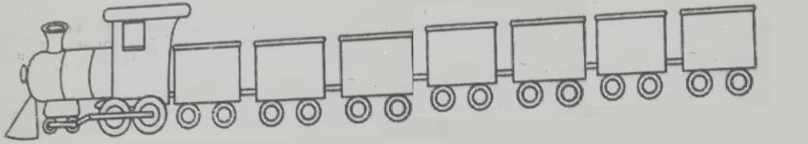

1. **Make a beautiful butterfly with paper tearing & pasting activity.**

**English -Say and Write Capital alphabets (A to Z ) ,**

**Practice Print letters-: ( c, a , i, o, r, m ,n ,s ,v,w,x, y,z ) (2 times)**

**Hindi - Say and Write d ls o (2 times)**

**Maths- Practice Dictation 0 to 100 ( 2 times)**

**Note : Do all the given work in Holidays Home Work notebook**