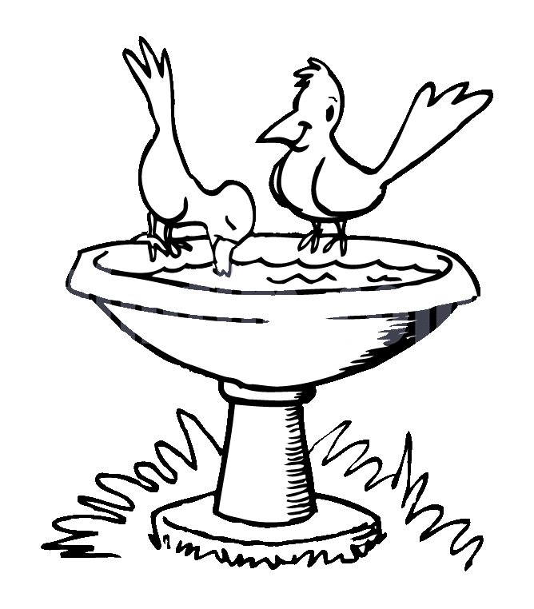**ZAD Global Sr. Sec. School**

**Summer Engagement**

**2019-20**

**Lower Kindergarten kids [LKG]**

**Name ………..**

**Colour and Decorate the picture.**

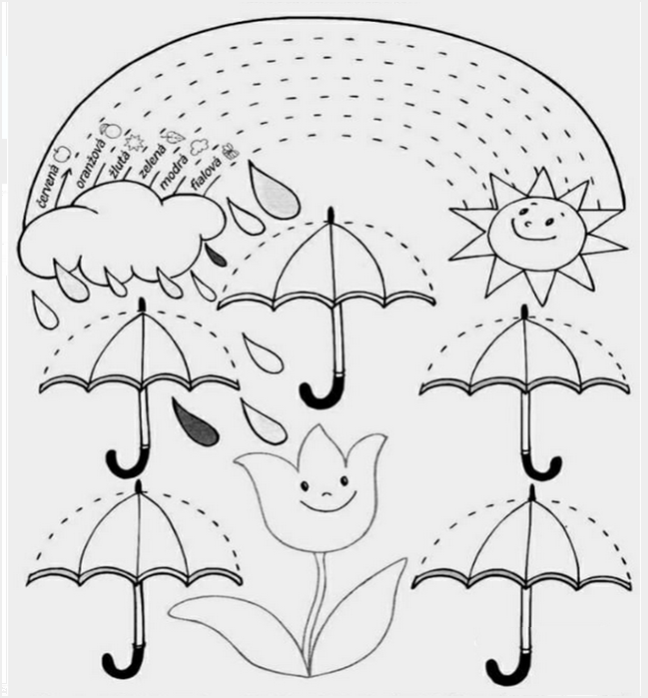

**ZAD Global Sr. Sec. School**

**Summer Engagement**

**2019-20**

**Name…………………Class L.K.G Section ………………….**

**In our head, we hear a humming,**

**Summer, summer, summer’s are coming**

**Soon we’re all going on a vacation**

**Gearing up with wonderful sensations.**

**Dear parents,**

The much awaited summer vacation is knocking at the door ! The very thoughts of summer break include image of time for relaxation to escape the heat , pursuing of leisure activities and including in good quality time with friends and family . There are plenty of productive ways that your ward can spend the vacation which can be fun relaxing and helpful for his/ her education career.

We wish to imbibe in our students the willingness to spend their summer vacation well .

**Some suggestions in this regard –**

* Practice spoken English at home.
* Encourage your child to read , give him / her some picture book for reading .
* Tell your children to save electricity and water.
* Have at least two meals together with your children. Teach them not to waste their food. Use a napkin and try not make a mess at mealtimes .
* When your child play make-believe they use their imaginations and develop creativity and praise your child when he/ she show their creativity.
* Share stories about your childhood and your family history.
* Be careful of your tone and body language when you talk to a child
* Allow your child to help you at home in household work like watering plants , arranging the dining table , organising his / her cupboard / room and praise him / her for the same.
* Don't give mobile to your child for playing games. Ask them to play outdoor games in evening for indoor games.
* Fix limited time to watch TV that also few particular channels like animal planet , Discovery Channel , Nick Junior etc.
* Make your ward learn and remember his/ her parents mobile/ landline number, House address etc. to make him/ her independent and secure.

**Vocabulary for a day**

Everyday choose a letter and start the day with it like letter -B

In breakfast you can give banana , bread and butter. Go to park and search the things like ball , baby , bench , butterfly , bee etc.

End of the day let him /her count the total words by recalling all the words.

**STAR PERFORMER OF THE HOUSE**

|  |  |  |  |  |  |  |  |
| --- | --- | --- | --- | --- | --- | --- | --- |
|  | MON | TUE | WED | THU | FRI | SAT | SUN |
| I can water plants |  |  |  |  |  |  |  |
| I can help mom |  |  |  |  |  |  |  |
| I love to share |  |  |  |  |  |  |  |
| I can arrange the room |  |  |  |  |  |  |  |

Appreciate them for their efforts.

**Use of Magic words like EXCUSE ME , SORRY , THANKS , PLEASE , MAY I.**

* **When asking for something , say “Please”.**
* **When receiving something , say “ Thank you”.**
* **Don’t interrupt grown- ups who are speaking with each other unless there is an emergency.**
* **If you need to get somebody's attention right away , the phrases “excuse me” is much polite way for you to enter the conversation.**
* **When you have any doubt about doing something ask permission first it can save you from many hours of grief letter .**

**The teachers are trying to encourage the children to use simple words , phrases and sentences like:-**

* **May I go to play?**
* **I have finished work .**
* **Ma’am may I go to the washroom?**
* **Ma’am may I go to the drink water?**
* **Ma’am may I come in please ?**
* **Ma’am may I go to wash my hands ?**
* **Ma’am I want to sit in the front row as I can't see from the back.**
* **Ma’am please repeat the concept as I am unable to understand it.**
* **Ma’am I have lost my shoes / blazer / tiffin box / water bottle etc..**
* **Ma’am I came late as I missed my bus. I am sorry for the delay.**
* **Ma’am , I am sorry , I have forgotten to bring my book , notebook , pencil / eraser drawing book etc.**
* **Ma’am I am sorry I couldn't complete my homework as I was unwell.**
* **Ma’am may I borrow a pencil / eraser / ruler etc. From my partner as I have forgotten to bring it today.**
* **Could you hand me the book.**
* **Could you please shut the door.**

**Children can be encouraged to use simple words and sentences at home also. For example-**

* **Mummy , can I help you in the kitchen.**
* **Mummy , can I lay the table today.**
* **Mummy , should I help you wash the dishes today.**
* **Papa, can I help you wash the car.**
* **Grandpa, should I come with you for a walk.**
* **Mummy can I get you glass of water.**
* **Mummy , may I take some more Ice - Cream for the fridge?**
* **Papa , I'm sorry I was rude to you.**
* **Papa , please teach me how to ride a bicycle.**
* **Didi , can you help me find my English notebook.**
* **Papa , can we go cycling together today.**
* **Wishing people properly- Hello Uncle / Aunty , How are you ?**
* **Wishing parents and elders Good morning , Good Afternoon , Good Evening and Good Night. If we as teachers and parents make a sincere effort and pay attention to the above mentioned points , we can help our children to learn to understand and speak English at an early age .**
* **The School has also devised some summer holiday homework that is linked to the curriculum and is also creative to monitor the progress of your ward.**
* **Please assist rather than take over , this would help in enhancing the child’s creative skills.**

**Note: Summer break will commence from 25th May 2019 and the school will reopen on 4th July 2019(Thursday).**

**Submit the holidays homework in a folder by 8th July 2019**

**English**

**Note :-Do the given work on pink colour A4 sheets.**

* Draw and colour letter and paste fresh leaves under it.
* Draw and colour letter and paste small Tringle Δ shape paper under it.
* Make letter L, T, H, I with the help of straw / Ice-cream sticks / tooth pick etc. and Paste 4-4 pictures related to each letters. L, T, H, I.
* Do written practice of L, T, I, H (Three Times) each in N.B.

**Hindi**

**Note:-Do the given work on Yellow colour A4 sheets.**

* Learn any one Hindi rhyme with action from You-tube on rainy season.
* Do written practice of **i** ,**"k** ,**Q** (Three Times) each in N.B.
* **diM+s ;k dkxt dk iz;ksx djds i - ijnk** बनाएं |
* माचिस की तीलियों की सहायता से एक बड़ा ष**-** षटकोण बनाएं
* **xqykc ds Qwy dh** पंखुड़ियां **dk iz;ksx djds Q- Qwy cuk,** |

|  |  |
| --- | --- |
| |  | | --- | |  | |

**Maths**

**Note:- Do the given work on Sky Blue colour A4 sheets.**

* Make Abacus with digits 1, 4, 7
* Paste or draw any two pictures of **Wet and Dry + Big and Small** Concept.
* Do written practice of 1, 4, 7 (Three Times) each in N.B

**E.V.S.**

**Note :Do the given work on Green colour A4 sheets.**

* Make a collage with the photograph of your family members.
* Take printout of your 2 favourite cartoon characters and fill colour in it.

**Project**

* Paste / Draw your favourite fruits in the basket.
* Visit to the near by market place and paste pictures of any five food items which you see in the market.
* Use red , blue, pink, Yellow and green colours on your hand and make hand impressions.

. Dear parents,

Kindly help your ward in learning these lines of Self Introduction**.**

Respected principal Ma’am, teachers and my dear friends.

Good Morning,

* My name is ……………. .
* I am student of LKG …………. In Zad Global School.
* My favourite food is ……………… .
* My favourite colour is …………… .
* I don’t like junk food
* I live in Rohtak ( Haryana ).
* I love my country India.

Thank you, Have a nice day.