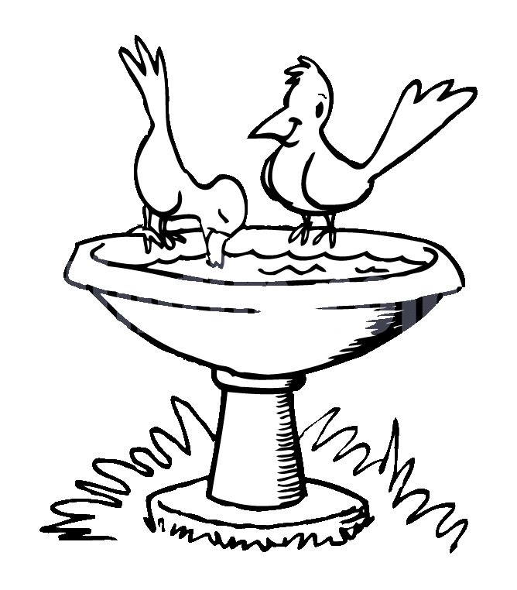**ZAD Global Sr. Sec. School**

**Summer Engagement**

**2019-20**

**Name ……….. … Class 3rd Section ………………….**

**Dear parents,**

The much awaited summer vacation is knocking at the door ! The very thoughts of summer break include image of time for relaxation to escape the heat , pursuing of leisure activities and including in good quality time with friends and family . There are plenty of productive ways that your ward can spend the vacation which can be fun relaxing and helpful for his/ her education career.

We wish to imbibe in our students the willingness to spend their summer vacation well .

**Some suggestions in this regard –**

* Practice spoken English at home.
* Encourage your child to read , give him / her some story books for reading .
* Tell your children to save electricity and water.
* Have at least two meals together with your children. Teach them not to waste their food. Use a napkin and try not make a mess at mealtimes .
* Help your child to make a bond of love with Grandparents. Ask grandparents to share stories about your childhood and family history.
* Be careful of your tone and body language when you talk to your child.
* Allow your child to help you at home in household work like watering plants , arranging the dining table , organising his / her cupboard / room and praise him / her for the same.
* Don't give mobile to your child for playing games. Ask them to play outdoor games in evening or indoor games.
* Fix limited time to watch TV that also few particular channels like animal planet , Discovery Channel , New Channels etc.
* Make your ward learn and remember his/ her parents mobile/ landline number, house address etc. to make him/ her independent and secure.

**Vocabulary for a day**

Everyday choose a letter and start the day with it like letter -B

In breakfast you can give banana , bread and butter. Go to park and search the things like ball , baby , bench , butterfly , bee etc.

End of the day let him /her count the total words by recalling all the words.

**STAR PERFORMER OF THE HOUSE**

|  |  |  |  |  |  |  |  |
| --- | --- | --- | --- | --- | --- | --- | --- |
|  | MON | TUE | WED | THU | FRI | SAT | SUN |
| I can water plants |  |  |  |  |  |  |  |
| I can help mom |  |  |  |  |  |  |  |
| I love to share |  |  |  |  |  |  |  |
| I can arrange the room |  |  |  |  |  |  |  |

Appreciate them for their efforts.

**Children can be encouraged to use simple words and sentences at home also. For example-**

* **Mummy , can I help you in the kitchen.**
* **Mummy , can I lay the table today.**
* **Mummy , should I help you wash the dishes today.**
* **Papa, can I help you wash the car.**
* **Grandpa, should I come with you for a walk.**
* **Mummy can I get you glass of water.**
* **Mummy , may I take some more Ice - Cream for the fridge?**
* **Papa , I'm sorry I was rude to you.**
* **Papa , please teach me how to ride a bicycle.**
* **Didi , can you help me find my English notebook.**
* **Papa , can we go cycling together today.**
* **Wishing people properly- Hello Uncle / Aunty , How are you ?**
* **Wishing parents and elders Good morning , Good Afternoon , Good Evening and Good Night. If we as teachers and parents make a sincere effort and pay attention to the above mentioned points , we can help our children to learn to understand and speak English at an early age .**
* **The School has also devised some summer holiday homework that is linked to the curriculum and is also creative to monitor the progress of your ward.**
* **Please assist rather than take over , this would help in enhancing the child’s creative skills.**

**Note: Summer break will commence from ….. May 2019 and the school will reopen on 4th July 2019(Thursday).**

**Submit the holidays homework in a folder by 8th July 2019 [Class- III]**

**English**

**Note : Do the given work on Pink colour A4 sheets.**

1. **Revise the syllabus of Term-1 done till date.**
2. **Learn any one poem of Term-1 Syllabus ( Ch-4 or Ch-8)**
3. **Write 15 sentences using different kinds of Adverb.**
4. **Paste a picture of market scene and describe it.**
5. **Paste or draw picture of five countable and Uncountable items of grocery which your mother buys every month.**
6. **Do 2 comprehension passage ( Pg 82 , 83 of Eng (Gr))**

**Hindi**

**Note : Do the given work on Yellow colour A4 sheets.**

1. **Revise the syllabus of Term-1 done till date.**
2. दादा-दादी या नाना-नानी से रामायण की कहानी सुन व सभी पात्रों के नाम लिखें |
3. घर के बड़ों की सहायता से देसी महीनों के नाम लिखें वह याद करें |
4. एक खुली हुई पुस्तक का चित्र बनाएं जिस के अलग-अलग पन्ने पर **10-10** पुलिंग और स्त्रीलिंग शब्द लिखें |
5. अपने परिवार के सभी सदस्यों के चित्र चिपकाकर उनकी दो - दो अच्छी आदतें लिखिए |
6. आपको कौन- सा त्योहार अच्छा लगता है और क्यों **?** आप उस दिन क्या-क्या करते हैं **?**
7. दिया गया कार्य हिंदी की उत्तर पुस्तिका में करें – गिनती  **(11-25) ,** मुहावरे  **(1-10) ,**  समूह वाची शब्द  **(1-7) ,** अनेकार्थी  **(1- 8) ,**पर्यायवाची शब्द **( 1-12)**

**Maths**

**Note : Do the given work on Sky Blue colour A4 sheets.**

1. **Do practice of Ch-2 and 3 in Practice note book.**
2. **L+W tables 7 to 14 , 2 – times.**
3. **Do book pgs:- 40 , 41, 49,50 ,53,56**
4. **Create a pictograph of any five fruits on A4 Sheet. Draw one smile for one fruit and decorate it. (Help pg- 183). Note : Keep a record of fruits eaten by you in summer vacations.**
5. **Do sums of Addition , Subtraction and Multiplication five each.**
6. **Look at the patterns and complete the series. Do it on A4 sheet.**

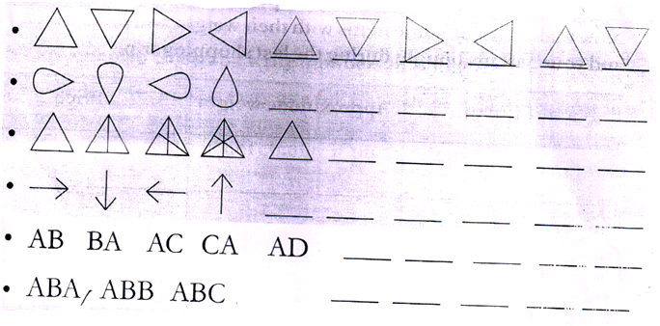

**EVS**

**Note : Do the given work on Green colour A4 sheets.**

1. **Revise Ch-2 full.**
2. **Read Ch-6, 7 thoroughly + Do activities on pg- 34 , 40, 46, 52, 59**

**Activities :**

1. **Collect some pictures of living things and make a colourful collage.**
2. **Paste five pictures of famous sport persons related to different sports.**

**Project Work:**

**Make 1 Green colour bin and 1 Blue colour bin using waste material and mention the list of wastes which we put in these bins.**

**Art : Do Pg no. 14 , 18 Craft:- 3D Paper flower , butterfly**

**I.T : Draw or paste any one computer part on coloured A4 sheet.**

**G.K : Do Pg no. 59 in book.**

5- छुट्टियों में आप जहां कहीं भी घूमने गए वहां आपने जो भी मजे किए उनके विषय में **10** पंक्तियां लिखें | अकबर - बीरबल की रोचक कहानियां पढ़ें और अपनी पसंदीदा कहानी को **A4** साइज शीट पर लिखें | क्या आप हमें अपने मनोरंजन के लिए पक्षियों को पिंजरे में कैद करके रखना चाहिए **?**  यदि हां तो क्यों **?** यदि नहीं तो क्यों **?** आप अपने कौन - कौन से काम स्वयं करते हैं **?** सूची बनाएं | दिया गया कार्य हिंदी की उत्तर पुस्तिका में करें | अनेक शब्दों के लिए एक शब्द **( 13-24) ,** श्रुतिसमभिन्नार्थक **( 6-10) ,** पर्यायवाची शब्द **( 12-22) ,** मुहावरे  **(13-25) ,** अनेकार्थी  **(1- 8) , yksdksfDr;k¡ (1- 5) , foykse** शब्द **(14- 26) ,**

6-

बाल राम कथा के पाठ **1-6** पढ़ें व प्रत्येक पाठ से **20- 25** प्रश्न / उत्तर लिखे वह याद करें | अपने बचपन की कोई मनमोहक घटना याद करके विस्तार से लिखें | रानी लक्ष्मीबाई का चित्र बनाए व वसंत पाठ-10 के आधार पर झांसी की रानी की जीवन जीवन कथा लिखें | तुम्हारा पसंदीदा विषय कौन - सा है और क्यों **?** दिया गया कार्य हिंदी की उत्तर पुस्तिका में करें

वाक्यांश के लिए एक शब्द **( 1-18) ,** श्रुतिसमभिन्नार्थक **( 1-15) ,** अनेकार्थी  **(1-12) , yksdksfDr;k¡ (1- 5) ,**

* Make a Wall hanging with the help of Ice-cream sticks / straws / waste CDs / disposal paper plates.

**G.K : Pg-59**

**Note :-** Do holidays homework in a separate English ,Maths ,Hindi and E.V.S

notebook in a legible writing.

Xxxxxxxxxxxxxxxx

iii

iv

Revise the syllabus of Term-1 done till date.

Do 2 comprehension passage ( Pg. no. 97 , 98 of Eng (Gr))

Learn any one poem of Term-1 syllabus ( Ch-5 or Ch-8)

Paste and market scene and describe it.

Learn Synonnym , Antonyms and Three form of the verb given in ch-4 (Eng Gr)

v

Revise the syllabus of Term-1 done till date .

Do 2 comprehension passage (Pg 103 , 104 of Eng(Gr))

Learn any one poem of Term-1 syllabus ( Ch- or Ch-)

Learn forms of the verb given in Ch-5 of Eng (Gr)

Learn Synonyms and Antonyms given in ch-4 of Eng(Gr)

G.K

Do pg 19 , 67

Vi

Revise the syllabus of Term-1 done till date.

Do 2 comprehension passage ( pg 167 , 168 of Eng(Gr))

Learn any one poem of Term-1 syllabus.

Learn i) Antonyms ii) Making Adjective from noun of Ch-37

Write a letter to your friend inviting him/her for summer vacations on A3 size sheet.

Write a paragraph on ‘ How you spent your summer vacations ‘ on A3 size sheet.

Do pg 66 , Read Ch-35

III Gk Do Pg -59 in book

IV Do Pg- 59 in book

III

IV Pg 15 , 18 ( Colourful star Heart Round Flower hanging)

V

Pg 17 , 15 ( Door hanging , Wind Chimes )

VI

Pg 30 , 31 , 59 , 70 craft – Make a Craft Dream Catcher

Sci V

Claen India , Green India – Play your part

You all must know , that things thrown into the trash could be recycled , reused or composed. If the waste is not managed efficiently,It ends up in a land fill where garbage takes a long time to decompose.

Some object like plastic may never decompose.

You can help by creating awareness on ‘ Sorting of Waste ‘ before it is disposed off.

1. Take 3 cut outs ( A4 Size) in the shape of bins in colours green , Brown and Pink.
2. On the Green cut out stick pictures of things that can be recycled . On the Brown cut out , stick pictures of things that can be composted.

xxxxxxxxxxxxxxxxx