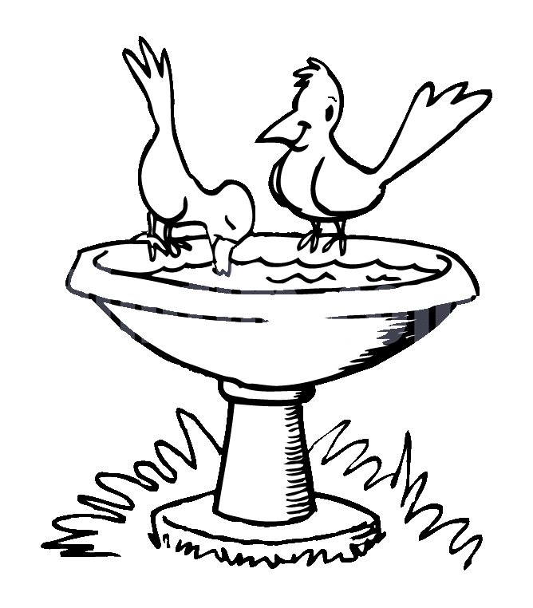**ZAD Global Sr. Sec. School**

**Summer Engagement**

**2019-20**

**Name ……….. … Class 4th Section ………………….**

**Dear parents,**

The much awaited summer vacation is knocking at the door ! The very thoughts of summer break include image of time for relaxation to escape the heat , pursuing of leisure activities and including in good quality time with friends and family . There are plenty of productive ways that your ward can spend the vacation which can be fun relaxing and helpful for his/ her education career.

We wish to imbibe in our students the willingness to spend their summer vacation well .

**Some suggestions in this regard –**

* Practice spoken English at home.
* Encourage your child to read , give him / her some story books for reading .
* Tell your children to save electricity and water.
* Have at least two meals together with your children. Teach them not to waste their food. Use a napkin and try not make a mess at mealtimes .
* Help your child to make a bond of love with Grandparents. Ask grandparents to share stories about your childhood and family history.
* Be careful of your tone and body language when you talk to your child.
* Allow your child to help you at home in household work like watering plants , arranging the dining table , organising his / her cupboard / room and praise him / her for the same.
* Don't give mobile to your child for playing games. Ask them to play outdoor games in evening or indoor games.
* Fix limited time to watch TV that also few particular channels like animal planet , Discovery Channel , New Channels etc.
* Make your ward learn and remember his/ her parents mobile/ landline number, house address etc. to make him/ her independent and secure.

**Vocabulary for a day**

Everyday choose a letter and start the day with it like letter -B

In breakfast you can give banana , bread and butter. Go to park and search the things like ball , baby , bench , butterfly , bee etc.

End of the day let him /her count the total words by recalling all the words.

**STAR PERFORMER OF THE HOUSE**

|  |  |  |  |  |  |  |  |
| --- | --- | --- | --- | --- | --- | --- | --- |
|  | MON | TUE | WED | THU | FRI | SAT | SUN |
| I can water plants |  |  |  |  |  |  |  |
| I can help mom |  |  |  |  |  |  |  |
| I love to share |  |  |  |  |  |  |  |
| I can arrange the room |  |  |  |  |  |  |  |

Appreciate them for their efforts.

**Children can be encouraged to use simple words and sentences at home also. For example-**

* **Mummy , can I help you in the kitchen.**
* **Mummy , can I lay the table today.**
* **Mummy , should I help you wash the dishes today.**
* **Papa, can I help you wash the car.**
* **Grandpa, should I come with you for a walk.**
* **Mummy can I get you glass of water.**
* **Mummy , may I take some more Ice - Cream from the fridge?**
* **Papa , I'm sorry I was rude to you.**
* **Papa , please teach me how to ride a bicycle.**
* **Didi , can you help me find my English notebook.**
* **Papa , can we go cycling together today.**
* **Wishing people properly- Hello Uncle / Aunty , How are you ?**
* **Wishing parents and elders Good morning , Good Afternoon , Good Evening and Good Night. If we as teachers and parents make a sincere effort and pay attention to the above mentioned points , we can help our children to learn to understand and speak English at an early age .**
* **The School has also devised some summer holiday homework that is linked to the curriculum and is also creative to monitor the progress of your ward.**
* **Please assist rather than take over , this would help in enhancing the child’s creative skills.**

**Note: Summer break will commence from ….. May 2019 and the school will reopen on 4th July 2019(Thursday).**

**Submit the holidays homework in a folder by 8th July 2019 [Class- IV ]**

**English**

**Note : Do the given work on Pink colour A4 sheets.**

1. **Revise the syllabus of Term-1 done till date.**
2. **Do 2 comprehension passage ( Pg. no. 97 , 98 of Eng (Gr))**
3. **Learn any one poem of Term-1 syllabus ( Ch-5 or Ch-8)**
4. **Paste any Beach scene and describe it.**
5. **Learn Synonym , Antonyms and Three forms of the verb given in ch-4 (Eng Gr)**

**Hindi**

**Note : Do the given work on Yellow colour A4 sheets.**

1. **Revise the syllabus of Term-1 done till date.**
2. **किन्ही 10 त्योहारों की सूची बनाएं और लिखें की देसी महीनों के अनुसार व कब मनाए जाते हैं ? जैसे- होली –फाल्गुन मास की पूर्णिमा को |**
3. **आपका जन्मदिन किस तारीख को होता है ? आप उस दिन क्या - क्या करते हैं ? विस्तार में लिखिए |**
4. **प्रतिदिन योगा करें व किन्ही 2 योगासनों के बारे में चित्र सहित लिखें |**
5. **“ हे शारदे मां ” यह प्रार्थना लिखे व याद कर |**
6. **एक गमले में पौधा लगाएं व उसकी देखभाल करें |**
7. **दिया गया कार्य हिंदी की उत्तर पुस्तिका में लिखें |**

**गिनती ( 26- 50) , अनेक शब्दों के लिए एक शब्द ( 1-15) , श्रुतिसमभिन्नार्थक ( 1-6) , पर्यायवाची शब्द ( 9-17) , मुहावरे (11-20) , समूह वाची शब्द (1-8) ,अनेकार्थी (1- 7) , foykse शब्द (12- 22)**

**Maths**

**Note : Do the given work on Sky Blue colour A4 sheets.**

1. **Do practice of Ch-1,2,3 and 4 in practice note book.**
2. **Learn tables 12 to 20.**
3. **Do sums of Addition , Subtraction , Multiplication and Division five each.**
4. **Do Pg 65 and 66 in book.**
5. **Measure the length of different sports thing with the help of string .Make a record on A4 Sheet ( Help Pg no. -139)**
6. **Let’s make a bhel puri.**

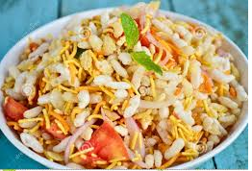**The ingredients for one plate bhel puri are as follows:**

|  |  |  |
| --- | --- | --- |
| **Ingredients** | **For one plate** | **For two plates** |
| **Potatoes** | **250g** | **500 g** |
| **Tomatoes** | **50 g** |  |
| **Onion** | **75 g** |  |
| **Puffed rice** | **100 g** |  |
| **Bhujia** | **75 g** |  |
| **Papri** | **50 g** |  |
| **Chaat Masala** | **10 g** |  |
| **Salt** | **10 g** |  |
| **Black pepper** | **5 g** |  |

**Draw this table on A4 sheet**

* **Write the ingredients for two plates. ______________**
* **What is the total weight of one plate bhel puri? ______________**
* **What is the weight of half plate bhel puri? ______________**
* **Raju does not want to mix tomatoes in the bhel puri. ______________**

**What is the weight of his one plate bhel puri?**

**Science**

**Note : Do the given work on Green colour A3 sheet.**

1. **Revise Ch-2, 3 and 4 with exercise.**

**Activities :-**

**1. Make a collage to show correct method of brushing teeth.**

**2. Visit a tailor’s shop & collect small pieces of different varieties of fabrics and paste these fabrics on A3**

**size sheet and write their type.**

**Project Work**

1. **Make a model of the solar system on thermocol sheet.**
2. **Make a model of Earth and paste slogan ‘ My Earth My Home ‘ . [Roll no. 1 to 15]**
3. **Make a poster on ‘ Healthy food, Healthy body’. [Roll no. 16 to 32]**

**Social Studies**

* **Ch- 10 Do activity (1,2) of Ch-10 ( pg no. 108)**
* **Making a beautiful drawing of desert on white A4 sheet.**

**Art : Do Pg no. 15 , 18**  **Craft:- Colourful star Heart Round Flower hanging**

**I.T : Write and decorate shortcut keys of MS-Office (any 10) on coloured A4 sheet.**

**G.K : Do Pg no. 59 in book.**

Class 6th

Ch-3 (History)🡪 Draw or paste pictures to show various occupation of Neolithic man.

Ch-6(History)🡪 Find out about the taxes levied upon us and the collection system.(Make a table of taxes and the collection system) .

Ch-2( Geo)🡪 Make a chart of important heat zones of the Earth , colour each zone with different colours.

Class 5th

From a newspaper , collect data from daily weather report for a week i.e, maximum and minimum temperature , cloud cover , predictions of rainfall. Make a table of this information in S.St N.B.

Make a chart of different letters – Devnagri , Roman , Arabic Urdu

**G.K.** : Do pg no.28 & 29

**Art & Craft** Do pg. no. 8, 24, 34

**Note :-**

* Do holidays homework in a separate English , Hindi and E.V.S small(approx 20 pgs) notebook in a legible writing.
* Revise the syllabus done till date in class.

**English**

**Note : Do the given work on Pink colour A4 sheet.**

5- छुट्टियों में आप जहां कहीं भी घूमने गए वहां आपने जो भी मजे किए उनके विषय में **10** पंक्तियां लिखें | अकबर - बीरबल की रोचक कहानियां पढ़ें और अपनी पसंदीदा कहानी को **A4** साइज शीट पर लिखें | क्या आप हमें अपने मनोरंजन के लिए पक्षियों को पिंजरे में कैद करके रखना चाहिए **?**  यदि हां तो क्यों **?** यदि नहीं तो क्यों **?** आप अपने कौन - कौन से काम स्वयं करते हैं **?** सूची बनाएं | दिया गया कार्य हिंदी की उत्तर पुस्तिका में करें | अनेक शब्दों के लिए एक शब्द **( 13-24) ,** श्रुतिसमभिन्नार्थक **( 6-10) ,** पर्यायवाची शब्द **( 12-22) ,** मुहावरे  **(13-25) ,** अनेकार्थी  **(1- 8) , yksdksfDr;k¡ (1- 5) , foykse** शब्द **(14- 26) ,**

6-

बाल राम कथा के पाठ **1-6** पढ़ें व प्रत्येक पाठ से **20- 25** प्रश्न / उत्तर लिखे वह याद करें | अपने बचपन की कोई मनमोहक घटना याद करके विस्तार से लिखें | रानी लक्ष्मीबाई का चित्र बनाए व वसंत पाठ-10 के आधार पर झांसी की रानी की जीवन जीवन कथा लिखें | तुम्हारा पसंदीदा विषय कौन - सा है और क्यों **?** दिया गया कार्य हिंदी की उत्तर पुस्तिका में करें

वाक्यांश के लिए एक शब्द **( 1-18) ,** श्रुतिसमभिन्नार्थक **( 1-15) ,** अनेकार्थी  **(1-12) , yksdksfDr;k¡ (1- 5) ,**

* Make a Wall hanging with the help of Ice-cream sticks / straws / waste CDs / disposal paper plates.

**G.K : Pg-59**

**Note :-** Do holidays homework in a separate English ,Maths ,Hindi and E.V.S

notebook in a legible writing.

Xxxxxxxxxxxxxxxx

iv

v

Revise the syllabus of Term-1 done till date .

Do 2 comprehension passage (Pg 103 , 104 of Eng(Gr))

Learn any one poem of Term-1 syllabus ( Ch- or Ch-)

Learn forms of the verb given in Ch-5 of Eng (Gr)

Learn Synonyms and Antonyms given in ch-4 of Eng(Gr)

G.K

Do pg 19 , 67

Vi

Revise the syllabus of Term-1 done till date.

Do 2 comprehension passage ( pg 167 , 168 of Eng(Gr))

Learn any one poem of Term-1 syllabus.

Learn i) Antonyms ii) Making Adjective from noun of Ch-37

Write a letter to your friend inviting him/her for summer vacations on A3 size sheet.

Write a paragraph on ‘ How you spent your summer vacations ‘ on A3 size sheet.

Do pg 66 , Read Ch-35

III Gk Do Pg -59 in book

IV Do Pg- 59 in book

III

V

Pg 17 , 15 ( Door hanging , Wind Chimes )

VI

Pg 30 , 31 , 59 , 70 craft – Make a Craft Dream Catcher

Sci V

Claen India , Green India – Play your part

You all must know , that things thrown into the trash could be recycled , reused or composed. If the waste is not managed efficiently,It ends up in a land fill where garbage takes a long time to decompose.

Some object like plastic may never decompose.

You can help by creating awareness on ‘ Sorting of Waste ‘ before it is disposed off.

1. Take 3 cut outs ( A4 Size) in the shape of bins in colours green , Brown and Pink.
2. On the Green cut out stick pictures of things that can be recycled . On the Brown cut out , stick pictures of things that can be composted.

Xxxxxxxxxxxxxxxxx

1. **Revise the syllabus of Term-1 done till date.**
2. **Learn any one poem of Term-1 Syllabus ( Ch-4 or Ch-8)**
3. **Write 15 sentences using different kinds of Adverb.**
4. **Paste a picture of market scene and describe it.**
5. **Paste or draw picture of five countable and Uncountable items of grocery which your mother buys every month.**
6. **Do 2 comprehension passage ( Pg 82 , 83 of Eng (Gr))**