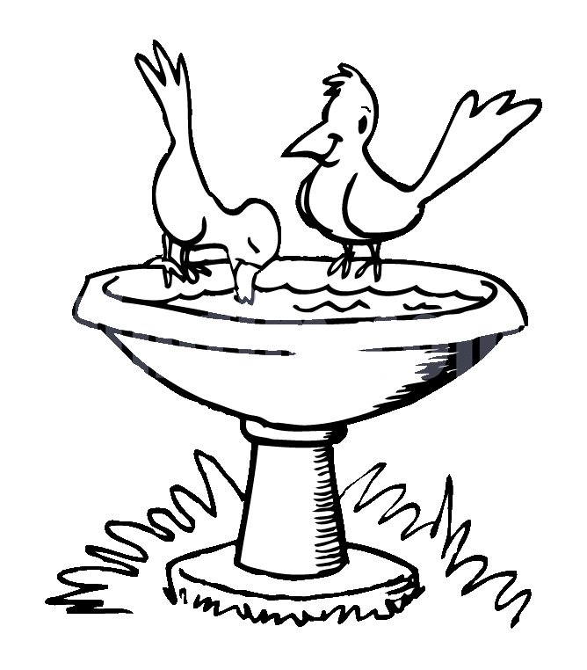**ZAD Global Sr. Sec. School**

**Summer Engagement**

**2019-20**

**Name ……….. … Class 5th Section ………………….**

**Dear parents,**

The much awaited summer vacation is knocking at the door ! The very thoughts of summer break include image of time for relaxation to escape the heat , pursuing of leisure activities and including in good quality time with friends and family . There are plenty of productive ways that your ward can spend the vacation which can be fun relaxing and helpful for his/ her education career.

We wish to imbibe in our students the willingness to spend their summer vacation well .

**Some suggestions in this regard –**

* Practice spoken English at home.
* Encourage your child to read , give him / her some story books for reading .
* Tell your children to save electricity and water.
* Have at least two meals together with your children. Teach them not to waste their food. Use a napkin and try not make a mess at mealtimes .
* Help your child to make a bond of love with Grandparents. Ask grandparents to share stories about your childhood and family history.
* Be careful of your tone and body language when you talk to your child.
* Allow your child to help you at home in household work like watering plants , arranging the dining table , organising his / her cupboard / room and praise him / her for the same.
* Don't give mobile to your child for playing games. Ask them to play outdoor games in evening or indoor games.
* Fix limited time to watch TV that also few particular channels like animal planet , Discovery Channel , New Channels etc.
* Make your ward learn and remember his/ her parents mobile/ landline number, house address etc. to make him/ her independent and secure.

**Vocabulary for a day**

Everyday choose a letter and start the day with it like letter -B

In breakfast you can give banana , bread and butter. Go to park and search the things like ball , baby , bench , butterfly , bee etc.

End of the day let him /her count the total words by recalling all the words.

**STAR PERFORMER OF THE HOUSE**

|  |  |  |  |  |  |  |  |
| --- | --- | --- | --- | --- | --- | --- | --- |
|  | MON | TUE | WED | THU | FRI | SAT | SUN |
| I can water plants |  |  |  |  |  |  |  |
| I can help mom |  |  |  |  |  |  |  |
| I love to share |  |  |  |  |  |  |  |
| I can arrange the room |  |  |  |  |  |  |  |

Appreciate them for their efforts.

**Children can be encouraged to use simple words and sentences at home also. For example-**

* **Mummy , can I help you in the kitchen.**
* **Mummy , can I lay the table today.**
* **Mummy , should I help you wash the dishes today.**
* **Papa, can I help you wash the car.**
* **Grandpa, should I come with you for a walk.**
* **Mummy can I get you glass of water.**
* **Mummy , may I take some more Ice - Cream for the fridge?**
* **Papa , I'm sorry I was rude to you.**
* **Papa , please teach me how to ride a bicycle.**
* **Didi , can you help me find my English notebook.**
* **Papa , can we go cycling together today.**
* **Wishing people properly- Hello Uncle / Aunty , How are you ?**
* **Wishing parents and elders Good morning , Good Afternoon , Good Evening and Good Night. If we as teachers and parents make a sincere effort and pay attention to the above mentioned points , we can help our children to learn to understand and speak English at an early age .**
* **The School has also devised some summer holiday homework that is linked to the curriculum and is also creative to monitor the progress of your ward.**
* **Please assist rather than take over , this would help in enhancing the child’s creative skills.**

**Note: Summer break will commence from ….. June 2019 and the school will reopen on 4th July 2019(Thursday).**

**Submit the holidays homework in a folder by 8th July 2019 [Class- V]**

**English**

**Revise the syllabus of Term-1 done till date.**

1. **Do 2 comprehension passage (Pg 103 , 104 of Eng(Gr))**
2. **Learn any one poem of Term-1 syllabus ( Poem 2 or Poem 3)**
3. **Learn forms of the verb given in Ch-5 of Eng (Gr)**
4. **Learn Synonyms and Antonyms given in ch-4 of Eng(Gr)**

**Hindi**

**Note : Do the given work on Yellow colour A4 sheets.**

1. **Revise the syllabus of Term-1 done till date.**
2. **छुट्टियों में आप जहां कहीं भी घूमने गए वहां आपने जो भी मजे किए उनके विषय में 10 पंक्तियां लिखें |**
3. **अकबर - बीरबल की रोचक कहानियां पढ़ें और अपनी पसंदीदा कहानी को A4 साइज शीट पर लिखें | क्या हमें अपने मनोरंजन के लिए पक्षियों को पिंजरे में कैद करके रखना चाहिए ?यदि हां तो क्यों ? यदि नहीं तो क्यों ?**
4. **आप अपने कौन - कौन से काम स्वयं करते हैं ? सूची बनाएं |**
5. **दिया गया कार्य हिंदी की उत्तर पुस्तिका में करें |**

**अनेक शब्दों के लिए एक शब्द ( 13-24) , श्रुतिसमभिन्नार्थक ( 6-10) , पर्यायवाची शब्द ( 12-22) , मुहावरे (13-25) , अनेकार्थी (1- 8) , yksdksfDr;k¡ (1- 5) , foykse शब्द (14- 26) ,**

**Maths**

**Note : Do the given work on Sky Blue colour A4 sheets.**

1. **Do practice of Ch-1,2 and 3 in practice note book.**
2. **Do book pgs: 42 , 51 ,53, 79, 102, 104, 111, 166.**
3. **Do project work of pg 127 in book.**
4. **Do 5-5 sums of HCF and LCM.**
5. **Draw factor tree of any 5 numbers .**
6. **Take a cardboard cylinder such as a shuttlecock box. Help your child to take it apart to find two circles (lid and bottom) and one rectangle. Make a record -**

**a) Height of original cylinder (before cutting )**

**b) Radius and diameter of circle and Area of the rectangle(after cutting).**

**Social Studies**

1. **Newspaper , collect the data from daily weather report for a week i.e, maximum and minimum temperature , cloud cover , predictions of rainfall. Make a table of this information in S.St N.B.**
2. **Make a chart of different letters – Devnagri , Roman , Arabic Urdu**

**Science**

1. **Revise Ch-3 and 4 with exercise.**
2. **Read Ch-5,6 thoroughly.**

**Activity: Topic Save & Conserve Water( Roll No. 1 to 20)**

**Note : Do the given work on Green colour A3 sheets.**

1. **Write a water pledge and get it signed by atleast 10 people in your locality / colony. Also take photographs & Paste atleast 2 photograph of your campaign on the poster.**
2. **Make a poster on ‘How to Save Water’ .**
3. **Make a poster on ‘Clean India’ ( Roll No. 1 to 20) , ‘Green India’ (Roll No. 21 to 40)**

**G.K : Do pg no.19 , 67 in book.**

**Art : Do Pg no. 17, 15 Craft:- Door Hanging , Wind Chimes**

**I.T : Make a model of any one part of computer(Monitor , CPU , UPS , Speakers, Keyboard ) using cardboard or thermocol sheet.**

**Maths**

**Note : Do the given work on Sky Blue colour A4 sheets.**

1. **Do practice of Ch-1,2 and 3 in practice note book.**
2. **Do book pgs: 42 , 51 ,53, 79, 102, 104, 111, 166.**
3. **Do project work of pg 127 in book.**
4. **Do 5-5 sums of HCF and LCM on Sky Blue colour A4 sheet.**
5. **Draw factor tree of any 5 numbers on Sky Blue colour A4 sheet.**
6. **Take a cardboard cylinder such as a shuttlecock box. Help your child to take it apart to find two circles (lid and bottom) and one rectangle. Make a record -**

**a) Height of original cylinder (before cutting )**

**b) Radius and diameter of circle and Area of the rectangle(after cutting).**

**Social Studies**

1. **Newspaper , collect the data from daily weather report for a week i.e, maximum and minimum temperature , cloud cover , predictions of rainfall. Make a table of this information in S.St N.B.**
2. **Make a chart of different letters – Devnagri , Roman , Arabic Urdu**

**Science**

1. **Revise Ch-3 and 4 with exercise.**
2. **Read Ch-5,6 thoroughly.**

**Activity: Topic Save & Conserve Water( Roll No. 1 to 20)**

**Note : Do the given work on Green colour A3 sheets.**

1. **Write a water pledge and get it signed by atleast 10 people in your locality / colony. Also take photographs & Paste atleast 2 photograph of your campaign on the poster.**
2. **Make a poster on ‘How to Save Water’ .**
3. **Make a poster on ‘Clean India’ ( Roll No. 1 to 20) , ‘Green India’ (Roll No. 21 to 40)**

**G.K : Do pg no.19 , 67 in book.**

**Art : Do Pg no. 17, 15 Craft:- Door Hanging , Wind Chimes**

**I.T : Make a model of any one part of computer(Monitor , CPU , UPS , Speakers, Keyboard ) using cardboard or thermocol sheet.**