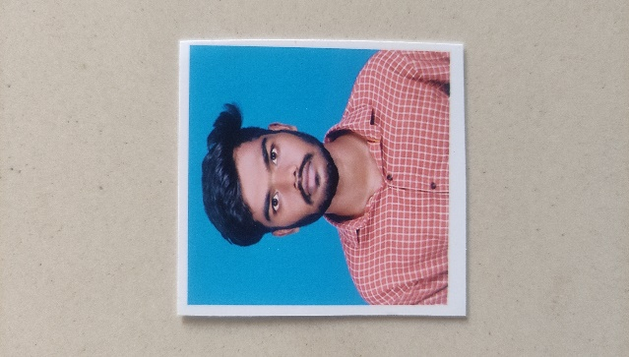**ASHOKKUMAR V**

**Email Id:** kumarashok68351@gmail.com

**Mobile:** +91 6379967312

**Address:** 12 Mrr Garden, T.V.kovil,

Trichy,Tamilnadu-620005

**Objective:**

Being passionate about my professional growth and striving to achieve excellence along with the organization by applying my updated knowledge and skills.

**Academic Profile:**

* MSC CS (Master of Science Computer Science)
* Institution: St.Joseph College, Trichy (Autonomous) (Bharathidasan University)
* Year of Passing: 2024
* CGPA: 69%
* Project : Online Food Order System

Environment: HTML / CSS/ Java Script / PHP / MySQL

* BCA (Bachelor of Computer Application)
* Institution: Sri mad Andavan Arts & Science College, Trichy (Autonomous) (Bharathidasan University)
* Year of Passing: 2022
* CGPA : 77%
* Project : Library Management System

Environment: HTML / CSS/ Java Script / PHP / Bootstrap / jQuery / MySQL

|  |
| --- |
| **Technical Expertise:** |

* Programming languages: **JavaScript, PHP**
* Tools: **MS Word, MS Excel**
* Databases: **MySQL**
* Web technologies: **HTML, CSS**
* Operating systems: **Windows 10**

**Skills:**

* Good communication
* Quick learner
* Ability to work independently

|  |  |
| --- | --- |
| **Personal Information** |  |
| Father’s name : | Visvalingam A |
| Date of birth : | 30 August 2002 |
| Gender : | Male |
| Nationality : | Indian |
| Languages Known : | English and Tamil |
| **Declaration:** |  |

I do hereby declare that the particulars of information and facts stated here in above are true, correct to the best of my knowledge and belief.