This file explains the creation of organization tree structure and resources in the projects.

Below is the diagram of the folder structure which is created using terraform code :

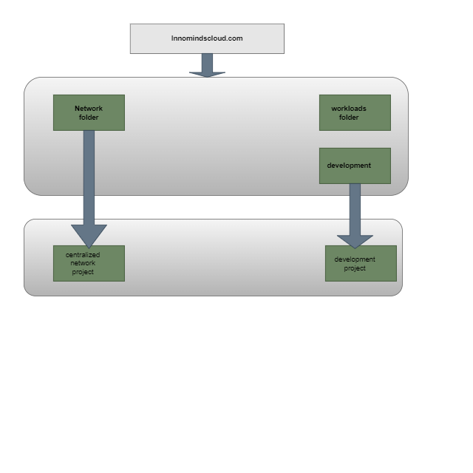We are creating 2 folders under the org **Innomindscloud.com** named workloads and Network folder.

The workloads folder has a nested folder named development where we could create development related projects.

Under the Network folder, we are creating a project which acts as a host project. We are also using this project for hosting Network resources, centralized logging as well.

1. Clone the azure repo : <https://dev.azure.com/DevOpsInnominds/_git/GCP_Landing_Zone>

2. By default, we are providing the folder names Network, workloads and development. We need provide the project names for centralized network project under **Network folder** and a development project under **development folder**.

3. Run the terraform init to initialize the working directory

4. Run the Terraform apply command and provide the project names and network and subnetworks created in the respective project.   
screenshot below for the same :

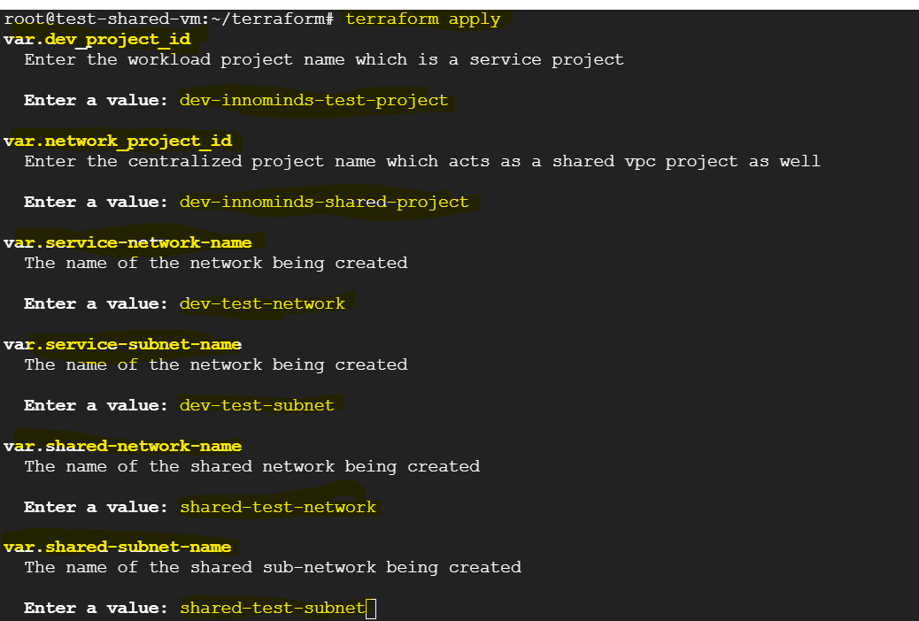

5. The terraform apply command will show the list and number of resources it is going to create. Then click on Yes and Enter.

Screenshot below :   
  
 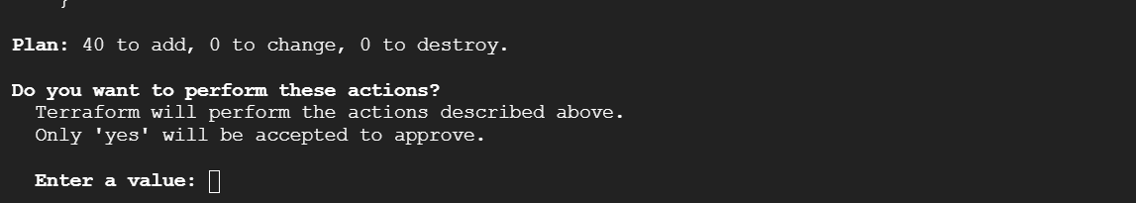

6. Once we enter Yes, the development project and centralized network project and the resources under the projects will start creating. Once the resources are created, we get the result as number of resources created.

Screenshot below:

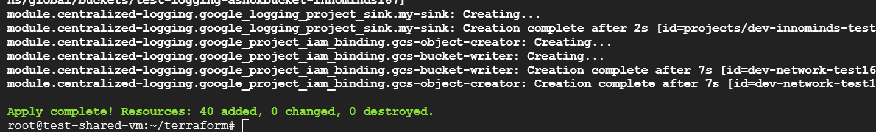

**Note** : The name of the centralized logging bucket should be globally unique, which needs to be modified under the modules/centralized-logging/main.tf

Screenshot below :   
 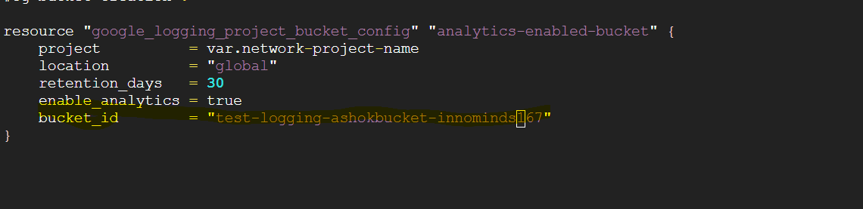

The folders and projects created using terraform can be verified from gcp console as well. Screenshot below for the same:   
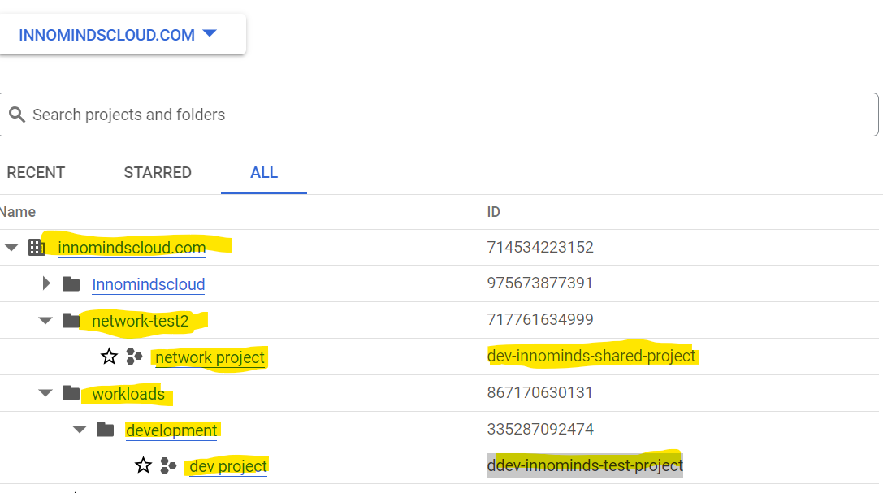

7. In the centralized network project, the resources created are :   
  
 i) Centralized logging bucket

ii) vpc network

iii) Firewall rules

iv) shared-vpc-host  
 v) vpc-peering

vi) Cloud NAT

vii) Cloud Router

viii) gcp required apis

In the development project, the resources we have created are :   
  
 i) compute engine

ii) vpc network and subnet   
 iii) shared-vpc-service

iv) vpc-peering

v) kubernetes cluster

vi) secret manager

vii) gcp required apis

Also, we have created the organization polices at the org level (Innomindscloud.com) which will be inherited by all the folders and projects under it.