**Abstract: In today's globe, there is an increase in street disasters due to road irregularities, particularly in countries like India. Especially when it's raining. The roads will grow slick as the season progresses, and there will be extra hazards. There will be a rapid increase in the amount of potholes. The purpose of this study is Toto build a pothole detection system that can help and redress the inconsistencies As a result, the user will benefit. Help keep them safe from unexpected road accidents potholes. The standalone system will direct the user to the appropriate location. The safest path based on the smallest amount of variables Potholes and traffic is two of the most common problems. This system assists the user in achieving their goals. Destination in a shorter amount of time. In addition, this system focuses on repairing flaws or potholes**

**Keywords**: Pothole; Road Surface Monitoring; Accelerometer.

I.INTRODUCTION

For municipal firms to promptly find and repair potholes, road monitoring is critical. If all of theroute details are stored on a central server

that anybody can access for free, drivers will take the most efficient path from the feed to your destination. Swish lanes, potholes, ridges, shrinkage joints, manholes, expansion joints, and other road features can all be grouped into distinct groups. Pits and bumps when a person finds himself obstructing his or her speed limit (also known as speed breakers). As a result, speed bumps and shifts on the server will allow us to erase earlier road information, allowing them to plan ahead of time to see how long it would take to complete the voyage.. Street viewing is now done manually, with the suggestion of using personnel solely for this purpose, or by volunteer drivers who receive any explosions and report them to the appropriate authorities. However, this method of dealing with traffic is inefficient and costly. There are several existing approaches for automatically detecting holes in the second place, one of which can be a responsive system and the other a non-responsive method. Optical and auditory sensors are used in the non-responsive system. These local sensors are costly, and to identify holes, they would benefit from a sophisticated algorithmic law. Vehicles with particular purposes will be rented because the equipment must be mounted above the vehicle so that the road condition can be seen. Another method is to utilize a responsive system that accesses and analyses incorrectly using mechanical sensors (such as measurement instruments and a gyroscope). This street view service will function on robot OS devices. Because the operating system is the most frequently used, our system attracts more volunteers for high-street viewing. This project explains how to use the built-in Android measurement tool to track 3-axis acceleration. The accelerometer's data is processed in the right way to determine the type of occurrence and its severity. With the Android constitution GPS, you can find out where a chuckhole or breaker has been discovered.

II. RELATED WORK

Many developers have created creative applications with the same concern in mind. The following are a few examples of such applications: A Novel Road Surface Monitoring System Using a Low-Cost Infrared Laser Sensor [1] IR, RGB, Depth images are used to detect cracks, potholes, and defects in pavement. It's a win for autonomous, cost-effective road and transportation system condition assessment. This system is incredibly low-cost. B. Design and construction of a GPS-GSM tracking system with Google Maps monitoring [7] It is a tracking system that prevents a car from being stolen. Increasing the safety of vehicles the algorithm not only finds the target's position, but also estimates the distance travelled between two stations. However, it does not include travel time between stations. C. Using IoT, Automatically Detecting and Notifying Potholes and Humps on Roads [2] The Raspberry Pi uses its camera to detect potholes and humps. Ultrasonic sensors are used to detect potholes and humps, as well as to determine their depth and height. It sends out alarms when there are potholes or humps in the road. This procedure is costly. D. Using Android Smartphones with Accelerometers to Detect Potholes in Real-Time [6] Using a mobile sensor system, detect road abnormalities. In our situation, the system should be able to detect events (potholes) in real time. Raw data gathering for off-line post-processing is categorised as an optional feature. . A smartphone's operating system should be capable of performing its native communication duties at a satisfactory degree of quality. There is no way to fix potholes with this procedure. E. Walking GPS: A viable approach for localization in wireless sensor networks that are manually deployed [4] The deployer (either a person or a vehicle) carries a GPS device that broadcasts its location on a regular basis. The sensor nodes that are being deployed deduce their position from the GPS device's location. It is cost-effective and has very low overhead. It merely provides a position that can be used in our project.

III. PROPOSED APPROACH

We're working on a traffic information app that also identifies potholes and serves as a warning system. The user first chooses a method of transportation and enters the source and destination addresses. There's an associate degree option for the consumer to pick the gap during which he wants to comprehend the traffic data. The application then displays the segments comprising the traffic density of various modes of transportation on the trail, which is provided via GPS. The average speed of the cars on this specific corridor is also shown. This allows the user to choose the best path with the least amount of traffic. The data on traffic is updated on a regular basis. C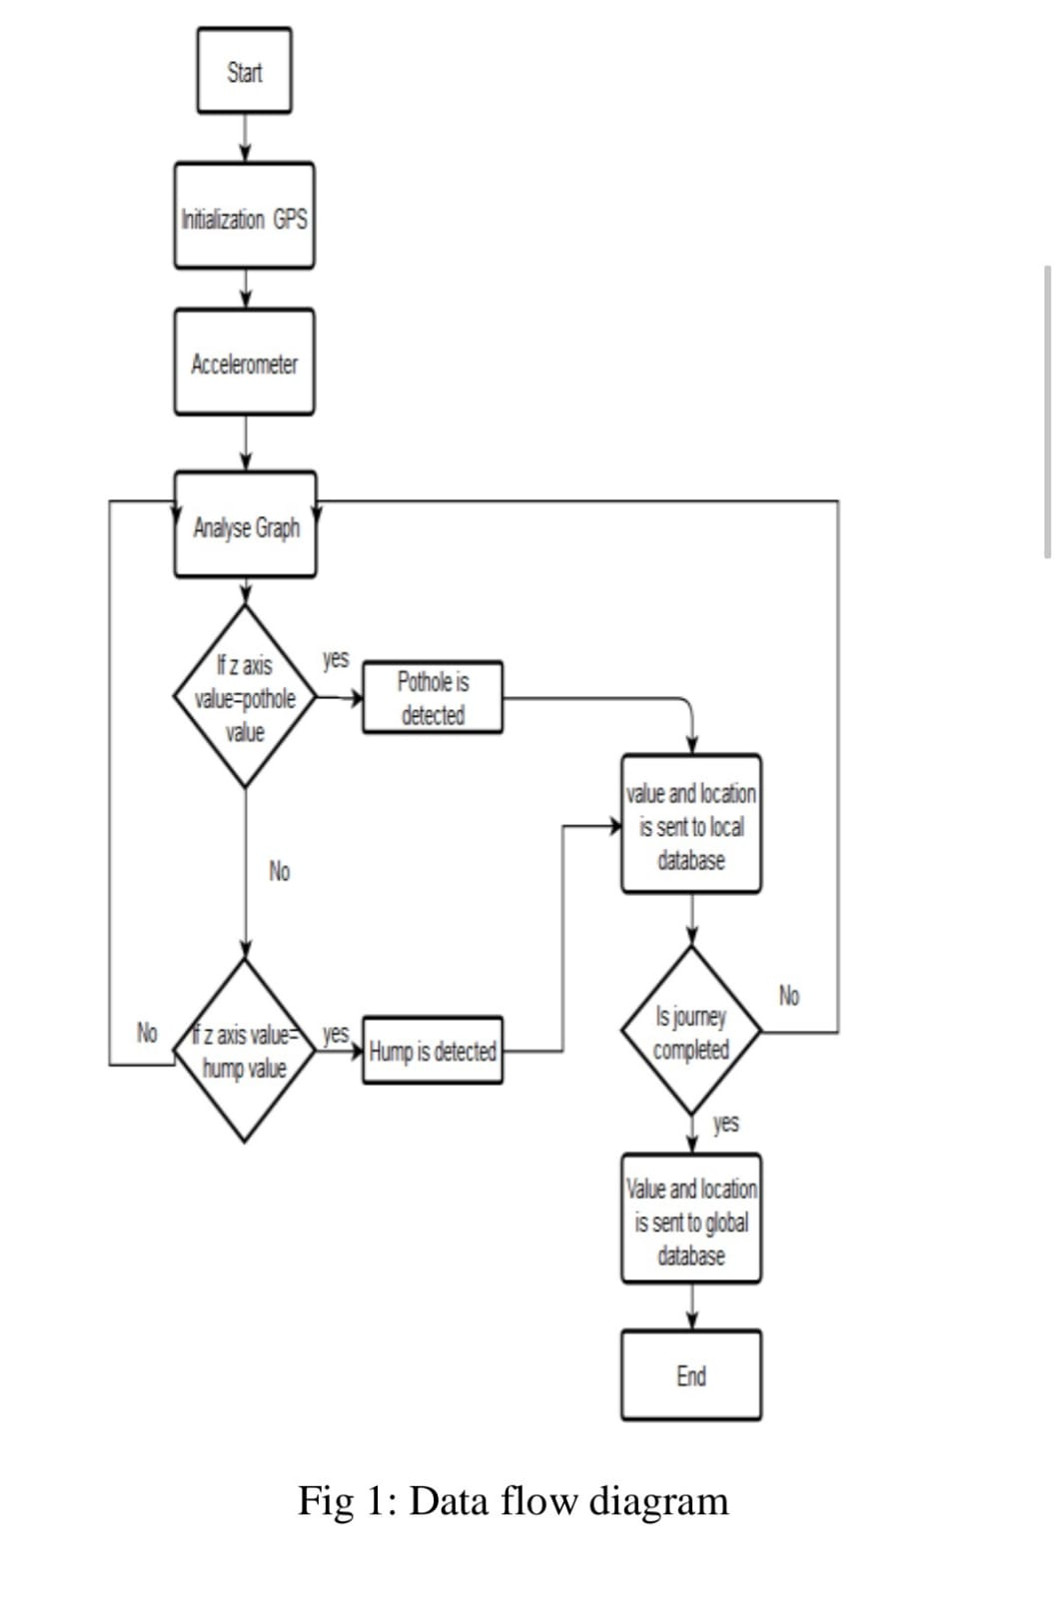

The user must first choose a mode of transportation and supply and destination. The density of traffic is also influenced by unresolved issues such as potholes. When a vehicle drives over a pothole, the measuring system detects the vibration, and if the vibration value matches the code, the pothole's latitude and longitude are saved as information. The data contains all of the observed potholes' values. If a pothole is identified three times by the user, the system automatically sends a message to the Corporation about the pothole's condition, which is then updated in the worldwide database. The values of potholes are erased from the global database once the problem has been resolved. There are three modules in the application.

A.User

Before entering the app, you will receive a notification to turn on the GPS. To begin their journey, the user must enter their source and destination information and click the "START" button. The map and potholes from the source to the destination can be viewed by users.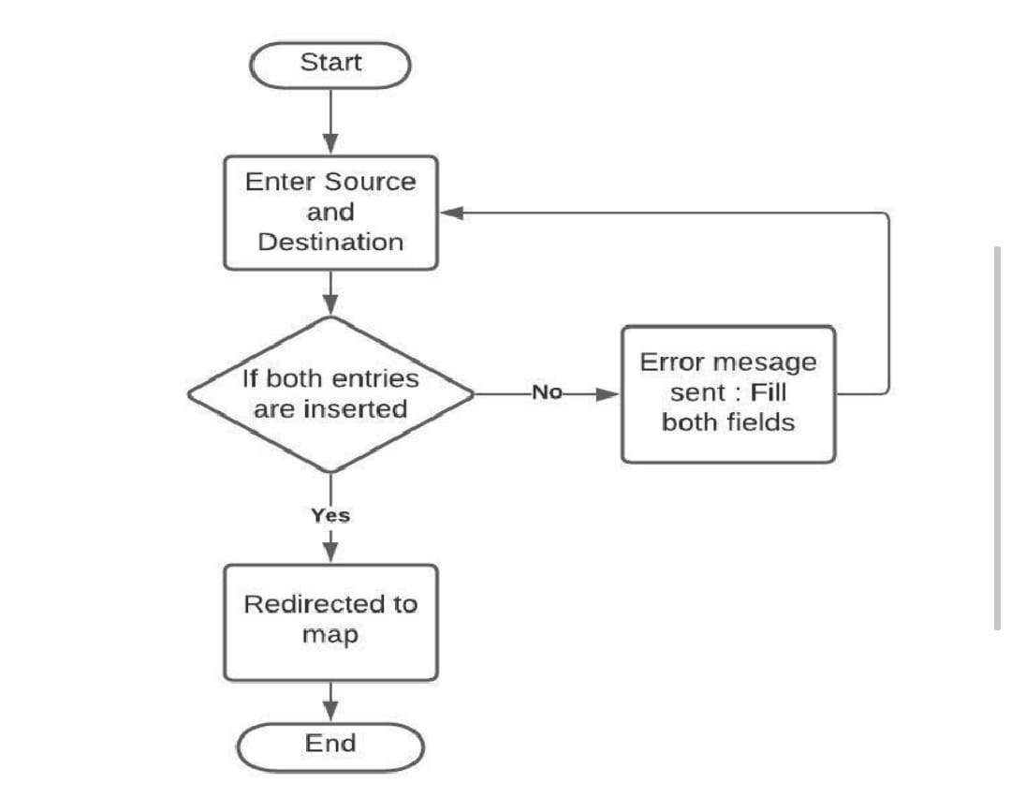

B. Server

The android device and the database are the two components of this module. Between the user module and the mobile application, it serves as an intermediary layer. When a pothole is discovered, the database is updated with information such as the severity, longitude, and latitude of the pothole. If the same data is entered three times, the authority receives an email..

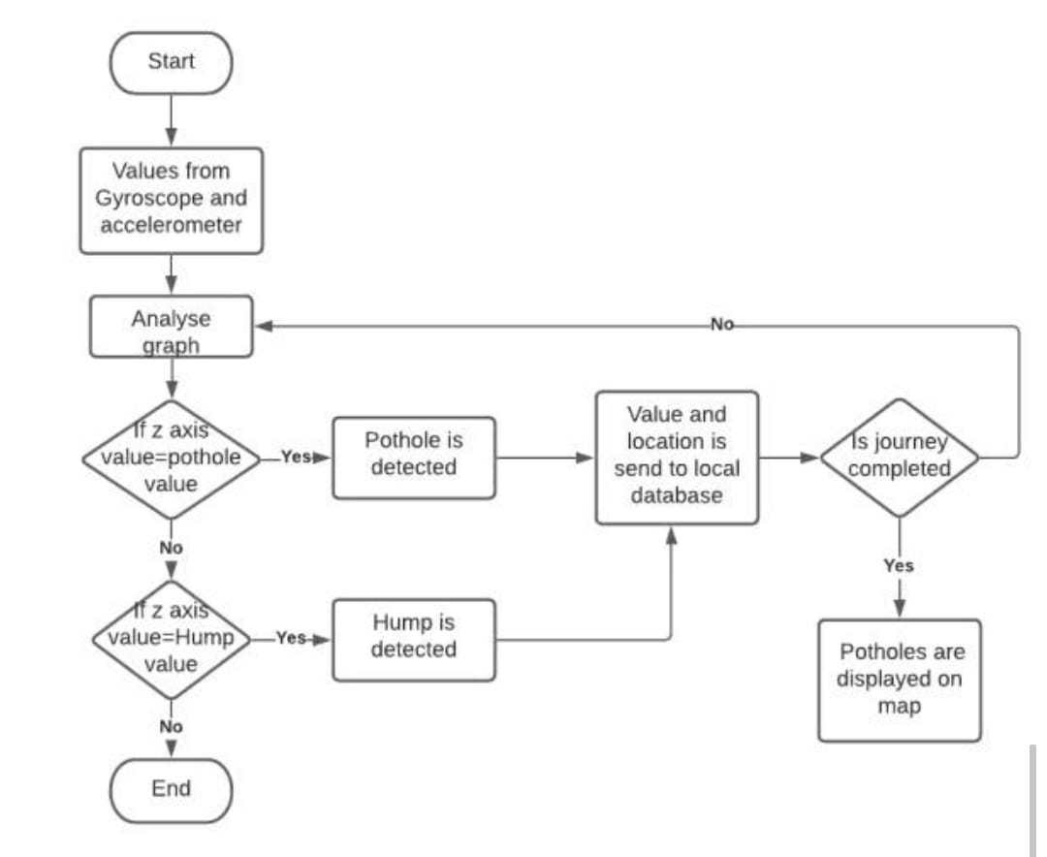

C. Web Application

This module is implemented as a robot application that is installed on the vehicle driver's phone and continuously operates in the background to provide timely notifications regarding the presence of holes. It first collects the vehicle's geographic location, then searches the server database for the locations of holes and speed breakers. It is calculated the distance between the vehicle position and the hole position entered in a database. An alarm message appears on the mobile screen if the distance between the two is less than a hundred meters. This message is accompanied by an audible beep to help the driver distinguish it from other flash messages..

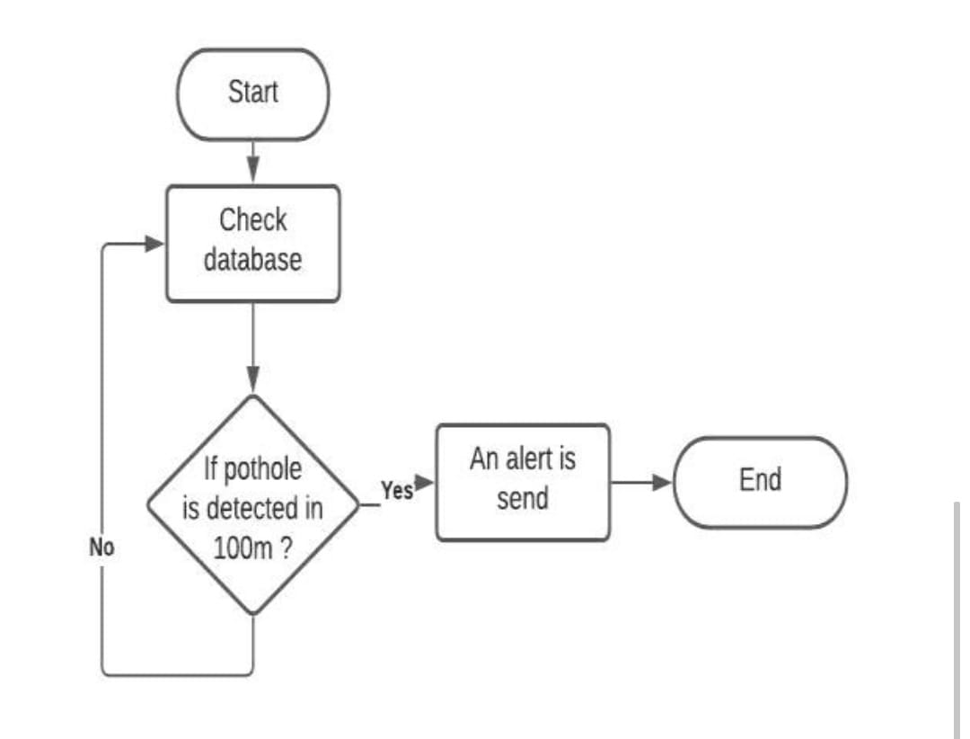

IV .EXPERIMENTAL RESULTS

The authors took the following path to analyse the delineated algorithmic rule. 1. Physically count the holes and record their locations.

2. Make your way along a four-kilometer road.

3.Confirming the accuracy of the information.

The designated road is 4 kilometers long, and it was over this distance that the check was conducted. In an extremely vehicle on the plane surface, an automaton phone running a programme created for this identical goal was unbroken. When the expedition came to a finish, the number of holes and humps discovered along the way were computed by looking into the data. The holes and humps recorded by the app are depicted in the tables below.

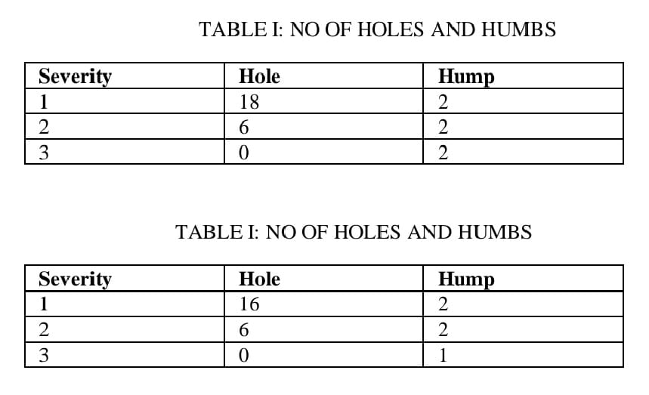

Tables I and II show how planned self-operating actions produce better outcomes than physical examination. The intended procedure's accuracy is determined to be 94.10 percent.

The following hurdles have been identified as part of the intended procedure:

I On an Android phone, a planned technique has been shown by placing the phone in a vehicle.

ii) Because the phone is unbroken on a flat surface, implicit alignment is considered an additional property.

iii) For the process and action capture, planned technique leverages real-time sensor information from the measuring system.

V.CONCLUSION AND FUTURE SCOPE

This study discusses the importance of paved surface monitoring in terms of passenger safety and security. A system based on shaking has been developed that mechanically detects the hole and hump, as well as their severity. This strategy could be useful for making safe moves, especially if the road condition is unknown. The proposed technique can be easily implemented on any automated device, primarily a smartphone. The paper's conclusion demonstrates that the planned technique has been approved. In the future, the algorithm might be tested on completely different road conditions to see whether there are any more complicated possibilities.

REFERENCES

[1] Mohammad R. Jahanshahi, Farrokh Jazizadeh, Sami F. Masri, and Burcin Becerik, "A Novel System for Road Surface Monitoring Using an Inexpensive Infrared Laser Sensor," Proc. SPIE 8345, Sensors and Smart Structures Technologies for Civil, Mechanical, and Aerospace Systems, 2012

[2] Kunal D. Patil, Shardul R. Patil, Vipul Kale, and Shubham S. Thorat4 "Automatic Detection and Notification of Potholes and Humps on Roads Using IoT," International journal of advanced research in science and engineering, volume no.07, special edition no.03, February 2018.

[3] M.Sivasakthi and S.Suresh, "Research On Vehicular Ad Hoc Networks: A Review," Journal of Applied Science and Engineering Researches, vol 2, no. 1, pages 23-27, 2013.

[4] R. Stoleru, T. He, and J. A. Stankovic, "Walking GPS: A realistic approach for localization in manually placed wireless sensor networks," IEEE Computer Society, pp. 480-489, 2004.

[5] P. Mohan, V. N. Padmanabhan, and R. Ramjee, "Nericell: Using Mobile Smartphones for Rich Monitoring of Road and Traffic Conditions," in Proceedings of the 6th ACM conference on Embedded Network Sensor Systems, ser. SenSys '08, pp. 375-358, 2008.