CARETRACK
PATIENT MANAGEMENT SYSTEM
Mini Web Application – CRUD-Based Web Application
VSB Skill Vault Activity 3
Project Documentation
Prepared for academic submission
Date: 17 September 2026

1. Title and Project Overview
CareTrack – Patient Management System is a web-based CRUD application designed to manage patient and appointment information in a structured digital system. The application provides a simple interface for creating, viewing, editing and deleting patient records and appointment records.
The application is intended as an academic mini-project demonstrating practical web development concepts including responsive UI design, React component development, database integration, authentication, validation and CRUD operations.
Project Item | Details
Project Name | CareTrack – Patient Management System
Project Type | Mini Web Application – CRUD-Based Web Application
Primary Users | Receptionist / Hospital Staff / Administrator (academic prototype)
Main Modules | Patients and Appointments
Frontend | React + TypeScript
Styling | Tailwind CSS
Backend/Data Platform | Supabase
Database | PostgreSQL through Supabase
Deployment | Cloudflare Workers / Static Assets

2. Problem Statement
Managing patient information manually using notebooks, spreadsheets or disconnected files can make record retrieval and updating difficult. It can also lead to duplicate entries, outdated information and inefficient appointment management.
The problem addressed by CareTrack is the need for a simple centralized web application through which patient records and appointments can be maintained using standard Create, Read, Update and Delete operations.

3. Objectives
- Develop a responsive web application for basic patient record management.
- Implement complete CRUD operations for patient records.
- Implement CRUD operations for appointment records.
- Connect the frontend application to a real Supabase PostgreSQL database.
- Provide form validation and user-friendly error/success feedback.
- Provide search and filtering functionality for easier record retrieval.
- Maintain a clear relationship between patients and their appointments.
- Demonstrate practical frontend, database and deployment concepts.
- Deploy the application online so it can be accessed through a browser.

4. Technology Stack
Technology | Purpose
React | Builds the interactive user interface using reusable components.
TypeScript | Adds static typing and improves code reliability.
Tailwind CSS | Provides responsive and consistent UI styling.
Supabase | Provides PostgreSQL database, authentication and Data API services.
PostgreSQL | Stores patients and appointments as structured relational data.
Vite | Development server and frontend build tool.
Cloudflare Workers | Hosts/deploys the production web application.
Git / GitHub | Source-code version control and project reference.

5. System Architecture
CareTrack follows a client-to-cloud database architecture. The React frontend communicates with Supabase using the Supabase JavaScript client. Supabase provides authentication and access to the PostgreSQL database. Cloudflare hosts the built frontend application.
Layer | Component | Responsibility
Presentation | React + TypeScript | Pages, forms, tables, navigation and user interactions.
UI | Tailwind CSS | Responsive layout, buttons, cards, forms and visual states.
Application/Data | Supabase JavaScript Client | Sends authentication and CRUD requests.
Database | Supabase PostgreSQL | Stores patients and appointments.
Hosting | Cloudflare Workers | Serves the production web application.

Architecture flow:
User Browser → React + TypeScript UI → Supabase Client → Supabase API → PostgreSQL Database
↓
Cloudflare Hosting

6. Database / ER Diagram
The system uses two main relational entities: patients and appointments. An appointment belongs to a patient through a patient reference. The exact foreign-key implementation should match the final Supabase schema used in the deployed project.
Table | Important Fields | Purpose
patients | id, patient_id, full_name, date_of_birth, gender, blood_group, phone, email, address, emergency_contact, medical_condition, registration_date | Stores patient demographic and contact information.
appointments | id, patient_id, doctor, appointment_date, appointment_time, reason, status | Stores appointment details associated with a patient.

ER relationship:
PATIENTS (1) ─────────────── (M) APPOINTMENTS
Relationship explanation: one patient can have multiple appointments, while each appointment is associated with one patient.

7. User Interface Screenshots
Insert screenshots from the final working application in this section. Recommended screenshots:
- Login / Sign-up screen (if authentication is enabled).
- Patient Directory / Patient List.
- Add Patient form.
- Edit Patient form.
- Delete confirmation / successful deletion.
- Appointments list.
- Add/Edit Appointment form.
- Supabase table showing stored patient and appointment records.
- Final deployed application in the browser.
Screenshot placeholders:
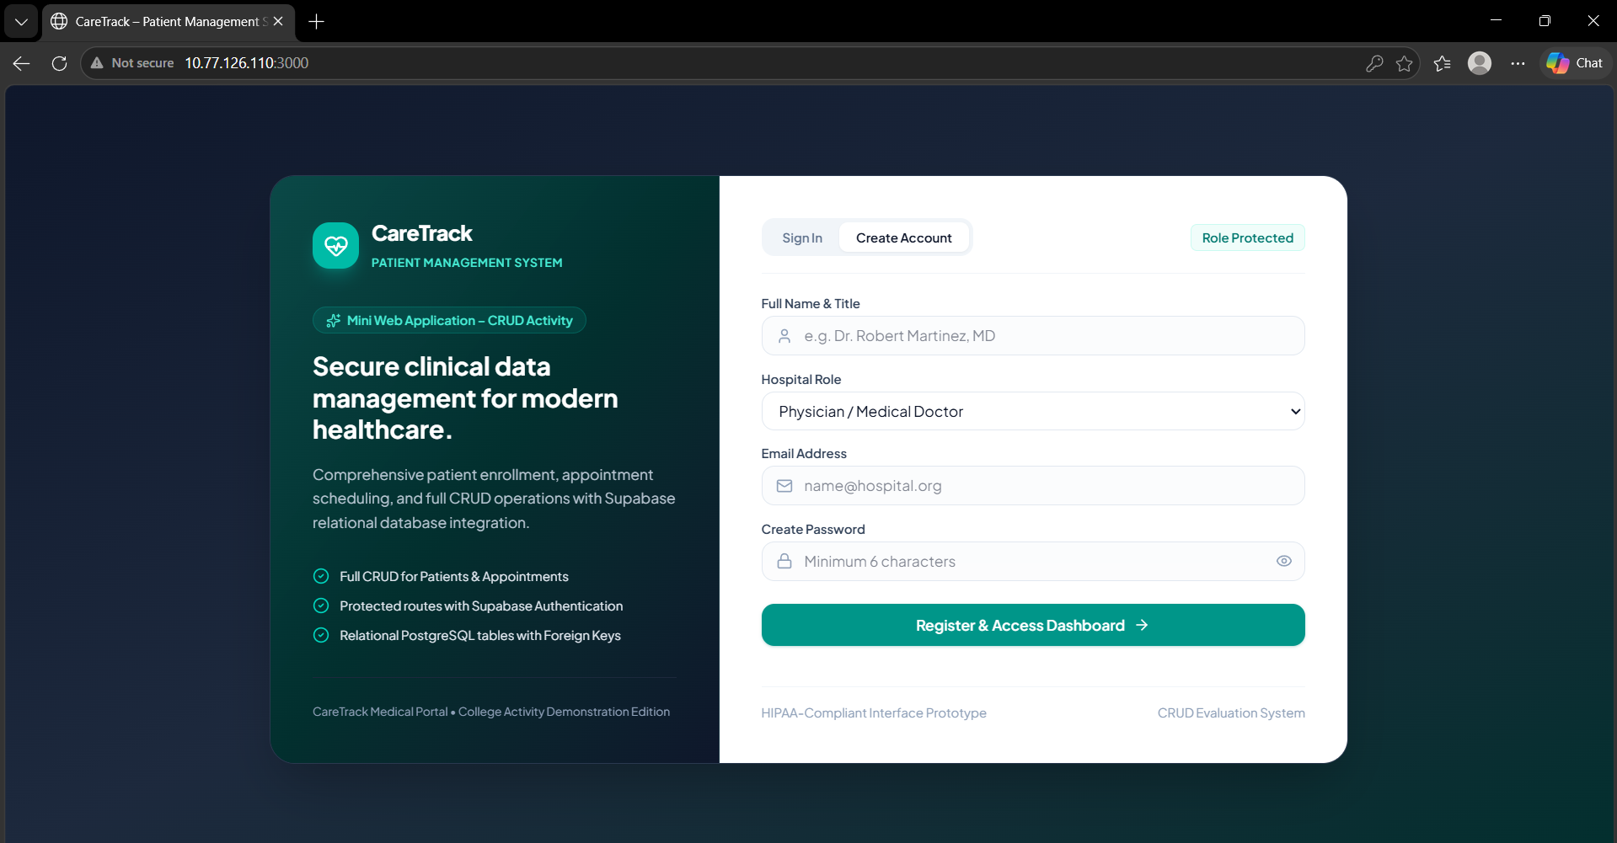
Figure 1 – Login screen
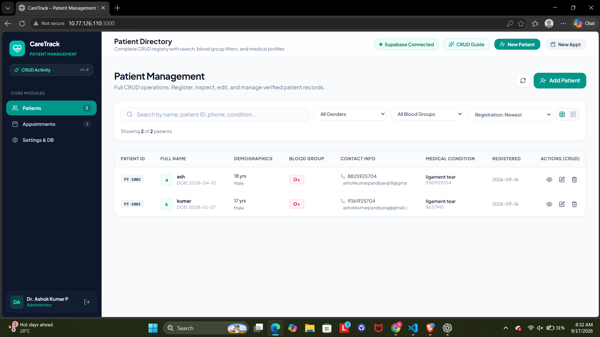
Figure 2 – Patient Directory
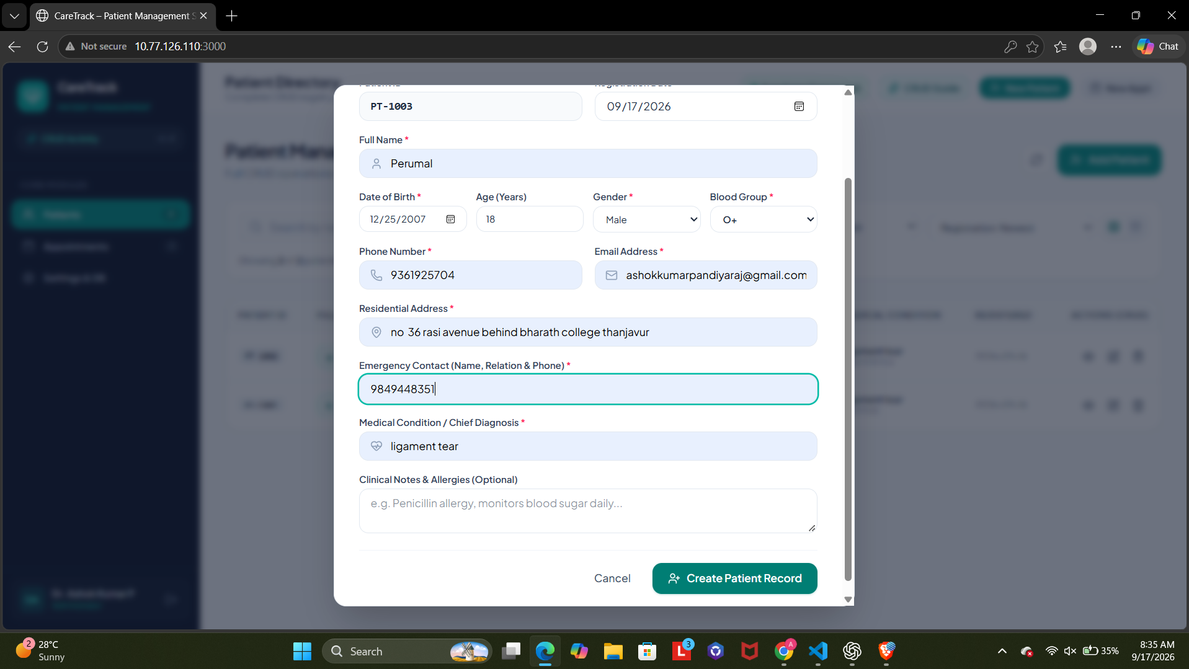
Figure 3 – Add Patient form
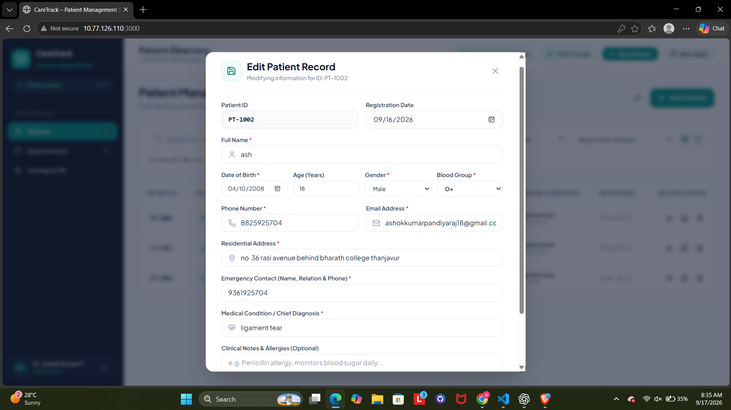
Figure 4 – Edit Patient form
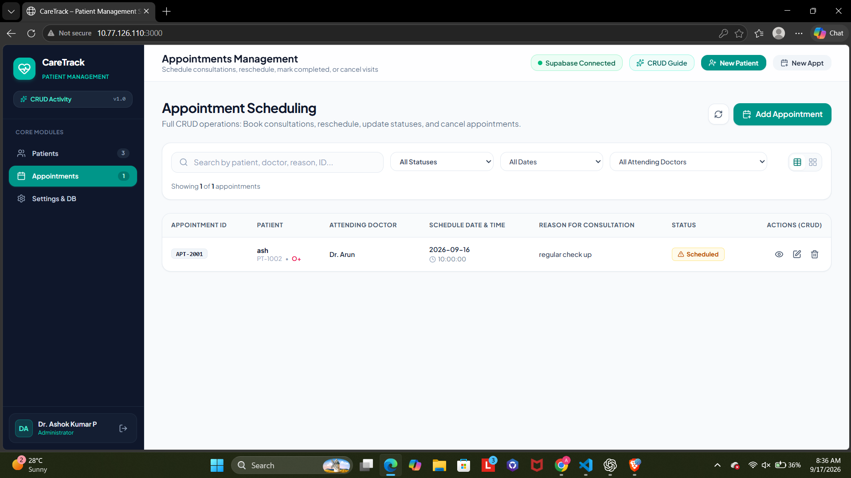
Figure 5 – Appointment Management
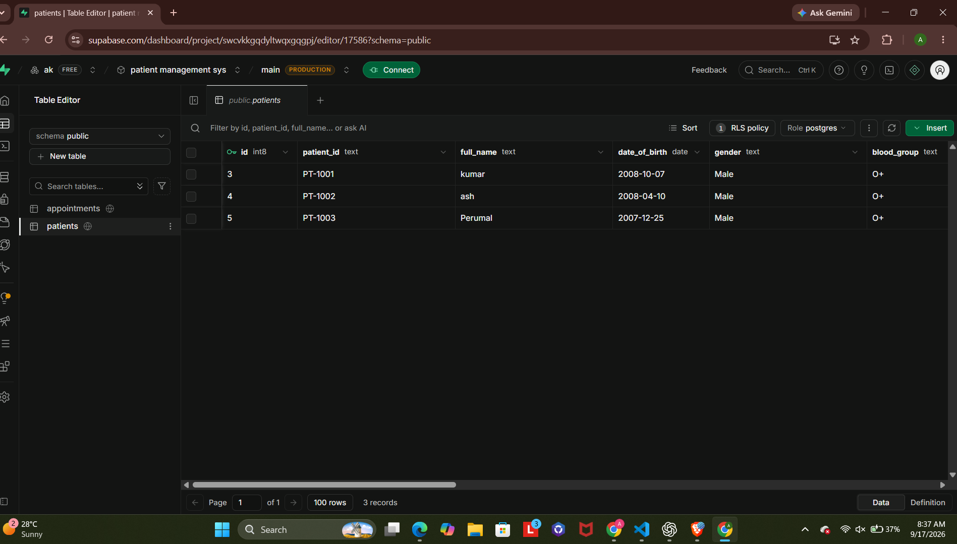
Figure 6 – Supabase patients table
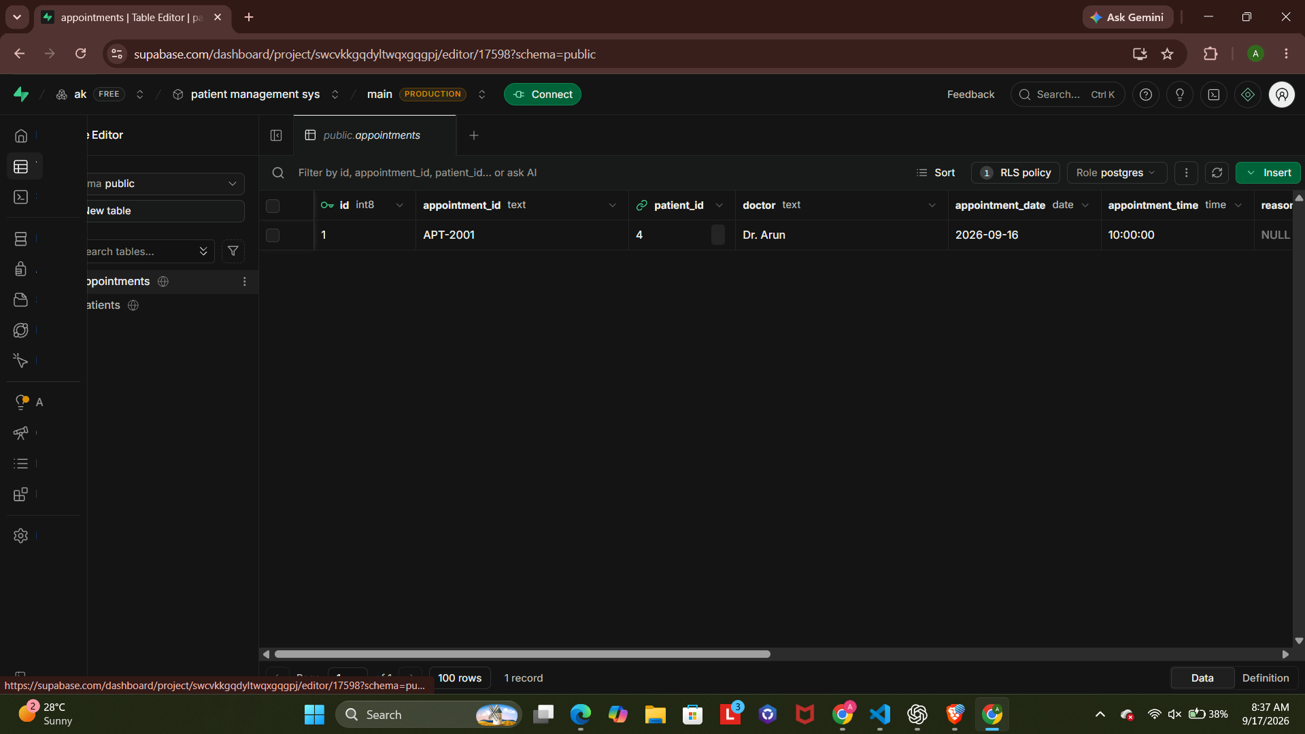
Figure 7 – Supabase appointments table
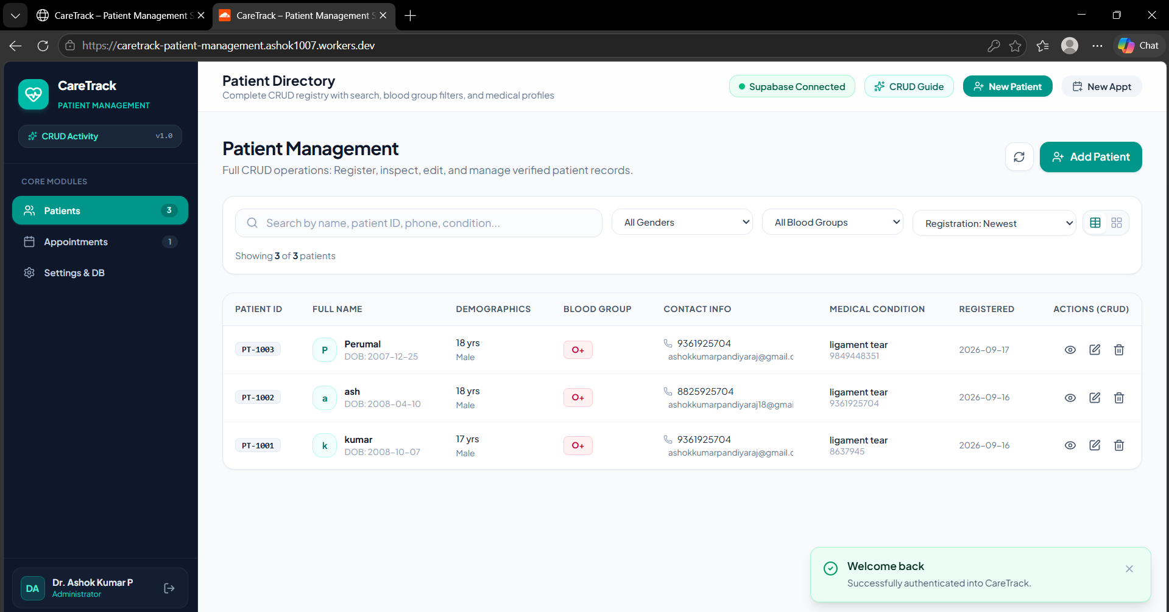
Figure 8 – Deployed CareTrack application

8. API / Supabase Endpoint Documentation
The frontend uses the Supabase JavaScript client rather than manually implementing a separate REST server. Supabase exposes database operations through its Data API. The browser-side client is initialized using the Supabase project URL and publishable key stored in Vite environment variables.
Operation | Entity | Application Action
Create | patients | Insert a new patient record.
Read | patients | Retrieve and display patient records.
Update | patients | Modify an existing patient record.
Delete | patients | Remove an existing patient record.
Create | appointments | Create a new appointment.
Read | appointments | Retrieve appointment records.
Update | appointments | Modify appointment details/status.
Delete | appointments | Remove an appointment.

Environment variables used by the frontend:
- VITE_SUPABASE_URL – Supabase project URL.
- VITE_SUPABASE_PUBLISHABLE_KEY – Supabase publishable key.
Security note: secret/service-role keys must not be placed in frontend source code or exposed through client-side environment variables.

9. CRUD Implementation Details

9.1 Create
The Create operation is implemented through patient and appointment forms. After validation, the application sends an insert request to the corresponding Supabase table and refreshes the displayed data.

9.2 Read
The Read operation retrieves records from Supabase and displays them in structured tables/cards. Search and filtering can be applied to make records easier to locate.

9.3 Update
The Update operation opens an existing record in an editable form. After changes are validated, the corresponding database record is updated.

9.4 Delete
The Delete operation removes the selected record after a confirmation step. The interface then refreshes so the deleted record is no longer displayed.

10. Testing Results
The following test matrix should be completed against the final deployed version before submission. Replace the status column with the actual result after final verification.
Test ID | Test Case | Expected Result | Status
TC01 | Open application | Application loads without a blank/error screen. | Verify
TC02 | Add patient | New patient is stored and appears in Patient Directory. | Verify
TC03 | View patients | Stored patient records are retrieved from Supabase. | Verify
TC04 | Edit patient | Selected patient information is updated. | Verify
TC05 | Delete patient | Selected patient is removed after confirmation. | Verify
TC06 | Add appointment | Appointment is stored and displayed. | Verify
TC07 | Edit appointment | Appointment details/status are updated. | Verify
TC08 | Delete appointment | Selected appointment is removed. | Verify
TC09 | Search/filter | Matching records are displayed correctly. | Verify
TC10 | Invalid form input | Validation message prevents invalid submission. | Verify
TC11 | Database persistence | Refresh does not remove saved Supabase data. | Verify
TC12 | Responsive UI | Application remains usable on desktop/mobile widths. | Verify

11. Installation and Execution Steps
- Install Node.js and npm.
- Open the project folder in VS Code.
- Install project dependencies using: npm install
- Create a .env file in the project root.
- Configure VITE_SUPABASE_URL with the Supabase project URL.
- Configure VITE_SUPABASE_PUBLISHABLE_KEY with the Supabase publishable key.
- Ensure the patients and appointments tables exist in Supabase and the required access policies are configured.
- Start the local development server using: npm run dev
- Open the local URL displayed by Vite in the browser.
- Verify patient and appointment CRUD operations.
- Build the project using: npm run build
- Deploy the final build to Cloudflare using the configured Wrangler deployment command.
For React + Vite applications, Cloudflare's current deployment approach uses the Cloudflare Vite plugin and Wrangler. SPA routing should be configured so application routes continue to resolve correctly.

12. Challenges and Solutions
Challenge | Solution
Moving from demo/local data to a real database | Connected the application data layer to Supabase PostgreSQL and removed local/demo persistence.
Keeping CRUD operations consistent with the UI | Centralized database operations and refreshed displayed records after mutations.
Managing form validation | Added required-field validation and user feedback before database operations.
Maintaining patient–appointment relationships | Used a patient reference in appointment records and displayed the related patient information.
Preparing the application for deployment | Configured Vite build output and Cloudflare Wrangler deployment for the React SPA.
Protecting database credentials | Used frontend-safe Supabase project URL and publishable key; secret keys are not exposed in the client.

13. Future Enhancements
- Role-based access for administrator, receptionist and doctor accounts.
- Doctor management as a separate database table instead of a fixed list.
- Patient medical history and prescription modules.
- Appointment calendar and reminder notifications.
- Dashboard analytics and monthly reports.
- Export patient/appointment reports to PDF or CSV.
- Audit logs for tracking record changes.
- Advanced filtering and pagination for large datasets.
- Improved accessibility and multilingual support.
- Integration with email/SMS notification services.

14. Git Repository / Reference Details
Add the final Git repository URL and deployed application URL below before submission.
Reference | Details
Git Repository | [ INSERT FINAL GITHUB REPOSITORY URL ]
Live Application | [ INSERT FINAL CLOUDFLARE URL ]
Database | Supabase PostgreSQL
Deployment Platform | Cloudflare Workers

15. Conclusion
CareTrack demonstrates the development of a practical CRUD-based web application using modern frontend and cloud database technologies. The project combines React and TypeScript for the user interface, Supabase for authentication/database services, PostgreSQL for structured data storage, and Cloudflare for deployment. The application provides the core operations required for managing patients and appointments and can be extended into a larger healthcare-management prototype.

Appendix A – Submission Checklist
- Title and project overview included.
- Problem statement included.
- Objectives included.
- Technology stack included.
- System architecture included.
- Database/ER diagram included.
- UI screenshots inserted.
- API/Supabase documentation included.
- CRUD implementation details included.
- Testing results updated with actual final results.
- Installation and execution steps included.
- Challenges and solutions included.
- Future enhancements included.
- Git repository URL added.
- Live Cloudflare URL added.

