Stores Sales Prediction

***Wireframe Documentation***

Homepage

The Store Sales Prediction System is completely done in a Single Section -

1. Once we open the link for the website, we need to provide the necessary input and click on the submit button.

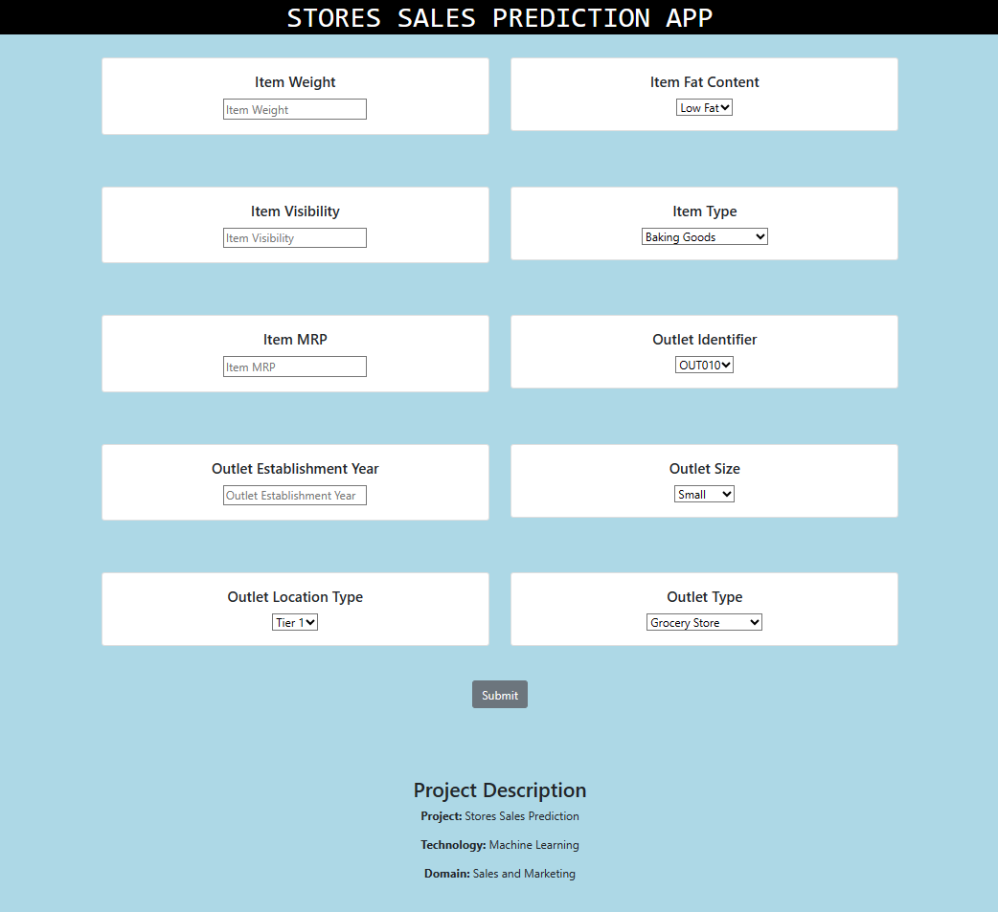

With respect to the User’s input, our Store Sales Prediction System will predict the item outlet sales of the product of the particular store. A sample view of the Web Application showing results is below:

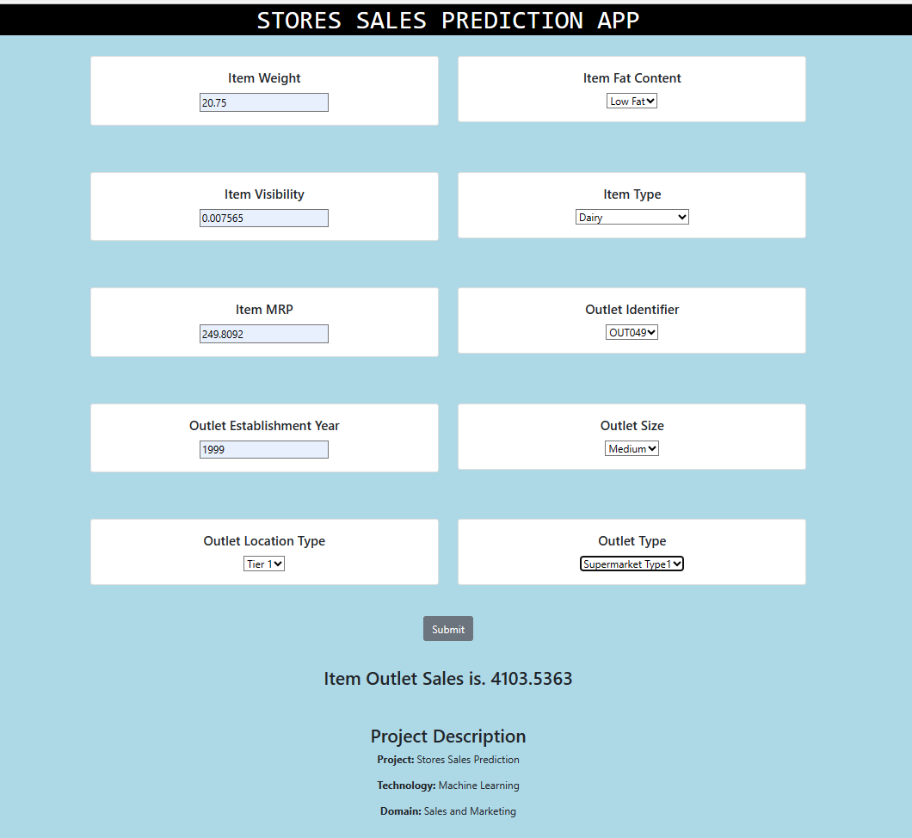

# About Page

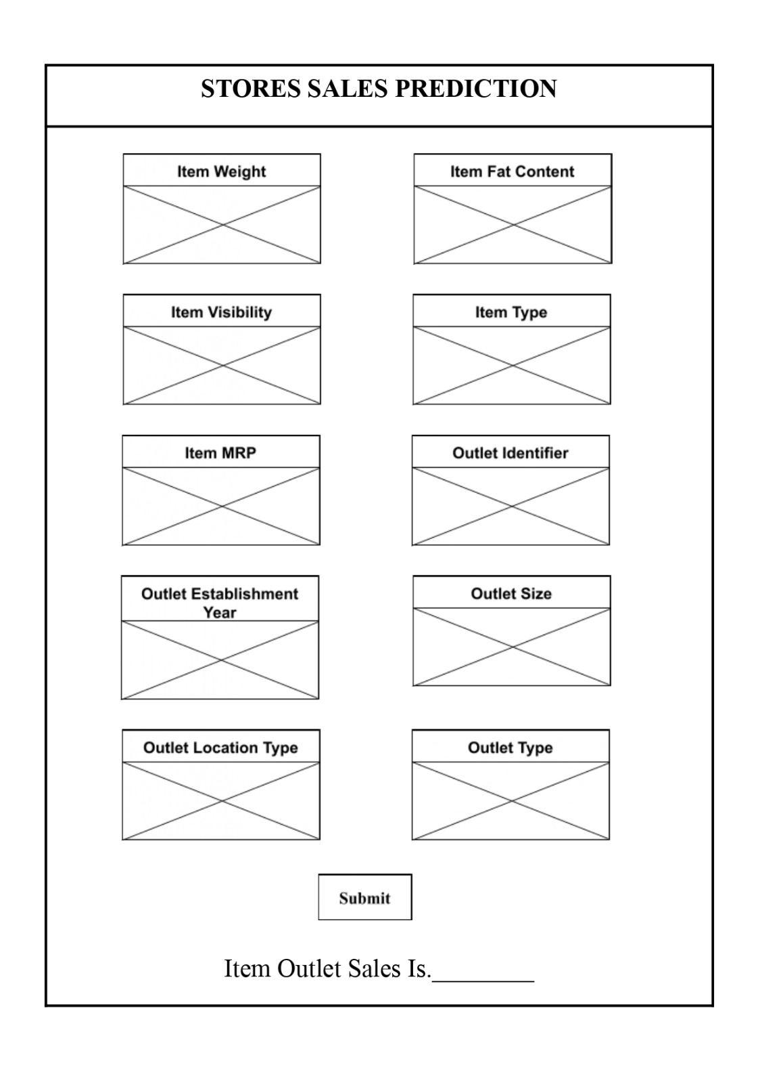

The **Crossed Sections** in above sample can be used for entering the necessary values necessary for predicting the sales of the product.