SPAM HAM CLASSIFIER

***Wireframe Documentation***

*Homepage*

The Spam Ham Classifier is completely done in a Single Section -

1. Once we open the link for the website, we need to enter the message in the input text box and click on the predict button.

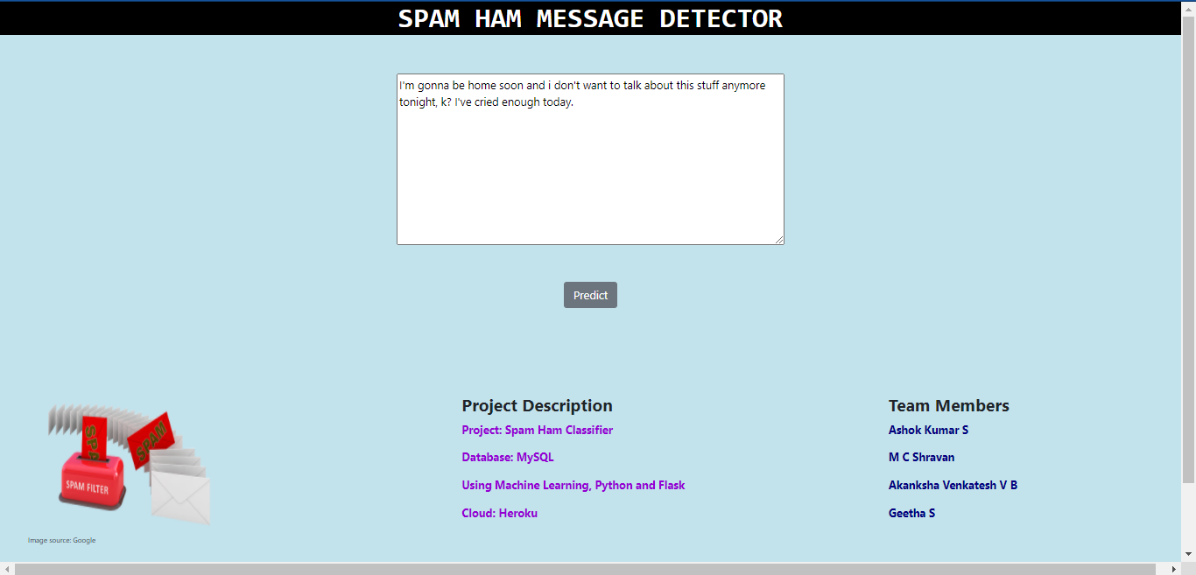

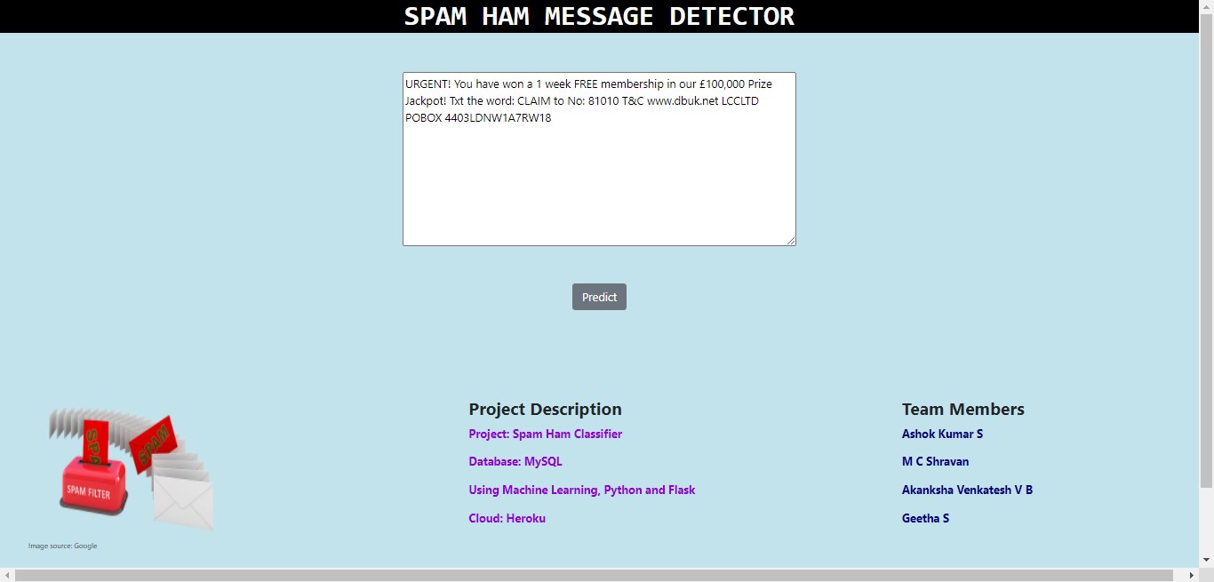

With respect to the User’s message in the input box, our Spam Ham Classifier will predict if the message is spam or ham (legitimate).

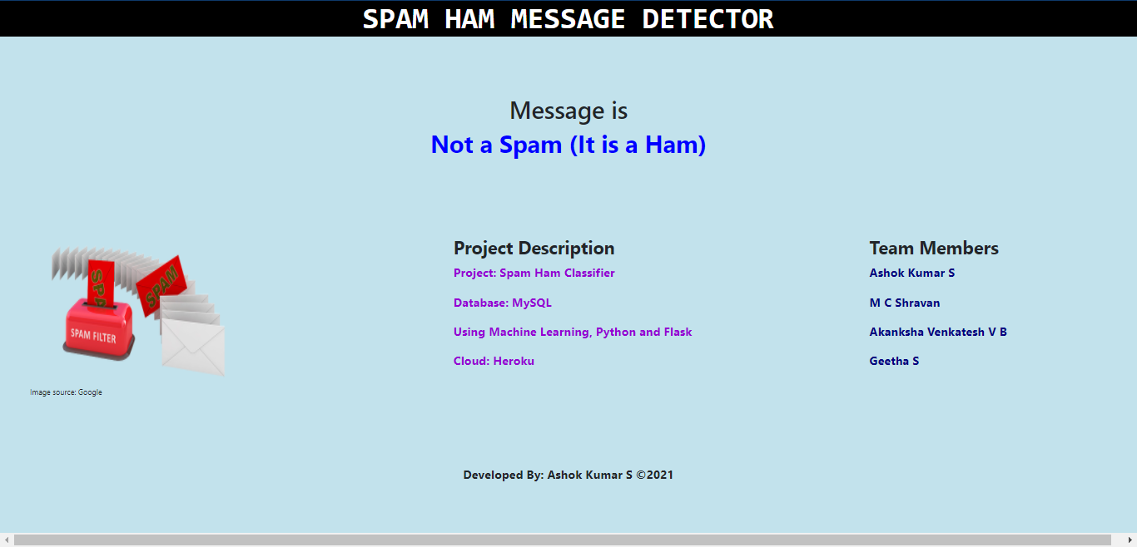

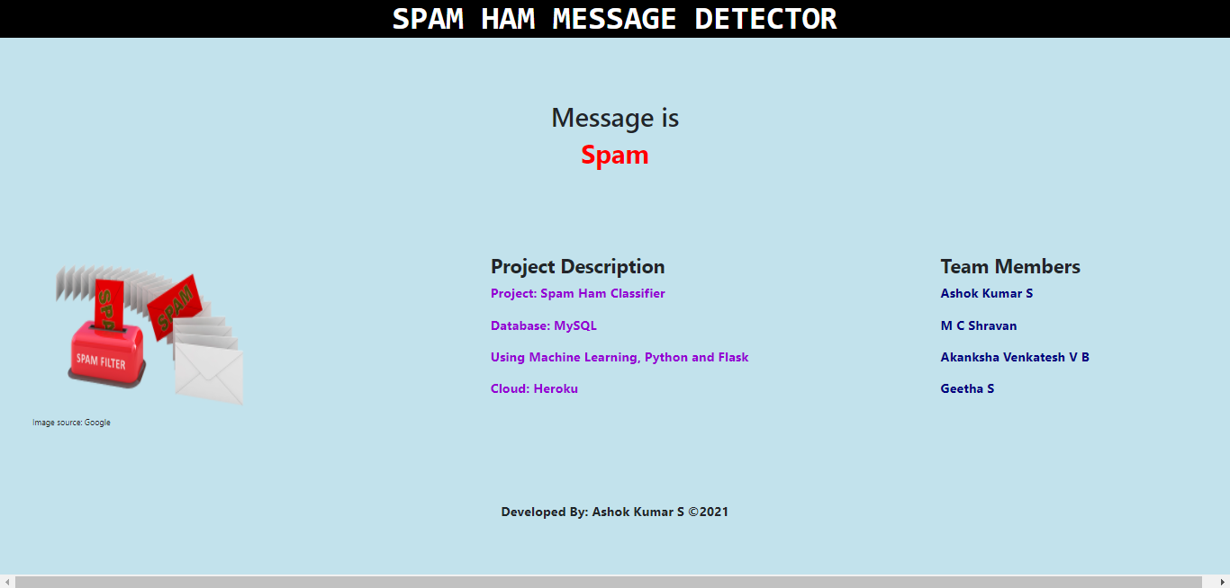

# About Page

# Home Page

# Result Page

