**Assignment 1: Ontology Design**

**Group 12**

|  |  |  |
| --- | --- | --- |
|  |  |  |

**Team Members**

| CS21M012 | Bhawna Bansal |
| --- | --- |
| CS21M060 | Saurabh Sathe |
| CS21M009 | Ashok Kumar Thota |
| CS21M006 | Ankita Chauhan |
| CS21M026 | Kankan Jana |

Domain**: TV series**

**DTD :**

<!ELEMENT tvseries (#PCDATA | info | cast | crew | awards)*>

<!ELEMENT info (#PCDATA | titles | story-line | release-dates | genres | streamingmedia | production | Certificate | writter | shooting-location | director | creator | rating | seasons | movie-characters | songs)*>

<!ELEMENT cast (#PCDATA | actor | actress)*>

<!ELEMENT crew (#PCDATA | music-director | costume-designer | set-designer | singer | sound-designer | makeup-artist | production-manager | cinematographer | composer | associate-producer | location-manager | script-editor | additional-dialogue)*>

<!ELEMENT awards (#PCDATA | nominee | winner)*>

<!ELEMENT titles (#PCDATA | title)*>

<!ELEMENT title (#PCDATA)>

<!ELEMENT streamingmedia (#PCDATA)>

<!ELEMENT production (#PCDATA)>

<!ELEMENT release-dates (#PCDATA | date)*>

<!ELEMENT date (#PCDATA)>

<!ELEMENT genres (#PCDATA | type)*>

<!ELEMENT type (#PCDATA)>

<!ELEMENT Certificate (#PCDATA)>

<!ELEMENT writter (#PCDATA | person)*>

<!ELEMENT shooting-location (#PCDATA | location)*>

<!ELEMENT location (#PCDATA)>

<!ELEMENT director (#PCDATA | person)*>

<!ELEMENT person (#PCDATA | name)*>

<!ELEMENT name (#PCDATA)>

<!ELEMENT rating (#PCDATA | item)*>

<!ELEMENT item (#PCDATA)>

<!ATTLIST item by CDATA #IMPLIED>

<!ELEMENT songs (#PCDATA | song)*>

<!ELEMENT song (#PCDATA | title | singers | duration)*>

<!ATTLIST director roleid CDATA #IMPLIED>

<!ATTLIST writter roleid CDATA #IMPLIED>

<!ATTLIST date country CDATA #IMPLIED>

<!ELEMENT constume-designer (#PCDATA | person)*>

<!ATTLIST constume-designer roleid CDATA #IMPLIED>

<!ELEMENT about (#PCDATA)>

<!ELEMENT episode (#PCDATA | duration | number | title)*>

<!ELEMENT cinematographer (#PCDATA | person)*>

<!ATTLIST cinematographer roleid CDATA #IMPLIED>

<!ELEMENT number (#PCDATA)>

<!ELEMENT character (#PCDATA | name)*>

<!ATTLIST character playedBy CDATA #IMPLIED>

<!ATTLIST character leadrole CDATA #IMPLIED>

<!ATTLIST character debutant CDATA #IMPLIED>

<!ELEMENT location-manager (#PCDATA | person)*>

<!ATTLIST location-manager roleid CDATA #IMPLIED>

<!ELEMENT season (#PCDATA | number | relese | about | episodes)*>

<!ELEMENT movie-characters (#PCDATA | character)*>

<!ELEMENT episodes (#PCDATA | total | episode)*>

<!ELEMENT seasons (#PCDATA | season)*>

<!ATTLIST song songid CDATA #IMPLIED>

<!ELEMENT singers (#PCDATA | singerid)*>

<!ELEMENT set-designer (#PCDATA | person)*>

<!ATTLIST set-designer roleid CDATA #IMPLIED>

<!ELEMENT actress (#PCDATA | person)*>

<!ATTLIST actress roleid CDATA #IMPLIED>

<!ELEMENT script-editor (#PCDATA | person)*>

<!ATTLIST script-editor roleid CDATA #IMPLIED>

<!ELEMENT music-director (#PCDATA | person)*>

<!ATTLIST music-director roleid CDATA #IMPLIED>

<!ELEMENT category (#PCDATA)>

<!ELEMENT singerid (#PCDATA)>

<!ELEMENT winner (#PCDATA | award)*>

<!ELEMENT person (#PCDATA | name)*>

<!ATTLIST person personId CDATA #IMPLIED>

<!ATTLIST person hiredby CDATA #IMPLIED>

<!ATTLIST person debutant CDATA #IMPLIED>

<!ELEMENT associate-producer (#PCDATA | person)*>

<!ATTLIST associate-producer roleid CDATA #IMPLIED>

<!ELEMENT additional-dialogue (#PCDATA | person)*>

<!ATTLIST additional-dialogue roleid CDATA #IMPLIED>

<!ELEMENT singer (#PCDATA | person)*>

<!ATTLIST singer roleid CDATA #IMPLIED>

<!ELEMENT artist (#PCDATA | singerid)*>

<!ELEMENT production-manager (#PCDATA | person)*>

<!ATTLIST production-manager roleid CDATA #IMPLIED>

<!ATTLIST title country CDATA #IMPLIED>

<!ATTLIST tvseries seriesid CDATA #IMPLIED>

<!ELEMENT duration (#PCDATA)>

<!ELEMENT total (#PCDATA)>

<!ELEMENT award (#PCDATA | catagory)*>

<!ATTLIST award nomineeid CDATA #IMPLIED>

<!ATTLIST award name CDATA #IMPLIED>

<!ATTLIST award wonby CDATA #IMPLIED>

<!ELEMENT nominee (#PCDATA | award)*>

<!ELEMENT creator (#PCDATA | person)*>

<!ATTLIST creator roleid CDATA #IMPLIED>

<!ELEMENT makeup-artist (#PCDATA | person)*>

<!ATTLIST makeup-artist roleid CDATA #IMPLIED>

<!ELEMENT composer (#PCDATA | person)*>

<!ATTLIST composer roleid CDATA #IMPLIED>

<!ELEMENT actor (#PCDATA | person)*>

<!ATTLIST actor roleid CDATA #IMPLIED>

<!ELEMENT relese (#PCDATA)>

<!ELEMENT sound-designer (#PCDATA | person)*>

<!ATTLIST sound-designer roleid CDATA #IMPLIED>

**Description of DTD :**

* The root element of the document is tvseries.
* The element info has content particles:  ( titles , story-line , release-dates ,genres , streamingmedia , production  Certificate , writer , shooting-location , director , creator , rating , seasons , movie-characters , songs)*
* The element cast has content particles : (actor ,  actress)*
* The element crew has content particles : (music-director , costume-designer , set-designer , singer , sound-designer , makeup-artist , production-manager , cinematographer , composer , associate-producer , location-manager , script-editor , additional-dialogue)*
* The element awards has content particles : ( nominee , winner)*
* The element titles has content particles : (title)*
* The element title has parsable character data.
* The element streamingmedia has parsable character data.
* The element production has parsable character data.
* The element  release-dates has content particles : (date)*
* The element date has parsable character data.
* The element  genres  has content particles : ( type )*
* The element type has parsable character data.
* The element Certificate has parsable character data.
* The element  writter  has content particles : ( person )*
* The element  shooting-location  has content particles : ( location)*
* The location type has parsable character data
* The element  director  has content particles : ( person )*
* The element  person has content particles : ( name)*

* The element  rating  has content particles : ( item)*
* The location item has parsable character data
* The element songs has content particle:  ( song )*.
* The element song has content particles:  (title , singers , duration)*.
* The element constume-designer has content particle:  ( person )*.
* The element about has parsable character data.
* The element number  has parsable character data.
* The element episode  has content particles:  ( duration , number , title )*.
* The element cinematographer  has content particle:  ( person )*.
* The element number  has parsable character data.
* The element character  has content particle: name.
* The element  location-manager has a content particle: person.
* The element season has content particles: “( number , release, about, episodes)”.
* The element  movie-characters has content particle: “( character )*”.
* The element episodes has content particles: ( total , episode )*.
* The element  seasons  has content particle: ( season )*.
* The element  singers  has content particle:  ( singerid )*
* The element set-designer has content particle: ( person )*
* The element  actress  has content particle: ( person )*
* The element script-editor has  content particle: ( person )*
* The element  music-director has  content particle: ( person )*
* The element category contains parsable character data.
* The element singerid  contains parsable character data.
* The element  winner has content particle: ( award )*

* The element person has content particle: ( name )*
* The element associate-producer has content particle: ( person )*
* The element additional-dialogue has content particle: ( person )*
* The element singer has content particle:  ( person )*
* The element artist has content particle: ( singerid )*
* The element production-manager has  content particle:  ( person )*

      .

* The element additional-dialogue has a content particle:( person )*.
* The element singer has a content particle:( person )*.
* The element duration contains parsable character data.
* The element total contains parsable character data.
* The element award has content particle:category.
* The element nominee has a content particle:award.
* The element creator has a content particle: person.
* The element makeup-artist has a content particle: person.
* The element composer has a content particle: person.
* The element actor has content:person.
* The element relese contain parsable character data.
* The element sound-designer has content:person.

**XML based on above DTD :**

<?xml version="1.0"?>

<!DOCTYPE tvseries SYSTEM "file:/C:/Users/Saurabh/Downloads/ss.dtd">

<!-- You have to delete the DOCTYPE below -->

<tvseries seriesid="123456" >

    <info>

        <titles>

            <title country="India">The Family Man</title>

            <title country="USA">The Family Man</title>

            <title country="Brazil">Homem de Família</title>

        </titles>

        <story-line>The Family Man is an edgy action-drama series, which tells the story of a mpersonIddle-class man who works for a special cell of the National Investigation Agency. While he tries to protect the nation from terrorists, he also has to protect his family from the impact of his secretive, high-pressure, and low paying job.

        </story-line>

        <release-dates>

            <date country="Brazil">19 September 2019    </date>

            <date country="USA">19 September 2019    </date>

            <date country="India">20 September 2019    </date>S

        </release-dates>

        <genres>

            <type>Action</type>

            <type>Comedy</type>

            <type>Drama</type>

        </genres>

        <streamingmedia>Amazon Prime</streamingmedia>

        <production>D2R Films</production>

        <Certificate>18+</Certificate>

        <writter roleid="1">

            <person personId="10">    <name>Raj NpersonIdimoru </name></person>

            <person personId="11">    <name>Krishna D.K </name></person>

        </writter>

        <shooting-location>

            <location>Ballard Estate</location>

            <location>Chennai</location>

            <location>Delhi</location>

        </shooting-location>

        <director roleid="0">

            <person personId="10"  >

                <name>Raj NpersonIdimoru </name>

            </person>

            <person personId="11"  >

                <name>Krishna D.K </name>

            </person>

        </director>

        <creator roleid="2" >

            <person personId="11" hiredby="10">

                <name>Krishna D.K.</name>

            </person>

            <person personId="10" hiredby="10"><name>Raj NpersonIdimoru</name>

            </person>

        </creator>

        <rating>

            <item by="imdb">8.5/10</item>

            <item by="gadgets360">3.5/5</item>

        </rating>

        <seasons>

            <season>

                <number>1</number>

                <relese>19 September 2019</relese>

                <about>Srikant Tiwari (Manoj Bajpayee) is an intelligence officer working in National Investigation Agency’s fictitious cell, Threat Analysis and Surveillance Cell (TASC), which specialises in predicting terrorist attacks. While Tiwari is a senior analyst with laudable work history, he has to disguise himself as a regular employee stuck in a dead-end government job.

                </about>

                <episodes>

                    <total>10</total>

                    <episode><duration>49:00</duration><number>1</number><title>The Family Man</title></episode>

                    <episode> <duration>49:00</duration><number>2</number> <title>Sleepers</title></episode>

                    <episode> <duration>49:00</duration><number>3</number><title>Anti-National</title></episode>

                    <episode><duration>49:00</duration><number>4</number><title>Patriots</title></episode>

                    <episode><duration>49:00</duration><number>5</number><title>Pariah</title></episode>

                    <episode><duration>49:00</duration><number>6</number><title>Dance of Death</title></episode>

                    <episode><duration>49:00</duration><number>7</number><title>Paradise</title></episode>

                    <episode><duration>49:00</duration><number>8</number><title>Act of War</title></episode>

                    <episode><duration>49:00</duration><number>9</number><title>Fighting Dirty</title></episode>

                    <episode><duration>49:00</duration><number>10</number><title>The Bomb</title></episode>

                </episodes>

            </season>

            <season>

                <number>2</number>

                <about>Srikant Tiwari (Manoj Bajpayee) quits T.A.S.C. and joins a regular 9-5 job in an I.T. company. DevopersonId of the juicy adventures that defined his routine earlier, Tiwari is engulfed in boredom and underlying frustration. As he gets to know about an attack being planned by the Sri Lankan Tamils,it doesn’t take him long to quit his current soul-sucking job and swing back to the agency. However, the danger this time is greater and closer to home.

                </about>

                <relese>4 June 2021</relese>

                <episodes>

                    <total>9</total>

                    <episode> <duration>49:00</duration><number>1</number><title>Exile</title></episode>

                    <episode> <duration>49:00</duration><number>2</number><title>Weapon</title></episode>

                    <episode> <duration>49:00</duration><number>3</number><title>Angel of Death</title></episode>

                    <episode> <duration>49:00</duration><number>4</number><title>Eagle</title></episode>

                    <episode>  <duration>49:00</duration><number>5</number><title>Homecoming</title></episode>

                    <episode> <duration>49:00</duration><number>6</number><title>Martyrs</title></episode>

                    <episode> <duration>49:00</duration><number>7</number><title>Collateral Damage</title></episode>

                    <episode> <duration>49:00</duration><number>8</number><title>Vendetta</title></episode>

                    <episode> <duration>49:00</duration><number>9</number><title>The Final Act</title></episode>

                </episodes>

            </season>

        </seasons>

        <movie-characters>

            <character playedBy="2"><name>JK Talpade</name></character>

            <character  playedBy="0" leadrole="true"><name>Srikant Tiwari</name></character>

            <character playedBy="100" debutant="true" > <name>Ajit</name></character>

            <character playedBy="4"><name>Atharv</name></character>

            <character playedBy="1" leadrole="true"><name>Suchitra Tiwari</name></character>

            <character playedBy="3" ><name>Dhriti</name></character>

        </movie-characters>

        <songs>

            <song songid='0'><title>Kiske Liye Tu Marega</title>

                <singers>

                    <singerid>12</singerid>

                    <singerid>13</singerid>

                   </singers>

                <duration>3:09</duration>

            </song>

            <song songid='2'><title>Banjara</title>

                <singers >

                    <singerid>14</singerid>

                    </singers>

                <duration>5:00</duration>

            </song>

            <song songid='3'><title>Dega Jaan</title>

                <singers >

                    <singerid>12</singerid>

                    <singerid>13</singerid>

                </singers>

                <duration>5:00</duration>

            </song>

        </songs>

    </info>

    <cast>

            <actor roleid="25" >

                <person personId="0" hiredby="11">

                    <name >Manoj Bajpayee</name>

                </person>

                <person personId="2" hiredby="11">

                    <name>Sharib Hashmi</name>

                </person>

                <person personId="100" debutant="true" hiredby="10">

                    <name>Vijay Vikram Singh</name>

                </person>

                <person personId="4" hiredby="10">

                    <name>Vedant Sinha</name>

                </person>

            </actor>

        <actress roleid="26">

           <person personId="1" hiredby="10" >

            <name >Priyamani</name>

            </person>

            <person personId="3" hiredby="10">

                <name>Ashlesha Thakur</name>

            </person>

        </actress>

          </cast>

    <crew>

        <music-director roleid="3">

            <person personId="16" hiredby="11">    <name>Ketan Sodha </name></person>

            <person personId="17" hiredby="11">    <name>Sachin Sanghvi </name></person>

        </music-director>

        <constume-designer roleid="4">

            <person personId="19" hiredby="10">

            <name>Krish Khatri</name>

        </person>

            <person personId="20" hiredby="10">

                <name>Suveera Ambade</name>

            </person>

            <person personId="21" hiredby="11"><name>Swetesh Ambade</name>

            </person></constume-designer>

        <set-designer roleid="5" >

            <person personId="23" hiredby="10"><name>Yasmin Sethi</name>

        </person>

            <person personId="24" hiredby="10"><name>Monica Balsara </name>

        </person>

        </set-designer >

        <singer roleid="100">

            <person personId="12" hiredby="10"><name >Shreya Ghoshal</name></person>

            <person personId="13" hiredby="11"><name >Mellow D</name></person>

            <person personId="14" hiredby="10"><name >Ved Jamsandekar</name></person>

        </singer>

        <sound-designer roleid="6">

            <person personId="240" hiredby="11"><name>Anuroop Kukreja</name>

        </person>

            <person personId="24" hiredby="11"><name>Brendan Golden</name>

        </person>

        </sound-designer >

        <makeup-artist roleid="7" > <person personId="205"  hiredby="10"><name>Latta Pathak</name>

        </person>

            <person personId="25" hiredby="10"><name>SajpersonId Khan</name></person>

        </makeup-artist>

        <production-manager roleid="8">

            <person personId="26" hiredby="10"><name>Naseer Khan</name>

        </person>

            <person personId="27" hiredby="10"><name>Nasir Ahmed Khan</name>

            </person>

        </production-manager>

        <cinematographer roleid="9"> <person personId="28" hiredby="10"><name>Nigam Bomzan</name>

        </person></cinematographer>

        <music-director roleid="10"><person personId="29" hiredby="10"><name>Sachin Sanghvi</name>

        </person></music-director>

        <composer roleid="11"> <person personId="30" hiredby="10"><name>Ketan Sodha</name>

        </person></composer>

        <associate-producer roleid="12"> <person personId="31" hiredby="10"><name>Anuradha Sharma</name>

        </person></associate-producer>

        <location-manager roleid="13"> <person personId="32" hiredby="10"><name>Sanju Balmeeki</name>

        </person></location-manager>

        <script-editor roleid="14"><person personId="33" hiredby="10"><name>Ravi Shankar Muppa    </name>

        </person></script-editor>

        <additional-dialogue roleid="15"><person personId="34" hiredby="10"><name>

            Sumit Arora</name>

        </person></additional-dialogue>

    </crew>

<awards>

    <nominee>

        <award nomineeid="0" name="Asian Academy Creative Award">

            <catagory>Best Actor in a Leading Role</catagory>

        </award>

        <award nomineeid="5" name="Asian Academy Creative Award">

            <catagory>Best Direction (Fiction)</catagory>

        </award>

    </nominee>

    <winner>

        <award wonby="0" name="Dada Saheb Phalke Award">

          <catagory>Best Actor - Web Series</catagory>

        </award>

    </winner>

</awards>

</tvseries>

**Ontology Ashok Kumar Thota  
Assignment-2 CS21M009**

**XPATH:**

**Query1:** //titles/title[3]

**Description:** Selects the third title which is the child of the titles element.

**Results:**

System ID: F:\sem 2\Theory and Applications of Ontologies\Assignment\Assignment\onto.xml

Description: Homem de Família

XPath location: /tvseries[1]/info[1]/titles[1]/title[3]

Start location: 9:13

End location: 9:61

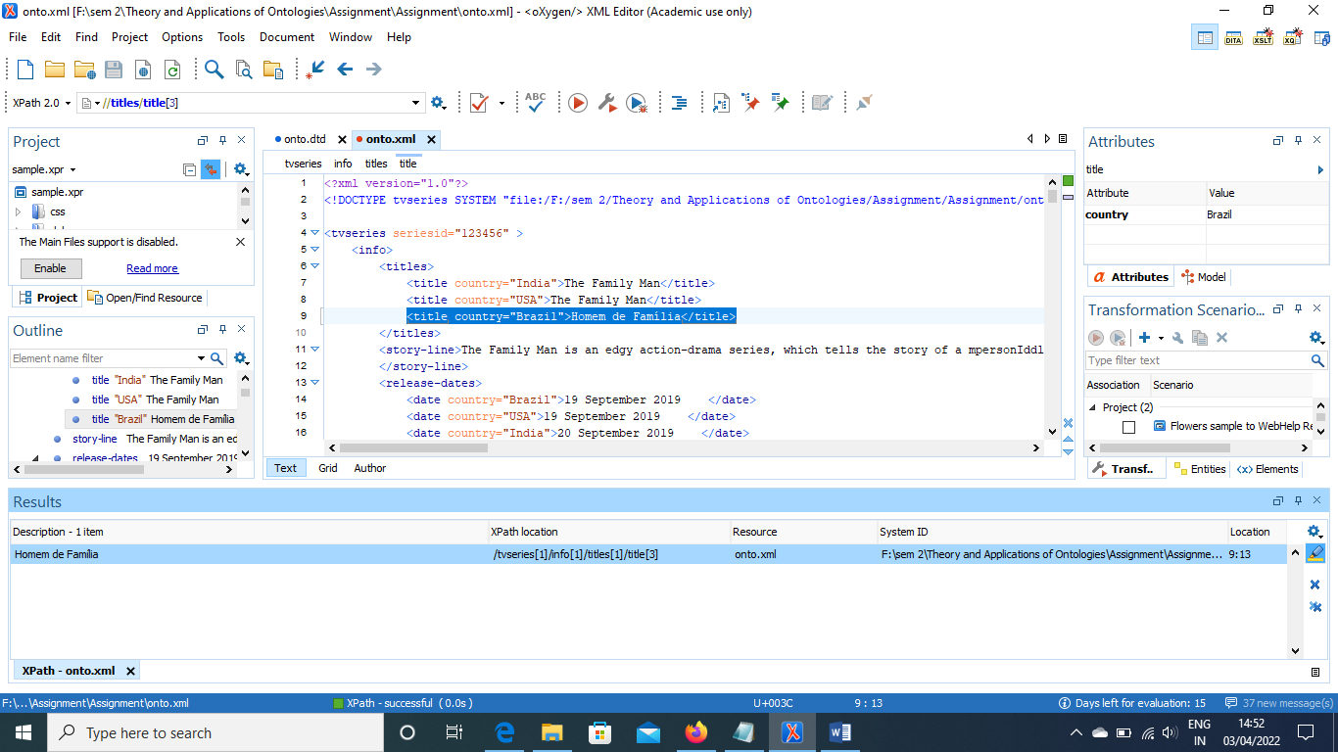

**Query2:** //*/*/name

**Description:** Selects every name that has at least two ancestors.

**Results:**

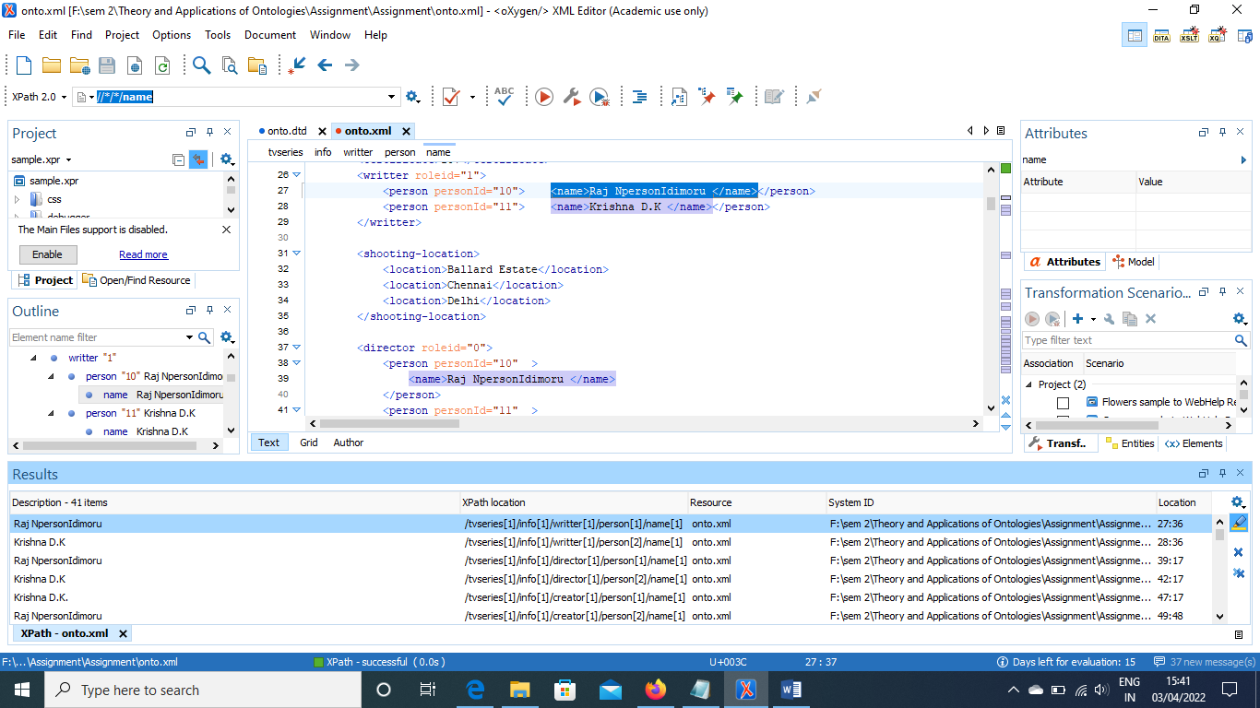

**Query3:** //director/person[normalize-space(@personId)="10"]/*

**Description:** Selects every person element with attribute personId

and with value 10.

**Results:**

System ID: F:\sem 2\Theory and Applications of Ontologies\Assignment\Assignment\onto.xml

Description: Raj NpersonIdimoru

XPath location: /tvseries[1]/info[1]/director[1]/person[1]/name[1]

Start location: 39:17

End location: 39:49

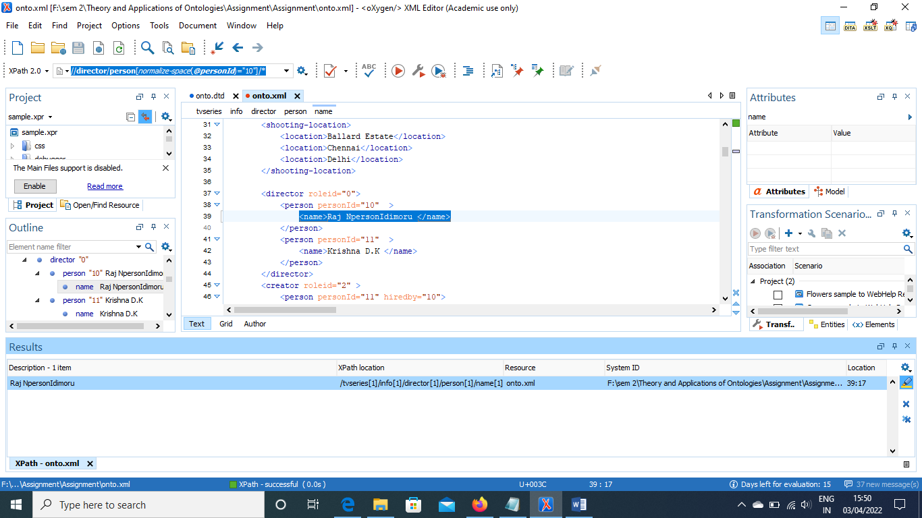

**XQUERY**

**Query1: for** **$x** **in** /**tvseries**/**info**/**titles**/**title**  
 **where** **$x**/***@country***="India"   
 **return** **$x**

**Description:​** Print the title, where attribute country is India.

**Results:**

<?xml version="1.0" encoding="UTF-8"?>  
<title country="India">The Family Man</title>

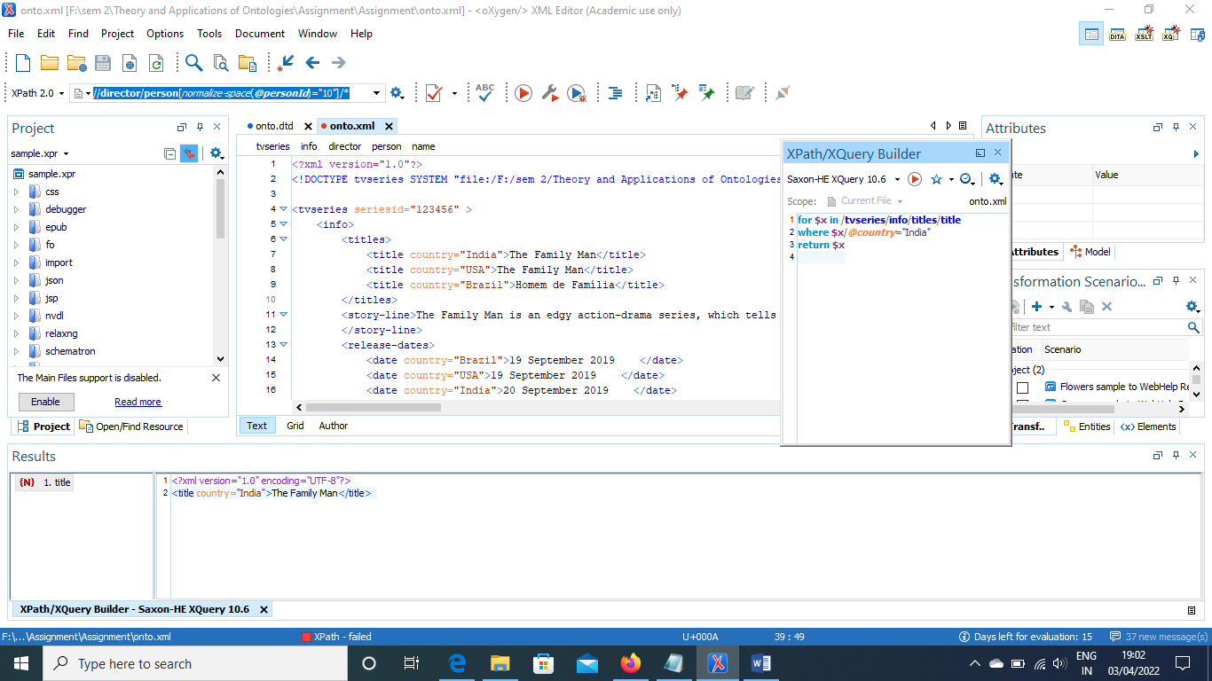

**Query2: for** **$x** **in** /**tvseries**/**info**/**director**/**person**  
 **where** **$x**/***@personId***="10"  
 **return** **$x**/**name**

**Description:​** Name of the Director, whose personId is 10.

**Results:**

<?xml version="1.0" encoding="UTF-8"?>  
<name>Raj NpersonIdimoru </name>

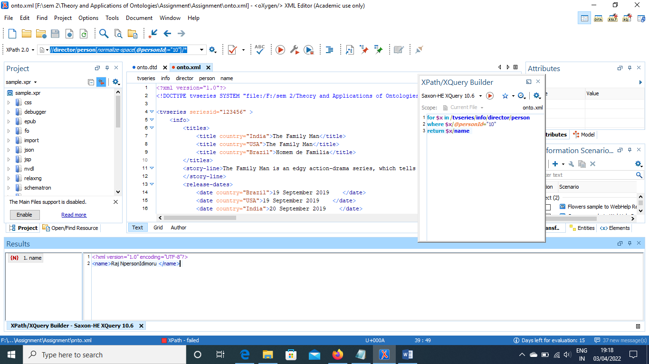

**Query3: for** **$x** **in** /**tvseries**/**cast**/**actor**/**person**  
 **where** **$x**/***@hiredby***="10"  
 **order by** **$x**/**name**  
 **return** **$x**/**name**

**Description:​** Name of the actor, in cast whose hireby is 10, order by name.

**Results:**

<?xml version="1.0" encoding="UTF-8"?>  
<name>Vedant Sinha</name>  
<name>Vijay Vikram Singh</name>

