Gstreamer
Swetha Huded Emp ID 831

GStreamer is a pipeline based multimedia framework that links together a wide variety of media processing systems to complete complex workflows. For instance, GStreamer can be used to build a system that reads files in one format, processes them, and exports them in another. The formats and processes can be changed in a plug and play fashion.
The GStreamer framework is designed to make it easy to write applications that handle audio or video or both. It isn't restricted to audio and video, and can process any kind of data flow. The pipeline design is made to have little overhead above what the applied filters induce. This makes GStreamer a good framework for designing even high-end audio applications which put high demands on latency.
One of the most obvious uses of GStreamer is using it to build a media player. GStreamer already includes components for building a media player that can support a very wide variety of formats, including MP3, Ogg/Vorbis, MPEG-1/2, AVI, Quicktime, mod, and more. GStreamer, however, is much more than just another media player. Its main advantages are that the pluggable components can be mixed and matched into arbitrary pipelines so that it's possible to write a full-fledged video or audio editing application.
The framework is based on plugins that will provide the various codec and other functionality. The plugins can be linked and arranged in a pipeline. This pipeline defines the flow of the data. Pipelines can also be edited with a GUI editor and saved as XML so that pipeline libraries can be made with a minimum of effort.
The GStreamer core function is to provide a framework for plugins, data flow and media type handling/negotiation. It also provides an API to write applications using the various plugins.
Specifically, GStreamer provides
- an API for multimedia applications
- a plugin architecture
- a pipeline architecture
- a mechanism for media type handling/negotiation
- a mechanism for synchronization
- over 250 plug-ins providing more than 1000 elements
- a set of tools

GStreamer plug-ins could be classified into
- protocols handling
- sources: for audio and video (involves protocol plugins)
- formats: parsers, formaters, muxers, demuxers, metadata, subtitles
- codecs: coders and decoders
- filters: converters, mixers, effects, ...
- sinks: for audio and video (involves protocol plugins)

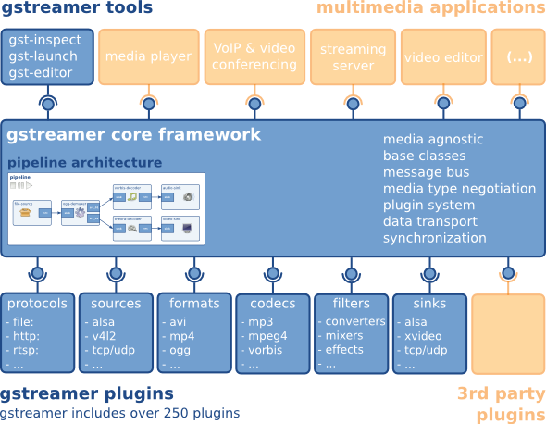
GStreamer is packaged into
- gstreamer: the core package
- gst-plugins-base: an essential exemplary set of elements
- gst-plugins-good: a set of good-quality plug-ins under LGPL
- gst-plugins-ugly: a set of good-quality plug-ins that might pose distribution problems
- gst-plugins-bad: a set of plug-ins that need more quality
- gst-libav: a set of plug-ins that wrap libav for decoding and encoding
- a few others packages

Gstreamer Installation Procedure:
You need to edit the sources.list file so enter:
sudo nano /etc/apt/sources.list
and add the following to the end of the file:
deb http://vontaene.de/raspbian-updates/ . Main
Press CTRL+X to save and exit
Now run an update (which will make use of the line just added):
sudo apt-get update
Now install gstreamer
sudo apt-get install gstreamer1.0
Project Use case:
Audio and Video Streaming on Linux PC:
1. To Stream Local audio (mp3, wav) on Linux PC type the below command
gst-play-1.0 /...path to file .../test.mp3
2. To Stream Local video (mp4) on Linux PC type the below command
gst-play-1.0 /...path to file.../test.mp4
Audio and Video Streaming on Raspberry PI3:
1. To Stream Local audio (mp3, wav) on Raspberry Pi3 type the below command
gst-play-1.0 /...path to file .../test.mp3
2. To Stream Local video (mp4) on Raspberry pi3 type the below command
gst-play-1.0 /...path to file.../test.mp4
Video streaming from Linux PC to Raspberry PI over LAN:
1. To Stream a video from Linux PC to Linux PC try the below command
At server side (Linux PC):
gst-launch-1.0 -v filesrc location = video.mp4 ! decodebin ! x264enc ! rtph264pay ! udpsink host=/Ip address of client/ port=5000

At client side (Linux PC):
gst-launch-1.0 -v udpsrc port=5000 caps="application/x-rtp, media=video, clock-rate=90000, encoding-name=H264, payload=96, ssrc=3394826012, timestamp-offset=2215812541, seqnum-offset=46353" ! rtph264depay ! decodebin ! videoconvert ! autovideosink sync=false

2. To Stream a video from Linux PC to Raspberry PI3 try the below command
At server side (Linux PC) :
gst-launch-1.0 -v filesrc location = video.mp4 ! decodebin ! x264enc ! rtph264pay ! udpsink host=/Ip address of client/ port=5000
At client side (Raspberry PI3) :
gst-launch-1.0 -v udpsrc port=5000 caps="application/x-rtp, media=video, clock-rate=90000, encoding-name=H264, payload=96, ssrc=3394826012, timestamp-offset=2215812541, seqnum-offset=46353" ! rtph264depay ! decodebin ! videoconvert ! autovideosink sync=false

Results:
Audio and Video Streaming on Linux PC:
Able to Stream both audio and video of any format (mp3,mp4,wav..) on Linux PC
Audio and Video Streaming on Raspberry PI3:
Able to Stream audio formats on Raspberry PI3
Video streaming from Linux PC to Raspberry PI over LAN:
Able to Stream audio formats from Linux PC to Raspberry PI3 over LAN
Limitations:
Video frames are looping (only few frames are streaming)

