INTERNATIONAL INSTITUTE OF INFORMATION TECHNOLOGY, BANGALORE

Project Report
Denoising Scanned Text Images

Team Guide:
Dr. Dinesh Babu Jayagopi
17-May-2017

Naveen(MT2016090) Ashok(MT2016028) Sarvesh (MT2016078) Vishal (MT2016153)
Lakshendra (MT2016074) Sharda (MT2016126)

Table of Contents

1. Introduction
1.1 Purpose
1.2 Motivation of solving this problem
1.3 References
2. Overall Description
2.1 Product Perspective
2.2 Product Functions

3. Data Set

4. Training Algorithm and Results

5. Future Enhancements

1. Introduction
1.1 Purpose
OCR is the process of digitizing printed or handwritten documents. OCR makes previously static content editable, searchable, and much easier to share. Coffee stains, wrinkles, sunspots are keeping a lot of these documents from being digitized. Segmentation of text from badly degraded document images are a very challenging task due to the high inter/intra-variation between the document background and the foreground text of different document images. Given a scanned text image, our task is to remove the stains, wrinkles from these images and make it suitable for OCR .
1.2 Motivation for solving the problem
India is praised for its rich past and the culture. The rich heritage of the country has been carried over generations through the manuscripts and historic writings. A great deal of effort is being made to prevent their further degradation. A lot of research is also done in finding methods to digitize these documents so that they can be immortalized. But in order to achieve this, the noise in the documents (result of exposure to environmental factors and age) has to be eliminated. This increases their availability by making it easier to share, search and edit. Many documents are held back due to being damaged. Presence of noise in such scanned images keep them from being digitized. This gives rise to an interesting problem of removing the noise from such documents so it becomes easier to apply OCR on them.
1.3 References and Summary
a) Efficient Image Denoising for Effective Digitization using Image Processing Techniques and
Neural Networks - By B.J. Sowmy :
The authors aim to develop a model that helps denoise images of such documents retaining on the text. The primary goal of their project is to help ease document digitization. They intend to study the effects of combining image processing techniques and neural networks. Image processing techniques like thresholding, filtering, edge detection, morphological operations, etc. will be applied to pre-process images to yield higher accuracy of neural network models.

b) A Gentle Introduction to Gradient Boosting - By Cheng Li:
Gradient boosting is a machine learning technique for regression and classification problems, which produces a prediction model in the form of an ensemble of weak prediction models typically decision trees. It builds the model in a stage-wise fashion like other boosting methods do, and it generalizes them by allowing optimization of an arbitrary differentiable loss function.
Gradient Boosting = Gradient Descent + Boosting

2. Overall Description
2.1 Product Perspective
When a user give dirty document text image(eg. Coffee Stains, Creases, Crumbled marks, Stains in background) to our denoising dirty document system , our system will remove the noise from the dirty text image and give the output as clear image in readable text format.
3. Dataset
The dataset consists of training and test sets. These contain images of text documents with
added synthetic noise. The training set also includes the images without noise. The synthetic
noise added to the images broadly fall into the following categories:

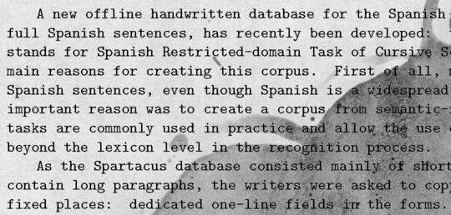
Coffee Stains

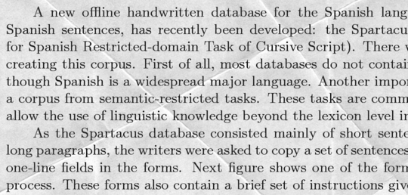
Creases

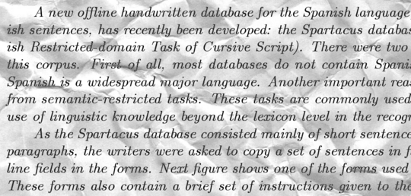
Crumbled marks

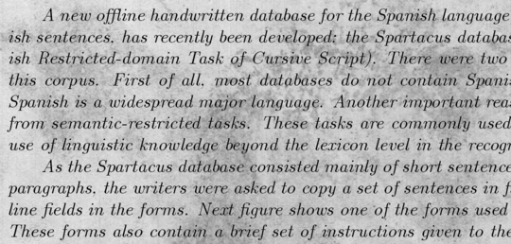
Stains in background

This dataset has been obtained from kaggle.com.
It contains 215 dirty images for training purpose and test set contains 50 different images.

4.Training Algorithm and Results
4.1 Least squares regression
Objective:
The objective of this step is to use linear regression to predict the pixel intensities. This will not completely remove the creases, but will certainly help in designing a robust regression model.

Procedure:
In order to provide the images as training input to the regression algorithm, we unfold the image into a single column vector(implemented as a numpy array). This process is followed for both noisy and clean image. Now we fit a linear model to predict the pixel intensities using the unfolded training data. The model simply learns to predict the correct intensities given a noisy image. It does not exploit other information like the range of intensities that the pixel falls into or locality of the pixel.

Result:
Using this method, we are able to get rid of most of the creases in the image. We were still left with grey marks around the creases which will be handled by the next model. The model reduced the mean squared error from 15.70 % to 8.60%.
4.2 Image Thresholding
Objective:
In an ideal case, a scanned text image should contain pixel intensities close to 0 or to 255. The noise takes some intermediate values. This is why we use thresholding to deal with the intermediate values.

Procedure:
The main challenge in this step is to determine an appropriate threshold for the images. To identify potential thresholds, we can look at the histogram of a sample image. It has two breaks between local maxima, so it leaves us with two thresholds. We can test both and determine the suitable one. An even better approach would be to perform K-Means clustering on the image. We make 3 clusters out of the pixel intensities and obtain the threshold as half the difference between maximum of middle cluster and minimum of highest cluster.

Result:
We were able to remove almost all the noise due to creases. However, this model does not help when the image has coffee stains. We handle this problem using Median filtering and Edge detection. The sample input and output after ensembling these two models is shown below:

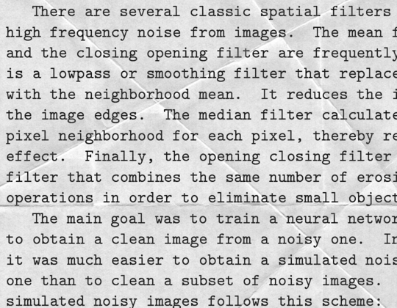
Noisy Image

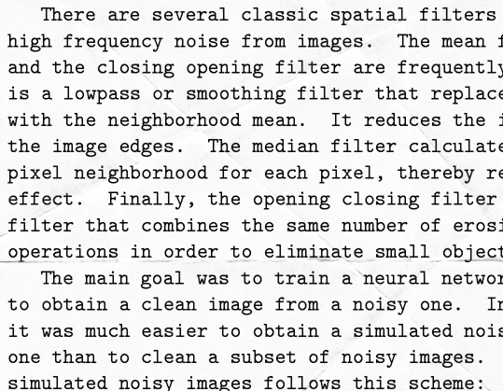
Cleaned Image

4.3 Gradient Boosting
We use gradient boosting to ensemble the predictions of weak predictive models. The predictions made by regression, thresholding etc. are now used for training the GBM regression algorithm. We make use of XGBoost library to perform gradient boosting. XGBoost is short for “Extreme Gradient Boosting”, based upon the original model proposed in the paper Greedy Function Approximation: A Gradient Boosting Machine, by Friedman. The input to this algorithm is the matrix of prediction of the previous steps. This matrix is obtained simply by stacking the columns vectors of the predictions of regression, thresholding, etc. Its is now a matrix with as many rows as the no. of pixels and columns equal to the number of features. The XGB Regressor is trained on this matrix and output is predicted. We use root mean square error to evaluate the performance of the predictive solution.
Description of Approach :
The problem is that coffee cup stains are dark and we need to find some features that distinguish between dark stains and dark writing. By using thresholding, we will separate the darker writing from the dark background stain.
We will use adaptive thresholding because this algorithm calculates the threshold for a small regions of the image. So we get different thresholds for different regions of the same image and it gives us better results for images with darker writing and dark background stains.

Adaptive Method - It decides how thresholding value is calculated.

- cv2.ADAPTIVE_THRESH_MEAN_C : threshold value is the mean of neighbourhood area.
- cv2.ADAPTIVE_THRESH_GAUSSIAN_C : threshold value is the weighted sum of neighbourhood values where weights are a gaussian window.

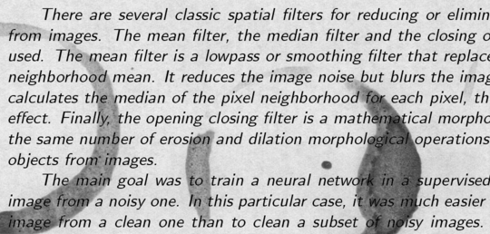
Coffee Stains

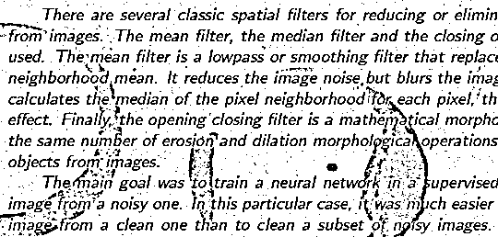

Adaptive Thresh Mean Output

Adaptive Thresh Gaussian Output

The adaptive thresholding is good at separating the letters from the background. The coffee cup stain isn’t removed, but we are starting to successfully clean it up. This suggests that adaptive thresholding will be an important predictor in our ensemble.
Now, We need to engineer a feature that can distinguish between writing and these edges of stains. This can be done by canny edge detection. It is the process of calculating the slope of the 3D surface of the image, and retaining lines where the slope is high. We noted that writing has a pair of parallel edges around each stroke, while the boundary of the stain has only a single edge, so the presence of a pair of edges may be a useful feature for separating stains from writing. We shall be using image morphology because If we dilate the edges, then the pair of edges around the writing will expand to include the writing inside, and the edge of the stain will also expand.

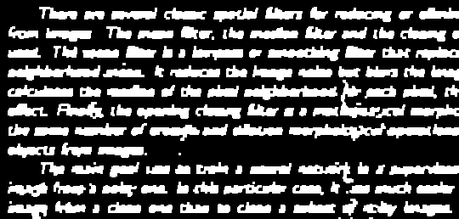

Although the stains has been completely removed but this writing is not readable so we will put all the previous features like canny edges and dilated/eroded edges to our gradient boosting model.

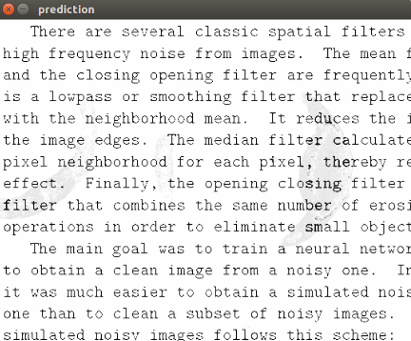

We have improved the RMSE score on the training set from 5.4% to 4.1.

4.4 Median filter

Objective:
Until now we are not able to remove the coffee cup stains. So, now we will remove coffee cup stains i.e. background from the text image with the help of median filter . So, basically now we are removing the background from the text image.

Procedure:
For input in median filter, firstly we convert the image into array then we applied the median filter on that array. So, output after applying median filter we will get background of image. But we interested in finding foreground so subtract the background from original image we got foreground.

Result :
After applying median filter, we got the following output-

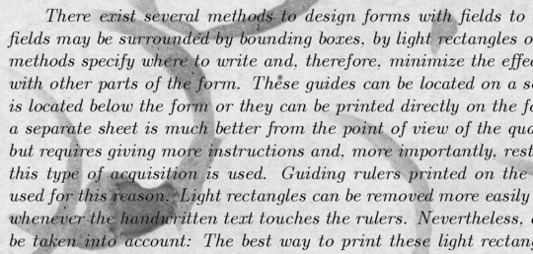
Input Image

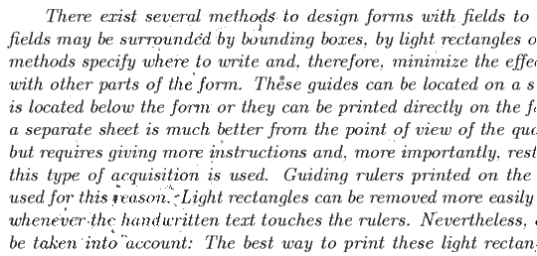
Output Image

We have improved the RMSE score on the training set from 4.1% to 2.4%.

5. Future Enhancements
Until now we cleaned the text images using different image processing and machine learning as we are getting the good result. The total RMSE we are getting is 2.4 %. But we can further try to reduced it using convolutional neural network(CNN).We can get better clarity in text images by using CNN because in this we do not do any feature engineering it automatically extracts the features from the image.

