Open VS2017 and crate a project of below type

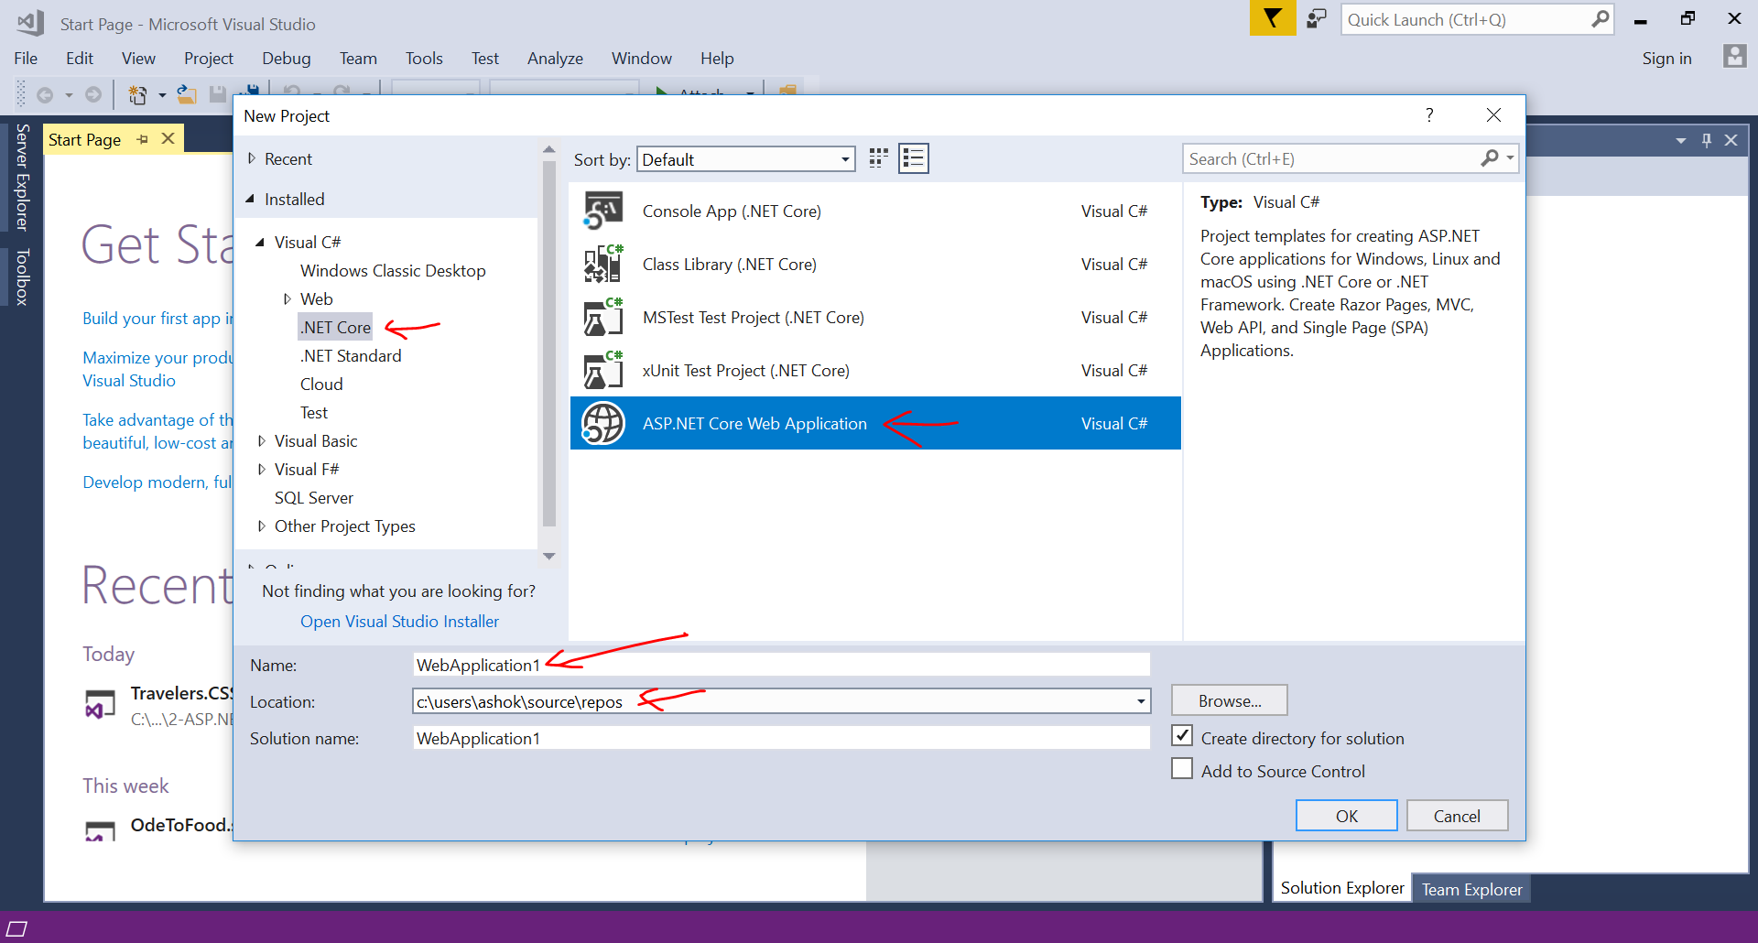

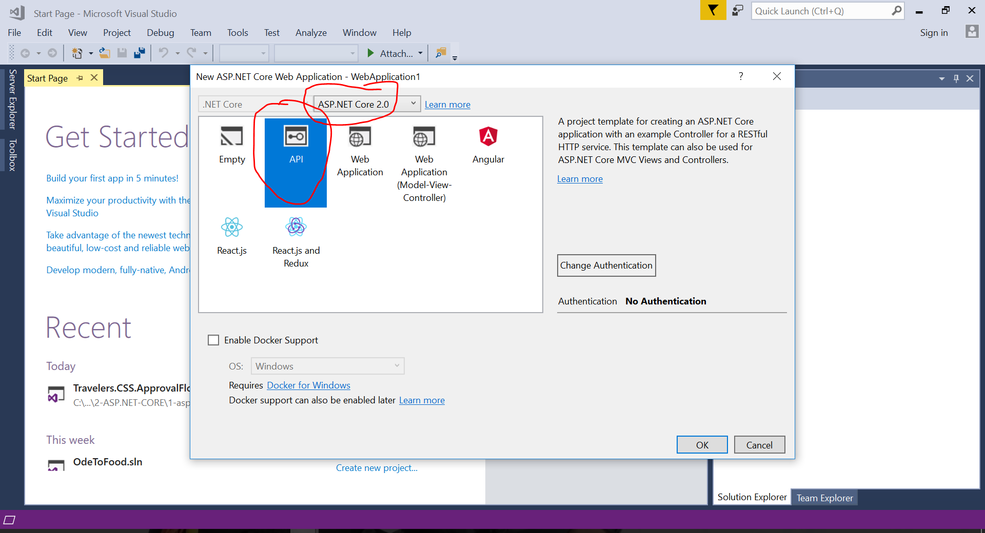

Create below folder structure

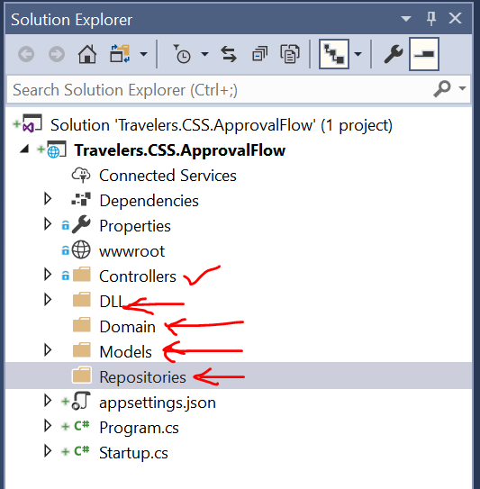

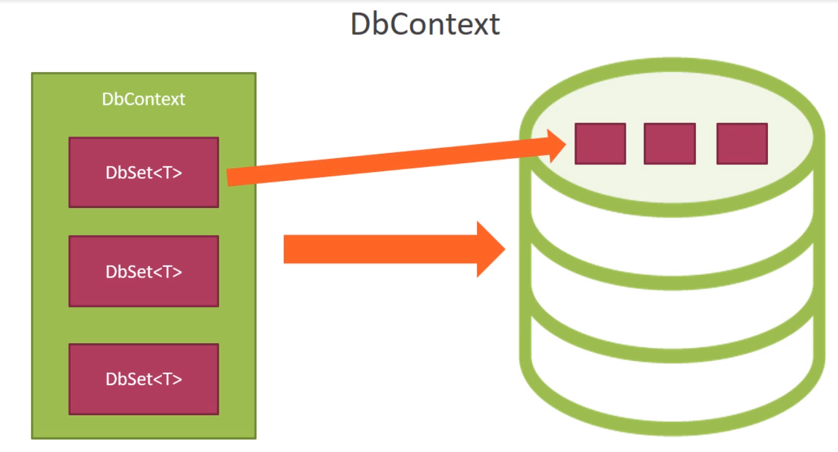

Try to create below class under DLL folder , it will not compile as we need Microsoft.EntityFrameworkCore package

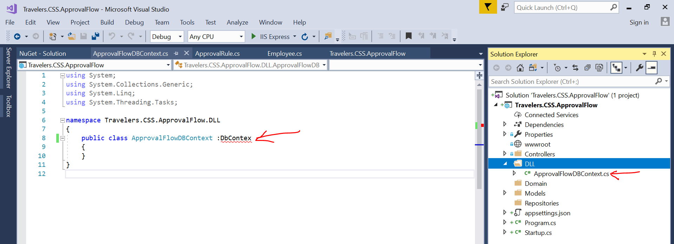

Install below packages from package manager

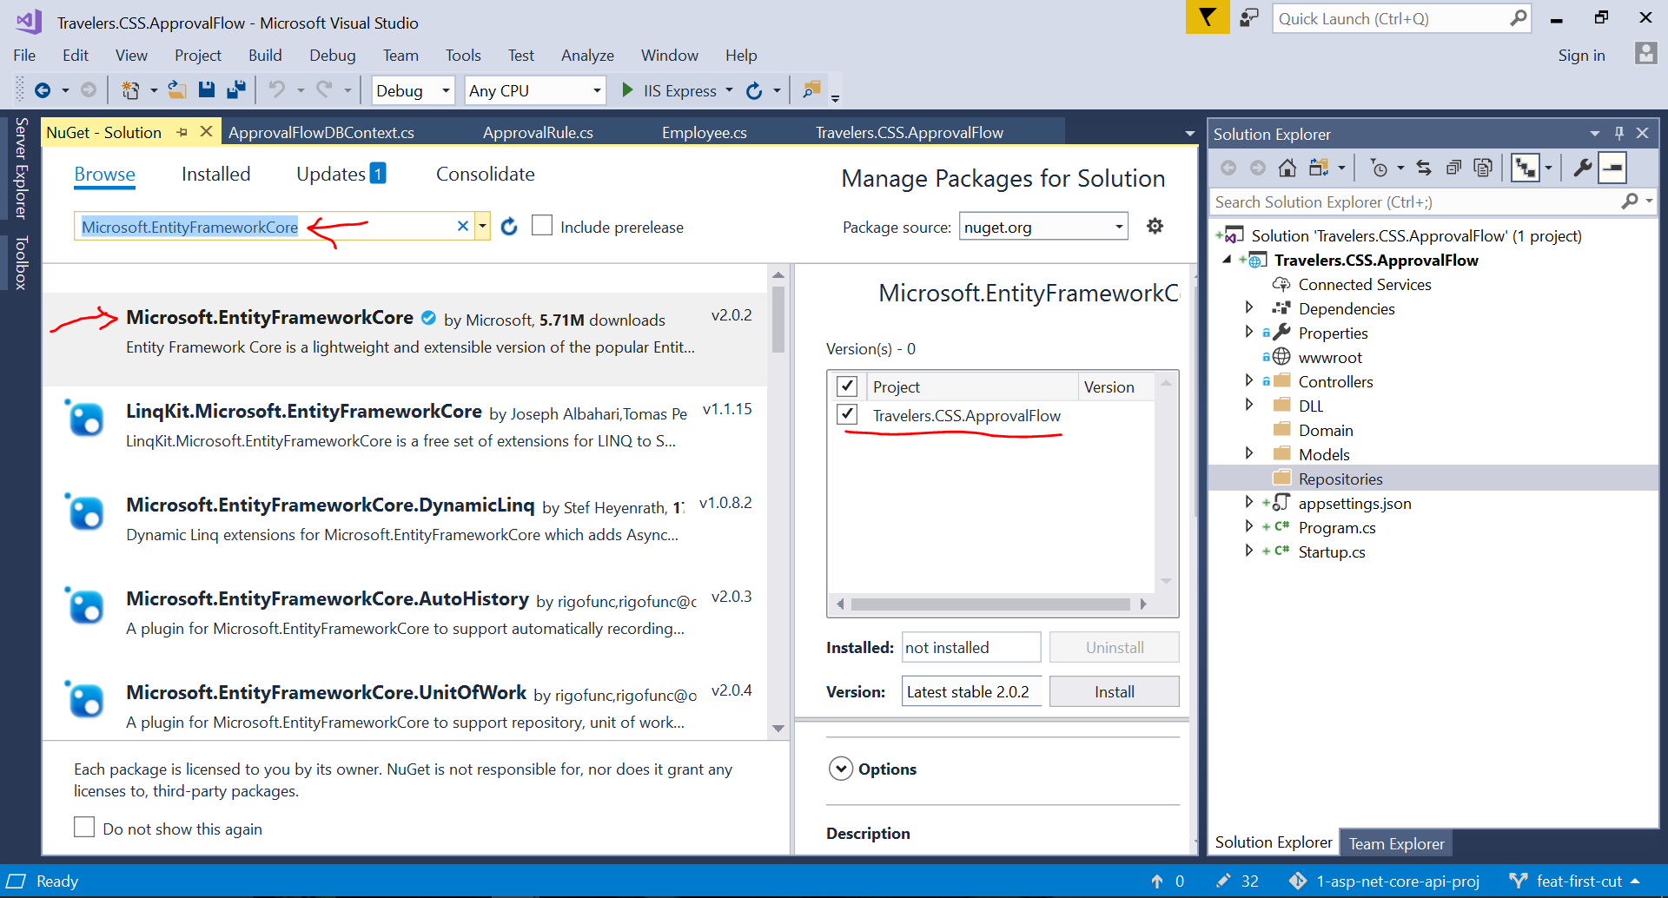

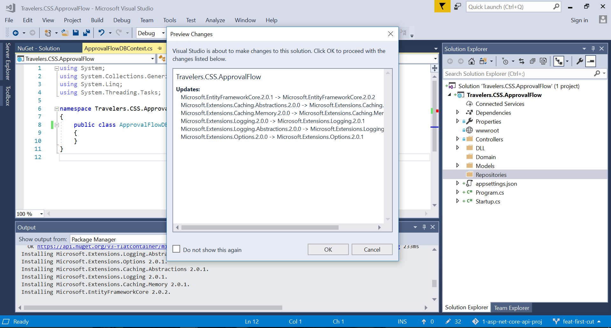

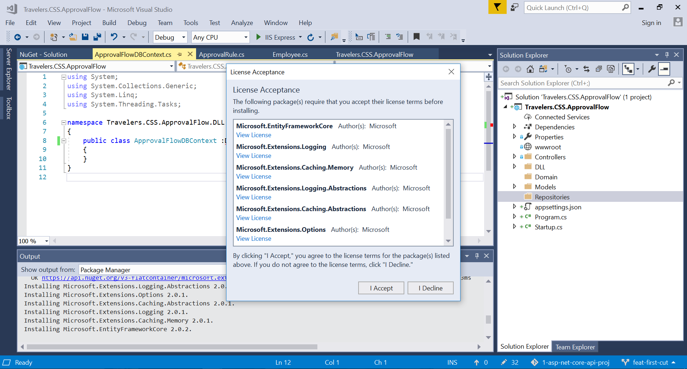

Use Entity Framework core and compile the ApprovalFlowDBContext

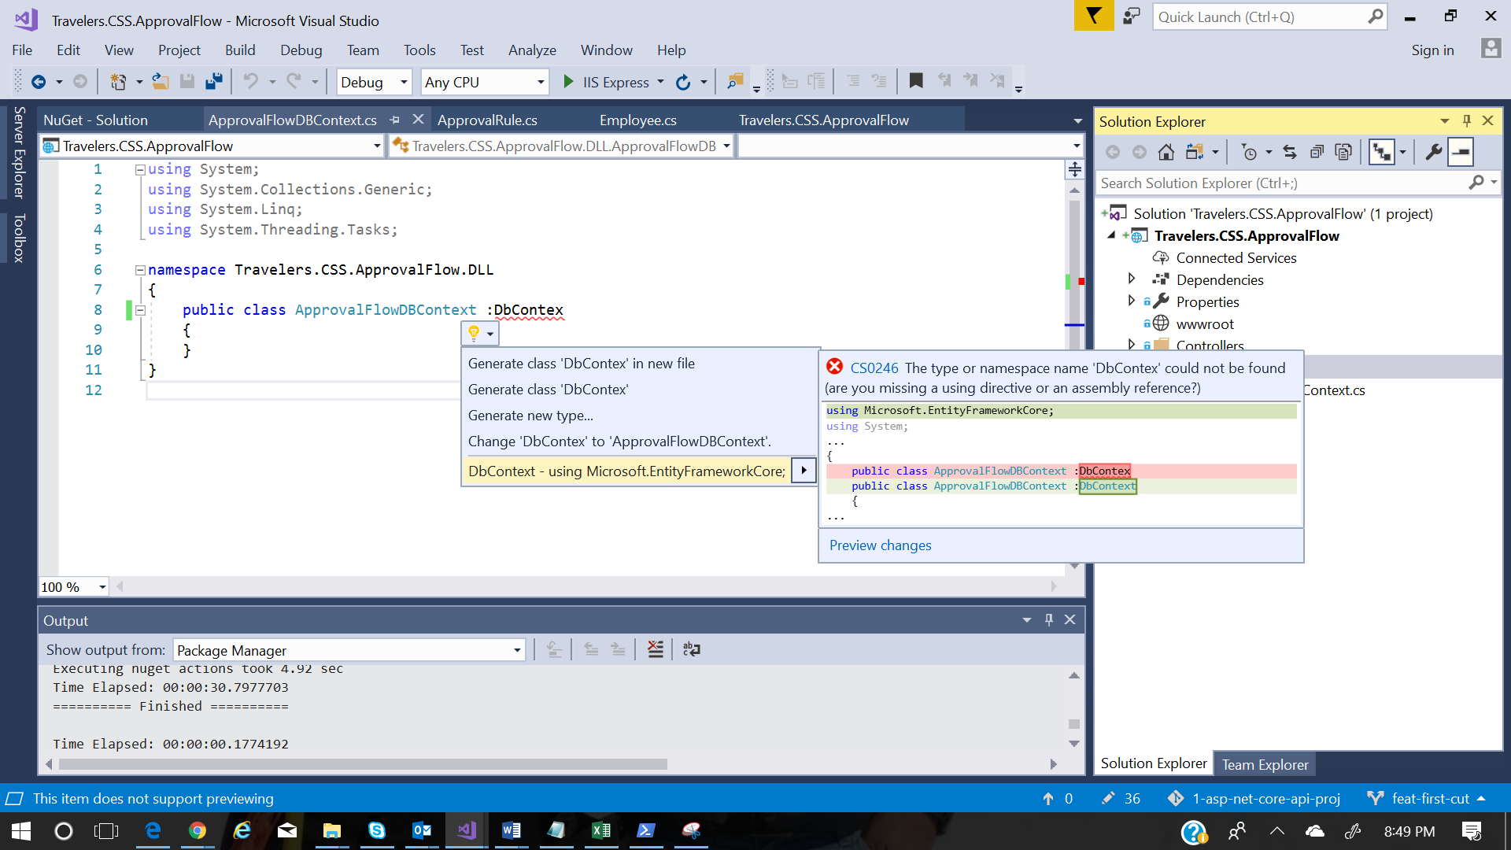

Unit of work video

<https://www.youtube.com/watch?v=IzcJE6_kg8g>

We have to make dotnet ef command work inorder to perform DB operation using EF , so we need to install the relevantpackage

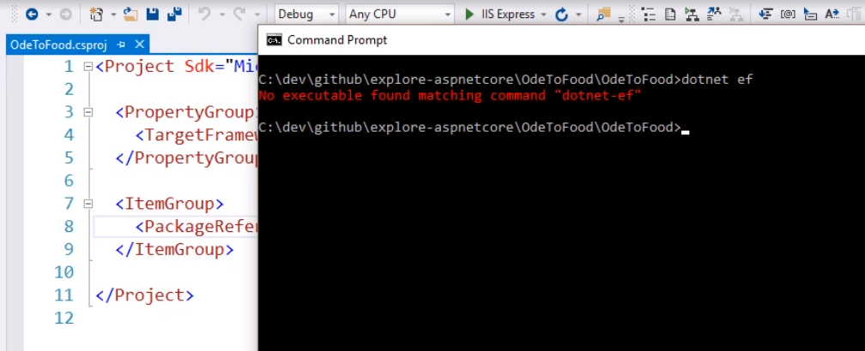

Include below package in the project file and restore

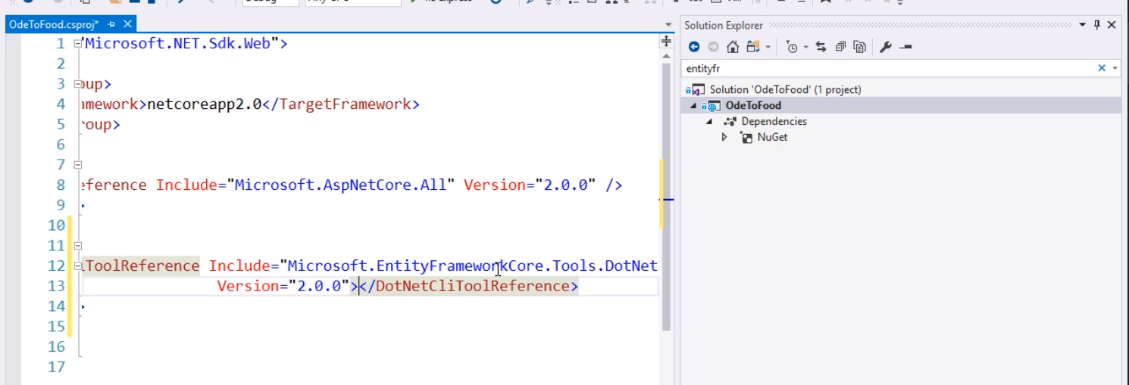

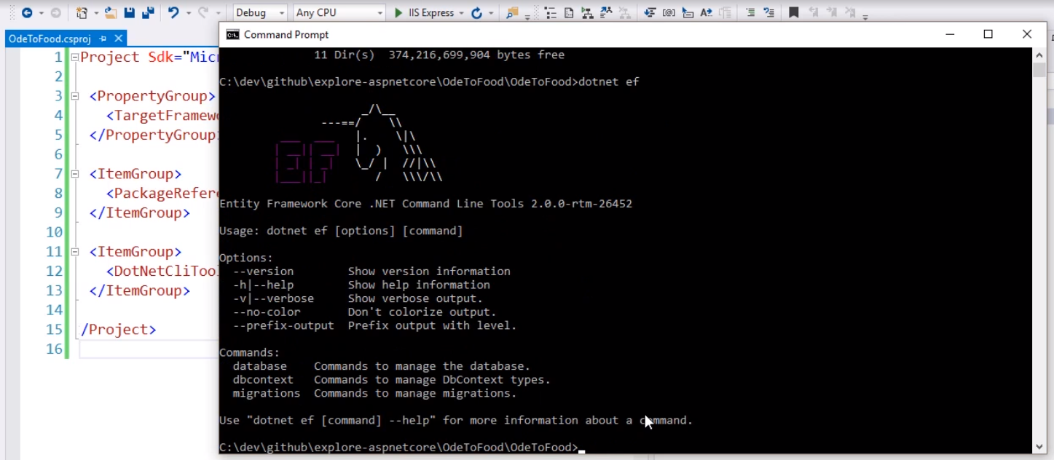

Or refer this

<https://docs.microsoft.com/en-us/ef/core/get-started/aspnetcore/new-db>

## Install Entity Framework Core

Install the package for the EF Core database provider(s) you want to target. This walkthrough uses SQL Server. For a list of available providers see [Database Providers](https://docs.microsoft.com/en-us/ef/core/providers/index).

* **Tools > NuGet Package Manager > Package Manager Console**
* Run Install-Package Microsoft.EntityFrameworkCore.SqlServer

We will be using some Entity Framework Core Tools to create a database from your EF Core model. So we will install the tools package as well:

* Run Install-Package Microsoft.EntityFrameworkCore.Tools

We will be using some ASP.NET Core Scaffolding tools to create controllers and views later on. So we will install this design package as well:

* Run Install-Package Microsoft.VisualStudio.Web.CodeGeneration.Design

Migration script generation

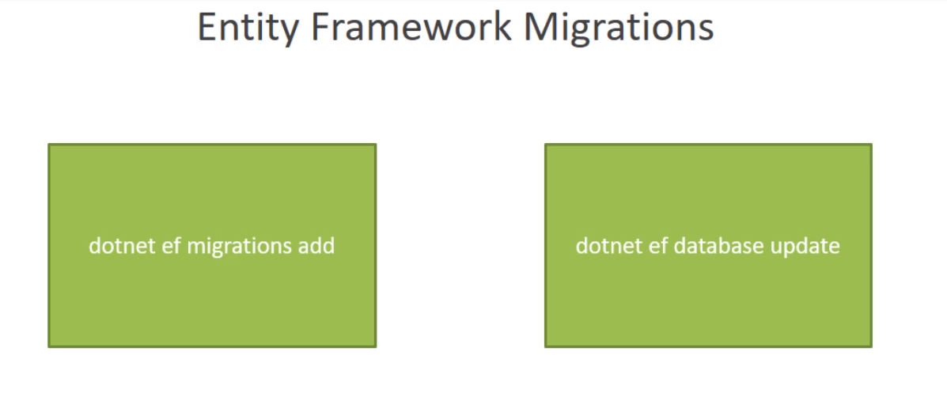

Install below one also along with above ones

Microsoft.EntityFrameworkCore.Tools.Dotnet

If you try to install the above package , you get below error

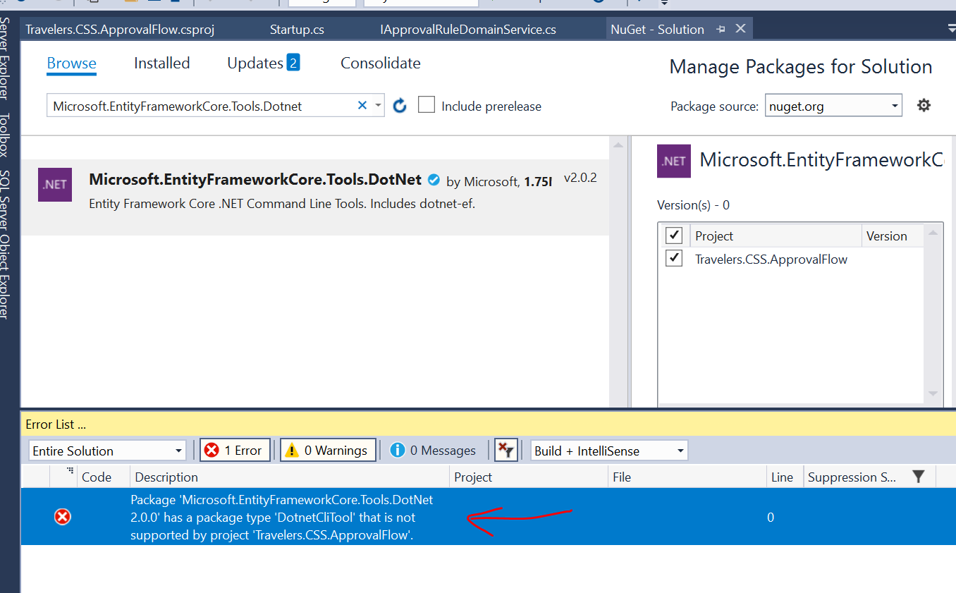

Instead directly include the below package in the csproj file

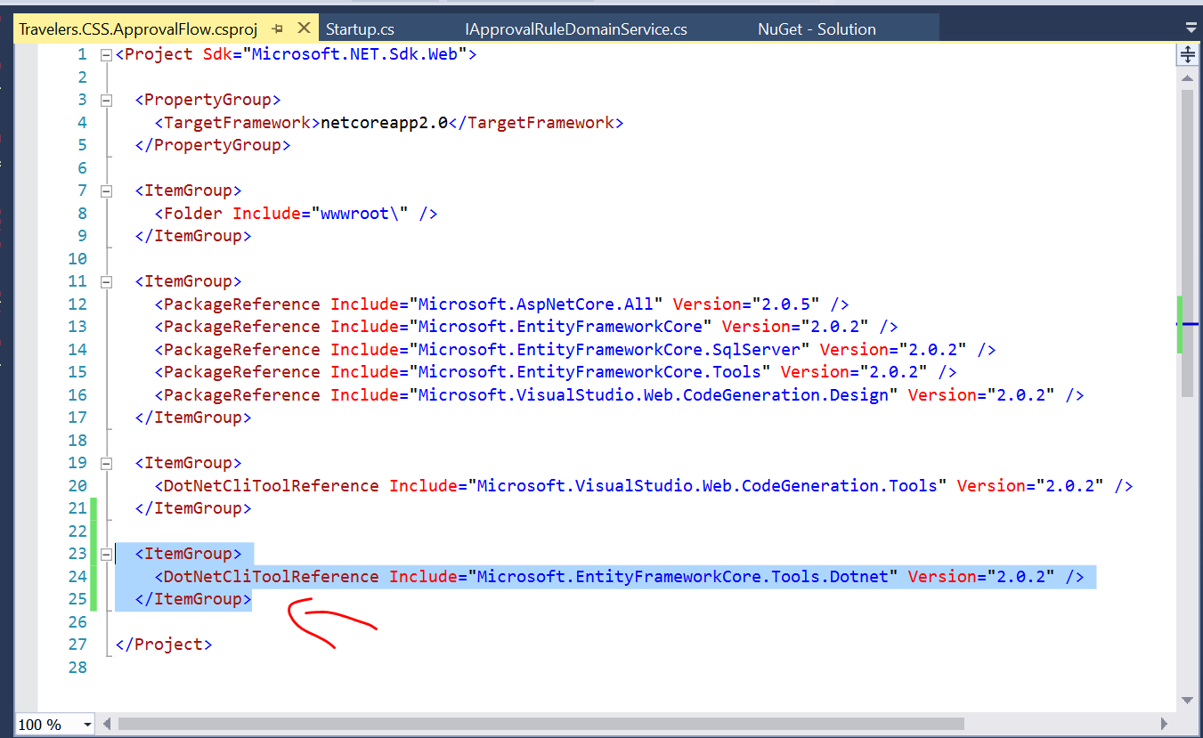

And then execute the command

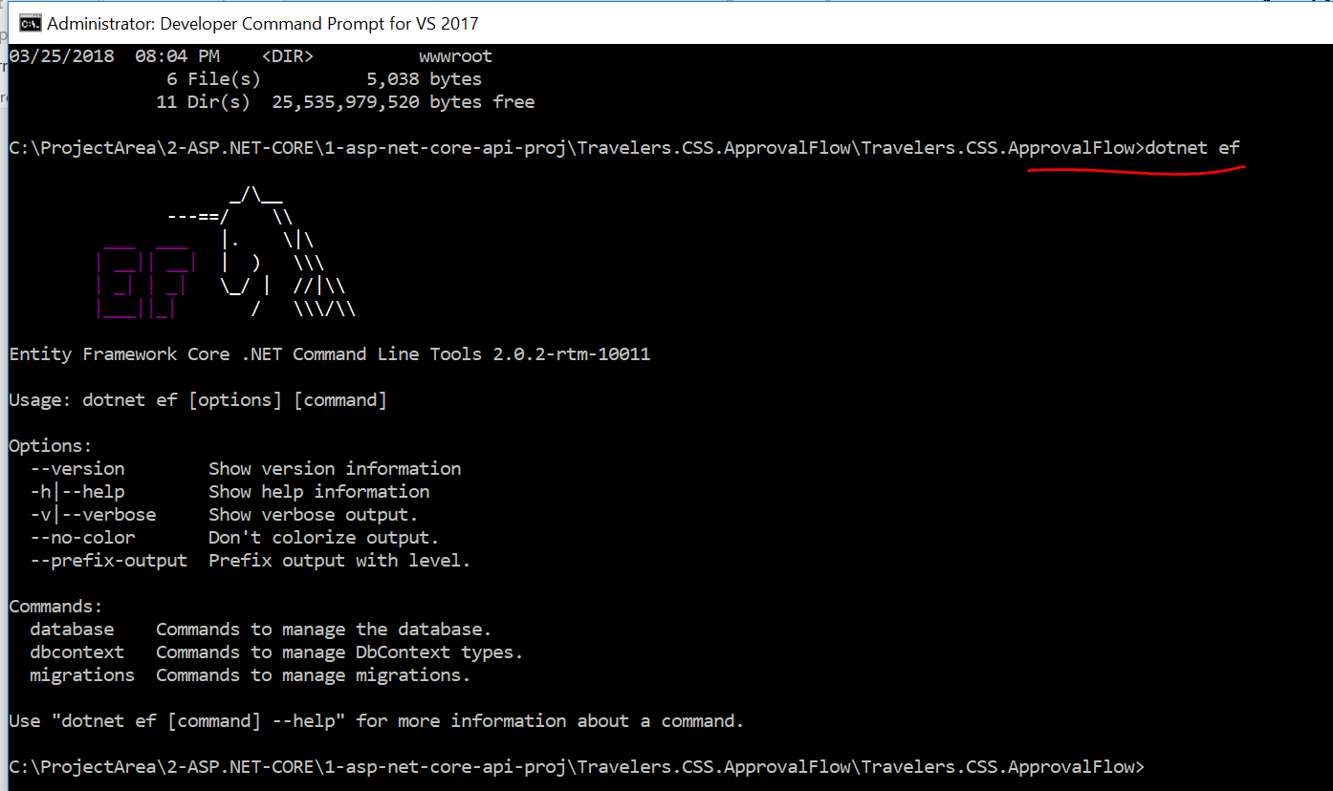

We can execute the below commands and see the DB info

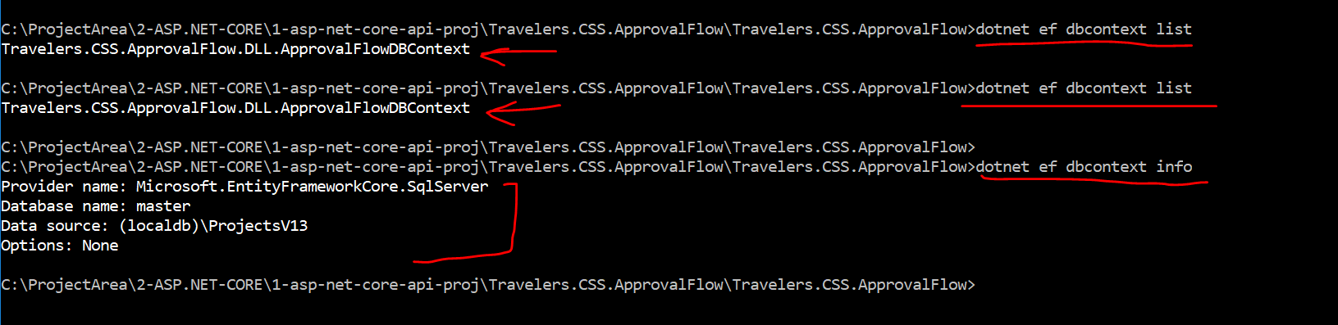

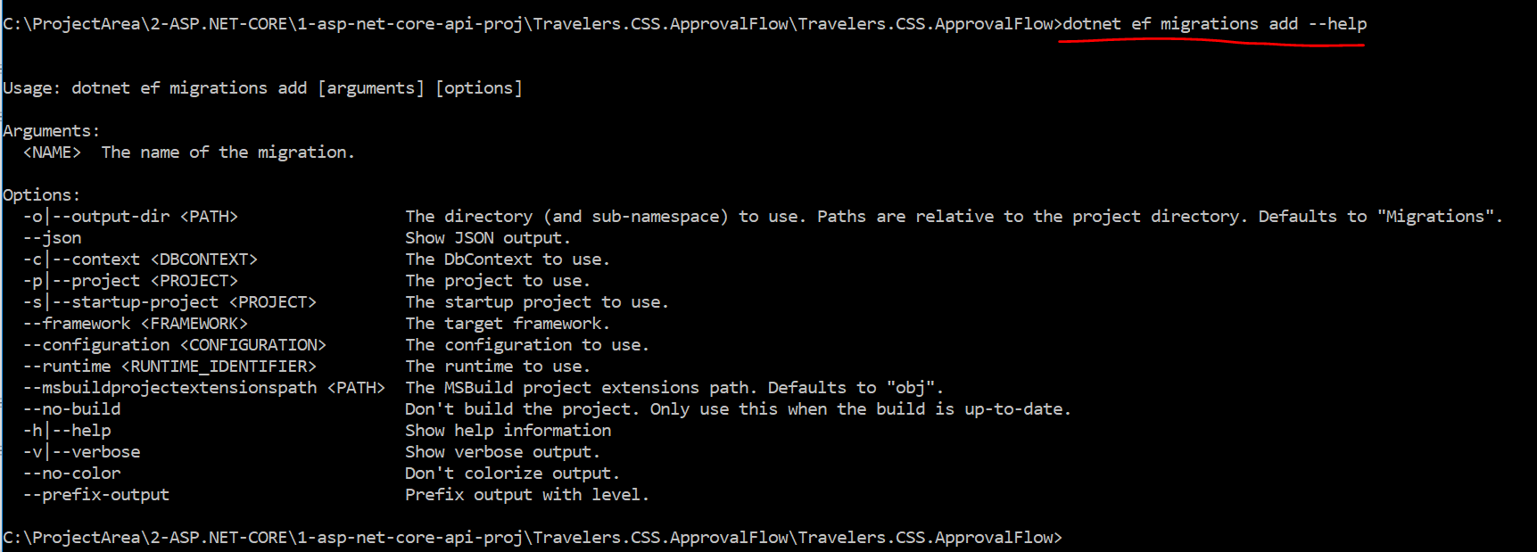

Execute the below command to create the migration script



Migration script gets created under a new folder called migrations as shown below.

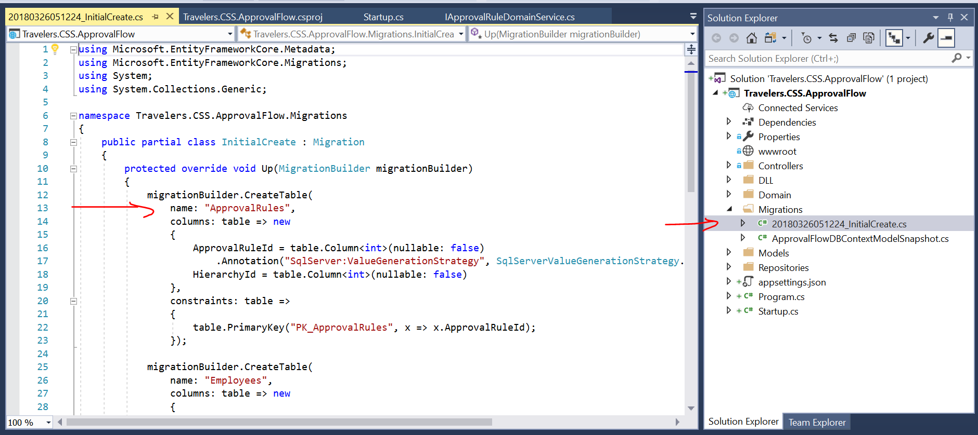

TO apply the script to DB execute the below command

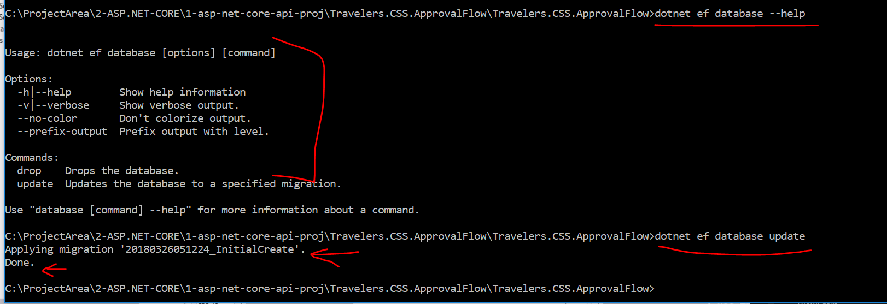

Now if you open the SQL server object explorer , you will see the new tables created.

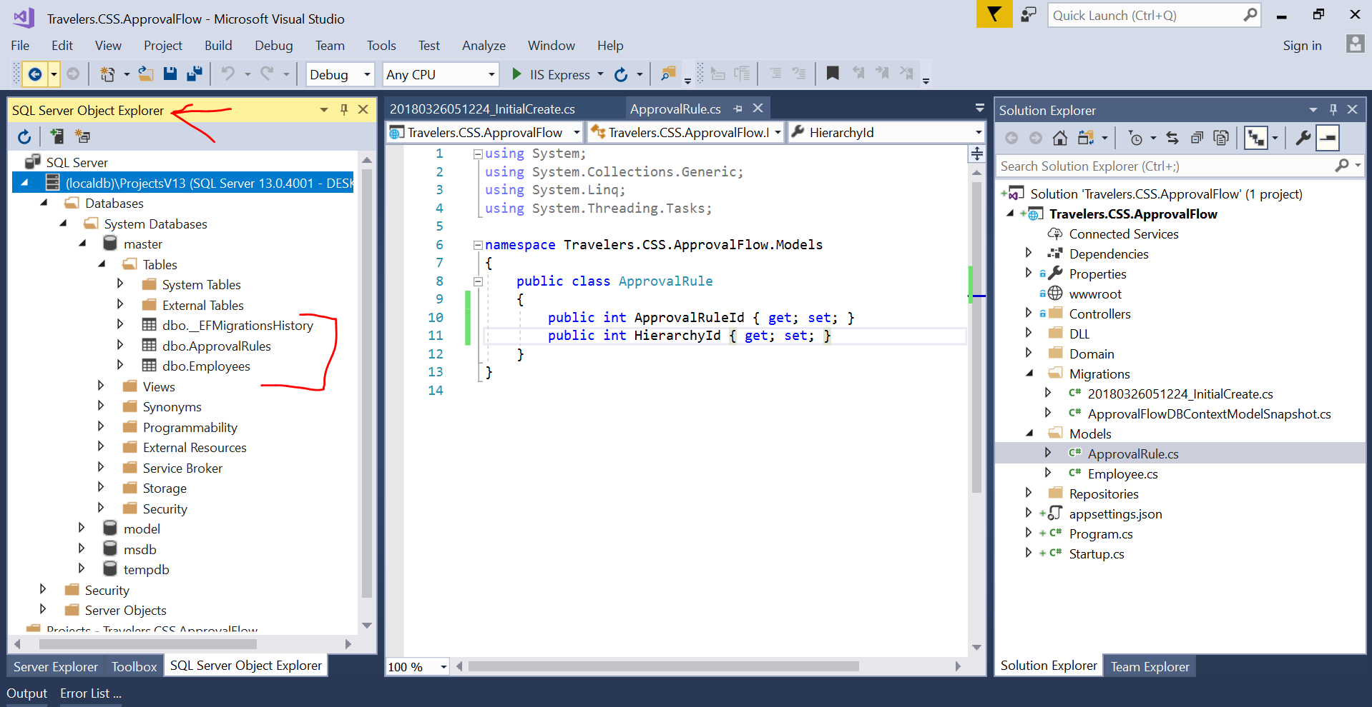

Open the table and add some data to try out the Get Operation

