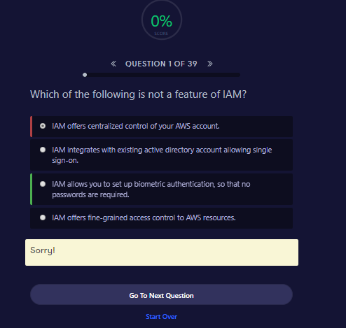

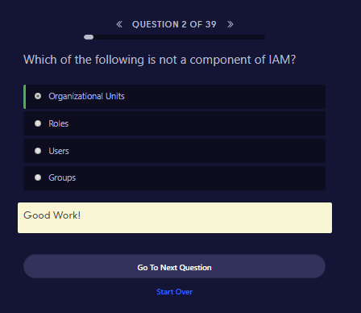

. 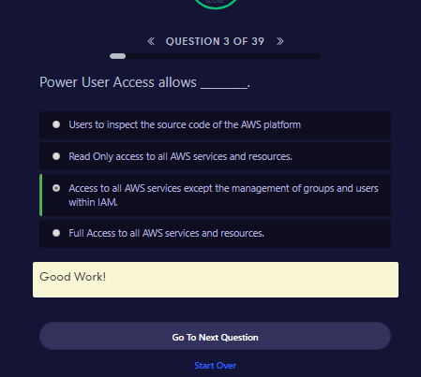

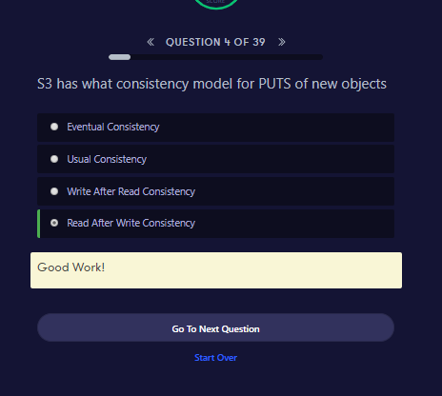

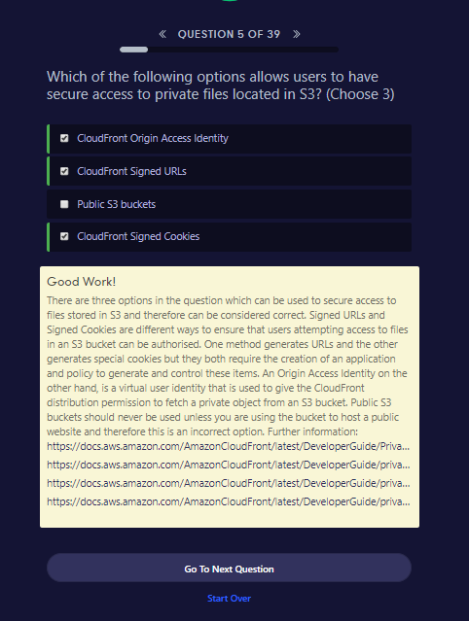

##### **Good Work!**

There are three options in the question which can be used to secure access to files stored in S3 and therefore can be considered correct. Signed URLs and Signed Cookies are different ways to ensure that users attempting access to files in an S3 bucket can be authorised. One method generates URLs and the other generates special cookies but they both require the creation of an application and policy to generate and control these items. An Origin Access Identity on the other hand, is a virtual user identity that is used to give the CloudFront distribution permission to fetch a private object from an S3 bucket. Public S3 buckets should never be used unless you are using the bucket to host a public website and therefore this is an incorrect option. Further information: <https://docs.aws.amazon.com/AmazonCloudFront/latest/DeveloperGuide/PrivateContent.html><https://docs.aws.amazon.com/AmazonCloudFront/latest/DeveloperGuide/private-content-signed-urls.html><https://docs.aws.amazon.com/AmazonCloudFront/latest/DeveloperGuide/private-content-signed-cookies.html><https://docs.aws.amazon.com/AmazonCloudFront/latest/DeveloperGuide/private-content-restricting-access-to-s3.html>

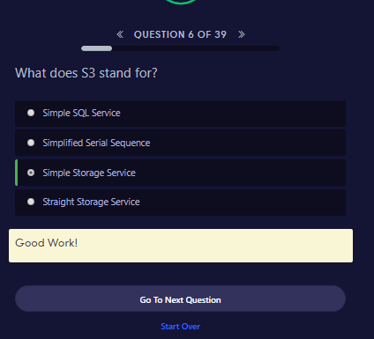

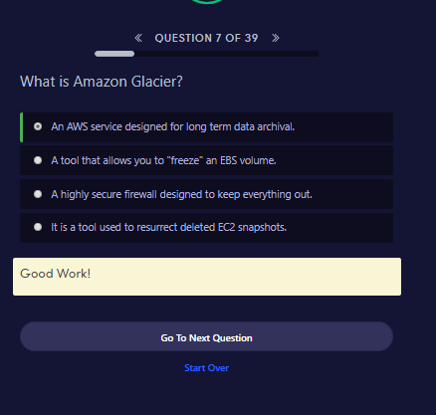

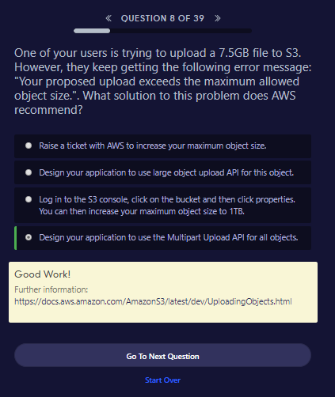

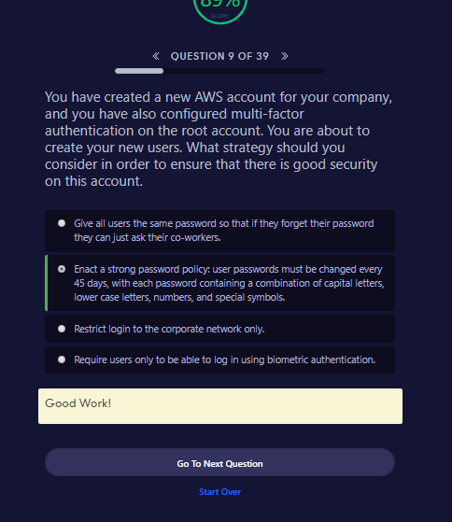

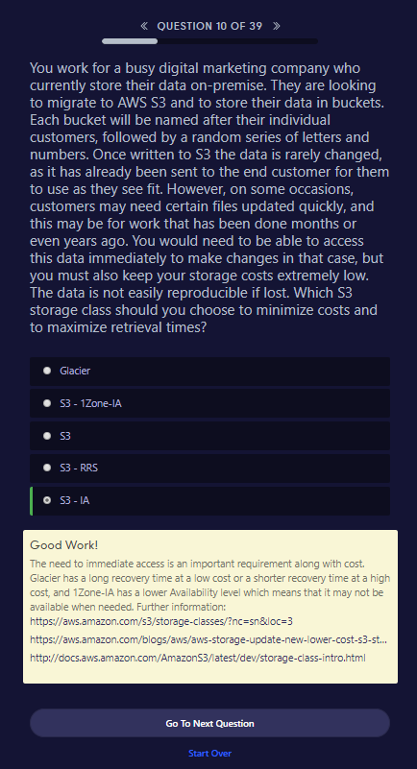

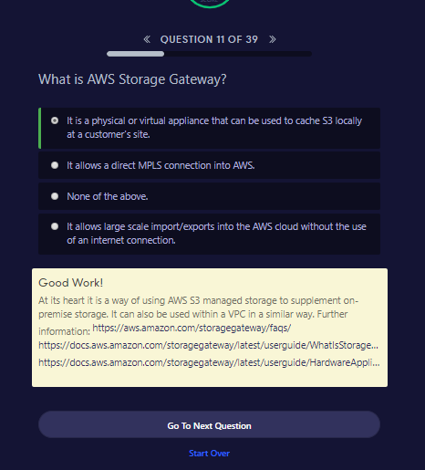

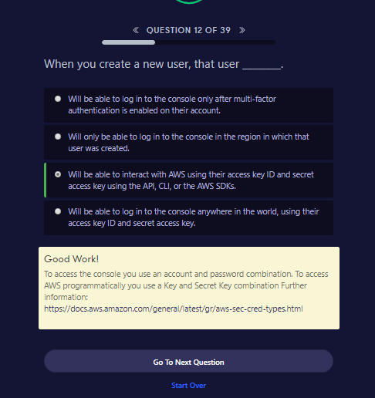

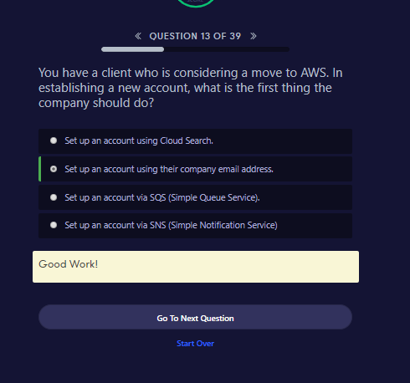

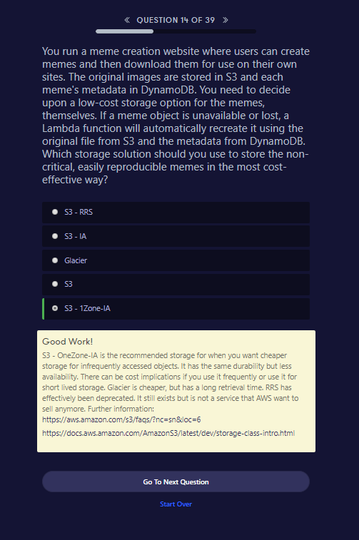

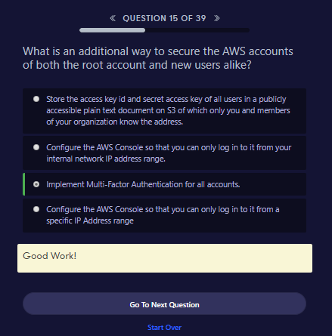

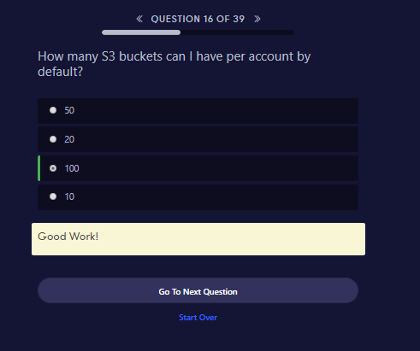

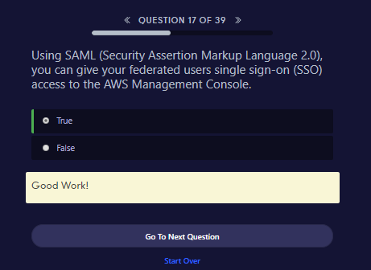

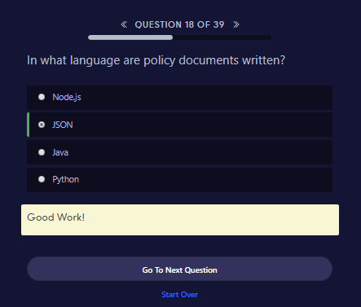

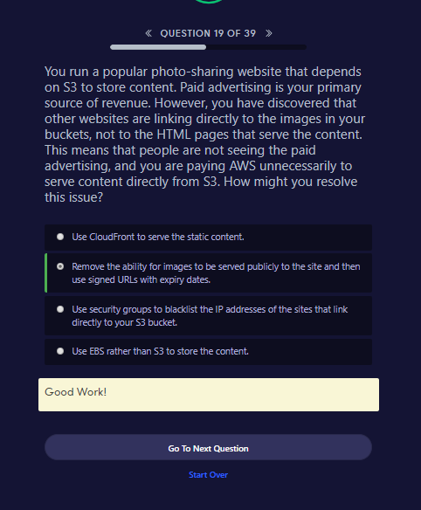

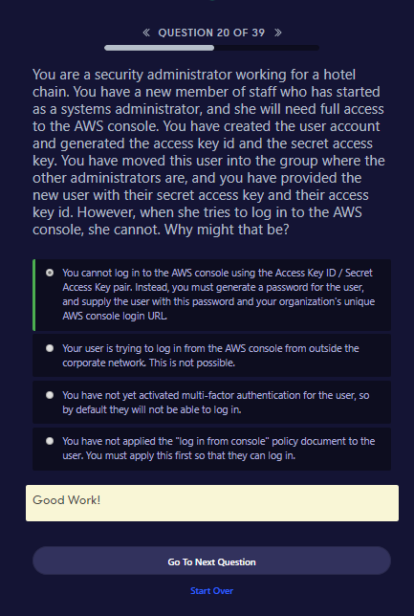

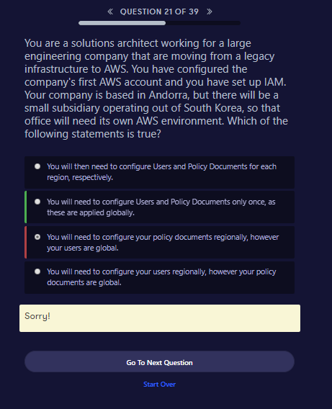

This could be wrong

<https://aws.amazon.com/about-aws/whats-new/2018/04/requested-region-context-key/>

# Easier Way To Control Access To AWS Regions Using IAM Policies

Posted On: Apr 25, 2018

AWS Identity and Access Management (IAM) now enables simplified permissions management by allowing you to use a single IAM policy condition across all AWS services to control access to specific regions. By adding the new global condition key ‘aws:RequestedRegion’ in the condition element of your IAM policy, you can control access to the regions in which an IAM principal (user or role) can perform AWS actions.

For example, you can specify the regions your developers can launch new EC2 instances, create databases in RDS, and create Lambda functions by using the single global condition key in your IAM policy.

To learn more about this new global condition, please visit [AWS Global and IAM Condition Context Keys](https://docs.aws.amazon.com/IAM/latest/UserGuide/reference_policies_condition-keys.html#AvailableKeys)

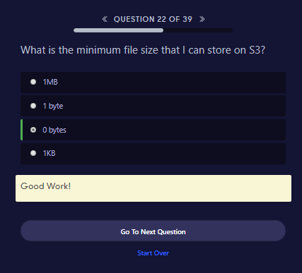

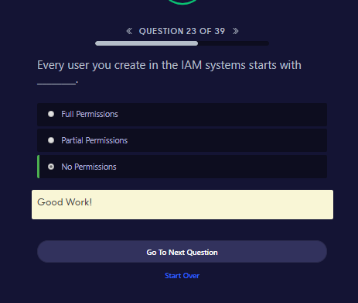

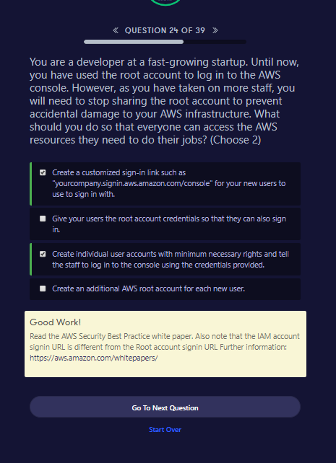

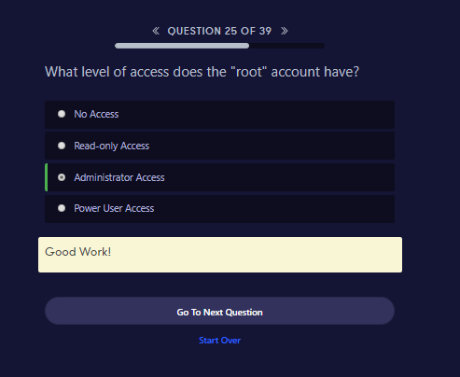

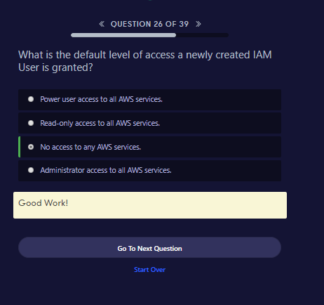

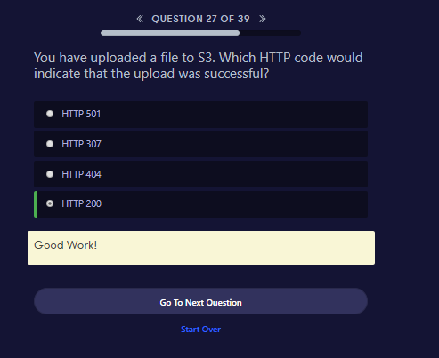

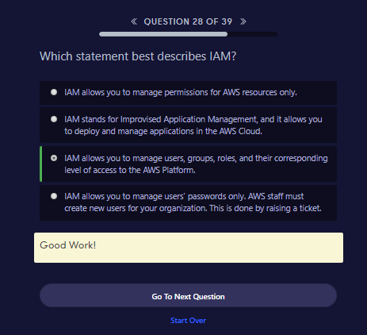

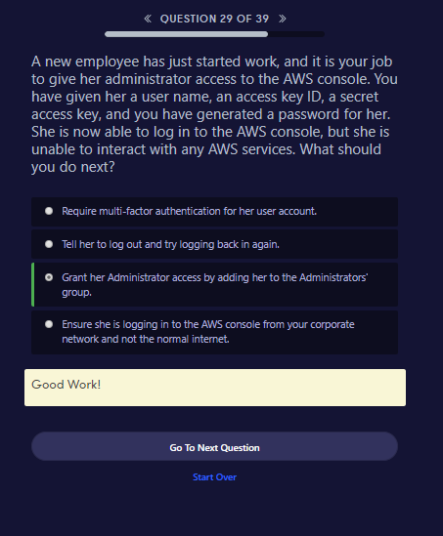

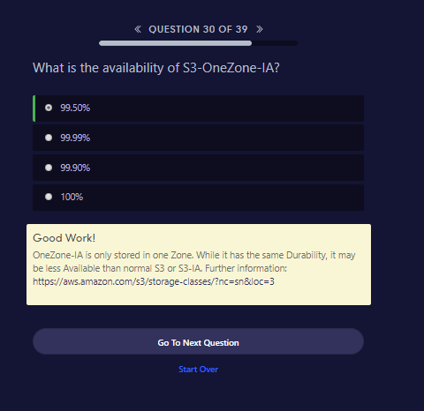

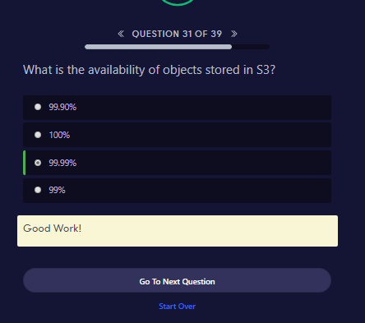

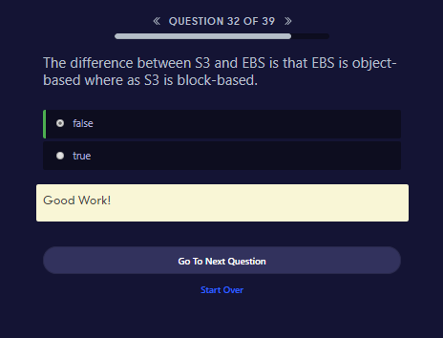

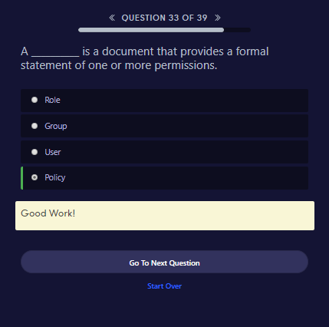

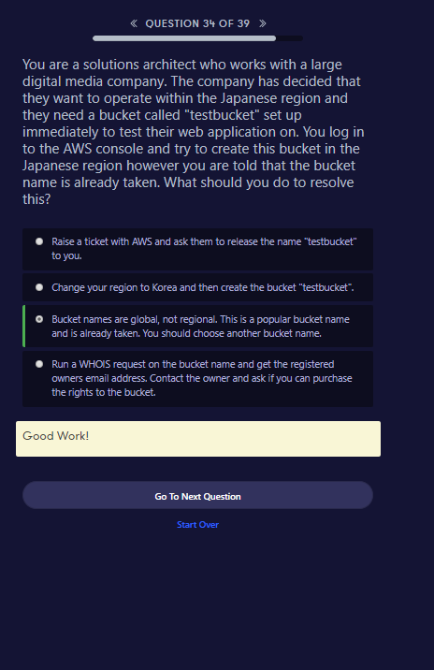

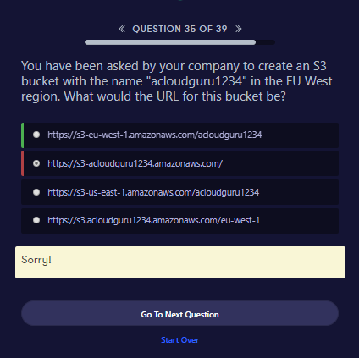

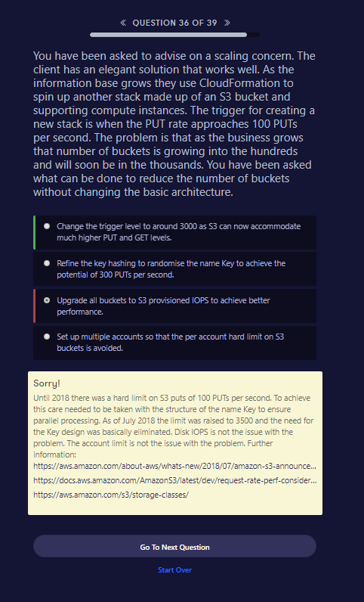

##### **Sorry!**

Until 2018 there was a hard limit on S3 puts of 100 PUTs per second. To achieve this care needed to be taken with the structure of the name Key to ensure parallel processing. As of July 2018 the limit was raised to 3500 and the need for the Key design was basically eliminated. Disk IOPS is not the issue with the problem. The account limit is not the issue with the problem. Further information: <https://aws.amazon.com/about-aws/whats-new/2018/07/amazon-s3-announces-increased-request-rate-performance/><https://docs.aws.amazon.com/AmazonS3/latest/dev/request-rate-perf-considerations.html><https://aws.amazon.com/s3/storage-classes/>

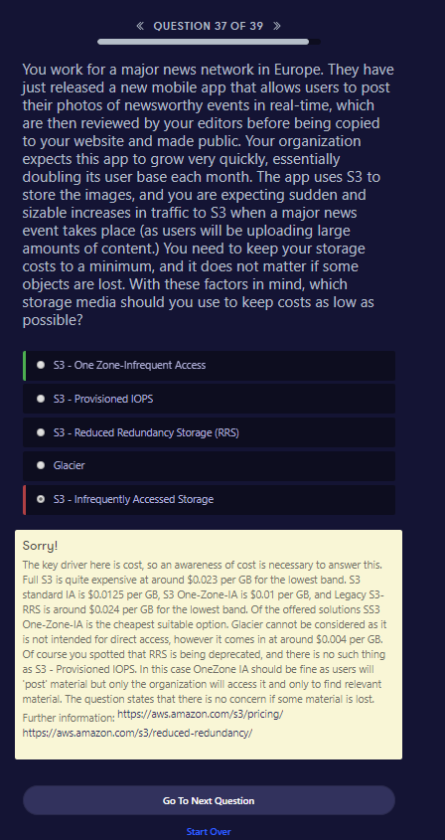

##### **Sorry!**

The key driver here is cost, so an awareness of cost is necessary to answer this. Full S3 is quite expensive at around $0.023 per GB for the lowest band. S3 standard IA is $0.0125 per GB, S3 One-Zone-IA is $0.01 per GB, and Legacy S3-RRS is around $0.024 per GB for the lowest band. Of the offered solutions SS3 One-Zone-IA is the cheapest suitable option. Glacier cannot be considered as it is not intended for direct access, however it comes in at around $0.004 per GB. Of course you spotted that RRS is being deprecated, and there is no such thing as S3 - Provisioned IOPS. In this case OneZone IA should be fine as users will 'post' material but only the organization will access it and only to find relevant material. The question states that there is no concern if some material is lost. Further information: <https://aws.amazon.com/s3/pricing/><https://aws.amazon.com/s3/reduced-redundancy/>

