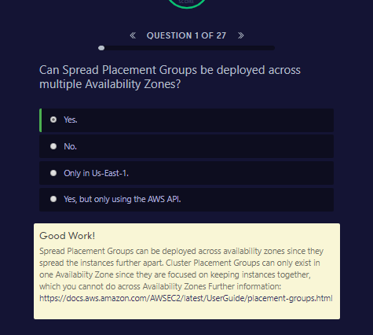

Good Work!

Spread Placement Groups can be deployed across availability zones since they spread the instances further apart. Cluster Placement Groups can only exist in one Availabiity Zone since they are focused on keeping instances together, which you cannot do across Availability Zones Further information: <https://docs.aws.amazon.com/AWSEC2/latest/UserGuide/placement-groups.html>

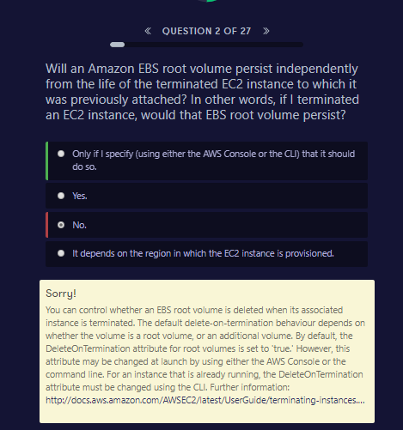

##### Sorry!

You can control whether an EBS root volume is deleted when its associated instance is terminated. The default delete-on-termination behaviour depends on whether the volume is a root volume, or an additional volume. By default, the DeleteOnTermination attribute for root volumes is set to 'true.' However, this attribute may be changed at launch by using either the AWS Console or the command line. For an instance that is already running, the DeleteOnTermination attribute must be changed using the CLI. Further information: <http://docs.aws.amazon.com/AWSEC2/latest/UserGuide/terminating-instances.html#delete-on-termination-running-instance>

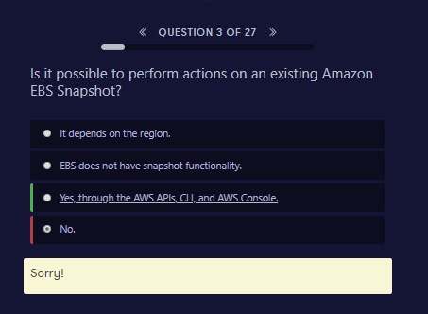

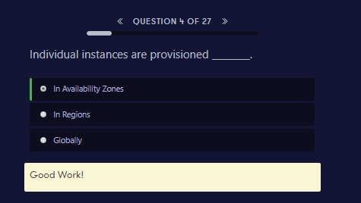

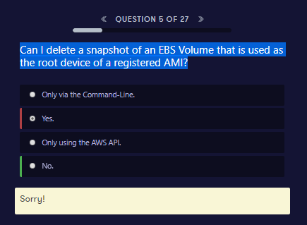

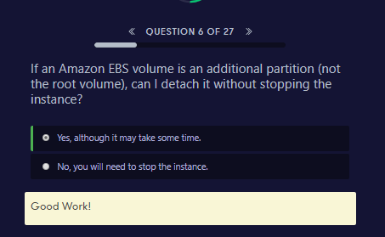

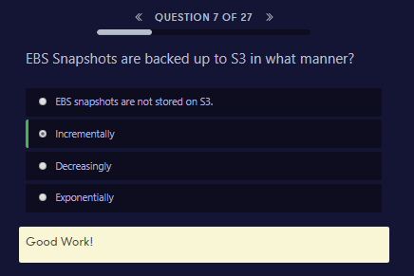

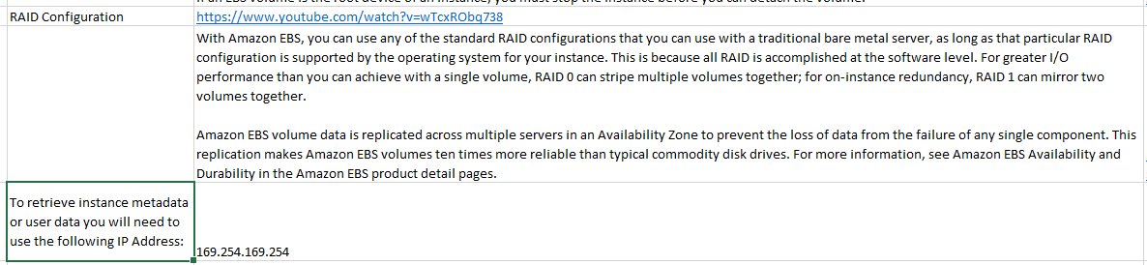

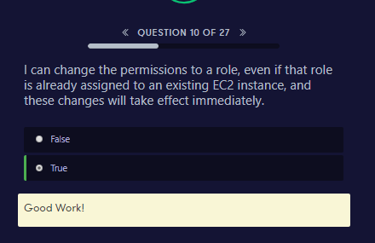

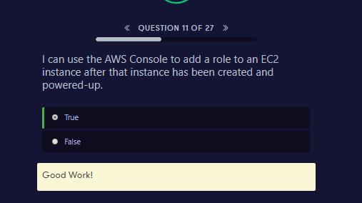

<https://acloud.guru/forums/aws-certified-sysops-administrator-associate/discussion/-KfDwy_ivfsSbrlEdETk/can_you_assign_a_role_to_an_al>

ia http://docs.aws.amazon.com/AWSEC2/latest/UserGuide/iam-roles-for-amazon-ec2.html#attach-iam-role :

**Attaching an IAM Role to an Instance**

After you've created an IAM role, you can attach it to a running or stopped instance.

To attach an IAM role to an instance using the console

1. Open the Amazon EC2 console at https://console.aws.amazon.com/ec2/.

2. In the navigation pane, choose Instances.

3. Select the instance, choose Actions, Attach/Replace IAM role.

4. Select the IAM role to attach to your instance, and choose Apply.

**Replacing an IAM Role**

You can replace an IAM role for a running instance. You can do this if you want to change the IAM role for an instance without detaching the existing one first; for example, to ensure that API actions performed by applications running on the instance are not interrupted.

To replace an IAM role for an instance using the console

1. Open the Amazon EC2 console at https://console.aws.amazon.com/ec2/.

2. In the navigation pane, choose Instances.

3. Select the instance, choose Actions, Attach/Replace IAM role.

4. Select the IAM role to attach to your instance, and choose Apply.

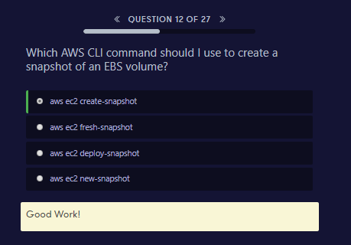

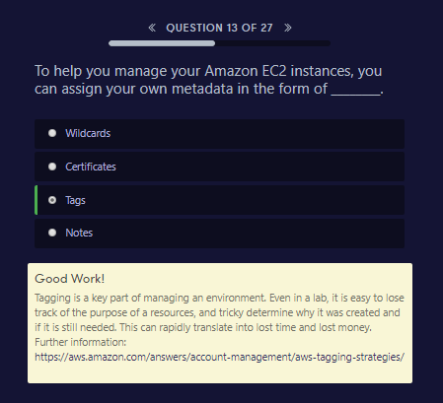

To help you manage your instances, images, and other Amazon EC2 resources, you can optionally assign your own metadata to each resource in the form of tags. This topic describes tags and shows you how to create them.

##### Good Work!

Tagging is a key part of managing an environment. Even in a lab, it is easy to lose track of the purpose of a resources, and tricky determine why it was created and if it is still needed. This can rapidly translate into lost time and lost money. Further information: <https://aws.amazon.com/answers/account-management/aws-tagging-strategies/>

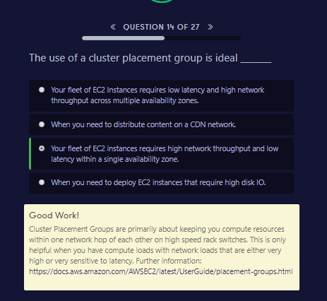

##### Good Work!

Cluster Placement Groups are primarily about keeping you compute resources within one network hop of each other on high speed rack switches. This is only helpful when you have compute loads with network loads that are either very high or very sensitive to latency. Further information: <https://docs.aws.amazon.com/AWSEC2/latest/UserGuide/placement-groups.html>

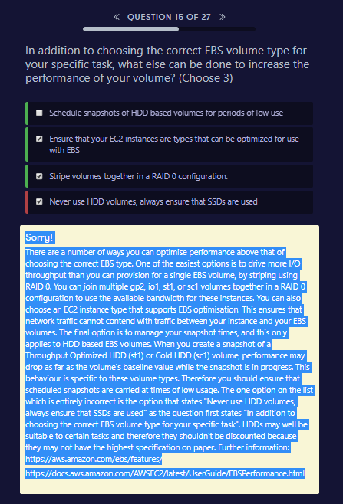

##### Sorry!

There are a number of ways you can optimise performance above that of choosing the correct EBS type. One of the easiest options is to drive more I/O throughput than you can provision for a single EBS volume, by striping using RAID 0. You can join multiple gp2, io1, st1, or sc1 volumes together in a RAID 0 configuration to use the available bandwidth for these instances. You can also choose an EC2 instance type that supports EBS optimisation. This ensures that network traffic cannot contend with traffic between your instance and your EBS volumes. The final option is to manage your snapshot times, and this only applies to HDD based EBS volumes. When you create a snapshot of a Throughput Optimized HDD (st1) or Cold HDD (sc1) volume, performance may drop as far as the volume's baseline value while the snapshot is in progress. This behaviour is specific to these volume types. Therefore you should ensure that scheduled snapshots are carried at times of low usage. The one option on the list which is entirely incorrect is the option that states "Never use HDD volumes, always ensure that SSDs are used" as the question first states "In addition to choosing the correct EBS volume type for your specific task". HDDs may well be suitable to certain tasks and therefore they shouldn't be discounted because they may not have the highest specification on paper. Further information: <https://aws.amazon.com/ebs/features/><https://docs.aws.amazon.com/AWSEC2/latest/UserGuide/EBSPerformance.html>

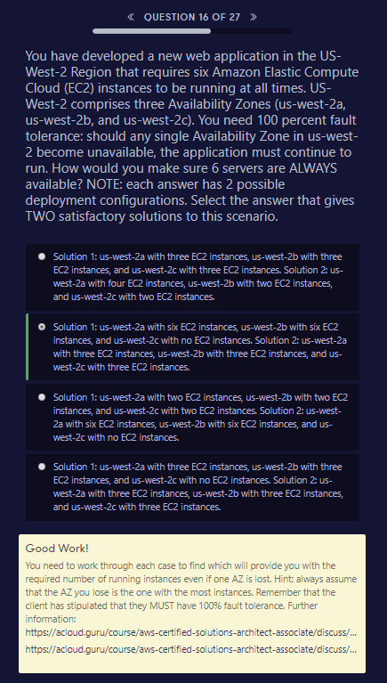

##### Good Work!

You need to work through each case to find which will provide you with the required number of running instances even if one AZ is lost. Hint: always assume that the AZ you lose is the one with the most instances. Remember that the client has stipulated that they MUST have 100% fault tolerance. Further information: <https://acloud.guru/course/aws-certified-solutions-architect-associate/discuss/-KFIeaB-fySmPO6lHppl/for-question-5-why-not-use-all-az-for-the-first-answer><https://acloud.guru/course/aws-certified-solutions-architect-associate/discuss/-KFAnKuYopjjH3LCNdwN/ec2-quiz-qestion>

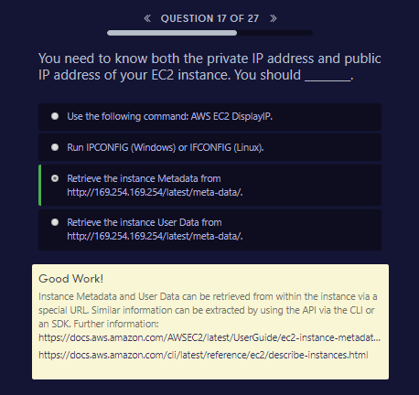

##### Good Work!

Instance Metadata and User Data can be retrieved from within the instance via a special URL. Similar information can be extracted by using the API via the CLI or an SDK. Further information: <https://docs.aws.amazon.com/AWSEC2/latest/UserGuide/ec2-instance-metadata.html><https://docs.aws.amazon.com/cli/latest/reference/ec2/describe-instances.html>

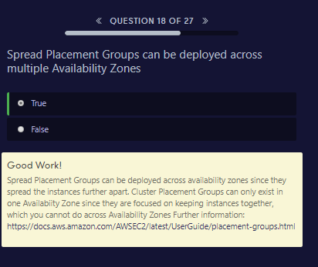

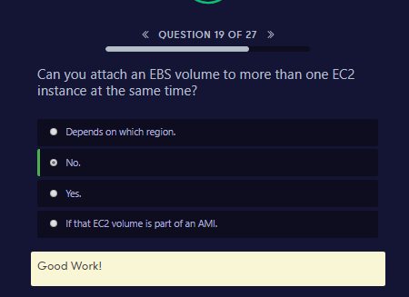

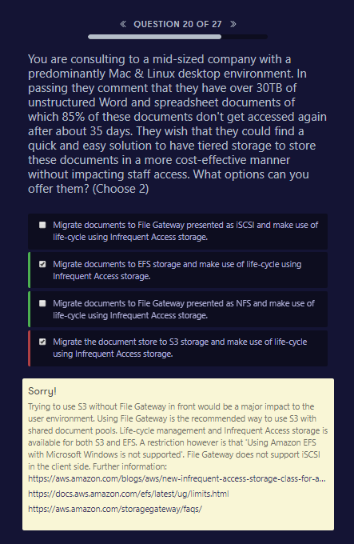

##### Sorry!

Trying to use S3 without File Gateway in front would be a major impact to the user environment. Using File Gateway is the recommended way to use S3 with shared document pools. Life-cycle management and Infrequent Access storage is available for both S3 and EFS. A restriction however is that 'Using Amazon EFS with Microsoft Windows is not supported'. File Gateway does not support iSCSI in the client side. Further information: <https://aws.amazon.com/blogs/aws/new-infrequent-access-storage-class-for-amazon-elastic-file-system-efs/><https://docs.aws.amazon.com/efs/latest/ug/limits.html><https://aws.amazon.com/storagegateway/faqs/>

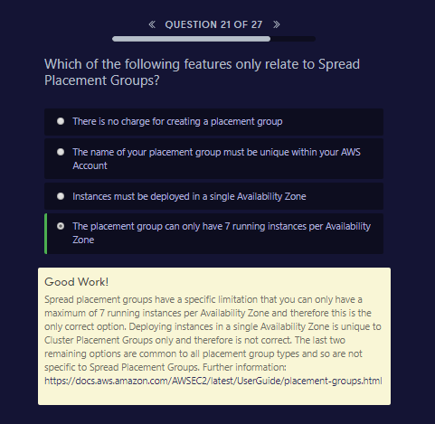

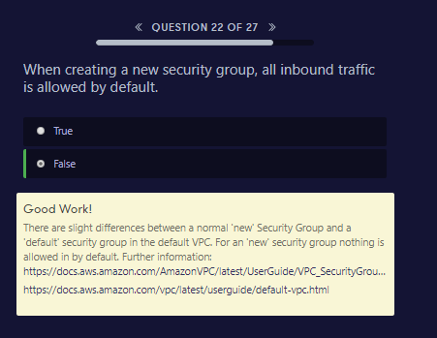

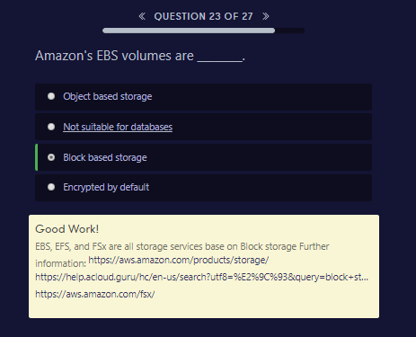

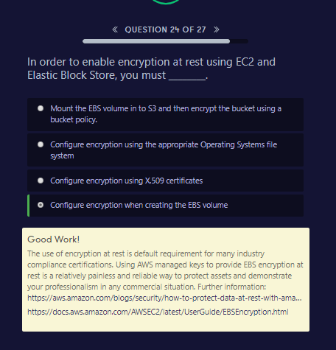

##### Good Work!

The use of encryption at rest is default requirement for many industry compliance certifications. Using AWS managed keys to provide EBS encryption at rest is a relatively painless and reliable way to protect assets and demonstrate your professionalism in any commercial situation. Further information: <https://aws.amazon.com/blogs/security/how-to-protect-data-at-rest-with-amazon-ec2-instance-store-encryption/><https://docs.aws.amazon.com/AWSEC2/latest/UserGuide/EBSEncryption.html>

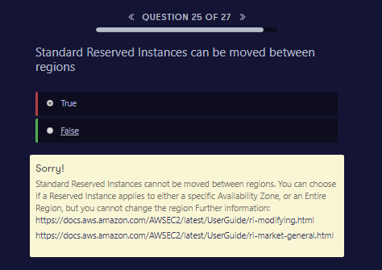

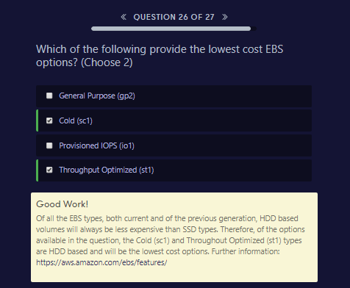

##### Good Work!

Of all the EBS types, both current and of the previous generation, HDD based volumes will always be less expensive than SSD types. Therefore, of the options available in the question, the Cold (sc1) and Throughout Optimized (st1) types are HDD based and will be the lowest cost options. Further information: <https://aws.amazon.com/ebs/features/>

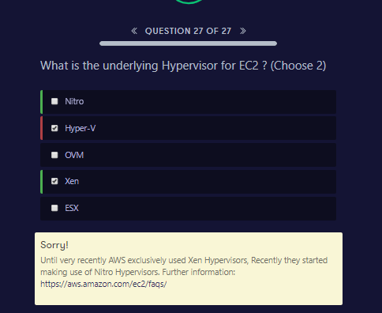

##### Sorry!

Until very recently AWS exclusively used Xen Hypervisors, Recently they started making use of Nitro Hypervisors. Further information: <https://aws.amazon.com/ec2/faqs/>