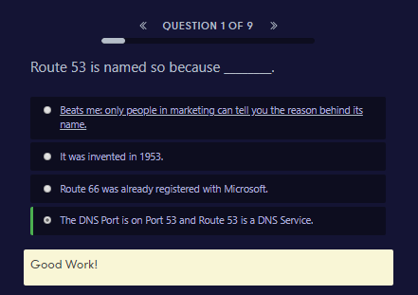

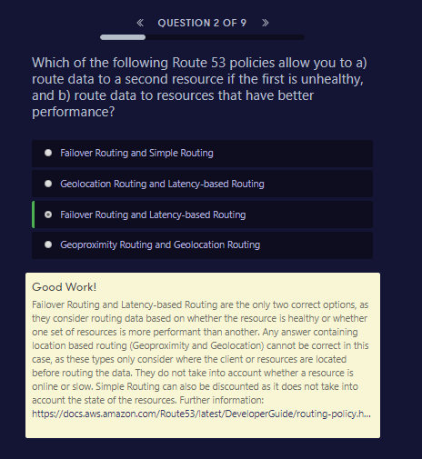

Good Work!

Failover Routing and Latency-based Routing are the only two correct options, as they consider routing data based on whether the resource is healthy or whether one set of resources is more performant than another. Any answer containing location based routing (Geoproximity and Geolocation) cannot be correct in this case, as these types only consider where the client or resources are located before routing the data. They do not take into account whether a resource is online or slow. Simple Routing can also be discounted as it does not take into account the state of the resources. Further information: <https://docs.aws.amazon.com/Route53/latest/DeveloperGuide/routing-policy.html>

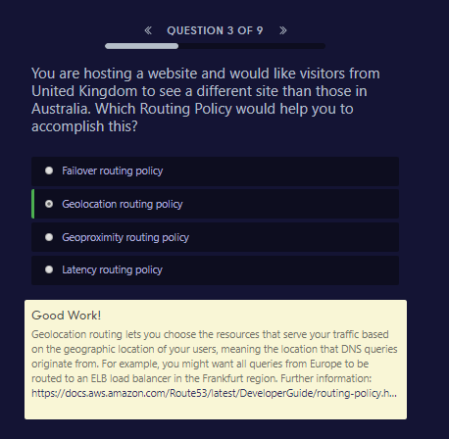

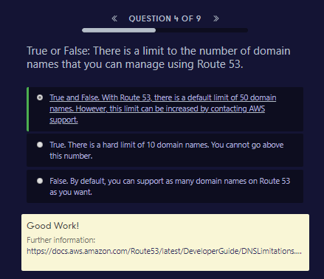

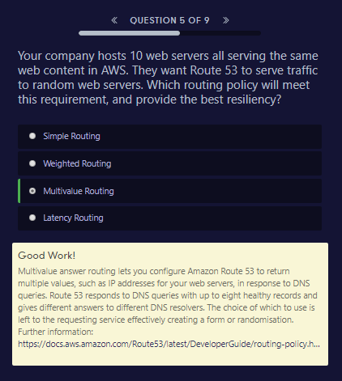

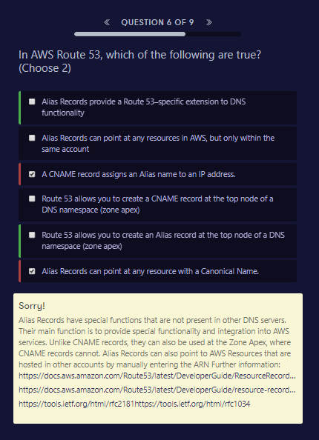

##### Sorry!

Alias Records have special functions that are not present in other DNS servers. Their main function is to provide special functionality and integration into AWS services. Unlike CNAME records, they can also be used at the Zone Apex, where CNAME records cannot. Alias Records can also point to AWS Resources that are hosted in other accounts by manually entering the ARN Further information: <https://docs.aws.amazon.com/Route53/latest/DeveloperGuide/ResourceRecordTypes.html>

<https://docs.aws.amazon.com/Route53/latest/DeveloperGuide/resource-record-sets-choosing-alias-non-alias.html>

<https://tools.ietf.org/html/rfc2181><https://tools.ietf.org/html/rfc1034>

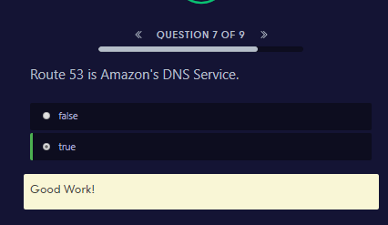

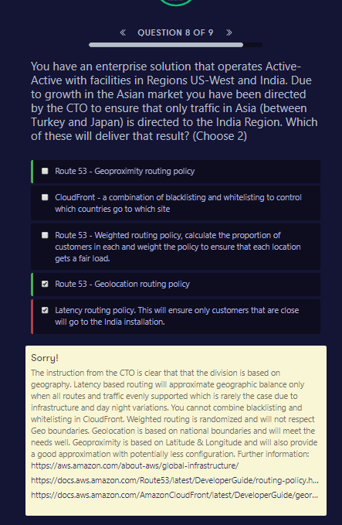

##### Sorry!

The instruction from the CTO is clear that that the division is based on geography. Latency based routing will approximate geographic balance only when all routes and traffic evenly supported which is rarely the case due to infrastructure and day night variations. You cannot combine blacklisting and whitelisting in CloudFront. Weighted routing is randomized and will not respect Geo boundaries. Geolocation is based on national boundaries and will meet the needs well. Geoproximity is based on Latitude & Longitude and will also provide a good approximation with potentially less configuration. Further information: <https://aws.amazon.com/about-aws/global-infrastructure/><https://docs.aws.amazon.com/Route53/latest/DeveloperGuide/routing-policy.html#routing-policy-geo><https://docs.aws.amazon.com/AmazonCloudFront/latest/DeveloperGuide/georestrictions.html>

