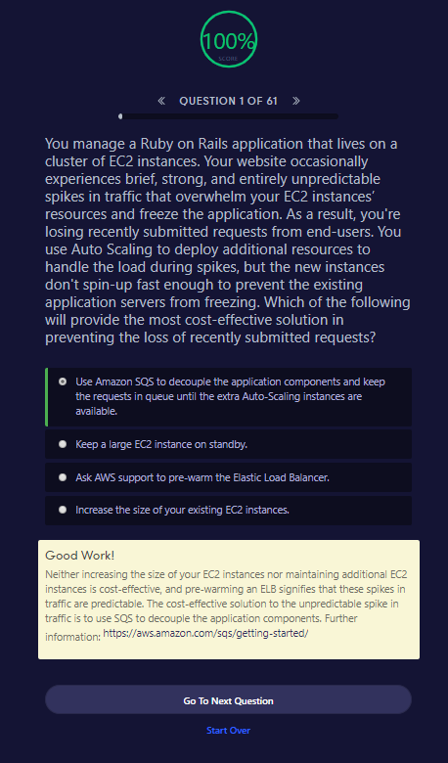

Good Work!

Neither increasing the size of your EC2 instances nor maintaining additional EC2 instances is cost-effective, and pre-warming an ELB signifies that these spikes in traffic are predictable. The cost-effective solution to the unpredictable spike in traffic is to use SQS to decouple the application components. Further information: <https://aws.amazon.com/sqs/getting-started/>

Go To Next QuestionStart Over

[ACG Logo Cloud](https://acloud.guru/)

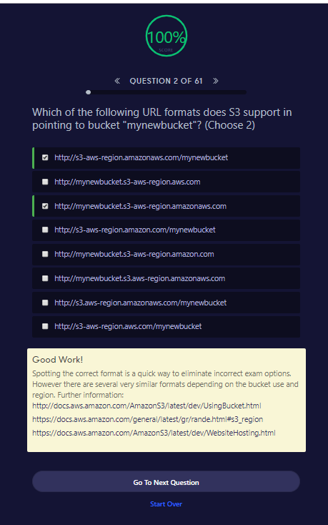

##### Good Work!

Spotting the correct format is a quick way to eliminate incorrect exam options. However there are several very similar formats depending on the bucket use and region. Further information: <http://docs.aws.amazon.com/AmazonS3/latest/dev/UsingBucket.html><https://docs.aws.amazon.com/general/latest/gr/rande.html#s3_region><https://docs.aws.amazon.com/AmazonS3/latest/dev/WebsiteHosting.html>

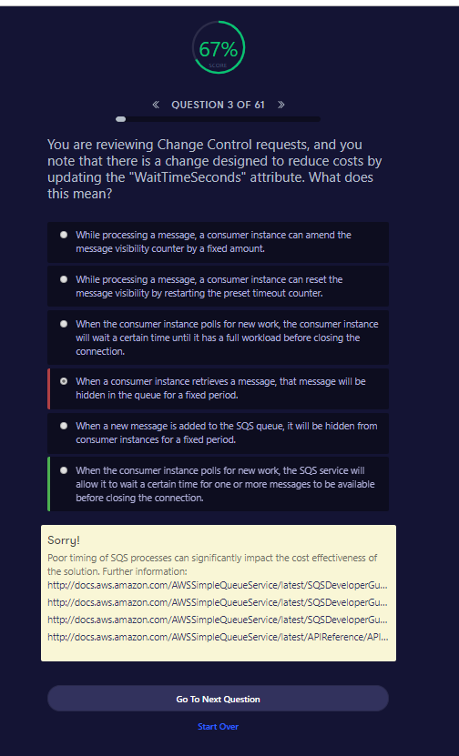

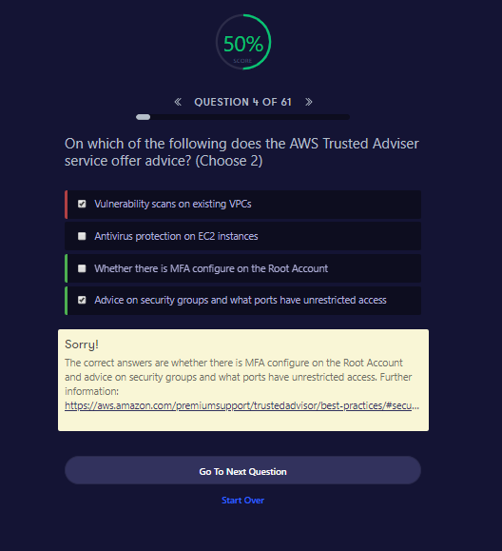

Sorry!

The correct answers are whether there is MFA configure on the Root Account and advice on security groups and what ports have unrestricted access. Further information: <https://aws.amazon.com/premiumsupport/trustedadvisor/best-practices/#security>

Go To Next QuestionStart Over

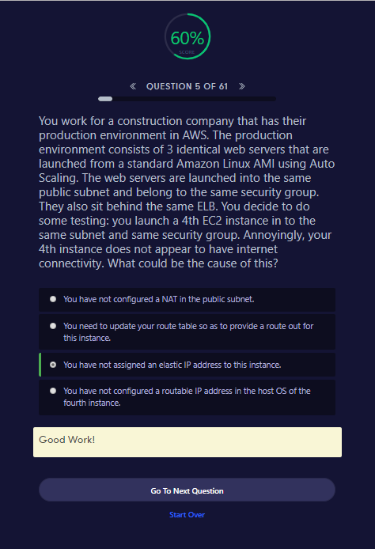

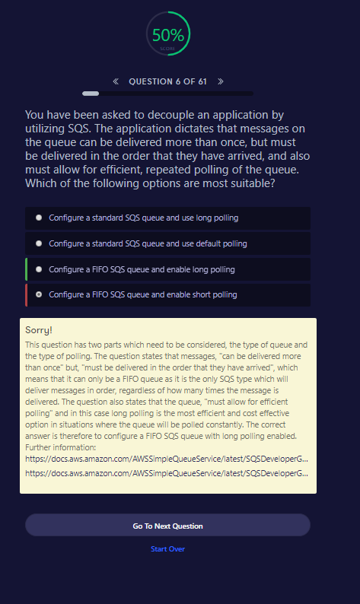

Sorry!

This question has two parts which need to be considered, the type of queue and the type of polling. The question states that messages, "can be delivered more than once" but, "must be delivered in the order that they have arrived", which means that it can only be a FIFO queue as it is the only SQS type which will deliver messages in order, regardless of how many times the message is delivered. The question also states that the queue, "must allow for efficient polling" and in this case long polling is the most efficient and cost effective option in situations where the queue will be polled constantly. The correct answer is therefore to configure a FIFO SQS queue with long polling enabled. Further information: <https://docs.aws.amazon.com/AWSSimpleQueueService/latest/SQSDeveloperGuide/FIFO-queues.html><https://docs.aws.amazon.com/AWSSimpleQueueService/latest/SQSDeveloperGuide/sqs-long-polling.html>

Go To Next QuestionStart Over

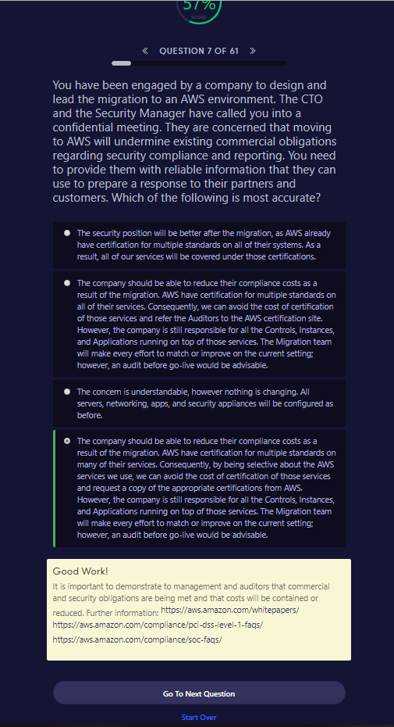

##### Good Work!

It is important to demonstrate to management and auditors that commercial and security obligations are being met and that costs will be contained or reduced. Further information: <https://aws.amazon.com/whitepapers/><https://aws.amazon.com/compliance/pci-dss-level-1-faqs/><https://aws.amazon.com/compliance/soc-faqs/>

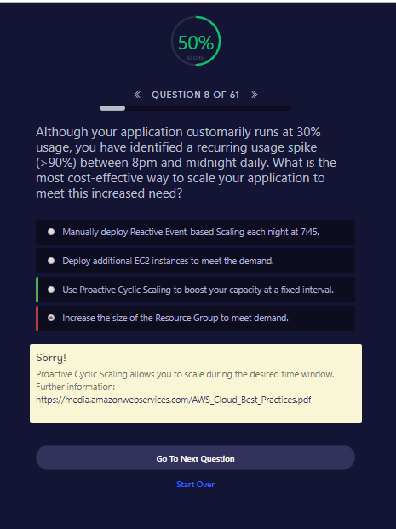

##### Sorry!

Proactive Cyclic Scaling allows you to scale during the desired time window. Further information: <https://media.amazonwebservices.com/AWS_Cloud_Best_Practices.pdf>

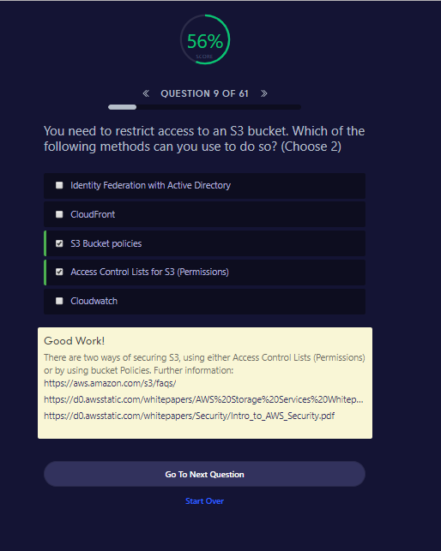

Good Work!

There are two ways of securing S3, using either Access Control Lists (Permissions) or by using bucket Policies. Further information: <https://aws.amazon.com/s3/faqs/><https://d0.awsstatic.com/whitepapers/AWS%20Storage%20Services%20Whitepaper-v9.pdf><https://d0.awsstatic.com/whitepapers/Security/Intro_to_AWS_Security.pdf>

Go To Next QuestionStart Over

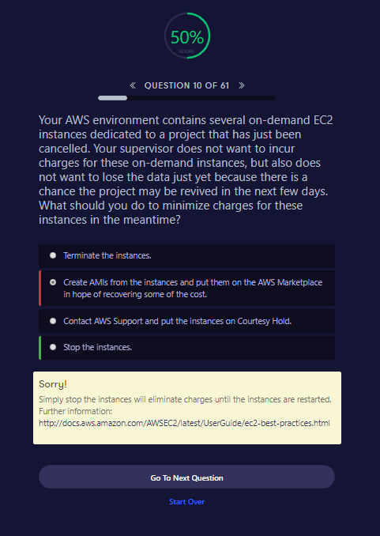

##### Sorry!

Simply stop the instances will eliminate charges until the instances are restarted. Further information: <http://docs.aws.amazon.com/AWSEC2/latest/UserGuide/ec2-best-practices.html>

### 4. You have a distributed application that periodically processes large volumes of data across multiple Amazon EC2 Instances. The application is designed to recover gracefully from Amazon EC2 instance failures. You are required to accomplish this task in the most cost effective way.

**Which of the following will meet your requirements?**

1. Spot Instances
2. Reserved instances
3. Dedicated instances
4. On-Demand instances

**Answer: A**

**Explanation:**Since the work we are addressing here is not continuous, a reserved instance shall be idle at times, same goes with On Demand instances. Also it does not make sense to launch an On Demand instance whenever work comes up, since it is expensive. Hence Spot Instances will be the right fit because of their low rates and no long term commitments.

### **5. How is stopping and terminating an instance different from each other?**

Starting, stopping and terminating are the three states in an EC2 instance, let’s discuss them in detail:

* **Stopping and Starting** an instance: When an instance is stopped, the instance performs a normal shutdown and then transitions to a stopped state. All of its Amazon EBS volumes remain attached, and you can start the instance again at a later time. You are not charged for additional instance hours while the instance is in a stopped state.
* **Terminating** an instance: When an instance is terminated, the instance performs a normal shutdown, then the attached Amazon EBS volumes are deleted unless the volume’s *deleteOnTermination* attribute is set to false. The instance itself is also deleted, and you can’t start the instance again at a later time.

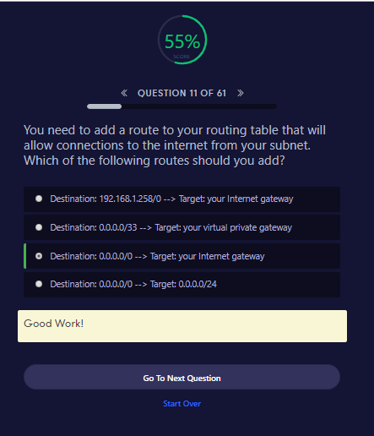

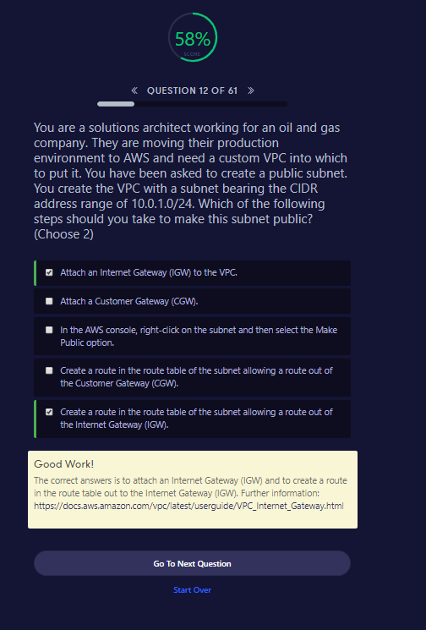

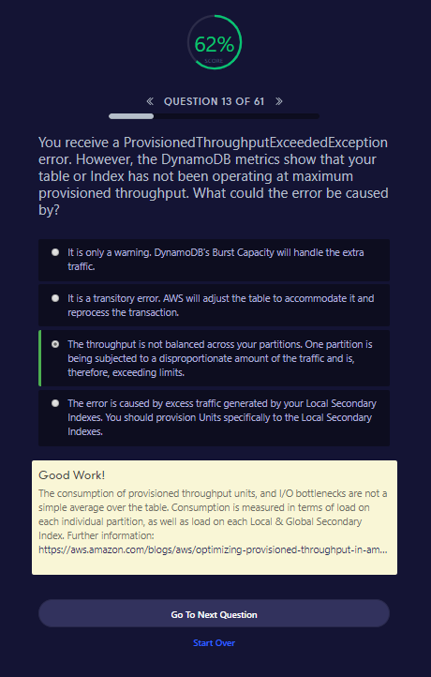

NEED TO GO TO DYNAMO DB IN DEPTH – Answered this in fluke

Good Work!

The consumption of provisioned throughput units, and I/O bottlenecks are not a simple average over the table. Consumption is measured in terms of load on each individual partition, as well as load on each Local & Global Secondary Index. Further information: <https://aws.amazon.com/blogs/aws/optimizing-provisioned-throughput-in-amazon-dynamodb/>

Go To Next QuestionStart Over

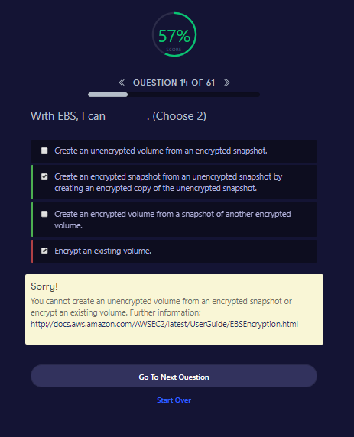

EASY PEESY , I MADE A MISTAKE

##### Sorry!

You cannot create an unencrypted volume from an encrypted snapshot or encrypt an existing volume. Further information: <http://docs.aws.amazon.com/AWSEC2/latest/UserGuide/EBSEncryption.html>

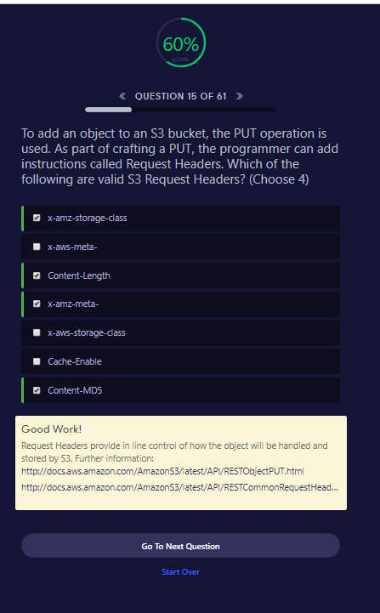

##### Good Work!

Request Headers provide in line control of how the object will be handled and stored by S3. Further information: <http://docs.aws.amazon.com/AmazonS3/latest/API/RESTObjectPUT.html><http://docs.aws.amazon.com/AmazonS3/latest/API/RESTCommonRequestHeaders.html>

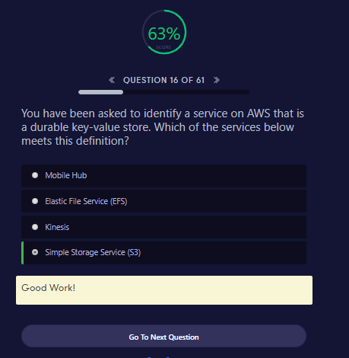

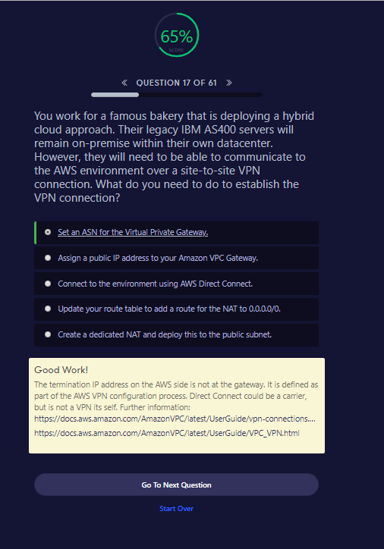

65%SCORE

**QUESTION 17 OF 61**

You work for a famous bakery that is deploying a hybrid cloud approach. Their legacy IBM AS400 servers will remain on-premise within their own datacenter. However, they will need to be able to communicate to the AWS environment over a site-to-site VPN connection. What do you need to do to establish the VPN connection?

Set an ASN for the Virtual Private Gateway.

Assign a public IP address to your Amazon VPC Gateway.

Connect to the environment using AWS Direct Connect.

Update your route table to add a route for the NAT to 0.0.0.0/0.

Create a dedicated NAT and deploy this to the public subnet.

Good Work!

The termination IP address on the AWS side is not at the gateway. It is defined as part of the AWS VPN configuration process. Direct Connect could be a carrier, but is not a VPN its self. Further information: <https://docs.aws.amazon.com/AmazonVPC/latest/UserGuide/vpn-connections.html><https://docs.aws.amazon.com/AmazonVPC/latest/UserGuide/VPC_VPN.html>

Go To Next QuestionStart Over

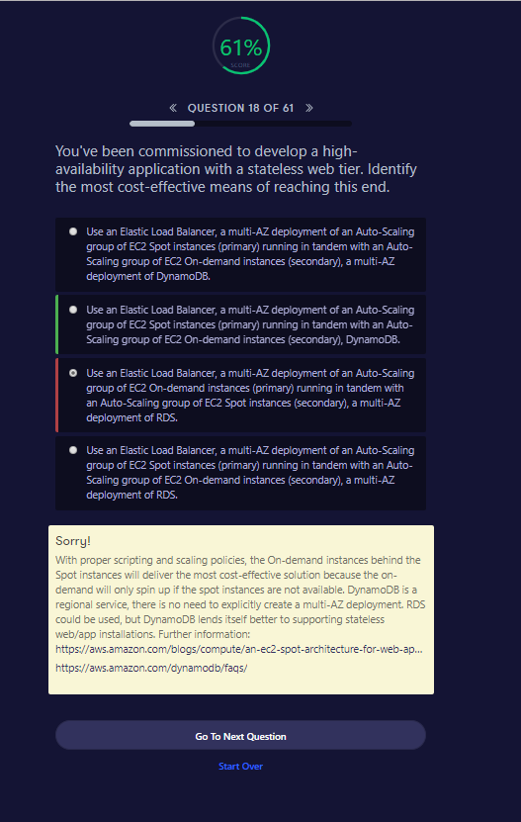

##### Sorry!

With proper scripting and scaling policies, the On-demand instances behind the Spot instances will deliver the most cost-effective solution because the on-demand will only spin up if the spot instances are not available. DynamoDB is a regional service, there is no need to explicitly create a multi-AZ deployment. RDS could be used, but DynamoDB lends itself better to supporting stateless web/app installations. Further information: <https://aws.amazon.com/blogs/compute/an-ec2-spot-architecture-for-web-applications/><https://aws.amazon.com/dynamodb/faqs/>

**QUESTION 18 OF 61**

You've been commissioned to develop a high-availability application with a stateless web tier. Identify the most cost-effective means of reaching this end.

Use an Elastic Load Balancer, a multi-AZ deployment of an Auto-Scaling group of EC2 Spot instances (primary) running in tandem with an Auto-Scaling group of EC2 On-demand instances (secondary), a multi-AZ deployment of DynamoDB.

Use an Elastic Load Balancer, a multi-AZ deployment of an Auto-Scaling group of EC2 Spot instances (primary) running in tandem with an Auto-Scaling group of EC2 On-demand instances (secondary), DynamoDB.

Use an Elastic Load Balancer, a multi-AZ deployment of an Auto-Scaling group of EC2 On-demand instances (primary) running in tandem with an Auto-Scaling group of EC2 Spot instances (secondary), a multi-AZ deployment of RDS.

Use an Elastic Load Balancer, a multi-AZ deployment of an Auto-Scaling group of EC2 Spot instances (primary) running in tandem with an Auto-Scaling group of EC2 On-demand instances (secondary), a multi-AZ deployment of RDS.

Sorry!

With proper scripting and scaling policies, the On-demand instances behind the Spot instances will deliver the most cost-effective solution because the on-demand will only spin up if the spot instances are not available. DynamoDB is a regional service, there is no need to explicitly create a multi-AZ deployment. RDS could be used, but DynamoDB lends itself better to supporting stateless web/app installations. Further information: <https://aws.amazon.com/blogs/compute/an-ec2-spot-architecture-for-web-applications/><https://aws.amazon.com/dynamodb/faqs/>

Go To Next QuestionStart Over

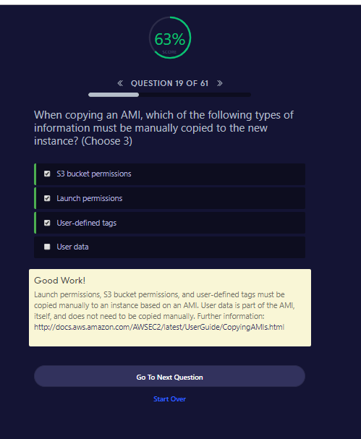

**QUESTION 19 OF 61**

When copying an AMI, which of the following types of information must be manually copied to the new instance? (Choose 3)

S3 bucket permissions

Launch permissions

User-defined tags

User data

Good Work!

Launch permissions, S3 bucket permissions, and user-defined tags must be copied manually to an instance based on an AMI. User data is part of the AMI, itself, and does not need to be copied manually. Further information: <http://docs.aws.amazon.com/AWSEC2/latest/UserGuide/CopyingAMIs.html>

Go To Next QuestionStart Over

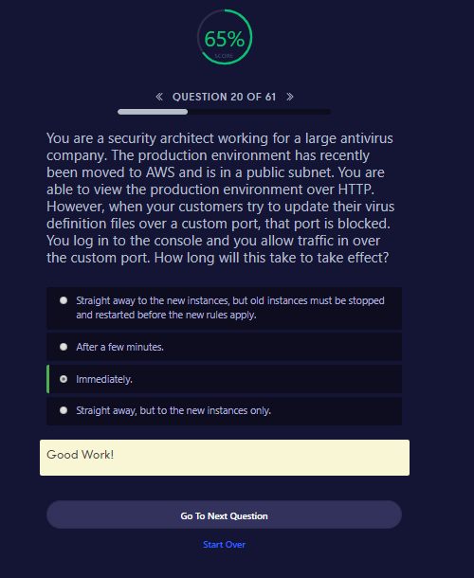

**QUESTION 20 OF 61**

You are a security architect working for a large antivirus company. The production environment has recently been moved to AWS and is in a public subnet. You are able to view the production environment over HTTP. However, when your customers try to update their virus definition files over a custom port, that port is blocked. You log in to the console and you allow traffic in over the custom port. How long will this take to take effect?

Straight away to the new instances, but old instances must be stopped and restarted before the new rules apply.

After a few minutes.

Immediately.

Straight away, but to the new instances only.

Good Work!

Go To Next QuestionStart Over

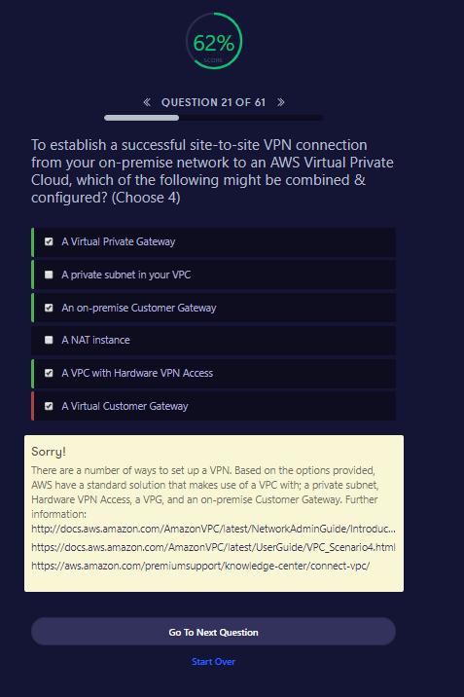

**QUESTION 21 OF 61**

To establish a successful site-to-site VPN connection from your on-premise network to an AWS Virtual Private Cloud, which of the following might be combined & configured? (Choose 4)

A Virtual Private Gateway

A private subnet in your VPC

An on-premise Customer Gateway

A NAT instance

A VPC with Hardware VPN Access

A Virtual Customer Gateway

Sorry!

There are a number of ways to set up a VPN. Based on the options provided, AWS have a standard solution that makes use of a VPC with; a private subnet, Hardware VPN Access, a VPG, and an on-premise Customer Gateway. Further information:

<http://docs.aws.amazon.com/AmazonVPC/latest/NetworkAdminGuide/Introduction.html#CustomerGatewayConfiguration>

<https://docs.aws.amazon.com/AmazonVPC/latest/UserGuide/VPC_Scenario4.html>

<https://aws.amazon.com/premiumsupport/knowledge-center/connect-vpc/>

Go To Next QuestionStart Over

<https://docs.aws.amazon.com/vpc/latest/userguide/VPC_Scenarios.html>

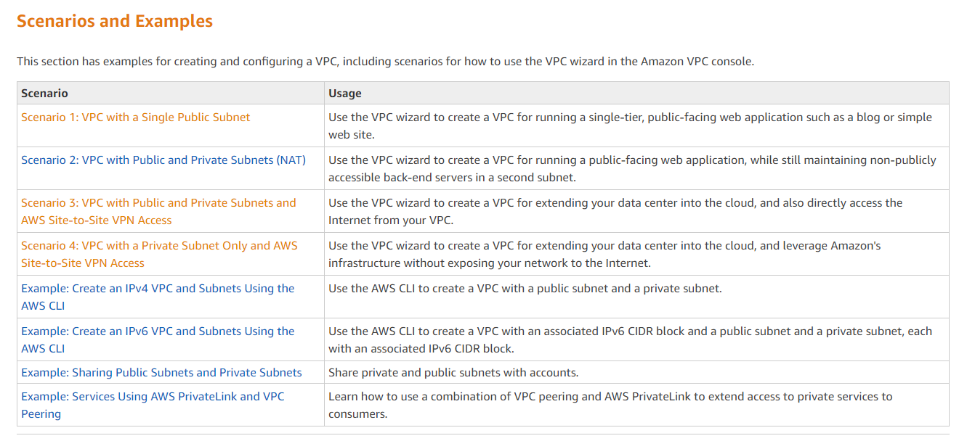

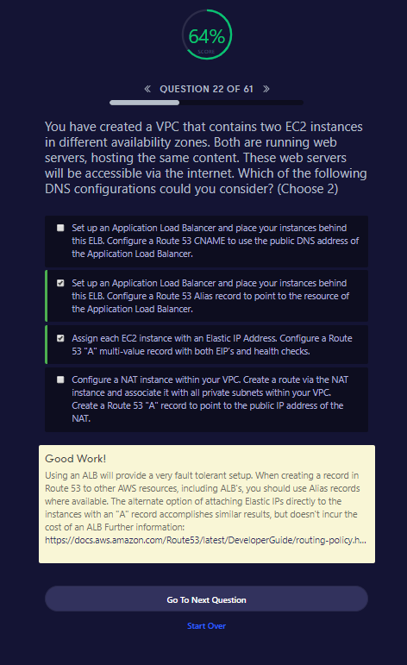

You have created a VPC that contains two EC2 instances in different availability zones. Both are running web servers, hosting the same content. These web servers will be accessible via the internet. Which of the following DNS configurations could you consider? (Choose 2)

Set up an Application Load Balancer and place your instances behind this ELB. Configure a Route 53 CNAME to use the public DNS address of the Application Load Balancer.

Set up an Application Load Balancer and place your instances behind this ELB. Configure a Route 53 Alias record to point to the resource of the Application Load Balancer.

Assign each EC2 instance with an Elastic IP Address. Configure a Route 53 "A" multi-value record with both EIP’s and health checks.

Configure a NAT instance within your VPC. Create a route via the NAT instance and associate it with all private subnets within your VPC. Create a Route 53 "A" record to point to the public IP address of the NAT.

Good Work!

Using an ALB will provide a very fault tolerant setup. When creating a record in Route 53 to other AWS resources, including ALB's, you should use Alias records where available. The alternate option of attaching Elastic IPs directly to the instances with an "A" record accomplishes similar results, but doesn't incur the cost of an ALB Further information: <https://docs.aws.amazon.com/Route53/latest/DeveloperGuide/routing-policy.html#routing-policy-failover>

Go To Next QuestionStart Over

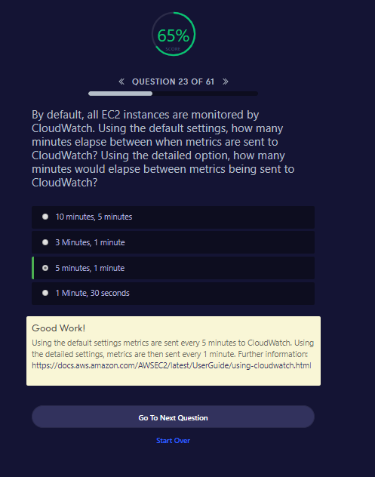

By default, all EC2 instances are monitored by CloudWatch. Using the default settings, how many minutes elapse between when metrics are sent to CloudWatch? Using the detailed option, how many minutes would elapse between metrics being sent to CloudWatch?

10 minutes, 5 minutes

3 Minutes, 1 minute

5 minutes, 1 minute

1 Minute, 30 seconds

Good Work!

Using the default settings metrics are sent every 5 minutes to CloudWatch. Using the detailed settings, metrics are then sent every 1 minute. Further information: <https://docs.aws.amazon.com/AWSEC2/latest/UserGuide/using-cloudwatch.html>

Go To Next QuestionStart Over

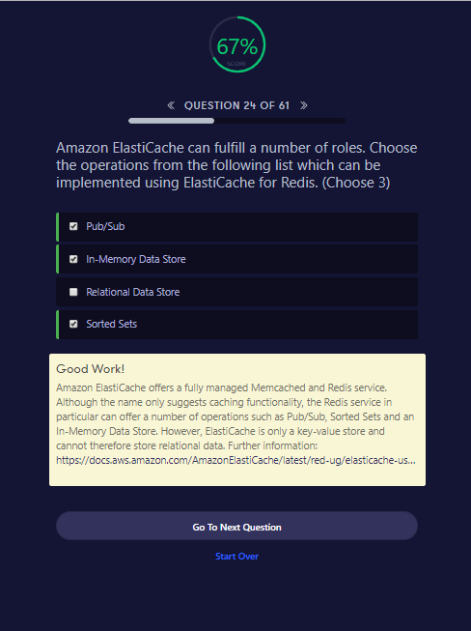

Amazon ElastiCache can fulfill a number of roles. Choose the operations from the following list which can be implemented using ElastiCache for Redis. (Choose 3)

Pub/Sub

In-Memory Data Store

Relational Data Store

Sorted Sets

Good Work!

Amazon ElastiCache offers a fully managed Memcached and Redis service. Although the name only suggests caching functionality, the Redis service in particular can offer a number of operations such as Pub/Sub, Sorted Sets and an In-Memory Data Store. However, ElastiCache is only a key-value store and cannot therefore store relational data. Further information: <https://docs.aws.amazon.com/AmazonElastiCache/latest/red-ug/elasticache-use-cases.html>

Go To Next QuestionStart Over

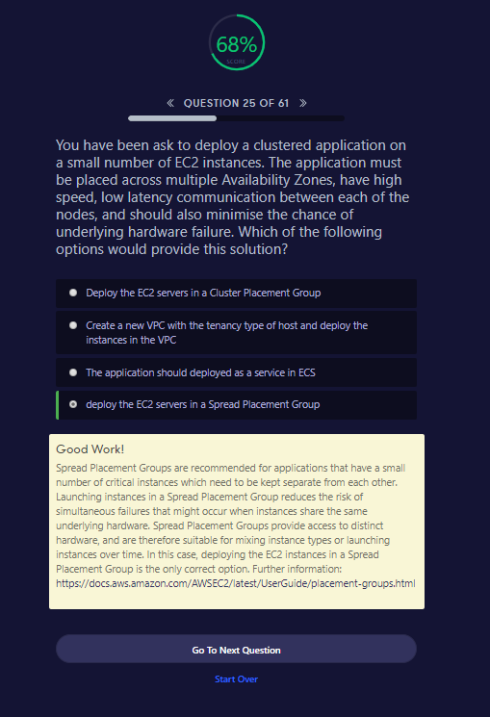

You have been ask to deploy a clustered application on a small number of EC2 instances. The application must be placed across multiple Availability Zones, have high speed, low latency communication between each of the nodes, and should also minimise the chance of underlying hardware failure. Which of the following options would provide this solution?

Deploy the EC2 servers in a Cluster Placement Group

Create a new VPC with the tenancy type of host and deploy the instances in the VPC

The application should deployed as a service in ECS

deploy the EC2 servers in a Spread Placement Group

Good Work!

Spread Placement Groups are recommended for applications that have a small number of critical instances which need to be kept separate from each other. Launching instances in a Spread Placement Group reduces the risk of simultaneous failures that might occur when instances share the same underlying hardware. Spread Placement Groups provide access to distinct hardware, and are therefore suitable for mixing instance types or launching instances over time. In this case, deploying the EC2 instances in a Spread Placement Group is the only correct option. Further information: <https://docs.aws.amazon.com/AWSEC2/latest/UserGuide/placement-groups.html>

Go To Next QuestionStart Over

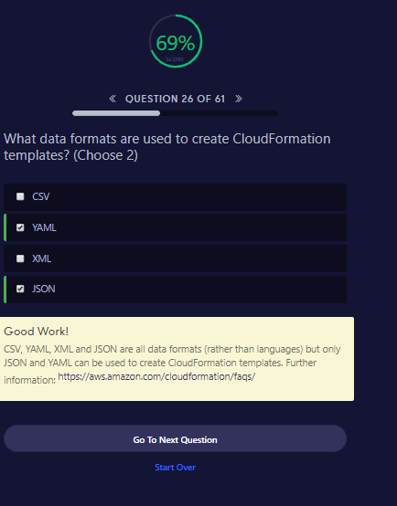

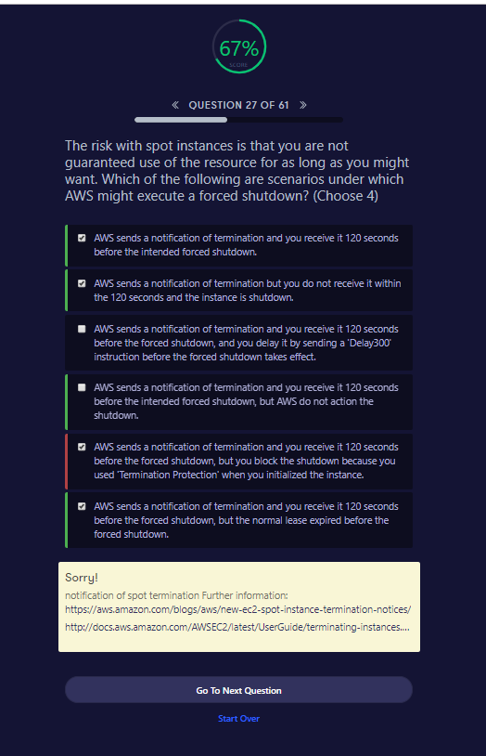

Sorry!

notification of spot termination Further information: <https://aws.amazon.com/blogs/aws/new-ec2-spot-instance-termination-notices/><http://docs.aws.amazon.com/AWSEC2/latest/UserGuide/terminating-instances.html#Using_ChangingDisableAPITermination>

Go To Next QuestionStart Over

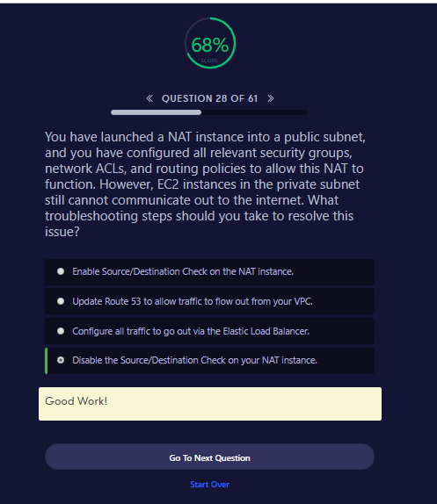

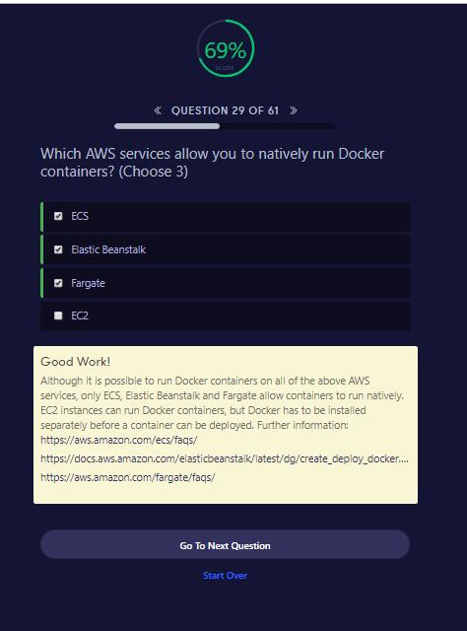

Which AWS services allow you to natively run Docker containers? (Choose 3)

ECS

Elastic Beanstalk

Fargate

EC2

Good Work!

Although it is possible to run Docker containers on all of the above AWS services, only ECS, Elastic Beanstalk and Fargate allow containers to run natively. EC2 instances can run Docker containers, but Docker has to be installed separately before a container can be deployed. Further information: <https://aws.amazon.com/ecs/faqs/><https://docs.aws.amazon.com/elasticbeanstalk/latest/dg/create_deploy_docker.html><https://aws.amazon.com/fargate/faqs/>

Go To Next QuestionStart Over

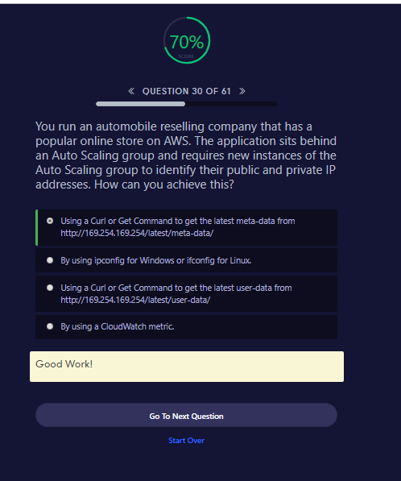

**QUESTION 30 OF 61**

You run an automobile reselling company that has a popular online store on AWS. The application sits behind an Auto Scaling group and requires new instances of the Auto Scaling group to identify their public and private IP addresses. How can you achieve this?

Using a Curl or Get Command to get the latest meta-data from http://169.254.169.254/latest/meta-data/

By using ipconfig for Windows or ifconfig for Linux.

Using a Curl or Get Command to get the latest user-data from http://169.254.169.254/latest/user-data/

By using a CloudWatch metric.

Good Work!

Go To Next QuestionStart Over

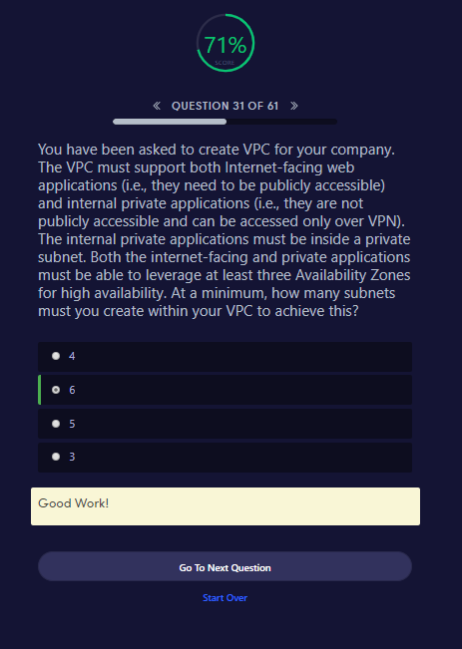

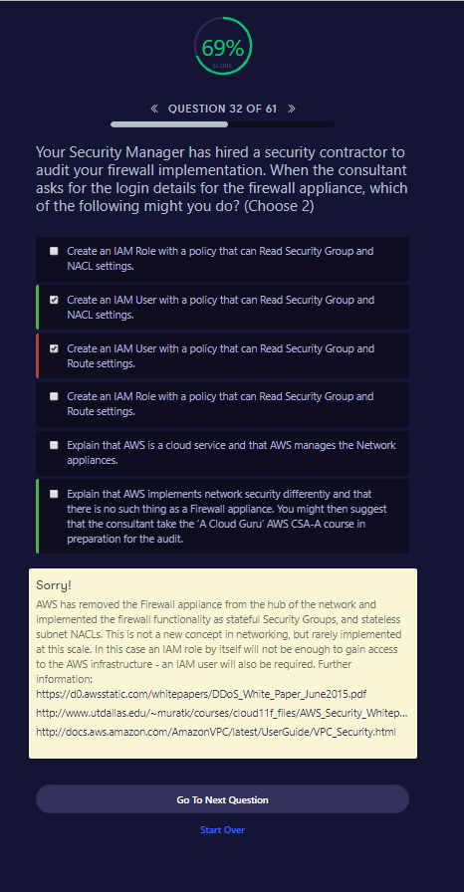

**QUESTION 32 OF 61**

Your Security Manager has hired a security contractor to audit your firewall implementation. When the consultant asks for the login details for the firewall appliance, which of the following might you do? (Choose 2)

Create an IAM Role with a policy that can Read Security Group and NACL settings.

Create an IAM User with a policy that can Read Security Group and NACL settings.

Create an IAM User with a policy that can Read Security Group and Route settings.

Create an IAM Role with a policy that can Read Security Group and Route settings.

Explain that AWS is a cloud service and that AWS manages the Network appliances.

Explain that AWS implements network security differently and that there is no such thing as a Firewall appliance. You might then suggest that the consultant take the ‘A Cloud Guru’ AWS CSA-A course in preparation for the audit.

Sorry!

AWS has removed the Firewall appliance from the hub of the network and implemented the firewall functionality as stateful Security Groups, and stateless subnet NACLs. This is not a new concept in networking, but rarely implemented at this scale. In this case an IAM role by itself will not be enough to gain access to the AWS infrastructure - an IAM user will also be required. Further information: <https://d0.awsstatic.com/whitepapers/DDoS_White_Paper_June2015.pdf><http://www.utdallas.edu/~muratk/courses/cloud11f_files/AWS_Security_Whitepaper.pdf><http://docs.aws.amazon.com/AmazonVPC/latest/UserGuide/VPC_Security.html>

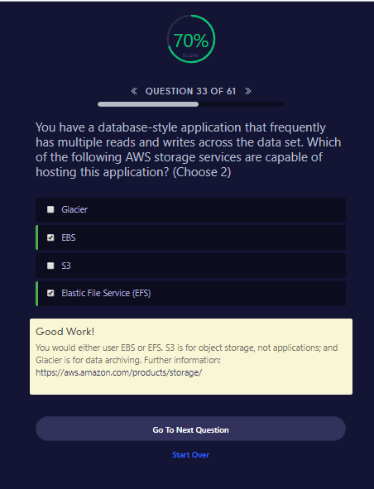

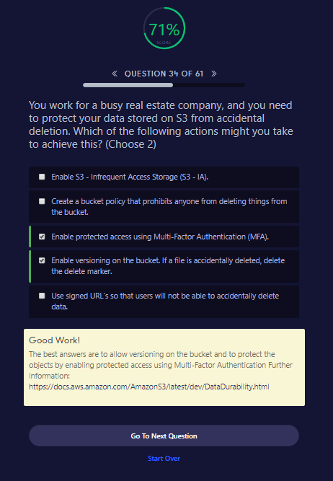

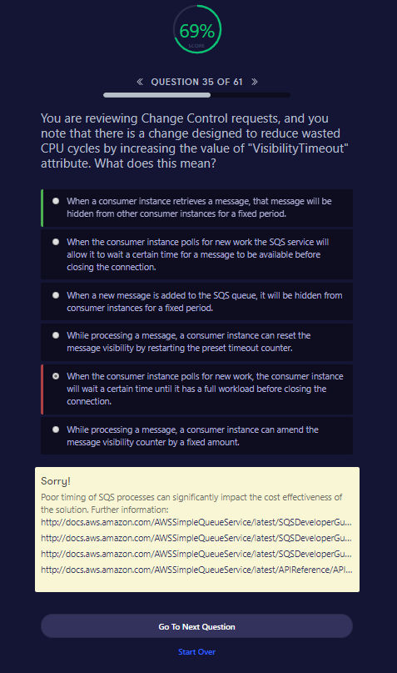

You are reviewing Change Control requests, and you note that there is a change designed to reduce wasted CPU cycles by increasing the value of "VisibilityTimeout" attribute. What does this mean?

When a consumer instance retrieves a message, that message will be hidden from other consumer instances for a fixed period.

When the consumer instance polls for new work the SQS service will allow it to wait a certain time for a message to be available before closing the connection.

When a new message is added to the SQS queue, it will be hidden from consumer instances for a fixed period.

While processing a message, a consumer instance can reset the message visibility by restarting the preset timeout counter.

When the consumer instance polls for new work, the consumer instance will wait a certain time until it has a full workload before closing the connection.

While processing a message, a consumer instance can amend the message visibility counter by a fixed amount.

Sorry!

Poor timing of SQS processes can significantly impact the cost effectiveness of the solution. Further information: <http://docs.aws.amazon.com/AWSSimpleQueueService/latest/SQSDeveloperGuide/sqs-delay-queues.html><http://docs.aws.amazon.com/AWSSimpleQueueService/latest/SQSDeveloperGuide/AboutVT.html><http://docs.aws.amazon.com/AWSSimpleQueueService/latest/SQSDeveloperGuide/sqs-long-polling.html><http://docs.aws.amazon.com/AWSSimpleQueueService/latest/APIReference/API_ChangeMessageVisibility.html>

Go To Next QuestionStart Over