Installation
- STEP1 – Install node from nodejs.org
  - 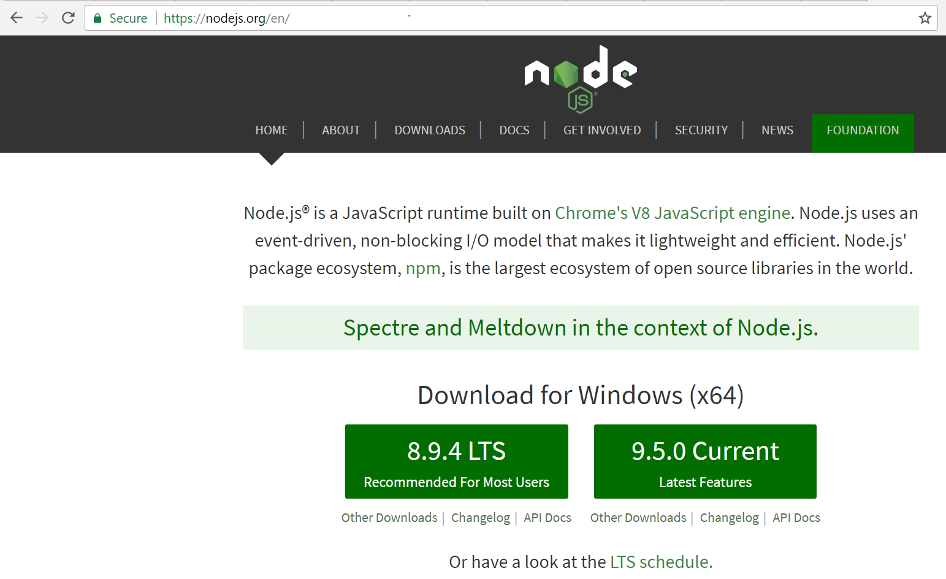
- STEP3 – npm init from any project folder
  - 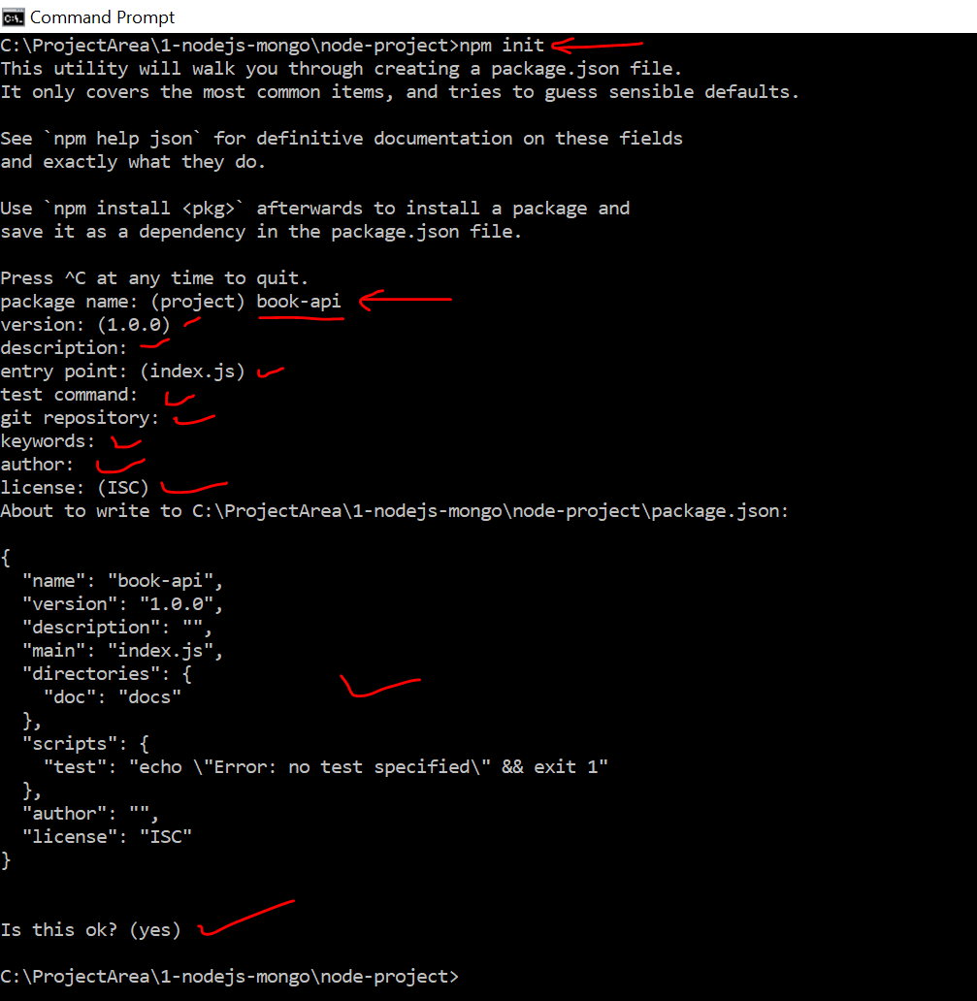
- STEP3 – Install Express (Notice package.json after the command)
  - 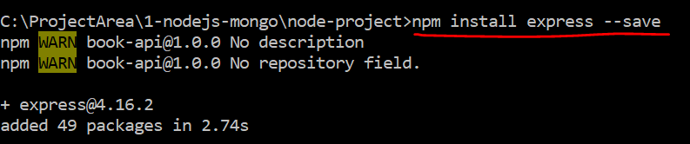
- STEP4 – Open the code is editor and notice..
  - 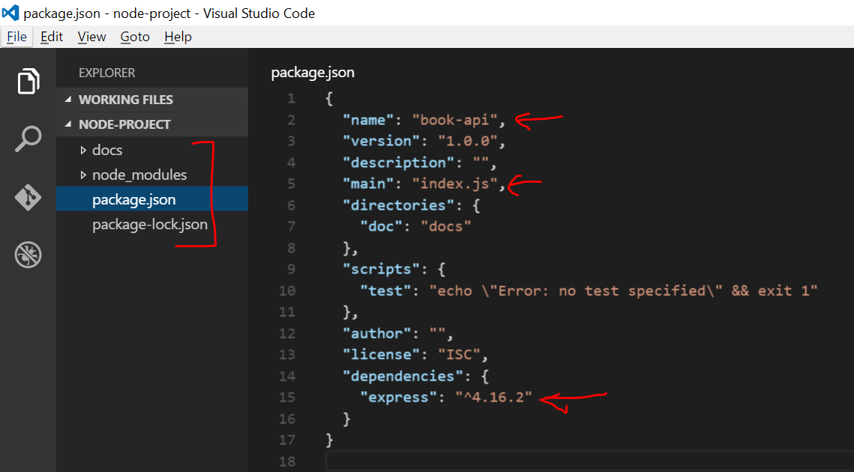

- Simple ‘Hello World’
  - 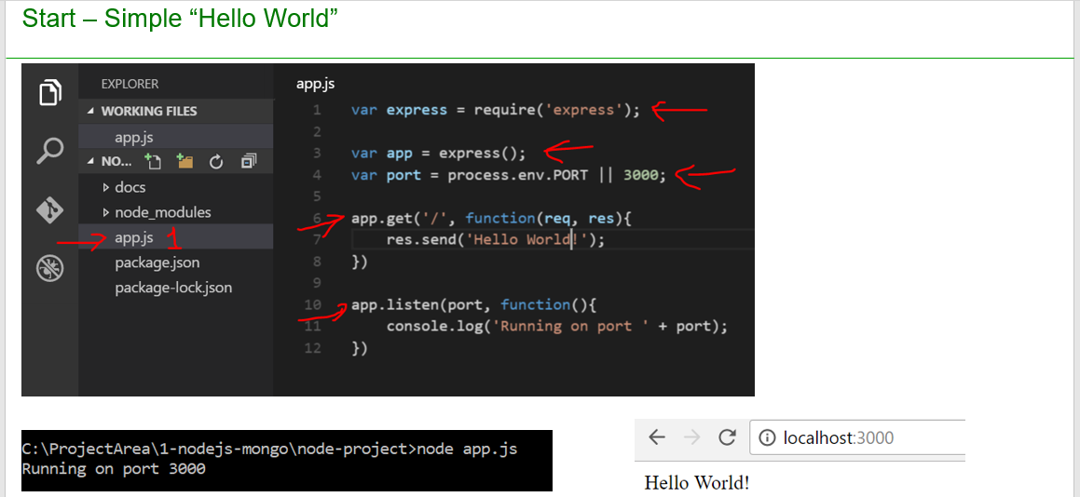
  - Open app.js and past the below code

var express = require('express')
var app = new express()
var port = 3000
app.get('/', function(req,res){
res.send('Hello world')
})
app.listen(port,function(){
console.log('Running on port' + port)
})
- Go to project folder and run below command
    - Node app.js
- Type localhost:3000 is chrome(browser) to get the message
  - 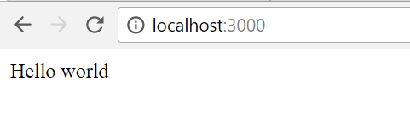

- GET API using router
  - 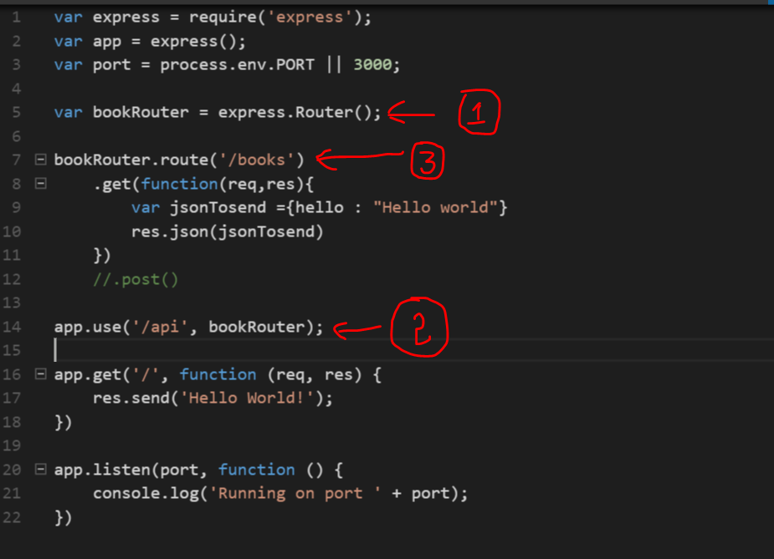
  - Paste the below code in app.js and run http://localhost:3000/api/books
var express = require('express');
var app = express();
var port = process.env.PORT || 3000;

var bookRouter = express.Router();

bookRouter.route('/books')
.get(function(req,res){
var jsonTosend ={hello : "Hello world"}
res.json(jsonTosend)
})
//.post()

app.use('/api', bookRouter);

app.get('/', function (req, res) {
res.send('Hello World!');
})

app.listen(port, function () {
console.log('Running on port ' + port);
})

- Wire up MongoDB
  - 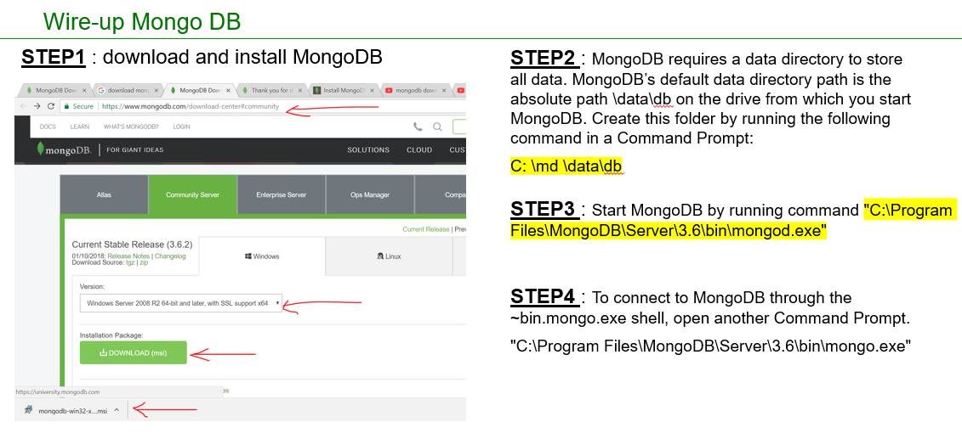
- GET API using Books model and mongoose
  - Install mongoose using npm install mongoose
  - 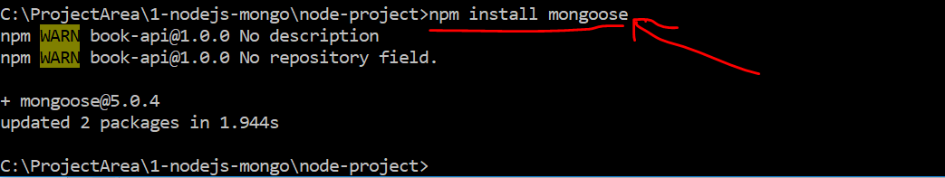
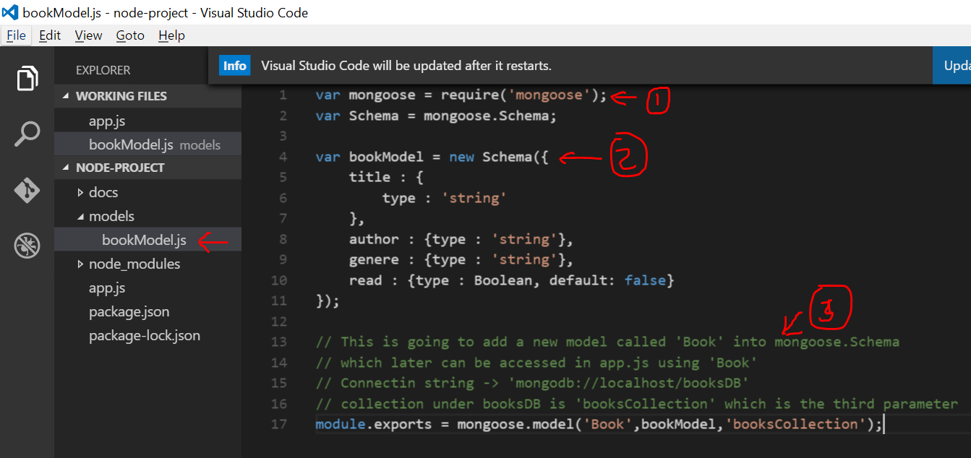
  - Add a file bookModel.js and paste below code
var mongoose = require('mongoose');
var Schema = mongoose.Schema;

var bookModel = new Schema({
title : {
type : 'string'
},
author : {type : 'string'},
genere : {type : 'string'},
read : {type : Boolean, default: false}
});

// This is going to add a new model called 'Book' into mongoose.Schema
// which later can be accessed in app.js using 'Book'
// Connectin string -> 'mongodb://localhost/booksDB'
// collection under booksDB is 'booksCollection' which is the third parameter
module.exports = mongoose.model('Book',bookModel,'booksCollection');

  - Update app.js with below code
  - 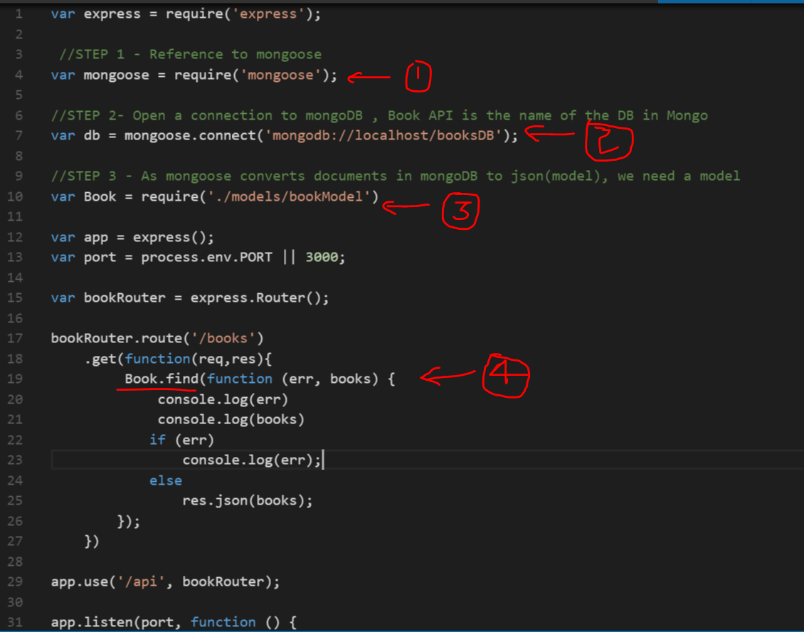
var express = require('express');

//STEP 1 - Reference to mongoose
var mongoose = require('mongoose');

//STEP 2- Open a connection to mongoDB , Book API is the name of the DB in Mongo
var db = mongoose.connect('mongodb://localhost/booksDB');

//STEP 3 - As mongoose converts documents in mongoDB to json(model), we need a model
var Book = require('./models/bookModel')

var app = express();
var port = process.env.PORT || 3000;

var bookRouter = express.Router();

bookRouter.route('/books')
.get(function(req,res){
Book.find(function (err, books) {
console.log(err)
console.log(books)
if (err)
console.log(err);
else
res.json(books);
});
})

app.use('/api', bookRouter);

app.listen(port, function () {
console.log('Running on port ' + port);
})

- GET API with filtering
  - 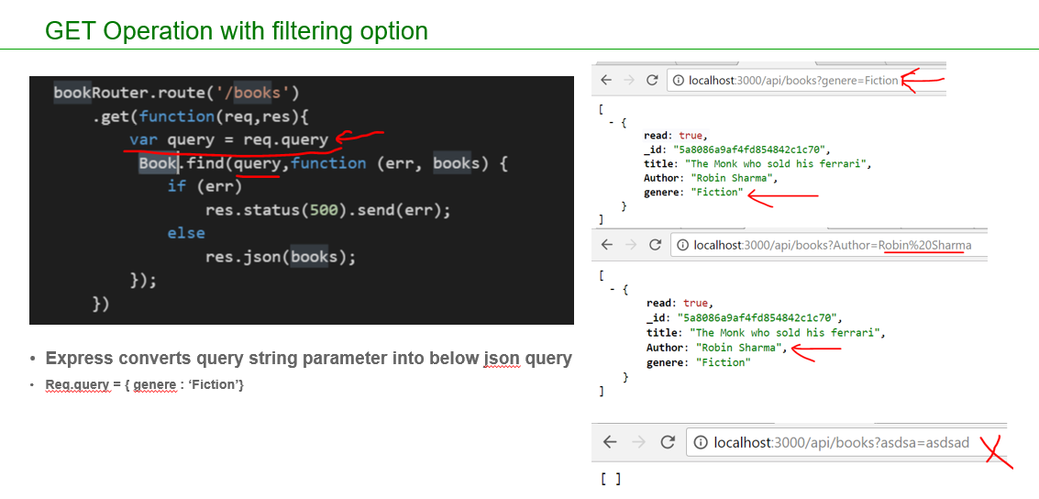
  - Place the below code appropriately in app.js ( do not overwrite entire app.js)
bookRouter.route('/books')
.get(function(req,res){
var query = req.query
Book.find(query,function (err, books) {
if (err)
res.status(500).send(err);
else
res.json(books);
});
})

- GET API with filter name check
  - 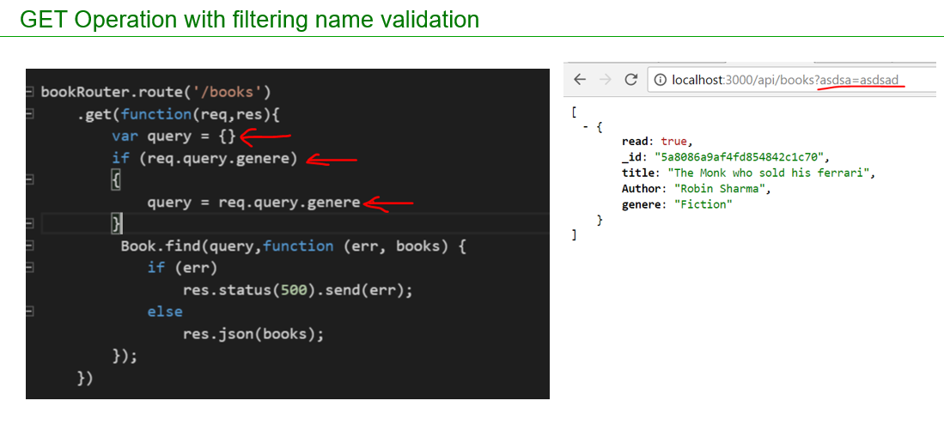
  - Place the below code appropriately in app.js ( do not overwrite entire app.js)
bookRouter.route('/books')
.get(function(req,res){
var query = {}
if (req.query.genere)
{
query = req.query.genere
}
Book.find(query,function (err, books) {
if (err)
res.status(500).send(err);
else
res.json(books);
});
})

- GET API to get a single item
  - 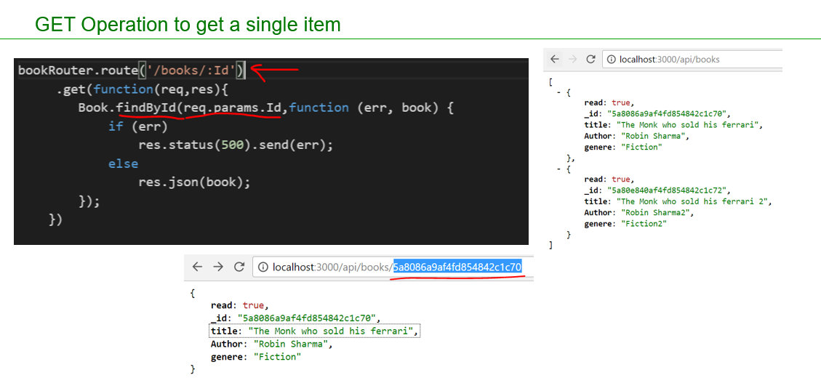
  - Place the below code appropriately in app.js ( do not overwrite entire app.js)
bookRouter.route('/books/:Id')
.get(function(req,res){
Book.findById(req.params.Id,function (err, book) {
if (err)
res.status(500).send(err);
else
res.json(book);
});
})

- Posting data
  - Install body parser package which is required to read the posted data and convert them to json
  - 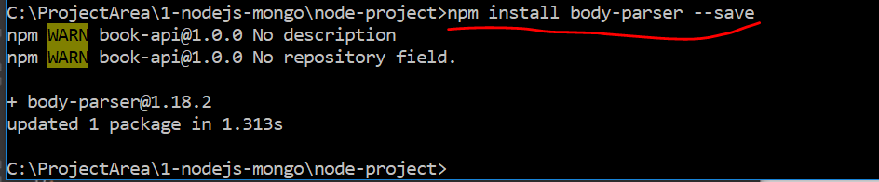
  - POST API code changes in app.js
  - 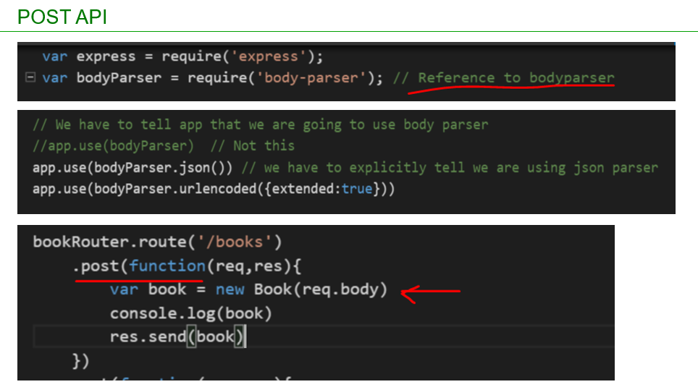
  - Place the below code appropriately in app.js ( do not overwrite entire app.js)
var bodyParser = require('body-parser'); // Reference to bodyparser

// We have to tell app that we are going to use body parser
//app.use(bodyParser) // Not this
app.use(bodyParser.json()) // we have to explicitly tell we are using json parser
app.use(bodyParser.urlencoded({extended:true}))

bookRouter.route('/books')
.post(function(req,res){
var book = new Book(req.body)
console.log(book)
res.send(book)
})

  - Insert below json into DB
    - {
    - "title": "The Monk who sold his ferrari",
    - "author": "Robin Sharma",
    - "genre": "Fiction",
    - "read": false
    - }
  - Execute the code using postman or soapui
  - 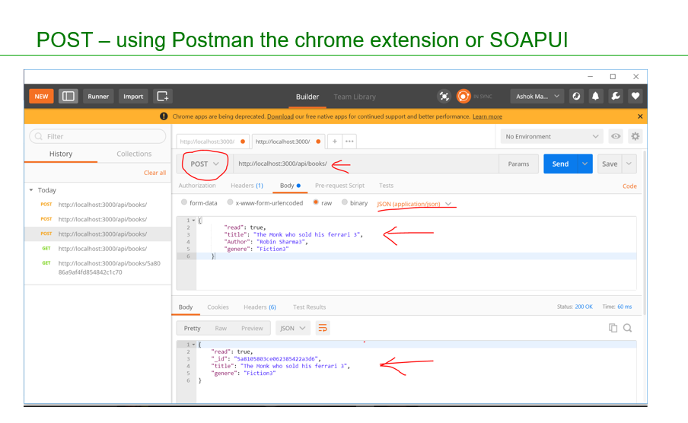

- Posting data – Save to Mongodb
  - 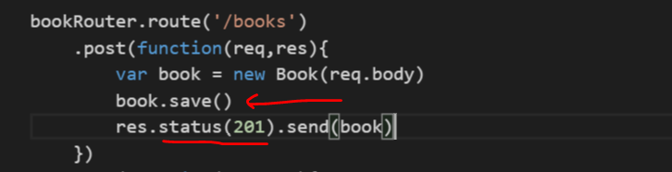
  - Place the below code appropriately in app.js ( do not overwrite entire app.js)
bookRouter.route('/books')
.post(function(req,res){
var book = new Book(req.body)
book.save()
res.status(201).send(book)
})

- Posting data – Injecting model with code cleanup
  - As our code in app.js is growing we need move some code(routing API code) to a separate file and inject books into it
  - Create a file as shown below
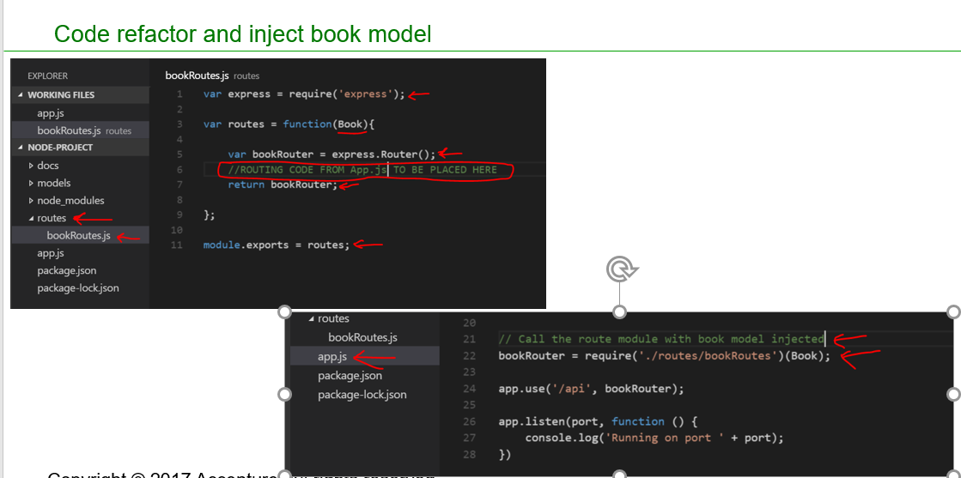
  - Place the below code appropriately in bookRoutes.js
var express = require('express');

var routes = function(){
var bookRouter = express.Router();

bookRouter.route('/books')
.post(function(req,res){
var book = new Book(req.body)
book.save()
res.status(201).send(book)
})
.get(function(req,res){
var query = {}
if (req.query.genere)
{
query = req.query.genere
}
Book.find(query,function (err, books) {
if (err)
res.status(500).send(err);
else
res.json(books);
});
})

bookRouter.route('/books/:Id')
.get(function(req,res){
Book.findById(req.params.Id,function (err, book) {
if (err)
res.status(500).send(err);
else
res.json(book);
});
})

return bookRouter;
};

module.exports = routes;

- Place the below code appropriately in app.js ( do not overwrite entire app.js)
// Call the route module with book model injected
bookRouter = require('./routes/bookRoutes')(Book);

- PUT API
  - 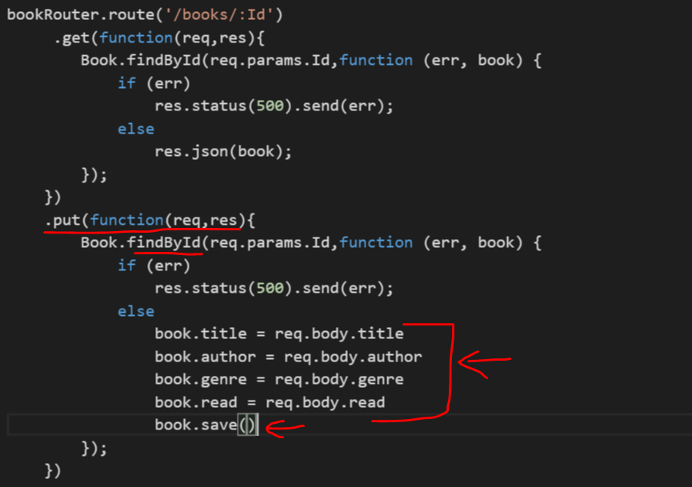
  - Place the below code appropriately in bookRoutes.js
bookRouter.route('/books/:Id')
.get(function(req,res){
Book.findById(req.params.Id,function (err, book) {
if (err)
res.status(500).send(err);
else
res.json(book);
});
})
.put(function(req,res){
Book.findById(req.params.Id,function (err, book) {
if (err)
res.status(500).send(err);
else
book.title = req.body.title
book.author = req.body.author
book.genre = req.body.genre
book.read = req.body.read
book.save()
});
})

- PATCH API
  - 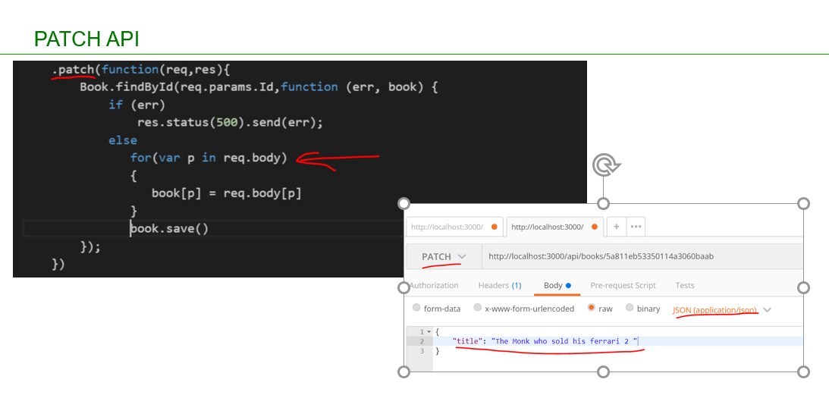
  - Place the below code appropriately in bookRoutes.js
.patch(function(req,res){
Book.findById(req.params.Id,function (err, book) {
if (err)
res.status(500).send(err);
else
for(var p in req.body)
{
book[p] = req.body[p]
}
book.save()
});
})

- Refactor with middleware
  - 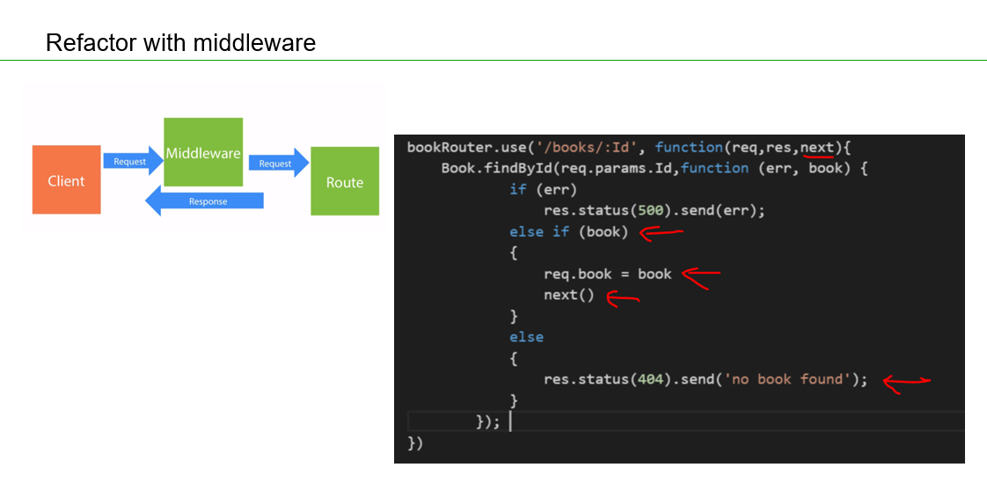

  - Place the below code appropriately in bookRoutes.js
// Middle Ware
bookRouter.use('/books/:Id', function(req,res,next){
Book.findById(req.params.Id,function (err, book) {
if (err)
res.status(500).send(err);
else if (book)
{
req.book = book
next()
}
else
{
res.status(404).send('no book found');
}
});
})

bookRouter.route('/books/:Id')
.get(function(req,res){
res.json(req.book);
})
.put(function(req,res){
req.book.title = req.body.title
req.book.author = req.body.author
req.book.genre = req.body.genre
req.book.read = req.body.read
req.book.save()
res.json(req.book)
})
.patch(function(req,res){
if(req.body._id)
delete req.body._id

for(var p in req.body)
{
req.book[p] = req.body[p]
}
req.book.save()
res.json(req.book)
})

- Remove API
