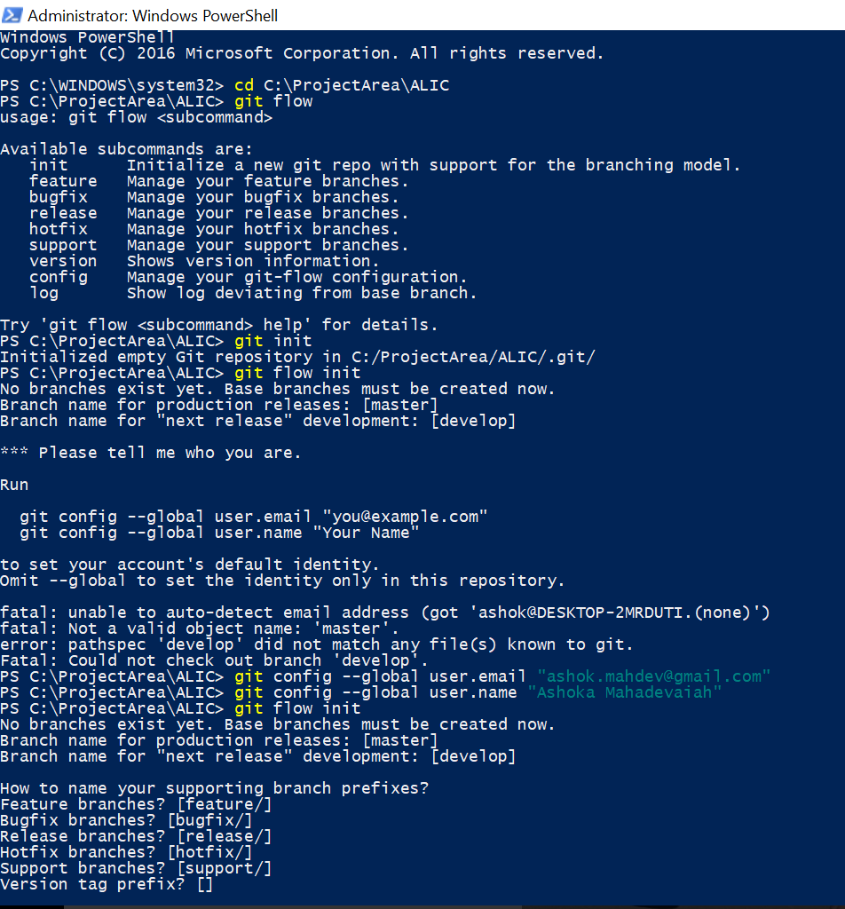

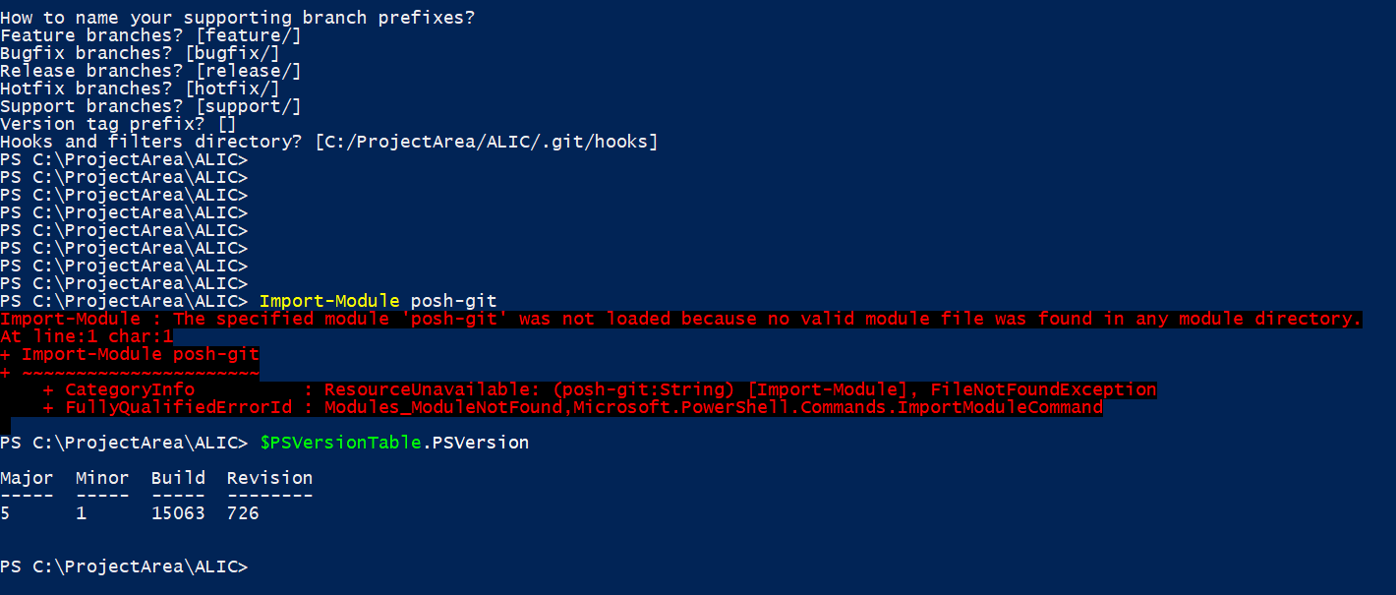

**Installation**

**Prerequisites**

Before installing posh-git make sure the following prerequisites have been met.

1. PowerShell 2.0 or higher. Check your PowerShell version by executing $PSVersionTable.PSVersion.
2. Script execution policy must be set to either RemoteSigned or Unrestricted. Check the script execution policy setting by executing Get-ExecutionPolicy. If the policy is not set to one of the two required values, run PowerShell as Administrator and execute Set-ExecutionPolicy RemoteSigned -Scope CurrentUser -Confirm.
3. Git must be installed and available via the PATH environment variable. Check that git is accessible from PowerShell by executing git --version from PowerShell. If git is not recognized as the name of a command verify that you have Git installed. If not, install Git from [https://git-scm.com](https://git-scm.com/). If you have Git installed, make sure the path to git.exe is in your PATH environment variable.

**Installing posh-git via PowerShellGet**

If you are on PowerShell version 5 or higher, execute the command below to install from the [PowerShell Gallery](https://www.powershellgallery.com/):

PowerShellGet\Install-Module posh-git -Scope CurrentUser

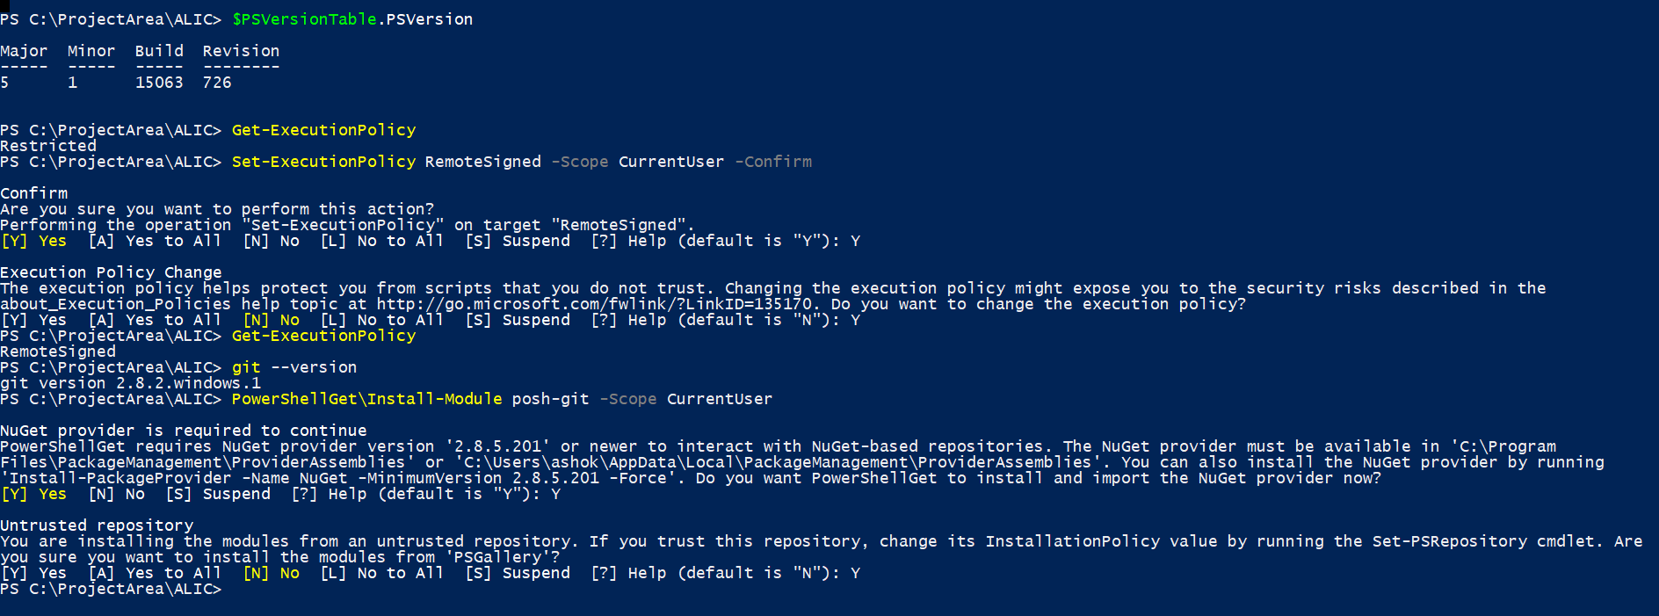

<https://github.com/dahlbyk/posh-git>

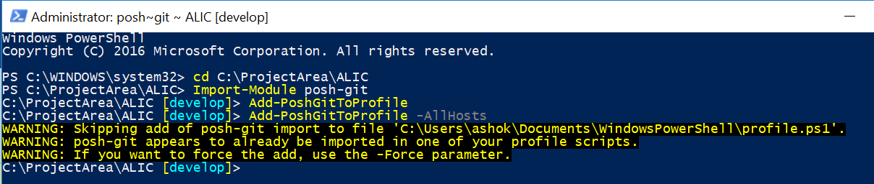

Pulling the project locally from github

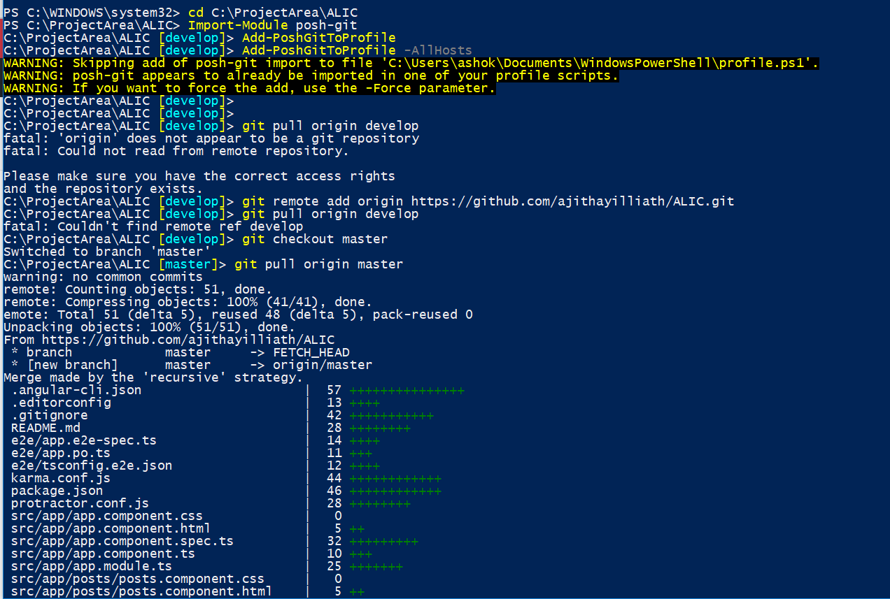

Running the app

