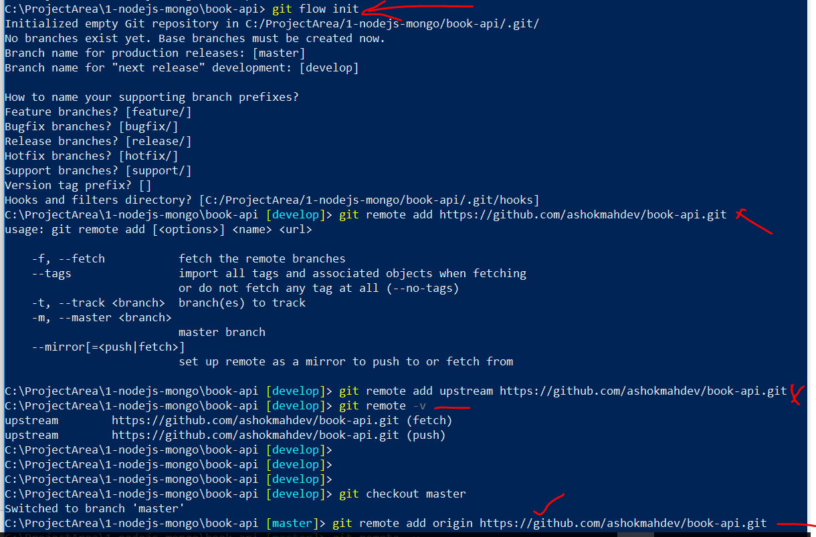

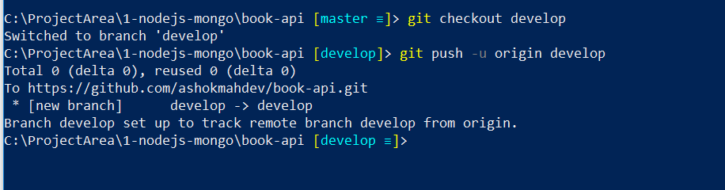

After above step we can see develop branch in github and similar command was executed earlier for master branch as well

