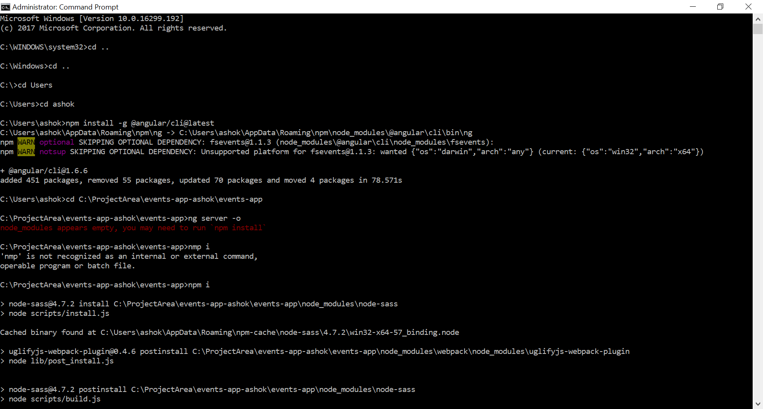

If required do below at global level and local?

Npm uninstall -g angular-cli

Npm uninstall –save-dev angular-cli

Npm cache verify

Npm install -g @angular/cli@latest

https://github.com/angular/angular-cli/issues/9292

sudo npm uninstall -g @angular/cli

sudo npm cache verify

sudo npm install -g @angular/cli@latest

rm -rf node_modules dist

npm install --save-dev @angular/cli@latest

npm install

sudo npm update -D && sudo npm update -S

sudo npm install typescript@'>=2.4.2 <2.7.0'

npm install --save-dev typescript@2.6.2

npm install --save-dev @angular/compiler@5.2.7

npm install typescript@'>=2.4.2 <2.5.0'