1. Node – 6.9.1
2. NPM – 3.10.8
3. Postgress (Z:\Elephant\Softwares\Postgress)
4. postgresql-9.4.1-1-windows-x64 (database)

**Note: Password for Postgress: ashok@123**

1. dcpostgresqlfree (Connecting api for dot net and postgress)
2. edb_pgagent (agent for running jobs)

(Please run all these in sequence.)

1. Visual Studio
2. Visual Studio Code for node code.
3. Protractor : 4.0.13 version
4. Hank Repo : (Z:\Elephant\HankRepo\hank)
5. ProtectorAutomation (run npm install)
6. Elephant.Hank.AngularWeb (run npm install)

**Note: If issue comes please run the bower install if the css does not load.**

Hank Database creation and restore:

1. Run PgAdmin and create a new database
2. Restore the backup from the URl: (Z:\Elephant\HankRepo\HankRawDatabase.backup)
3. Open the project of the api. (Elephant.Hank.Api) and set the postgress connection string.
4. Open the Elephant.Hank.AngularWeb and set the Url of the above api in **appsettings.config** file.
5. Run the command **grunt serve –force**

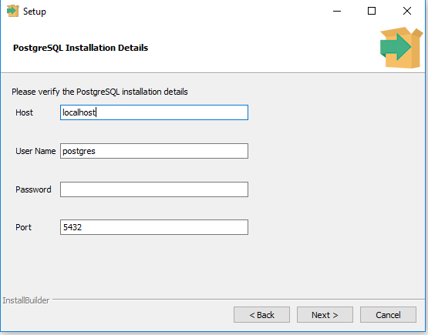

1. Window application settings.

Hard Dependency: Copy the template and create a log folder in Debug or Release folder.

1. Protector settings.

Build the window application for protector to run the exe.

On command window : npm install –g [protractor@4.0.13](mailto:protractor@4.0.13)

1. Sellanium grid installation: (Z:\Elephant\HankHubNodeLatest )

Copy the folders and put them in the root

1. Copy our own ipaddress in the node module project.