<https://help.github.com/desktop/guides/getting-started/installing-github-desktop/>

# Installing GitHub Desktop

You can install GitHub Desktop on supported Microsoft Windows or OS X operating systems.

Before you set up GitHub Desktop, you must already have a GitHub or GitHub Enterprise account.

* For more information on creating a GitHub account, see "[Signing up for a new GitHub account](https://help.github.com/articles/signing-up-for-a-new-github-account/)".
* For a GitHub Enterprise account, contact your GitHub Enterprise site administrator.

### Downloading and installing GitHub Desktop

You can install GitHub Desktop on Microsoft Windows 7 or later .

1. Visit the [GitHub Desktop download page](https://desktop.github.com/).
2. Choose **Download for Windows**.
3. In your computer's **Downloads** folder, double-click **GitHub Desktop**.
4. In the pop-up window, click **Install**.
5. After the program has been installed, click **Run**.

### Setting up GitHub Desktop

After you've launched GitHub Desktop, you can choose to set up GitHub Desktop right away, or you can skip the setup process.

If you'd like to skip setup, you can [authenticate to GitHub](https://help.github.com/desktop/guides/getting-started/authenticating-to-github), [create or edit your Git configuration](https://help.github.com/desktop/guides/getting-started/configuring-git-for-github-desktop), and [add repositories](https://help.github.com/desktop/guides/contributing/adding-a-repository-from-your-local-computer-to-github-desktop) later.

# Authenticating to GitHub

Add your GitHub.com or GitHub Enterprise account information to GitHub Desktop so you can access your repositories.

Before you authenticate, you must already have a GitHub or GitHub Enterprise account.

* For more information on creating a GitHub account, see "[Signing up for a new GitHub account](https://help.github.com/articles/signing-up-for-a-new-github-account/)".
* For a GitHub Enterprise account, contact your GitHub Enterprise site administrator.

**Note:** If your organization is on the [Business plan](https://help.github.com/articles/organization-billing-plans) and has enabled SAML single sign-on, you must create and authorize a personal access token to access protected content. For more information on creating personal access tokens, see "[Creating a personal access token for the command line](https://help.github.com/articles/creating-a-personal-access-token-for-the-command-line). For more information on authenticating with SAML single sign-on, see "[About authentication with SAML single sign-on](https://help.github.com/articles/about-authentication-with-saml-single-sign-on)."

1. In the upper-right corner of the app, click .

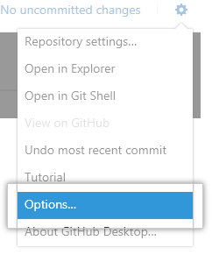

1. Choose **Options**.

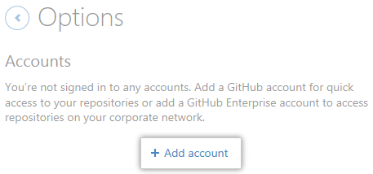

1. Under **Accounts**, click **Add account**.

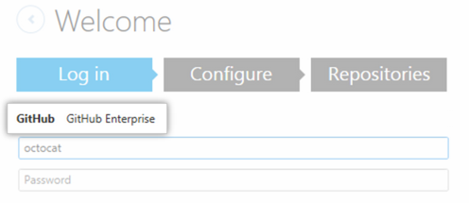

1. Under **Log in**, choose **GitHub** or **GitHub Enterprise**, depending on which product you're using.

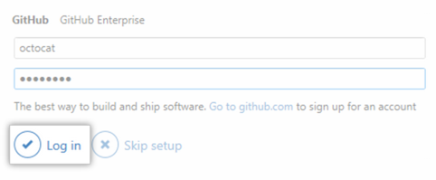

1. Type your credentials, then click **Log in**.

# Configuring Git for GitHub Desktop

If you don't already have Git installed, you must configure it before using GitHub Desktop.

GitHub Desktop uses the email address you set in your local Git configuration to connect commits with your GitHub or GitHub Enterprise account.

**Tips**:

* Anyone will be able to see the email address in your Git configuration if you make public commits. For more information, see "[Keeping your email address private](https://help.github.com/articles/keeping-your-email-address-private/)."
* If you run into trouble using GitHub Desktop behind a proxy server, you may be able to configure Git with your proxy credentials. For more information, see "[Can I log in behind a proxy server?](https://help.github.com/desktop/faq/articles/can-i-log-in-behind-a-proxy-server)"

1. Sign in to GitHub or GitHub Enterprise.
2. 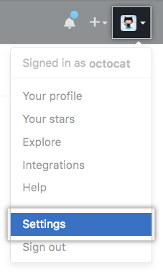In the upper-right corner of any page, click your profile photo, then click **Settings**.

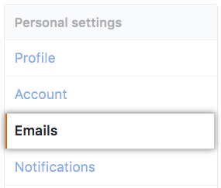

1. In the left sidebar, click **Emails**.
2. Copy the email address you'd like to use in your local Git configuration.
3. Return to GitHub Desktop.
4. In the upper-right corner of the app, click .



1. Choose **Options**.

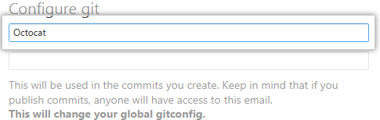

1. Under **Configure Git**, in the **Full name** field, type the name you'd like to use for your Git configuration.
2. In the **Email** field, paste the email address you copied from your GitHub or GitHub Enterprise account settings.

# Adding a repository from your local computer to GitHub Desktop

You can add any Git repository to GitHub Desktop, even if it's not a GitHub repository.

1. In the top left corner of the app, click .

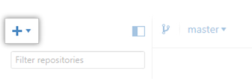

1. At the top of the menu, click **Add**.

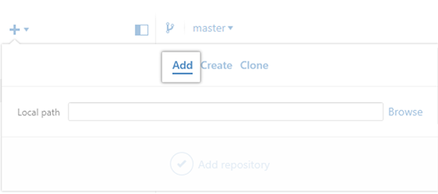

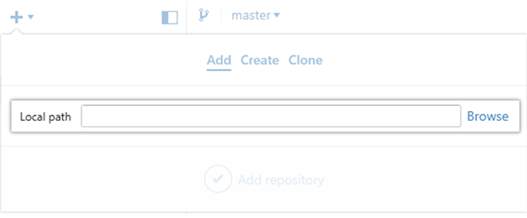

1. Click **Browse** and, using Windows Explorer, navigate to the local repository you want to add.

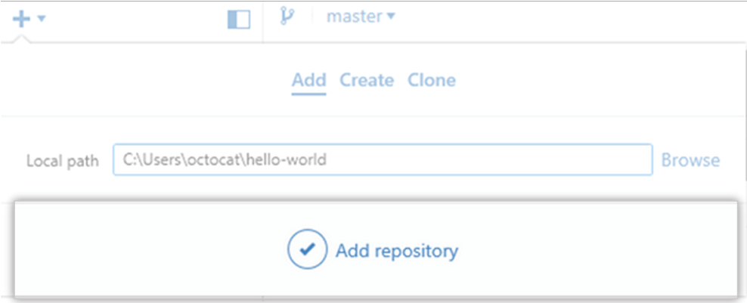

1. Click **Add repository**.