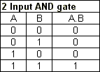

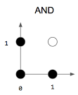

Using the AND gate data, we should get a weight vector of [-3, 2, 1].

This means that the bias is -3 and the weights are 2 and 1 for x_1 andx_2,

respectively.

To verify this weight vector is correct, we can try going through a few examples.

If both inputs are 0, then the pre-activation will be -3+0\*2+0\*1 = -3.

When applying our activation function, we get 0, which is exactly 0 AND 0!

