RAJALAKSHMI INSTITUTE OF TECHNOLOGY
DEPARTMENT OF INFORMATION TECHNOLOGY
IT-2357
WEB PROGRAMMING
WORKBOOK AND LAB MANUAL

Name of the Student :
Roll No :
Class :

JavaScript
JavaScript is the world's most popular programming language.
It is the language for HTML, for the web, for servers, PCs, laptops, tablets, phones, and more.

JavaScript is a Scripting Language
A scripting language is a lightweight programming language.
JavaScript is programming code that can be inserted into HTML pages.
JavaScript code can be executed by all modern web browsers.
JavaScript is easy to learn.

What You Will Learn
Below is a taste of what you will learn in this tutorial.

JavaScript: Writing Into HTML Output

Example
document.write("<h1>This is a heading</h1>");
document.write("<p>This is a paragraph</p>");
JavaScript: Reacting to Events
Example
<button type="button" onclick="alert('Welcome!')">Click Me!</button>
The alert() function is not much used in JavaScript, but it is quite handy for trying out code.
The onclick event is only one of the many HTML events you will learn about in this tutorial.

JavaScript: Changing HTML Content
Using JavaScript to manipulate the content of HTML elements is a very common.
Example
x=document.getElementById("demo") //Find the element
x.innerHTML="Hello JavaScript"; //Change the content
JavaScript: Changing HTML Styles
Changing the style of an HTML element, is a variant of changing an HTML attribute.
Example
x=document.getElementById("demo") //Find the element
x.style.color="#ff0000"; //Change the style
JavaScript: Validate Input
JavaScript is commonly used to validate input.
Example
if isNaN(x) {alert("Not Numeric")};
avaScripts in HTML must be inserted between <script> and </script> tags.
JavaScripts can be put in the <body> and in the <head> section of an HTML page.

The <script> Tag
To insert a JavaScript into an HTML page, use the <script> tag.
The <script> and </script> tells where the JavaScript starts and ends.
The lines between the <script> and </script> contain the JavaScript:
<script>
alert("My First JavaScript");
</script>
You don't have to understand the code above. Just take it for a fact, that the browser will interpret and execute the JavaScript code between the <script> and </script> tags.
JavaScript in <body>
In this example, JavaScript writes into the HTML <body> while the page loads:
Example
<!DOCTYPE html>
<html>
<body>
.
.
<script>
document.write("<h1>This is a heading</h1>");
document.write("<p>This is a paragraph</p>");
</script>
.
.
</body>
</html>
JavaScript Functions and Events
The JavaScript statements, in the example above, are executed while the page loads.
More often, we want to execute code when an event occurs, like when the user clicks a button.
If we put JavaScript code inside a function, we can call that function when an event occurs.
You will learn much more about JavaScript functions and events in later chapters.

JavaScript in <head> or <body>
You can place an unlimited number of scripts in an HTML document.
Scripts can be in the <body> or in the <head> section of HTML, and/or in both.
It is a common practice to put functions in the <head> section, or at the bottom of the page. This way they are all in one place and do not interfere with page content.

A JavaScript Function in <head>
In this example, a JavaScript function is placed in the <head> section of an HTML page.
The function is called when a button is clicked:
Example
<!DOCTYPE html>
<html>
<head>
<script>
function myFunction()
{
document.getElementById("demo").innerHTML="My First JavaScript Function";
}
</script>
</head>
<body>
<h1>My Web Page</h1>
<p id="demo">A Paragraph</p>
<button type="button" onclick="myFunction()">Try it</button>
</body>
</html>
A JavaScript Function in <body>
In this example, a JavaScript function is placed in the <body> section of an HTML page.
The function is called when a button is clicked:
Example
<!DOCTYPE html>
<html>
<body>
<h1>My Web Page</h1>
<p id="demo">A Paragraph</p>
<button type="button" onclick="myFunction()">Try it</button>
<script>
function myFunction()
{
document.getElementById("demo").innerHTML="My First JavaScript Function";
}
</script>
</body>
</html>
External JavaScripts
Scripts can also be placed in external files. External files often contain code to be used by several different web pages.
External JavaScript files have the file extension .js.
To use an external script, point to the .js file in the "src" attribute of the <script> tag:
Example
<!DOCTYPE html>
<html>
<body>
<script src="myScript.js"></script>
</body>
</html>
JavaScript is typically used to manipulate HTML elements.

Manipulating HTML Elements
To access an HTML element from JavaScript, you can use the document.getElementById(id) method.
Use the "id" attribute to identify the HTML element:
Example
Access the HTML element with the specified id, and change its content:
<!DOCTYPE html>
<html>
<body>
<h1>My First Web Page</h1>
<p id="demo">My First Paragraph</p>
<script>
document.getElementById("demo").innerHTML="My First JavaScript";
</script>
</body>
</html>
The JavaScript is executed by the web browser. In this case, the browser will access the HTML element with id="demo", and replace its content (innerHTML) with "My First JavaScript".

Writing to The Document Output
The example below writes a <p> element directly into the HTML document output:
Example
<!DOCTYPE html>
<html>
<body>
<h1>My First Web Page</h1>
<script>
document.write("<p>My First JavaScript</p>");
</script>
</body>
</html>
Warning
Use document.write() only to write directly into the document output.
If you execute document.write after the document has finished loading, the entire HTML page will be overwritten:
Example
<!DOCTYPE html>
<html>
<body>
<h1>My First Web Page</h1>
<p>My First Paragraph.</p>
<button onclick="myFunction()">Try it</button>
<script>
function myFunction()
{
document.write("Oops! The document disappeared!");
}
</script>
</body>
</html>
JavaScript is a sequence of statements to be executed by the browser.

JavaScript Statements
JavaScript statements are "commands" to the browser.
The purpose of the statements is to tell the browser what to do.
This JavaScript statement tells the browser to write "Hello Dolly" inside an HTML element with id="demo":
document.getElementById("demo").innerHTML="Hello Dolly";
Semicolon ;
Semicolon separates JavaScript statements.
Normally you add a semicolon at the end of each executable statement.
Using semicolons also makes it possible to write many statements on one line.
JavaScript Code
JavaScript code (or just JavaScript) is a sequence of JavaScript statements.
Each statement is executed by the browser in the sequence they are written.
This example will manipulate two HTML elements:
Example
document.getElementById("demo").innerHTML="Hello Dolly";
document.getElementById("myDIV").innerHTML="How are you?";
JavaScript Code Blocks
JavaScript statements can be grouped together in blocks.
Blocks start with a left curly bracket, and end with a right curly bracket.
The purpose of a block is to make the sequence of statements execute together.
A good example of statements grouped together in blocks, are JavaScript functions.
This example will run a function that will manipulate two HTML elements:
Example
function myFunction()
{
document.getElementById("demo").innerHTML="Hello Dolly";
document.getElementById("myDIV").innerHTML="How are you?";
}
JavaScript is Case Sensitive
JavaScript is case sensitive.
Watch your capitalization closely when you write JavaScript statements:
A function getElementById is not the same as getElementbyID.
A variable named myVariable is not the same as MyVariable.

White Space
JavaScript ignores extra spaces. You can add white space to your script to make it more readable. The following lines are equivalent:
var person="Hege";
var person = "Hege";

Break up a Code Line
You can break up a code line within a text string with a backslash. The example below will be displayed properly:
document.write("Hello \
World!");
However, you cannot break up a code line like this:
document.write \
("Hello World!");
JavaScript comments can be used to make the code more readable.

JavaScript Comments
Comments will not be executed by JavaScript.
Comments can be added to explain the JavaScript, or to make the code more readable.
Single line comments start with //.
The following example uses single line comments to explain the code:
Example
// Write to a heading:
document.getElementById("myH1").innerHTML="Welcome to my Homepage";
// Write to a paragraph:
document.getElementById("myP").innerHTML="This is my first paragraph.";
JavaScript Multi-Line Comments
Multi line comments start with /* and end with */.
The following example uses a multi line comment to explain the code:
Example
/*
The code below will write
to a heading and to a paragraph,
and will represent the start of
my homepage:
*/
document.getElementById("myH1").innerHTML="Welcome to my Homepage";
document.getElementById("myP").innerHTML="This is my first paragraph.";
Using Comments to Prevent Execution
In the following example the comment is used to prevent the execution of one of the codelines (can be suitable for debugging):
Example
//document.getElementById("myH1").innerHTML="Welcome to my Homepage";
document.getElementById("myP").innerHTML="This is my first paragraph.";
In the following example the comment is used to prevent the execution of a code block (can be suitable for debugging):
Example
/*
document.getElementById("myH1").innerHTML="Welcome to my Homepage";
document.getElementById("myP").innerHTML="This is my first paragraph.";
*/
Using Comments at the End of a Line
In the following example the comment is placed at the end of a code line:
Example
var x=5; // declare x and assign 5 to it
var y=x+2; // declare y and assign x+2 to it
JavaScript variables are "containers" for storing information:
Example
var x=5;
var y=6;
var z=x+y;
Much Like Algebra
x=5
y=6
z=x+y
In algebra we use letters (like x) to hold values (like 5).
From the expression z=x+y above, we can calculate the value of z to be 11.
In JavaScript these letters are called variables.
JavaScript Variables
As with algebra, JavaScript variables can be used to hold values (x=5) or expressions (z=x+y).
Variable can have short names (like x and y) or more descriptive names (age, sum, totalvolume).
- Variable names must begin with a letter
- Variable names can also begin with $ and _ (but we will not use it)
- Variable names are case sensitive (y and Y are different variables)

JavaScript Data Types
JavaScript variables can also hold other types of data, like text values (person="John Doe").
In JavaScript a text like "John Doe" is called a string.
There are many types of JavaScript variables, but for now, just think of numbers and strings.
When you assign a text value to a variable, put double or single quotes around the value.
When you assign a numeric value to a variable, do not put quotes around the value. If you put quotes around a numeric value, it will be treated as text.
Example
var pi=3.14;
var person="John Doe";
var answer='Yes I am!';
Declaring (Creating) JavaScript Variables
Creating a variable in JavaScript is most often referred to as "declaring" a variable.
You declare JavaScript variables with the var keyword:
var carname;
After the declaration, the variable is empty (it has no value).
To assign a value to the variable, use the equal sign:
carname="Volvo";
However, you can also assign a value to the variable when you declare it:
var carname="Volvo";
In the example below we create a variable called carname, assigns the value "Volvo" to it, and put the value inside the HTML paragraph with id="demo":
Example
<p id="demo"></p>
var carname="Volvo";
document.getElementById("demo").innerHTML=carname;
One Statement, Many Variables
You can declare many variables in one statement. Just start the statement with var and separate the variables by comma:
var lastname="Doe", age=30, job="carpenter";
Your declaration can also span multiple lines:
var lastname="Doe",
age=30,
job="carpenter";

Value = undefined
In computer programs, variables are often declared without a value. The value can be something that has to be calculated, or something that will be provided later, like user input. Variable declared without a value will have the valueundefined.
The variable carname will have the value undefined after the execution of the following statement:
var carname;

Re-Declaring JavaScript Variables
If you re-declare a JavaScript variable, it will not lose its value:.
The value of the variable carname will still have the value "Volvo" after the execution of the following two statements:
var carname="Volvo";
var carname;

JavaScript Arithmetic
As with algebra, you can do arithmetic with JavaScript variables, using operators like = and +:
Example
y=5;
x=y+2;
String, Number, Boolean, Array, Object, Null, Undefined.

JavaScript Has Dynamic Types
JavaScript has dynamic types. This means that the same variable can be used as different types:
Example
var x; // Now x is undefined
var x = 5; // Now x is a Number
var x = "John"; // Now x is a String
JavaScript Strings
A string is a variable which stores a series of characters like "John Doe".
A string can be any text inside quotes. You can use single or double quotes:
Example
var carname="Volvo XC60";
var carname='Volvo XC60';
You can use quotes inside a string, as long as they don't match the quotes surrounding the string:
Example
var answer="It's alright";
var answer="He is called 'Johnny'";
var answer='He is called "Johnny"';
JavaScript Numbers
JavaScript has only one type of numbers. Numbers can be written with, or without decimals:
Example
var x1=34.00; // Written with decimals
var x2=34; // Written without decimals
Extra large or extra small numbers can be written with scientific (exponential) notation:
Example
var y=123e5; // 12300000
var z=123e-5; // 0.00123
JavaScript Booleans
Booleans can only have two values: true or false.
var x=true;
var y=false;
Booleans are often used in conditional testing. You will learn more about conditional testing in a later chapter of this tutorial.

JavaScript Arrays
The following code creates an Array called cars:
var cars=new Array();
cars[0]="Saab";
cars[1]="Volvo";
cars[2]="BMW";
or (condensed array):
var cars=new Array("Saab","Volvo","BMW");
or (literal array):
Example
var cars=["Saab","Volvo","BMW"];
Array indexes are zero-based, which means the first item is [0], second is [1], and so on.
You will learn a lot more about arrays in later chapters of this tutorial.

JavaScript Objects
An object is delimited by curly braces. Inside the braces the object's properties are defined as name and value pairs (name : value). The properties are separated by commas:
var person={firstname:"John", lastname:"Doe", id:5566};
The object (person) in the example above has 3 properties: firstname, lastname, and id.
Spaces and line breaks are not important. Your declaration can span multiple lines:
var person={
firstname : "John",
lastname : "Doe",
id : 5566
};
You can address the object properties in two ways:
Example
name=person.lastname;
name=person["lastname"];
Undefined and Null
Undefined is the value of a variable with no value.
Variables can be emptied by setting the value to null;
Example
cars=null;
person=null;
Declaring Variables as Objects
When a variable is declared with the keyword "new", the variable is declared as an object:
var name = new String;
var x = new Number;
var y = new Boolean;
Almost everything in JavaScript can be an Object: Strings, Functions, Arrays, Dates....
Objects are just data, with properties and methods.

Properties and Methods
Properties are values associated with objects.
Methods are actions that objects can perform.

A Real Life Object. A Car:
Object | Properties | Methods
 | car.name = Fiat  car.model = 500  car.weight = 850kg  car.color = white | car.start()  car.drive()  car.brake()
The properties of the car include name, model, weight, color, etc.
All cars have these properties, but the property values differ from car to car.
The methods of the car could be start(), drive(), brake(), etc.
All cars have these methods, but they are performed at different times.

Objects in JavaScript:
In JavaScript, objects are data (variables), with properties and methods.
You create a JavaScript String object when you declare a string variable like this:
var txt = new String("Hello World");
String objects have built-in properties and methods:
Object | Property | Method
"Hello World" | txt.length | txt.indexOf("World")
The string object above has a length property of 11, and the indexOf("World") method will return 6.
Creating JavaScript Objects
Almost "everything" in JavaScript can be objects. Strings, Dates, Arrays, Functions....
You can also create your own objects.
This example creates an object called "person", and adds four properties to it:
Example
person=new Object();
person.firstname="John";
person.lastname="Doe";
person.age=50;
person.eyecolor="blue";
Accessing Object Properties
The syntax for accessing the property of an object is:
objectName.propertyName
This example uses the length property of the String object to find the length of a string:
var message="Hello World!";
var x=message.length;
The value of x, after execution of the code above will be:
12

Accessing Object Methods
You can call a method with the following syntax:
objectName.methodName()
This example uses the toUpperCase() method of the String object, to convert a text to uppercase:
var message="Hello world!";
var x=message.toUpperCase();
The value of x, after execution of the code above will be:
HELLO WORLD!
A function is a block of code that will be executed when "someone" calls it:
Example
<!DOCTYPE html>
<html>
<head>
<script>
function myFunction()
{
alert("Hello World!");
}
</script>
</head>
<body>
<button onclick="myFunction()">Try it</button>
</body>
</html>

JavaScript Function Syntax
A function is written as a code block (inside curly { } braces), preceded by the function keyword:
function functionname()
{
some code to be executed
}
The code inside the function will be executed when "someone" calls the function.
The function can be called directly when an event occurs (like when a user clicks a button), and it can be called from "anywhere" by JavaScript code.
Calling a Function with Arguments
When you call a function, you can pass along some values to it, these values are called arguments or parameters.
These arguments can be used inside the function.
You can send as many arguments as you like, separated by commas (,)
myFunction(argument1,argument2)
Declare the argument, as variables, when you declare the function:
function myFunction(var1,var2)
{
some code
}
The variables and the arguments must be in the expected order. The first variable is given the value of the first passed argument etc.
Example
<button onclick="myFunction('Harry Potter','Wizard')">Try it</button>
<script>
function myFunction(name,job)
{
alert("Welcome " + name + ", the " + job);
}
</script>
The function above will alert "Welcome Harry Potter, the Wizard" when the button is clicked.
The function is flexible, you can call the function using different arguments, and different welcome messages will be given:
Example
<button onclick="myFunction('Harry Potter','Wizard')">Try it</button>
<button onclick="myFunction('Bob','Builder')">Try it</button>
The example above will alert "Welcome Harry Potter, the Wizard" or "Welcome Bob, the Builder" depending on which button is clicked.

Functions With a Return Value
Sometimes you want your function to return a value back to where the call was made.
This is possible by using the return statement.
When using the return statement, the function will stop executing, and return the specified value.

Syntax
function myFunction()
{
var x=5;
return x;
}
The function above will return the value 5.
Note: It is not the entire JavaScript that will stop executing, only the function. JavaScript will continue executing code, where the function-call was made from.
The function-call will be replaced with the return value:
var myVar=myFunction();
The variable myVar holds the value 5, which is what the function "myFunction()" returns.
You can also use the return value without storing it as a variable:
document.getElementById("demo").innerHTML=myFunction();
The innerHTML of the "demo" element will be 5, which is what the function "myFunction()" returns.
You can make a return value based on arguments passed into the function:

Example
Calculate the product of two numbers, and return the result:
function myFunction(a,b)
{
return a*b;
}
document.getElementById("demo").innerHTML=myFunction(4,3);
The innerHTML of the "demo" element will be:
12
The return statement is also used when you simply want to exit a function. The return value is optional:
function myFunction(a,b)
{
if (a>b)
{
return;
}
x=a+b
}
The function above will exit the function if a>b, and will not calculate the sum of a and b.

Local JavaScript Variables
A variable declared (using var) within a JavaScript function becomes LOCAL and can only be accessed from within that function. (the variable has local scope).
You can have local variables with the same name in different functions, because local variables are only recognized by the function in which they are declared.
Local variables are deleted as soon as the function is completed.

Global JavaScript Variables
Variables declared outside a function, become GLOBAL, and all scripts and functions on the web page can access it.

The Lifetime of JavaScript Variables
The lifetime JavaScript variables starts when they are declared.
Local variables are deleted when the function is completed.
Global variables are deleted when you close the page.

Assigning Values to Undeclared JavaScript Variables
If you assign a value to variable that has not yet been declared, the variable will automatically be declared as a GLOBALvariable.
This statement:
carname="Volvo";
will declare the variable carname as a global variable , even if it is executed inside a function.
= is used to assign values.
+ is used to add values.

The assignment operator = is used to assign values to JavaScript variables.
The arithmetic operator + is used to add values together.
Example
Assign values to variables and add them together:
y=5;
z=2;
x=y+z;
The result of x will be:
7
JavaScript Arithmetic Operators
Arithmetic operators are used to perform arithmetic between variables and/or values.
Given that y=5, the table below explains the arithmetic operators:
Operator | Description | Example | Result of x | Result of y
+ | Addition | x=y+2 | 7 | 5
- | Subtraction | x=y-2 | 3 | 5
* | Multiplication | x=y*2 | 10 | 5
/ | Division | x=y/2 | 2.5 | 5
% | Modulus (division remainder) | x=y%2 | 1 | 5
++ | Increment | x=++y | 6 | 6
++ | Increment | x=y++ | 5 | 6
-- | Decrement | x=--y | 4 | 4
-- | Decrement | x=y-- | 5 | 4

JavaScript Assignment Operators
Assignment operators are used to assign values to JavaScript variables.
Given that x=10 and y=5, the table below explains the assignment operators:
Operator | Example | Same As | Result
= | x=y |  | x=5
+= | x+=y | x=x+y | x=15
-= | x-=y | x=x-y | x=5
*= | x*=y | x=x*y | x=50
/= | x/=y | x=x/y | x=2
%= | x%=y | x=x%y | x=0

The + Operator Used on Strings
The + operator can also be used to add string variables or text values together.
Example
To add two or more string variables together, use the + operator.
txt1="What a very";
txt2="nice day";
txt3=txt1+txt2;
The result of txt3 will be:
What a verynice day

To add a space between the two strings, insert a space into one of the strings:
Example
txt1="What a very ";
txt2="nice day";
txt3=txt1+txt2;
The result of txt3 will be:
What a very nice day
or insert a space into the expression:
Example
txt1="What a very";
txt2="nice day";
txt3=txt1+" "+txt2;
The result of txt3 will be:
What a very nice day
Adding Strings and Numbers
Adding two numbers, will return the sum, but adding a number and a string will return a string:
Example
x=5+5;
y="5"+5;
z="Hello"+5;
The result of x,y, and z will be:
10
55
Hello5
Comparison and Logical operators are used to test for true or false.

Comparison Operators
Comparison operators are used in logical statements to determine equality or difference between variables or values.
Given that x=5, the table below explains the comparison operators:
Operator | Description | Comparing | Returns
== | equal to | x==8 | false
== | equal to | x==5 | true
=== | exactly equal to (equal value and equal type) | x==="5" | false
=== | exactly equal to (equal value and equal type) | x===5 | true
!= | not equal | x!=8 | true
!== | not equal (different value or different type) | x!=="5" | true
!== | not equal (different value or different type) | x!==5 | false
> | greater than | x>8 | false
< | less than | x<8 | true
>= | greater than or equal to | x>=8 | false
<= | less than or equal to | x<=8 | true

How Can it be Used
Comparison operators can be used in conditional statements to compare values and take action depending on the result:
if (age<18) x="Too young";
You will learn more about the use of conditional statements in the next chapter of this tutorial.

Logical Operators
Logical operators are used to determine the logic between variables or values.
Given that x=6 and y=3, the table below explains the logical operators:
Operator | Description | Example
&& | and | (x < 10 && y > 1) is true
|| | or | (x==5 || y==5) is false
! | not | !(x==y) is true

Conditional Operator
JavaScript also contains a conditional operator that assigns a value to a variable based on some condition.

Syntax
variablename=(condition)?value1:value2

Example

Example
If the variable age is a value below 18, the value of the variable voteable will be "Too young, otherwise the value ofvoteable will be "Old enough":
voteable=(age<18)?"Too young":"Old enough";
Conditional statements are used to perform different actions based on different conditions.

Conditional Statements
Very often when you write code, you want to perform different actions for different decisions. You can use conditional statements in your code to do this.
In JavaScript we have the following conditional statements:
- if statement - use this statement to execute some code only if a specified condition is true
- if...else statement - use this statement to execute some code if the condition is true and another code if the condition is false
- if...else if....else statement - use this statement to select one of many blocks of code to be executed
- switch statement - use this statement to select one of many blocks of code to be executed

If Statement
Use the if statement to execute some code only if a specified condition is true.

Syntax
if (condition)
{
code to be executed if condition is true
}
Note that if is written in lowercase letters. Using uppercase letters (IF) will generate a JavaScript error!

Example
Make a "Good day" greeting if the time is less than 20:00:
if (time<20)
{
x="Good day";
}
The result of x will be:
Good day
Notice that there is no ..else.. in this syntax. You tell the browser to execute some code only if the specified condition is true.

If...else Statement
Use the if....else statement to execute some code if a condition is true and another code if the condition is not true.

Syntax
if (condition)
{
code to be executed if condition is true
}
else
{
code to be executed if condition is not true
}

Example
If the time is less than 20:00, you will get a "Good day" greeting, otherwise you will get a "Good evening" greeting
if (time<20)
{
x="Good day";
}
else
{
x="Good evening";
}
The result of x will be:
Good day

If...else if...else Statement
Use the if....else if...else statement to select one of several blocks of code to be executed.

Syntax
if (condition1)
{
code to be executed if condition1 is true
}
else if (condition2)
{
code to be executed if condition2 is true
}
else
{
code to be executed if neither condition1 nor condition2 is true
}

Example
If the time is less than 10:00, you will get a "Good morning" greeting, if not, but the time is less than 20:00, you will get a "Good day" greeting, otherwise you will get a "Good evening" greeting:
if (time<10)
{
x="Good morning";
}
else if (time<20)
{
x="Good day";
}
else
{
x="Good evening";
}
The result of x will be:
Good day
The switch statement is used to perform different action based on different conditions.

The JavaScript Switch Statement
Use the switch statement to select one of many blocks of code to be executed.

Syntax
switch(n)
{
case 1:
execute code block 1
break;
case 2:
execute code block 2
break;
default:
code to be executed if n is different from case 1 and 2
}
This is how it works: First we have a single expression n (most often a variable), that is evaluated once. The value of the expression is then compared with the values for each case in the structure. If there is a match, the block of code associated with that case is executed. Use break to prevent the code from running into the next case automatically.

Example
Display today's weekday-name. Note that Sunday=0, Monday=1, Tuesday=2, etc:
var day=new Date().getDay();
switch (day)
{
case 0:
x="Today it's Sunday";
break;
case 1:
x="Today it's Monday";
break;
case 2:
x="Today it's Tuesday";
break;
case 3:
x="Today it's Wednesday";
break;
case 4:
x="Today it's Thursday";
break;
case 5:
x="Today it's Friday";
break;
case 6:
x="Today it's Saturday";
break;
}
The result of x will be:
Today it's Wednesday
The default Keyword
Use the default keyword to specify what to do if there is no match:
Example
If it is NOT Saturday or Sunday, then write a default message:
var day=new Date().getDay();
switch (day)
{
case 6:
x="Today it's Saturday";
break;
case 0:
x="Today it's Sunday";
break;
default:
x="Looking forward to the Weekend";
}
The result of x will be:
Looking forward to the Weekend
Loops can execute a block of code a number of times.

JavaScript Loops
Loops are handy, if you want to run the same code over and over again, each time with a different value.
Often this is the case when working with arrays:
Instead of writing:
document.write(cars[0] + "<br>");
document.write(cars[1] + "<br>");
document.write(cars[2] + "<br>");
document.write(cars[3] + "<br>");
document.write(cars[4] + "<br>");
document.write(cars[5] + "<br>");

You can write:
for (var i=0;i<cars.length;i++)
{
document.write(cars[i] + "<br>");
}
Different Kinds of Loops
JavaScript supports different kinds of loops:
- for - loops through a block of code a number of times
- for/in - loops through the properties of an object
- while - loops through a block of code while a specified condition is true
- do/while - also loops through a block of code while a specified condition is true

The For Loop
The for loop is often the tool you will use when you want to create a loop.
The for loop has the following syntax:
for (statement 1; statement 2; statement 3)
{
the code block to be executed
}
Statement 1 is executed before the loop (the code block) starts.
Statement 2 defines the condition for running the loop (the code block).
Statement 3 is executed each time after the loop (the code block) has been executed.
Example
for (var i=0; i<5; i++)
{
x=x + "The number is " + i + "<br>";
}
From the example above, you can read:
Statement 1 sets a variable before the loop starts (var i=0).
Statement 2 defines the condition for the loop to run (i must be less than 5).
Statement 3 increases a value (i++) each time the code block in the loop has been executed.

Statement 1
Normally you will use statement 1 to initiate the variable used in the loop (var i=0).
This is not always the case, JavaScript doesn't care, and statement 1 is optional.
You can initiate any (or many) values in statement 1:
Example:
for (var i=0,len=cars.length; i<len; i++)
{
document.write(cars[i] + "<br>");
}
And you can omit statement 1 (like when your values are set before the loop starts):
Example:
var i=2,len=cars.length;
for (; i<len; i++)
{
document.write(cars[i] + "<br>");
}
Statement 2
Often statement 2 is used to evaluate the condition of the initial variable.
This is not always the case, JavaScript doesn't care, and statement 2 is optional.
If statement 2 returns true, the loop will start over again, if it returns false, the loop will end.
Statement 3
Often statement 3 increases the initial variable.
This is not always the case, JavaScript doesn't care, and statement 3 is optional.
Statement 3 could do anything. The increment could be negative (i--), or larger (i=i+15).
Statement 3 can also be omitted (like when you have corresponding code inside the loop):
Example:
var i=0,len=cars.length;
for (; i<len; )
{
document.write(cars[i] + "<br>");
i++;
}
The For/In Loop
The JavaScript for/in statement loops through the properties of an object:
Example
var person={fname:"John",lname:"Doe",age:25};
for (x in person)
{
txt=txt + person[x];
}
Loops can execute a block of code as long as a specified condition is true.

The While Loop
The while loop loops through a block of code as long as a specified condition is true.

Syntax
while (condition)
{
code block to be executed
}

Example
The loop in this example will continue to run as long as the variable i is less than 5:

Example
while (i<5)
{
x=x + "The number is " + i + "<br>";
i++;
}

The Do/While Loop
The do/while loop is a variant of the while loop. This loop will execute the code block once, before checking if the condition is true, then it will repeat the loop as long as the condition is true.

Syntax
do
{
code block to be executed
}
while (condition);

Example
The example below uses a do/while loop. The loop will always be executed at least once, even if the condition is false, because the code block is executed before the condition is tested:

Example
do
{
x=x + "The number is " + i + "<br>";
i++;
}
while (i<5);
Do not forget to increase the variable used in the condition, otherwise the loop will never end!

Comparing For and While
If you have read the previous chapter, about the for loop, you will discover that a while loop is much the same as a for loop, with statement 1 and statement 3 omitted.
The loop in this example uses a for loop to display all the values in the cars array:
Example
cars=["BMW","Volvo","Saab","Ford"];
var i=0;
for (;cars[i];)
{
document.write(cars[i] + "<br>");
i++;
}
The loop in this example uses a while loop to display all the values in the cars array:
Example
cars=["BMW","Volvo","Saab","Ford"];
var i=0;
while (cars[i])
{
document.write(cars[i] + "<br>");
i++;
}
The break statement "jumps out" of a loop.
The continue statement "jumps over" one iteration in the loop.

The Break Statement
You have already seen the break statement used in an earlier chapter of this tutorial. It was used to "jump out" of a switch() statement.
The break statement can also be used to jump out of a loop.
The break statement breaks the loop and continues executing the code after the loop (if any):
Example
for (i=0;i<10;i++)
{
if (i==3)
{
break;
}
x=x + "The number is " + i + "<br>";
}
Since the if statement has only one single line of code, the braces can be omitted:
for (i=0;i<10;i++)
{
if (i==3) break;
x=x + "The number is " + i + "<br>";
}

The Continue Statement
The continue statement breaks one iteration (in the loop), if a specified condition occurs, and continues with the next iteration in the loop.
This example skips the value of 3:
Example
for (i=0;i<=10;i++)
{
if (i==3) continue;
x=x + "The number is " + i + "<br>";
}
JavaScript Labels
As you have already seen, in the chapter about the switch statement, JavaScript statements can be labeled.
To label JavaScript statements you precede the statements with a colon:
label:
statements
The break and the continue statements are the only JavaScript statements that can "jump out of" a code block.
Syntax:
break labelname;
continue labelname;
The continue statement (with or without a label reference) can only be used inside a loop.
The break statement, without a label reference, can only be used inside a loop or a switch.
With a label reference, it can be used to "jump out of" any JavaScript code block:
Example
cars=["BMW","Volvo","Saab","Ford"];
list:
{
document.write(cars[0] + "<br>");
document.write(cars[1] + "<br>");
document.write(cars[2] + "<br>");
break list;
document.write(cars[3] + "<br>");
document.write(cars[4] + "<br>");
document.write(cars[5] + "<br>");
}
The try statement lets you test a block of code for errors.
The catch statement lets you handle the error.
The throw statement lets you create custom errors.

Errors Will Happen!
When the JavaScript engine is executing JavaScript code, different errors can occur:
It can be syntax errors, typically coding errors or typos made by the programmer.
It can be misspelled or missing features in the language (maybe due to browser differences).
It can be errors due to wrong input, from a user, or from an Internet server.
And, of course, it can be many other unforeseeable things.

JavaScript Throws Errors
When an error occurs, when something goes wrong, the JavaScript engine will normally stop, and generate an error message.
The technical term for this is: JavaScript will throw an error.

JavaScript try and catch
The try statement allows you to define a block of code to be tested for errors while it is being executed.
The catch statement allows you to define a block of code to be executed, if an error occurs in the try block.
The JavaScript statements try and catch come in pairs.

Syntax
try
{
//Run some code here
}
catch(err)
{
//Handle errors here
}

Examples
In the example below we have deliberately made a typo in the code in the try block.
The catch block catches the error in the try block, and executes code to handle it:

Example
<!DOCTYPE html>
<html>
<head>
<script>
var txt="";
function message()
{
try
{
adddlert("Welcome guest!");
}
catch(err)
{
txt="There was an error on this page.\n\n";
txt+="Error description: " + err.message + "\n\n";
txt+="Click OK to continue.\n\n";
alert(txt);
}
}
</script>
</head>
<body>
<input type="button" value="View message" onclick="message()">
</body>
</html>

The Throw Statement
The throw statement allows you to create a custom error.
The correct technical term is to create or throw an exception.
If you use the throw statement together with try and catch, you can control program flow and generate custom error messages.

Syntax
throw exception
The exception can be a JavaScript String, a Number, a Boolean or an Object.

Example
This example examines the value of an input variable. If the value is wrong, an exception (error) is thrown. The error is caught by the catch statement and a custom error message is displayed:

Example
<script>
function myFunction()
{
var y=document.getElementById("mess");
y.innerHTML="";
try
{
var x=document.getElementById("demo").value;
if(x=="") throw "empty";
if(isNaN(x)) throw "not a number";
if(x>10) throw "too high";
if(x<5) throw "too low";
}
catch(err)
{
y.innerHTML="Error: " + err + ".";
}
}
</script>
<h1>My First JavaScript</h1>
<p>Please input a number between 5 and 10:</p>
<input id="demo" type="text">
<button type="button" onclick="myFunction()">Test Input</button>
<p id="mess"></p>
JavaScript Form Validation
JavaScript can be used to validate data in HTML forms before sending off the content to a server.
Form data that typically are checked by a JavaScript could be:
- has the user left required fields empty?
- has the user entered a valid e-mail address?
- has the user entered a valid date?
- has the user entered text in a numeric field?

Required Fields
The function below checks if a field has been left empty. If the field is blank, an alert box alerts a message, the function returns false, and the form will not be submitted:
function validateForm()
{
var x=document.forms["myForm"]["fname"].value;
if (x==null || x=="")
{
alert("First name must be filled out");
return false;
}
}
The function above could be called when a form is submitted:
Example
<form name="myForm" action="demo_form.asp" onsubmit="return validateForm()" method="post">
First name: <input type="text" name="fname">
<input type="submit" value="Submit">
</form>
E-mail Validation
The function below checks if the content has the general syntax of an email.
This means that the input data must contain an @ sign and at least one dot (.). Also, the @ must not be the first character of the email address, and the last dot must be present after the @ sign, and minimum 2 characters before the end:
function validateForm()
{
var x=document.forms["myForm"]["email"].value;
var atpos=x.indexOf("@");
var dotpos=x.lastIndexOf(".");
if (atpos<1 || dotpos<atpos+2 || dotpos+2>=x.length)
{
alert("Not a valid e-mail address");
return false;
}
}
The function above could be called when a form is submitted:
Example
<form name="myForm" action="demo_form.asp" onsubmit="return validateForm();" method="post">
Email: <input type="text" name="email">
<input type="submit" value="Submit">
</form>
"Everything" in JavaScript is an Object.
In addition, JavaScript allows you to define your own objects.

Everything is an Object
In JavaScript almost everything is an object. Even primitive datatypes (except null and undefined) can be treated as objects.
- Booleans can be objects or primitive data treated as objects
- Numbers can be objects or primitive data treated as objects
- Strings are also objects or primitive data treated as objects
- Dates are always objects
- Maths and Regular Expressions are always objects
- Arrays are always objects
- Even functions are always objects

JavaScript Objects
An object is just a special kind of data, with properties and methods.

Accessing Object Properties
Properties are the values associated with an object.
The syntax for accessing the property of an object is:
objectName.propertyName
This example uses the length property of the String object to find the length of a string:
var message="Hello World!";
var x=message.length;
The value of x, after execution of the code above will be:
12

Accessing Objects Methods
Methods are the actions that can be performed on objects.
You can call a method with the following syntax:
objectName.methodName()
This example uses the toUpperCase() method of the String object, to convert a text to uppercase:
var message="Hello world!";
var x=message.toUpperCase();
The value of x, after execution of the code above will be:
HELLO WORLD!

Creating JavaScript Objects
With JavaScript you can define and create your own objects.
There are 2 different ways to create a new object:
- 1. Define and create a direct instance of an object.
- 2. Use a function to define an object, then create new object instances.

Creating a Direct Instance
The following example creates a new instance of an object, and adds four properties to it:
Example
person=new Object();
person.firstname="John";
person.lastname="Doe";
person.age=50;
person.eyecolor="blue";
Alternative syntax (using object literals):
Example
person={firstname:"John",lastname:"Doe",age:50,eyecolor:"blue"};
Using an Object Constructor
The following example uses a function to construct the object:
Example
function person(firstname,lastname,age,eyecolor)
{
this.firstname=firstname;
this.lastname=lastname;
this.age=age;
this.eyecolor=eyecolor;
}
The reason for all the "this" stuff is that you're going to have more than one person at a time (which person you're dealing with must be clear). That's what "this" is: the instance of the object at hand.

Creating JavaScript Object Instances
Once you have a object constructor, you can create new instances of the object, like this:
var myFather=new person("John","Doe",50,"blue");
var myMother=new person("Sally","Rally",48,"green");

Adding Properties to JavaScript Objects
You can add new properties to an existing object by simply giving it a value.
Assume that the person object already exists - you can then give it new properties:
person.nationality="English";
x=person.nationality;
The value of x, after execution of the code above will be:
English

Adding Methods to JavaScript Objects
Methods are just functions attached to objects.
Defining methods to an object is done inside the constructor function:
function person(firstname,lastname,age,eyecolor)
{
this.firstname=firstname;
this.lastname=lastname;
this.age=age;
this.eyecolor=eyecolor;
this.changeName=changeName;
function changeName(name)
{
this.lastname=name;
}
}
The changeName() function assigns the value of name to the person's lastname property.
Now You Can Try:
myMother.changeName("Doe");
avaScript knows which person you are talking about by "substituting" this with myMother.

JavaScript Classes
JavaScript is an object oriented language, but JavaScript does not use classes.
In JavaScript you don’t define classes and create objects from these classes (as in most other object oriented languages).
JavaScript is prototype based, not class based.

JavaScript for...in Loop
The JavaScript for...in statement loops through the properties of an object.

Syntax
for (variable in object)
{
code to be executed
}
Note: The block of code inside of the for...in loop will be executed once for each property.

Example
Looping through the properties of an object:

Example
var person={fname:"John",lname:"Doe",age:25};
for (x in person)
{
txt=txt + person[x];
}
JavaScript has only one type of number.
Numbers can be written with, or without decimals.

JavaScript Numbers
JavaScript numbers can be written with, or without decimals:
Example
var pi=3.14; // A number written with decimals
var x=34; // A number written without decimals
Extra large or extra small numbers can be written with scientific (exponent) notation:
Example
var y=123e5; // 12300000
var z=123e-5; // 0.00123

JavaScript Numbers are 64-bit Floating Point
JavaScript is not a typed language. Unlike many other programming languages, it does not define different types of numbers, like integers, short, long, floating-point etc.
JavaScript numbers are always stored as double precision floating point numbers, following the international IEEE 754 standard.
This format stores numbers in 64 bits, where the number (the fraction) is stored in bits 0 to 51, the exponent in bits 52 to 62, and the sign in bit 63:
Value (aka Fraction/Mantissa) | Exponent | Sign
52 bits (0 - 51) | 11 bits (52 - 62) | 1 bit (63)

Precision
Integers (numbers without a period or exponent notation) are considered accurate up to 15 digits.
The maximum number of decimals is 17, but floating point arithmetic is not always 100% accurate:
Example
var x = 0.2+0.1; // result will be 0.30000000000000004
Try it yourself »

Octal and Hexadecimal
JavaScript interprets numeric constants as octal if they are preceded by a zero, and as hexadecimal if they are preceded by a zero and "x".
Example
var y = 0377;
var z = 0xFF;
By default, Javascript displays numbers as base 10 decimals.
But you can use the toString() method to output numbers as base 16 (hex), base 8 (octal), or base 2 (binary).
Example
var myNumber=128;
myNumber.toString(16); // returns 80
myNumber.toString(8); // returns 200
myNumber.toString(2); // returns 10000000
Infinity
If you calculate a number outside the largest number provided by Javascript, Javascript will return the value of Infinity or -Infinity (positive or negative overflow):
Example
myNumber=2;
while (myNumber!=Infinity)
{
myNumber=myNumber*myNumber; // Calculate until Infinity
}
Division by 0 (zero) also generates Infinity:
Example
var x = 2/0;
var y = -2/0;
NaN - Not a Number
NaN is JavaScript reserved word indicating that the result of a numeric operation was not a number.
You can use the global JavaScript function isNaN(value) to find out if a value is a number.
Example
var x = 1000 / "Apple";
isNaN(x); // returns true
var y = 100 / "1000";
isNaN(y); // returns false
Division by 0 (zero) generates Infinity, but Infinity is a number:
Example
var x = 1000 / 0;
isNaN(x); // returns false
Numbers Can be Numbers or Objects
JavaScript numbers can be primitive values created from literals, like var x = 123;
JavaScript number can also be objects created with the new keyword, like var y = new Number(123);
Example
var x = 123;
var y = new Number(123);
typeof(x) // returns Number
typeof(y) // returns Object
Normally, because of some nasty side effects, you will not define numbers as objects.
Example
var x = 123;
var y = new Number(123);
(x === y) // is false because x is a number and y is an object.
Number Properties
- MAX_VALUE
- MIN_VALUE
- NEGATIVE_INFINITY
- POSITIVE_INFINITY
- NaN
- prototype
- constructor
All number properties are properties of JavaScripts' number object wrapper called Number.
These properties can only be accesses as Number.MAX_VALUE.
Using num.MAX_VALUE, where num is a created object or a primitive number value, will return undefined.

Number Methods
- toExponential()
- toFixed()
- toPrecision()
- toString()
- valueOf()
Note: Primitive values, like 3.14, cannot have properties and methods (because they are not objects).
With JavaScript, all methods of the number object are also available to primitive values, because Javascript will temporarily transfer primitive values to objects before executing the methods.
The String object is used for storing and manipulating text.

JavaScript Strings
A string simply stores a series of characters like "John Doe".
A string can be any text inside quotes. You can use single or double quotes:
Example
var carname="Volvo XC60";
var carname='Volvo XC60';
You can access each character in a string with its position (index):
Example
var character=carname[7];
String indexes are zero-based, which means the first character is [0], the second is [1], and so on.
You can use quotes inside a string, as long as they don't match the quotes surrounding the string:
Example
var answer="It's alright";
var answer="He is called 'Johnny'";
var answer='He is called "Johnny"';
Or you can put quotes inside a string by using the \ escape character:
Example
var answer='It\'s alright';
var answer="He is called \"Johnny\"";
String Length
The length of a string (a string object) is found in the built in property length:
Example
var txt="Hello World!";
document.write(txt.length);
var txt="ABCDEFGHIJKLMNOPQRSTUVWXYZ";
document.write(txt.length);
Finding a String in a String
The indexOf() method returns the position (as a number) of the first found occurrence of a specified text inside a string:
Example
var str="Hello world, welcome to the universe.";
var n=str.indexOf("welcome");
The method returns -1 if the specified text is not found.
The lastIndexOf() method starts searching at the end of the string instead of at the beginning.

Matching Content
The match() method can be used to search for a matching content in a string:
Example
var str="Hello world!";
document.write(str.match("world") + "<br>");
document.write(str.match("World") + "<br>");
document.write(str.match("world!"));
Replacing Content
The replace() method replaces a specified value with another value in a string.
Example
str="Please visit Microsoft!"
var n=str.replace("Microsoft","W3Schools");
Upper Case and Lower Case
A string is converted to upper/lower case with the methods toUpperCase() / toLowerCase():
Example
var txt="Hello World!"; // String
var txt1=txt.toUpperCase(); // txt1 is txt converted to upper
var txt2=txt.toLowerCase(); // txt2 is txt converted to lower
Convert a String to an Array
A string is converted to an array with the built in method string.split():
Example
txt="a,b,c,d,e" // String
txt.split(","); // Split on commas
txt.split(" "); // Split on spaces
txt.split("|"); // Split on pipe
Special Characters
The backslash (\) can be used to insert apostrophes, new lines, quotes, and other special characters into a string.
Look at the following JavaScript code:
var txt="We are the so-called "Vikings" from the north.";
document.write(txt);
In JavaScript, a string is started and stopped with either single or double quotes. This means that the string above will be chopped to: We are the so-called
To solve this problem, you must place a backslash (\) before each double quote in "Viking". This turns each double quote into a string literal:
var txt="We are the so-called \"Vikings\" from the north.";
document.write(txt);
JavaScript will now output the proper text string: We are the so-called "Vikings" from the north.
The table below lists other special characters that can be added to a text string with the backslash sign:
Code | Outputs
\' | single quote
\" | double quote
\\ | backslash
\n | new line
\r | carriage return
\t | tab
\b | backspace
\f | form feed

Strings Can be Strings or Objects
JavaScript strings can be primitive values created from literals, like var x = "John";
JavaScript strings can also be objects created with the new keyword, like var y = new String("John");
Example
var x = "John";
var y = new String("John");
typeof(x) // returns String
typeof(y) // returns Object
Normally, because of some nasty side effects, you will not define strings as objects.
Example
var x = "John";
var y = new String("John");
(x === y) // is false because x is a string and y is an object.
Note: Primitive values, like "John", cannot have properties or methods (because they are not objects).
With JavaScript, all methods and properties of the string object are also available to primitive values, because Javascript will temporarily transfer primitive values to objects before executing the methods or properties.

String Properties and Methods
Properties:
- length
- prototype
- constructor
Methods:
- charAt()
- charCodeAt()
- concat()
- fromCharCode()
- indexOf()
- lastIndexOf()
- localeCompare()
- match()
- replace()
- search()
- slice()
- split()
- substr()
- substring()
- toLowerCase()
- toUpperCase()
- toString()
- trim()
- valueOf()

Create a Date Object
The Date object is used to work with dates and times.
Date objects are created with the Date() constructor.
There are four ways of initiating a date:
new Date() // current date and time
new Date(milliseconds) //milliseconds since 1970/01/01
new Date(dateString)
new Date(year, month, day, hours, minutes, seconds, milliseconds)
Most parameters above are optional. Not specifying, causes 0 to be passed in.
Once a Date object is created, a number of methods allow you to operate on it. Most methods allow you to get and set the year, month, day, hour, minute, second, and milliseconds of the object, using either local time or UTC (universal, or GMT) time.
All dates are calculated in milliseconds from 01 January, 1970 00:00:00 Universal Time (UTC) with a day containing 86,400,000 milliseconds.
Some examples of initiating a date:
var today = new Date()
var d1 = new Date("October 13, 1975 11:13:00")
var d2 = new Date(79,5,24)
var d3 = new Date(79,5,24,11,33,0)

Set Dates
We can easily manipulate the date by using the methods available for the Date object.
In the example below we set a Date object to a specific date (14th January 2010):
var myDate=new Date();
myDate.setFullYear(2010,0,14);
And in the following example we set a Date object to be 5 days into the future:
var myDate=new Date();
myDate.setDate(myDate.getDate()+5);
Note: If adding five days to a date shifts the month or year, the changes are handled automatically by the Date object itself!

Compare Two Dates
The Date object is also used to compare two dates.
The following example compares today's date with the 14th January 2100:
var x=new Date();
x.setFullYear(2100,0,14);
var today = new Date();
if (x>today)
{
alert("Today is before 14th January 2100");
}
else
{
alert("Today is after 14th January 2100");
}
Create an array, and assign values to it:
Example
var mycars = new Array();
mycars[0] = "Saab";
mycars[1] = "Volvo";
mycars[2] = "BMW";
What is an Array?
An array is a special variable, which can hold more than one value at a time.
If you have a list of items (a list of car names, for example), storing the cars in single variables could look like this:
var car1="Saab";
var car2="Volvo";
var car3="BMW";
However, what if you want to loop through the cars and find a specific one? And what if you had not 3 cars, but 300?
The solution is an array!
An array can hold many values under a single name, and you can access the values by referring to an index number.

Create an Array
An array can be created in three ways.
The following code creates an Array object called myCars:
1: Regular:
var myCars=new Array();
myCars[0]="Saab";
myCars[1]="Volvo";
myCars[2]="BMW";
2: Condensed:
var myCars=new Array("Saab","Volvo","BMW");
3: Literal:
var myCars=["Saab","Volvo","BMW"];

Access an Array
You refer to an element in an array by referring to the index number.
This statement access the value of the first element in myCars:
var name=myCars[0];
This statement modifies the first element in myCars:
myCars[0]="Opel";
You Can Have Different Objects in One Array
All JavaScript variables are objects. Array elements are objects. Functions are objects.
Because of this, you can have variables of different types in the same Array.
You can have objects in an Array. You can have functions in an Array. You can have arrays in an Array:
myArray[0]=Date.now;
myArray[1]=myFunction;
myArray[2]=myCars;

Array Methods and Properties
The Array object has predefined properties and methods:
var x=myCars.length // the number of elements in myCars
var y=myCars.indexOf("Volvo") // the index position of "Volvo"
Create New Methods
Prototype is a global constructor in JavaScript. It can construct new properties and methods for any JavaScript Objects.
Example: Make a new Array method.
Array.prototype.ucase=function()
{
for (i=0;i<this.length;i++)
{this[i]=this[i].toUpperCase();}
}
Create a Boolean Object
The Boolean object represents two values: "true" or "false".
The following code creates a Boolean object called myBoolean:
var myBoolean=new Boolean();
If the Boolean object has no initial value, or if the passed value is one of the following:
- 0
- -0
- null
- ""
- false
- undefined
- NaN
the object is set to false. For any other value it is set to true (even with the string "false")!
Math Object
The Math object allows you to perform mathematical tasks.
The Math object includes several mathematical constants and methods.
Syntax for using properties/methods of Math:
var x=Math.PI;
var y=Math.sqrt(16);
Note: Math is not a constructor. All properties and methods of Math can be called by using Math as an object without creating it.

Mathematical Constants
JavaScript provides eight mathematical constants that can be accessed from the Math object. These are: E, PI, square root of 2, square root of 1/2, natural log of 2, natural log of 10, base-2 log of E, and base-10 log of E.
You may reference these constants from your JavaScript like this:
Math.E
Math.PI
Math.SQRT2
Math.SQRT1_2
Math.LN2
Math.LN10
Math.LOG2E
Math.LOG10E

Mathematical Methods
In addition to the mathematical constants that can be accessed from the Math object there are also several methods available.
The following example uses the round() method of the Math object to round a number to the nearest integer:
document.write(Math.round(4.7));
The code above will result in the following output:
5
The following example uses the random() method of the Math object to return a random number between 0 and 1:
document.write(Math.random());
The code above can result in the following output:
0.9207098567858338
The following example uses the floor() and random() methods of the Math object to return a random number between 0 and 10:
document.write(Math.floor(Math.random()*11));
The code above can result in the following output:
6
What is RegExp?
A regular expression is an object that describes a pattern of characters.
When you search in a text, you can use a pattern to describe what you are searching for.
A simple pattern can be one single character.
A more complicated pattern can consist of more characters, and can be used for parsing, format checking, substitution and more.
Regular expressions are used to perform powerful pattern-matching and "search-and-replace" functions on text.
Syntax
var patt=new RegExp(pattern,modifiers);
or more simply:
var patt=/pattern/modifiers;
- pattern specifies the pattern of an expression
- modifiers specify if a search should be global, case-sensitive, etc.

RegExp Modifiers
Modifiers are used to perform case-insensitive and global searches.
The i modifier is used to perform case-insensitive matching.
The g modifier is used to perform a global match (find all matches rather than stopping after the first match).
Example 1
Do a case-insensitive search for "w3schools" in a string:
var str="Visit W3Schools";
var patt1=/w3schools/i;
The marked text below shows where the expression gets a match:
Visit W3Schools
Example 2
Do a global search for "is":
var str="Is this all there is?";
var patt1=/is/g;
The marked text below shows where the expression gets a match:
Is this all there is?
Example 3
Do a global, case-insensitive search for "is":
var str="Is this all there is?";
var patt1=/is/gi;
The marked text below shows where the expression gets a match:
Is this all there is?
test()
The test() method searches a string for a specified value, and returns true or false, depending on the result.
The following example searches a string for the character "e":
Example
var patt1=new RegExp("e");
document.write(patt1.test("The best things in life are free"));
Since there is an "e" in the string, the output of the code above will be:
true
exec()
The exec() method searches a string for a specified value, and returns the text of the found value. If no match is found, it returns null.
The following example searches a string for the character "e":
Example 1
var patt1=new RegExp("e");
document.write(patt1.exec("The best things in life are free"));
Since there is an "e" in the string, the output of the code above will be:
e
With the HTML DOM, JavaScript can access all the elements of an HTML document.

The HTML DOM (Document Object Model)
When a web page is loaded, the browser creates a Document Object Model of the page.
The HTML DOM model is constructed as a tree of Objects:
The HTML DOM Tree
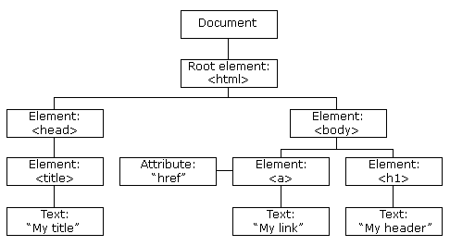
With a programmable object model, JavaScript gets all the power it needs to create dynamic HTML:
- JavaScript can change all the HTML elements in the page
- JavaScript can change all the HTML attributes in the page
- JavaScript can change all the CSS styles in the page
- JavaScript can react to all the events in the page

Ex.No: 1
Date:
Topic: Javascript Introduction
AIM:
To write HTML code to demonstrate javascript .
PROCEDURE:

PROGRAM:

OUTPUT:
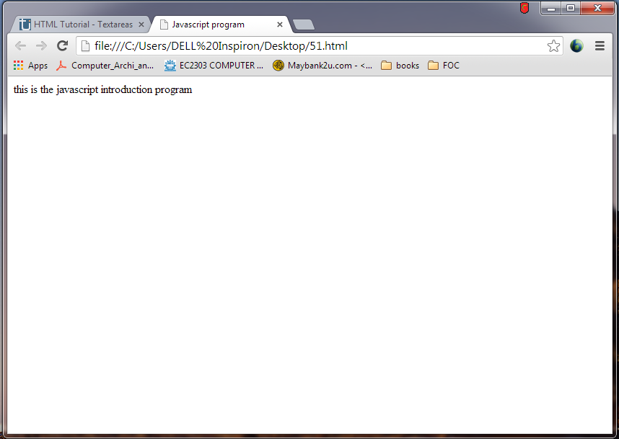

RESULT:
Thus the HTML code to demonstrate javascript was executed successfully.
Ex.No: 2
Date:
Topic: Javascript Location
AIM:
To write HTML code to demonstrate javascript location.
PROCEDURE:
Javascript location indicates when to indicate the message.
PROGRAM:

OUTPUT:
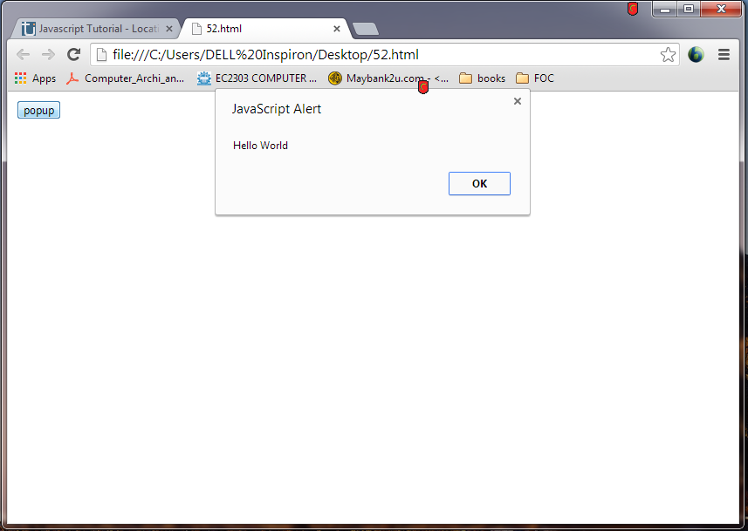

RESULT:
Thus the HTML code to demonstrate javascript location was executed successfully.
Ex.No: 3
Date:
Topic: Javascript External
AIM:
To write HTML code to demonstrate javascript location.
PROCEDURE:
Javascript External must satisfy two conditions.
- The file to be imported must be a javascript and only javascript.
- The file must have the extension “.js”
PROGRAM:

OUTPUT:
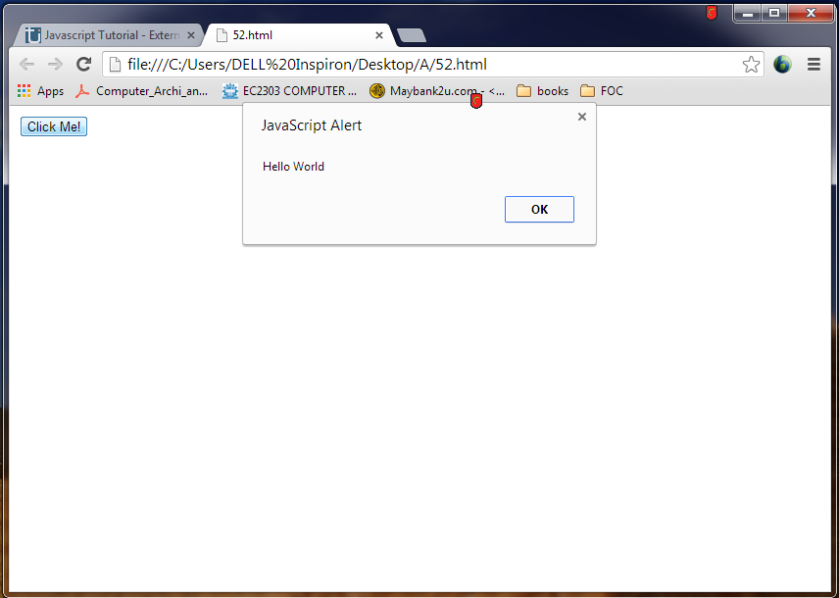

RESULT:
Thus the HTML code to demonstrate javascript external was executed successfully.
Ex.No: 4
Date:
Topic: Javascript operators
AIM:
To write HTML code to demonstrate javascript operators.
PROCEDURE:
Various operators are used by javascript. The conditional operator is “?:”
SYNTAX:
Condition?expression1:expression2
Where expression1 denotes the true condition and expression 2 denotes false condition.
PROGRAM:

OUTPUT:
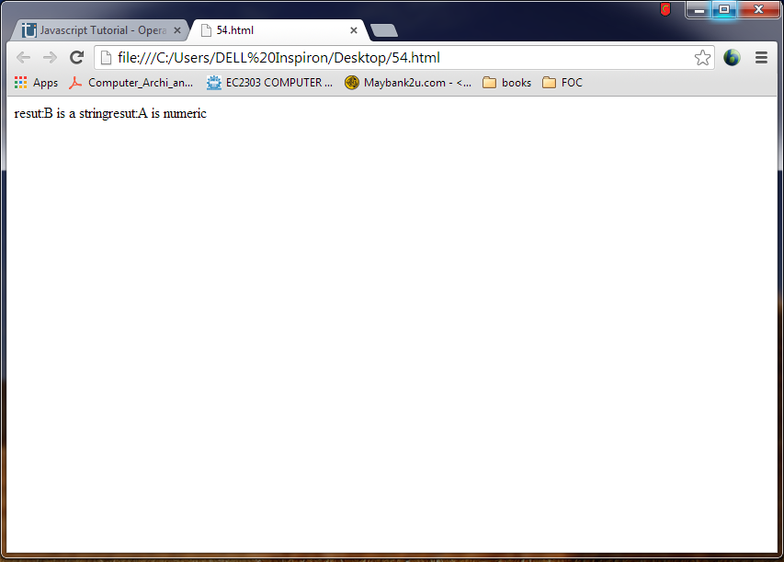

RESULT:
Thus the HTML code to demonstrate javascript operators was executed successfully.
Ex.No: 5
Date:
Topic: Javascript variables
AIM:
To write HTML code to demonstrate javascript variables
PROCEDURE:
In javascript variables are declared using the reserved word “var”. The value of this variable can be string, numeric or Boolean value.
SYNTAX:
Var variablename = value;
PROGRAM:

OUTPUT:
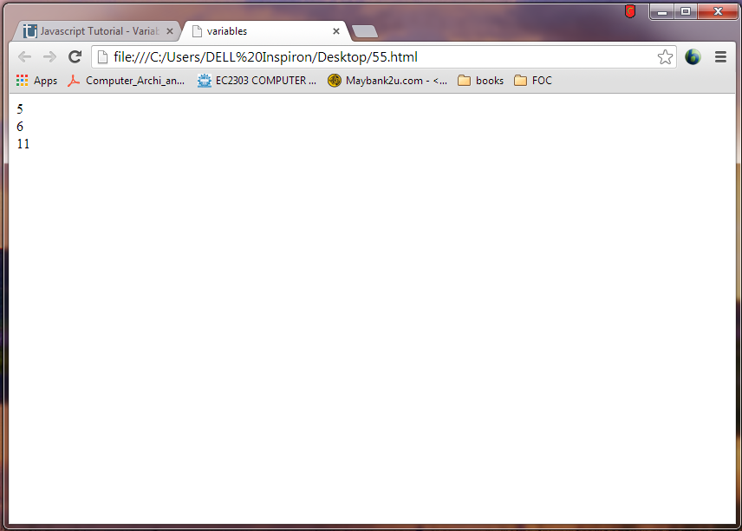

RESULT:
Thus the HTML code to demonstrate javascript variables was executed successfully.
Ex.No: 6
Date:
Topic: Javascript Events
AIM:
To write HTML code to demonstrate javascript events
PROCEDURE:
When an even to occurs, a specific action is performed as specified.
SYNTAX:
onclick = “any function;
PROGRAM:

OUTPUT:
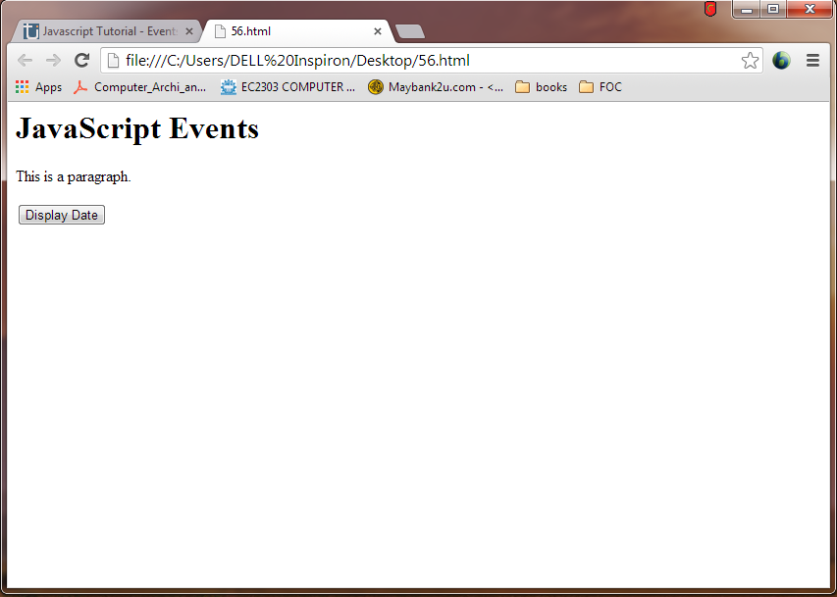
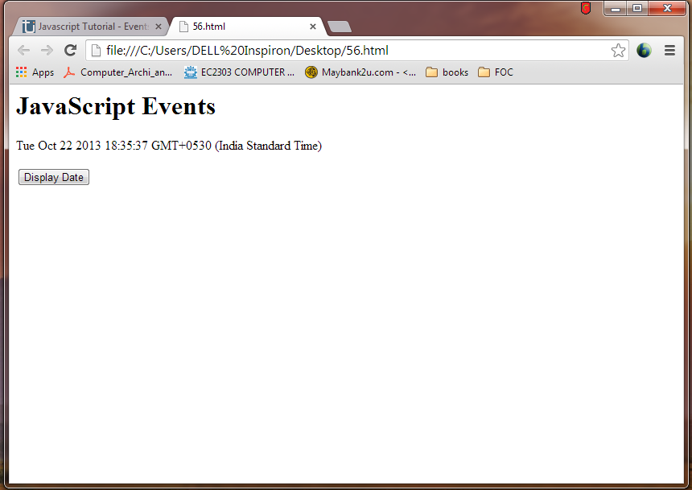
RESULT:
Thus the HTML code to demonstrate javascript events was executed successfully.
Ex.No: 7
Date:
Topic: Javascript if
AIM:
To write HTML code to demonstrate javascript if
PROCEDURE:
If statement is selection statement . If condition is true the statements following the if will be executed otherwise the else part will be executed.
SYNTAX:
If(condition)
Statement if the condition is true
PROGRAM:

OUTPUT:
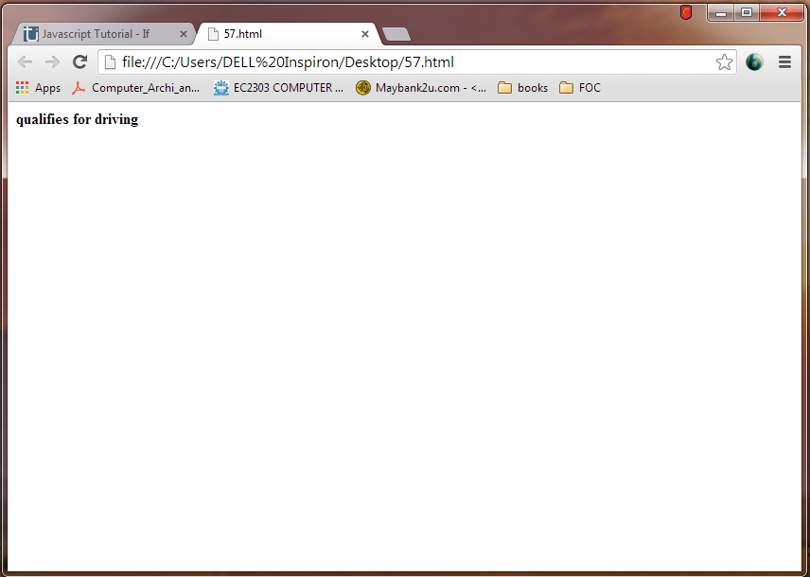

RESULT:
Thus the HTML code to demonstrate javascript if was executed successfully.
Ex.No: 8
Date:
Topic: Javascript Else if
AIM:
To write HTML code to demonstrate javascript else-if
PROCEDURE:
If the condition is true, if statement is executed otherwise else part will be executed.
SYNTAX:
If(condition)
{
Statement1;
}
Else
{
Statement2;
}
PROGRAM:

OUTPUT:
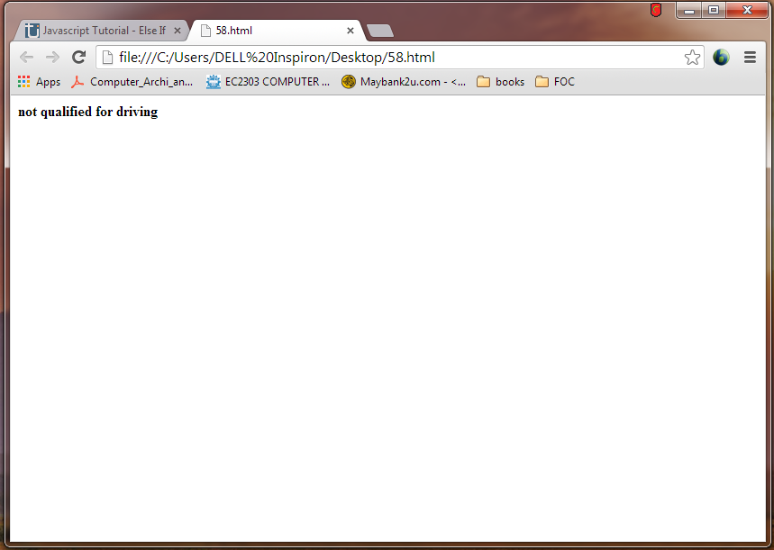

RESULT:
Thus the HTML code to demonstrate javascript else-if was executed successfully.
Ex.No: 9
Date:
Topic: Javascript while
AIM:
To write HTML code to demonstrate javascript while
PROCEDURE:
While statement helps in implementing the iterative logic of the program.
SYNTAX:
Some initial condition;
While(terminating condition)
{
Some statements;
Stepping condition;
}
PROGRAM:

OUTPUT:
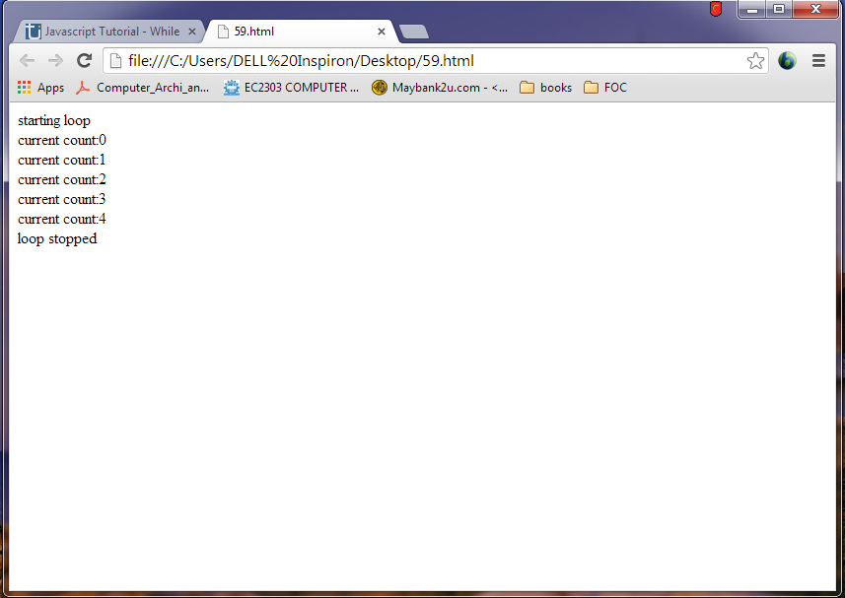

RESULT:
Thus the HTML code to demonstrate javascript while was executed successfully.
Ex.No: 10
Date:
Topic: Javascript-for
AIM:
To write HTML code to demonstrate javascript-for.
PROCEDURE:
Javascript for is the most commonly used programming construct. It has 3 parts,
- Initialisation
- Condition
- Incrementaion/decrementation
SYNTAX:
for (initial condition ; terminating condition ; stepping condition)
PROGRAM:

OUTPUT:

RESULT:
Thus the HTML code to demonstrate javascript for was executed successfully.
Ex.No: 11
Date:
Topic: Javascript Array
AIM:
To write HTML code to demonstrate javascript array.
PROCEDURE:
The array object allows to store multiple values in a single variable
The maximum length allowed for an array is 4, 294, 967, 295
SYNTAX:
Var array-name = new array(“value1”, “value2”,…..”valuen”);
PROGRAM:

OUTPUT:
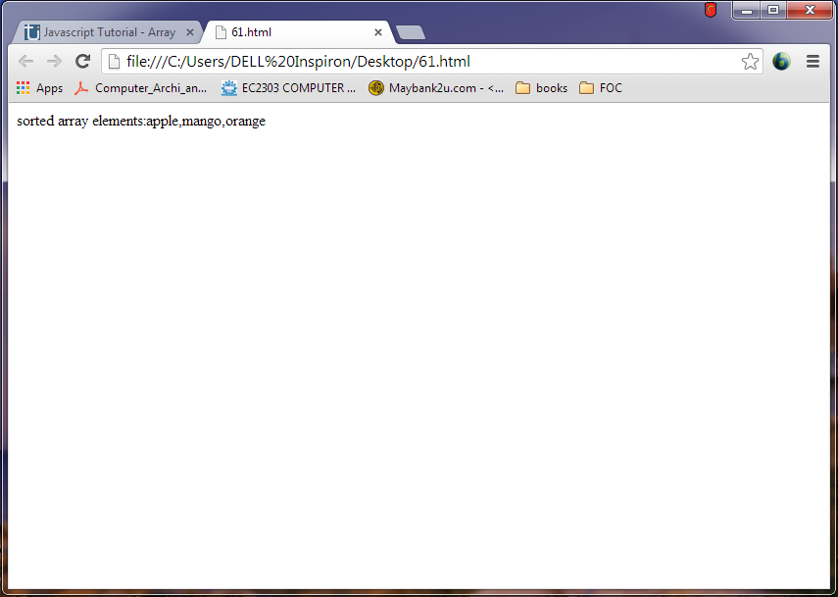

RESULT:
Thus the HTML code to demonstrate javascript array was executed successfully.
Ex.No: 12
Date:
Topic: Javascript Alert
AIM:
To write HTML code to demonstrate javascript alert
PROCEDURE:
The javascript alert is a dialogue box that pops up and takes the focus away from the current window and forces the web browser to see the alert message.
SYNTAX:
Var array-name = new array(“value1”, “value2”,…..”valuen”);
PROGRAM:

OUTPUT:
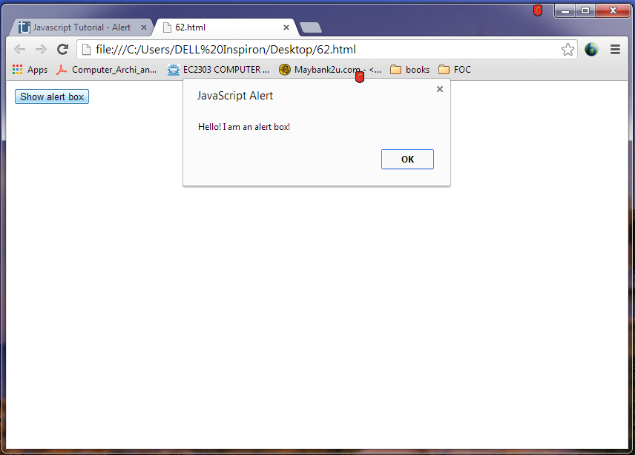

RESULT:
Thus the HTML code to demonstrate javascript alert was executed successfully.
Ex.No: 13
Date:
Topic: Javascript Confirm
AIM:
To write HTML code to demonstrate javascript confirm
PROCEDURE:
Confirm box is often used if we want the user to verify before accepting things
SYNTAX:
Confirm(“some text”);
PROGRAM:

OUTPUT:
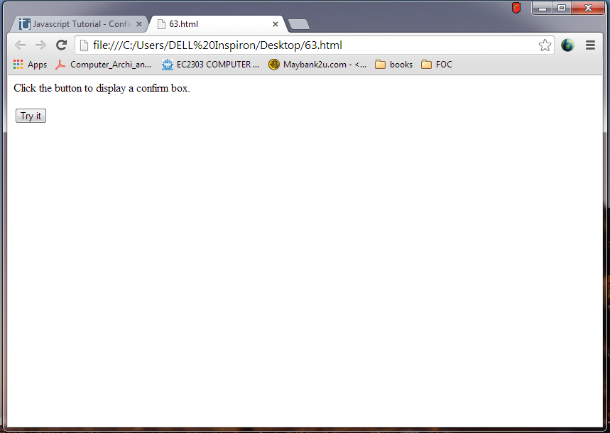
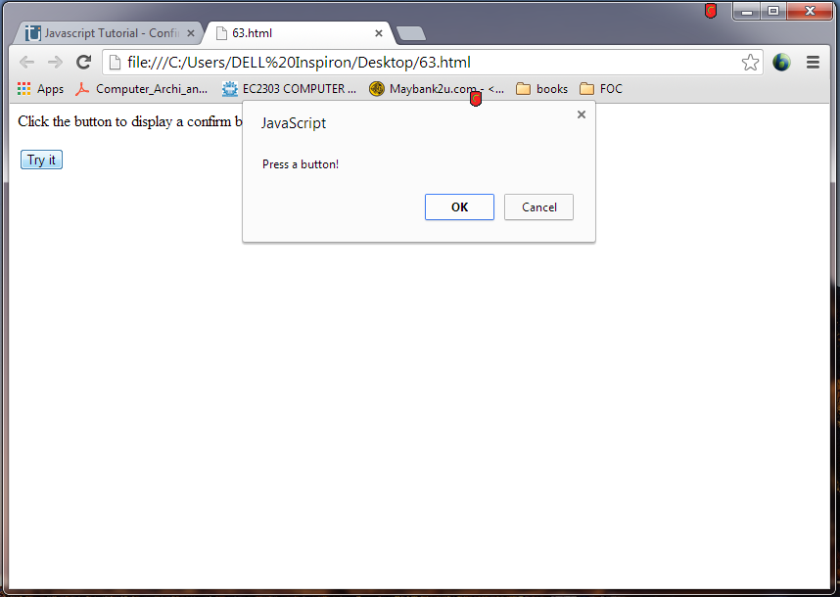
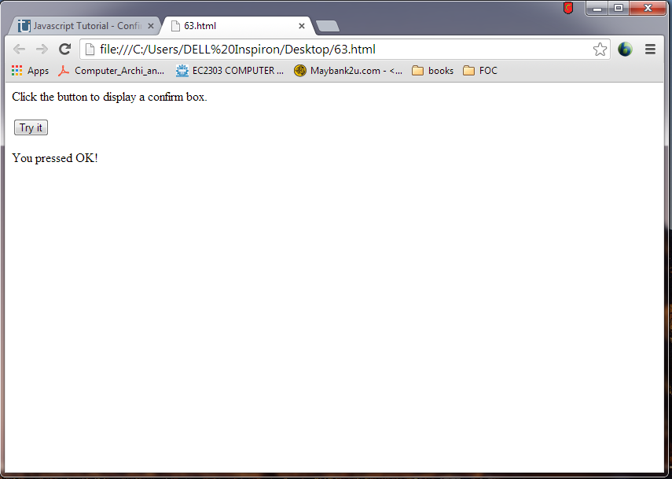
RESULT:
Thus the HTML code to demonstrate javascript confirm was executed successfully.
Ex.No: 14
Date:
Topic: Javascript Prompt
AIM:
To write HTML code to demonstrate javascript prompt
PROCEDURE:
Confirm box is often used if we want the user to verify before accepting things
SYNTAX:
Confirm(“some text”);
PROGRAM:

OUTPUT:
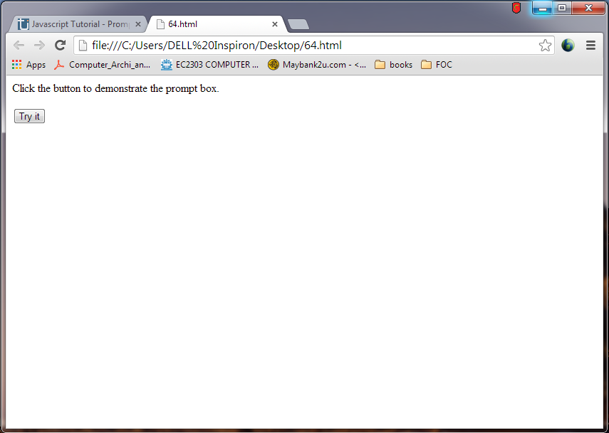
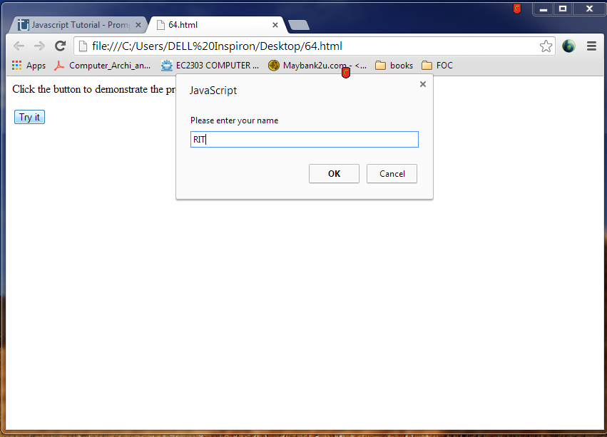
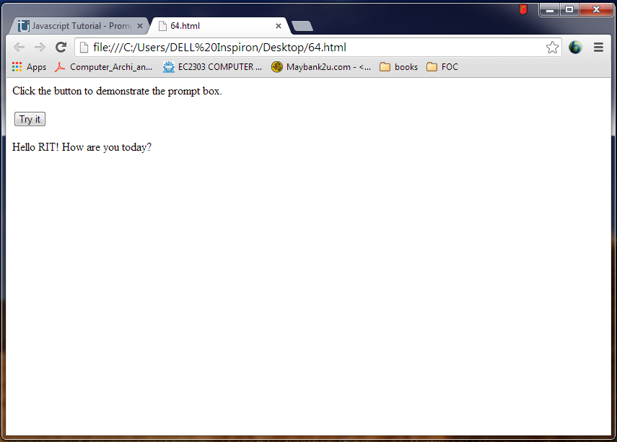
RESULT:
Thus the HTML code to demonstrate javascript prompt was executed successfully.
Ex.No: 15
Date:
Topic: Javascript Print
AIM:
To write HTML code to demonstrate javascript print
PROCEDURE:
Confirm box is often used if we want the user to verify before accepting things
SYNTAX:
Confirm(“some text”);
PROGRAM:

OUTPUT:
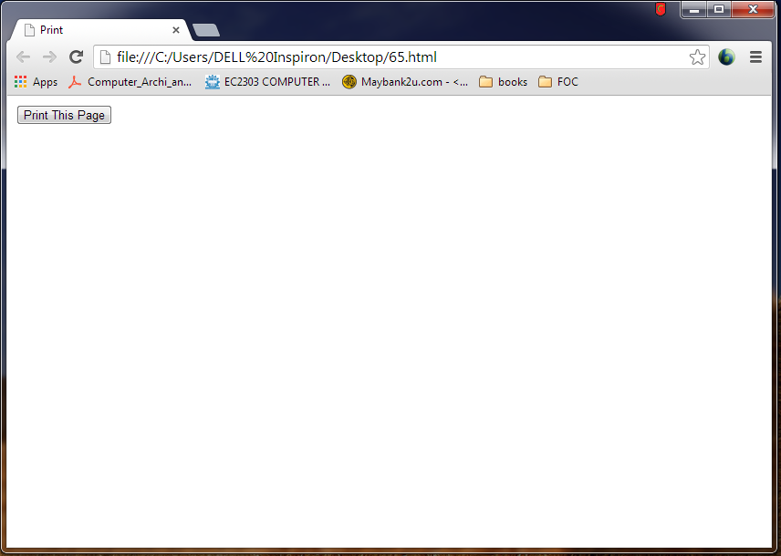
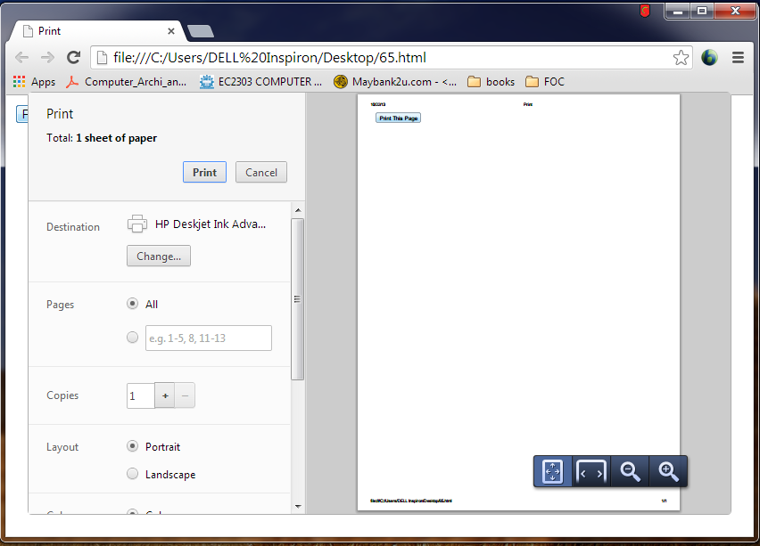

RESULT:
Thus the HTML code to demonstrate javascript print was executed successfully.

Ex.No: 16
Date:
Topic: Javascript Redirect
AIM:
To write HTML code to demonstrate javascript redirect
PROCEDURE:
Javascript redirect will redirect the web page into another web page after a particular amount of time.
SYNTAX:
Window.location(“some text”);
PROGRAM:

OUTPUT:
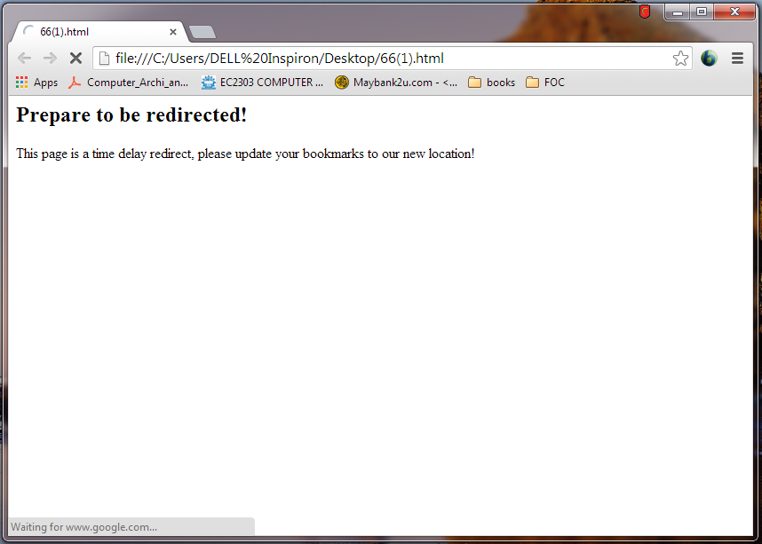
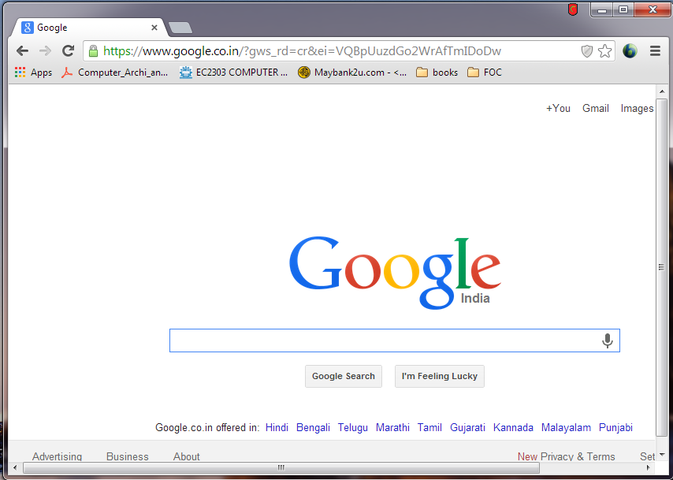
RESULT:
Thus the HTML code to demonstrate javascript redirect was executed successfully.
Ex.No: 17
Date:
Topic: Javascript Popup
AIM:
To write HTML code to demonstrate javascript popup
PROCEDURE:
Javascript popup creates a new browser window, customized to your specifications, without the use of an HTML anchor tag
SYNTAX:
Window.open(“some text”);
PROGRAM:

OUTPUT:
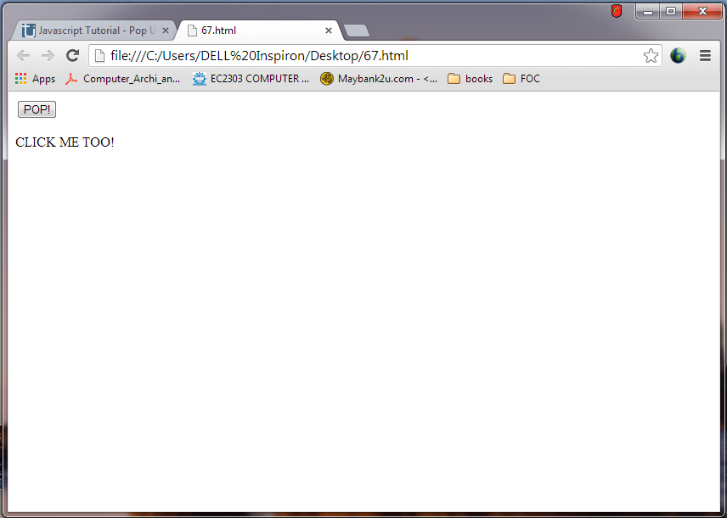
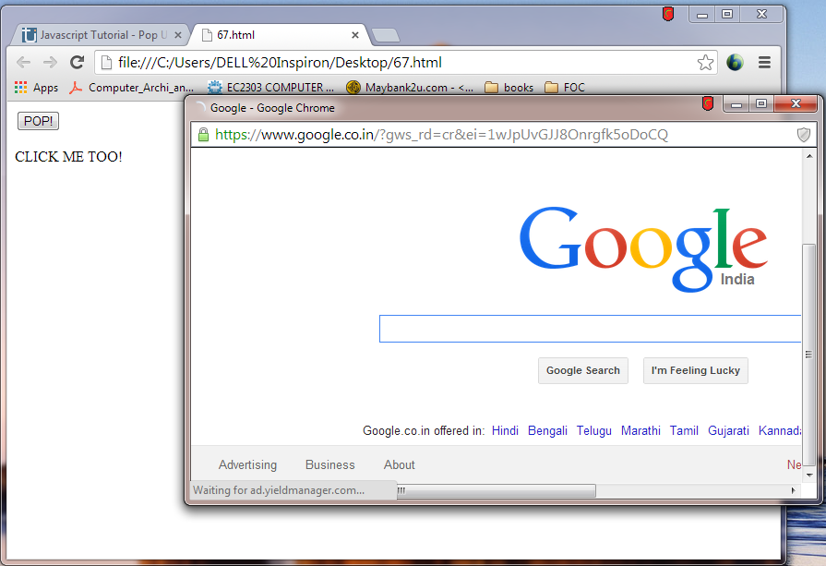

RESULT:
Thus the HTML code to demonstrate javascript popup was executed successfully.
Ex.No: 18
Date:
Topic: Javascript Date and clock
AIM:
To write HTML code to demonstrate javascript date and clock.
PROCEDURE:
Javascript date and clock displays the date and clock of the current usage.
SYNTAX:
getMonth(), getDate(), getHours(), getMinutes()
PROGRAM:

OUTPUT:
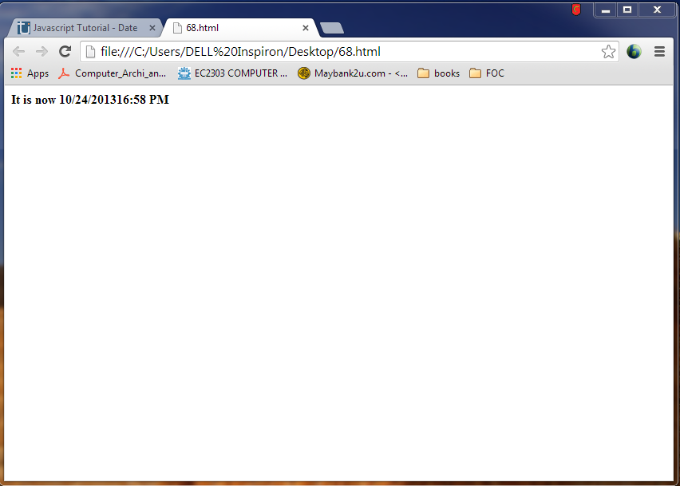
RESULT:
Thus the HTML code to demonstrate javascript date and clock was executed successfully.
Ex.No: 19
Date:
Topic: Javascript Form validation – Checking for non-empty
AIM:
To write HTML code to demonstrate javascript form validation – checking for non – empty.
PROCEDURE:
It provides a method to check the user entered information before they can ever submit it.
PROGRAM:

OUTPUT:
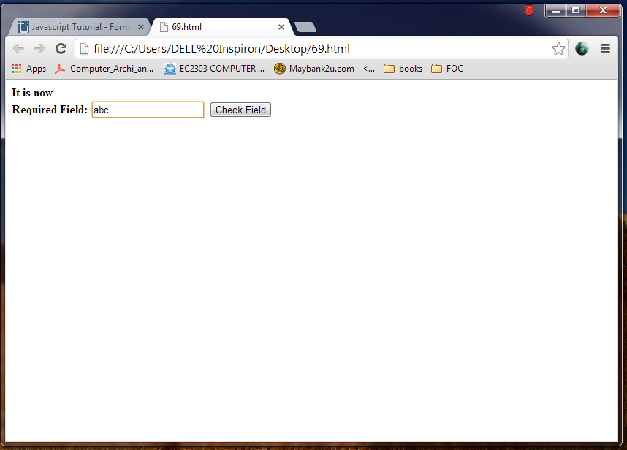

RESULT:
Thus the HTML code to demonstrate javascript form validation – checking for non – empty was executed successfully.

Ex.No: 20
Date:
Topic: Javascript Form validation – Checking for all numbers
AIM:
To write HTML code to demonstrate javascript form validation – checking for all numbers.
PROCEDURE:
It provides a entering a credit card number, phone number, zip code similar information you want to be able to ensure that the input is all numbers.
PROGRAM:

OUTPUT:
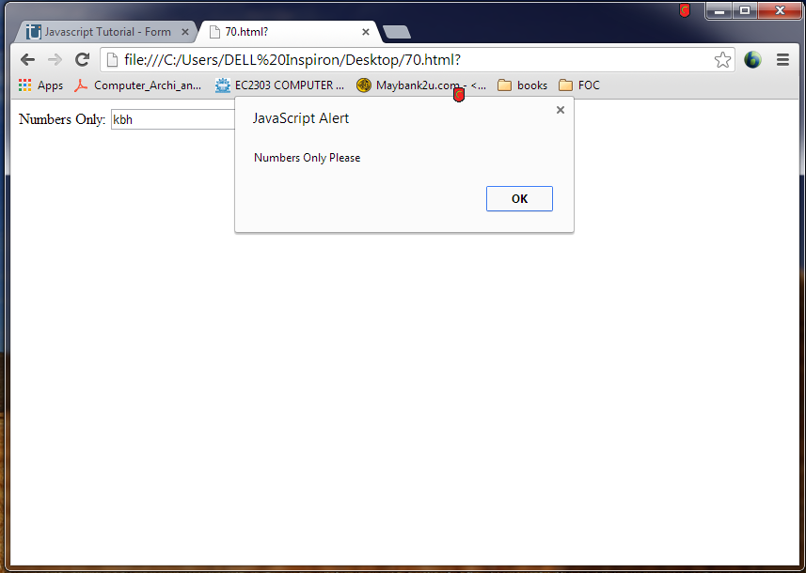
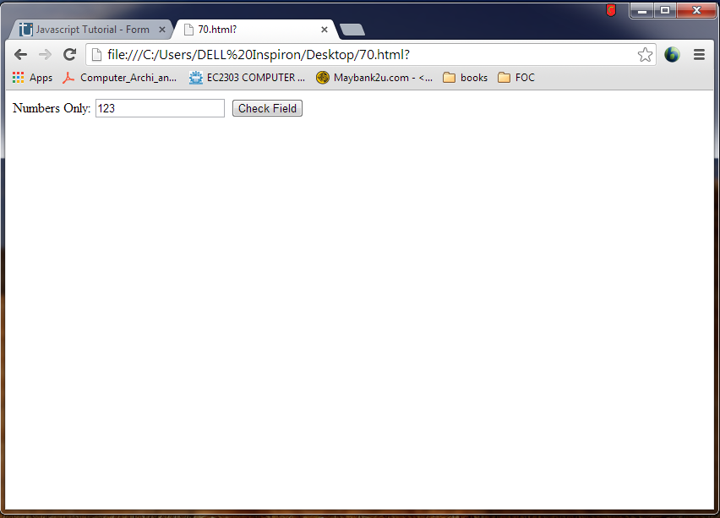

RESULT:
Thus the HTML code to demonstrate javascript form validation – checking for all numbers was executed successfully.
Ex.No: 21
Date:
Topic: Javascript Form validation – Checking for all letters
AIM:
To write HTML code to demonstrate javascript form validation – checking for all letters.
PROCEDURE:
This function will be identical to isNumeric except for the change to the regular expression we use inside the match function.
PROGRAM:

OUTPUT:
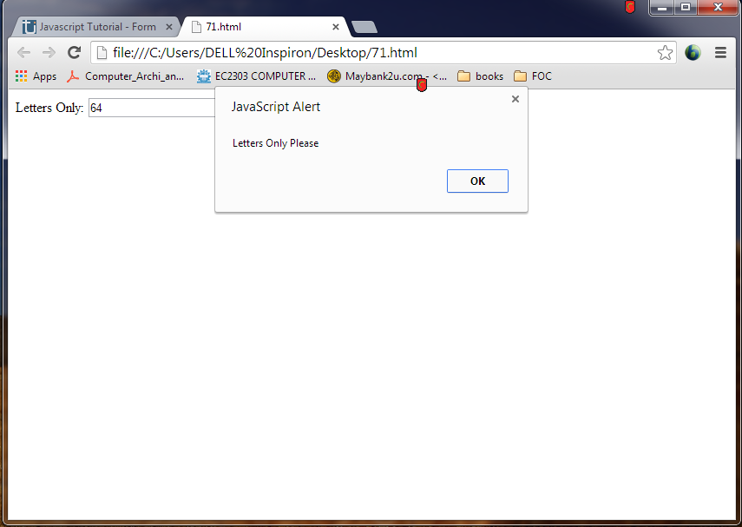
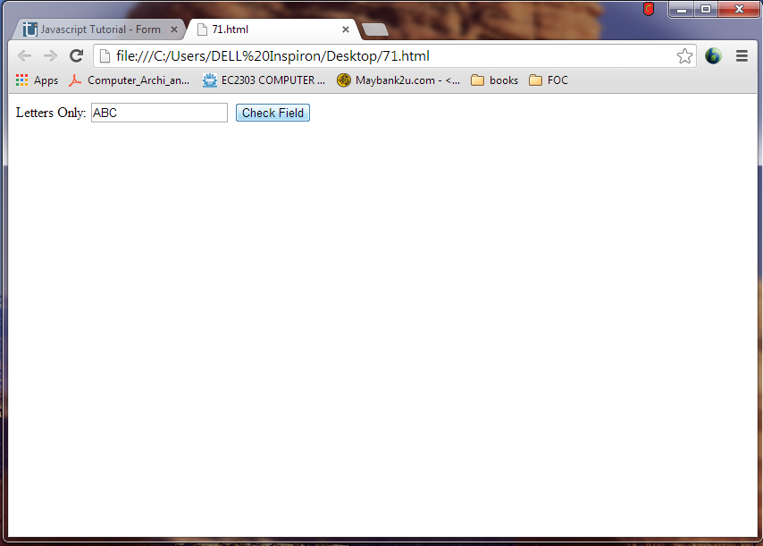
RESULT:
Thus the HTML code to demonstrate javascript form validation – checking for all letters was executed successfully.
Ex.No: 22
Date:
Topic: Javascript Form validation – Checking for all letters and numbers
AIM:
To write HTML code to demonstrate javascript form validation – checking for all letters and numbers.
PROCEDURE:
By combining both the isAlphabet and isNumeric functions into one we can check to see if a text input contains only letters and numbers.
PROGRAM:

OUTPUT:
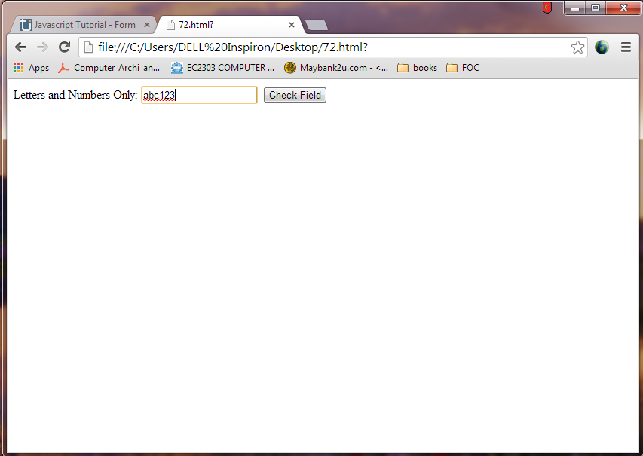

RESULT:
Thus the HTML code to demonstrate javascript form validation – checking for all letters and numbers was executed successfully.
Ex.No: 23
Date:
Topic: Javascript Form validation – Checking for length restriction
AIM:
To write HTML code to demonstrate javascript form validation – checking for length restriction PROCEDURE:
It restricts the number of characters a user can enter.
PROGRAM:

OUTPUT:
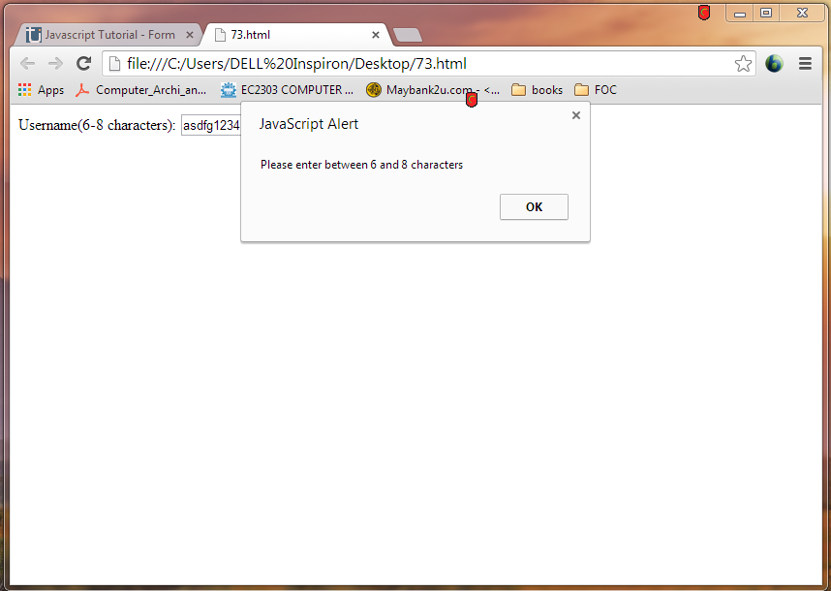

RESULT:
Thus the HTML code to demonstrate javascript form validation – checking for length restriction was executed successfully.
Ex.No: 24
Date:
Topic: Javascript Form validation – Checking for selection mode
AIM:
To write HTML code to demonstrate javascript form validation – checking for selection mode. PROCEDURE:
To be sure that someone has actually selected a choice from an HTML select input. By making the first option of your selected input something like “Please Choose” you can spur the user to both make a selection and allow you to check to see if the default option “Please Choose” is still selected when the submit form
PROGRAM:

OUTPUT:
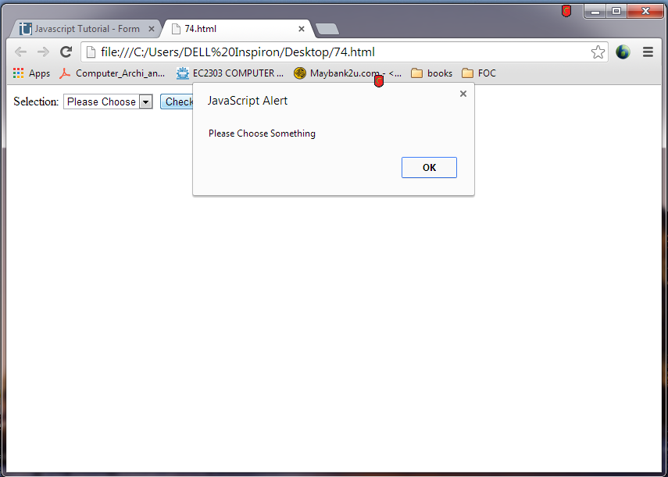

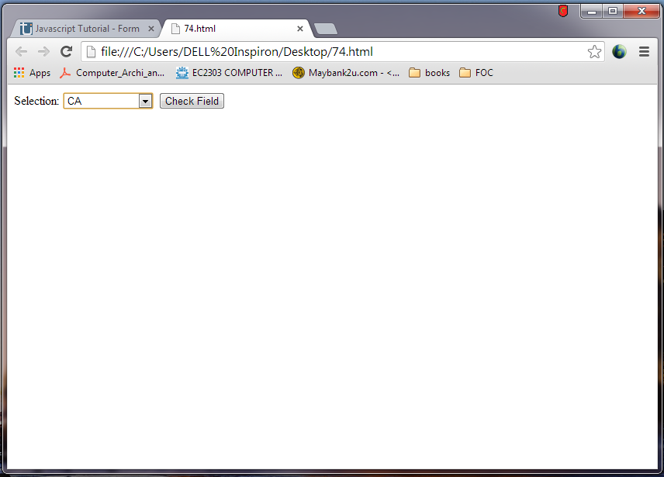

RESULT:
Thus the HTML code to demonstrate javascript form validation – checking for selection mode was executed successfully.
Ex.No: 25
Date:
Topic: Javascript Form validation – Checking for email validation
AIM:
To write HTML code to demonstrate javascript form validation – checking for email validation PROCEDURE:
Checking for valid email address
PROGRAM:

OUTPUT:
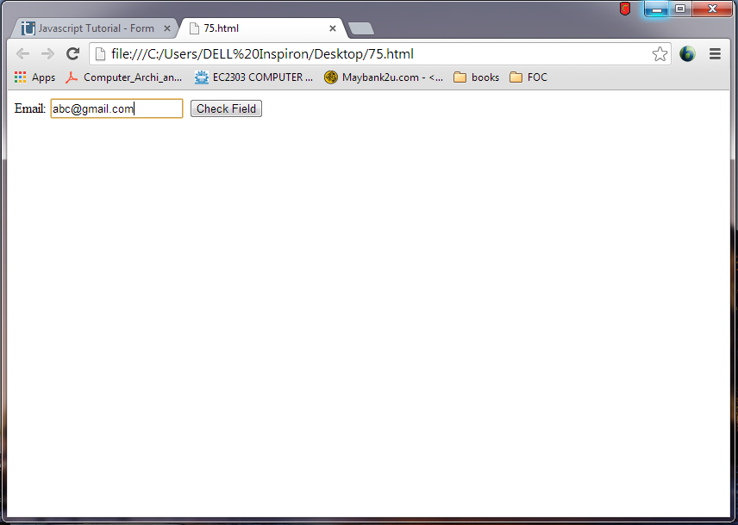

RESULT:
Thus the HTML code to demonstrate javascript form validation – checking for email validation was executed successfully.
Ex.No: 26
Date:
Topic: Validating Web Form
AIM:
To write HTML code for creating web page using forms.
PROCEDURE:
Form allows the user to input data on the web page. It is used to pass data to the server.
SYNTAX:
<form>
<input>
</form>
PROGRAM:

OUTPUT:
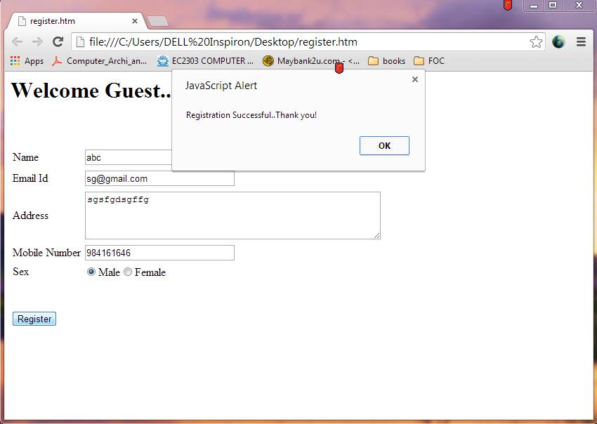

RESULT:
Thus the write HTML code for creating web page using forms was executed successfully.

OUTPUT:
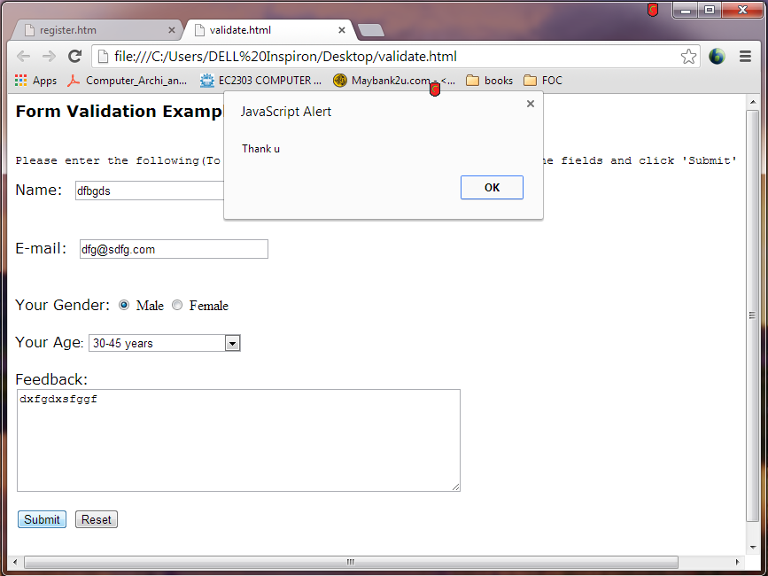

Ex.No: 27
Date:
Topic: Palette
AIM:
To set background and foreground of the control text area b selecting a color from the color palette.
PROCEDURE:
Create a palette that extends to Applet.
Create a foreground and background and panel set layout.
Assign color to each background.
PROGRAM:

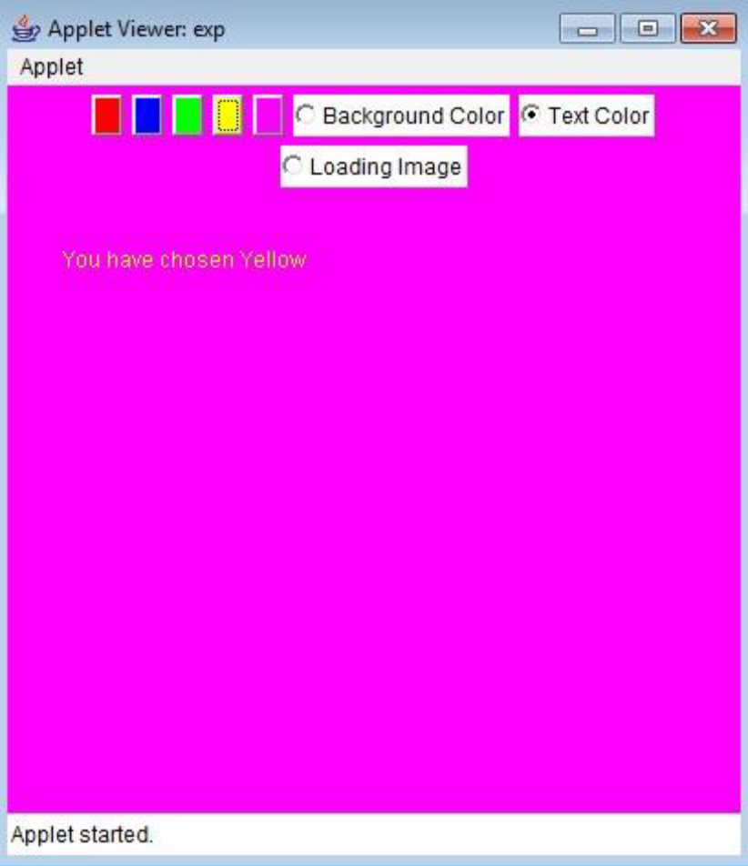

(or)

OUTPUT:

RESULT:
Thus the program to implement palette was executed successfully.

