RAJALAKSHMI INSTITUTE OF TECHNOLOGY
DEPARTMENT OF INFORMATION TECHNOLOGY
IT-6512
WEB PROGRAMMING
WORKBOOK AND LAB MANUAL

Name of the Student :
Roll No :
Class :

Servlet Tutorial

Servlet technology is used to create web application (resides at server side and generates dynamic web page).
Servet technology is robust and scalable as it uses the java language. Before Servlet, CGI (Common Gateway Interface) scripting language was used as a server-side programming language. But there were many disadvantages of this technology. We have discussed these disadvantages below.
There are many interfaces and classes in the servlet API such as Servlet, GenericServlet, HttpServlet, ServletRequest, ServletResponse etc.

What is a Servlet?
Servlet can be described in many ways, depending on the context.
- Servlet is a technology i.e. used to create web application.
- Servlet is an API that provides many interfaces and classes including documentations.
- Servlet is an interface that must be implemented for creating any servlet.
- Servlet is a class that extend the capabilities of the servers and respond to the incoming request. It can respond to any type of requests.
- Servlet is a web component that is deployed on the server to create dynamic web page.
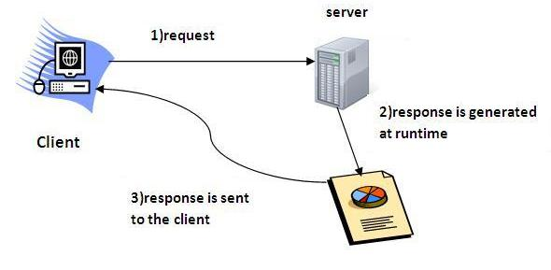

What is web application?
A web application is an application accessible from the web. A web application is composed of web components like Servlet, JSP, Filter etc. and other components such as HTML. The web components typically execute in Web Server and respond to HTTP request.

CGI(Commmon Gateway Interface)
CGI technology enables the web server to call an external program and pass HTTP request information to the external program to process the request. For each request, it starts a new process.
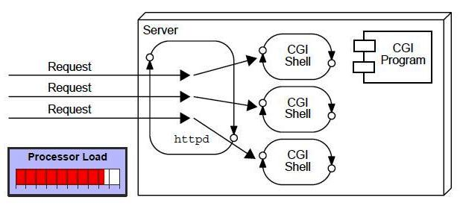

Disadvantages of CGI
There are many problems in CGI technology:
- If number of clients increases, it takes more time for sending response.
- For each request, it starts a process and Web server is limited to start processes.
- It uses platform dependent language e.g. C, C++, perl.

Advantage of Servlet
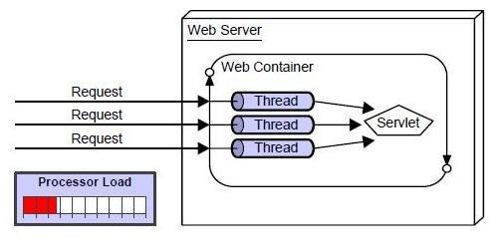
There are many advantages of Servlet over CGI. The web container creates threads for handling the multiple requests to the servlet. Threads have a lot of benefits over the Processes such as they share a common memory area, lighweight, cost of communication between the threads are low. The basic benefits of servlet are as follows:
- better performance: because it creates a thread for each request not process.
- Portability: because it uses java language.
- Robust: Servlets are managed by JVM so no need to worry about momory leak, garbage collection etc.
- Secure: because it uses java language..

Servlet API
The javax.servlet and javax.servlet.http packages represent interfaces and classes for servlet api. Let's see what are the interfaces of javax.servlet package.

Interfaces in javax.servlet package
There are many interfaces in javax.servlet package. They are as follows:
- Servlet
- ServletRequest
- ServletResponse
- RequestDispatcher
- ServletConfig
- ServletContext
- SingleThreadModel
- Filter
- FilterConfig
- FilterChain
- ServletRequestListener
- ServletRequestAttributeListener
- ServletContextListener
- ServletContextAttributeListener

Classes in javax.servlet package
There are many classes in javax.servlet package. They are as follows:
- GenericServlet
- ServletInputStream
- ServletOutputStream
- ServletRequestWrapper
- ServletResponseWrapper
- ServletRequestEvent
- ServletContextEvent
- ServletRequestAttributeEvent
- ServletContextAttributeEvent
- ServletException
- UnavailableException

Interfaces in javax.servlet.http package
There are many interfaces in javax.servlet.http package. They are as follows:
- HttpServletRequest
- HttpServletResponse
- HttpSession
- HttpSessionListener
- HttpSessionAttributeListener
- HttpSessionBindingListener
- HttpSessionActivationListener
- HttpSessionContext (deprecated now)

Classes in javax.servlet.http package
There are many classes in javax.servlet.http package. They are as follows:
- HttpServlet
- Cookie
- HttpServletRequestWrapper
- HttpServletResponseWrapper
- HttpSessionEvent
- HttpSessionBindingEvent
- HttpUtils (deprecated now)

Servlet Interface
Servlet interface provides common behaviour to all the servlets.
Servlet interface needs to be implemented for creating any servlet (either directly or indirectly). It provides 3 life cycle methods that are used to initialize the servlet, to service the requests, and to destroy the servlet and 2 non-life cycle methods.

Methods of Servlet interface
There are 5 methods in Servlet interface. The init, service and destroy are the life cycle methods of servlet. These are invoked by the web container.
Method | Description
public void init(ServletConfig config) | initializes the servlet. It is the life cycle method of servlet and invoked by the web container only once.
public void service(ServletRequest request,ServletResponse response) | provides response for the incoming request. It is invoked at each request by the web container.
public void destroy() | is invoked only once and indicates that servlet is being destroyed.
public ServletConfig getServletConfig() | returns the object of ServletConfig.
public String getServletInfo() | returns information about servlet such as writer, copyright, version etc.

Servlet Example by implementing Servlet interface
Let's see the simple example of servlet by implementing the servlet interface.
File: First.java
- import java.io.*;
- import javax.servlet.*;

- public class First implements Servlet{
- ServletConfig config=null;

- public void init(ServletConfig config){
- this.config=config;
- System.out.println("servlet is initialized");
- }

- public void service(ServletRequest req,ServletResponse res)
- throws IOException,ServletException{

- res.setContentType("text/html");

- PrintWriter out=res.getWriter();
- out.print("<html><body>");
- out.print("<b>hello simple servlet</b>");
- out.print("</body></html>");

- }
- public void destroy(){System.out.println("servlet is destroyed");}
- public ServletConfig getServletConfig(){return config;}
- public String getServletInfo(){return "copyright 2007-1010";}

- }

GenericServlet class
GenericServlet class implements Servlet,ServletConfig and Serializable interfaces. It provides the implementaion of all the methods of these interfaces except the service method.
GenericServlet class can handle any type of request so it is protocol-independent.
You may create a generic servlet by inheriting the GenericServlet class and providing the implementation of the service method.

Methods of GenericServlet class
There are many methods in GenericServlet class. They are as follows:
- public void init(ServletConfig config) is used to initialize the servlet.
- public abstract void service(ServletRequest request, ServletResponse response) provides service for the incoming request. It is invoked at each time when user requests for a servlet.
- public void destroy() is invoked only once throughout the life cycle and indicates that servlet is being destroyed.
- public ServletConfig getServletConfig() returns the object of ServletConfig.
- public String getServletInfo() returns information about servlet such as writer, copyright, version etc.
- public void init() it is a convenient method for the servlet programmers, now there is no need to call super.init(config)
- public ServletContext getServletContext() returns the object of ServletContext.
- public String getInitParameter(String name) returns the parameter value for the given parameter name.
- public Enumeration getInitParameterNames() returns all the parameters defined in the web.xml file.
- public String getServletName() returns the name of the servlet object.
- public void log(String msg) writes the given message in the servlet log file.
- public void log(String msg,Throwable t) writes the explanatory message in the servlet log file and a stack trace.

Servlet Example by inheriting the GenericServlet class
Let's see the simple example of servlet by inheriting the GenericServlet class.
File: First.java
- import java.io.*;
- import javax.servlet.*;

- public class First extends GenericServlet{
- public void service(ServletRequest req,ServletResponse res)
- throws IOException,ServletException{

- res.setContentType("text/html");

- PrintWriter out=res.getWriter();
- out.print("<html><body>");
- out.print("<b>hello generic servlet</b>");
- out.print("</body></html>");

- }
- }

HttpServlet class
The HttpServlet class extends the GenericServlet class and implements Serializable interface. It provides http specific methods such as doGet, doPost, doHead, doTrace etc.

Methods of HttpServlet class
There are many methods in HttpServlet class. They are as follows:
- public void service(ServletRequest req,ServletResponse res) dispatches the request to the protected service method by converting the request and response object into http type.
- protected void service(HttpServletRequest req, HttpServletResponse res) receives the request from the service method, and dispatches the request to the doXXX() method depending on the incoming http request type.
- protected void doGet(HttpServletRequest req, HttpServletResponse res) handles the GET request. It is invoked by the web container.
- protected void doPost(HttpServletRequest req, HttpServletResponse res) handles the POST request. It is invoked by the web container.
- protected void doHead(HttpServletRequest req, HttpServletResponse res) handles the HEAD request. It is invoked by the web container.
- protected void doOptions(HttpServletRequest req, HttpServletResponse res) handles the OPTIONS request. It is invoked by the web container.
- protected void doPut(HttpServletRequest req, HttpServletResponse res) handles the PUT request. It is invoked by the web container.
- protected void doTrace(HttpServletRequest req, HttpServletResponse res) handles the TRACE request. It is invoked by the web container.
- protected void doDelete(HttpServletRequest req, HttpServletResponse res) handles the DELETE request. It is invoked by the web container.
- protected long getLastModified(HttpServletRequest req) returns the time when HttpServletRequest was last modified since midnight January 1, 1970 GMT.

Life Cycle of a Servlet (Servlet Life Cycle)
The web container maintains the life cycle of a servlet instance. Let's see the life cycle of the servlet:
- Servlet class is loaded.
- Servlet instance is created.
- init method is invoked.
- service method is invoked.
- destroy method is invoked.
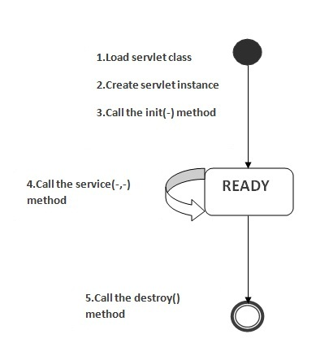
As displayed in the above diagram, there are three states of a servlet: new, ready and end. The servlet is in new state if servlet instance is created. After invoking the init() method, Servlet comes in the ready state. In the ready state, servlet performs all the tasks. When the web container invokes the destroy() method, it shifts to the end state.

1) Servlet class is loaded
The classloader is responsible to load the servlet class. The servlet class is loaded when the first request for the servlet is received by the web container.

2) Servlet instance is created
The web container creates the instance of a servlet after loading the servlet class. The servlet instance is created only once in the servlet life cycle.

3) init method is invoked
The web container calls the init method only once after creating the servlet instance. The init method is used to initialize the servlet. It is the life cycle method of the javax.servlet.Servlet interface. Syntax of the init method is given below:
- public void init(ServletConfig config) throws ServletException

4) service method is invoked
The web container calls the service method each time when request for the servlet is received. If servlet is not initialized, it follows the first three steps as described above then calls the service method. If servlet is initialized, it calls the service method. Notice that servlet is initialized only once. The syntax of the service method of the Servlet interface is given below:
- public void service(ServletRequest request, ServletResponse response)
- throws ServletException, IOException

5) destroy method is invoked
The web container calls the destroy method before removing the servlet instance from the service. It gives the servlet an opportunity to clean up any resource for example memory, thread etc. The syntax of the destroy method of the Servlet interface is given below:
- public void destroy()

Steps to create the servlet using Tomcat server
There are five steps to create a servlet. These stepse are required for all the servers. We are using apache tomcat server in this example. The steps are as follows:
- Create a directory structure
- Create a Servlet
- Compile the Servlet
- Create a deployment descriptor
- Start the server and deploy the application

1)Create a directory structures
The directory structure defines that where to put the different types of files so that web container may get the information and respond to the client. The Sun Microsystem defines a unique standard to be followed by all the server vendors. Let's see the directory structure that must be followed to create the servlet.
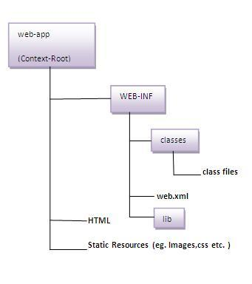
As you can see that the servlet class file must be in the classes folder. The web.xml file must be under the WEB-INF folder.

2)Create a Servlet
There are three ways to create the servlet.
- By implementing the Servlet interface
- By inheriting the GenericServlet class
- By inheriting the HttpServlet class
The HttpServlet class is widely used to create the servlet because it provides methods to handle http requests such as doGet(), doPost, doHead() etc.
In this example we are going to create a servlet that extends the HttpServlet class. In this example, we are inheriting the HttpServlet class and providing the implementation of the doGet() method. Notice that get request is the default request.
DemoServlet.java
- import javax.servlet.http.*;
- import javax.servlet.*;
- import java.io.*;
- public class DemoServlet extends HttpServlet{
- public void doGet(HttpServletRequest req,HttpServletResponse res)
- throws ServletException,IOException
- {
- res.setContentType("text/html");//setting the content type
- PrintWriter pw=res.getWriter();//get the stream to write the data

- //writing html in the stream
- pw.println("<html><body>");
- pw.println("Welcome to servlet");
- pw.println("</body></html>");

- pw.close();//closing the stream
- }}

3)Compile the servlet
For compiling the Servlet, jar file is required to be loaded. Different Servers provide different jar files:

Jar file | Server
1) servlet-api.jar | Apache Tomacat
2) weblogic.jar | Weblogic
3) javaee.jar | Glassfish
4) javaee.jar | JBoss

Two ways to load the jar file
- set classpath
- paste the jar file in JRE/lib/ext folder
Put the java file in any folder. After compiling the java file paste the class file of servlet in WEB-INF/classes folder.

4)Create the deployment descriptor:
The deployment descriptor is an xml file, from which Web Container gets the information about the servet to be invoked. The web container uses the Parser to get the information from the web.xml file. There are many xml parsers such as SAX, DOM and Pull. There are many elements in the web.xml file. Here is given some necessary elements to run the simple servlet.
web.xml file
- <web-app>

- <servlet>
- <servlet-name>sonoojaiswal</servlet-name>
- <servlet-class>DemoServlet</servlet-class>
- </servlet>

- <servlet-mapping>
- <servlet-name>sonoojaiswal</servlet-name>
- <url-pattern>/welcome</url-pattern>
- </servlet-mapping>

- </web-app>

Description of the elements of web.xml file
There are too many elements in the web.xml file. Here is the illustration of some elements that is used in the above web.xml file. The elements are as follows:

<web-app> represents the whole application.
<servlet> is sub element of <web-app> and represents the servlet.
<servlet-name> is sub element of <servlet> represents the name of the servlet.
<servlet-class> is sub element of <servlet> represents the class of the servlet.
<servlet-mapping> is sub element of <web-app>. It is used to map the servlet.
<url-pattern> is sub element of <servlet-mapping>. This pattern is used at client side to invoke the servlet.

5)Start the Server
To start Apache Tomcat server, double click on the startup.bat file under apachetomcat/bin folder.

What to do if I start the tomcat server first time?
To start Apache Tomcat server JAVA_HOME and JRE_HOME must be set in Environment variables.
Go to My Computer properties->Click on advanced tab then environment variables->Click on the new tab of user variable->Write JAVA_HOME in variable name and paste the path of jdk folder in variable value->ok->ok->ok
Go to My Computer properties:
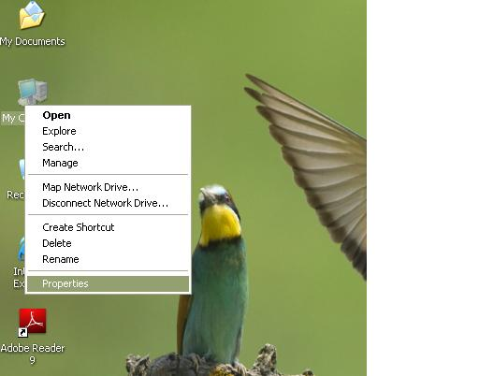
Click on advanced tab then environment variables:
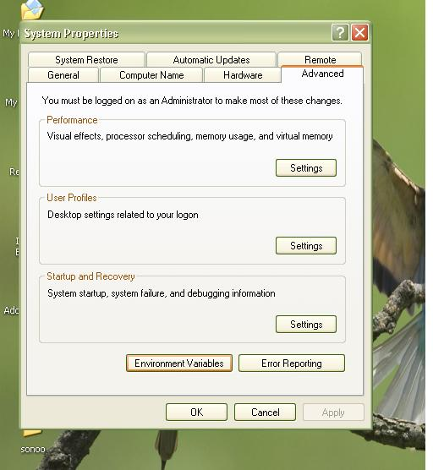
Click on the new tab of user variable:
Write JAVA_HOME in variable name and paste the path of jdk folder in variable value:
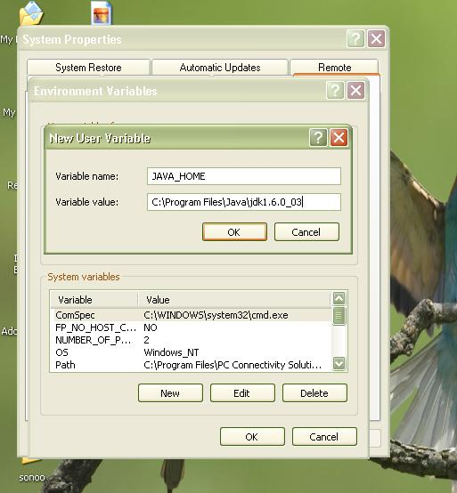

After setting the JAVA_HOME double click on the startup.bat file in apache tomcat/bin.
Note: There are two types of tomcat available:
- Apache tomcat that needs to extract only (no need to install)
- Apache tomcat that needs to install
It is the example of apache tomcat that needs to extract only.
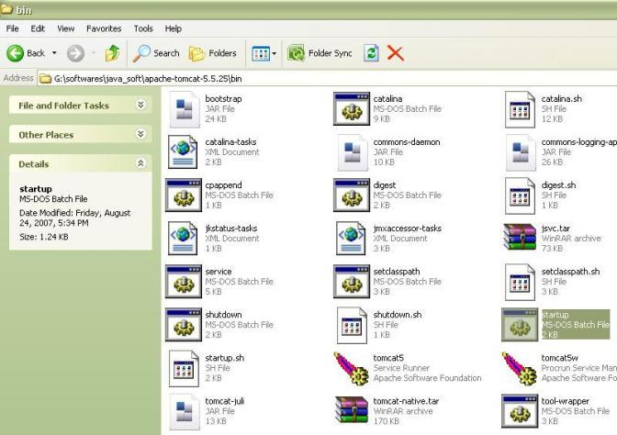
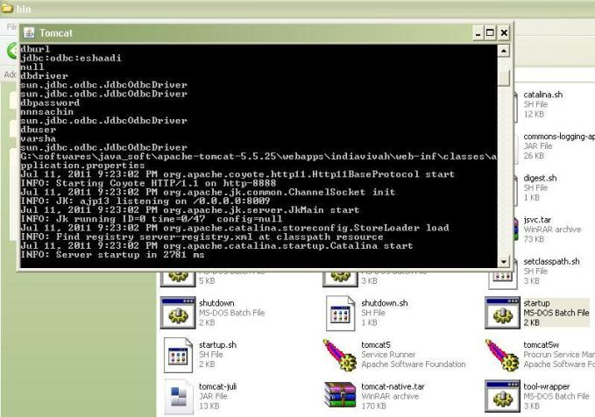

Now server is started successfully.

How to change port number of apache tomcat
Changing the port number is required if there is another server running on the same system with same port number.Suppose you have installed oracle, you need to change the port number of apache tomcat because both have the default port number 8080.
Open server.xml file in notepad under apache-tomcat/conf folder . Change the Connector port = 8080 and replace 8080 by any four digit number instead of 8080. Let us replace it by 8888 and save this file.

How to deploy the your project
Copy the project and paste it in the webapps folder under apache tomcat.
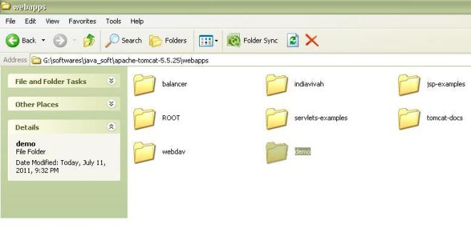
There are several ways to deploy the project. The are:
- By copying the context(project) folder into the webapps directory
- By copying the war folder into the webapps directory
- By selecting the folder path from the server
- By selecting the war file from the server
- projectfolder><strong> jar cvf myproject.war *</strong>
Creating war file has an advantage that moving the project from one location to another takes less time.

How to access the servlet
open broser and write http://hostname:portno/contextroot/urlpattern
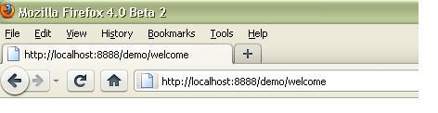

How Servlet works?
It is important to learn how servlet works for understanding the servlet well. Here, we are going to get the internal detail about the first servlet program.
The server checks if the servlet is requested for the first time.
If yes, web container does the following tasks:
- loads the servlet class.
- instantiates the servlet class.
- calls the init method passing the ServletConfig object
else
- calls the service method passing request and response objects
The web container calls the destroy method when it needs to remove the servlet such as at time of stopping server or undeploying the project.

How web container handles the servlet request?
The web container is responsible to handle the request. Let's see how it handles the request.
- maps the request with the servlet in the web.xml file.
- creates request and response objects for this request
- calls the service method on the thread
- The public service method internally calls the protected service method
- The protected service method calls the doGet method depending on the type of request.
- The doGet method generates the response and it is passed to the client.
- After sending the response, the web container deletes the request and response objects. The thread is contained in the thread pool or deleted depends on the server implementation.

What is written inside the public service method?
The public service method converts the ServletRequest object into the HttpServletRequest type and ServletResponse object into the HttpServletResponse type. Then, calls the service method passing these objects. Let's see the internal code:
- public void service(ServletRequest req, ServletResponse res)
- throws ServletException, IOException
- {
- HttpServletRequest request;
- HttpServletResponse response;
- try
- {
- request = (HttpServletRequest)req;
- response = (HttpServletResponse)res;
- }
- catch(ClassCastException e)
- {
- throw new ServletException("non-HTTP request or response");
- }
- service(request, response);
- }

What is written inside the protected service method?
The protected service method checks the type of request, if request type is get, it calls doGet method, if request type is post, it calls doPost method, so on. Let's see the internal code:
- protected void service(HttpServletRequest req, HttpServletResponse resp)
- throws ServletException, IOException
- {
- String method = req.getMethod();
- if(method.equals("GET"))
- {
- long lastModified = getLastModified(req);
- if(lastModified == -1L)
- {
- doGet(req, resp);
- }
- ....
- //rest of the code
- }
- }

ServletRequest Interface
- ServletRequest Interface
- Methods of ServletRequest interface
- Example of ServletRequest interface
- Displaying all the header information
An object of ServletRequest is used to provide the client request information to a servlet such as content type, content length, parameter names and values, header informations, attributes etc.

Methods of ServletRequest interface
There are many methods defined in the ServletRequest interface. Some of them are as follows:
Method | Description
public String getParameter(String name) | is used to obtain the value of a parameter by name.
public String[] getParameterValues(String name) | returns an array of String containing all values of given parameter name. It is mainly used to obtain values of a Multi select list box.
java.util.Enumeration getParameterNames() | returns an enumeration of all of the request parameter names.
public int getContentLength() | Returns the size of the request entity data, or -1 if not known.
public String getCharacterEncoding() | Returns the character set encoding for the input of this request.
public String getContentType() | Returns the Internet Media Type of the request entity data, or null if not known.
public ServletInputStream getInputStream() throws IOException | Returns an input stream for reading binary data in the request body.
public abstract String getServerName() | Returns the host name of the server that received the request.
public int getServerPort() | Returns the port number on which this request was received.

Example of ServletRequest to display the name of the user
In this example, we are displaying the name of the user in the servlet. For this purpose, we have used the getParameter method that returns the value for the given request parameter name.
index.html
- <form action="welcome" method="get">
- Enter your name<input type="text" name="name"><br>
- <input type="submit" value="login">
- </form>
DemoServ.java
- import javax.servlet.http.*;
- import javax.servlet.*;
- import java.io.*;
- public class DemoServ extends HttpServlet{
- public void doGet(HttpServletRequest req,HttpServletResponse res)
- throws ServletException,IOException
- {
- res.setContentType("text/html");
- PrintWriter pw=res.getWriter();

- String name=req.getParameter("name");//will return value
- pw.println("Welcome "+name);

- pw.close();
- }}

RequestDispatcher Interface
The RequestDispacher interface provides the facility of dispatching the request to another resource it may be html, servlet or jsp.This interface can also be used to include the content of antoher resource also. It is one of the way of servlet collaboration.
There are two methods defined in the RequestDispatcher interface.

Methods of RequestDispatcher interface
The RequestDispatcher interface provides two methods. They are:
- public void forward(ServletRequest request,ServletResponse response)throws ServletException,java.io.IOException:Forwards a request from a servlet to another resource (servlet, JSP file, or HTML file) on the server.
- public void include(ServletRequest request,ServletResponse response)throws ServletException,java.io.IOException:Includes the content of a resource (servlet, JSP page, or HTML file) in the response.
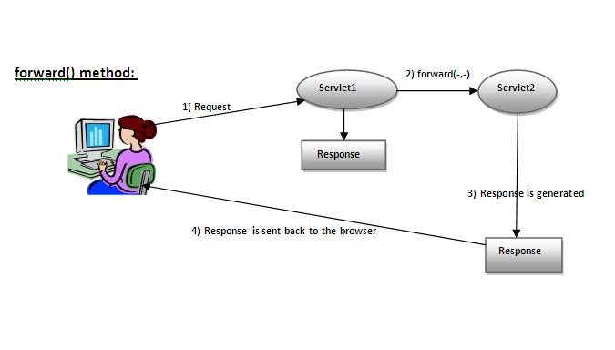
As you see in the above figure, response of second servlet is sent to the client. Response of the first servlet is not displayed to the user.

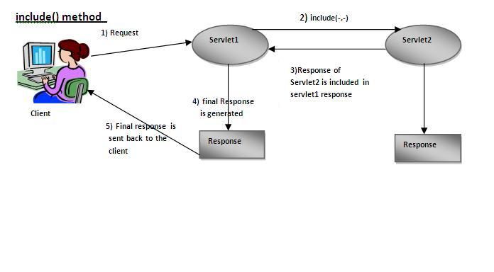
As you can see in the above figure, response of second servlet is included in the response of the first servlet that is being sent to the client.

How to get the object of RequestDispatcher
The getRequestDispatcher() method of ServletRequest interface returns the object of RequestDispatcher. Syntax:

Syntax of getRequestDispatcher method
- public RequestDispatcher getRequestDispatcher(String resource);

Example of using getRequestDispatcher method
- RequestDispatcher rd=request.getRequestDispatcher("servlet2");
- //servlet2 is the url-pattern of the second servlet

- rd.forward(request, response);//method may be include or forward

Example of RequestDispatcher interface
In this example, we are validating the password entered by the user. If password is servlet, it will forward the request to the WelcomeServlet, otherwise will show an error message: sorry username or password error!. In this program, we are cheking for hardcoded information. But you can check it to the database also that we will see in the development chapter. In this example, we have created following files:
- index.html file: for getting input from the user.
- Login.java file: a servlet class for processing the response. If password is servet, it will forward the request to the welcome servlet.
- WelcomeServlet.java file: a servlet class for displaying the welcome message.
- web.xml file: a deployment descriptor file that contains the information about the servlet.
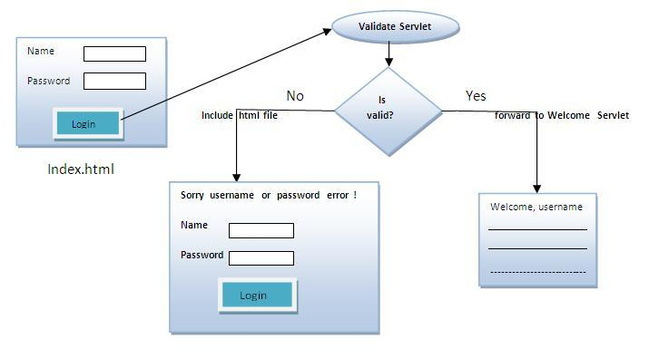

index.html
- <form action="servlet1" method="post">
- Name:<input type="text" name="userName"/><br/>
- Password:<input type="password" name="userPass"/><br/>
- <input type="submit" value="login"/>
- </form>

Login.java
- import java.io.*;
- import javax.servlet.*;
- import javax.servlet.http.*;

- public class Login extends HttpServlet {

- public void doPost(HttpServletRequest request, HttpServletResponse response)
- throws ServletException, IOException {

- response.setContentType("text/html");
- PrintWriter out = response.getWriter();

- String n=request.getParameter("userName");
- String p=request.getParameter("userPass");

- if(p.equals("servlet"){
- RequestDispatcher rd=request.getRequestDispatcher("servlet2");
- rd.forward(request, response);
- }
- else{
- out.print("Sorry UserName or Password Error!");
- RequestDispatcher rd=request.getRequestDispatcher("/index.html");
- rd.include(request, response);

- }
- }

- }

WelcomeServlet.java
- import java.io.*;
- import javax.servlet.*;
- import javax.servlet.http.*;

- public class WelcomeServlet extends HttpServlet {

- public void doPost(HttpServletRequest request, HttpServletResponse response)
- throws ServletException, IOException {

- response.setContentType("text/html");
- PrintWriter out = response.getWriter();

- String n=request.getParameter("userName");
- out.print("Welcome "+n);
- }

- }

web.xml
- <web-app>
- <servlet>
- <servlet-name>Login</servlet-name>
- <servlet-class>Login</servlet-class>
- </servlet>
- <servlet>
- <servlet-name>WelcomeServlet</servlet-name>
- <servlet-class>WelcomeServlet</servlet-class>
- </servlet>

- <servlet-mapping>
- <servlet-name>Login</servlet-name>
- <url-pattern>/servlet1</url-pattern>
- </servlet-mapping>
- <servlet-mapping>
- <servlet-name>WelcomeServlet</servlet-name>
- <url-pattern>/servlet2</url-pattern>
- </servlet-mapping>

- <welcome-file-list>
- <welcome-file>index.html</welcome-file>
- </welcome-file-list>
- </web-app>
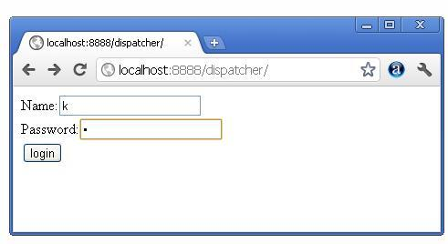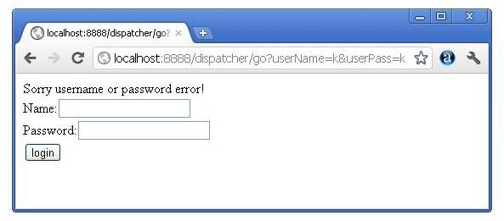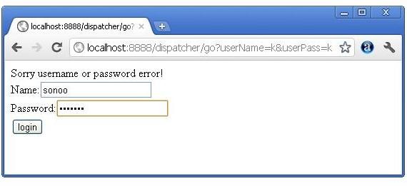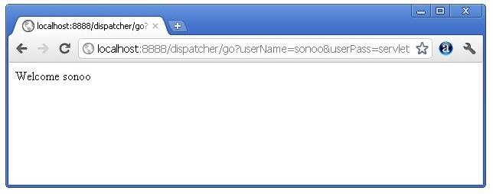

sendRedirect() method:

The sendRedirect() method of HttpServletResponse interface can be used to redirect response to another resource, it may be servlet, jsp or html file. It can accept relative URL. This method can work inside and outside the server as it uses the URL bar of the browser.

Syntax of sendRedirect() method
- public void sendRedirect(String URL)throws IOException;

Example of sendRedirect() method
In this example, we are redirecting the request to the google server. Notice that sendRedirect method works at client side, that is why we can our request to anywhere. We can send our request within and outside the server.

DemoServlet.java
- import java.io.*;
- import javax.servlet.*;
- import javax.servlet.http.*;

- public class DemoServlet extends HttpServlet{
- public void doGet(HttpServletRequest req,HttpServletResponse res)
- throws ServletException,IOException
- {
- res.setContentType("text/html");
- PrintWriter pw=res.getWriter();

- response.sendRedirect("http://www.google.com");

- pw.close();
- }}

ServletConfig Interface
An object of ServletConfig is created by the web container for each servlet. This object can be used to get configuration information from web.xml file.
If the configuration information is modified from the web.xml file, we don't need to change the servlet. So it is easier to manage the web application if any specific content is modified from time to time.

Advantage of ServletConfig
The core advantage of ServletConfig is that you don't need to edit the servlet file if information is modified from the web.xml file.

Methods of ServletConfig interface
- public String getInitParameter(String name):Returns the parameter value for the specified parameter name.
- public Enumeration getInitParameterNames():Returns an enumeration of all the initialization parameter names.
- public String getServletName():Returns the name of the servlet.
- public ServletContext getServletContext():Returns an object of ServletContext.

How to get the object of ServletConfig
- getServletConfig() method of Servlet interface returns the object of ServletConfig.

Syntax of getServletConfig() method
- public ServletConfig getServletConfig();

Example of getServletConfig() method
- ServletConfig config=getServletConfig();
- //Now we can call the methods of ServletConfig interface

Syntax to provide the initialization parameter for a servlet
The init-param sub-element of servlet is used to specify the initialization parameter for a servlet.
- <web-app>
- <servlet>
- ......

- <init-param>
- <param-name>parametername</param-name>
- <param-value>parametervalue</param-value>
- </init-param>
- ......
- </servlet>
- </web-app>

Example of ServletConfig to get initialization parameter
In this example, we are getting the one initialization parameter from the web.xml file and printing this information in the servlet.
DemoServlet.java
- import java.io.*;
- import javax.servlet.*;
- import javax.servlet.http.*;

- public class DemoServlet extends HttpServlet {
- public void doGet(HttpServletRequest request, HttpServletResponse response)
- throws ServletException, IOException {

- response.setContentType("text/html");
- PrintWriter out = response.getWriter();

- ServletConfig config=getServletConfig();
- String driver=config.getInitParameter("driver");
- out.print("Driver is: "+driver);

- out.close();
- }

- }
web.xml
- <web-app>

- <servlet>
- <servlet-name>DemoServlet</servlet-name>
- <servlet-class>DemoServlet</servlet-class>

- <init-param>
- <param-name>driver</param-name>
- <param-value>sun.jdbc.odbc.JdbcOdbcDriver</param-value>
- </init-param>

- </servlet>

- <servlet-mapping>
- <servlet-name>DemoServlet</servlet-name>
- <url-pattern>/servlet1</url-pattern>
- </servlet-mapping>

- </web-app>

Example of ServletConfig to get all the initialization parameters
In this example, we are getting all the initialization parameter from the web.xml file and printing this information in the servlet.
DemoServlet.java
- import java.io.IOException;
- import java.io.PrintWriter;
- import java.util.Enumeration;

- import javax.servlet.ServletConfig;
- import javax.servlet.ServletException;
- import javax.servlet.http.HttpServlet;
- import javax.servlet.http.HttpServletRequest;
- import javax.servlet.http.HttpServletResponse;

- public class DemoServlet extends HttpServlet {
- public void doGet(HttpServletRequest request, HttpServletResponse response)
- throws ServletException, IOException {

- response.setContentType("text/html");
- PrintWriter out = response.getWriter();

- ServletConfig config=getServletConfig();
- Enumeration<string> e=config.getInitParameterNames();

- String str="";
- while(e.hasMoreElements()){
- str=e.nextElement();
- out.print("<br>Name: "+str);
- out.print(" value: "+config.getInitParameter(str));
- }

- out.close();
- }

- }

- </string>
web.xml
- <web-app>

- <servlet>
- <servlet-name>DemoServlet</servlet-name>
- <servlet-class>DemoServlet</servlet-class>

- <init-param>
- <param-name>username</param-name>
- <param-value>system</param-value>
- </init-param>

- <init-param>
- <param-name>password</param-name>
- <param-value>oracle</param-value>
- </init-param>

- </servlet>

- <servlet-mapping>
- <servlet-name>DemoServlet</servlet-name>
- <url-pattern>/servlet1</url-pattern>
- </servlet-mapping>

- </web-app>

ServletContext Interface
An object of ServletContext is created by the web container at time of deploying the project. This object can be used to get configuration information from web.xml file. There is only one ServletContext object per web application.
If any information is shared to many servlet, it is better to provide it from the web.xml file using the <context-param> element.

Advantage of ServletContext
Easy to maintain if any information is shared to all the servlet, it is better to make it available for all the servlet. We provide this information from the web.xml file, so if the information is changed, we don't need to modify the servlet. Thus it removes maintenance problem.

Usage of ServletContext Interface
There can be a lot of usage of ServletContext object. Some of them are as follows:
- The object of ServletContext provides an interface between the container and servlet.
- The ServletContext object can be used to get configuration information from the web.xml file.
- The ServletContext object can be used to set, get or remove attribute from the web.xml file.
- The ServletContext object can be used to provide inter-application communication.
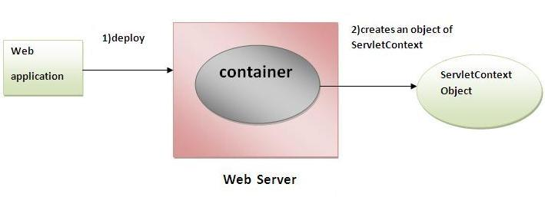

Commonly used methods of ServletContext interface
There is given some commonly used methods of ServletContext interface.
- public String getInitParameter(String name):Returns the parameter value for the specified parameter name.
- public Enumeration getInitParameterNames():Returns the names of the context's initialization parameters.
- public void setAttribute(String name,Object object):sets the given object in the application scope.
- public Object getAttribute(String name):Returns the attribute for the specified name.
- public Enumeration getInitParameterNames():Returns the names of the context's initialization parameters as an Enumeration of String objects.
- public void removeAttribute(String name):Removes the attribute with the given name from the servlet context.

How to get the object of ServletContext interface
- getServletContext() method of ServletConfig interface returns the object of ServletContext.
- getServletContext() method of GenericServlet class returns the object of ServletContext.

Syntax of getServletContext() method
- public ServletContext getServletContext()

Example of getServletContext() method
- //We can get the ServletContext object from ServletConfig object
- ServletContext application=getServletConfig().getServletContext();

- //Another convenient way to get the ServletContext object
- ServletContext application=getServletContext();

Syntax to provide the initialization parameter in Context scope
The context-param element, subelement of web-app, is used to define the initialization parameter in the application scope. The param-name and param-value are the sub-elements of the context-param. The param-name element defines parameter name and and param-value defines its value.
- <web-app>
- ......

- <context-param>
- <param-name>parametername</param-name>
- <param-value>parametervalue</param-value>
- </context-param>
- ......
- </web-app>

Example of ServletContext to get the initialization parameter
In this example, we are getting the initialization parameter from the web.xml file and printing the value of the initialization parameter. Notice that the object of ServletContext represents the application scope. So if we change the value of the parameter from the web.xml file, all the servlet classes will get the changed value. So we don't need to modify the servlet. So it is better to have the common information for most of the servlets in the web.xml file by context-param element. Let's see the simple example:
DemoServlet.java
- import java.io.*;
- import javax.servlet.*;
- import javax.servlet.http.*;

- public class DemoServlet extends HttpServlet{
- public void doGet(HttpServletRequest req,HttpServletResponse res)
- throws ServletException,IOException
- {
- res.setContentType("text/html");
- PrintWriter pw=res.getWriter();

- //creating ServletContext object
- ServletContext context=getServletContext();

- //Getting the value of the initialization parameter and printing it
- String driverName=context.getInitParameter("dname");
- pw.println("driver name is="+driverName);

- pw.close();

- }}
web.xml
- <web-app>

- <servlet>
- <servlet-name>sonoojaiswal</servlet-name>
- <servlet-class>DemoServlet</servlet-class>
- </servlet>

- <context-param>
- <param-name>dname</param-name>
- <param-value>sun.jdbc.odbc.JdbcOdbcDriver</param-value>
- </context-param>

- <servlet-mapping>
- <servlet-name>sonoojaiswal</servlet-name>
- <url-pattern>/context</url-pattern>
- </servlet-mapping>

- </web-app>

Example of ServletContext to get all the initialization parameters
In this example, we are getting all the initialization parameter from the web.xml file. For getting all the parameters, we have used the getInitParameterNames() method in the servlet class.
DemoServlet.java
- import java.io.*;
- import javax.servlet.*;
- import javax.servlet.http.*;

- public class DemoServlet extends HttpServlet{
- public void doGet(HttpServletRequest req,HttpServletResponse res)
- throws ServletException,IOException
- {
- res.setContentType("text/html");
- PrintWriter out=res.getWriter();

- ServletContext context=getServletContext();
- Enumeration<string> e=context.getInitParameterNames();

- String str="";
- while(e.hasMoreElements()){
- str=e.nextElement();
- out.print("<br> "+context.getInitParameter(str));
- }
- }}

- </string>
web.xml
- <web-app>

- <servlet>
- <servlet-name>sonoojaiswal</servlet-name>
- <servlet-class>DemoServlet</servlet-class>
- </servlet>

- <context-param>
- <param-name>dname</param-name>
- <param-value>sun.jdbc.odbc.JdbcOdbcDriver</param-value>
- </context-param>

- <context-param>
- <param-name>username</param-name>
- <param-value>system</param-value>
- </context-param>

- <context-param>
- <param-name>password</param-name>
- <param-value>oracle</param-value>
- </context-param>

- <servlet-mapping>
- <servlet-name>sonoojaiswal</servlet-name>
- <url-pattern>/context</url-pattern>
- </servlet-mapping>

- </web-app>

Attribute in Servlet
An attribute is an object that can be set, get or removed from one of the following scopes:
- request scope
- session scope
- application scope
The servlet programmer can pass informations from one servlet to another using attributes. It is just like passing object from one class to another so that we can reuse the same object again and again.

Attribute specific methods of ServletRequest, HttpSession and ServletContext interface
There are following 4 attribute specific methods. They are as follows:
- public void setAttribute(String name,Object object):sets the given object in the application scope.
- public Object getAttribute(String name):Returns the attribute for the specified name.
- public Enumeration getInitParameterNames():Returns the names of the context's initialization parameters as an Enumeration of String objects.
- public void removeAttribute(String name):Removes the attribute with the given name from the servlet context.

Example of ServletContext to set and get attribute
In this example, we are setting the attribute in the application scope and getting that value from another servlet.

DemoServlet1.java
- import java.io.*;
- import javax.servlet.*;
- import javax.servlet.http.*;

- public class DemoServlet1 extends HttpServlet{
- public void doGet(HttpServletRequest req,HttpServletResponse res)
- {
- try{

- res.setContentType("text/html");
- PrintWriter out=res.getWriter();

- ServletContext context=getServletContext();
- context.setAttribute("company","IBM");

- out.println("Welcome to first servlet");
- out.println("<a href='servlet2'>visit</a>");
- out.close();

- }catch(Exception e){out.println(e);}

- }}

DemoServlet2.java
- import java.io.*;
- import javax.servlet.*;
- import javax.servlet.http.*;

- public class DemoServlet2 extends HttpServlet{
- public void doGet(HttpServletRequest req,HttpServletResponse res)
- {
- try{

- res.setContentType("text/html");
- PrintWriter out=res.getWriter();

- ServletContext context=getServletContext();
- String n=(String)context.getAttribute("company");

- out.println("Welcome to "+n);
- out.close();

- }catch(Exception e){out.println(e);}

- }}

web.xml
- <web-app>

- <servlet>
- <servlet-name>s1</servlet-name>
- <servlet-class>DemoServlet1</servlet-class>
- </servlet>

- <servlet-mapping>
- <servlet-name>s1</servlet-name>
- <url-pattern>/servlet1</url-pattern>
- </servlet-mapping>

- <servlet>
- <servlet-name>s2</servlet-name>
- <servlet-class>DemoServlet2</servlet-class>
- </servlet>

- <servlet-mapping>
- <servlet-name>s2</servlet-name>
- <url-pattern>/servlet2</url-pattern>
- </servlet-mapping>

- </web-app>

Difference between ServletConfig and ServletContext
The servletconfig object refers to the single servlet whereas servletcontext object refers to the whole web application.

Cookies in Session Tracking
- Cookies in Session Tracking
- Session Tracking
- Session Tracking Techniques
- Cookies
- javax.servlet.http.Cookie class
- Example of using Cookies
Cookie is a mechanism to maintain the state of an user. Before cookie, let's see what is sesion tracking and what are ways to perform session tracking.

Session Tracking
Session simply means a particular interval of time.
Session Tracking is a way to maintain state of an user. Http protocol is a stateless protocol. Each time user requests to the server, server treats the request as the new request. So we need to maintain the state of an user to recognize to particular user.
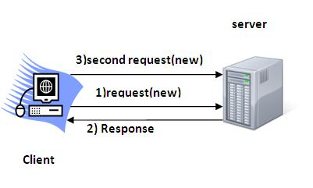

Why use Session Tracking?
To recognize the user.

Session Tracking Techniques
There are four techniques used in Session tracking:
- Cookies
- Hidden Form Field
- URL Rewriting
- HttpSession

1) Cookies
A cookie is a small piece of information that is persisted between the multiple client requests.A cookie has a name, a single value, and optional attributes such as a comment, path and domain qualifiers, a maximum age, and a version number.
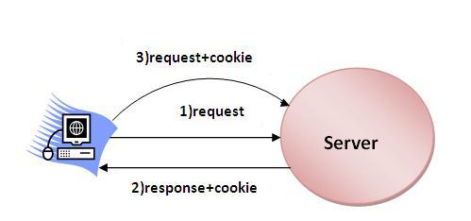

javax.servlet.http.Cookie class
javax.servlet.http.Cookie class provides the functionality of using cookies.

Constructor of Cookie class
Cookie(String name, String value): Constructs a cookie with a specified name and value.

Commonly used methods of Cookie class
There are given some commonly used methods of the Cookie class.
- public void setMaxAge(int expiry):Sets the maximum age of the cookie in seconds.
- public String getName():Returns the name of the cookie. The name cannot be changed after creation.
- public String getValue():Returns the value of the cookie.

Other methods required for using Cookies
For adding cookie or getting the value from the cookie, we need some methods provided by other interfaces. They are:
- public void addCookie(Cookie ck):method of HttpServletResponse interface is used to add cookie in response object.
- public Cookie[] getCookies():method of HttpServletRequest interface is used to return all the cookies from the browser.

Advantage of Cookies
- Simplest technique of maintaining the state.
- Cookies are maintained at client side.

Disadvantage of Cookies
- It will not work if cookie is disabled from the browser.
- Only textual information can be set in Cookie object.

Example of using Cookies
In this example, we are storing the name of the user in the cookie object and accessing it in another servlet. As we know well that session corresponds to the particular user. So if you access it from too many browsers with different values, you will get the different value.
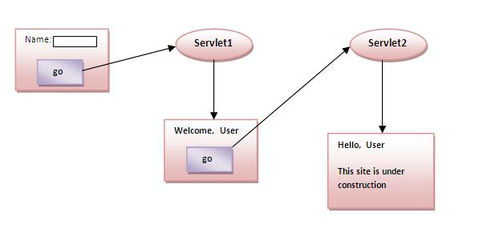

index.html
- <form action="servlet1" method="post">
- Name:<input type="text" name="userName"/><br/>
- <input type="submit" value="go"/>
- </form>

FirstServlet.java
- import java.io.*;
- import javax.servlet.*;
- import javax.servlet.http.*;

- public class FirstServlet extends HttpServlet {

- public void doPost(HttpServletRequest request, HttpServletResponse response){
- try{

- response.setContentType("text/html");
- PrintWriter out = response.getWriter();

- String n=request.getParameter("userName");
- out.print("Welcome "+n);

- Cookie ck=new Cookie("uname",n);//creating cookie object
- response.addCookie(ck);//adding cookie in the response

- //creating submit button
- out.print("<form action='servlet2'>");
- out.print("<input type='submit' value='go'>");
- out.print("</form>");

- out.close();

- }catch(Exception e){System.out.println(e);}
- }
- }

SecondServlet.java
- import java.io.*;
- import javax.servlet.*;
- import javax.servlet.http.*;

- public class SecondServlet extends HttpServlet {

- public void doPost(HttpServletRequest request, HttpServletResponse response){
- try{

- response.setContentType("text/html");
- PrintWriter out = response.getWriter();

- Cookie ck[]=request.getCookies();
- out.print("Hello "+ck[0].getValue());

- out.close();

- }catch(Exception e){System.out.println(e);}
- }

- }

web.xml
- <web-app>

- <servlet>
- <servlet-name>s1</servlet-name>
- <servlet-class>FirstServlet</servlet-class>
- </servlet>

- <servlet-mapping>
- <servlet-name>s1</servlet-name>
- <url-pattern>/servlet1</url-pattern>
- </servlet-mapping>

- <servlet>
- <servlet-name>s2</servlet-name>
- <servlet-class>SecondServlet</servlet-class>
- </servlet>

- <servlet-mapping>
- <servlet-name>s2</servlet-name>
- <url-pattern>/servlet2</url-pattern>
- </servlet-mapping>

- </web-app>

Hidden Form Field
In case of Hidden Form Field an invisible textfield is used for maintaing the state of an user. In such case, we store the information in the hidden field and get it from another servlet. This approach is better if we have to submit form in all the pages and we don't want to depend on the browser.
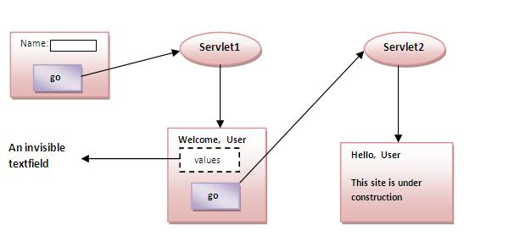

Advantage of Hidden Form Field
- It will always work whether cookie is disabled or not.

Disadvantage of Hidden Form Field:
- It is maintained at server side.
- Extra form submission is required on each pages.
- Only textual information can be used.

Example of using Hidden Form Field
In this example, we are storing the name of the user in a hidden textfield and getting that value from another servlet.

index.html
- <form action="servlet1">
- Name:<input type="text" name="userName"/><br/>
- <input type="submit" value="go"/>
- </form>

FirstServlet.java
- import java.io.*;
- import javax.servlet.*;
- import javax.servlet.http.*;

- public class FirstServlet extends HttpServlet {

- public void doGet(HttpServletRequest request, HttpServletResponse response){
- try{

- response.setContentType("text/html");
- PrintWriter out = response.getWriter();

- String n=request.getParameter("userName");
- out.print("Welcome "+n);

- //creating form that have invisible textfield
- out.print("<form action='servlet2'>");
- out.print("<input type='hidden' name="uname" value='"+n+"'>");
- out.print("<input type='submit' value='go'>");
- out.print("</form>");

- out.close();

- }catch(Exception e){System.out.println(e);}
- }

- }

SecondServlet.java
- import java.io.*;
- import javax.servlet.*;
- import javax.servlet.http.*;

- public class SecondServlet extends HttpServlet {

- public void doGet(HttpServletRequest request, HttpServletResponse response)
- try{

- response.setContentType("text/html");
- PrintWriter out = response.getWriter();

- //Getting the value from the hidden field
- String n=request.getParameter("uname");
- out.print("Hello "+n);

- out.close();

- }catch(Exception e){System.out.println(e);}
- }

- }

web.xml
- <web-app>

- <servlet>
- <servlet-name>s1</servlet-name>
- <servlet-class>FirstServlet</servlet-class>
- </servlet>

- <servlet-mapping>
- <servlet-name>s1</servlet-name>
- <url-pattern>/servlet1</url-pattern>
- </servlet-mapping>

- <servlet>
- <servlet-name>s2</servlet-name>
- <servlet-class>SecondServlet</servlet-class>
- </servlet>

- <servlet-mapping>
- <servlet-name>s2</servlet-name>
- <url-pattern>/servlet2</url-pattern>
- </servlet-mapping>

- </web-app>

URL Rewriting
In URL rewriting, we append a token or identifier to the URL of the next Servlet or the next resource. We can send parameter name/value pairs using the following format:
url?name1=value1&name2=value2&??
A name and a value is separated using an equal = sign, a parameter name/value pair is separated from another parameter using the ampersand(&). When the user clicks the hyperlink, the parameter name/value pairs will be passed to the server. From a Servlet, we can use getParameter() method to obtain a parameter value.
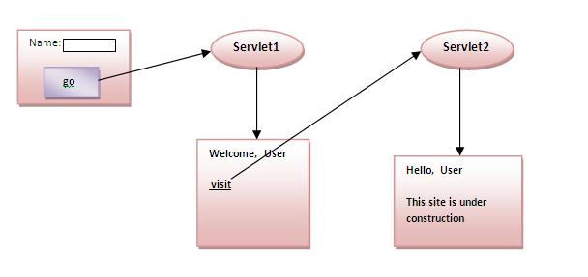

Advantage of URL Rewriting
- It will always work whether cookie is disabled or not (browser independent).
- Extra form submission is not required on each pages.

Disadvantage of URL Rewriting
- It will work only with links.
- It can send Only textual information.

Example of using URL Rewriting
In this example, we are maintaning the state of the user using link. For this purpose, we are appending the name of the user in the query string and getting the value from the query string in another page.

index.html
- <form action="servlet1">
- Name:<input type="text" name="userName"/><br/>
- <input type="submit" value="go"/>
- </form>

FirstServlet.java
- import java.io.*;
- import javax.servlet.*;
- import javax.servlet.http.*;

- public class FirstServlet extends HttpServlet {

- public void doGet(HttpServletRequest request, HttpServletResponse response){
- try{

- response.setContentType("text/html");
- PrintWriter out = response.getWriter();

- String n=request.getParameter("userName");
- out.print("Welcome "+n);

- //appending the username in the query string
- out.print("<a href='servlet2?uname="+n+"'>visit</a>");

- out.close();

- }catch(Exception e){System.out.println(e);}
- }

- }

SecondServlet.java
- import java.io.*;
- import javax.servlet.*;
- import javax.servlet.http.*;

- public class SecondServlet extends HttpServlet {

- public void doGet(HttpServletRequest request, HttpServletResponse response)
- try{

- response.setContentType("text/html");
- PrintWriter out = response.getWriter();

- //getting value from the query string
- String n=request.getParameter("uname");
- out.print("Hello "+n);

- out.close();

- }catch(Exception e){System.out.println(e);}
- }

- }

web.xml
- <web-app>

- <servlet>
- <servlet-name>s1</servlet-name>
- <servlet-class>FirstServlet</servlet-class>
- </servlet>

- <servlet-mapping>
- <servlet-name>s1</servlet-name>
- <url-pattern>/servlet1</url-pattern>
- </servlet-mapping>

- <servlet>
- <servlet-name>s2</servlet-name>
- <servlet-class>SecondServlet</servlet-class>
- </servlet>

- <servlet-mapping>
- <servlet-name>s2</servlet-name>
- <url-pattern>/servlet2</url-pattern>
- </servlet-mapping>

- </web-app>

4) HttpSession interface
In such case, container creates a session id for each user.The container uses this id to identify the particular user.An object of HttpSession can be used to perform two tasks:
- bind objects
- view and manipulate information about a session, such as the session identifier, creation time, and last accessed time.
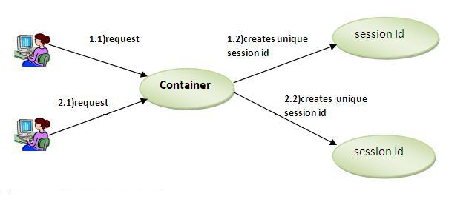

How to get the HttpSession object ?
The HttpServletRequest interface provides two methods to get the object of HttpSession:
- public HttpSession getSession():Returns the current session associated with this request, or if the request does not have a session, creates one.
- public HttpSession getSession(boolean create):Returns the current HttpSession associated with this request or, if there is no current session and create is true, returns a new session.

Commonly used methods of HttpSession interface
- public String getId():Returns a string containing the unique identifier value.
- public long getCreationTime():Returns the time when this session was created, measured in milliseconds since midnight January 1, 1970 GMT.
- public long getLastAccessedTime():Returns the last time the client sent a request associated with this session, as the number of milliseconds since midnight January 1, 1970 GMT.
- public void invalidate():Invalidates this session then unbinds any objects bound to it.

Example of using HttpSession
In this example, we are setting the attribute in the session scope in one servlet and getting that value from the session scope in another servlet. To set the attribute in the session scope, we have used the setAttribute() method of HttpSession interface and to get the attribute, we have used the getAttribute method.

index.html
- <form action="servlet1">
- Name:<input type="text" name="userName"/><br/>
- <input type="submit" value="go"/>
- </form>

FirstServlet.java
- import java.io.*;
- import javax.servlet.*;
- import javax.servlet.http.*;

- public class FirstServlet extends HttpServlet {

- public void doGet(HttpServletRequest request, HttpServletResponse response){
- try{

- response.setContentType("text/html");
- PrintWriter out = response.getWriter();

- String n=request.getParameter("userName");
- out.print("Welcome "+n);

- HttpSession session=request.getSession();
- session.setAttribute("uname",n);

- out.print("<a href='servlet2'>visit</a>");

- out.close();

- }catch(Exception e){System.out.println(e);}
- }

- }

SecondServlet.java
- import java.io.*;
- import javax.servlet.*;
- import javax.servlet.http.*;

- public class SecondServlet extends HttpServlet {

- public void doGet(HttpServletRequest request, HttpServletResponse response)
- try{

- response.setContentType("text/html");
- PrintWriter out = response.getWriter();

- HttpSession session=request.getSession(false);
- String n=(String)session.getAttribute("uname");
- out.print("Hello "+n);

- out.close();

- }catch(Exception e){System.out.println(e);}
- }

- }

web.xml
- <web-app>

- <servlet>
- <servlet-name>s1</servlet-name>
- <servlet-class>FirstServlet</servlet-class>
- </servlet>

- <servlet-mapping>
- <servlet-name>s1</servlet-name>
- <url-pattern>/servlet1</url-pattern>
- </servlet-mapping>

- <servlet>
- <servlet-name>s2</servlet-name>
- <servlet-class>SecondServlet</servlet-class>
- </servlet>

- <servlet-mapping>
- <servlet-name>s2</servlet-name>
- <url-pattern>/servlet2</url-pattern>
- </servlet-mapping>

- </web-app>

Event and Listener in Servlet
Events are basically occurrence of something. Changing the state of an object is known as an event.
We can perform some important tasks at the occurrence of these exceptions, such as counting total and current logged-in users, creating tables of the database at time of deploying the project, creating database connection object etc.
There are many Event classes and Listener interfaces in the javax.servlet and javax.servlet.http packages.

Event classes
The event classes are as follows:
- ServletRequestEvent
- ServletContextEvent
- ServletRequestAttributeEvent
- ServletContextAttributeEvent
- HttpSessionEvent
- HttpSessionBindingEvent

Event interfaces
The event interfaces are as follows:
- ServletRequestListener
- ServletRequestAttributeListener
- ServletContextListener
- ServletContextAttributeListener
- HttpSessionListener
- HttpSessionAttributeListener
- HttpSessionBindingListener
- HttpSessionActivationListener

Filter
A filter is an object that is used to perform filtering tasks such as conversion, log maintain, compression, encryption and decryption, input validation etc. A filter is invoked at the preprocessing and postprocessing of a request. It is pluggable, i.e. its entry is defined in the web.xml file, if we remove the entry of filter from the web.xml file, filter will be removed automatically and we don't need to change the servlet. So it will be easier to maintain the web application.
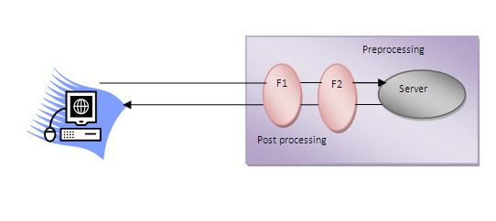

Usage of Filter
- recording all incoming requests
- logs the IP addresses of the computers from which the requests originate
- conversion
- data compression
- encryption and decryption
- input validation etc.

Advantage of Filter
- Filter is pluggable.
- One filter don't have dependency onto another resource.

Filter API
Like servlet filter have its own API.The javax.servlet package contains the three interfaces of Filter API
- Filter
- FilterChain
- FilterConfig

1) Filter interface
For creating any filter, you must implement the Filter interface.Filter interface provides the life cycle methods for a filter.
- public void init(FilterConfig config): init() method is invoked only once it is used to initialize the filter.
- public void doFilter(HttpServletRequest request,HttpServletResponse response, FilterChain chain): doFilter() method is invoked every time when user request to any resource, to which the filter is mapped.It is used to perform filtering tasks.
- public void destroy():This is invoked only once when filter is taken out of the service.

2) FilterChain interface
The object of FilterChain is responsible to invoke the next filter or resource in the chain.This object is passed in the doFilter method of Filter interface.The FilterChain interface contains only one method:
- public void doFilter(HttpServletRequest request, HttpServletResponse response): it passes the control to the next filter or resource.

How to define Filter
We can define filter same as servlet. Let's see the elements of filter and filter-mapping.
- <web-app>

- <filter>
- <filter-name>...</filter-name>
- <filter-class>...</filter-class>
- </filter>

- <filter-mapping>
- <filter-name>...</filter-name>
- <url-pattern>...</url-pattern>
- </filter-mapping>

- </web-app>
For mapping filter we can use, either url-pattern or servlet-name. The url-pattern elements has an advantage over servlet-name element i.e. it can be applied on servlet, JSP or HTML.

Simple Example of Filter
In this example, we are simply displaying information that filter is invoked automatically after the post processing of the request.

index.html
- <a href="servlet1">click here</a>

MyFilter.java
- import java.io.IOException;
- import java.io.PrintWriter;

- import javax.servlet.*;

- public class MyFilter implements Filter{

- public void init(FilterConfig arg0) throws ServletException {}

- public void doFilter(ServletRequest req, ServletResponse resp,
- FilterChain chain) throws IOException, ServletException {

- PrintWriter out=resp.getWriter();
- out.print("filter is invoked before");

- chain.doFilter(req, resp);//sends request to next resource

- out.print("filter is invoked after");
- }
- public void destroy() {}
- }

HelloServlet.java
- import java.io.IOException;
- import java.io.PrintWriter;

- import javax.servlet.ServletException;
- import javax.servlet.http.*;

- public class HelloServlet extends HttpServlet {
- public void doGet(HttpServletRequest request, HttpServletResponse response)
- throws ServletException, IOException {

- response.setContentType("text/html");
- PrintWriter out = response.getWriter();

- out.print("<br>welcome to servlet<br>");

- }

- }
web.xml
For defining the filter, filter element of web-app must be defined just like servlet.
- <web-app>

- <servlet>
- <servlet-name>s1</servlet-name>
- <servlet-class>HelloServlet</servlet-class>
- </servlet>

- <servlet-mapping>
- <servlet-name>s1</servlet-name>
- <url-pattern>/servlet1</url-pattern>
- </servlet-mapping>

- <filter>
- <filter-name>f1</filter-name>
- <filter-class>MyFilter</filter-class>
- </filter>

- <filter-mapping>
- <filter-name>f1</filter-name>
- <url-pattern>/servlet1</url-pattern>
- </filter-mapping>

- </web-app>

Authentication Filter
We can perform authentication in filter. Here, we are going to check to password given by the user in filter class, if given password is admin, it will forward the request to the WelcomeAdmin servlet otherwise it will display error message.

Example of authenticating user using filter
Let's see the simple example of authenticating user using filter. Here, we have created 4 files:
- index.html
- MyFilter.java
- AdminServlet.java
- web.xml
index.html
- <form action="servlet1">
- Name:<input type="text" name="name"/><br/>
- Password:<input type="password" name="password"/><br/>

- <input type="submit" value="login">

- </form>

MyFilter.java
- import java.io.IOException;
- import java.io.PrintWriter;
- import javax.servlet.*;

- public class MyFilter implements Filter{

- public void init(FilterConfig arg0) throws ServletException {}

- public void doFilter(ServletRequest req, ServletResponse resp,
- FilterChain chain) throws IOException, ServletException {

- PrintWriter out=resp.getWriter();

- String password=req.getParameter("password");
- if(password.equals("admin")){
- chain.doFilter(req, resp);//sends request to next resource
- }
- else{
- out.print("username or password error!");
- RequestDispatcher rd=req.getRequestDispatcher("index.html");
- rd.include(req, resp);
- }

- }
- public void destroy() {}

- }

AdminServlet.java
- import java.io.IOException;
- import java.io.PrintWriter;

- import javax.servlet.ServletException;
- import javax.servlet.http.*;

- public class AdminServlet extends HttpServlet {
- public void doGet(HttpServletRequest request, HttpServletResponse response)
- throws ServletException, IOException {

- response.setContentType("text/html");
- PrintWriter out = response.getWriter();

- out.print("welcome ADMIN");
- out.close();
- }
- }

web.xml
- <web-app>
- <servlet>
- <servlet-name>AdminServlet</servlet-name>
- <servlet-class>AdminServlet</servlet-class>
- </servlet>

- <servlet-mapping>
- <servlet-name>AdminServlet</servlet-name>
- <url-pattern>/servlet1</url-pattern>
- </servlet-mapping>

- <filter>
- <filter-name>f1</filter-name>
- <filter-class>MyFilter</filter-class>
- </filter>
- <filter-mapping>
- <filter-name>f1</filter-name>
- <url-pattern>/servlet1</url-pattern>
- </filter-mapping>

- </web-app>

FilterConfig
An object of FilterConfig is created by the web container. This object can be used to get the configuration information from the web.xml file.

Methods of FilterConfig interface
There are following 4 methods in the FilterConfig interface.
- public void init(FilterConfig config): init() method is invoked only once it is used to initialize the filter.
- public String getInitParameter(String parameterName): Returns the parameter value for the specified parameter name.
- public java.util.Enumeration getInitParameterNames(): Returns an enumeration containing all the parameter names.
- public ServletContext getServletContext(): Returns the ServletContext object.

Example of FilterConfig
In this example, if you change the param-value to no, request will be forwarded to the servlet otherwise filter will create the response with the message: this page is underprocessing. Let's see the simple example of FilterConfig. Here, we have created 4 files:
- index.html
- MyFilter.java
- HelloServlet.java
- web.xml
index.html
- <a href="servlet1">click here</a>

MyFilter.java
- import java.io.IOException;
- import java.io.PrintWriter;

- import javax.servlet.*;

- public class MyFilter implements Filter{
- FilterConfig config;

- public void init(FilterConfig config) throws ServletException {
- this.config=config;
- }

- public void doFilter(ServletRequest req, ServletResponse resp,
- FilterChain chain) throws IOException, ServletException {

- PrintWriter out=resp.getWriter();

- String s=config.getInitParameter("construction");

- if(s.equals("yes")){
- out.print("This page is under construction");
- }
- else{
- chain.doFilter(req, resp);//sends request to next resource
- }

- }
- public void destroy() {}
- }

HelloServlet.java
- import java.io.IOException;
- import java.io.PrintWriter;

- import javax.servlet.ServletException;
- import javax.servlet.http.*;

- public class HelloServlet extends HttpServlet {
- public void doGet(HttpServletRequest request, HttpServletResponse response)
- throws ServletException, IOException {

- response.setContentType("text/html");
- PrintWriter out = response.getWriter();

- out.print("<br>welcome to servlet<br>");

- }

- }

web.xml
- <web-app>

- <servlet>
- <servlet-name>HelloServlet</servlet-name>
- <servlet-class>HelloServlet</servlet-class>
- </servlet>

- <servlet-mapping>
- <servlet-name>HelloServlet</servlet-name>
- <url-pattern>/servlet1</url-pattern>
- </servlet-mapping>

- <filter>
- <filter-name>f1</filter-name>
- <filter-class>MyFilter</filter-class>
- <init-param>
- <param-name>construction</param-name>
- <param-value>no</param-value>
- </init-param>
- </filter>
- <filter-mapping>
- <filter-name>f1</filter-name>
- <url-pattern>/servlet1</url-pattern>
- </filter-mapping>

- </web-app>

Useful Filter Examples
There is given some useful examples of filter.

Example of sending response by filter only
MyFilter.java
- import java.io.*;
- import javax.servlet.*;

- public class MyFilter implements Filter{
- public void init(FilterConfig arg0) throws ServletException {}

- public void doFilter(ServletRequest req, ServletResponse res,
- FilterChain chain) throws IOException, ServletException {

- PrintWriter out=res.getWriter();

- out.print("<br/>this site is underconstruction..");
- out.close();

- }
- public void destroy() {}
- }

Example of counting number of visitors for a single page
MyFilter.java
- import java.io.*;
- import javax.servlet.*;

- public class MyFilter implements Filter{
- static int count=0;
- public void init(FilterConfig arg0) throws ServletException {}

- public void doFilter(ServletRequest req, ServletResponse res,
- FilterChain chain) throws IOException, ServletException {

- PrintWriter out=res.getWriter();
- chain.doFilter(request,response);

- out.print("<br/>Total visitors "+(++count));
- out.close();

- }
- public void destroy() {}
- }

Example of checking total response time in filter
MyFilter.java
- import java.io.*;
- import javax.servlet.*;

- public class MyFilter implements Filter{
- static int count=0;
- public void init(FilterConfig arg0) throws ServletException {}

- public void doFilter(ServletRequest req, ServletResponse res,
- FilterChain chain) throws IOException, ServletException {

- PrintWriter out=res.getWriter();
- long before=System.currentTimeMillis();

- chain.doFilter(request,response);

- long after=System.currentTimeMillis();
- out.print("<br/>Total response time "+(after-before)+" miliseconds");
- out.close();

- }
- public void destroy() {}
- }

ServletInputStream class
ServletInputStream class provides stream to read binary data such as image etc. from the request object. It is an abstract class.
The getInputStream() method of ServletRequestinterface returns the instance of ServletInputStream class. So can be get as:
- ServletInputStream sin=request.getInputStream();

Method of ServletInputStream class
There are only one method defined in the ServletInputStream class.
- int readLine(byte[] b, int off, int len) it reads the input stream.

ServletOutputStream class
- ServletOutputStream class
- Methods of ServletOutputStream class
- Example of ServletOutputStream class
ServletOutputStream class provides a stream to write binary data into the response. It is an abstract class.
The getOutputStream() method of ServletResponseinterface returns the instance of ServletOutputStream class. It may be get as:
- ServletOutputStream out=response.getOutputStream();

Methods of ServletOutputStream class
The ServletOutputStream class provides print() and println() methods that are overloaded.
- void print(boolean b){}
- void print(char c){}
- void print(int i){}
- void print(long l){}
- void print(float f){}
- void print(double d){}
- void print(String s){}
- void println{}
- void println(boolean b){}
- void println(char c){}
- void println(int i){}
- void println(long l){}
- void println(float f){}
- void println(double d){}
- void println(String s){}

Servlet with Annotation (feature of servlet3):
Annotation represents the metadata. If you use annotation, deployment descriptor (web.xml file) is not required. But you should have tomcat7 as it will not run in the previous versions of tomcat. @WebServlet annotation is used to map the servlet with the specified name.

Example of simple servlet by annotation
There is given the simple example of servlet with annotation.

Simple.java
- import java.io.IOException;
- import java.io.PrintWriter;

- import javax.servlet.ServletException;
- import javax.servlet.annotation.WebServlet;
- import javax.servlet.http.HttpServlet;
- import javax.servlet.http.HttpServletRequest;
- import javax.servlet.http.HttpServletResponse;

- @WebServlet("/Simple")
- public class Simple extends HttpServlet {
- private static final long serialVersionUID = 1L;

- protected void doGet(HttpServletRequest request, HttpServletResponse response)
- throws ServletException, IOException {

- response.setContentType("text/html");
- PrintWriter out=response.getWriter();

- out.print("<html><body>");
- out.print("<h3>Hello Servlet</h3>");
- out.print("</body></html>");
- }
- }

SingleThreadModel interface
The servlet programmer should implement SingleThreadModel interface to ensure that servlet can handle only one request at a time. It is a marker interface, means have no methods.

This interface is currently deprecated since Servlet API 2.4 because it doesn't solves all the thread-safety issues such as static variable and session attributes can be accessed by multiple threads at the same time even if we have implemented the SingleThreadModel interface. So it is recommended to use other means to resolve these thread safety issues such as synchronized block etc.

Example of SingleThreadModel interface
Let's see the simple example of implementing the SingleThreadModel interface.
- import java.io.IOException;
- import java.io.PrintWriter;
- import javax.servlet.ServletException;
- import javax.servlet.SingleThreadModel;
- import javax.servlet.http.HttpServlet;
- import javax.servlet.http.HttpServletRequest;
- import javax.servlet.http.HttpServletResponse;

- public class MyServlet extends HttpServlet implements SingleThreadModel{

- public void doGet(HttpServletRequest request, HttpServletResponse response)
- throws ServletException, IOException {

- response.setContentType("text/html");
- PrintWriter out = response.getWriter();

- out.print("welcome");
- try{Thread.sleep(10000);}catch(Exception e){e.printStackTrace();}
- out.print(" to servlet");

- out.close();
- }

- }

Ex.No: 1
Date:
Topic: Basic Servlet -HelloWorld
AIM:
To write a simple servlet program to display “HelloWorld”
PROCEDURE:
Servlets are Java classes which service HTTP requests and implement the javax.servlet.Servletinterface. Web application developers typically write servlets that extend javax.servlet.http.HttpServlet, an abstract class that implements the Servlet interface and is specially designed to handle HTTP requests.

OUTPUT:
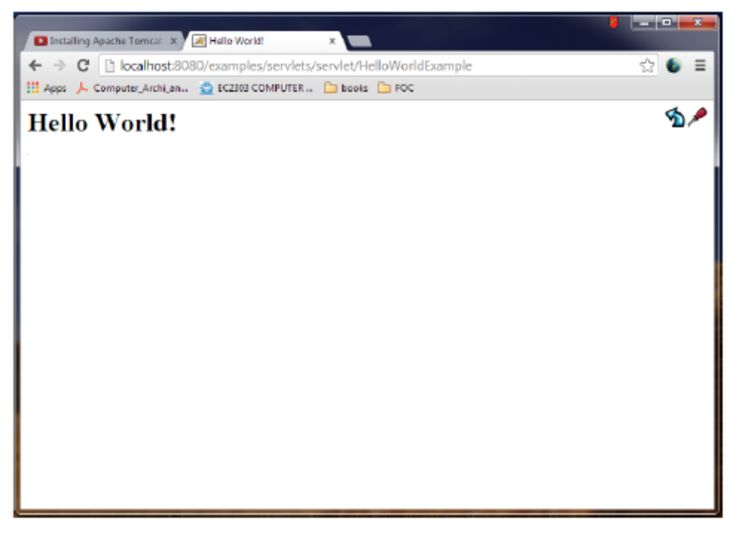

RESULT:
Thus the program to simple servlet to display HelloWorld was executed successfully.
Ex.No: 2
Date:
Topic: Basic Servlet -RequestInfo
AIM:
To write a simple servlet program to display the requested information
PROCEDURE:
Servlets are Java classes which service HTTP requests and implement the javax.servlet.Servletinterface. Web application developers typically write servlets that extend javax.servlet.http.HttpServlet, an abstract class that implements the Servlet interface and is specially designed to handle HTTP requests.
CODING:

OUTPUT:
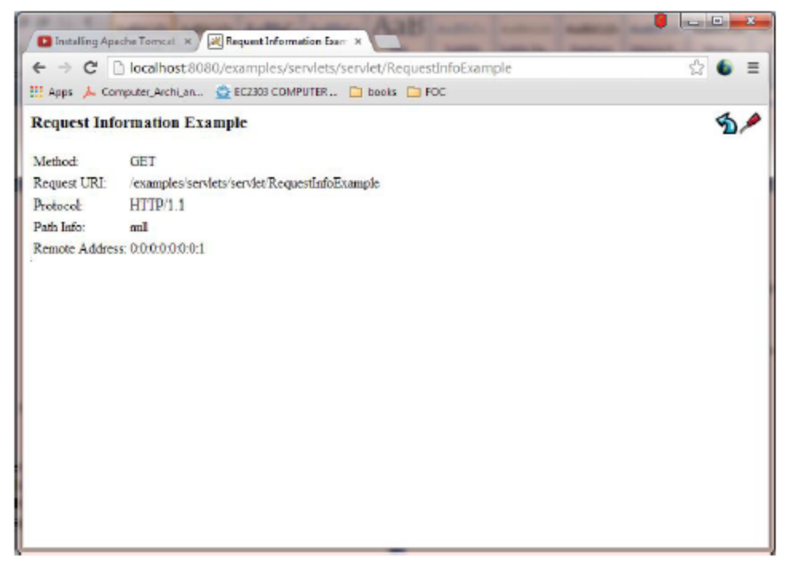

RESULT:
Thus the program to simple servlet to display requested information was executed successfully
Ex.No: 3
Date:
Topic: Basic Servlet -RequestHeaders
AIM:
To write a simple servlet program to display the requestedheader information
PROCEDURE:
Servlets are Java classes which service HTTP requests and implement the javax.servlet.Servletinterface. Web application developers typically write servlets that extend javax.servlet.http.HttpServlet, an abstract class that implements the Servlet interface and is specially designed to handle HTTP requests.
PROGRAM:

OUTPUT:
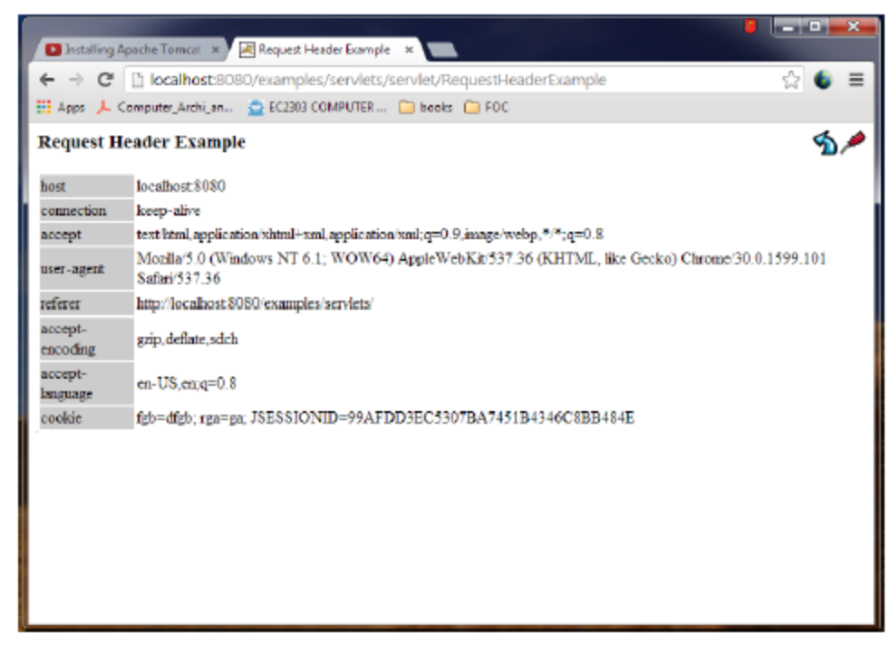

RESULT:
Thus the program to simple servlet to display requested header information was executed successfully.
Ex.No: 4
Date:
Topic: Basic Servlet -RequestParameters
AIM:
To write a simple servlet program to display the requested parameters information
PROCEDURE:
Servlets are Java classes which service HTTP requests and implement the javax.servlet.Servletinterface. Web application developers typically write servlets that extend javax.servlet.http.HttpServlet, an abstract class that implements the Servlet interface and is specially designed to handle HTTP requests.
PROGRAM:

OUTPUT:
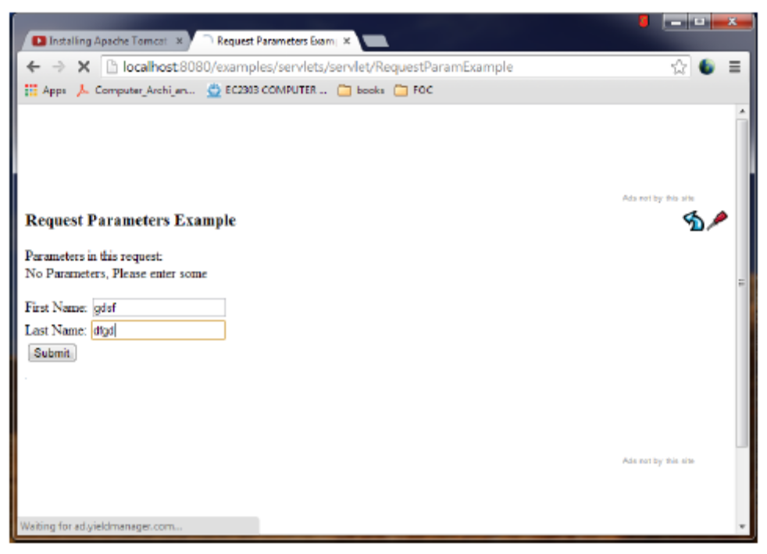
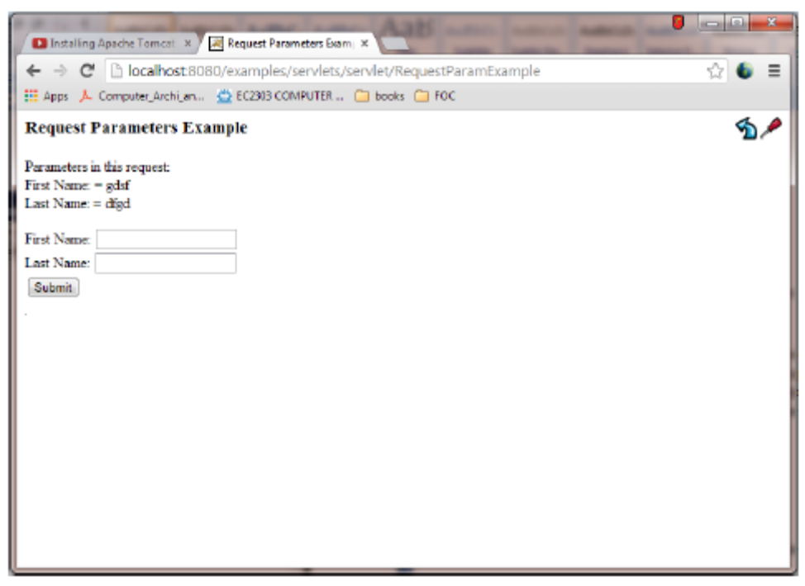
RESULT:
Thus the program to simple servlet to display requested parameter information was executed successfully.

Ex.No: 5
Date:
Topic: Basic Servlet -Cookies
AIM:
To write a simple servlet program to display the requested information
PROCEDURE:
Servlets are Java classes which service HTTP requests and implement the javax.servlet.Servletinterface. Web application developers typically write servlets that extend javax.servlet.http.HttpServlet, an abstract class that implements the Servlet interface and is specially designed to handle HTTP requests.
PROGRAM:

OUTPUT:
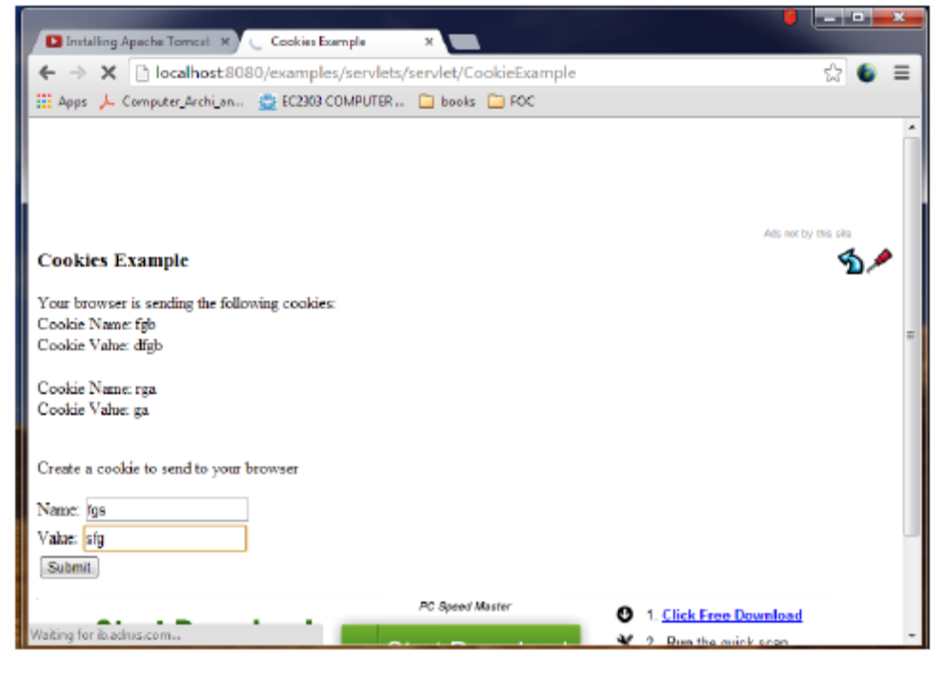
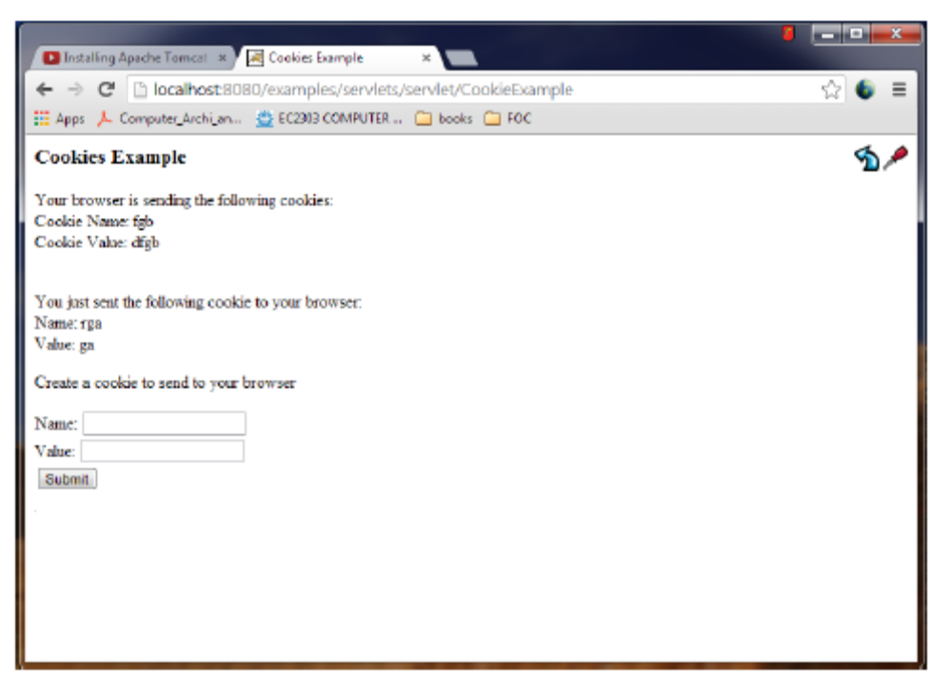

RESULT:
Thus the program to simple servlet to display cookies was executed successfully.
Ex.No: 6
Date:
Topic: Basic Servlet -Session
AIM:
To write a simple servlet program to display session
PROCEDURE:
Servlets are Java classes which service HTTP requests and implement the javax.servlet.Servletinterface. Web application developers typically write servlets that extend javax.servlet.http.HttpServlet, an abstract class that implements the Servlet interface and is specially designed to handle HTTP requests.
PROGRAM:

OUTPUT:
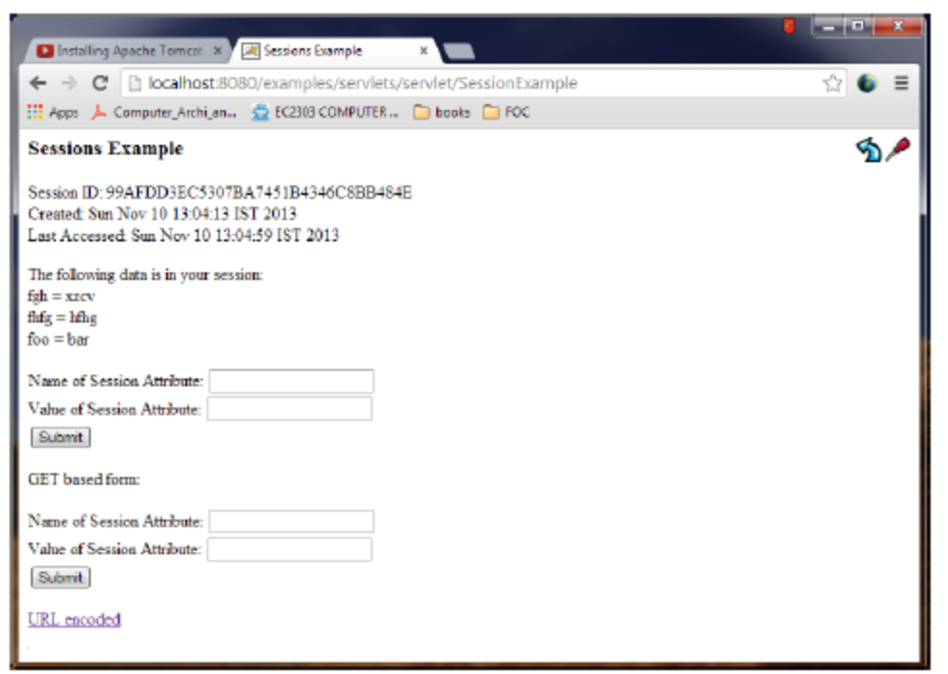

RESULT:
Thus the program to simple servlet to display session was executed successfully.
Ex.No: 7
Date:
Topic: To invoke servlets from HTML forms
AIM:
To write a servlet program to invoke servlets from HTML forms
PROCEDURE:
Apache software foundation is installed.
Write HTML program and save it in servlet folder.
Execute java program and save it in classes folder.
Execute the program based on the conditions.
PROGRAM:

OUTPUT:
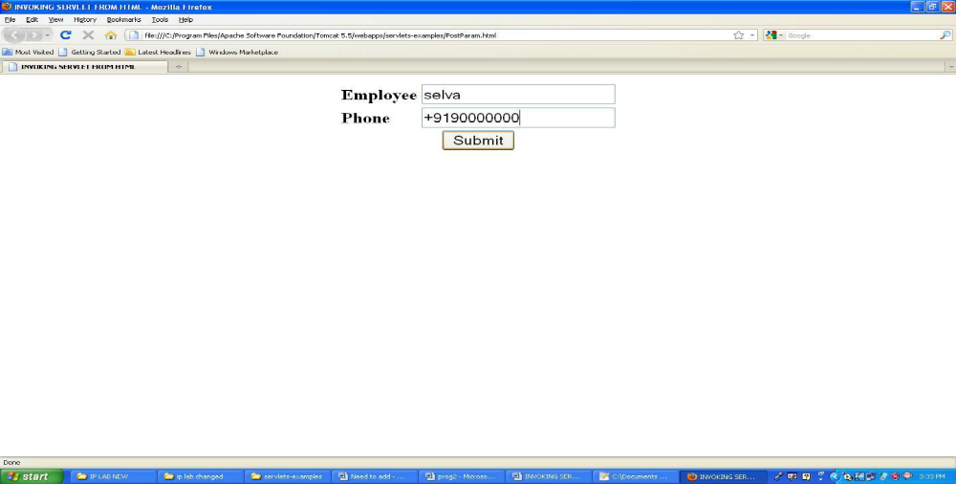

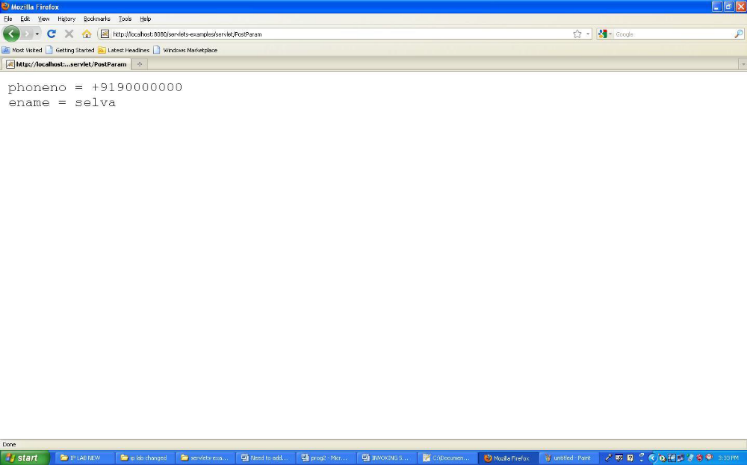
RESULT:
Thus the servlet program to invoke servlet from HTML forms was created and executed successfully.
Ex.No: 8
Date:
Topic: To invoke servlets from applets
Aim:
To write a applet to servlet program.
Algorithm:
Step1: Start the program
Step2: Write the servlet example program and save it in java
Step3: Write the xml in program and save in the file with extension filename.xml
Step 4: Save the AppletServletExample in java files
Step 5: Stop the program.
CODING:

OUTPUT:

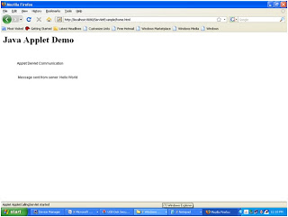

RESULT:
Thus the servlet program to invoke servlet from applet was created and executed successfully.

