RAJALAKSHMI INSTITUTE OF TECHNOLOGY
DEPARTMENT OF INFORMATION TECHNOLOGY
IT-6512
WEB PROGRAMMING
WORKBOOK AND LAB MANUAL

Name of the Student :
Roll No :
Class :
XML was designed to transport and store data.
HTML was designed to display data.

What You Should Already Know
Before you continue you should have a basic understanding of the following:
- HTML
- JavaScript
If you want to study these subjects first, find the tutorials on our Home page.

What is XML?
- XML stands for EXtensible Markup Language
- XML is a markup language much like HTML
- XML was designed to carry data, not to display data
- XML tags are not predefined. You must define your own tags
- XML is designed to be self-descriptive
- XML is a W3C Recommendation

The Difference Between XML and HTML
XML is not a replacement for HTML.
XML and HTML were designed with different goals:
- XML was designed to transport and store data, with focus on what data is
- HTML was designed to display data, with focus on how data looks
HTML is about displaying information, while XML is about carrying information.

XML Does Not DO Anything
Maybe it is a little hard to understand, but XML does not DO anything. XML was created to structure, store, and transport information.
The following example is a note to Tove, from Jani, stored as XML:
<note>
<to>Tove</to>
<from>Jani</from>
<heading>Reminder</heading>
<body>Don't forget me this weekend!</body>
</note>
The note above is quite self descriptive. It has sender and receiver information, it also has a heading and a message body.
But still, this XML document does not DO anything. It is just information wrapped in tags. Someone must write a piece of software to send, receive or display it.

With XML You Invent Your Own Tags
The tags in the example above (like <to> and <from>) are not defined in any XML standard. These tags are "invented" by the author of the XML document.
That is because the XML language has no predefined tags.
The tags used in HTML are predefined. HTML documents can only use tags defined in the HTML standard (like <p>, <h1>, etc.).
XML allows the author to define his/her own tags and his/her own document structure.

XML is Not a Replacement for HTML
XML is a complement to HTML.
It is important to understand that XML is not a replacement for HTML. In most web applications, XML is used to transport data, while HTML is used to format and display the data.
My best description of XML is this:
XML is a software- and hardware-independent tool for carrying information.

XML is a W3C Recommendation
XML became a W3C Recommendation on February 10, 1998.

XML is Everywhere
XML is now as important for the Web as HTML was to the foundation of the Web.
XML is the most common tool for data transmissions between all sorts of applications.
XML is used in many aspects of web development, often to simplify data storage and sharing.

XML Separates Data from HTML
If you need to display dynamic data in your HTML document, it will take a lot of work to edit the HTML each time the data changes.
With XML, data can be stored in separate XML files. This way you can concentrate on using HTML/CSS for display and layout, and be sure that changes in the underlying data will not require any changes to the HTML.
With a few lines of JavaScript code, you can read an external XML file and update the data content of your web page.

XML Simplifies Data Sharing
In the real world, computer systems and databases contain data in incompatible formats.
XML data is stored in plain text format. This provides a software- and hardware-independent way of storing data.
This makes it much easier to create data that can be shared by different applications.

XML Simplifies Data Transport
One of the most time-consuming challenges for developers is to exchange data between incompatible systems over the Internet.
Exchanging data as XML greatly reduces this complexity, since the data can be read by different incompatible applications.

XML Simplifies Platform Changes
Upgrading to new systems (hardware or software platforms), is always time consuming. Large amounts of data must be converted and incompatible data is often lost.
XML data is stored in text format. This makes it easier to expand or upgrade to new operating systems, new applications, or new browsers, without losing data.

XML Makes Your Data More Available
Different applications can access your data, not only in HTML pages, but also from XML data sources.
With XML, your data can be available to all kinds of "reading machines" (Handheld computers, voice machines, news feeds, etc), and make it more available for blind people, or people with other disabilities.

XML is Used to Create New Internet Languages
A lot of new Internet languages are created with XML.
Here are some examples:
- XHTML
- WSDL for describing available web services
- WAP and WML as markup languages for handheld devices
- RSS languages for news feeds
- RDF and OWL for describing resources and ontology
- SMIL for describing multimedia for the web

If Developers Have Sense
If they DO have sense, future applications will exchange their data in XML.
The future might give us word processors, spreadsheet applications and databases that can read each other's data in XML format, without any conversion utilities in between.
XML documents form a tree structure that starts at "the root" and branches to "the leaves".

An Example XML Document
XML documents use a self-describing and simple syntax:
<?xml version="1.0" encoding="ISO-8859-1"?>
<note>
<to>Tove</to>
<from>Jani</from>
<heading>Reminder</heading>
<body>Don't forget me this weekend!</body>
</note>
The first line is the XML declaration. It defines the XML version (1.0) and the encoding used (ISO-8859-1 = Latin-1/West European character set).
The next line describes the root element of the document (like saying: "this document is a note"):
<note>
The next 4 lines describe 4 child elements of the root (to, from, heading, and body):
<to>Tove</to>
<from>Jani</from>
<heading>Reminder</heading>
<body>Don't forget me this weekend!</body>
And finally the last line defines the end of the root element:
</note>
You can assume, from this example, that the XML document contains a note to Tove from Jani.
Don't you agree that XML is pretty self-descriptive?

XML Documents Form a Tree Structure
XML documents must contain a root element. This element is "the parent" of all other elements.
The elements in an XML document form a document tree. The tree starts at the root and branches to the lowest level of the tree.
All elements can have sub elements (child elements):
<root>
<child>
<subchild>.....</subchild>
</child>
</root>
The terms parent, child, and sibling are used to describe the relationships between elements. Parent elements have children. Children on the same level are called siblings (brothers or sisters).
All elements can have text content and attributes (just like in HTML).

Example:
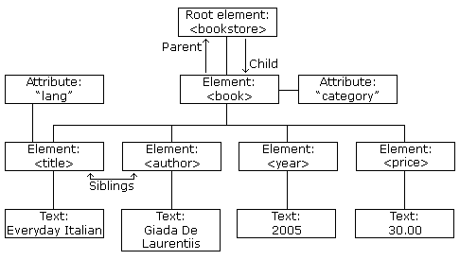
The image above represents one book in the XML below:
<bookstore>
<book category="COOKING">
<title lang="en">Everyday Italian</title>
<author>Giada De Laurentiis</author>
<year>2005</year>
<price>30.00</price>
</book>
<book category="CHILDREN">
<title lang="en">Harry Potter</title>
<author>J K. Rowling</author>
<year>2005</year>
<price>29.99</price>
</book>
<book category="WEB">
<title lang="en">Learning XML</title>
<author>Erik T. Ray</author>
<year>2003</year>
<price>39.95</price>
</book>
</bookstore>
The root element in the example is <bookstore>. All <book> elements in the document are contained within <bookstore>.
The <book> element has 4 children: <title>,< author>, <year>, <price>.
The syntax rules of XML are very simple and logical. The rules are easy to learn, and easy to use.

All XML Elements Must Have a Closing Tag
In HTML, some elements do not have to have a closing tag:
<p>This is a paragraph.
<br>
In XML, it is illegal to omit the closing tag. All elements must have a closing tag:
<p>This is a paragraph.</p>
<br />
Note: You might have noticed from the previous example that the XML declaration did not have a closing tag. This is not an error. The declaration is not a part of the XML document itself, and it has no closing tag.

XML Tags are Case Sensitive
XML tags are case sensitive. The tag <Letter> is different from the tag <letter>.
Opening and closing tags must be written with the same case:
<Message>This is incorrect</message>
<message>This is correct</message>
Note: "Opening and closing tags" are often referred to as "Start and end tags". Use whatever you prefer. It is exactly the same thing.

XML Elements Must be Properly Nested
In HTML, you might see improperly nested elements:
<b><i>This text is bold and italic</b></i>
In XML, all elements must be properly nested within each other:
<b><i>This text is bold and italic</i></b>
In the example above, "Properly nested" simply means that since the <i> element is opened inside the <b> element, it must be closed inside the <b> element.

XML Documents Must Have a Root Element
XML documents must contain one element that is the parent of all other elements. This element is called the rootelement.
<root>
<child>
<subchild>.....</subchild>
</child>
</root>

XML Attribute Values Must be Quoted
XML elements can have attributes in name/value pairs just like in HTML.
In XML, the attribute values must always be quoted.
Study the two XML documents below. The first one is incorrect, the second is correct:
<note date=12/11/2007>
<to>Tove</to>
<from>Jani</from>
</note>

<note date="12/11/2007">
<to>Tove</to>
<from>Jani</from>
</note>
The error in the first document is that the date attribute in the note element is not quoted.

Entity References
Some characters have a special meaning in XML.
If you place a character like "<" inside an XML element, it will generate an error because the parser interprets it as the start of a new element.
This will generate an XML error:
<message>if salary < 1000 then</message>
To avoid this error, replace the "<" character with an entity reference:
<message>if salary &lt; 1000 then</message>
There are 5 predefined entity references in XML:
&lt; | < | less than
&gt; | > | greater than
&amp; | & | ampersand
&apos; | ' | apostrophe
&quot; | " | quotation mark
Note: Only the characters "<" and "&" are strictly illegal in XML. The greater than character is legal, but it is a good habit to replace it.

Comments in XML
The syntax for writing comments in XML is similar to that of HTML.
<!-- This is a comment -->

White-space is Preserved in XML
HTML truncates multiple white-space characters to one single white-space:
HTML: | Hello Tove
Output: | Hello Tove
With XML, the white-space in a document is not truncated.

XML Stores New Line as LF
Windows applications stores a new line as: carriage return and line feed (CR+LF).
Unix and Mac OSX uses LF.
Old Mac systems uses CR.
XML stores a new line as LF.

An XML document contains XML Elements.

What is an XML Element?
An XML element is everything from (including) the element's start tag to (including) the element's end tag.
An element can contain:
- other elements
- text
- attributes
- or a mix of all of the above...
<bookstore>
<book category="CHILDREN">
<title>Harry Potter</title>
<author>J K. Rowling</author>
<year>2005</year>
<price>29.99</price>
</book>
<book category="WEB">
<title>Learning XML</title>
<author>Erik T. Ray</author>
<year>2003</year>
<price>39.95</price>
</book>
</bookstore>
In the example above, <bookstore> and <book> have element contents, because they contain other elements. <book> also has an attribute (category="CHILDREN"). <title>, <author>, <year>, and <price> have text content because they contain text.

XML Naming Rules
XML elements must follow these naming rules:
- Names can contain letters, numbers, and other characters
- Names cannot start with a number or punctuation character
- Names cannot start with the letters xml (or XML, or Xml, etc)
- Names cannot contain spaces
Any name can be used, no words are reserved.

Best Naming Practices
Make names descriptive. Names with an underscore separator are nice: <first_name>, <last_name>.
Names should be short and simple, like this: <book_title> not like this: <the_title_of_the_book>.
Avoid "-" characters. If you name something "first-name," some software may think you want to subtract name from first.
Avoid "." characters. If you name something "first.name," some software may think that "name" is a property of the object "first."
Avoid ":" characters. Colons are reserved to be used for something called namespaces (more later).
XML documents often have a corresponding database. A good practice is to use the naming rules of your database for the elements in the XML documents.
Non-English letters like éòá are perfectly legal in XML, but watch out for problems if your software vendor doesn't support them.

XML Elements are Extensible
XML elements can be extended to carry more information.
Look at the following XML example:
<note>
<to>Tove</to>
<from>Jani</from>
<body>Don't forget me this weekend!</body>
</note>
Let's imagine that we created an application that extracted the <to>, <from>, and <body> elements from the XML document to produce this output:
MESSAGE
To: Tove
From: Jani
Don't forget me this weekend!
Imagine that the author of the XML document added some extra information to it:
<note>
<date>2008-01-10</date>
<to>Tove</to>
<from>Jani</from>
<heading>Reminder</heading>
<body>Don't forget me this weekend!</body>
</note>
Should the application break or crash?
No. The application should still be able to find the <to>, <from>, and <body> elements in the XML document and produce the same output.
One of the beauties of XML, is that it can be extended without breaking applications.
XML elements can have attributes, just like HTML.
Attributes provide additional information about an element.

XML Attributes
In HTML, attributes provide additional information about elements:
<img src="computer.gif">
<a href="demo.asp">
Attributes often provide information that is not a part of the data. In the example below, the file type is irrelevant to the data, but can be important to the software that wants to manipulate the element:
<file type="gif">computer.gif</file>

XML Attributes Must be Quoted
Attribute values must always be quoted. Either single or double quotes can be used. For a person's sex, the person element can be written like this:
<person sex="female">
or like this:
<person sex='female'>
If the attribute value itself contains double quotes you can use single quotes, like in this example:
<gangster name='George "Shotgun" Ziegler'>
or you can use character entities:
<gangster name="George &quot;Shotgun&quot; Ziegler">

XML Elements vs. Attributes
Take a look at these examples:
<person sex="female">
<firstname>Anna</firstname>
<lastname>Smith</lastname>
</person>

<person>
<sex>female</sex>
<firstname>Anna</firstname>
<lastname>Smith</lastname>
</person>
In the first example sex is an attribute. In the last, sex is an element. Both examples provide the same information.
There are no rules about when to use attributes or when to use elements. Attributes are handy in HTML. In XML my advice is to avoid them. Use elements instead.

My Favorite Way
The following three XML documents contain exactly the same information:
A date attribute is used in the first example:
<note date="10/01/2008">
<to>Tove</to>
<from>Jani</from>
<heading>Reminder</heading>
<body>Don't forget me this weekend!</body>
</note>
A date element is used in the second example:
<note>
<date>10/01/2008</date>
<to>Tove</to>
<from>Jani</from>
<heading>Reminder</heading>
<body>Don't forget me this weekend!</body>
</note>
An expanded date element is used in the third: (THIS IS MY FAVORITE):
<note>
<date>
<day>10</day>
<month>01</month>
<year>2008</year>
</date>
<to>Tove</to>
<from>Jani</from>
<heading>Reminder</heading>
<body>Don't forget me this weekend!</body>
</note>

Avoid XML Attributes?
Some of the problems with using attributes are:
- attributes cannot contain multiple values (elements can)
- attributes cannot contain tree structures (elements can)
- attributes are not easily expandable (for future changes)
Attributes are difficult to read and maintain. Use elements for data. Use attributes for information that is not relevant to the data.
Don't end up like this:
<note day="10" month="01" year="2008"
to="Tove" from="Jani" heading="Reminder"
body="Don't forget me this weekend!">
</note>

XML Attributes for Metadata
Sometimes ID references are assigned to elements. These IDs can be used to identify XML elements in much the same way as the id attribute in HTML. This example demonstrates this:
<messages>
<note id="501">
<to>Tove</to>
<from>Jani</from>
<heading>Reminder</heading>
<body>Don't forget me this weekend!</body>
</note>
<note id="502">
<to>Jani</to>
<from>Tove</from>
<heading>Re: Reminder</heading>
<body>I will not</body>
</note>
</messages>
The id attributes above are for identifying the different notes. It is not a part of the note itself.
What I'm trying to say here is that metadata (data about data) should be stored as attributes, and the data itself should be stored as elements.
XML with correct syntax is "Well Formed" XML.
XML validated against a DTD is "Valid" XML.

Well Formed XML Documents
A "Well Formed" XML document has correct XML syntax.
The syntax rules were described in the previous chapters:
- XML documents must have a root element
- XML elements must have a closing tag
- XML tags are case sensitive
- XML elements must be properly nested
- XML attribute values must be quoted
<?xml version="1.0" encoding="ISO-8859-1"?>
<note>
<to>Tove</to>
<from>Jani</from>
<heading>Reminder</heading>
<body>Don't forget me this weekend!</body>
</note>

Valid XML Documents
A "Valid" XML document is a "Well Formed" XML document, which also conforms to the rules of a Document Type Definition (DTD):
<?xml version="1.0" encoding="ISO-8859-1"?>
<!DOCTYPE note SYSTEM "Note.dtd">
<note>
<to>Tove</to>
<from>Jani</from>
<heading>Reminder</heading>
<body>Don't forget me this weekend!</body>
</note>
The DOCTYPE declaration, in the example above, is a reference to an external DTD file. The content of the file is shown in the paragraph below.

XML DTD
The purpose of a DTD is to define the structure of an XML document. It defines the structure with a list of legal elements:
<!DOCTYPE note
[
<!ELEMENT note (to,from,heading,body)>
<!ELEMENT to (#PCDATA)>
<!ELEMENT from (#PCDATA)>
<!ELEMENT heading (#PCDATA)>
<!ELEMENT body (#PCDATA)>
]>
.

XML Schema
W3C supports an XML-based alternative to DTD, called XML Schema:
<xs:element name="note">
<xs:complexType>
<xs:sequence>
<xs:element name="to" type="xs:string"/>
<xs:element name="from" type="xs:string"/>
<xs:element name="heading" type="xs:string"/>
<xs:element name="body" type="xs:string"/>
</xs:sequence>
</xs:complexType>
</xs:element>
.

Raw XML files can be viewed in all major browsers.
Don't expect XML files to be displayed as HTML pages.

Viewing XML Files
<?xml version="1.0" encoding="ISO-8859-1"?>
- <note>
<to>Tove</to>
<from>Jani</from>
<heading>Reminder</heading>
<body>Don't forget me this weekend!</body>
</note>
Look at this XML file: note.xml
The XML document will be displayed with color-coded root and child elements. A plus (+) or minus sign (-) to the left of the elements can be clicked to expand or collapse the element structure. To view the raw XML source (without the + and - signs), select "View Page Source" or "View Source" from the browser menu.
Note: In Safari, only the element text will be displayed. To view the raw XML, you must right click the page and select "View Source"

Viewing an Invalid XML File
If an erroneous XML file is opened, the browser will report the error.
Why Does XML Display Like This?
XML documents do not carry information about how to display the data.
Since XML tags are "invented" by the author of the XML document, browsers do not know if a tag like <table> describes an HTML table or a dining table.
Without any information about how to display the data, most browsers will just display the XML document as it is.
In the next chapters, we will look at different solutions for the display problem, using CSS, XSLT, and JavaScript.
With CSS (Cascading Style Sheets) you can add display information to an XML document.

Displaying your XML Files with CSS?
It is possible to use CSS to format an XML document.
Below is an example of how to use a CSS style sheet to format an XML document:
Take a look at this XML file: The CD catalog
Then look at this style sheet: The CSS file
Finally, view: The CD catalog formatted with the CSS file
Below is a fraction of the XML file. The second line links the XML file to the CSS file:
<?xml version="1.0" encoding="ISO-8859-1"?>
<?xml-stylesheet type="text/css" href="cd_catalog.css"?>
<CATALOG>
<CD>
<TITLE>Empire Burlesque</TITLE>
<ARTIST>Bob Dylan</ARTIST>
<COUNTRY>USA</COUNTRY>
<COMPANY>Columbia</COMPANY>
<PRICE>10.90</PRICE>
<YEAR>1985</YEAR>
</CD>
<CD>
<TITLE>Hide your heart</TITLE>
<ARTIST>Bonnie Tyler</ARTIST>
<COUNTRY>UK</COUNTRY>
<COMPANY>CBS Records</COMPANY>
<PRICE>9.90</PRICE>
<YEAR>1988</YEAR>
</CD>
.
.
.
</CATALOG>
Formatting XML with CSS is not the most common method.
With XSLT you can transform an XML document into HTML.

Displaying XML with XSLT
XSLT is the recommended style sheet language of XML.
XSLT (eXtensible Stylesheet Language Transformations) is far more sophisticated than CSS.
XSLT can be used to transform XML into HTML, before it is displayed by a browser:
The XMLHttpRequest Object
The XMLHttpRequest object is used to exchange data with a server behind the scenes.
The XMLHttpRequest object is a developer's dream, because you can:
- Update a web page without reloading the page
- Request data from a server after the page has loaded
- Receive data from a server after the page has loaded
- Send data to a server in the background
Create an XMLHttpRequest Object
- All modern browsers (IE7+, Firefox, Chrome, Safari, and Opera) have a built-in XMLHttpRequest object.
- Syntax for creating an XMLHttpRequest object:
- xmlhttp=new XMLHttpRequest();
- Old versions of Internet Explorer (IE5 and IE6) use an ActiveX Object:
- xmlhttp=new ActiveXObject("Microsoft.XMLHTTP");

All modern browsers have a built-in XML parser.
An XML parser converts an XML document into an XML DOM object - which can then be manipulated with JavaScript.

Parse an XML Document
The following code fragment parses an XML document into an XML DOM object:
if (window.XMLHttpRequest)
{// code for IE7+, Firefox, Chrome, Opera, Safari
xmlhttp=new XMLHttpRequest();
}
else
{// code for IE6, IE5
xmlhttp=new ActiveXObject("Microsoft.XMLHTTP");
}
xmlhttp.open("GET","books.xml",false);
xmlhttp.send();
xmlDoc=xmlhttp.responseXML;

Parse an XML String
The following code fragment parses an XML string into an XML DOM object:
txt="<bookstore><book>";
txt=txt+"<title>Everyday Italian</title>";
txt=txt+"<author>Giada De Laurentiis</author>";
txt=txt+"<year>2005</year>";
txt=txt+"</book></bookstore>";
if (window.DOMParser)
{
parser=new DOMParser();
xmlDoc=parser.parseFromString(txt,"text/xml");
}
else // Internet Explorer
{
xmlDoc=new ActiveXObject("Microsoft.XMLDOM");
xmlDoc.async=false;
xmlDoc.loadXML(txt);
}
Note: Internet Explorer uses the loadXML() method to parse an XML string, while other browsers use the DOMParser object.

Access Across Domains
For security reasons, modern browsers do not allow access across domains.
This means, that both the web page and the XML file it tries to load, must be located on the same server.
A DOM (Document Object Model) defines a standard way for accessing and manipulating documents.

The XML DOM
The XML DOM defines a standard way for accessing and manipulating XML documents.
The XML DOM views an XML document as a tree-structure.
All elements can be accessed through the DOM tree. Their content (text and attributes) can be modified or deleted, and new elements can be created. The elements, their text, and their attributes are all known as nodes.

The HTML DOM
The HTML DOM defines a standard way for accessing and manipulating HTML documents.
All HTML elements can be accessed through the HTML DOM.

Load an XML File - Cross-browser Example
The following example parses an XML document ("note.xml") into an XML DOM object and then extracts some info from it with a JavaScript:
Example
<html>
<body>
<h1>W3Schools Internal Note</h1>
<div>
<b>To:</b> <span id="to"></span><br />
<b>From:</b> <span id="from"></span><br />
<b>Message:</b> <span id="message"></span>
</div>
<script>
if (window.XMLHttpRequest)
{// code for IE7+, Firefox, Chrome, Opera, Safari
xmlhttp=new XMLHttpRequest();
}
else
{// code for IE6, IE5
xmlhttp=new ActiveXObject("Microsoft.XMLHTTP");
}
xmlhttp.open("GET","note.xml",false);
xmlhttp.send();
xmlDoc=xmlhttp.responseXML;
document.getElementById("to").innerHTML=
xmlDoc.getElementsByTagName("to")[0].childNodes[0].nodeValue;
document.getElementById("from").innerHTML=
xmlDoc.getElementsByTagName("from")[0].childNodes[0].nodeValue;
document.getElementById("message").innerHTML=
xmlDoc.getElementsByTagName("body")[0].childNodes[0].nodeValue;
</script>
</body>
</html>
Important Note!
To extract the text "Tove" from the <to> element in the XML file above ("note.xml"), the syntax is:
getElementsByTagName("to")[0].childNodes[0].nodeValue
Notice that even if the XML file contains only ONE <to> element you still have to specify the array index [0]. This is because the getElementsByTagName() method returns an array.

Load an XML String - Cross-browser Example
The following example parses an XML string into an XML DOM object and then extracts some info from it with a JavaScript:
Example
<html>
<body>
<h1>W3Schools Internal Note</h1>
<div>
<b>To:</b> <span id="to"></span><br />
<b>From:</b> <span id="from"></span><br />
<b>Message:</b> <span id="message"></span>
</div>
<script>
txt="<note>";
txt=txt+"<to>Tove</to>";
txt=txt+"<from>Jani</from>";
txt=txt+"<heading>Reminder</heading>";
txt=txt+"<body>Don't forget me this weekend!</body>";
txt=txt+"</note>";
if (window.DOMParser)
{
parser=new DOMParser();
xmlDoc=parser.parseFromString(txt,"text/xml");
}
else // Internet Explorer
{
xmlDoc=new ActiveXObject("Microsoft.XMLDOM");
xmlDoc.async=false;
xmlDoc.loadXML(txt);
}
document.getElementById("to").innerHTML=
xmlDoc.getElementsByTagName("to")[0].childNodes[0].nodeValue;
document.getElementById("from").innerHTML=
xmlDoc.getElementsByTagName("from")[0].childNodes[0].nodeValue;
document.getElementById("message").innerHTML=
xmlDoc.getElementsByTagName("body")[0].childNodes[0].nodeValue;
</script>
</body>
</html>
Display XML Data in an HTML Page
In the following example, we open an XML file ("cd_catalog.xml"), then we loop through each CD element, and display the value of the ARTIST element and the TITLE element in an HTML table:
Example
<html>
<body>
<script>
if (window.XMLHttpRequest)
{// code for IE7+, Firefox, Chrome, Opera, Safari
xmlhttp=new XMLHttpRequest();
}
else
{// code for IE6, IE5
xmlhttp=new ActiveXObject("Microsoft.XMLHTTP");
}
xmlhttp.open("GET","cd_catalog.xml",false);
xmlhttp.send();
xmlDoc=xmlhttp.responseXML;
document.write("<table border='1'>");
var x=xmlDoc.getElementsByTagName("CD");
for (i=0;i<x.length;i++)
{
document.write("<tr><td>");
document.write(x[i].getElementsByTagName("ARTIST")[0].childNodes[0].nodeValue);
document.write("</td><td>");
document.write(x[i].getElementsByTagName("TITLE")[0].childNodes[0].nodeValue);
document.write("</td></tr>");
}
document.write("</table>");
</script>
</body>
</html>
The XML Document Used
In this application we will use the "cd_catalog.xml" file.

Display the First CD in an HTML div Element
The following example gets the XML data from the first CD element and displays it in an HTML element with id="showCD". The displayCD() function is called when the page is loaded:
Example
x=xmlDoc.getElementsByTagName("CD");
i=0;
function displayCD()
{
artist=(x[i].getElementsByTagName("ARTIST")[0].childNodes[0].nodeValue);
title=(x[i].getElementsByTagName("TITLE")[0].childNodes[0].nodeValue);
year=(x[i].getElementsByTagName("YEAR")[0].childNodes[0].nodeValue);
txt="Artist: " + artist + "<br />Title: " + title + "<br />Year: "+ year;
document.getElementById("showCD").innerHTML=txt;
}
Navigate Between the CDs
To navigate between the CDs, in the example above, add a next() and previous() function:
Example
function next()
{ // display the next CD, unless you are on the last CD
if (i<x.length-1)
{
i++;
displayCD();
}
}
function previous()
{ // displays the previous CD, unless you are on the first CD
if (i>0)
{
i--;
displayCD();
}
}
XML Namespaces provide a method to avoid element name conflicts.

Name Conflicts
In XML, element names are defined by the developer. This often results in a conflict when trying to mix XML documents from different XML applications.
This XML carries HTML table information:
<table>
<tr>
<td>Apples</td>
<td>Bananas</td>
</tr>
</table>
This XML carries information about a table (a piece of furniture):
<table>
<name>African Coffee Table</name>
<width>80</width>
<length>120</length>
</table>
If these XML fragments were added together, there would be a name conflict. Both contain a <table> element, but the elements have different content and meaning.
An XML parser will not know how to handle these differences.
Solving the Name Conflict Using a Prefix
Name conflicts in XML can easily be avoided using a name prefix.
This XML carries information about an HTML table, and a piece of furniture:
<h:table>
<h:tr>
<h:td>Apples</h:td>
<h:td>Bananas</h:td>
</h:tr>
</h:table>
<f:table>
<f:name>African Coffee Table</f:name>
<f:width>80</f:width>
<f:length>120</f:length>
</f:table>
In the example above, there will be no conflict because the two <table> elements have different names.

XML Namespaces - The xmlns Attribute
When using prefixes in XML, a so-called namespace for the prefix must be defined.
The namespace is defined by the xmlns attribute in the start tag of an element.
The namespace declaration has the following syntax. xmlns:prefix="URI".
<root>
<h:table xmlns:h="http://www.w3.org/TR/html4/">
<h:tr>
<h:td>Apples</h:td>
<h:td>Bananas</h:td>
</h:tr>
</h:table>
<f:table xmlns:f="http://www.w3schools.com/furniture">
<f:name>African Coffee Table</f:name>
<f:width>80</f:width>
<f:length>120</f:length>
</f:table>
</root>
In the example above, the xmlns attribute in the <table> tag give the h: and f: prefixes a qualified namespace.
When a namespace is defined for an element, all child elements with the same prefix are associated with the same namespace.
Namespaces can be declared in the elements where they are used or in the XML root element:
<root xmlns:h="http://www.w3.org/TR/html4/"
xmlns:f="http://www.w3schools.com/furniture">
<h:table>
<h:tr>
<h:td>Apples</h:td>
<h:td>Bananas</h:td>
</h:tr>
</h:table>
<f:table>
<f:name>African Coffee Table</f:name>
<f:width>80</f:width>
<f:length>120</f:length>
</f:table>
</root>
Note: The namespace URI is not used by the parser to look up information.
The purpose is to give the namespace a unique name. However, often companies use the namespace as a pointer to a web page containing namespace information.
Try to go to http://www.w3.org/TR/html4/.

Uniform Resource Identifier (URI)
A Uniform Resource Identifier (URI) is a string of characters which identifies an Internet Resource.
The most common URI is the Uniform Resource Locator (URL) which identifies an Internet domain address. Another, not so common type of URI is the Universal Resource Name (URN).
In our examples we will only use URLs.

Default Namespaces
Defining a default namespace for an element saves us from using prefixes in all the child elements. It has the following syntax:
xmlns="namespaceURI"
This XML carries HTML table information:
<table xmlns="http://www.w3.org/TR/html4/">
<tr>
<td>Apples</td>
<td>Bananas</td>
</tr>
</table>
This XML carries information about a piece of furniture:
<table xmlns="http://www.w3schools.com/furniture">
<name>African Coffee Table</name>
<width>80</width>
<length>120</length>
</table>

Namespaces in Real Use
XSLT is an XML language that can be used to transform XML documents into other formats, like HTML.
In the XSLT document below, you can see that most of the tags are HTML tags.
The tags that are not HTML tags have the prefix xsl, identified by the namespace xmlns:xsl="http://www.w3.org/1999/XSL/Transform":
<?xml version="1.0" encoding="ISO-8859-1"?>
<xsl:stylesheet version="1.0"
xmlns:xsl="http://www.w3.org/1999/XSL/Transform">
<xsl:template match="/">
<html>
<body>
<h2>My CD Collection</h2>
<table border="1">
<tr>
<th style="text-align:left">Title</th>
<th style="text-align:left">Artist</th>
</tr>
<xsl:for-each select="catalog/cd">
<tr>
<td><xsl:value-of select="title"/></td>
<td><xsl:value-of select="artist"/></td>
</tr>
</xsl:for-each>
</table>
</body>
</html>
</xsl:template>
</xsl:stylesheet>
All text in an XML document will be parsed by the parser.
But text inside a CDATA section will be ignored by the parser.

PCDATA - Parsed Character Data
XML parsers normally parse all the text in an XML document.
When an XML element is parsed, the text between the XML tags is also parsed:
<message>This text is also parsed</message>
The parser does this because XML elements can contain other elements, as in this example, where the <name> element contains two other elements (first and last):
<name><first>Bill</first><last>Gates</last></name>
and the parser will break it up into sub-elements like this:
<name>
<first>Bill</first>
<last>Gates</last>
</name>
Parsed Character Data (PCDATA) is a term used about text data that will be parsed by the XML parser.

CDATA - (Unparsed) Character Data
The term CDATA is used about text data that should not be parsed by the XML parser.
Characters like "<" and "&" are illegal in XML elements.
"<" will generate an error because the parser interprets it as the start of a new element.
"&" will generate an error because the parser interprets it as the start of an character entity.
Some text, like JavaScript code, contains a lot of "<" or "&" characters. To avoid errors script code can be defined as CDATA.
Everything inside a CDATA section is ignored by the parser.
A CDATA section starts with "<![CDATA[" and ends with "]]>":
<script>
<![CDATA[
function matchwo(a,b)
{
if (a < b && a < 0) then
{
return 1;
}
else
{
return 0;
}
}
]]>
</script>
In the example above, everything inside the CDATA section is ignored by the parser.
Notes on CDATA sections:
A CDATA section cannot contain the string "]]>". Nested CDATA sections are not allowed.
The "]]>" that marks the end of the CDATA section cannot contain spaces or line breaks.
XML documents can contain non ASCII characters, like Norwegian æ ø å , or French ê è é.
To avoid errors, specify the XML encoding, or save XML files as Unicode.

XML Encoding Errors
If you load an XML document, you can get two different errors indicating encoding problems:
An invalid character was found in text content.
You get this error if your XML contains non ASCII characters, and the file was saved as single-byte ANSI (or ASCII) with no encoding specified.
Single byte XML file with encoding attribute.
Same single byte XML file with no encoding attribute.
Switch from current encoding to specified encoding not supported.
You get this error if your XML file was saved as double-byte Unicode (or UTF-16) with a single-byte encoding (Windows-1252, ISO-8859-1, UTF-8) specified.
You also get this error if your XML file was saved with single-byte ANSI (or ASCII), with double-byte encoding (UTF-16) specified.
Double byte XML file without encoding.
Same double byte XML file with single byte encoding.

Windows Notepad
Windows Notepad save files as single-byte ANSI (ASCII) by default.
If you select "Save as...", you can specify ANSI, UTF-8, Unicode(UTF-16), or Unicode Big.
Experiment with the XML below (without any coding attribute), and save it as ANSI, UTF-8, and Unicode.
<?xml version="1.0"?>
<note>
<from>Jani</from>
<to>Tove</to>
<message>Norwegian: æøå. French: êèé</message>
</note>
Try to drag the files into your browser, ands see the result. Different browsers will display different results.
Experiment with different encodings:
<?xml version="1.0" encoding="us-ascii"?>
<?xml version="1.0" encoding="windows-1252"?>
<?xml version="1.0" encoding="ISO-8859-1"?>
<?xml version="1.0" encoding="UTF-8"?>
<?xml version="1.0" encoding="UTF-16"?>
Conclusion
- Always use the encoding attribute
- Use an editor that supports encoding
- Make sure you know what encoding the editor uses
- Use the same encoding in your encoding attribute

XML files are plain text files just like HTML files.
XML can easily be stored and generated by a standard web server.

Storing XML Files on the Server
XML files can be stored on an Internet server exactly the same way as HTML files.
Start Windows Notepad and write the following lines:
<?xml version="1.0" encoding="ISO-8859-1"?>
<note>
<from>Jani</from>
<to>Tove</to>
<message>Remember me this weekend</message>
</note>
Save the file on your web server with a proper name like "note.xml".

Generating XML with ASP
XML can be generated on a server without any installed XML software.
To generate an XML response from the server - simply write the following code and save it as an ASP file on the web server:
<%
response.ContentType="text/xml"
response.Write("<?xml version='1.0' encoding='ISO-8859-1'?>")
response.Write("<note>")
response.Write("<from>Jani</from>")
response.Write("<to>Tove</to>")
response.Write("<message>Remember me this weekend</message>")
response.Write("</note>")
%>
Note that the content type of the response must be set to "text/xml".

Generating XML with PHP
To generate an XML response from the server using PHP, use following code:
<?php
header("Content-type: text/xml");
echo "<?xml version='1.0' encoding='ISO-8859-1'?>";
echo "<note>";
echo "<from>Jani</from>";
echo "<to>Tove</to>";
echo "<message>Remember me this weekend</message>";
echo "</note>";
?>
Note that the content type of the response header must be set to "text/xml".

Generating XML From a Database
XML can be generated from a database without any installed XML software.
To generate an XML database response from the server, simply write the following code and save it as an ASP file on the web server:
<%
response.ContentType = "text/xml"
set conn=Server.CreateObject("ADODB.Connection")
conn.provider="Microsoft.Jet.OLEDB.4.0;"
conn.open server.mappath("/db/database.mdb")
sql="select fname,lname from tblGuestBook"
set rs=Conn.Execute(sql)
response.write("<?xml version='1.0' encoding='ISO-8859-1'?>")
response.write("<guestbook>")
while (not rs.EOF)
response.write("<guest>")
response.write("<fname>" & rs("fname") & "</fname>")
response.write("<lname>" & rs("lname") & "</lname>")
response.write("</guest>")
rs.MoveNext()
wend
rs.close()
conn.close()
response.write("</guestbook>")
%>
The example above uses ASP with ADO.

Transforming XML with XSLT on the Server
This ASP transforms an XML file to XHTML on the server:
<%
'Load XML
set xml = Server.CreateObject("Microsoft.XMLDOM")
xml.async = false
xml.load(Server.MapPath("simple.xml"))
'Load XSL
set xsl = Server.CreateObject("Microsoft.XMLDOM")
xsl.async = false
xsl.load(Server.MapPath("simple.xsl"))
'Transform file
Response.Write(xml.transformNode(xsl))
%>
Example explained
- The first block of code creates an instance of the Microsoft XML parser (XMLDOM), and loads the XML file into memory.
- The second block of code creates another instance of the parser and loads the XSL file into memory.
- The last line of code transforms the XML document using the XSL document, and sends the result as XHTML to your browser. Nice!

Saving XML To a File Using ASP
This ASP example creates a simple XML document and saves it on the server:
<%
text="<note>"
text=text & "<to>Tove</to>"
text=text & "<from>Jani</from>"
text=text & "<heading>Reminder</heading>"
text=text & "<body>Don't forget me this weekend!</body>"
text=text & "</note>"
set xmlDoc=Server.CreateObject("Microsoft.XMLDOM")
xmlDoc.async=false
xmlDoc.loadXML(text)
xmlDoc.Save("test.xml")
%>

Get the Value of an Element
The XML file used in the examples below: books.xml.
The following example retrieves the text value of the first <title> element:
Example
txt=xmlDoc.getElementsByTagName("title")[0].childNodes[0].nodeValue;
Get the Value of an Attribute
The following example retrieves the text value of the "lang" attribute of the first <title> element:
Example
txt=xmlDoc.getElementsByTagName("title")[0].getAttribute("lang");
Change the Value of an Element
The following example changes the text value of the first <title> element:
Example
x=xmlDoc.getElementsByTagName("title")[0].childNodes[0];
x.nodeValue="Easy Cooking";
Create a New Attribute
The XML DOM setAttribute() method can be used to change the value of an existing attribute, or to create a new attribute.
The following example adds a new attribute (edition="first") to each <book> element:
Example
x=xmlDoc.getElementsByTagName("book");
for(i=0;i<x.length;i++)
{
x[i].setAttribute("edition","first");
}
Create an Element
The XML DOM createElement() method creates a new element node.
The XML DOM createTextNode() method creates a new text node.
The XML DOM appendChild() method adds a child node to a node (after the last child).
To create a new element with text content, it is necessary to both create a new element node and a new text node, and then append it to an existing node.
The following example creates a new element (<edition>), with the following text: First, and adds it to the first <book> element:
Example
newel=xmlDoc.createElement("edition");
newtext=xmlDoc.createTextNode("First");
newel.appendChild(newtext);
x=xmlDoc.getElementsByTagName("book");
x[0].appendChild(newel);
Example explained:
- Create an <edition> element
- Create a text node with the following text: First
- Append the text node to the new <edition> element
- Append the <edition> element to the first <book> element

Remove an Element
The following example removes the first node in the first <book> element:
Example
x=xmlDoc.getElementsByTagName("book")[0];
x.removeChild(x.childNodes[0]);
list of XML technologies.

XHTML (Extensible HTML)
A stricter and cleaner XML based version of HTML.
XML DOM (XML Document Object Model)
A standard document model for accessing and manipulating XML.
XSL (Extensible Style Sheet Language) XSL consists of three parts:
- XSLT (XSL Transform) - transforms XML into other formats, like HTML
- XSL-FO (XSL Formatting Objects)- for formatting XML to screen, paper, etc
- XPath - a language for navigating XML documents
XQuery (XML Query Language)
An XML based language for querying XML data.
DTD (Document Type Definition)
A standard for defining the legal elements in an XML document.
XSD (XML Schema)
An XML-based alternative to DTD.
XLink (XML Linking Language)
A language for creating hyperlinks in XML documents.
XPointer (XML Pointer Language)
Allows the XLink hyperlinks to point to more specific parts in the XML document.
SOAP (Simple Object Access Protocol)
An XML-based protocol to let applications exchange information over HTTP.
WSDL (Web Services Description Language)
An XML-based language for describing web services.
RDF (Resource Description Framework)
An XML-based language for describing web resources.
RSS (Really Simple Syndication)
A format for syndicating news and the content of news-like sites.
SVG (Scalable Vector Graphics)
Defines graphics in XML format.
Some examples of how XML can be used to exchange information.

Example: XML News
XMLNews is a specification for exchanging news and other information.
Using such a standard makes it easier for both news producers and news consumers to produce, receive, and archive any kind of news information across different hardware, software, and programming languages.
An example XMLNews document:
<?xml version="1.0" encoding="ISO-8859-1"?>
<nitf>
<head>
<title>Colombia Earthquake</title>
</head>
<body>
<headline>
<hl1>143 Dead in Colombia Earthquake</hl1>
</headline>
<byline>
<bytag>By Jared Kotler, Associated Press Writer</bytag>
</byline>
<dateline>
<location>Bogota, Colombia</location>
<date>Monday January 25 1999 7:28 ET</date>
</dateline>
</body>
</nitf>

Example: XML Weather Service
An example of an XML national weather service from NOAA (National Oceanic and Atmospheric Administration):
<?xml version="1.0" encoding="ISO-8859-1" ?>
<current_observation>
<credit>NOAA's National Weather Service</credit>
<credit_URL>http://weather.gov/</credit_URL>
<image>
<url>http://weather.gov/images/xml_logo.gif</url>
<title>NOAA's National Weather Service</title>
<link>http://weather.gov</link>
</image>
<location>New York/John F. Kennedy Intl Airport, NY</location>
<station_id>KJFK</station_id>
<latitude>40.66</latitude>
<longitude>-73.78</longitude>
<observation_time_rfc822>Mon, 11 Feb 2008 06:51:00 -0500 EST
</observation_time_rfc822>
<weather>A Few Clouds</weather>
<temp_f>11</temp_f>
<temp_c>-12</temp_c>
<relative_humidity>36</relative_humidity>
<wind_dir>West</wind_dir>
<wind_degrees>280</wind_degrees>
<wind_mph>18.4</wind_mph>
<wind_gust_mph>29</wind_gust_mph>
<pressure_mb>1023.6</pressure_mb>
<pressure_in>30.23</pressure_in>
<dewpoint_f>-11</dewpoint_f>
<dewpoint_c>-24</dewpoint_c>
<windchill_f>-7</windchill_f>
<windchill_c>-22</windchill_c>
<visibility_mi>10.00</visibility_mi>
<icon_url_base>http://weather.gov/weather/images/fcicons/</icon_url_base>
<icon_url_name>nfew.jpg</icon_url_name>
<disclaimer_url>http://weather.gov/disclaimer.html</disclaimer_url>
<copyright_url>http://weather.gov/disclaimer.html</copyright_url>
</current_observation>

Ex.No:1
Date:
Topic: Simpe XML
To write a XML code to display the details in the HTML format using SAX.
ALGORITHM:
Step1: Start the program
Step2: Initialize the xml version and encoding format
Step3: Set the element information.
Step 4: Initialize all the details to PC data.
Step 5: Stop the program.
CODING:

OUTPUT:

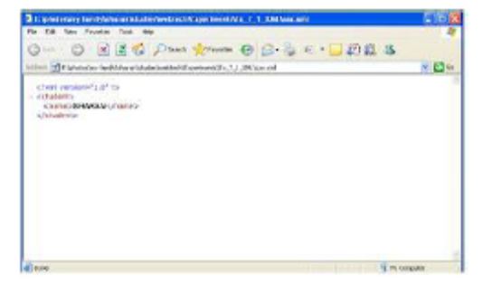

RESULT:
Thus a simple XML program was executed successfully.

Ex.No: 2
Date:
Topic: XML CSS
AIM:
To write a XML program with cascading style sheet
DESCRIPITION:

OUTPUT:
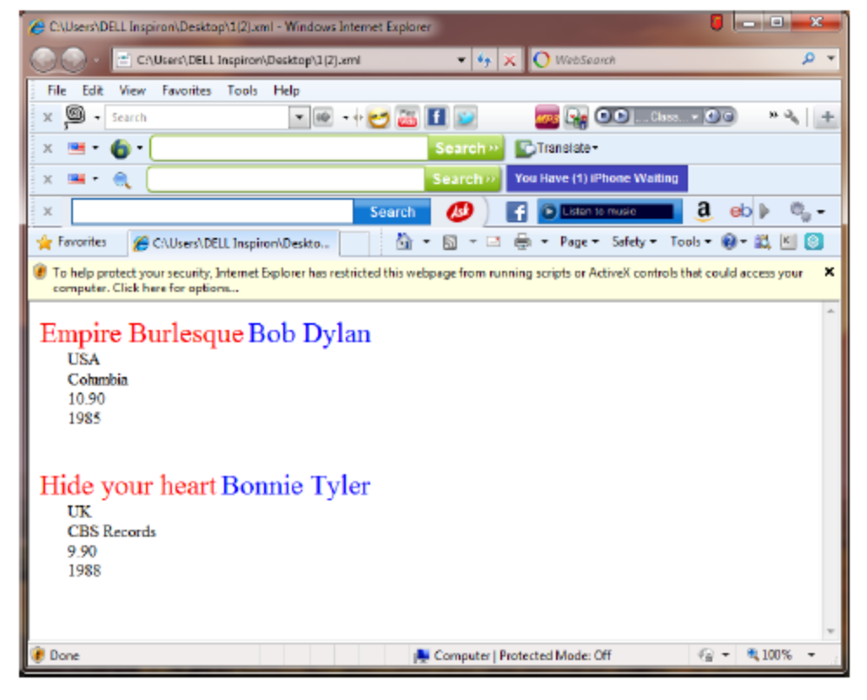

RESULT:
Thus a XML program with cascading style sheet was executed successfully.

Ex.No: 3
Date:
Topic: XML – XSL
AIM:
To write a xml program along with XSL.
DESCRIPTION:
XSL stands for EXtensible Stylesheet Language, and is a style sheet language for XML documents.
XSLT stands for XSL Transformations. In this tutorial you will learn how to use XSLT to transform XML documents into other formats, like XHTML.
PROGRAM.

OUTPUT:
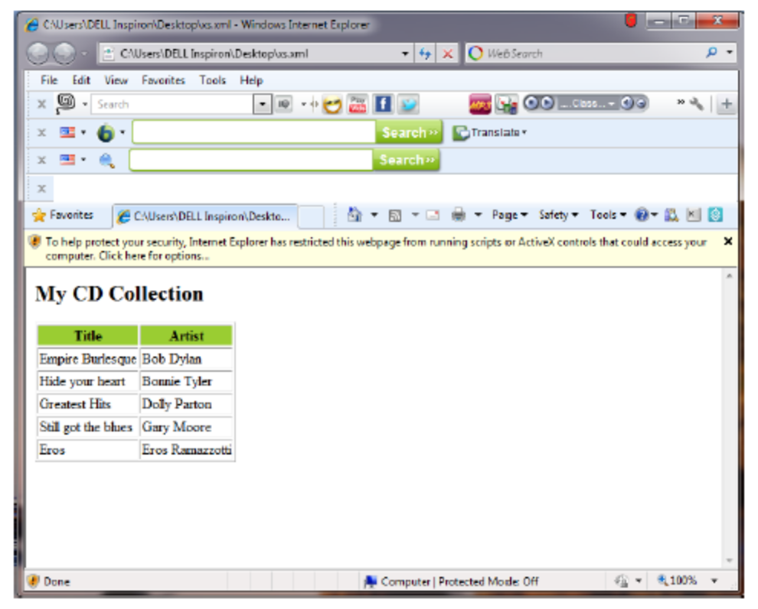

RESULT:
Thus a xml program along with xsl was executed successfully.

Ex.No: 4
Date:
Topic: XML – XSL choose
AIM:
To write a xml program along with XSL - choose
DESCRIPTION:
The <xsl:choose> element is used in conjunction with <xsl:when> and <xsl:otherwise> to express multiple conditional tests.
SYNATX:
<xsl:choose>
<xsl:when test="expression">
... some output ...
</xsl:when>
<xsl:otherwise>
... some output ....
</xsl:otherwise>
</xsl:choose>
PROGRAM.

OUTPUT:
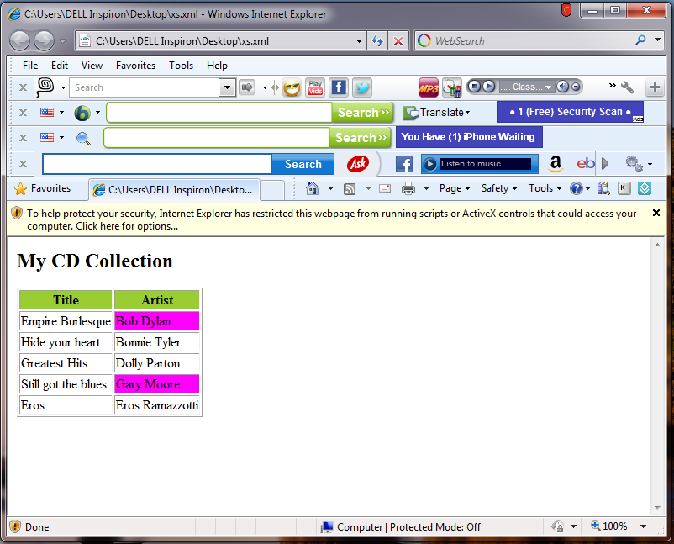

RESULT:
Thus a xml program along with xsl choose was executed successfully.
Ex.No: 5
Date:
Topic: XML – XSL apply
AIM:
To write a xml program along with XSL - apply
DESCRIPTION:
The <xsl:choose> element is used in conjunction with <xsl:when> and <xsl:otherwise> to express multiple conditional tests.
SYNTAX:
<xsl:choose>
<xsl:when test="expression">
... some output ...
</xsl:when>
<xsl:otherwise>
... some output ....
</xsl:otherwise>
</xsl:choose>
PROGRAM.

OUTPUT:
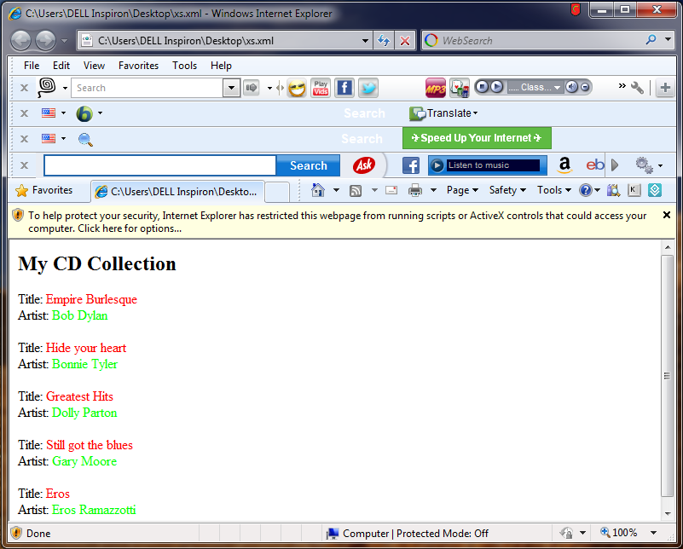

RESULT:
Thus a xml program along with xsl apply was executed successfully

