**Creating Get-WinEvent queries with FilterHashtable**

* Article
* 10/12/2021
* 6 minutes to read
* 5 contributors

To read the original June 3, 2014 **Scripting Guy** blog post, see [Use FilterHashTable to Filter Event Log with PowerShell](https://devblogs.microsoft.com/scripting/use-filterhashtable-to-filter-event-log-with-powershell/).

This article is an excerpt of the original blog post and explains how to use the Get-WinEvent cmdlet's **FilterHashtable** parameter to filter event logs. PowerShell's Get-WinEvent cmdlet is a powerful method to filter Windows event and diagnostic logs. Performance improves when a Get-WinEvent query uses the **FilterHashtable** parameter.

When you work with large event logs, it's not efficient to send objects down the pipeline to a Where-Object command. Prior to PowerShell 6, the Get-EventLog cmdlet was another option to get log data. For example, the following commands are inefficient to filter the **Microsoft-Windows-Defrag** logs:

PowerShellCopy

Get-EventLog -LogName Application | Where-Object Source -Match defrag

Get-WinEvent -LogName Application | Where-Object { $_.ProviderName -Match 'defrag' }

The following command uses a hash table that improves the performance:

PowerShellCopy

Get-WinEvent -FilterHashtable @{

LogName='Application'

ProviderName='*defrag'

}

**Blog posts about enumeration**

This article presents information about how to use enumerated values in a hash table. For more information about enumeration, read these **Scripting Guy** blog posts. To create a function that returns the enumerated values, see [Enumerations and Values](https://devblogs.microsoft.com/scripting/hey-scripting-guy-weekend-scripter-enumerations-and-values). For more information, see the [Scripting Guy series of blog posts about enumeration](https://devblogs.microsoft.com/scripting/?s=about+enumeration).

**Hash table key-value pairs**

To build efficient queries, use the Get-WinEvent cmdlet with the **FilterHashtable** parameter. **FilterHashtable** accepts a hash table as a filter to get specific information from Windows event logs. A hash table uses **key-value** pairs. For more information about hash tables, see [about_Hash_Tables](https://docs.microsoft.com/en-us/powershell/module/microsoft.powershell.core/about/about_hash_tables).

If the **key-value** pairs are on the same line, they must be separated by a semicolon. If each **key-value** pair is on a separate line, the semicolon isn't needed. For example, this article places **key-value** pairs on separate lines and doesn't use semicolons.

This sample uses several of the **FilterHashtable** parameter's **key-value** pairs. The completed query includes **LogName**, **ProviderName**, **Keywords**, **ID**, and **Level**.

The accepted **key-value** pairs are shown in the following table and are included in the documentation for the [Get-WinEvent](https://docs.microsoft.com/en-us/powershell/module/microsoft.powershell.diagnostics/Get-WinEvent) **FilterHashtable** parameter.

The following table displays the key names, data types, and whether wildcard characters are accepted for a data value.

| **Key name** | **Value data type** | **Accepts wildcard characters?** |
| --- | --- | --- |
| LogName | <String[]> | Yes |
| ProviderName | <String[]> | Yes |
| Path | <String[]> | No |
| Keywords | <Long[]> | No |
| ID | <Int32[]> | No |
| Level | <Int32[]> | No |
| StartTime | <DateTime> | No |
| EndTime | <DateTime> | No |
| UserID | <SID> | No |
| Data | <String[]> | No |
| <named-data> | <String[]> | No |

The <named-data> key represents a named event data field. For example, the Perflib event 1008 can contain the following event data:

XMLCopy

<EventData>

<Data Name="Service">BITS</Data>

<Data Name="Library">C:\Windows\System32\bitsperf.dll</Data>

<Data Name="Win32Error">2</Data>

</EventData>

You can query for these events using the following command:

PowerShellCopy

Get-WinEvent -FilterHashtable @{LogName='Application'; 'Service'='Bits'}

**Note**

The ability to query for <named-data> was added in PowerShell 6.

**Building a query with a hash table**

To verify results and troubleshoot problems, it helps to build the hash table one **key-value** pair at a time. The query gets data from the **Application** log. The hash table is equivalent to Get-WinEvent -LogName Application.

To begin, create the Get-WinEvent query. Use the **FilterHashtable** parameter's **key-value** pair with the key, **LogName**, and the value, **Application**.

PowerShellCopy

Get-WinEvent -FilterHashtable @{

LogName='Application'

}

Continue to build the hash table with the **ProviderName** key. Usually, the **ProviderName** is the name that appears in the **Source** field in the **Windows Event Viewer**. For example, .NET Runtime in the following screenshot:

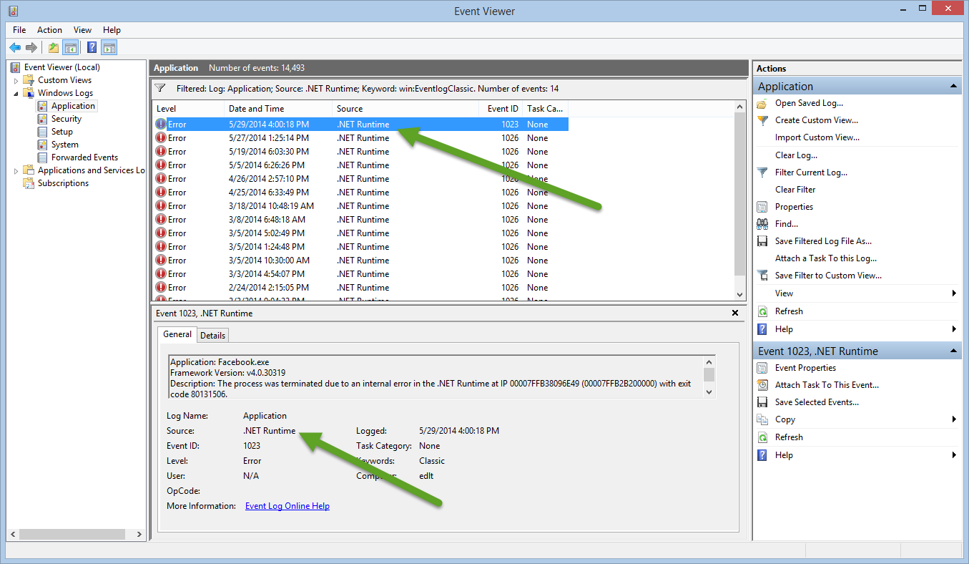

Update the hash table and include the **key-value** pair with the key, **ProviderName**, and the value, .NET Runtime.

PowerShellCopy

Get-WinEvent -FilterHashtable @{

LogName='Application'

ProviderName='.NET Runtime'

}

**Note**

For some event providers, the correct **ProviderName** can be obtained by looking on the **Details** tab in **Event Properties**. For example, events where the **Source** field shows Defrag, the correct **ProviderName** is Microsoft-Windows-Defrag.

If your query needs to get data from archived event logs, use the **Path** key. The **Path** value specifies the full path to the log file. For more information, see the **Scripting Guy** blog post, [Use PowerShell to Parse Saved Event Logs for Errors](https://devblogs.microsoft.com/scripting/use-powershell-to-parse-saved-event-logs-for-errors).

**Using enumerated values in a hash table**

**Keywords** is the next key in the hash table. The **Keywords** data type is an array of the [long] value type that holds a large number. Use the following command to find the maximum value of [long]:

PowerShellCopy

[long]::MaxValue

OutputCopy

9223372036854775807

For the **Keywords** key, PowerShell uses a number, not a string such as **Security**. **Windows Event Viewer** displays the **Keywords** as strings, but they are enumerated values. In the hash table, if you use the **Keywords** key with a string value, an error message is displayed.

Open the **Windows Event Viewer** and from the **Actions** pane, click on **Filter current log**. The **Keywords** drop-down menu displays the available keywords, as shown in the following screenshot:

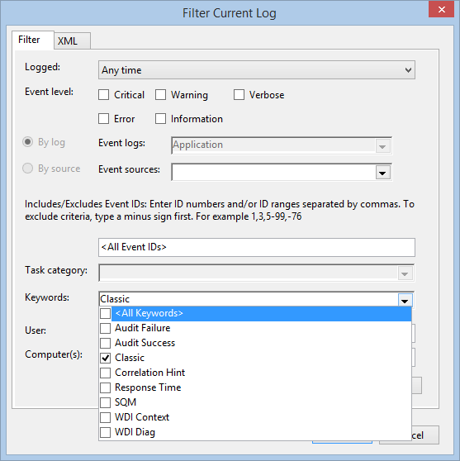

Use the following command to display the StandardEventKeywords property names.

PowerShellCopy

[System.Diagnostics.Eventing.Reader.StandardEventKeywords] | Get-Member -Static -MemberType Property

OutputCopy

TypeName: System.Diagnostics.Eventing.Reader.StandardEventKeywords

Name MemberType Definition

—- ———- ———-

AuditFailure Property static System.Diagnostics.Eventing.Reader.StandardEventKey…

AuditSuccess Property static System.Diagnostics.Eventing.Reader.StandardEventKey…

CorrelationHint Property static System.Diagnostics.Eventing.Reader.StandardEventKey…

CorrelationHint2 Property static System.Diagnostics.Eventing.Reader.StandardEventKey…

EventLogClassic Property static System.Diagnostics.Eventing.Reader.StandardEventKey…

None Property static System.Diagnostics.Eventing.Reader.StandardEventKey…

ResponseTime Property static System.Diagnostics.Eventing.Reader.StandardEventKey…

Sqm Property static System.Diagnostics.Eventing.Reader.StandardEventKey…

WdiContext Property static System.Diagnostics.Eventing.Reader.StandardEventKey…

WdiDiagnostic Property static System.Diagnostics.Eventing.Reader.StandardEventKey…

The enumerated values are documented in the **.NET Framework**. For more information, see [StandardEventKeywords Enumeration](https://docs.microsoft.com/en-us/dotnet/api/system.diagnostics.eventing.reader.standardeventkeywords).

The **Keywords** names and enumerated values are as follows:

| **Name** | **Value** |
| --- | --- |
| AuditFailure | 4503599627370496 |
| AuditSuccess | 9007199254740992 |
| CorrelationHint2 | 18014398509481984 |
| EventLogClassic | 36028797018963968 |
| Sqm | 2251799813685248 |
| WdiDiagnostic | 1125899906842624 |
| WdiContext | 562949953421312 |
| ResponseTime | 281474976710656 |
| None | 0 |

Update the hash table and include the **key-value** pair with the key, **Keywords**, and the **EventLogClassic** enumeration value, **36028797018963968**.

PowerShellCopy

Get-WinEvent -FilterHashtable @{

LogName='Application'

ProviderName='.NET Runtime'

Keywords=36028797018963968

}

**Keywords static property value (optional)**

The **Keywords** key is enumerated, but you can use a static property name in the hash table query. Rather than using the returned string, the property name must be converted to a value with the **Value__** property.

For example, the following script uses the **Value__** property.

PowerShellCopy

$C = [System.Diagnostics.Eventing.Reader.StandardEventKeywords]::EventLogClassic

Get-WinEvent -FilterHashtable @{

LogName='Application'

ProviderName='.NET Runtime'

Keywords=$C.Value__

}

**Filtering by Event Id**

To get more specific data, the query's results are filtered by **Event Id**. The **Event Id** is referenced in the hash table as the key **ID** and the value is a specific **Event Id**. The **Windows Event Viewer** displays the **Event Id**. This example uses **Event Id 1023**.

Update the hash table and include the **key-value** pair with the key, **ID** and the value, **1023**.

PowerShellCopy

Get-WinEvent -FilterHashtable @{

LogName='Application'

ProviderName='.NET Runtime'

Keywords=36028797018963968

ID=1023

}

**Filtering by Level**

To further refine the results and include only events that are errors, use the **Level** key. **Windows Event Viewer** displays the **Level** as string values, but they are enumerated values. In the hash table, if you use the **Level** key with a string value, an error message is displayed.

**Level** has values such as **Error**, **Warning**, or **Informational**. Use the following command to display the StandardEventLevel property names.

PowerShellCopy

[System.Diagnostics.Eventing.Reader.StandardEventLevel] | Get-Member -Static -MemberType Property

OutputCopy

TypeName: System.Diagnostics.Eventing.Reader.StandardEventLevel

Name MemberType Definition

---- ---------- ----------

Critical Property static System.Diagnostics.Eventing.Reader.StandardEventLevel Critical {get;}

Error Property static System.Diagnostics.Eventing.Reader.StandardEventLevel Error {get;}

Informational Property static System.Diagnostics.Eventing.Reader.StandardEventLevel Informational {get;}

LogAlways Property static System.Diagnostics.Eventing.Reader.StandardEventLevel LogAlways {get;}

Verbose Property static System.Diagnostics.Eventing.Reader.StandardEventLevel Verbose {get;}

Warning Property static System.Diagnostics.Eventing.Reader.StandardEventLevel Warning {get;}

The enumerated values are documented in the **.NET Framework**. For more information, see [StandardEventLevel Enumeration](https://docs.microsoft.com/en-us/dotnet/api/system.diagnostics.eventing.reader.standardeventlevel).

The **Level** key's names and enumerated values are as follows:

| **Name** | **Value** |
| --- | --- |
| Verbose | 5 |
| Informational | 4 |
| Warning | 3 |
| Error | 2 |
| Critical | 1 |
| LogAlways | 0 |

The hash table for the completed query includes the key, **Level**, and the value, **2**.

PowerShellCopy

Get-WinEvent -FilterHashtable @{

LogName='Application'

ProviderName='.NET Runtime'

Keywords=36028797018963968

ID=1023

Level=2

}

**Level static property in enumeration (optional)**

The **Level** key is enumerated, but you can use a static property name in the hash table query. Rather than using the returned string, the property name must be converted to a value with the **Value__** property.

For example, the following script uses the **Value__** property.

PowerShellCopy

$C = [System.Diagnostics.Eventing.Reader.StandardEventLevel]::Informational

Get-WinEvent -FilterHashtable @{

LogName='Application'

ProviderName='.NET Runtime'

Keywords=36028797018963968

ID=1023

Level=$C.Value__

}